EXOEXPLORER



Team Name

Team Member:
- Hendry Setiawan
- Arnoldus Purbrayen Delasabtejo

Indonesia Aerospace Hakathon 2025
- Abstract
The ExoExplorer focuses on analyzing exoplanetary data to determine planetary habitability using machine learning and interpretability techniques such as SHAP (Shapley Additive Explanations) [4]. The core objective of this project is to provide insightful predictions regarding the potential for life-supporting conditions on exoplanets. This project offers significant value by assisting astronomers and researchers in identifying promising exoplanet candidates for further study. The expected impact includes accelerating the search for habitable planets [1], improving understanding of planetary characteristics [3], and contributing to the broader field of astrobiology.

- Background
The quest to discover habitable exoplanets is a central pursuit in modern astronomy, driven by humanity's innate curiosity about life beyond Earth [2]. Since the first confirmed exoplanet discovery in the 1990s, astronomers have identified more than 5,000 exoplanets, each varying in size, composition, and orbital characteristics [6]. Despite these advances, determining whether these planets could support life remains challenging due to limited observational data and the complexity of planetary systems [7].
Recent trends in the space industry highlight increasing investments in cutting-edge exploration technologies, such as NASA's TESS (Transiting Exoplanet Survey Satellite) [7] and the James Webb Space Telescope (JWST) [10], which generate vast datasets ripe for analysis. Machine learning plays a vital role in processing this data efficiently, providing predictive insights into planetary habitability [9]. However, educational tools that make these insights accessible to non-experts are still lacking. ExoExplorer addresses this gap by combining machine learning with SHAP-based explanations [4] and LLM-driven interpretations [15][16]. This approach enables personalized educational experiences by adjusting explanations based on the user's age and understanding, making complex astronomical concepts approachable.

- Problem Statement
While significant progress has been made in detecting exoplanets, evaluating their habitability remains a difficult task [1]. Current assessment methods often produce predictions that lack interpretability, making them less valuable for both scientific research and educational purposes [5]. The absence of accessible tools that can explain these predictions in a user-friendly manner further limits public engagement and understanding.
ExoExplorer seeks to overcome these challenges by developing an educational software platform that uses machine learning to predict the habitability of exoplanets [8]. By integrating SHAP explanations and large language models like DeepSeek R1 and Llama [15][16], the software can provide clear, tailored explanations of prediction results. These explanations adapt to the user's level of understanding and age, offering an engaging educational experience. This solution not only supports scientific discovery but also makes the learning process more interactive and inclusive, encouraging a broader audience to explore the fascinating world of exoplanets [3].

- Objectives
  - Accurate Habitability Predictions: Develop robust machine learning models capable of predicting the habitability potential of exoplanets using diverse planetary features [9].
  - Interpretability Through SHAP: Utilize SHAP values to explain the influence of individual features on model predictions, ensuring transparency and scientific reliability [4].
  - Adaptive Explanations with LLMs: Implement large language models to provide user-specific explanations based on age and knowledge level, making complex scientific concepts accessible to a broader audience [15][16].
  - Educational Engagement: Design interactive educational tools that help users explore exoplanet data, understand machine learning predictions, and grasp planetary science concepts effectively [5].
  - Contribution to Astrobiology: Support astrobiology research by offering interpretable predictions that can guide further scientific exploration of potentially habitable exoplanets [1][3].

- Analysis
- Exploratory Data Analysis
The machine learning training data are obtained from the Habitable Worlds Catalog, released by Planetary Habitability Laboratory in University of Puerto Rico. It consists of 5,599 data and 118 columns. From all columns in the data, the used columns for analysis are 18 columns. Each column explains planet characteristics including physical conditions (temperature), orbital properties, stellar properties, and habitability.
Table 1. Name of used column in machine learning model
Columns | Description
P_ESI | Earth similarity index
P_SEMI_MAJOR_AXIS | Planet semi major axis
P_PERIOD | Planet orbit time
P_ECCENTRICITY | Planet eccentricity
P_FLUX | Planet mean stellar flux (earth units)
P_RADIUS | Planet radius (earth radii)
P_MASS | Planet mass (earth masses)
P_DENSITY | Planet density (earth units)
P_GRAVITY | Planet gravity (earth units)
P_TEMP_EQUIL_MIN | Planet minimum equilibrium temperature assuming bond albedo 0.3 (K)
P_TEMP_EQUIL_MAX | Planet maximum equilibrium temperature assuming bond albedo 0.3 (K)
P_TEMP_SURF_MIN | Planet minimum surface temperature (K)
P_TEMP_SURF_MAX | Planet maximum surface temperature (K)
S_TEMPERATURE | star effective temperature (K)
S_LUMINOSITY | Star luminosity (solar units)
S_TYPE_TEMP | Star spectral type (simplify one letter)
S_TIDAL_LOCK | star tidal lock zone outer edge (AU)
P_HABITABLE | Planet habitability condition

Based on the data, most discovered planets are not habitable (0). The habitable planets were less commonly found, including conservative (1) and optimistic (2), indicating an unbalanced data. Conservative planet means that the planet has liquid or solid surface water for a long time, like earth. Otherwise, an optimistic planet indicates that the planet has liquid surface water at some time in the past. This zone is considered larger than the conservative zone.
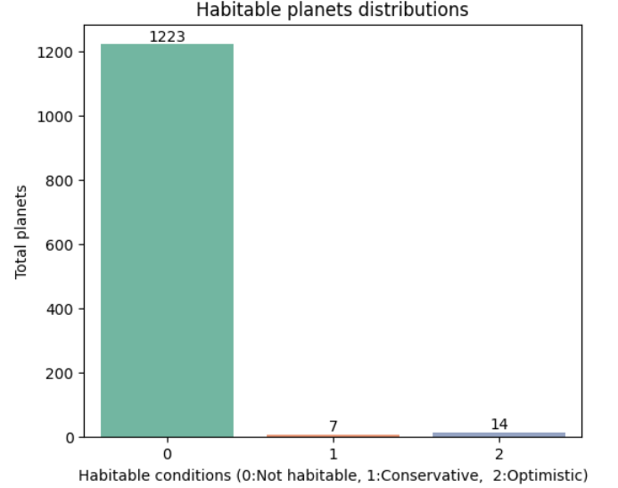
Image I. Habitable exoplanets distribution

Most exoplanets from this data were discovered during 2015 to 2017, caused by advancements in detection methods. After 2017, the discoveries declined and increased in 2022 to 2023.
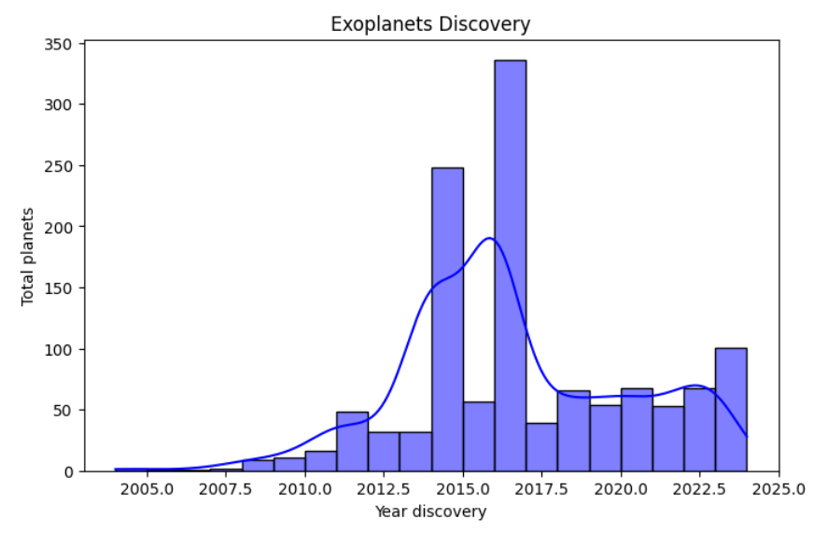
Image II. Year of exoplanets discovery

The discovered exoplanets were mostly found by the Transit method. This method is based on the observation of the dimming of a star's light when a planet appears to pass in front of it. The dimming light is commonly displayed by a light curves graph, which shows the light received over a period of time. The other methods, including radial velocity and orbital brightness were less commonly used for detecting exoplanets.
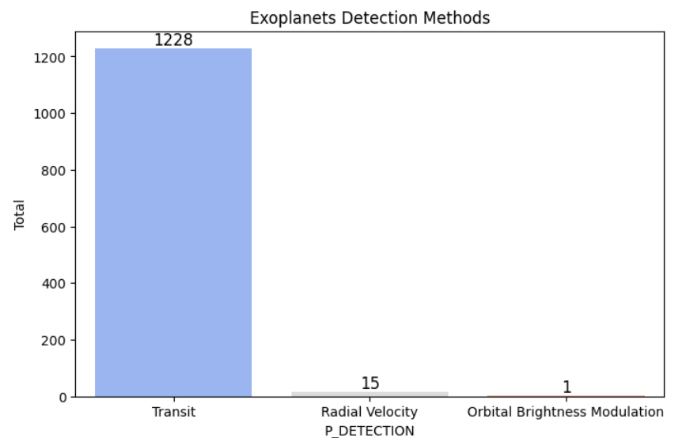
Image III. Exoplanet discovery method

- Data Preprocessing
The data preprocessing for machine learning training consists of splitting data, implementing one-hot encoding for categorical columns and SMOTE for addressing imbalance data in the P_HABITABLE as the target column. The data were split into 80% training and 20% for testing. Furthermore, the categorical data including S_TYPE_TEMP is transformed into numerical forms using one hot encoding. One hot encoding changes every category item into binary format . Finally, SMOTE is used for balancing the P_HABITABLE column. SMOTE oversamples the minority items including conservative habitable planets and optimistic habitable planets.

- Modelling
The model used for predicting exoplanet habitability is XGBoost . XGBoost stands for Extreme Gradient Boosting. This model consists of a gradient boosted decision tree for classifying categories. To improve model performance, randomized search CV is used for finding the best hyperparameter model. Finally, the performance of the model was evaluated by testing data.

Table II. Performance of XGboost model
Metrics | Score
Accuracy | 99.6%
Macro precission | 92%
Macro recall | 100%
Macro F1-score | 95%

Based on the evaluation metrics, the model successfully predicted almost 99.6% of exoplanet habitability conditions. Furthermore, the model has high F1-score, showing a strong balance between precision and recall score. Perfect macro recall score (100%), indicates that the model successfully classified every planet habitability without false negatives. Also, high precision score (92%) indicates that the model rarely predicted false positive exoplanets habitability.
- Solution
The program runs based on the python programming language. The used frameworks are :
- Frontend :
  - Streamlit : for user interface
- Backend :
  - Modelling :
    - Pandas, numpy & sckit-learn : data manipulation and data preprocessing
    - Xgboost : model training and prediction
    - Joblib : model deployment
  - SHAP graph :
    - SHAP & Matplotlib : generating SHAP graph
    - Selenium : saving generated SHAP graph in image format
  - LLM :
    - Langchain : Developing LLM model and providing LLM pipeline with Groq for generating output using the RAG (Retrieval-Augmented Generation) process or a prompt-based generation approach.
    - Sentence transformer : Embedding user documents for RAG purposes
    - FAISS : a vector store, created for saving embedded documents and used for generating output using the RAG approach.
    - Groq : AI inference, providing base main models, Deepseek R1 Distill Llama-70b and Llama-3.3-70b

The program runs based on this workflow :
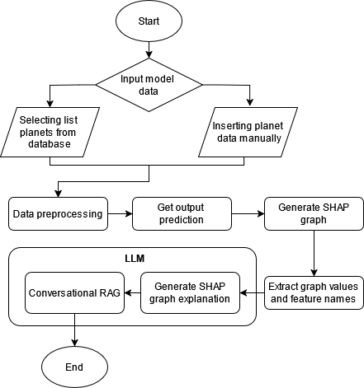
Image IV. Program workflows
- Input data
Firstly, the model needs a planetary input data for machine learning prediction. The user can select the planetary data from the planet database or manually insert data. The planet database consists of planets name, detection, physical and stellar information. The database is from the same data used in machine learning model training.
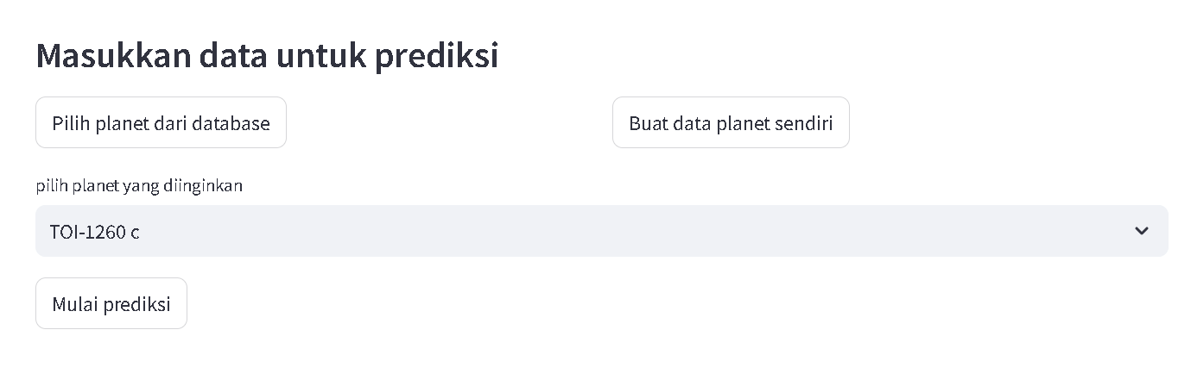
Image IV. Inserting planet data from database

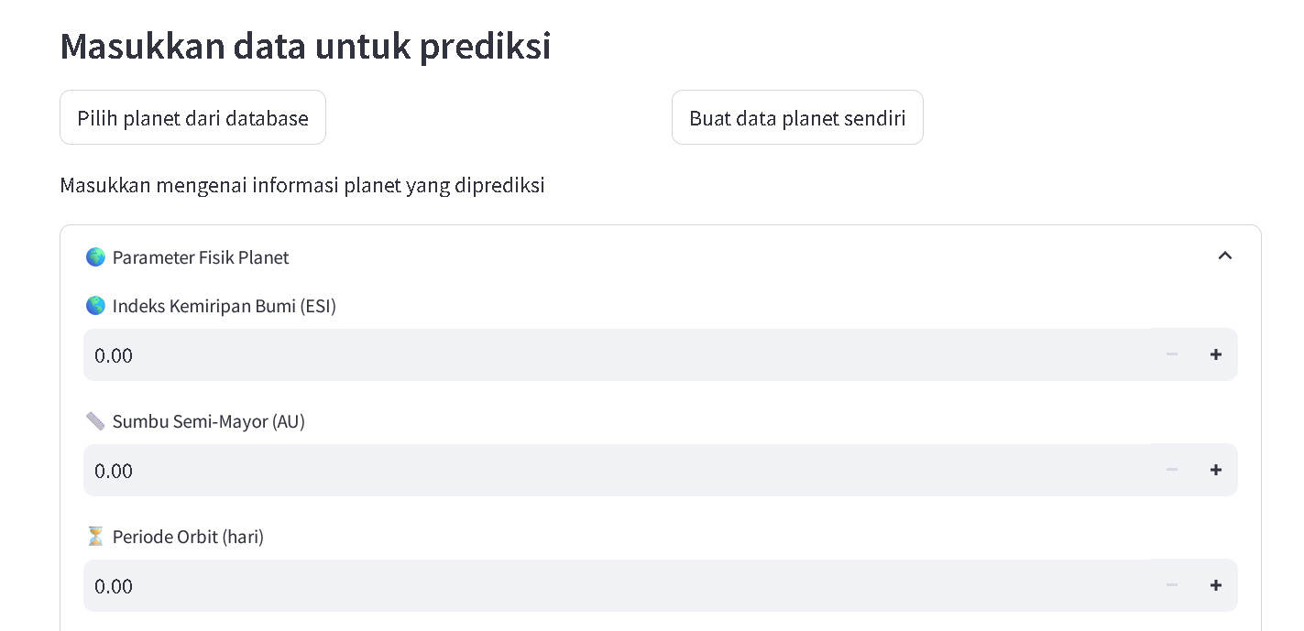
Image V. Inserting planet data manually

- Data preprocessing
After inserting planetary data, the categorical column, ( S_TYPE_TEMP) is changed into binary format using one hot encoding.
- Model prediction
The preprocessed data are ready to use for model prediction. The model processes the input and outputs 3 classes' probability score in a single matrix. To get the final output, the highest probability in each row is selected using the argmax function, which returns the index of highest probability. This index is mapped to its corresponding class label to get label output.
- Generate SHAP Graphics

What is SHAP value ? SHAP (SHapley Additive exPlanations) values help explain how machine learning models make predictions. They come from game theory and work by figuring out how much each feature contributes to the final result. SHAP values are based on Shapley values, a concept from cooperative game theory introduced by Lloyd Shapley in 1953. Shapley values provide a mathematically fair way to distribute a total gain (or payout) among players in a game, based on their contributions.
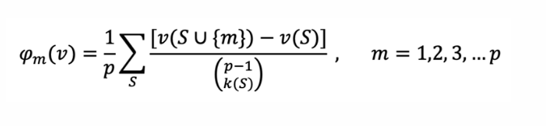
Image VI. Shapley Formulas
For a given member, m, the summation is over all the subsets S, of the team, T={1,2,3,…,p},that one can construct after excluding m. In the above formula, k(S) is the size of S, v(S) is the value achieved by subteam S, and v(S∪{m}) is the realized value after m joins S.

This program uses SHAP to analyze and visualize the feature importance of an XGBoost model’s prediction. To generate the SHAP graphics, it needs the trained XGboost model, model input and output (index, label and probability score ). The trained model and model input are fed into TreeExplaineer to compute SHAP values for each key feature. Then, the bar local plot is generated, emphasizing the most influential features of a prediction.
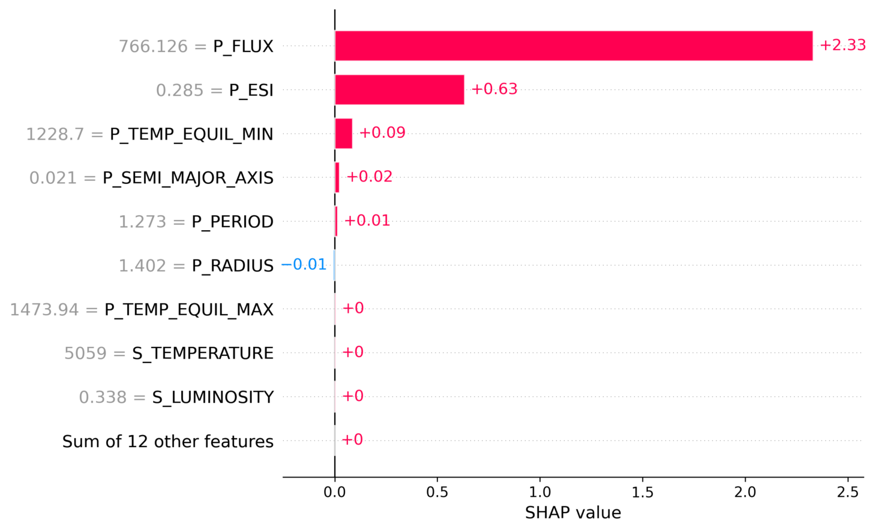
Image VII. Example SHAP graph
In a Y axis, it consists of feature names and their values. However, in the X axis, it consists of SHAP value, showing each feature contribution positively or negatively. The positive contribution is shown by the red color, otherwise the blue color shows the contribution to the prediction negatively. The importance of features are shown by the length of the bar. For example, P_FLUX is the most important variable, because the bar length is the longest than other variables. The graph is also saved and would be used in the SHAP graph interpretation.

- Extracting Graph Features
After generating a SHAP graph, the feature names and their values would be extracted. The extraction is needed to ensure accuracy and relevance for the LLM generation to interpret the graph. The extracted SHAP values and feature names would be paired to create a dictionary. This dictionary is sorted by absolute SHAP values to rank features by importance and converted to a readable string format.

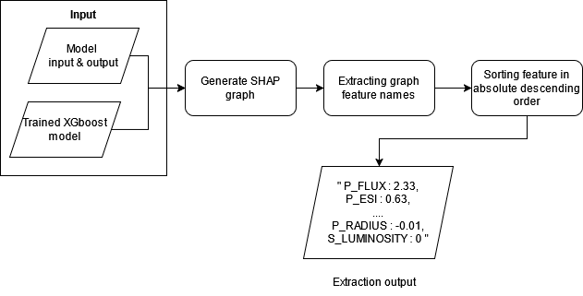
Image VIII. Extracting SHAP graph values workflows

- Generate SHAP Explanation
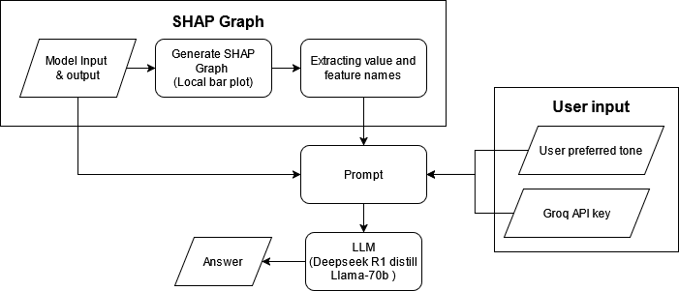
Image VIII. Generating SHAP graph interpretations using LLM workflows

Following the extraction of SHAP values from local bar graphs, these are used as a prompt to generate graph explanations using the LLM model.

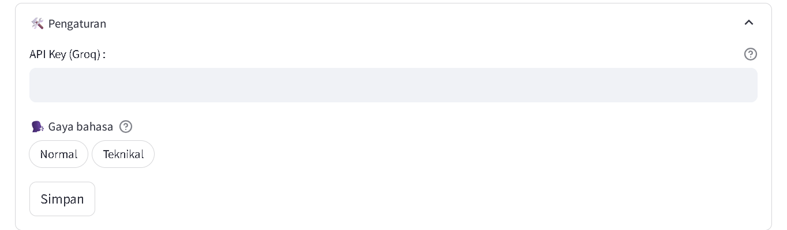
Image IX. Inserting API Key and user preferred tone

To support the generation process, the model takes user input, including user-preferred tones and Groq API key. The user-preferred tones can be selected from two options :
- Normal :
  - Use simple and clear language without complex technical terms.
  - Explain concepts in a way that is easy to understand.
  - Provide step-by-step guidance where necessary.
- Technical
  - Use proper technical terminology and provide in-depth explanations.
  - Refer to academic concepts and industry standards.
  - Offer advanced insights and analyses according to the professional context.

The selected tone is used for the LLM prompt to generate results that are more suited to the user's preferences. To get the Groq API key, the user needs to access https://console.groq.com/keys. The API key is accessed for free and users can get it effortlessly. The API key used for accessing model “Deepseek R1 Distill Llama 70b” and generating explanations based on prompt. The generated LLM result consists of 4 parts :
- Planetary information: Explaining the planet information such as planet name and detection information (detection method, used research facilities, and discovery year). The information is given if the user takes planetary input from the planet's database and does not enter it manually.
- Meaning of Prediction: Explaining the given output means. For example, if the model predicts ‘optimistically habitable,’ briefly explain what this means.
- Identify Key Features: Explaining key features and impact to the model prediction
- Conclusion : Explaining a summary of the findings of the analysis, emphasising how the features affected the model predictions, as well as any important patterns or observations.
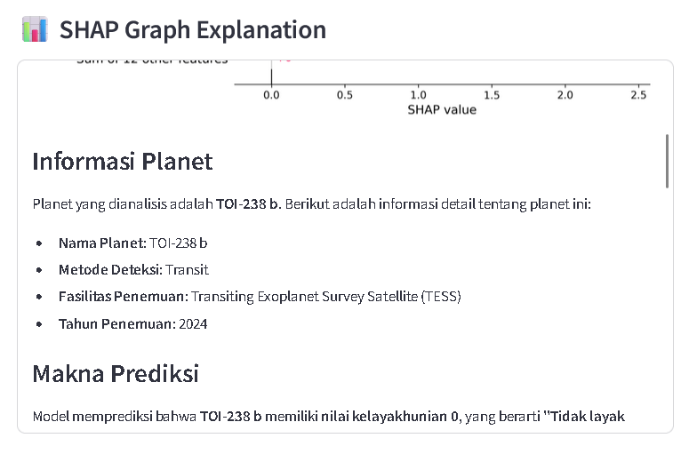
Image X. SHAP graph explanation example output

- Conversational RAG
The generated SHAP graph could be further explored using a conversational RAG process. It works by generating output based on chat history and gathered information.
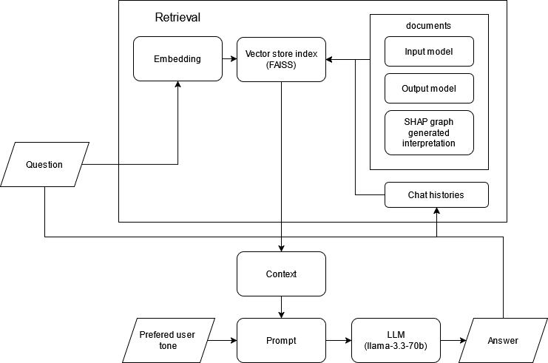
Image XI. Conversational RAG workflows

When the user inserts the question, the question is embedded using a sentence transformer into numerical representation and compared against the vector store index with Faiss to retrieve relevant contents. The vector store contains documents including, inserted input model, output model, SHAP graph generated information and chat histories. The retrieved documents are combined to form a context that will guide the LLM in generating an accurate response.
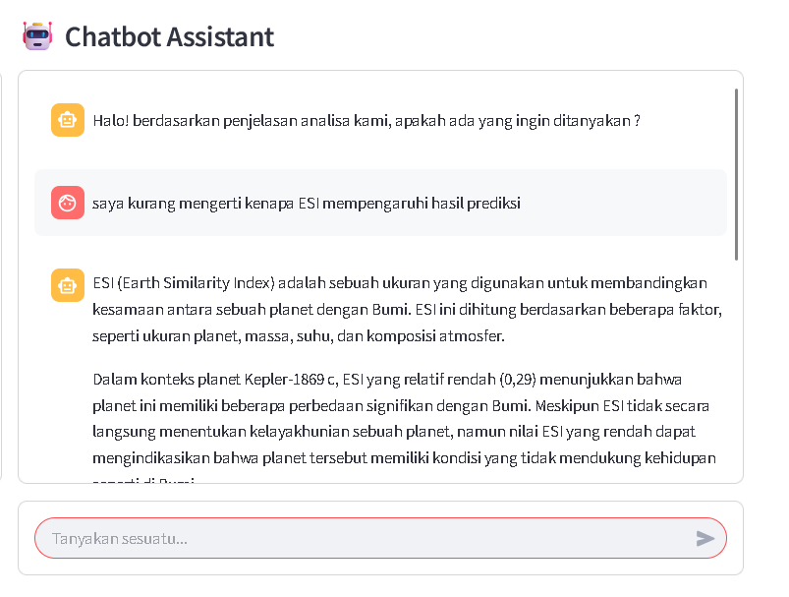
Image XII. Conversational RAG example output
The retrieved documents, alongside the user preferred tone are combined with prompt. Then, the prompt is fed into the LLM model of Llama-3.3-70b in Groq to generate an answer. After generating an answer, both the question and answer are saved for another question.

- Conclusion
ExoExplorer is a program that assists in the analysis of exoplanetary data by determining planetary habitability using machine learning and interpretability techniques such as SHAP (Shapley Additive exPlanations) and Large Language Models. The program utilises XGBoost for machine learning prediction, achieving 99.6% accuracy. The machine learning model is trained with the Habitable Worlds Catalog dataset, released by the Planetary Habitability Laboratory at the University of Puerto Rico. This consists of 5,599 planets, with the target column of "P_HABITABLE" including values of 0: Not habitable, 1: conservative , 2: optimistic . The LLM models are obtained from Groq, an AI inference providing base model including Deepseek R1 Distill Llama-70b for generating SHAP graph explanation and Llama-3.3-70b for conversational RAG process.

- Attachment
  - Github link : https://github.com/hendrSet312/exoplanet-chatbot
  - Presentation video : https://www.youtube.com/watch?v=m9IMlXTVKgM

- Source :

Ali Awan, A. (2023, June 28). An introduction to SHAP values and machine learning interpretability. Datacamp. Retrieved March 9, 2025, from https://www.datacamp.com/tutorial/introduction-to-shap-values-machine-learning-interpretability
bar plot — SHAP latest documentation. (n.d.). https://shap.readthedocs.io/en/latest/example_notebooks/api_examples/plots/bar.html
Batalha, N. M. (2014). Exploring Exoplanet Populations with Kepler. Proceedings of the National Academy of Sciences, 111(35), 12647–12653.
Beichman, C., et al. (2014). Observing Exoplanets with the James Webb Space Telescope (JWST). Publications of the Astronomical Society of the Pacific, 126(946), 1134.
DeepSeek Research. (2024). DeepSeek R1: A Large Language Model for Scientific Reasoning. Retrieved from https://deepseek.ai
LangChain. (n.d.). Conversational RAG. Retrieved March 9, 2025, from https://python.langchain.com/v0.2/docs/tutorials/qa_chat_history/
Lundberg, S. M., & Lee, S.-I. (2017). A Unified Approach to Interpreting Model Predictions. Advances in Neural Information Processing Systems (NeurIPS), 30.
Madhusudhan, N., Nixon, C. A., & Mousis, O. (2020). The Atmospheres of Exoplanets: From Observations to Models. Annual Review of Astronomy and Astrophysics, 58, 521-584.
Meta AI. (2024). Llama Models for AI-Driven Scientific Explanations. Retrieved from https://ai.meta.com/llama
Molnar, C. (2022). Interpretable Machine Learning. Lulu.com.
NASA Exoplanet Archive. (2024). Exoplanet Catalog Data. Retrieved from https://exoplanetarchive.ipac.caltech.edu/
Perryman, M. (2018). The Exoplanet Handbook (2nd ed.). Cambridge University Press.
Perryman, M. A. C. (2021). Astronomical Applications of Artificial Intelligence. Cambridge University Press.
Rein, H., & Tamayo, D. (2017). Machine Learning for Exoplanet Science. Monthly Notices of the Royal Astronomical Society, 469(3), 3042–3051.
Ricker, G. R., et al. (2015). The Transiting Exoplanet Survey Satellite (TESS). Journal of Astronomical Telescopes, Instruments, and Systems, 1(1), 014003.
Seager, S. (2013). Exoplanet Habitability. Science, 340(6132), 577-581.
Valencia, D., Guillot, T., Parmentier, V., & Freedman, R. (2013). Bulk Composition of Exoplanets. The Astrophysical Journal, 775(1), 10.
Villanueva, D., & Marley, M. (2023). Atmospheric Characterization of Exoplanets Using AI Methods. The Astrophysical Journal, 953(2), 75.
What is XGBoost? (n.d.). NVIDIA Data Science Glossary. https://www.nvidia.com/en-us/glossary/xgboost/
Zingales, T., & Waldmann, I. P. (2018). Exoplanetary Atmospheric Retrieval Using Machine Learning. The Astronomical Journal, 156(1), 1-18.

