|  |  |  |  |  |
| --- | --- | --- | --- | --- |
| BUKU PETUNJUK | | | | |
|  | |  | |  |
| APLIKASI LAPSITHAR | | | | |
|  | Laporan Situasi Harian  Badan Kesatuan Bangsa dan Politik Kab. Bintan | |  | |

Daftar Isi

Pendahuluan 3

STRUKTUR APLIKASI LAPSITHAR 3

1. Executive Summary 6

2. Company Overview 7

3. Business Description 8

4. Market Analysis 10

5. Operating Plan 12

6. Marketing and Sales Plan 13

7. Financial Plan 15

Appendix 18

Instructions for Getting Started with Estimated Start-Up Costs 19

Instructions for Getting Started on Profit & Loss Projections 21

# Pendahuluan

Aplikasi Lapsithar merupakan *website* yang memuat informasi-informasi yang berhubungan dengan laporan situasi harian yang terjadi di ruang lingkup Kabupaten Bintan. Badan Kesatuan Bangsa dan Politik sebagai Admin Layanan yang disediakan berupa cetak laporan harian dalam bentuk excel atau pdf, serta unduhan file yang berhubungan dengan laporan harian yang dibuat oleh setiap user.

## STRUKTUR APLIKASI LAPSITHAR

Aplikasi Lapsithar terdiri dari dua akses level yaitu User dan Admin, yaitu sebagai berikut :

Halaman Login

Pengguna atau biasa disebut *user* maupun *admin* pada Aplikasi Lapsithar, Halaman pertama kali yang akan diakses mereka adalah halaman login.

Tampilan Halaman Login

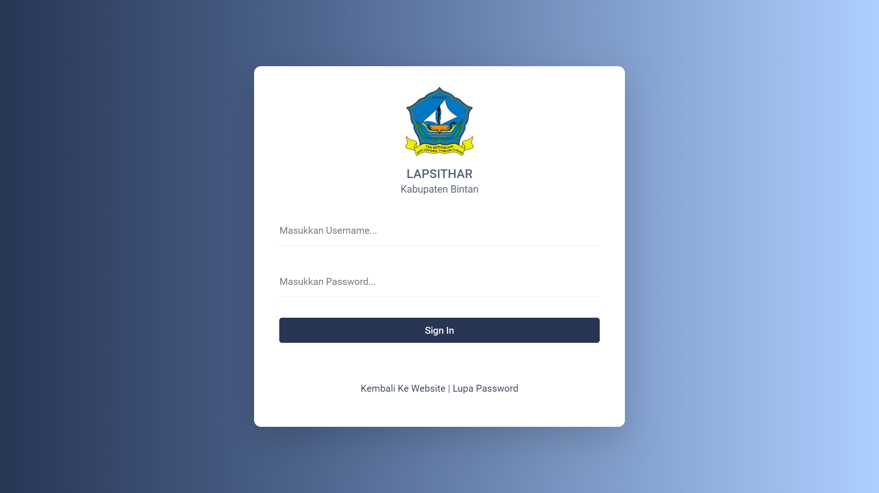

**4**

**5**

**3**

**2**

**1**

Penjelasan dari gambar tersebut :

1. Penggunamemasukkan username yang sudah didaftarkan oleh *admin*.
2. Penggunamemasukkan password dengan benar.
3. Penggunamenekan tombol *sign in* untuk masuk kedalam sistem.
4. Jika Penggunamenekan *link* Kembali ke Website maka akan diarahkan ke website utama kesbangpol yaitu bakesbangpol.bintankab.go.id
5. Jika Penggunalupa password, bisa menekan link *lupa password*, kemudian akan diarahkan ke halaman *Lupa Password*.

Tampilan Halaman Lupa Password

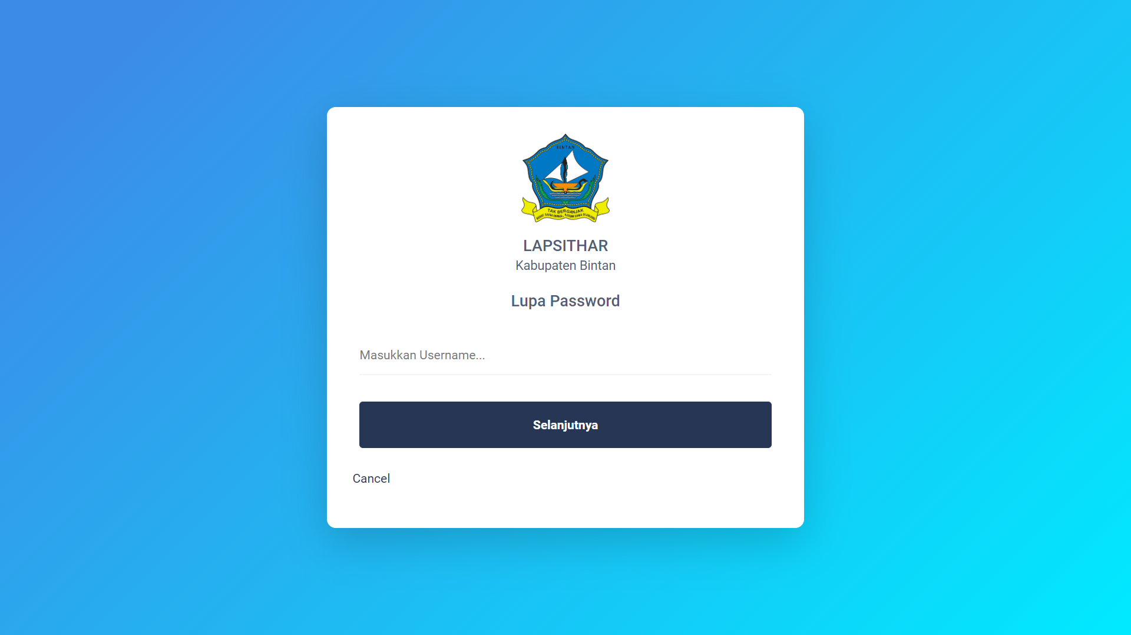

**3**

**2**

**1**

Penjelasan dari gambar tersebut :

1. 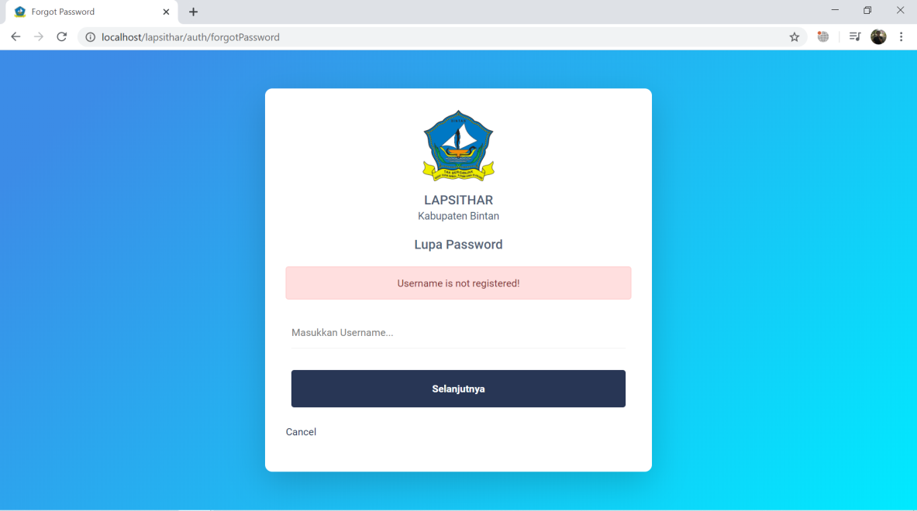 Penggunamemasukkan username yang sudah terdaftar di sistem, apabila salah akan muncul pesan artinya username tidak terdaftar.
2. Jika Penggunamemasukkan username dengan benar, tekan tombol selanjutnya dan akan dialihkan ke halaman ganti password.
3. Jika menekan *link* *cancel* maka pengguna akan diarahkan ke halaman login.

Tampilan Halaman Ganti Password

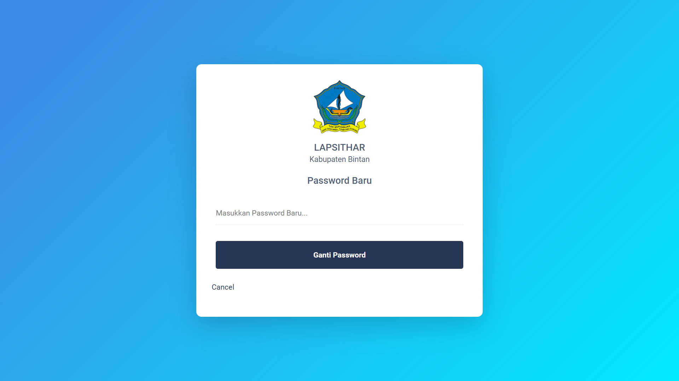

**3**

**2**

**1**

Penjelasan dari gambar tersebut :

1. Penggunamemasukkan password yang ingin diganti sesuai keinginan.
2. 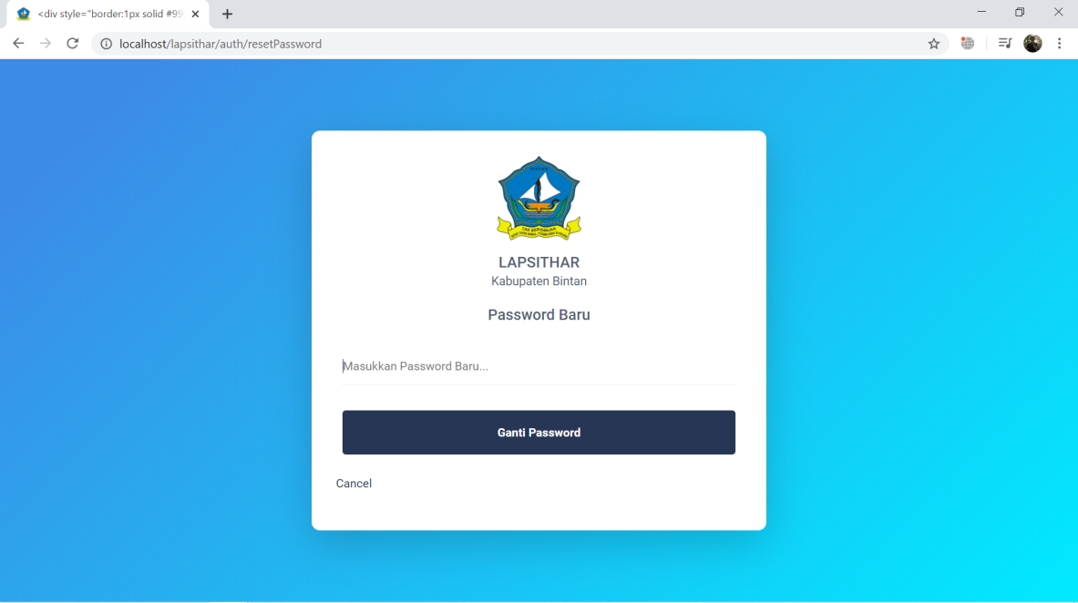Kemudian Pengguna menekan tombol maka password lama dari pengguna tersebut telah tergantikan dengan password yang baru, dan pengguna akan diarahkan kembali ke halam login
3. Jika menekan *link* *cancel* maka pengguna akan diarahkan ke halaman login.

# Executive Summary

The Executive Summary should be written last after the remainder of the plan has been finished. It is an overview (with a suggested length of no more than one page) of the business, including the problem the business aims to solve, why this business’ solution is different, the business’ ideal customer, and the expected results. The Executive Summary should provide a high-level and optimistic description of the company.

If the business requires outside investment or external investors, include how much is needed, how it will be used, and how it will make the business more profitable. Think of this section as the first thing a potential investor reads, thus, it must capture their interest quickly.

Suggested headings to organize this business plan include the following.

* Opportunity:What problem will the business solve?
* Mission: What problem will the business solve?
* Solution: How will the service uniquely solve the problem identified?
* Market focus: What market and ideal customers will the business target?
* Competitive advantage: How does the business intend to succeed against its competitors?
* Ownership: Who are the major stakeholders in the company?
* Expected returns: What are the key milestones for revenue, profits, growth, and customers?

# Company Overview

The Company Overview is a brief summary of the intended business, including what it uniquely delivers, the mission, how it got started, market positioning, operational structure, and financial goals. After reviewing this section, the reader should have a broad understanding of what the business is setting out to do and how it is organized.

This section is not meant to be lengthy. Keep it short and succinct. This is the snapshot of the business. The type of business will determine what of the following sections will be required for the business plan. Only include what is needed to properly represent the business and remove anything else.

* Company summary: This is the introductory section to the company, also known as the ‘elevator pitch’ of what the company stands for and is setting out to do. Include the company’s goals and some of the near-term objectives. Even if it is a small, service-oriented company, developing a summary is an important step to explain and focus the core business.
* Mission statement: This is a concise statement on the guiding principles of the company and what the company aims to do for customers, employees, owners, and other stakeholders.
* Company history: This provides the back story, especially the personal story, of why the business was founded. Use this section to give the overarching history of the company from its start and bring the reader up-to-date on where the company is now in terms of sales, profits, key services, and customers.
* Markets and services: This outlines the target market and related needs that the company will address. Include brief descriptions of offered services and targeted markets and customer types. This section can be a general overview as more details will be suggested in a later section of this plan.
* Operational structure: This describes the operational details of the business. List any potential employees needed on the payroll to make the business run.
* Financial goals: This describes the start-up capital needed, projected revenue and profits, forecast, and budget of the business.

# Business Description

This section will first frame the business opportunity and should answer the question: what problem(s) is the company trying to solve? Use a case example to describe the customers’ pain point and how it is solved today. If the business’ service addresses something the market has yet to identify as a problem (for instance, a new mobile app or a new clothing line), then also describe how the business’ solution reduces stress, saves money, or brings joy to the customer.

After framing the opportunity, describe the service in detail and how it is the solution the business offers, how it solves that problem, and what benefits customers will receive.

This section also describes in more detail how the services will be rendered and the pricing structure (e.g., fixed rate versus an hourly fee). Describe how the company plans to differentiate from its competitors. What is the target market and how can the customer capitalize on your unique offering?

Depending on the type of business, the following sections may or may not be necessary. Only include relevant sections and remove everything else.

* Opportunity: Describe the current market for the business’ offered service. At a high level, what is the market and who are its participants; is it business customers or consumers; what is the specific geography, etc.? More details on the market will be provided in the next section of the plan. Next, describe the current state of available services and how the business will offer better. Also discuss any additional services the company plans to offer in the future.
* Product overview: Describe the service offerings of the business in as much detail as possible. If it is effective to include pictures, this would be a good place to place them.
* Key participants: Identify any strategic partners in the business, such as critical suppliers, distributors, referral partners, or any others. In some businesses, products are custom-made and any break in their supply will impact the business. There may be key contributors to the services offered, so it is important to identify them.
* Pricing: Provide pricing of the service, gross margin projects, and upgrade paths. Describe why the company’s pricing will be attractive to the target market. Have a gauge on the competitor’s pricing and explain how the business’ service is unique to justify its pricing structure.
* Note the difference between working hours and billable hours. All working hours are not billable. If the business has employees with differing skill levels (for example, in a law practice, there are associates, paralegals, lawyers, partners, etc.), indicate the various billing rates.
* Communicate rates clearly to clients and customers. If there are potential additional fees which will be passed on to clients or customers, define and establish them up front.

# Market Analysis

The Market Analysis provides the reader with an understanding of how well the business knows and understands its market and if it is big enough to support the business objectives. This section provides an overview of the industry that the business will participate in. As this section is narrowed down to the ideal customer based on the business strategy, the plan will define the target market. A detailed description and sizing of the target market will help the reader understand the market value the business is pursuing (the number of potential customers multiplied by the average revenue for the product or service).

In defining the target market, the plan will identify key elements such as geographic location, demographics, buyer characteristics, the target market's needs, and how market needs are currently being met. If there are any direct competitors, explain how the company’s service compares to the competitors in terms of solving the consumers’ problems.

This section may also include a Strengths, Weaknesses, Opportunities, and Threats (SWOT) Analysis as necessary, to better assess the business’ position against the competition.

Depending on the type of business, the following sections may or may not be necessary. Only include what is need and remove everything else.

* Industry type: Begin with the broader descriptions of the market opportunity. For instance, if the intended business is a travel agency, the industry type would be service industry. In this particular market, the global revenues are projected to exceed $183 billion, but the local agency will have a much smaller market. Identify the potential clientele in the company’s local geography that might fit into the target demographic group. This section will also identify any industry regulations and evaluate trends in market growth and stability.
* Market segmentation: This section defines the main market segments and those the business is targeting now. A market segment is a group of people (or other businesses) within the industry, identify smaller segments, such as luxury travel or exotic cruisers. The market can also be segmented by criteria such as quality, price, range of products, geography, demographics, and others. A few other elements to consider answer questions such as: Is the segment growing, shrinking, or will it be flat for the next few years? What percentage of the market will be reachable? What share of the market is anticipated within the next 2-3 years? Graphics are best used in a section like this to either show growth (line graph) or percentages of markets or groups (pie chart).
* Competition: All businesses compete in one way or another. It may be with specific, direct competitors or it may be with the way customers have been doing things for a long time. When identifying the competition, identify who else is providing services to solve the same problem the business seeks to address. What are the business’ advantages over these competitors? How will the company’s voice be heard over the noise of competitors? Sometimes a business plan includes a matrix of features and compares how each business offers or does not offer those features. This section reflects how the company’s solution is different and better suited for the identified target market compared to the competition.
* SWOT analysis: A SWOT analysis may be included by completing the boxes below to assess the business’ current environment’s strengths and weaknesses (internal) and opportunities and threats (external). This is a good exercise to go through on an annual basis. After completing the analysis, provide thoughts on: how the business’ strengths can help maximize opportunities and minimize threats; how its weaknesses can slow the company’s ability to capitalize on the opportunities; and how the business’ weaknesses could expose it to threats.

|  |  |  |
| --- | --- | --- |
| STRENGTHS   * Advantage * Capabilities * Assets, people * Experience * Financial reserves * Value proposition * Price, value, quality |  | WEAKNESSES   * Disadvantages * Gap in capabilities * Cash Flow * Suppliers * Experience * Areas to improve * Causes of lose sales |
| OPPORTUNITIES   * Areas to improve * New segments * Industry trends * New products * New innovations * Key partnership | THREATS   * Economy movement * Obstacles faced * Competitor actions * Political impacts * Environmental effects * Loss of key staff * Market demand |

# Operating Plan

Additionally, it is necessary to outline how the company currently and will continue to develop and maintain a loyal customer base. This section includes management responsibilities with dates and budgets and making sure results can be tracked. What are the envisioned phases for future growth and the capabilities that need to be in place to realize growth?

The operating plan describes how the business works. Depending on the type of the business, important elements of this plan should include how the company will bring services to market and how it will support customers. It is the logistics, technology, and basic blocking and tackling of the business.

Depending on the type of business, the following sections may or may not be necessary. Only include what is needed and remove everything else. Remember: try to keep the business plan as short as possible. Excessive detail in this section could easily make the plan too long.

* Order fulfillment: Describe the company’s procedures for delivering services to its customers. As a service company, determine how to keep track of the customer base, form of communications, and how best to manage sales and data.
* Payment: Describe the standard payment terms and the payment methods accepted. Describe the pricing plans (one-time service fees, hourly-based fees, markups, and any other fees) and any impact on cash flow.
* Technology: If technology is critical to the business, whether it is part of the service offering or is fundamental to delivering a service, describe the key technologies used that are proprietary. If the business data (company or customer) is at risk, describe the data security plan in place, as well as any backup or recovery in the case of a disaster or outage.
* Key customers: Identify any customers that are important to the success of the business due to a partnership, volume, or pathway to a new market. Also identify any customers who bring in more than 10% of the company’s revenues.
* Key employees and organization: Describe unique skills or experiences that are required of the current team. If necessary, describe any proprietary recruiting or training processes in place. List key employees that are necessary for success. Include an organization chart to support this section.
* Facilities: Describe the type of business facility, whether leased, owned, or a shared business premises. Provide a listing of business locations, their purpose, and future plans for these facilities. If there are no facilities, and the business plans to buy or lease them, include that in this plan.

# Marketing and Sales Plan

Promoting the business, whether through generating leads or traffic to a website or store, is one of the most important functions of any business. In this section of the plan, provide details of intended marketing of the business. Describe the key messages and channels used for generating leads and promoting the business. This section should also describe any sales strategy. Depending on the type of business, the following sections may or may not be necessary. Only include what is needed and remove everything else.

* Key messages: Describe the key messages that will elevate services in the target customers’ eyes. If there is sample collateral or graphical images of some messages, include them.
* Marketing activities: Which of the following promotion options provide the company the best chance of product recognition, qualified leads, store traffic, or appointments?
* Media advertising (newspaper, magazine, television, radio)
* Direct mail
* Telephone solicitation
* Seminars or business conferences
* Joint advertising with other companies
* Word of mouth or fixed signage
* Digital marketing such as social media, email marketing, SEO, or blogging
* Provide limited free consultations (such as free job pricing for Contractors, free landscaping consultation for landscapers, or free pricing opinions for real estate agents)
* Sponsor local sports teams or other community events
* Give free informational talks either at the business offices or for local businesses offering complementary services (such as a real estate agent providing seminars about preparing a home to bring to market)
* Do free work for local non-profits (such as an ad agency designing a local farmer’s market’s website for free)
* Sales strategy: If needed, what will be the sales approach? Will there be full-time commissioned sales people, contract sales, or another approach? Many one-on-one service businesses are heavily reliant on word of mouth. Take this into account when developing the sales strategy.

# Financial Plan

Creating a financial plan is where all of the business planning comes together. Up to this point, the target market, target customers, and pricing have all been identified. These items, along with assumptions, will help estimate the company’s sales forecast. The other side of the business will be what expenses are expected. This is important on an ongoing basis to see when the business is profitable. It is also important to know what expenses will need to be funded before customer sales, or the cash they generate, is received.

At a minimum, this section should include estimated start-up costs and projected profit and loss, along with a summary of the assumptions being made with these projections. Assumptions should include initial and ongoing sales, along with the timing of these inflows.

* Projected start-up costs: The table below shows a sample of ongoing and one-time cost items that the business might need in order to open. Many businesses are paid on credit over time and do not have cash coming in immediately. It is necessary to make assumptions about how many months of recurring items, in addition to one-time expenses, to estimate when cash will begin to flow into the company. To begin with, the company will have to fund out of savings or an initial investment. There is a blank table in the Appendix to complete potential start-up cost projections.

|  |  |  |  |  |
| --- | --- | --- | --- | --- |
| START-UP COSTS | | | | |
| Your Office-Based Agency | January 1, 20xx | | | |
| COST ITEMS | MONTHS | COST/ MONTH | ONE-TIME COST | TOTAL COST |
| Advertising/Marketing | 3 | $300 | $2,000 | $2,900 |
| Employee Salaries* | 4 | $500 | $2 | $2,002 |
| Employee Payroll Taxes and Benefits | 4 | $100 | $1,500 | $1,600 |
| Rent/Lease Payments/Utilities | 4 | $750 | $2,500 | $5,500 |
| Postage/Shipping | 1 | $25 | $25 | $50 |
| Communication/Telephone | 4 | $70 | $280 | $560 |
| Computer Equipment |  | $0 | $1,500 | $1,500 |
| Computer Software |  | $0 | $300 | $300 |
| Insurance |  | $0 | $60 | $60 |
| Interest Expense |  | $0 | $0 | $0 |
| Bank Service Charges |  | $0 | $0 | $0 |
| Supplies |  | $0 | $0 | $0 |
| Travel & Entertainment |  | $0 | $0 | $0 |
| Equipment |  | $0 | $2,500 | $2,500 |
| Furniture & Fixtures |  | $0 | $0 | $0 |
| Leasehold Improvements |  | $0 | $0 | $0 |
| Security Deposit(s) |  | $0 | $0 | $0 |
| Business Licenses/Permits/Fees |  | $0 | $5,000 | $5,000 |
| Professional Services - Legal, Accounting |  | $0 | $1,500 | $1,500 |
| Consultant(s) |  | $0 | $0 | $0 |
| Inventory |  | $0 | $0 | $0 |
| Cash-On-Hand (Working Capital) |  | $0 | $1,000 | $1,000 |
| Miscellaneous |  | $0 | $2,000 | $2,000 |
| ESTIMATED START-UP BUDGET |  |  |  | $26,472 |
| *Based on part-time employees. This may change once you hit your growth benchmark. | | | | |

**Projected profit and loss model:** The model below shows a sample of the projections a small business is forecasting for their first 12 months of operations. The top portion of the table shows projected sales and gross profit. This is a good place to begin creating the company’s sales forecast. The next section itemizes the recurring expenses the business is projecting for the same months. These should be consistent with the estimated start-up costs completed in the prior section. At the bottom of this model, it will possible to see when the company is becoming profitable and what expense items are the most impactful to its profitability. There is a blank table in the Appendix to complete the business’ own start-up cost projections.

|  |  |  |  |  |  |  |  |  |  |  |  |  |  |  |
| --- | --- | --- | --- | --- | --- | --- | --- | --- | --- | --- | --- | --- | --- | --- |
| START-UP COSTS | | | | | | | | | | | | | | |
| Your Office-Based Agency | | | | | | | January 1, 20xx | | | | | | | |
| REVENUE | JAN | FEB | MAR | APR | MAY | JUN | | JUL | AUG | SEP | OCT | NOV | DEC | YTD |
| Estimated Sales | $5,000 | $13,000 | $16,000 | $7,000 | $14,500 | $16,400 | | $22,500 | $23,125 | $24,549 | $22,000 | $25,000 | $27,349 | $216,423 |
| Less Sales Returns & Discounts | $0 | ($350) | $0 | ($206) | ($234) | $0 | | $0 | ($280) | ($1,200) | ($1,600) | $0 | ($2,400) | ($6,270) |
| Service Revenue | $0 | $0 | $0 | $0 | $0 | $250 | | $350 | $100 | $0 | $0 | $1,245 | $1,360 | $3,305 |
| Other Revenue | $0 | $0 | $0 | $0 | $0 | $0 | | $0 | $1,500 | $0 | $0 | $0 | $0 | $1,500 |
| Net Sales | $5,000 | $12,650 | $16,000 | $6,794 | $14,266 | $16,650 | | $22,850 | $24,445 | $23,349 | $20,400 | $26,245 | $26,309 | $214,958 |
| Cost of Goods Sold* | $2,000 | $5,200 | $6,400 | $2,800 | $5,800 | $6,560 | | $9,000 | $9,250 | $9,820 | $8,800 | $10,000 | $10,940 | $86,569 |
| Gross Profit | $3,000 | $7,450 | $9,600 | $3,994 | $8,466 | $10,090 | | $13,850 | $15,195 | $13,529 | $11,600 | $16,245 | $15,369 | $128,389 |
| EXPENSES | JAN | FEB | MAR | APR | MAY | JUN | | JUL | AUG | SEP | OCT | NOV | DEC | YTD |
| Salaries & Wages | $2,500 | $2,500 | $3,500 | $5,000 | $5,000 | $5,000 | | $8,000 | $9,000 | $9,000 | $9,000 | $9,000 | $9,000 | $76,500 |
| Marketing/Advertising | $400 | $450 | $450 | $450 | $900 | $900 | | $900 | $900 | $900 | $900 | $1,200 | $1,200 | $9,550 |
| Sales Commissions | $250 | $650 | $800 | $350 | $725 | $820 | | $1,125 | $1,156 | $1,227 | $1,100 | $1,250 | $1,367 | $10,821 |
| Rent | $1,250 | $1,250 | $1,250 | $1,250 | $1,250 | $1,250 | | $1,250 | $1,250 | $1,250 | $1,250 | $1,250 | $1,250 | $15,000 |
| Utilities | $250 | $150 | $200 | $200 | $200 | $250 | | $250 | $250 | $200 | $200 | $250 | $250 | $2,650 |
| Website Expenses | $175 | $175 | $175 | $175 | $175 | $175 | | $175 | $175 | $175 | $175 | $225 | $225 | $2,200 |
| Internet/Phone | $110 | $110 | $110 | $110 | $110 | $110 | | $110 | $110 | $110 | $110 | $110 | $110 | $1,320 |
| Insurance | $165 | $165 | $165 | $165 | $165 | $165 | | $165 | $165 | $165 | $165 | $165 | $165 | $1,980 |
| Travel | $100 | $0 | $0 | $250 | $0 | $0 | | $0 | $0 | $675 | $800 | $0 | $0 | $1,825 |
| Legal/Accounting | $1,200 | $0 | $0 | $450 | $0 | $500 | | $0 | $0 | $0 | $0 | $0 | $250 | $2,400 |
| Office Supplies | $125 | $125 | $125 | $125 | $125 | $125 | | $125 | $125 | $125 | $125 | $125 | $125 | $1,500 |
| Interest Expense | $0 | $0 | $0 | $0 | $0 | $0 | | $0 | $0 | $0 | $0 | $0 | $0 | $0 |
| Total Expenses | $6,525 | $5,575 | $6,775 | $8,525 | $8,650 | $9,295 | | $12,100 | $13,131 | $13,827 | $13,825 | $13,575 | $13,942 | $125,746 |
| Income Before Taxes | ($3,525) | $1,875 | $2,825 | ($4,531) | ($184) | $795 | | $1,750 | $2,064 | ($298) | ($2,225) | $2,670 | $1,427 | $2,643 |
| Income Tax Expense | ($529) | $281 | $424 | ($680) | ($28) | $119 | | $263 | $310 | ($45) | ($334) | $401 | $214 | $396 |
| NET INCOME | ($2,996) | $1,594 | $2,401 | ($3,851) | ($156) | $676 | | $1,488 | $1,754 | ($253) | ($1,891) | $2,270 | $1,213 | $2,246 |
| *In the service industry, Cost of Goods Sold is the monetized value of the time spent on the client. | | | | | | | | | | | | | | |

# Appendix

|  |  |  |  |  |
| --- | --- | --- | --- | --- |
| START-UP COSTS | | | | |
| Your Office-Based Agency | | January 1, 20xx | | |
| COST ITEMS | MONTHS | COST/ MONTH | ONE-TIME COST | TOTAL COST |
| Advertising/Marketing |  |  |  |  |
| Employee Salaries |  |  |  |  |
| Employee Payroll Taxes and Benefits |  |  |  |  |
| Rent/Lease Payments/Utilities |  |  |  |  |
| Postage/Shipping |  |  |  |  |
| Communication/Telephone |  |  |  |  |
| Computer Equipment |  |  |  |  |
| Computer Software |  |  |  |  |
| Insurance |  |  |  |  |
| Interest Expense |  |  |  |  |
| Bank Service Charges |  |  |  |  |
| Supplies |  |  |  |  |
| Travel & Entertainment |  |  |  |  |
| Equipment |  |  |  |  |
| Furniture & Fixtures |  |  |  |  |
| Leasehold Improvements |  |  |  |  |
| Security Deposit(s) |  |  |  |  |
| Business Licenses/Permits/Fees |  |  |  |  |
| Professional Services - Legal, Accounting |  |  |  |  |
| Consultant(s) |  |  |  |  |
| Inventory |  |  |  |  |
| Cash-On-Hand (Working Capital) |  |  |  |  |
| Miscellaneous |  |  |  |  |
| ESTIMATED START-UP BUDGET |  |  |  |  |

## Instructions for Getting Started with Estimated Start-Up Costs

Determining a business' startup costs is critical to ensure enough cash is available to begin business operations within the budgeted time frame as well as within the cost budget. Startup costs typically fall within two categories: monthly costs and one-time costs. Monthly costs cover costs that occur each month during the startup period, and one-time costs are costs that will be incurred once during the startup period.

Steps for preparation:

* Step 1: Enter the company name and the date this estimate is being prepared.
* Step 2: Enter the number of months and the monthly cost for each cost item that is recurring. For one-time costs only, skip the monthly costs. If there are cost items that have both recurring and one-time amounts, enter those as well. The total cost will calculate automatically in the far-right column.
* Step 3: Once all of the costs are entered, review the individual items and total amount to see where the budget can be fine-tuned or move something out into the future when more revenue is coming in.

|  |  |  |  |  |  |  |  |  |  |  |  |  |  |  |
| --- | --- | --- | --- | --- | --- | --- | --- | --- | --- | --- | --- | --- | --- | --- |
| START-UP COSTS | | | | | | | | | | | | | | |
| Your Office-Based Agency | | | | | | | | January 1, 20xx | | | | | | |
| REVENUE | JAN | FEB | MAR | APR | MAY | JUN | JUL | | AUG | SEP | OCT | NOV | DEC | YTD |
| Estimated Product Sales |  |  |  |  |  |  |  | |  |  |  |  |  |  |
| Less Sales Returns & Discounts |  |  |  |  |  |  |  | |  |  |  |  |  |  |
| Service Revenue |  |  |  |  |  |  |  | |  |  |  |  |  |  |
| Other Revenue |  |  |  |  |  |  |  | |  |  |  |  |  |  |
| Net Sales |  |  |  |  |  |  |  | |  |  |  |  |  |  |
| Cost of Goods Sold |  |  |  |  |  |  |  | |  |  |  |  |  |  |
| Gross Profit |  |  |  |  |  |  |  | |  |  |  |  |  |  |
| EXPENSES | JAN | FEB | MAR | APR | MAY | JUN | JUL | | AUG | SEP | OCT | NOV | DEC | YTD |
| Salaries & Wages |  |  |  |  |  |  |  | |  |  |  |  |  |  |
| Marketing/Advertising |  |  |  |  |  |  |  | |  |  |  |  |  |  |
| Sales Commissions |  |  |  |  |  |  |  | |  |  |  |  |  |  |
| Rent |  |  |  |  |  |  |  | |  |  |  |  |  |  |
| Utilities |  |  |  |  |  |  |  | |  |  |  |  |  |  |
| Website Expenses |  |  |  |  |  |  |  | |  |  |  |  |  |  |
| Internet/Phone |  |  |  |  |  |  |  | |  |  |  |  |  |  |
| Insurance |  |  |  |  |  |  |  | |  |  |  |  |  |  |
| Travel |  |  |  |  |  |  |  | |  |  |  |  |  |  |
| Legal/Accounting |  |  |  |  |  |  |  | |  |  |  |  |  |  |
| Office Supplies |  |  |  |  |  |  |  | |  |  |  |  |  |  |
| Interest Expense |  |  |  |  |  |  |  | |  |  |  |  |  |  |
| Other 1 |  |  |  |  |  |  |  | |  |  |  |  |  |  |
| Total Expenses |  |  |  |  |  |  |  | |  |  |  |  |  |  |
| Income Before Taxes |  |  |  |  |  |  |  | |  |  |  |  |  |  |
| Income Tax Expense |  |  |  |  |  |  |  | |  |  |  |  |  |  |
| NET INCOME |  |  |  |  |  |  |  | |  |  |  |  |  |  |
| * In the service industry, Cost of Goods Sold is the monetized value of the time spent on the client. | | | | | | | | | | | | | | |

## Instructions for Getting Started on Profit & Loss Projections

Completing projections for Profit and Loss of a new company is a good exercise to understand and communicate when the company will begin to break even and see how sales and profits will grow. The top portion of the model to the left, Revenue, is a good way to forecast sales, month by month for the first year. The lower portion then applies estimated expenses for the same period of time to derive the business' profitability.

Steps for preparation:

* **Step 1:** Enter the company name and the date this projection is being prepared.
* **Step 2:** For each month, beginning in January or whenever the start is estimated, enter the expected sales to be. This could be for a single service or multiple services. Add lines to this model for additional offerings. From this, subtract any product returns or discounts that are to be tracked (these should be shown as negative numbers, for example, -10). Below Net Sales, enter the Cost of Goods Sold. This refers to the monetized value of the time spent on a particular client.
* **Step 3:** For each month, enter the estimated salaries, marketing, utilities, and other items that are projected.
* **Step 4:** Once all of the costs have been entered, review the individual items and total amount to see where projections can be fine-tuned or move something out into the future when more revenue is coming in. The objective is to get to profitability and positive cash flow as quickly as possible.