**Answer Sheet**

========================== **Required Questions** ===========================

**Question 1:** What is the latest stable version of OpenSSL? Which version is installed on the EOS machine? (**Hint:** You can find the latest stable version from the Downloads page in OpenSSL web site.)

The latest stable version is openssl 1.1.1

The version on my pc is openssl 1.1.1 11 September 2018

**Question 2:** What is the command you would use to display all of the cyphers?

openssl list-cipher-commands

**Question 3:** What were the ciphers and operations modes that you tried?

openssl enc -**aes-256-cbc** -salt -in lab01_Cryto_OpenSSL_final.docx -out lab01.enc.docx

openssl enc -a -salt -**base64** -in lab01_Crypto_OpenSSL_final.docx -out lab01.enc.base64.docx

openssl enc -a -salt -**pbkdf2** -in lab01_Crypto_OpenSSL_final.docx -out lab01.enc.pdkdf2.docx

**Question 4:** Was the plain text retrieved from the cipher text correctly? If no, explain why.

Yes

openssl enc -aes~~-~~256-cbc -d -in lab01.enc.docx

**Question 5:** Take screenshots that show the encrypted pictures (both ECB and CBC modes) when they are viewed and attach them here. Indicate the operation mode that is used for encrypting them for each.

openssl enc -a -salt -aes-128-cbc -in pic_lab01.bmp -out pic-aes-128-cbc.bmp

openssl enc -a -salt -aes-128-cbc -in pic_lab01.bmp -out pic-aes-128-ecb.bmp

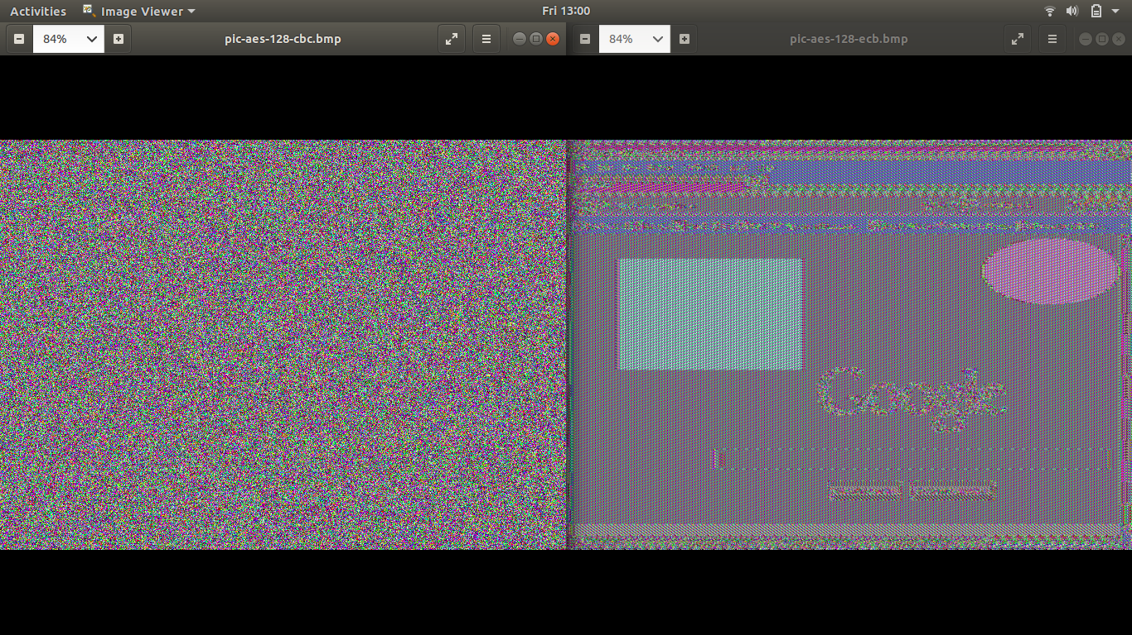

**Question 6:** Please explain your observations of the results for the previous question. More specifically, please argue the ECB mode against the CBC mode. Which operation mode can more completely hide the original information and is more secure? Explain your arguments.

CBC is more secure because it does an a better job at hiding the image there is no out line in the cbc encryption when the header is applied.

ECB is essentially the first generation of the aes it is the most basic form of block cipher encryption.

CBC is a more advanced form of block cipher encryption.

=========================== **Bonus Part (4%)** ============================

**Question B01:** Briefly describe what you did and attach your working code.

**Question B02:** Give a diagram or table to show your measured results. Briefly summarize your observations.