课程实验报告
课程名称 | 网络协议编程实验 | 班级 | 网络1802 | 实验日期 | 2020.11.25
姓名 | 崔文轩 | 学号 | 201858080237 | 实验成绩
实验名称 | 编写一个 FTP 上传或下载程序
实  验  目  的 | - 熟悉C#的界面搭建  - 完成相关基本功能实现  - 熟悉基本控件
实  验  环  境 | Win 10  VS2019
实  验  步  骤  及  测  试  结  果 | （给出实验内容和程序具体描述，详细记录在调试过程中出现的问题及解决方法，记录实验执行的结果。本部分为重点内容，给出关键过程及结果的截图。）  代码：  using System;  using System.Windows.Forms;  using System.Net;  using System.IO;  namespace 上传下载程序  {  public partial class Form1 : Form  {  private static readonly string rootPath = "/";  private static readonly int defaultReadWriteTimeout = 300000;  private static readonly int defaultFtpPort = 21;  #region 设置初始化参数  private string host = string.Empty;  public string Host  {  get  {  return this.host ?? string.Empty;  }  }  private string username = string.Empty;  public string Username  {  get  {  return this.username;  }  }  private string password = string.Empty;  public string Password  {  get  {  return this.password;  }  }  IWebProxy proxy = null;  public IWebProxy Proxy  {  get  {  return this.proxy;  }  set  {  this.proxy = value;  }  }  private int port = defaultFtpPort;  public int Port  {  get  {  return port;  }  set  {  this.port = value;  }  }  private bool enableSsl = false;  public bool EnableSsl  {  get  {  return enableSsl;  }  }  private bool usePassive = true;  public bool UsePassive  {  get  {  return usePassive;  }  set  {  this.usePassive = value;  }  }  private bool useBinary = true;  public bool UserBinary  {  get  {  return useBinary;  }  set  {  this.useBinary = value;  }  }  private string remotePath = rootPath;  public string RemotePath  {  get  {  return remotePath;  }  set  {  string result = rootPath;  if (!string.IsNullOrEmpty(value) && value != rootPath)  {  result = Path.Combine(Path.Combine(rootPath, value.TrimStart('/').TrimEnd('/')), "/"); // 进行路径的拼接  }  this.remotePath = result;  }  }  private int readWriteTimeout = defaultReadWriteTimeout;  public int ReadWriteTimeout  {  get  {  return readWriteTimeout;  }  set  {  this.readWriteTimeout = value;  }  }  #endregion  #region 构造函数  // public FtpHelper(string host, string username, string password)  // : this(host, username, password, defaultFtpPort, null, false, true, true, defaultReadWriteTimeout)  // {  // }  /// <summary>  /// 构造函数  /// </summary>  /// <param name="host">主机名</param>  /// <param name="username">用户名</param>  /// <param name="password">密码</param>  /// <param name="port">端口号 默认21</param>  /// <param name="proxy">代理 默认没有</param>  /// <param name="enableSsl">是否使用ssl 默认不用</param>  /// <param name="useBinary">使用二进制</param>  /// <param name="usePassive">获取或设置客户端应用程序的数据传输过程的行为</param>  /// <param name="readWriteTimeout">读写超时时间 默认5min</param>  public void FtpHelper(string host, string username, string password, int port, IWebProxy proxy, bool enableSsl, bool useBinary, bool usePassive, int readWriteTimeout)  {  this.host = host.ToLower().StartsWith("ftp://") ? host : "ftp://" + host;  this.username = username;  this.password = password;  this.port = port;  this.proxy = proxy;  this.enableSsl = enableSsl;  this.useBinary = useBinary;  this.usePassive = usePassive;  this.readWriteTimeout = readWriteTimeout;  }  #endregion  /// <summary>  /// 拼接URL  /// </summary>  /// <param name="host">主机名</param>  /// <param name="remotePath">地址</param>  /// <param name="fileName">文件名</param>  /// <returns>返回完整的URL</returns>  private string UrlCombine(string host, string remotePath, string fileName)  {  string result = new Uri(new Uri(new Uri(host.TrimEnd('/')), remotePath), fileName).ToString(); ;  return result;  }  /// 创建连接  private FtpWebRequest CreateConnection(string url, string method)  {  FtpWebRequest request = (FtpWebRequest)FtpWebRequest.Create(new Uri(url));  request.Credentials = new NetworkCredential(this.username, this.password);  request.Proxy = this.proxy;  request.KeepAlive = false;  request.UseBinary = useBinary;  request.UsePassive = usePassive;  request.EnableSsl = enableSsl;  request.Method = method;  Console.WriteLine(request);  return request;  }  public Form1()  {  InitializeComponent();  }  private void button1_Click(object sender, EventArgs e)  {  string str1 = textBox3.Text;  string str2 = textBox4.Text;  string str3 = textBox5.Text;  FtpHelper(str1, str2, str3, defaultFtpPort, null, false, true, true, defaultReadWriteTimeout);  string stradress = textBox1.Text;//上传文本地址  FileInfo fileInfo = new FileInfo(stradress);  FileInfo localFile = fileInfo;  string remoteFileName = textBox2.Text;  //bool result = false;  if (localFile.Exists)  {  try  {  string url = UrlCombine(Host, RemotePath, remoteFileName);  FtpWebRequest request = CreateConnection(url, WebRequestMethods.Ftp.UploadFile);  using (Stream rs = request.GetRequestStream())  using (FileStream fs = localFile.OpenRead())  {  byte[] buffer = new byte[1024 * 4];  int count = fs.Read(buffer, 0, buffer.Length);  while (count > 0)  {  rs.Write(buffer, 0, count);  count = fs.Read(buffer, 0, buffer.Length);  }  fs.Close();  //result = true;  }  label3.Text = "上传成功！";  }  catch (WebException ex)  {  MessageBox.Show(ex.Message);  }  //return result;  }  // 处理本地文件不存在的情况  //return false;  }  private void button2_Click(object sender, EventArgs e)  {  string str1 = textBox3.Text;  string str2 = textBox4.Text;  string str3 = textBox5.Text;  FtpHelper(str1, str2, str3, defaultFtpPort, null, false, true, true, defaultReadWriteTimeout);  string localName = textBox1.Text;  string stradress = textBox2.Text;  //FileInfo fileInfo = new FileInfo(stradress);  string serverName = stradress;  // bool result = false;  using (FileStream fs = new FileStream(localName, FileMode.OpenOrCreate))  {  try  {  string url = UrlCombine(Host, RemotePath,serverName);  Console.WriteLine(url);  FtpWebRequest request = CreateConnection(url, WebRequestMethods.Ftp.DownloadFile);  request.ContentOffset = fs.Length;  using (FtpWebResponse response = (FtpWebResponse)request.GetResponse())  {  fs.Position = fs.Length;  byte[] buffer = new byte[1024 * 4];  int count = response.GetResponseStream().Read(buffer, 0, buffer.Length);  while (count > 0)  {  fs.Write(buffer, 0, count);  count = response.GetResponseStream().Read(buffer, 0, buffer.Length);  }  response.GetResponseStream().Close();  }  //result = true;  label3.Text = "下载成功！";  }  catch (WebException ex)  {  // 处理ftp连接中的异常  // MessageBox.Show(ex.Message);  }  }  }  private void label2_Click(object sender, EventArgs e)  {  }  private void label3_Click(object sender, EventArgs e)  {  }  private void Form1_Load(object sender, EventArgs e)  {  }  private void label5_Click(object sender, EventArgs e)  {  }  private void textBox4_TextChanged(object sender, EventArgs e)  {  }  }  }  截图：  - 程序设计界面  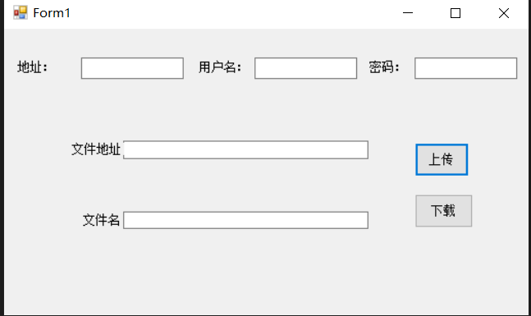  - 实验结果  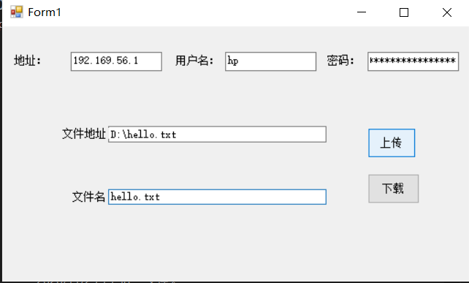  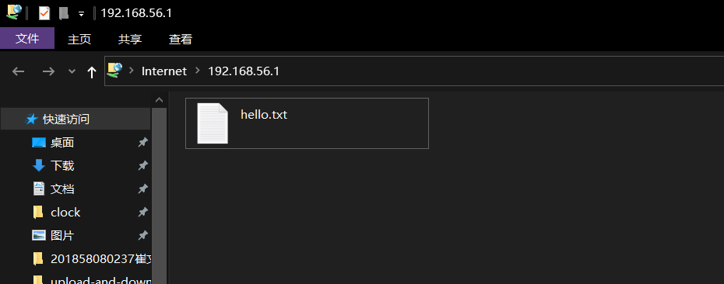  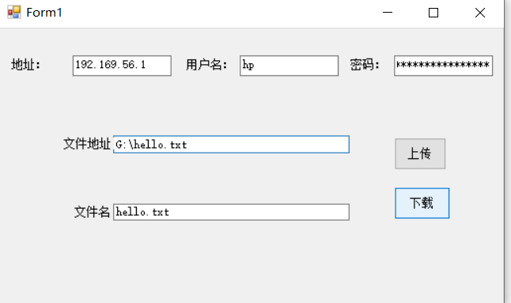  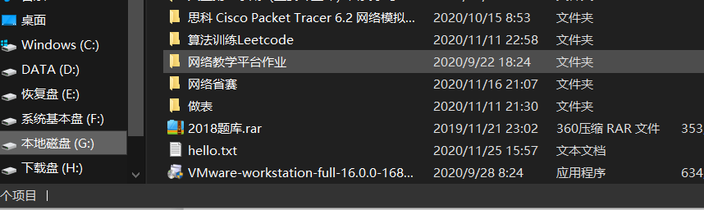
实  验  总  结 | （对实验结果进行分析，实验心得体会及改进意见，问题回答）  通过本次实验，我了解到了关于Socket的相关类属性以及其代码编写格式，对FTP的类也有了一定的属性。

