Appendix

Data and Sample Selection
The data are taken from the 1968 to 1992 waves of the Panel Study of Income Dynamics (PSID). The PSID over samples poor households, which is in part corrected by using weights. Excluding households who are not members of the SRC sample makes almost no difference.

Sample Selection
All observations for a given individual are excluded, if any of the following criteria fail to hold:
- Years of schooling greater than 0 in some years and less than 25 in all years.
- At least 10 years with valid earnings observations.
- Birth year between 1898 and 1975
In addition, observations are excluded for years during which any of the following criteria fail to hold:
- Individual is living in the family unit.
- Individual is head or “wife.”
- Age < 95 years.
- Annual hours worked between 500 and 4,000.
- The individual has positive weight.

Variable Construction and Transformations
Years of Schooling. If years of schooling are not reported in all years, they are interpolated. For interior observations with missing schooling, the algorithm linearly interpolates adjacent values and rounds to the nearest integer. For leading observations with missing schooling, it is assumed that schooling after age 30 equals the first observed value. Similarly trailing missing values are set to the last reported value after the age of 30. The top education level ever attained by an individual is the one recorded for the last observation with schooling. I do not use the maximum level ever recorded because it is contaminated by measurement error.
Other Variables. An individual is considered household head, if “sequence number” ≤ 20 and “relationship to head” = 1 or 10. An individual is considered a wife, if “sequence number” ≤ 20 and “relationship to head” = 2, 20, or 22. A son or daughter has “relationship to head” = 3 or 30. Earnings are converted into 1992 dollars using the consumer price index.

Characterizing the Empirical Earnings Distribution
From the distribution of present values of earnings within each education/sex class, it is possible to solve for the earnings by ability and schooling (Eq,s). The identifying assumption is that the present value of earnings is increasing in q for every level of education. The algorithm is as follows:
- Guess the fractions of college graduates in each ability class, Pr(s = 2 | q).
- Compute the distribution of household types, Pr(q, s) = Pr(s | q) · Pr(q).
- Compute the implied Eq,s. Within schooling class s, the top Pr(nq | s) households are of type nq. They correspond to the top earners in the empirical earnings distribution for schooling level s. Compute their average earnings, Enq,s. Proceed to class nq   and identify them with the next Pr(nq | s) households. Continue until type q = 1 is reached.
- Update Pr(s = 2 | q) from the data. Sort the (q,s)-classes by Eq,s and construct their cumulative mass. Divide the empirical earnings distribution into nq classes and compute the fraction with college in each class. Calculate the amount of mass each (q, s) class contributes to each empirical earnings class. From this obtain the implied fraction of college graduates in each empirical class. Use the deviations from the actual fractions of college graduates to update the guess for Pr(s = 2 | q).
This algorithm jointly determines Eq,s and Pr(q, s). The main benefit of this procedure is to require only the weak identifying assumption that earnings are increasing in ability. The main drawback is that neither existence nor uniqueness of a solution can be guaranteed. This does not seem to be a problem for the cases reported in the paper (nq between 4 and 7; equal mass in each ability class), but it means that there may be assumptions about Pr(q) under which the model cannot be solved.

Estimating Intergenerational Transition Probabilities

Sample Selection
A potential parent is any individual that satisfies the following criteria:
- At least 10 earnings/wage observations at ages >= 18.
- Reports education at some age >= 25 (to ensure that completed education can be inferred).
Due to the PSID’s success in following individuals over time, the typical parent has more than 20 years of earnings observations. The vast majority has observations in all years. This alleviates measurement error problems in the estimation of permanent earnings. A potential child is any individual that satisfies the following criteria:
- The individual lives as a child in another family unit at some age less than 18 (“relationship to head” = 3 or 30).
- The parent can be identified (see below).
- At least 10 earnings observations are available at a later point when the individual has become head or wife of a family unit and is at least 18 years old.
- The individual reports education at some age past 25 (to ensure that completed education can be inferred).
Since children must cross age 18 during the sample, their birth years are always between 1952 and 1972.

Matching Parents and Children
There are three ways of matching parents with their children. The first method uses the relationship file. It is not used because the data in this file end in 1985. The second method matches the recorded IDs of parents in the individual file. If a record has 1968 interview number and sequence number for the father or mother, then the parent can be directly identified in the individual cross-year file. This is the most direct method, but the parental ID is missing for all children whose parents attrited before 1985.
The third method is therefore used to identify parents in cases where the second method fails. It uses the relationship to head information during years when the person lived as a child (relationships to head = 3 or 30) in another family unit. If there is a unique head of this family unit in those years, this head must be the father or mother. Unfortunately, there may be multiple heads during one year, if the head moved into or out of the family unit. In these cases, the algorithm collects the identity of the heads during all years. If there are multiple matches within some years, but unique matches within others, the unique matches are identified as the mothers or fathers. If more than one head is recorded in all years or if the unique head differs across years, the observation is discarded (such cases are rare).
Multiple children of the same parents are included. Parent-child pairs are assigned the children’s weights.

Measuring Intergenerational Mobility
For each parent and child I estimate ability, schooling and earnings using the methods described above. This allows to construct a joint distribution Pr(q, s, qP, sP) of parents’ and children’s characteristics and a transition matrix, Pr(q, s | qP, sP), that gives the probability that a parent has a child of type (q, s), given that the parent has type (qP, sP). A similar transition matrix can be computed for schooling and earnings.

Constructing a Stationary Distribution
From the data, I estimate the population composition Pr(q,s) and the transition probabilities Pr(q | qP, sP) and Pr(s | q, sP). However, since the U.S. population composition is not stationary, applying measured transition probabilities to Pr(q,s) does not recover Pr(q,s) as required by the model. Moreover, neither parents nor children will have exactly the required mass in each q class. There are two approaches to resolving this problem.
One approach is to take the transition probabilities as given and find the stationary distribution implied by them. The drawback of this approach is that it may generate a population distribution far from the data. Moreover, it would require to jointly estimate the stationary distribution and the earnings levels Eq,s, which is intractable.
I therefore adopt an alternative approach which treats the observed Pr(q,s) distribution as if it were the stationary distribution and to adjust the transition probabilities to be consistent with it. This is conveniently done in two steps. First, find a constant Cq such that
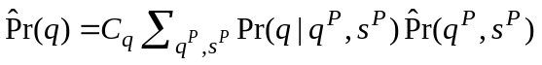
yields the same marginal distribution of q as postulated by the model (denoted by ^). Thus applying 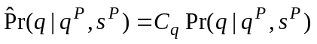 to 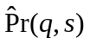 recovers 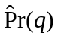. Then find a matrix of constants so that
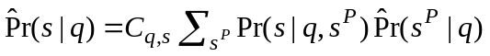,
Thus, applying 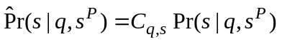 to the distribution 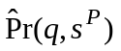 generated by 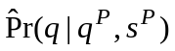 replicates . The adjusted transition probabilities are mostly close to the estimated ones (see tables A1 and A2); there is a small number of exceptions. However, the sample size is too small to estimate the probabilities in each cell accurately.
[INSERT TABLE A1 HERE]
[INSERT TABLE A2 HERE]

Galton Regressions
In order to compare my findings with those reported in the literature, I also estimate intergenerational persistence of permanent earnings using a Galton equation of the form
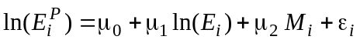.
Here, E denotes the individual’s estimate of the present value of lifetime earnings, corrected for cohort effects and Mi is a dummy variable equal to one for male children. In the results reported here only fathers and their children are included in the estimation, but including daughters as well does not change the qualitative results. The estimate of 1 is near 0.3, which is within the range of values reported in the literature when permanent earnings are estimated using 5 year averages of annual earnings (Mulligan 1997). Higher coefficients are typically found when parental earnings are estimated using instrumental variables. I do not follow this approach because good instruments are hard to find and my sample contains more than 20 years of earnings observations for the typical parent, which mitigates measurement errors due to transitory shocks.
An interesting finding is that the transmission coefficient is considerably smaller for parents with a college degree (only around 0.16). Estimating a similar regression for school attainment yields a 1 of 0.3, which is also within the range of values reported in the literature.

Parameter Choices
Tuition. The tuition variable represents the annual direct cost of attending college. This should include all privately paid costs, except forgone earnings. There is no tuition for high school, reflecting the fact that 90% of the direct cost of high school education is paid for by the public sector (Cohn and Geske 1990). In 1990, tuition and fees for colleges and other higher education amounted to $37.4 billion or 0.67% of GDP. It is hard to say whether this figure understates or overstates the private cost of attending college. On the one hand there are additional direct costs, on the other hand a fraction of tuition and fees is paid for by the public sector. The ratio of aggregate college tuition to output is therefore set to 0.5%.
Government. The wage tax function for the progressive case is given by
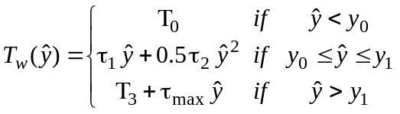
The marginal labor tax schedule is piecewise linear in earnings:
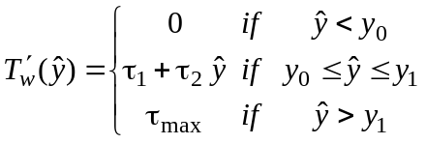.
Given the choice of range boundaries below, this simplifies to
The range boundaries are defined such that the average tax schedule is continuous: 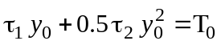 and 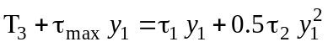. The slope coefficients are defined so that the marginal tax schedule is continuous: 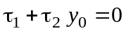 and 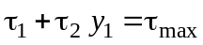. In addition, I require a marginal tax rate at zero net earnings of 1. The income level at which maximum taxes are reached is specified exogenously (y1).
Based on Internal Revenue Service data for 1998, 1 and 2 are chosen to match marginal tax rates of 0.15 at y = y* and the maximum marginal tax rate of max = 0.36 at y1 = $70,000. This neglects the fact that in the U.S. tax code an additional tax bracket exists. It has a marginal tax rate of 39.6% for AGI’s over $278,000. The model does not have households with earnings that high. The deductible is y* = $9,660 (see HLT). Average earnings per adult are set to $30,000.

Appendix Tables

Table A1. Estimated and adjusted transition probabilities: Pr(q | qP, sP)
 | sP = 1 |  |  |  | sP = 2
qP = 1 | q = 1 | q = 2 | q = 3 | q = 4 | q = 1 | q = 2 | q = 3 | q = 4
Estimated | 30.5 | 24.6 | 27.1 | 17.7 | 19.2 | 11.3 | 48.4 | 21.1
Adjusted | 45.7 | 25.2 | 24.2 | 14.4 | 28.8 | 11.6 | 43.1 | 17.1
qP = 2
Estimated | 14.1 | 45.8 | 22.9 | 17.2 | 10.8 | 19.5 | 31.4 | 38.3
Adjusted | 21.1 | 46.9 | 20.4 | 13.9 | 16.2 | 20.0 | 28.0 | 31.0
qP = 3
Estimated | 15.9 | 23.1 | 35.1 | 25.9 | 20.4 | 15.4 | 17.0 | 47.2
Adjusted | 23.8 | 23.7 | 31.3 | 21.0 | 30.5 | 15.8 | 15.2 | 38.2
qP = 4
Estimated | 7.7 | 15.4 | 31.4 | 45.5 | 5.4 | 5.2 | 23.3 | 66.1
Adjusted | 11.6 | 15.8 | 27.9 | 36.9 | 8.1 | 5.3 | 20.7 | 53.6

Table A2. Estimated and adjusted transition probabilities: Pr(s | q, sP)
 | sP = 1 |  |  |  | sP = 2
s = 1 | q = 1 | q = 2 | q = 3 | q = 4 | q = 1 | q = 2 | q = 3 | q = 4
Estimated | 92.3 | 89.4 | 83.9 | 71.0 | 71.0 | 47.1 | 46.6 | 20.9
Adjusted | 94.0 | 88.8 | 84.3 | 79.5 | 72.3 | 46.8 | 46.8 | 23.4
s = 1
Estimated | 7.7 | 10.6 | 16.1 | 29.0 | 29.0 | 52.9 | 53.4 | 79.1
Adjusted | 6.6 | 11.0 | 15.8 | 25.2 | 24.8 | 54.7 | 52.6 | 68.9

Figures

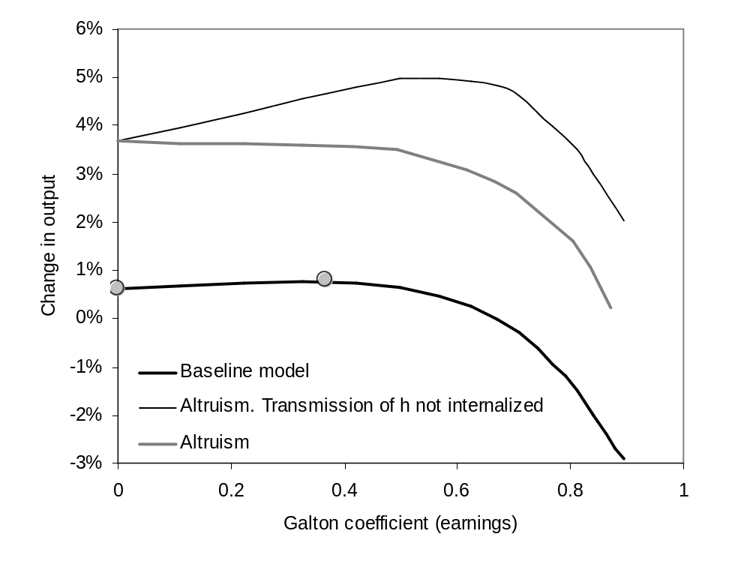
Figure 1. Change in output for varying degrees of earnings persistence
Review of Economic Dynamics, Author: Lutz Hendricks

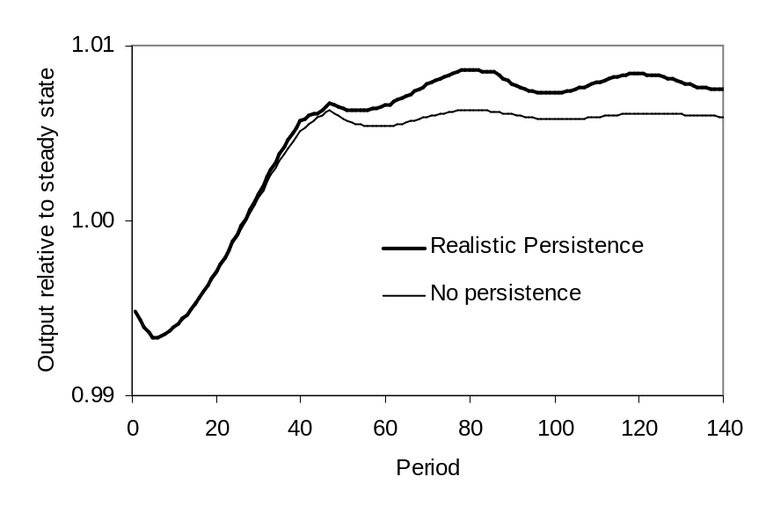
Figure 2. Trajectories of output relative to steady state
Review of Economic Dynamics, Author: Lutz Hendricks

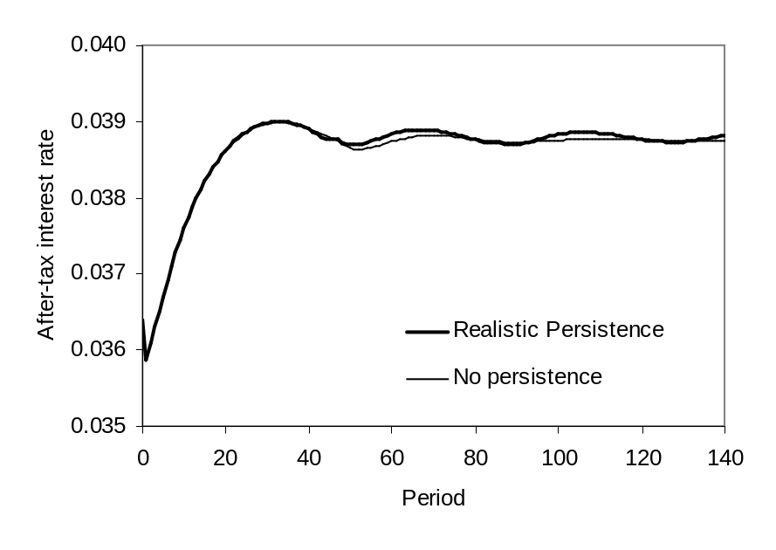
Figure 3. Trajectories of the real interest rate
Review of Economic Dynamics, Author: Lutz Hendricks

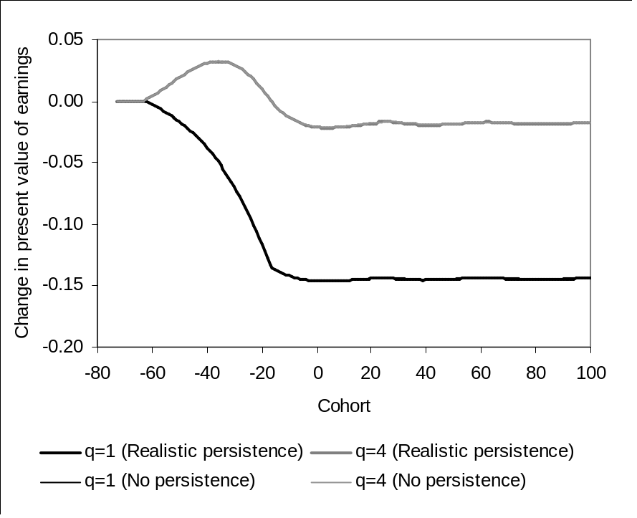
Figure 4. Welfare changes by cohort and ability class
Review of Economic Dynamics, Author: Lutz Hendricks

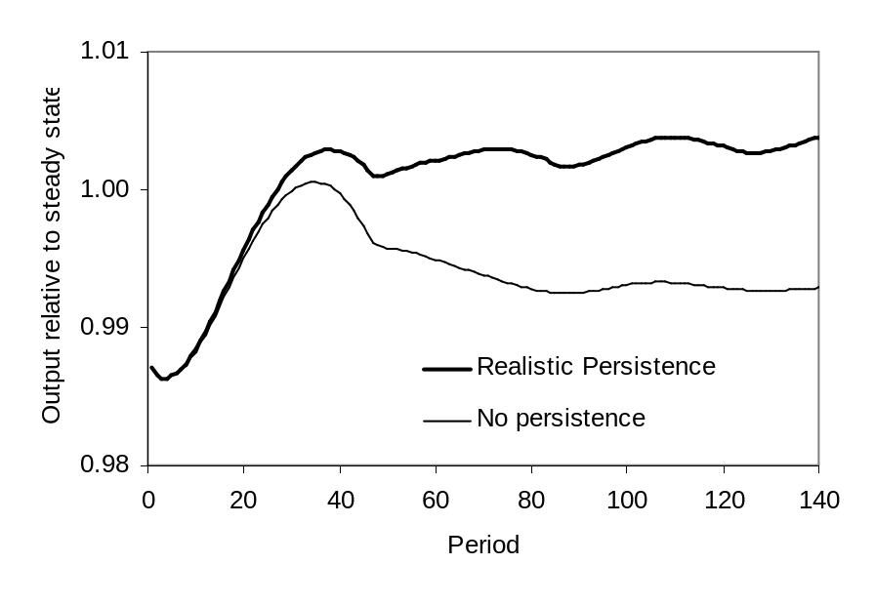
Figure 5. Trajectory of output relative to steady state. Job-training subsidy.
Review of Economic Dynamics, Author: Lutz Hendricks

Tables
Table 1. Distribution of lifetime earnings
 | q = 1 | q = 2 | q = 3 | q = 4
Present value of
earnings (Eq,s)
s = 1 | 234,752 | 421,667 | 582,668 | 778,706
s = 2 | 149,501 | 411,993 | 601,300 | 903,702
College premium | -36.3 | -2.3 | 3.2 | 16.1
Fraction with  college | 9.4 | 15.4 | 23.4 | 41.7
Notes: The present value of earnings is measured in 1992 dollars. The college premium is defined
as (average earnings of all college graduates) / (average earnings of all others).

Table 2. Probability that a child attends college
 | q = 1 | q = 2 | q = 3 | q = 4
sP = 1 | 6.6 | 11.0 | 15.8 | 25.2
sP = 2 | 24.8 | 54.7 | 52.6 | 68.9
Notes: The table shows 100 · Pr(s = 2 | q, sP).

Table 3. Transition probabilities for child ability
 |  | q = 1 | q = 2 | q = 3 | q = 4
qP = 1 | sP = 1 | 45.5 | 28.0 | 17.9 | 8.6
 | sP = 2 | 26.5 | 27.9 | 25.7 | 19.9
qP = 4 | sP = 1 | 17.5 | 24.6 | 28.2 | 29.6
 | sP = 2 | 10.4 | 19.5 | 28.1 | 41.9
Notes: The table shows 100 · Pr(q | qP, sP).
Table 4. Baseline parameters
Households |  |  | Education
aR = 65  ac = 16  aB = 40  aL = 75  σ = 2  β  Qq  sP) | Retirement age  Start of consumption  Age of child birth  Age of death  Matches K/Y = 2.5  Matches Pr(q)  Matches  Pr(q > 2 | qP > 2, sP) |  | a0 = 7  as = [18, 22]  Hq,s  μ(q), ν(s)  σ(q)  ds | Based on school enrollment data  Matches estimated Eq,s  Matches Pr(s | q)  Matches sensitivity of college enrollment to tuition changes  Matches aggregate tuition spending of 0.7% of Y
Firms |  |  | Job Training
θ = 0.3  δK = 0.08  1  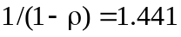 | Capital share in GNP  Matches I/Y = 0.2  Matches ratio of college to high school earnings  HLT |  | Bs  ϕ = 0.45  ψ = 0.30  δh = 0 | Matches earnings growth between ages 28 and 48  Heckman (1976)  HLT

Table 5. Steady state effects of moving to a proportional income tax
Percentage changes | No intergenerational transmission | Only transmission  of schooling | Baseline  model
Output | 0.6 | 0.6 | 0.8
Capital stock | -1.6 | -1.6 | -1.5
Labor input | 1.6 | 1.6 | 1.8
High school labor input (L1) | 0.1 | 0.2 | 0.3
College labor input (L2) | 4.6 | 4.6 | 4.8
High school wage rate (ω1) | 0.0 | 0.0 | 0.0
College wage rate (ω2) | -3.0 | -2.9 | -3.0
Quintile ratio | 18.3 | 18.2 | 17.8
College premium | -1.8 | -0.6 | 2.1
Galton coefficient for earnings | -- | -- | 1.3
Percentage point changes
Fraction with college | -0.6 | -0.7 | -0.8
q = 1 | 2.0 | 1.8 | 1.3
q = 2 | -4.5 | -4.6 | -4.7
q = 3 | -5.7 | -5.8 | -6.2
q = 4 | 5.8 | 5.9 | 6.0
Fraction among college educated with q = 1 | 2.6 | 2.4 | 1.9
with q = 4 | 7.9 | 8.2 | 9.3
Pr(q = 4) | 0.0 | 0.0 | 0.2
Pr(s = 2 | sP) with sP = 1 | -0.6 | 0.2 | -0.4
with sP = 2 | -0.6 | -2.6 | -0.9

tb8
Percentage changes | No intergenerational transmission | Only transmission of schooling | Baseline model
Output | 0.3 | 0.3 | 1.7
Capital stock | -9.9 | -10.0 | -8.9
Labor input | 5.1 | 5.0 | 6.6
High school labor input (L1) | 6.2 | 5.9 | 7.7
College labor input (L2) | 2.7 | 3.1 | 4.2
High school wage rate (ω1) | -5.2 | -5.1 | -5.3
College wage rate (ω2) | -3.0 | -3.3 | -3.1
Quintile ratio | 19.6 | 20.7 | 18.4
College premium | -93.7 | -97.8 | -95.4
Galton coefficient for earnings | -- | -- | 3.5
Percentage point changes
Fraction with college | 3.2 | 3.6 | 3.4
q = 1 | 21.3 | 22.4 | 21.3
q = 2 | 0.3 | 0.6 | 1.7
q = 3 | -2.2 | -2.0 | -1.9
q = 4 | -6.5 | -6.6 | -7.8
Fraction among college educated with q = 1 | 19.4 | 20.0 | 18.1
with q = 4 | -12.1 | -12.7 | -12.1
Pr(q = 4) | 0.0 | 0.0 | 1.2
Pr(s = 2 | sP) with sP = 1 | 3.2 | 0.8 | 2.3
with sP = 2 | 3.2 | 5.7 | 0.8

Not to be printed

Variables
Object | Value | Reference | Label
nq | 4 | 4 | nq
nq/2 | 2 | 2 | median_nq

