Evaluating the detection space_Analysis report

Milo Marsfeldt Skovfoged & Alexander Schiller Rasmussen

25/5/2020

1. Introduction
2. Data information
3. Predicition of course completion time
4. Number of collisions
5. Walking speed
6. Number of detections
7. Analysis conclusion

## Introduction

This is the statistical report associated with the paper “Evaluating the detection space” by Milo Marsfeldt Skovfoged & Alexander Schiller Rasmussen. The field of study lies in researching visually impaired/blind navigation through environments, to find an ideal Range of looking ahead and Field of Detection (FOD), for the most progressive travel-route, while avoiding collisions as much as possible. This report gives an overview of what data was gathered and analysed, in regrads to different points of interrest.

## Data information

Below, a summary of our data is presented. In total, 420 tests were completed over three days (140 per day), using three different Field Of Detections (FOD - Baseline, WholeRoom and Corridor), with exception of WholeRoom and Corridor differing between three ranges (two, three and four meters), as Baseline represents the original wite cane. Scenarios describe the amount of different parkours the system was tested on (each condition with different lengths). In addition, each test logged the speed of the participant, the amount of objects detected by the cane, the amount of collisions by the user and the completion time of the individual parkours.

## testID day Scenario FOD Range   
## Min. : 1.0 Min. :1 Min. : 1.00 Baseline : 60 Min. :1.000   
## 1st Qu.:105.8 1st Qu.:1 1st Qu.: 5.75 Corridor :180 1st Qu.:2.000   
## Median :210.5 Median :2 Median :10.50 WholeRoom:180 Median :3.000   
## Mean :210.5 Mean :2 Mean :10.50 Mean :2.714   
## 3rd Qu.:315.2 3rd Qu.:3 3rd Qu.:15.25 3rd Qu.:4.000   
## Max. :420.0 Max. :3 Max. :20.00 Max. :4.000   
## avgSpeed medianSpeed maxSpeed minSpeed objectDetected   
## Min. :0.3595 Min. :0.2511 Min. :1.243 Min. :0 Min. : 0.000   
## 1st Qu.:0.5723 1st Qu.:0.5986 1st Qu.:1.835 1st Qu.:0 1st Qu.: 6.000   
## Median :0.6434 Median :0.6898 Median :2.069 Median :0 Median : 8.000   
## Mean :0.6337 Mean :0.6842 Mean :2.078 Mean :0 Mean : 9.152   
## 3rd Qu.:0.7012 3rd Qu.:0.7587 3rd Qu.:2.318 3rd Qu.:0 3rd Qu.:12.000   
## Max. :0.9803 Max. :1.2506 Max. :2.988 Max. :0 Max. :28.000   
## objectCollisions Time totalTimeTraining timeFDRtrain   
## Min. :0.000 Min. : 8.016 Min. : 18 Min. : 10.00   
## 1st Qu.:0.000 1st Qu.:12.136 1st Qu.:1737 1st Qu.: 77.75   
## Median :1.000 Median :13.625 Median :3154 Median :145.50   
## Mean :1.124 Mean :13.971 Mean :3090 Mean :147.41   
## 3rd Qu.:2.000 3rd Qu.:15.160 3rd Qu.:4522 3rd Qu.:213.25   
## Max. :6.000 Max. :25.143 Max. :5868 Max. :347.00   
## timeFDtrain timeDtrain totalTimeTrainingHrs  
## Min. : 11.0 Min. : 11.0 Min. :0.0050   
## 1st Qu.: 171.5 1st Qu.: 507.5 1st Qu.:0.4825   
## Median : 360.0 Median : 997.5 Median :0.8760   
## Mean : 391.1 Mean :1004.4 Mean :0.8583   
## 3rd Qu.: 604.0 3rd Qu.:1492.2 3rd Qu.:1.2563   
## Max. :1031.0 Max. :2182.0 Max. :1.6300

To test for normality in our data, we conducted a Shapiro Wilks test

##   
## Shapiro-Wilk normality test  
##   
## data: LogSpeed  
## W = 0.97242, p-value = 3.937e-07

##   
## Shapiro-Wilk normality test  
##   
## data: daggByScen$objectDetected  
## W = 0.95131, p-value = 1.543e-10

##   
## Shapiro-Wilk normality test  
##   
## data: daggByScen$objectCollisions  
## W = 0.85476, p-value < 2.2e-16

and illustrated the data in qq-plots for a better overview.

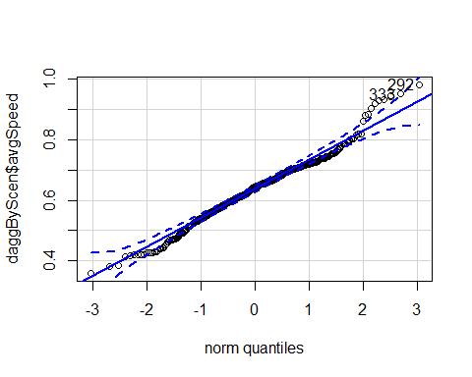

## [1] 292 333

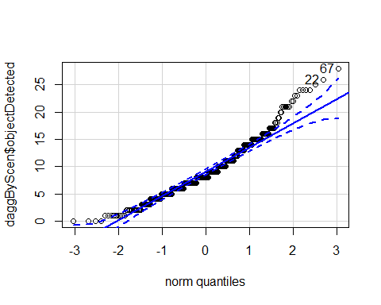

## [1] 67 22

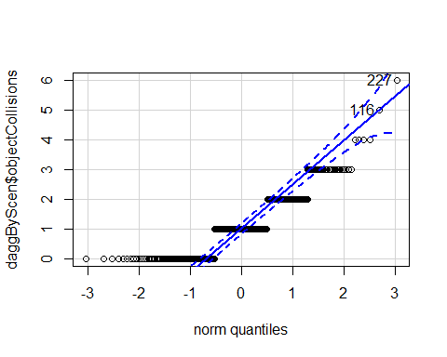

## [1] 227 116

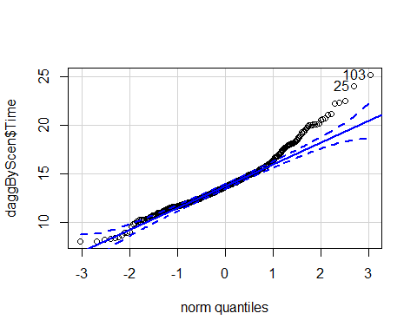

## [1] 103 25

The p-values show a significant difference and, thereby rejects the nullhypothesis of the data following a normal distributed. For analysing the results further we will be using glm models wiht a Poisson distribution.

<<<<<<< HEAD To visualise the difference between FOD and range, in regards to object collisions, object detections and walking speed, the following models were summarized, using Guassian and Possoin distirbutions, which regardless of our data’s distribution did not change the outcome of significance.

======= ### Training Time ###### Walking speed

##   
## Call:  
## lm(formula = avgSpeed ~ totalTimeTrainingHrs, data = daggByScen)  
##   
## Residuals:  
## Min 1Q Median 3Q Max   
## -0.23023 -0.05483 -0.00408 0.03962 0.34464   
##   
## Coefficients:  
## Estimate Std. Error t value Pr(>|t|)   
## (Intercept) 0.531821 0.008565 62.09 <2e-16 ***  
## totalTimeTrainingHrs 0.118715 0.008787 13.51 <2e-16 ***  
## ---  
## Signif. codes: 0 '***' 0.001 '**' 0.01 '*' 0.05 '.' 0.1 ' ' 1  
##   
## Residual standard error: 0.08317 on 418 degrees of freedom  
## Multiple R-squared: 0.3039, Adjusted R-squared: 0.3023   
## F-statistic: 182.5 on 1 and 418 DF, p-value: < 2.2e-16

##### Object Detected

##   
## Call:  
## glm(formula = objectDetected ~ totalTimeTrainingHrs, family = "poisson",   
## data = daggByScen)  
##   
## Deviance Residuals:   
## Min 1Q Median 3Q Max   
## -4.3912 -1.1003 -0.3181 0.8434 4.6829   
##   
## Coefficients:  
## Estimate Std. Error z value Pr(>|z|)   
## (Intercept) 2.34279 0.03298 71.04 < 2e-16 ***  
## totalTimeTrainingHrs -0.15294 0.03484 -4.39 1.13e-05 ***  
## ---  
## Signif. codes: 0 '***' 0.001 '**' 0.01 '*' 0.05 '.' 0.1 ' ' 1  
##   
## (Dispersion parameter for poisson family taken to be 1)  
##   
## Null deviance: 1150.6 on 419 degrees of freedom  
## Residual deviance: 1131.4 on 418 degrees of freedom  
## AIC: 2767.8  
##   
## Number of Fisher Scoring iterations: 4

##### Object Collisions

##   
## Call:  
## glm(formula = objectCollisions ~ totalTimeTrainingHrs, family = "poisson",   
## data = daggByScen)  
##   
## Deviance Residuals:   
## Min 1Q Median 3Q Max   
## -1.5746 -1.4509 -0.1062 0.6960 3.2328   
##   
## Coefficients:  
## Estimate Std. Error z value Pr(>|z|)   
## (Intercept) 0.21595 0.09480 2.278 0.0227 *  
## totalTimeTrainingHrs -0.11732 0.09946 -1.180 0.2381   
## ---  
## Signif. codes: 0 '***' 0.001 '**' 0.01 '*' 0.05 '.' 0.1 ' ' 1  
##   
## (Dispersion parameter for poisson family taken to be 1)  
##   
## Null deviance: 446.47 on 419 degrees of freedom  
## Residual deviance: 445.08 on 418 degrees of freedom  
## AIC: 1132  
##   
## Number of Fisher Scoring iterations: 5

### Walking speed

###### Wholeroom

##   
## Call:  
## lm(formula = avgSpeed ~ Range + totalTimeTrainingHrs, data = wrDat)  
##   
## Residuals:  
## Min 1Q Median 3Q Max   
## -0.17424 -0.04707 -0.00039 0.04010 0.17986   
##   
## Coefficients:  
## Estimate Std. Error t value Pr(>|t|)   
## (Intercept) 0.560661 0.020344 27.559 < 2e-16 ***  
## Range -0.019036 0.006087 -3.127 0.00206 **   
## totalTimeTrainingHrs 0.118251 0.009263 12.767 < 2e-16 ***  
## ---  
## Signif. codes: 0 '***' 0.001 '**' 0.01 '*' 0.05 '.' 0.1 ' ' 1  
##   
## Residual standard error: 0.06667 on 177 degrees of freedom  
## Multiple R-squared: 0.4928, Adjusted R-squared: 0.487   
## F-statistic: 85.98 on 2 and 177 DF, p-value: < 2.2e-16

###### Corridor

##   
## Call:  
## lm(formula = avgSpeed ~ Range + totalTimeTrainingHrs, data = corrDat)  
##   
## Residuals:  
## Min 1Q Median 3Q Max   
## -0.153438 -0.056756 -0.009303 0.034975 0.295740   
##   
## Coefficients:  
## Estimate Std. Error t value Pr(>|t|)   
## (Intercept) 0.536982 0.029569 18.160 < 2e-16 ***  
## Range 0.014043 0.007612 1.845 0.0667 .   
## totalTimeTrainingHrs 0.089962 0.019905 4.520 1.13e-05 ***  
## ---  
## Signif. codes: 0 '***' 0.001 '**' 0.01 '*' 0.05 '.' 0.1 ' ' 1  
##   
## Residual standard error: 0.08338 on 177 degrees of freedom  
## Multiple R-squared: 0.119, Adjusted R-squared: 0.109   
## F-statistic: 11.95 on 2 and 177 DF, p-value: 1.355e-05

###### AllData

##   
## Call:  
## lm(formula = avgSpeed ~ FOD + totalTimeTrainingHrs, data = daggByScen)  
##   
## Residuals:  
## Min 1Q Median 3Q Max   
## -0.25083 -0.05114 -0.00642 0.03784 0.32080   
##   
## Coefficients:  
## Estimate Std. Error t value Pr(>|t|)   
## (Intercept) 0.5558388 0.0124786 44.543 < 2e-16 ***  
## FODCorridor 0.0003908 0.0118657 0.033 0.974   
## FODWholeRoom -0.0500231 0.0118576 -4.219 3.02e-05 ***  
## totalTimeTrainingHrs 0.1155152 0.0084248 13.711 < 2e-16 ***  
## ---  
## Signif. codes: 0 '***' 0.001 '**' 0.01 '*' 0.05 '.' 0.1 ' ' 1  
##   
## Residual standard error: 0.07954 on 416 degrees of freedom  
## Multiple R-squared: 0.3664, Adjusted R-squared: 0.3618   
## F-statistic: 80.19 on 3 and 416 DF, p-value: < 2.2e-16

###### FOD and Range

##   
## Call:  
## lm(formula = avgSpeed ~ FOD * Range + totalTimeTrainingHrs, data = daggByScen)  
##   
## Residuals:  
## Min 1Q Median 3Q Max   
## -0.25087 -0.05350 -0.00338 0.03726 0.32092   
##   
## Coefficients: (1 not defined because of singularities)  
## Estimate Std. Error t value Pr(>|t|)   
## (Intercept) 0.574736 0.014259 40.306 < 2e-16 ***  
## FODCorridor -0.060641 0.025577 -2.371 0.01820 *   
## FODWholeRoom -0.011985 0.018554 -0.646 0.51867   
## Range -0.019018 0.007185 -2.647 0.00844 **   
## totalTimeTrainingHrs 0.115659 0.008337 13.872 < 2e-16 ***  
## FODCorridor:Range 0.033020 0.010162 3.250 0.00125 **   
## FODWholeRoom:Range NA NA NA NA   
## ---  
## Signif. codes: 0 '***' 0.001 '**' 0.01 '*' 0.05 '.' 0.1 ' ' 1  
##   
## Residual standard error: 0.07871 on 414 degrees of freedom  
## Multiple R-squared: 0.3825, Adjusted R-squared: 0.3751   
## F-statistic: 51.29 on 5 and 414 DF, p-value: < 2.2e-16

######Detections

##   
## Call:  
## lm(formula = avgSpeed ~ objectDetected + totalTimeTrainingHrs,   
## data = corrDat)  
##   
## Residuals:  
## Min 1Q Median 3Q Max   
## -0.147539 -0.045352 -0.008708 0.038099 0.212122   
##   
## Coefficients:  
## Estimate Std. Error t value Pr(>|t|)   
## (Intercept) 0.666685 0.018653 35.742 < 2e-16 ***  
## objectDetected -0.014170 0.001592 -8.902 6.40e-16 ***  
## totalTimeTrainingHrs 0.110758 0.016861 6.569 5.46e-10 ***  
## ---  
## Signif. codes: 0 '***' 0.001 '**' 0.01 '*' 0.05 '.' 0.1 ' ' 1  
##   
## Residual standard error: 0.06996 on 177 degrees of freedom  
## Multiple R-squared: 0.3797, Adjusted R-squared: 0.3727   
## F-statistic: 54.18 on 2 and 177 DF, p-value: < 2.2e-16

######Collisions

##   
## Call:  
## lm(formula = avgSpeed ~ objectCollisions + totalTimeTrainingHrs,   
## data = corrDat)  
##   
## Residuals:  
## Min 1Q Median 3Q Max   
## -0.149024 -0.048948 -0.007235 0.036751 0.267067   
##   
## Coefficients:  
## Estimate Std. Error t value Pr(>|t|)   
## (Intercept) 0.613116 0.019503 31.436 < 2e-16 ***  
## objectCollisions -0.026411 0.005771 -4.577 8.87e-06 ***  
## totalTimeTrainingHrs 0.085415 0.019030 4.488 1.29e-05 ***  
## ---  
## Signif. codes: 0 '***' 0.001 '**' 0.01 '*' 0.05 '.' 0.1 ' ' 1  
##   
## Residual standard error: 0.0796 on 177 degrees of freedom  
## Multiple R-squared: 0.197, Adjusted R-squared: 0.188   
## F-statistic: 21.72 on 2 and 177 DF, p-value: 3.677e-09

### Object detections

###### Wholeroom

##   
## Call:  
## glm(formula = objectDetected ~ Range + totalTimeTrainingHrs,   
## family = "poisson", data = wrDat)  
##   
## Deviance Residuals:   
## Min 1Q Median 3Q Max   
## -4.1657 -1.3337 -0.1778 0.9567 3.9447   
##   
## Coefficients:  
## Estimate Std. Error z value Pr(>|z|)   
## (Intercept) 2.05021 0.09269 22.118 < 2e-16 ***  
## Range 0.16790 0.02719 6.175 6.62e-10 ***  
## totalTimeTrainingHrs -0.15671 0.04212 -3.721 0.000199 ***  
## ---  
## Signif. codes: 0 '***' 0.001 '**' 0.01 '*' 0.05 '.' 0.1 ' ' 1  
##   
## (Dispersion parameter for poisson family taken to be 1)  
##   
## Null deviance: 549.85 on 179 degrees of freedom  
## Residual deviance: 498.23 on 177 degrees of freedom  
## AIC: 1248.3  
##   
## Number of Fisher Scoring iterations: 4

###### Corridor

##   
## Call:  
## glm(formula = objectDetected ~ Range + totalTimeTrainingHrs,   
## family = "poisson", data = corrDat)  
##   
## Deviance Residuals:   
## Min 1Q Median 3Q Max   
## -3.9370 -0.6827 0.0345 0.6125 2.9336   
##   
## Coefficients:  
## Estimate Std. Error z value Pr(>|z|)   
## (Intercept) 1.73454 0.13269 13.072 <2e-16 ***  
## Range 0.03363 0.03336 1.008 0.3134   
## totalTimeTrainingHrs 0.19708 0.08831 2.232 0.0256 *   
## ---  
## Signif. codes: 0 '***' 0.001 '**' 0.01 '*' 0.05 '.' 0.1 ' ' 1  
##   
## (Dispersion parameter for poisson family taken to be 1)  
##   
## Null deviance: 306.44 on 179 degrees of freedom  
## Residual deviance: 300.43 on 177 degrees of freedom  
## AIC: 973.27  
##   
## Number of Fisher Scoring iterations: 4

###### AllData

##   
## Call:  
## glm(formula = objectDetected ~ FOD + totalTimeTrainingHrs, family = "poisson",   
## data = daggByScen)  
##   
## Deviance Residuals:   
## Min 1Q Median 3Q Max   
## -4.0492 -1.1262 -0.0757 0.8221 3.8829   
##   
## Coefficients:  
## Estimate Std. Error z value Pr(>|z|)   
## (Intercept) 2.08163 0.05512 37.765 < 2e-16 ***  
## FODCorridor 0.03900 0.05516 0.707 0.47959   
## FODWholeRoom 0.45229 0.05272 8.579 < 2e-16 ***  
## totalTimeTrainingHrs -0.11968 0.03405 -3.515 0.00044 ***  
## ---  
## Signif. codes: 0 '***' 0.001 '**' 0.01 '*' 0.05 '.' 0.1 ' ' 1  
##   
## (Dispersion parameter for poisson family taken to be 1)  
##   
## Null deviance: 1150.61 on 419 degrees of freedom  
## Residual deviance: 960.28 on 416 degrees of freedom  
## AIC: 2600.8  
##   
## Number of Fisher Scoring iterations: 4

###### Detections based on FOD and Range

##   
## Call:  
## glm(formula = objectDetected ~ FOD * Range + totalTimeTrainingHrs,   
## family = "poisson", data = daggByScen)  
##   
## Deviance Residuals:   
## Min 1Q Median 3Q Max   
## -4.2211 -1.1104 -0.0722 0.7905 4.0312   
##   
## Coefficients: (1 not defined because of singularities)  
## Estimate Std. Error z value Pr(>|z|)   
## (Intercept) 1.91725 0.06133 31.262 < 2e-16 ***  
## FODCorridor 0.10499 0.11807 0.889 0.373893   
## FODWholeRoom 0.10826 0.07791 1.389 0.164692   
## Range 0.16741 0.02718 6.158 7.36e-10 ***  
## totalTimeTrainingHrs -0.12345 0.03433 -3.596 0.000323 ***  
## FODCorridor:Range -0.13362 0.04303 -3.106 0.001898 **   
## FODWholeRoom:Range NA NA NA NA   
## ---  
## Signif. codes: 0 '***' 0.001 '**' 0.01 '*' 0.05 '.' 0.1 ' ' 1  
##   
## (Dispersion parameter for poisson family taken to be 1)  
##   
## Null deviance: 1150.61 on 419 degrees of freedom  
## Residual deviance: 921.07 on 414 degrees of freedom  
## AIC: 2565.5  
##   
## Number of Fisher Scoring iterations: 4

###### Detections based on Collisions

##   
## Call:  
## glm(formula = objectDetected ~ objectCollisions + totalTimeTrainingHrs,   
## family = "poisson", data = daggByScen)  
##   
## Deviance Residuals:   
## Min 1Q Median 3Q Max   
## -4.1365 -1.1047 -0.2906 0.8008 4.7782   
##   
## Coefficients:  
## Estimate Std. Error z value Pr(>|z|)   
## (Intercept) 2.21658 0.03893 56.941 < 2e-16 ***  
## objectCollisions 0.09771 0.01534 6.369 1.90e-10 ***  
## totalTimeTrainingHrs -0.13962 0.03492 -3.999 6.37e-05 ***  
## ---  
## Signif. codes: 0 '***' 0.001 '**' 0.01 '*' 0.05 '.' 0.1 ' ' 1  
##   
## (Dispersion parameter for poisson family taken to be 1)  
##   
## Null deviance: 1150.6 on 419 degrees of freedom  
## Residual deviance: 1092.0 on 417 degrees of freedom  
## AIC: 2730.4  
##   
## Number of Fisher Scoring iterations: 5

###### Detections based on Time

##   
## Call:  
## glm(formula = objectDetected ~ Time + totalTimeTrainingHrs, family = "poisson",   
## data = daggByScen)  
##   
## Deviance Residuals:   
## Min 1Q Median 3Q Max   
## -4.9046 -1.0084 -0.1804 0.6692 5.2133   
##   
## Coefficients:  
## Estimate Std. Error z value Pr(>|z|)   
## (Intercept) 0.745049 0.116509 6.395 1.61e-10 ***  
## Time 0.094808 0.006448 14.703 < 2e-16 ***  
## totalTimeTrainingHrs 0.135546 0.040169 3.374 0.00074 ***  
## ---  
## Signif. codes: 0 '***' 0.001 '**' 0.01 '*' 0.05 '.' 0.1 ' ' 1  
##   
## (Dispersion parameter for poisson family taken to be 1)  
##   
## Null deviance: 1150.61 on 419 degrees of freedom  
## Residual deviance: 921.82 on 417 degrees of freedom  
## AIC: 2560.3  
##   
## Number of Fisher Scoring iterations: 4

### Object collisions

###### Wholeroom

##   
## Call:  
## glm(formula = objectCollisions ~ Range + totalTimeTrainingHrs,   
## family = "poisson", data = wrDat)  
##   
## Deviance Residuals:   
## Min 1Q Median 3Q Max   
## -1.53490 -1.35388 -0.06493 0.70972 2.21131   
##   
## Coefficients:  
## Estimate Std. Error z value Pr(>|z|)  
## (Intercept) 0.01630 0.30423 0.054 0.957  
## Range 0.05283 0.09141 0.578 0.563  
## totalTimeTrainingHrs -0.22081 0.14242 -1.550 0.121  
##   
## (Dispersion parameter for poisson family taken to be 1)  
##   
## Null deviance: 193.82 on 179 degrees of freedom  
## Residual deviance: 191.08 on 177 degrees of freedom  
## AIC: 464.72  
##   
## Number of Fisher Scoring iterations: 5

###### Corridor

##   
## Call:  
## glm(formula = objectCollisions ~ Range + totalTimeTrainingHrs,   
## family = "poisson", data = corrDat)  
##   
## Deviance Residuals:   
## Min 1Q Median 3Q Max   
## -1.6155 -1.4335 -0.1051 0.5873 3.3530   
##   
## Coefficients:  
## Estimate Std. Error z value Pr(>|z|)  
## (Intercept) -0.00236 0.33394 -0.007 0.994  
## Range 0.08897 0.08592 1.036 0.300  
## totalTimeTrainingHrs -0.15996 0.22515 -0.710 0.477  
##   
## (Dispersion parameter for poisson family taken to be 1)  
##   
## Null deviance: 189.72 on 179 degrees of freedom  
## Residual deviance: 188.15 on 177 degrees of freedom  
## AIC: 490.54  
##   
## Number of Fisher Scoring iterations: 5

###### Alldata

##   
## Call:  
## glm(formula = objectCollisions ~ FOD + totalTimeTrainingHrs,   
## family = "poisson", data = daggByScen)  
##   
## Deviance Residuals:   
## Min 1Q Median 3Q Max   
## -1.7994 -1.3753 -0.0849 0.6818 3.2125   
##   
## Coefficients:  
## Estimate Std. Error z value Pr(>|z|)   
## (Intercept) 0.48286 0.13312 3.627 0.000286 ***  
## FODCorridor -0.24954 0.12780 -1.953 0.050874 .   
## FODWholeRoom -0.38444 0.13008 -2.956 0.003122 **   
## totalTimeTrainingHrs -0.12160 0.09956 -1.221 0.221960   
## ---  
## Signif. codes: 0 '***' 0.001 '**' 0.01 '*' 0.05 '.' 0.1 ' ' 1  
##   
## (Dispersion parameter for poisson family taken to be 1)  
##   
## Null deviance: 446.47 on 419 degrees of freedom  
## Residual deviance: 436.69 on 416 degrees of freedom  
## AIC: 1127.6  
##   
## Number of Fisher Scoring iterations: 5

## Number of collisions

The plot below summarizes the number of collisions for the baseline and the two conditions at each range. Increasing the range from 1 - 2-m results in a 33% and 40% decrease in collisions for the and respectably. For ranges over two meter both aEMA have a non-significant increase in collisions - ( = 0.052, z(177) = 0.578, p = .6) and ( = 0.09, z(177) = 1.04, p = .3).

## `summarise()` regrouping output by 'Range' (override with `.groups` argument)

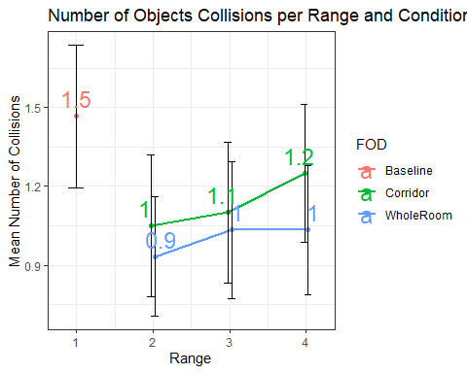

## Walking speed

The mean walking speed for the baseline and the two conditions at each range can be seen in the plot below. Multiple regression analysis showed that for the increasing the detection range resulted in decreasing the participants walking speed ( = -0.019, t(177) = -3.13, p = .002), however, using the had a non-significant increase in waking speed ( = 0.014, t(177) = 1.85, p = .06). When comparing the two conditions to the white cane showed that the did not significant influence the walking speed of the user ( < 0.001, t(416) = 0.033, p = 0.9), while the resulted the user walking slower ( = -0.05, t(416) = -4.22, p < .001).

The more obstacles the participant detected the slower he walked ( = -0.01, z(177) = -8.9, p < .001). Likewise, colliding with an obstacle reduces the participants walking speed ( = -0.03, z(177) = -4.58, p < .001).

## `summarise()` regrouping output by 'Range' (override with `.groups` argument)

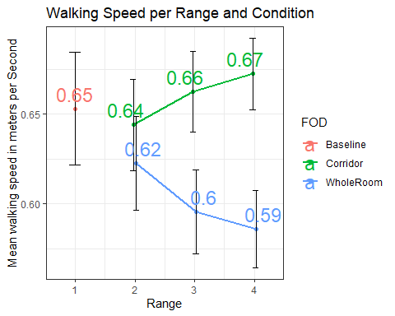

## Number of detections

The following plot summarizes the number of detections for the baseline and the two conditions at each range. When using the the mean number of detections increased by 39% between a range of 2-m and 3-m while only increasing 2% between a range of 3-m and 4-m. Thus, a multiple regression analysis shows that range was a significant predictor when using the ( = 0.167, z(177) = 6.18, p < .001), however, range was not significant predictor for obstacle detection with the ( = 0.033, z(177) = 1.008, p = .3). When comparing the to the white cane no significant predictor was found ( = 0.04, z(416) = 0.71, p = 0.5), while the detected more obstacles compared to the white cane ( = 0.45, z(416) = 8.58, p < .001).

## `summarise()` regrouping output by 'Range' (override with `.groups` argument)

