Manual of QIBA-PDF-Evaluation tool

This manual will shortly introduce how to maneuver the application.

* If you are going to run the source code, please download and install the necessary packages. You will find the relevant information in file ‘README.md’ .
* The stand-alone installer for Windows is now available. After installing it on the computer, you will have the same using experience with running the application as running the source code in Python.
* Run QIBA evaluate tool. The slash window will show and last for 2 seconds.



* The interface on initialization should look like:

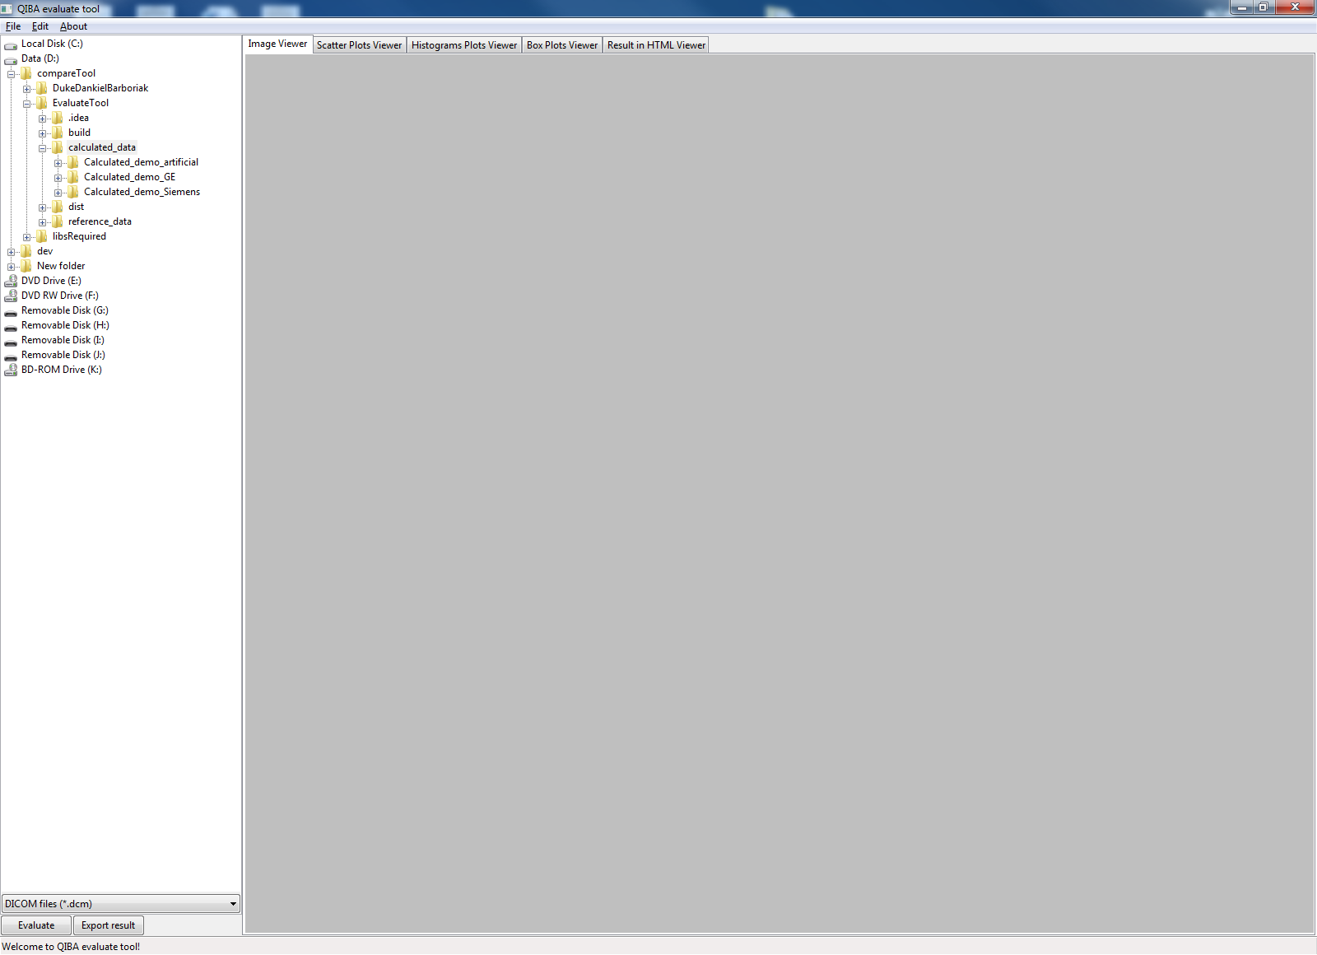

The left side of the window is the tree list of the directories and files. By default, the directory of the application will be selected. Later you could load calculated files from the tree list.

* In order to import the calculated data, please left click to select the DICOM file that you want to import. Then right click on it, resulting in a popup menu with two options: “Load as calculated Ktrans” and “Load as calculated Ve”. Left click to choose the corresponding option in the popup menu to load the file.

By default, the tree list will open the folder “calculated_data”. The sub folders contain data for demonstrating. When you need to test your own data, you can put the data under the folder ‘calculated_data’, so that the data can be handily imported.

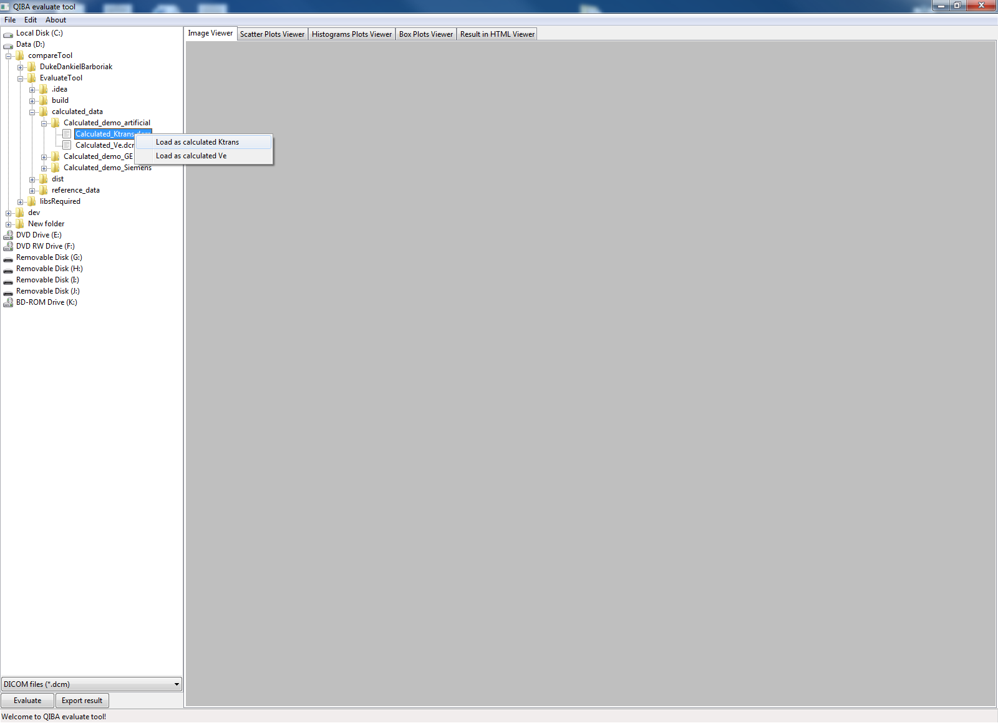

* By default, the reference files are loaded on launching the application. (The reference files lie in the folder “reference_data”.) In case you want to change the reference files, please click on the menu bar “Edit -> Load Ktrans reference parameter map…” or “Edit -> Load Ve reference parameter map…”. In the new file selection dialog, you can choose the DICOM file that you want to load as reference data.

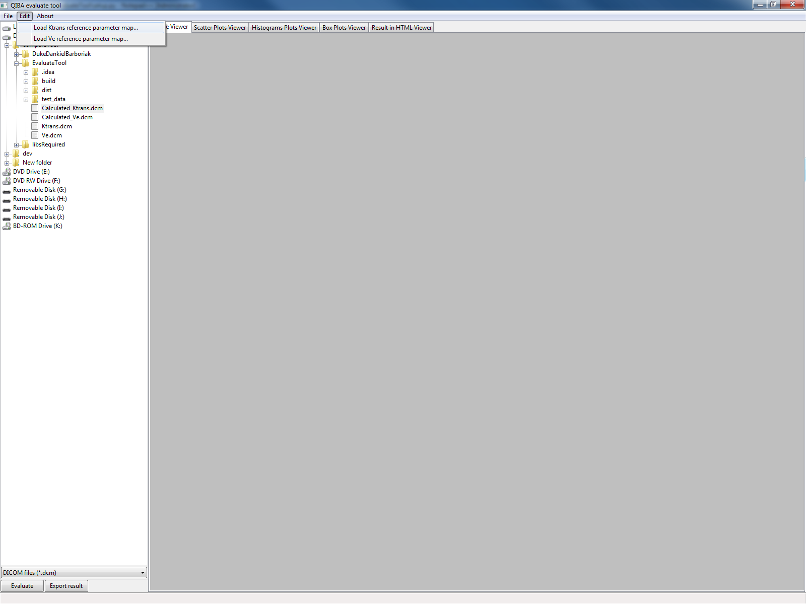

* Once the calculated Ktrans and Ve are loaded, the evaluation will start by clicking on the “Evaluate” button at the bottom of the left column of the window. The status bar will show the “Evaluating…”. When the status bar shows the message “Evaluation finished.”, the evaluation results could be viewed from the tabs on the right side of the window.
* The tab “Image Viewer” shows the preview of the calculate Ktrans and Ve files, the error compared to the reference files, and the normalized error, in each column from the left side to the right side. There are color bars besides the figures, which you can refer to to read the value range and value mapping.

The first column shows the calculated Ktrans and Ve in black and white. You can have a general impression of the value distribution according to the changing of the parameters. Generally the brighter the pixel is, the higher the calculated value is.

The Second column shows the error map between calculated and reference data. Each pixel is the result of corresponding pixel in calculated data being subtracted with that in the reference data. Generally the more the color approaches to the red direction, the larger the error is.

The third column shows the normalized error. This is out of the consideration that the error could be related with the original value itself. Therefore normalized error may give a more uniformed standard of the error level. Each pixel’s value comes from the division of the error by the reference pixel value. Similarly as the error map, the more the color approaches to the red direction, the larger the normalized error is.

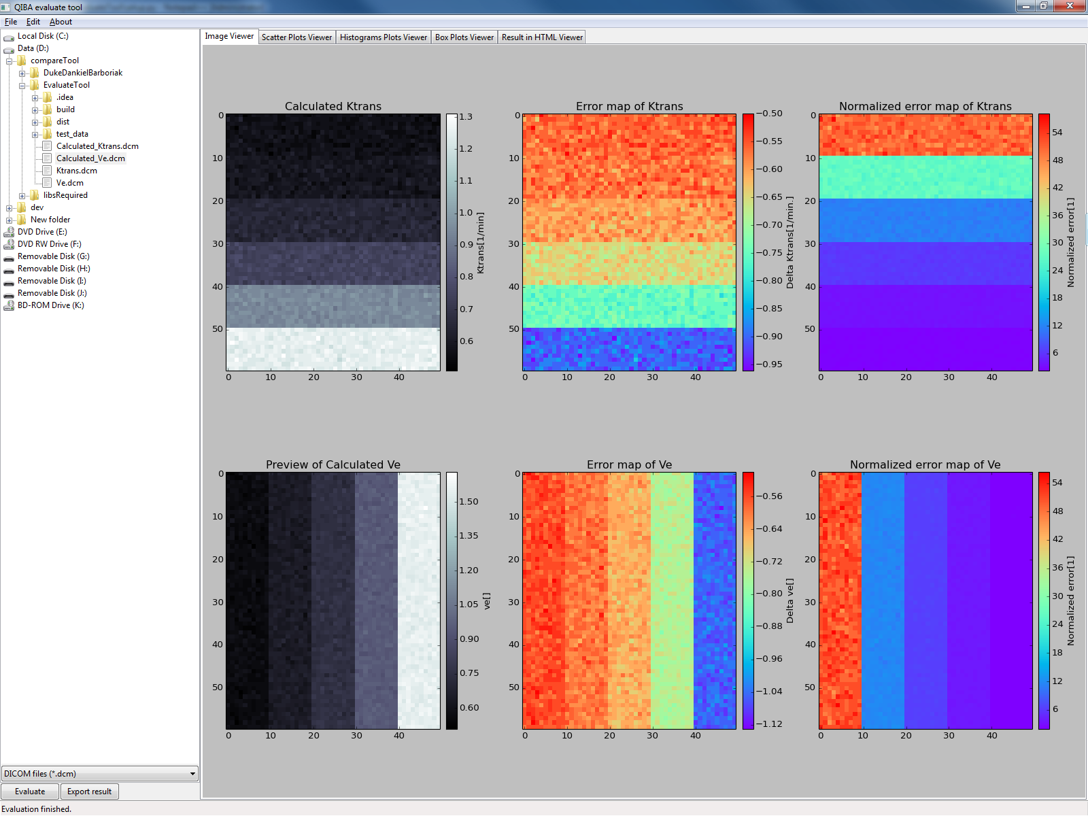

* The tab “Scatter Plots Viewer” shows the scatter plots of the calculated and the reference Ktrans and Ve. As described in the legend, the blue and green dots denote pixels from the calculated and reference respectively.

Considering the reference Ktrans (or Ve) has discrete values, being a constant for each row (or column) in the data map, the dots of corresponding row (or column) will be plotted aligning to that x-axis.

For the reference data, the pixel values in one row (for Ktrans) or column (for Ve) share the same constant value. Therefore in the scatter plot it shows that all green dots of a row (or column) overlap to each other. For the calculated data, as they share the same parameter, the blue dots align to the same x-axis. But they may scatter vertically, showing there’s variance of the value in a row (or column).

From these plots you can see the trend of the values, which offer some information of which model (e.g. linear or logarithmic) the calculated parameter may fit. For example, with the artificial calculated data which were generated from the reference data by adding Gaussian noise, scaling by two and adding 0.5, it can be easily read from the plots that the calculated data follow the linear model, and have scaling factor and extra bias value.

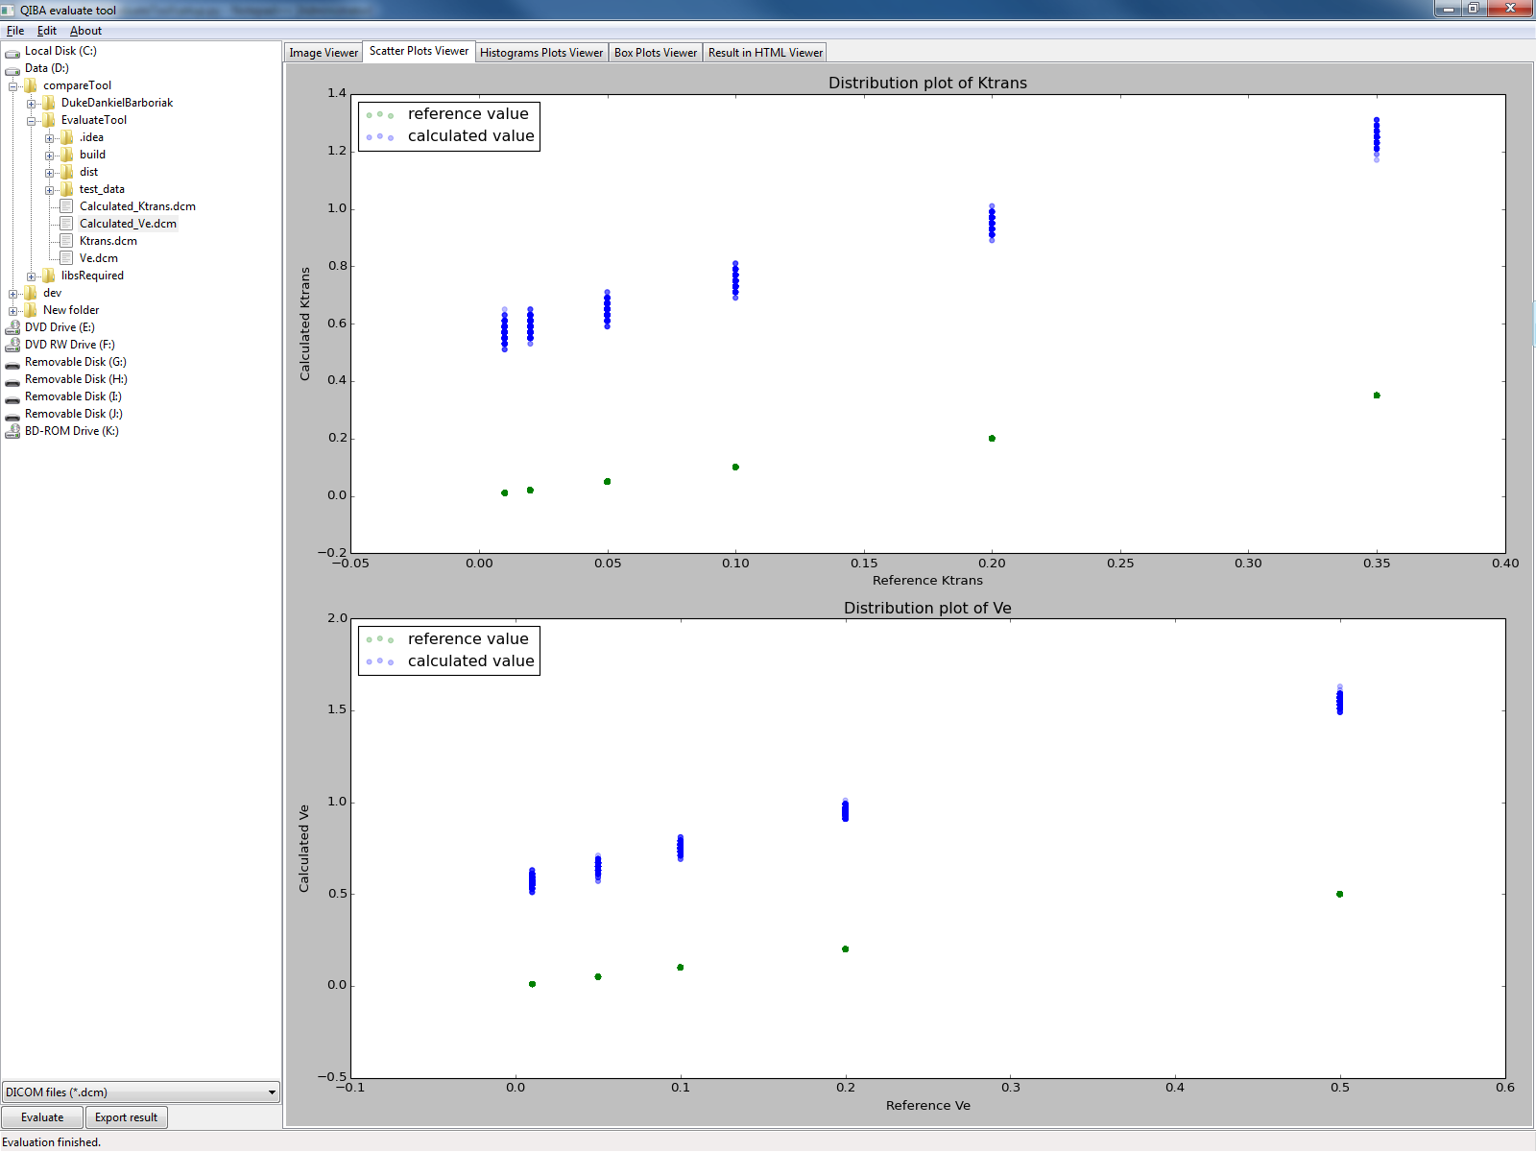

* The tab “Histograms Plots Viewer” shows the histogram of each patch from calculated Ktrans and Ve, so that you can have a look at the distribution of the pixels in each patch of difference parameter combination.

All histograms have the uniformed y-axis limits, so that the comparison among different patched is easier. The minimum and maximum values of a patch are denoted on the x-axis for reference.

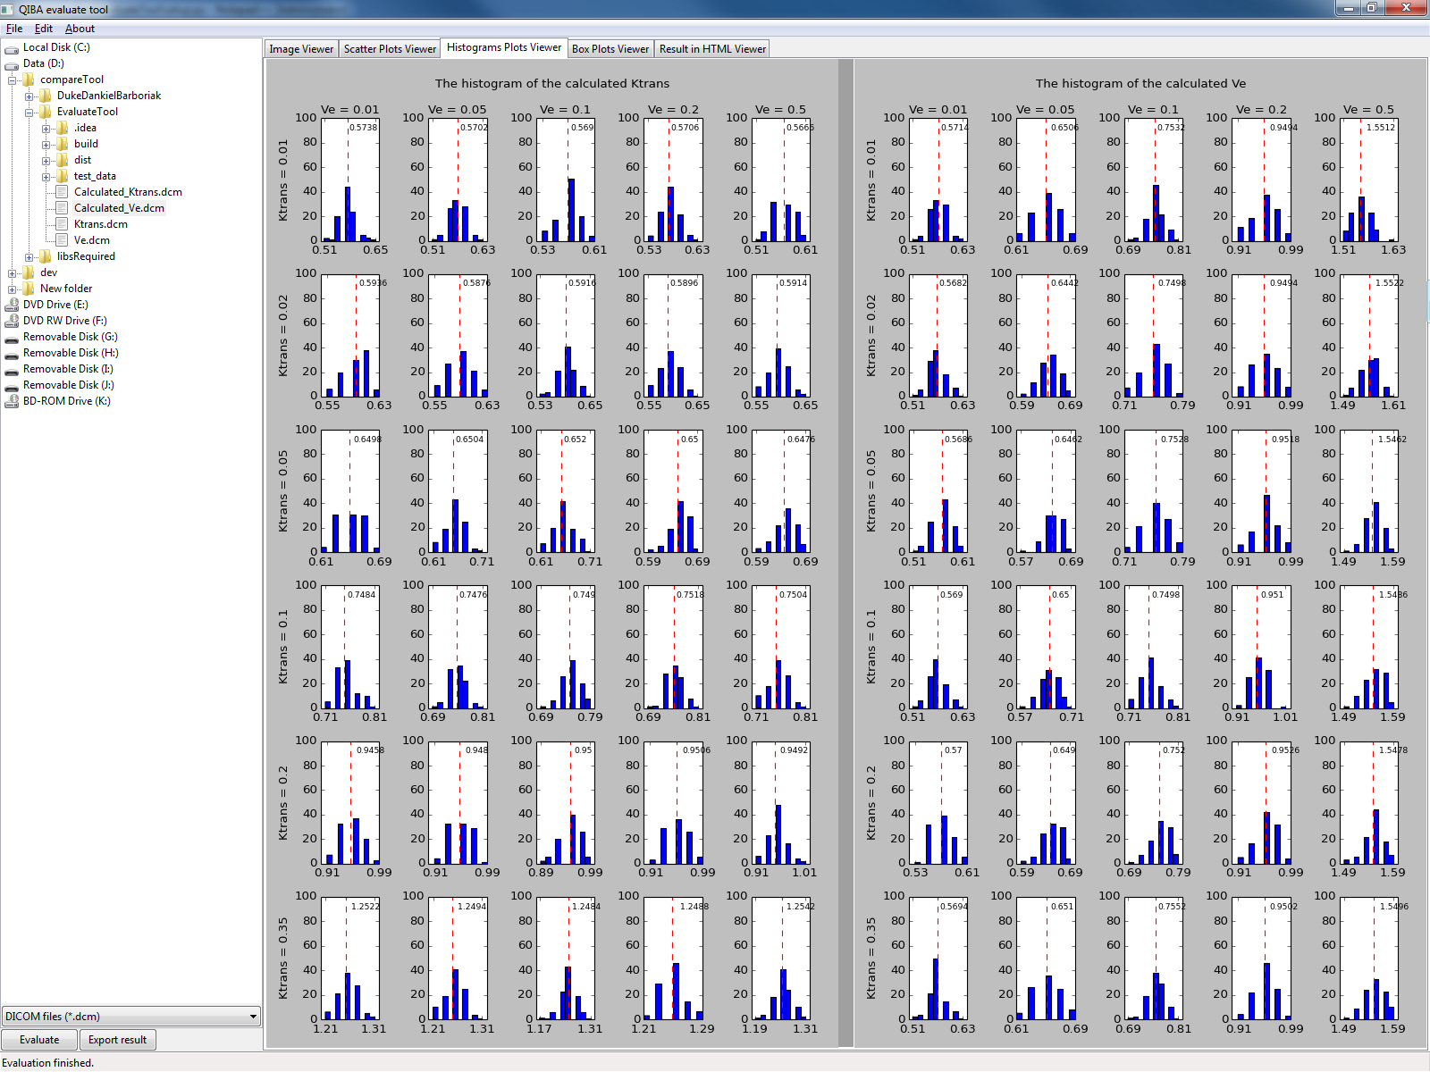

* The tab “Box Plots Viewer” shows the box plots of each patch in the calculated Ktrans and Ve files. It offers another view of the distribution of the patches with different parameter combinations.

The vertical dash lines are used to separate the rows (or columns), as each box plot is responsible for one patch. From these plots you could see (roughly) the statistics of each patch, like the mean value, the 1st and 3rd quartile, the minimum and maximum value. The more precise value of those statistics could be found in the tab “Result in HTML viewer” .

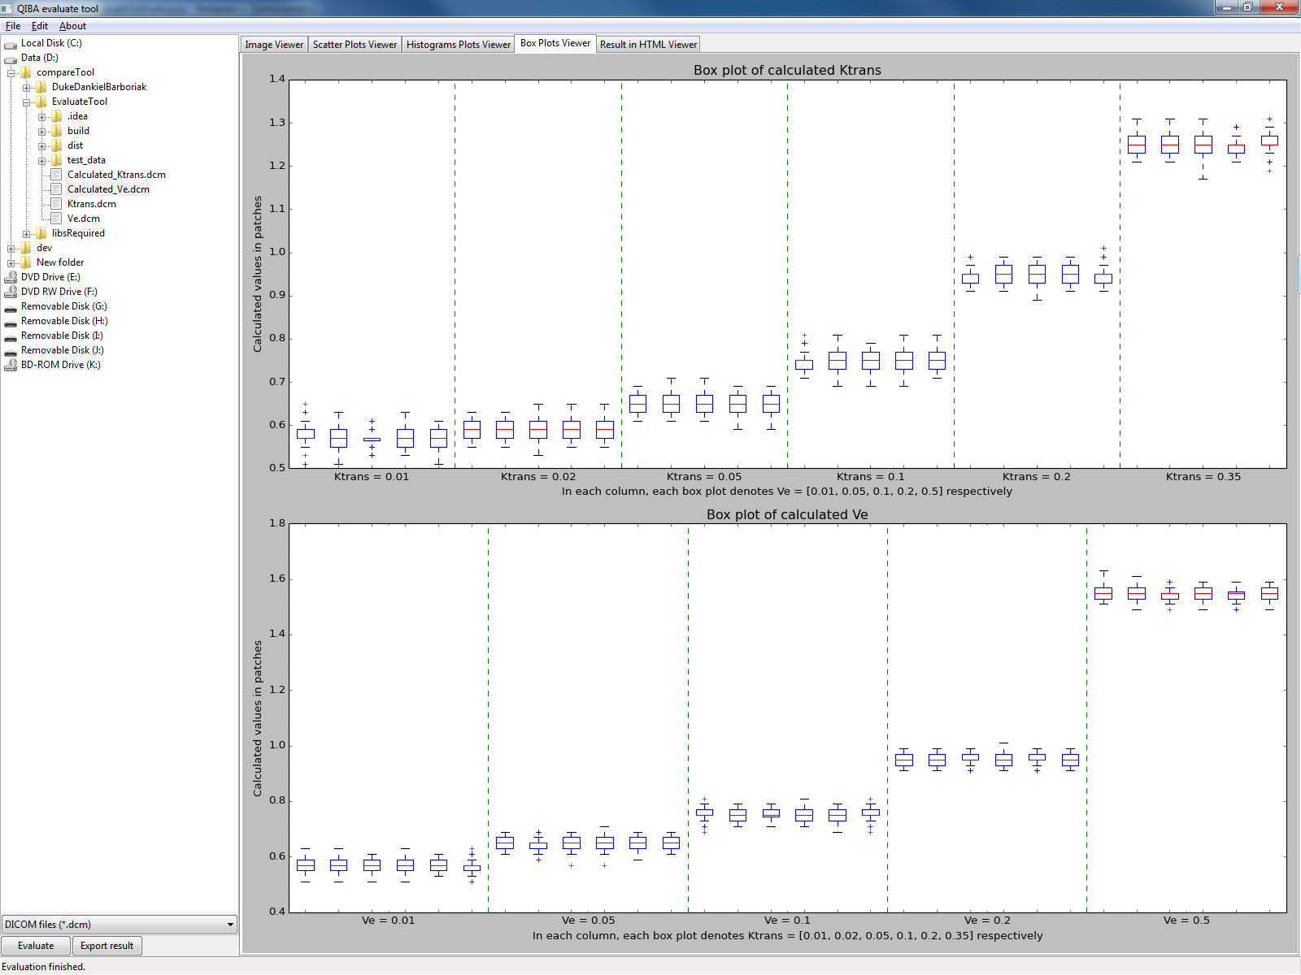

* The tab “Result in HTML Viewer” shows the results in HTML form. Unlike the tabs introduced before, this tab shows the results in html form, i.e. without special visualization method. From these tables you can read the value more precisely.

Assuming that the calculated parameters follow linear model, the planar fitting results shows the fitting parameters.

The following tables show some statistics like the mean, median, std. deviation, 1st and 3rd quartile, minimum and maximum value, t-test result.

