<h1>WEB DESIGN CRASH COURSE</h1>

based on a course by Jeffrey Thompson [github.com/jeffthompson](http://www.github.com/jeffthompson/webdesignexamples)

modified by Hendrik Leper for Mediakunst @ KASK

SETUP

For today’s workshop, you will need:

**TEXT EDITOR** I suggest [Brackets](http://brackets.io/) (free and open), but you can also use [Text Wrangler](http://www.barebones.com/products/textwrangler) (also free), or the built-in text editor on your computer (Text Edit for Mac users, Notepad for Windows)

**BROWSER** The program you view websites in! We will use Chrome as it works well with Brackets. But you should really be testing your sites on all current browsers including Firefox, Safari, Internet Explorer (currently Microsoft Edge), ...

**FTP CLIENT** An FTP application to copy your web page files to a remote server. [Filezilla](https://filezilla-project.org/) and [Cyberduck](https://cyberduck.io/) are two good options.

**EXAMPLES** Today, rather than type along, we’ll be using example files found here:

<https://github.com/hendrikleper/WebDesignExamples>

TERMINOLOGY

**HTML** The “nouns” of the web – things like paragraphs and images. HTML elements are called “tags”, denoted by < >.

**CSS** Styles apply to elements across your site – they form the adjectives to HTML nouns, setting things from color, size, and placement of elements, as well as fancier things like animations and transitions.

**FTP** Stands for File Transfer Protocol. Is a way to connect to a remote server and transfer your files to it.

**PHP** A server-side scripting language to create dynamic HTML pages. Takes a bit of getting used to, but is very powerful (especially for larger, more complex sites).

**JAVASCRIPT** A client-side scripting language for everything from basic user interaction to dynamic content like animated transitions and full-on videogames! Often extended with the popular [JQuery](http://jquery.com/) library.

**SERVER** The hard-drive that stores and “serves” your website’s files to visitors. This is often called “hosting” – Hogent gives you some [very basic hosting](http://helpdesk.hogent.be/helpdesk/assets/File/handleiding_webs.pdf) (no php and no database). Ask me if you need a more advanced hosting or tips.

**DOMAIN NAME** The address to your site (like mediakunst.be) – this is essentially “rented” on a yearly basis (usually about $15/year from your hosting provider).

BASIC PAGE STRUCTURE

There are a few basic things a web page must have in order to work:

<!DOCTYPE html>

<html>

<head>

<title>This is my awesome website</title>

</head>

<body>

<!-- this where your page content goes! -->

<p>Welcome to my new website.</p>

</body>

</html>

Note that HTML tags have an opening and closing tag. For more details, see the example files.

CSS STYLING

Styles separate content (the HTML) from its visual presentation, making updates to your site easier and more flexible. They can be applied to:

**HTML ELEMENTS p {**

Tags like paragraphs (right), font-size: 12px;

images, links, etc }

**IDs** #blog-post {

Unique items on the page, given color: rgb(255,0,0);

name and noted by a “#” in CSS }

**CLASSES** .thumbnails {

Items used multiple times on width: 250px;

a page and noted by a “.” }

**CSS SYNTAX**

A CSS rule-set consists of a selector and a declaration block.

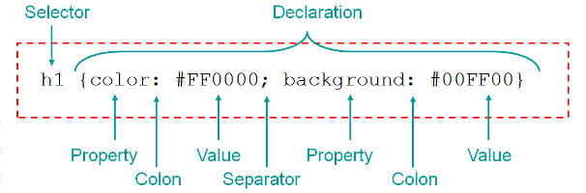

**SOME COMMON CSS PROPERTIES**

While certainly nowhere near exhaustive, here are some common properties:

background color or image width/height defines size of elements

font-family font to use text-align left, center, right , justify

font-size in pixels or ems

border around an element

color font color

text-decoration underline, none, etc – mostly used for links

**COLOR**

There are several ways of defining color in websites – the two easiest to learn are:

COLOR NAMES

Basic, built-in colors can be used by name, such as:

white, black, red, blue, aqua, darkslateblue, lavenderblush, snow

See this page for a full listing: <http://www.w3schools.com/html/html_colornames.asp>

RGB VALUES

Red, green, and blue (RGB) can be mixed to create all the colors; values are between 0 (no color) – 255 (full amount). For example:

white rgb(255,255,255)

black rgb(0,0,0)

red rgb(255,0,0)

yellow rgb(255,255,0)

CSS BOX MODEL

In CSS, we define the spacing through **margins** (space around an element) and **padding** (space inside an element). For example, if the orange box below is a <div> tag with text inside…

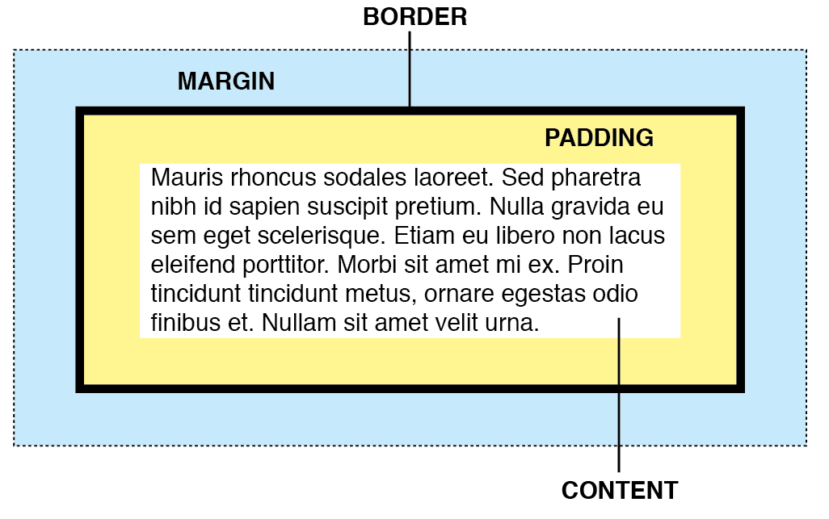

**PADDING** Space **inside** an item – here it is 10px on all sides

**MARGIN** Space around the **outside** of an item – here it is 20px on the sides, but 10px on the top and bottom

**BORDER** The border property is a shorthand property for border-width, border-style & border-color

The resulting style…

div {

padding: 10px; /* only 1 number = all sides */

margin: 10px 20px 10px 20px; /* 4 #s = top, right, bottom, left */

border: 5px solid black;

}

Margins can also be set to auto, which is used to center elements:

margin: 5px auto 10px auto; /* auto on L/R centers the element */

See the example files for more details!

IMAGES

**FILE FORMATS** Use compressed formats such as jpg, png, or gif

**FILE SIZE** Small file size is very important! Shoot for 300–500kb. In order to get your files small enough, see the two parameters below.

**RESOLUTION** Most monitors could only display 72 pixels-per-inch (ppi), so resizing your images to that resolution is important for creating smaller files. Use Photoshop’s Image > Image Size...

**DIMENSIONS** We’ve been measuring most layout elements by pixels, so resizing your images to be no larger than necessary will help reduce file size. If your <div> is 700px wide, make your images the same.

**COMPRESS!** If possible, save your images using Photoshop’s File > Save for Web... option to compress your images.

FURTHER RESOURCES

**MY OLD COURSE** <https://goo.gl/oXVQ8s>(in dutch)

**THE INTERNET!** Seriously. Google is your best friend. Also…

**W3 SCHOOLS** Run by the authority that sets web standards.

[http://www.w3schools.com](http://www.w3schools.com/)

**STACK OVERFLOW** A site for questions-and-answers relating to all things code.

[http://stackoverflow.com](http://stackoverflow.com/)

**ONLINE TUTORIALS** There are many other tutorials online as [Codecademy](https://www.codecademy.com/).

**FIND SOME OTHERS?** Let me know and I’ll add them to this list!