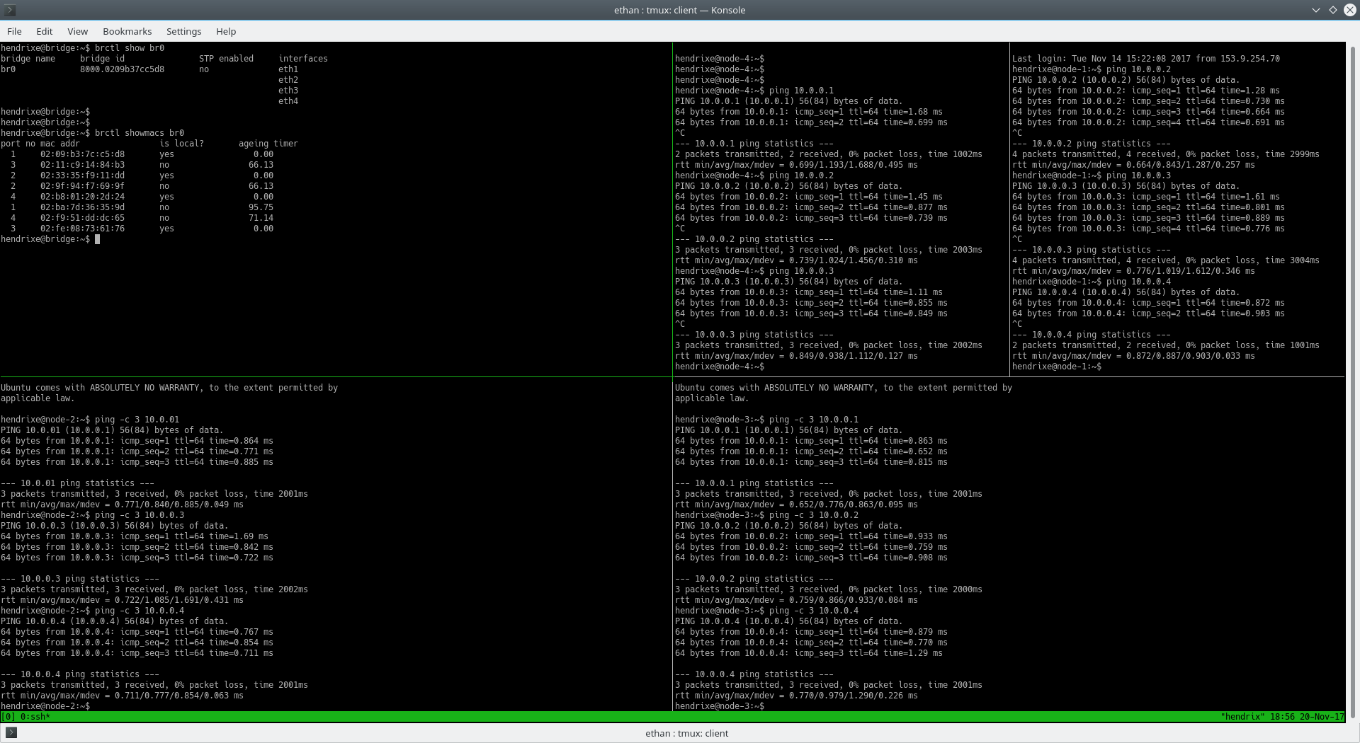
1.

2.
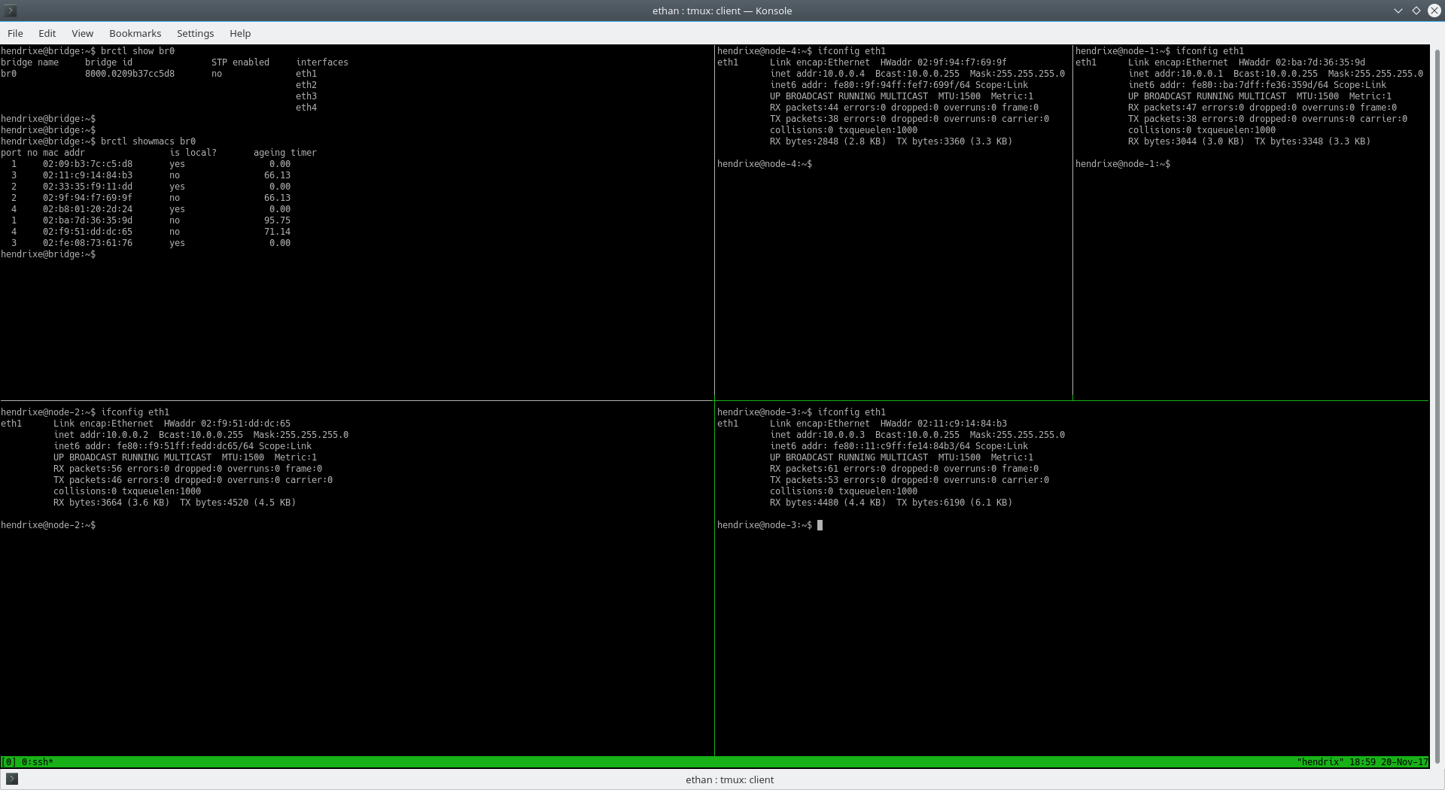

3.
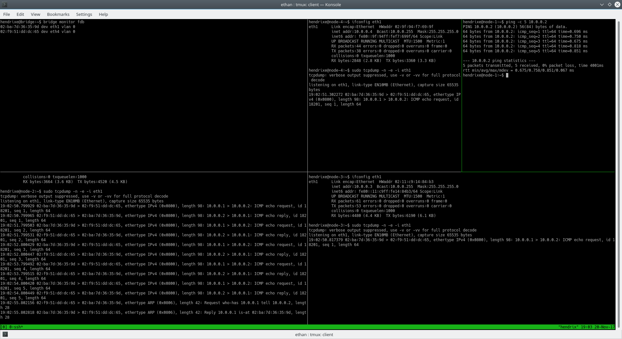
4.
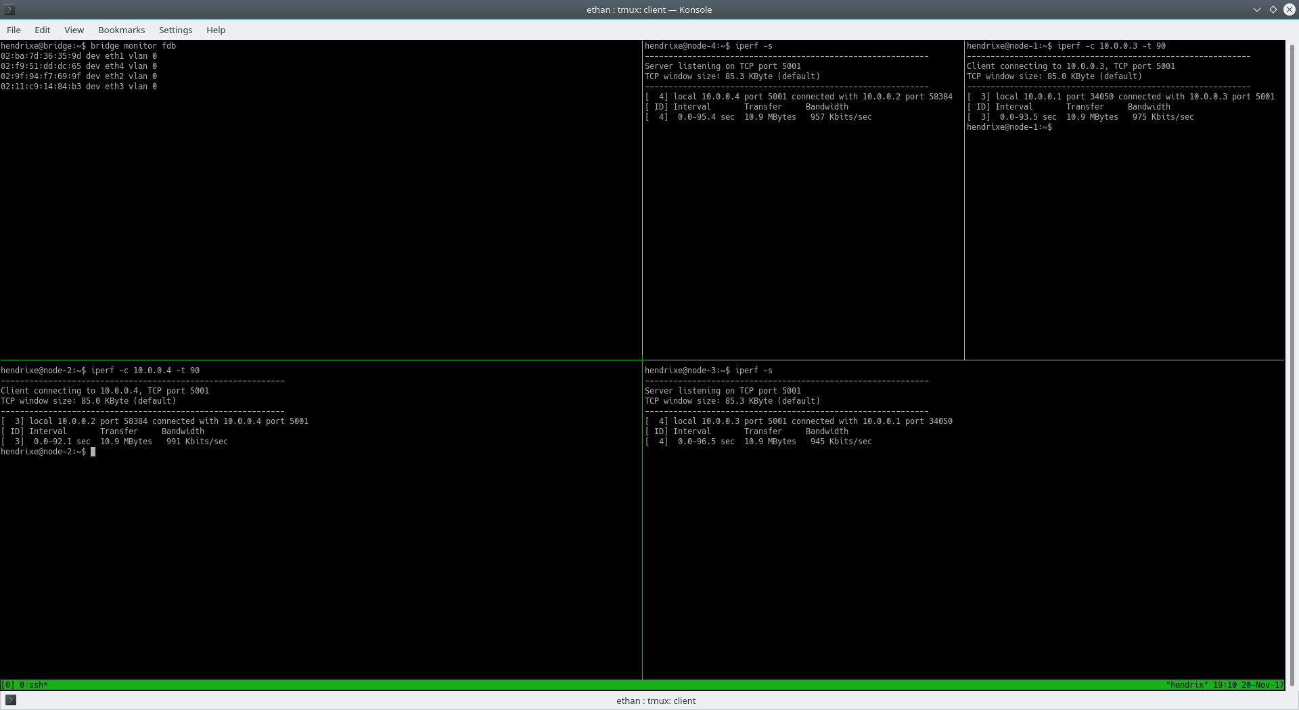

5.
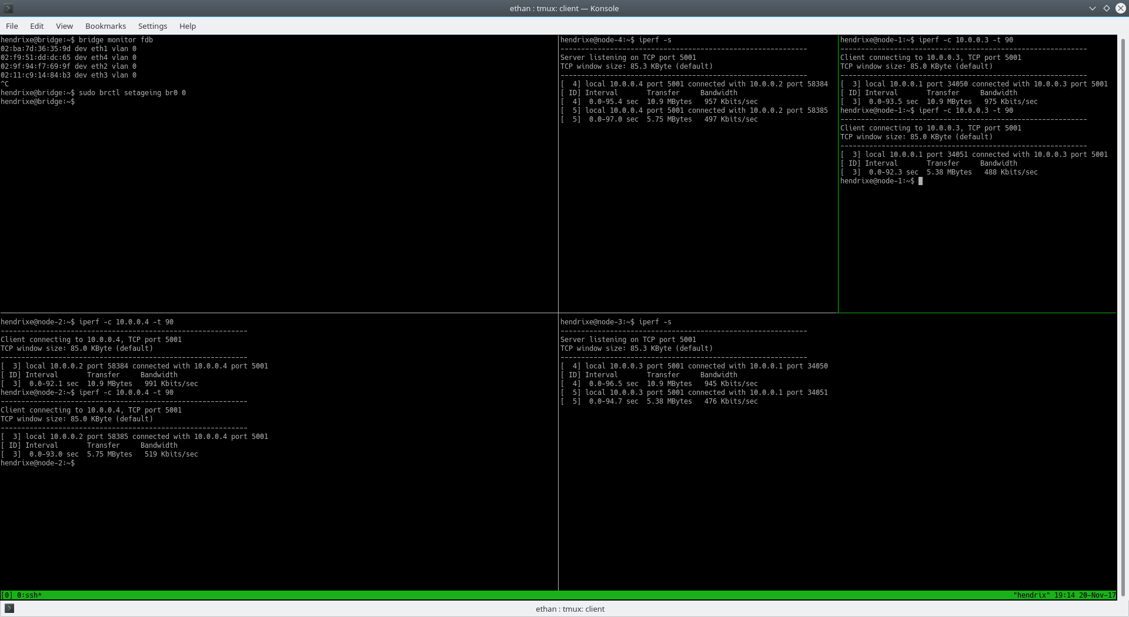
Switch Learning Table
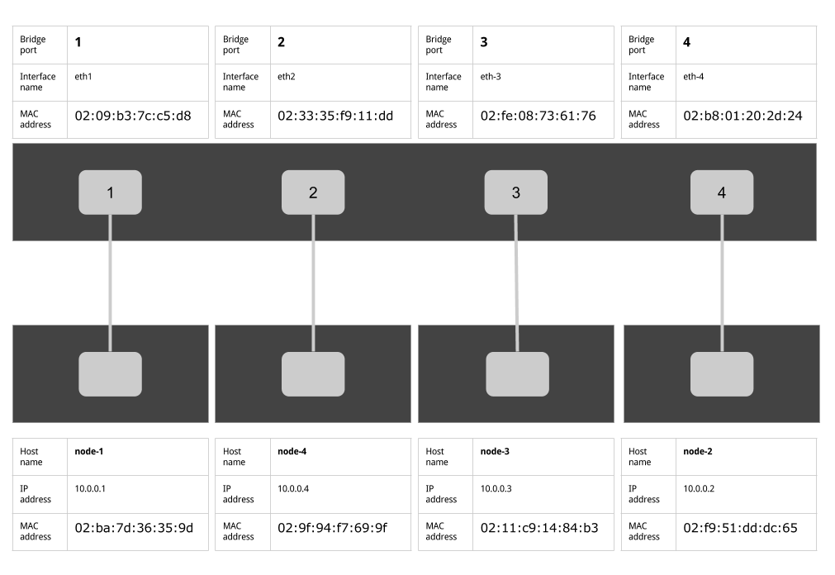
Effect on a smaller collision domain variation
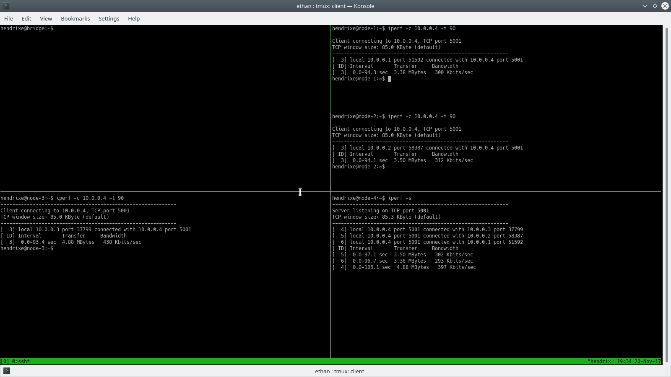
With MAC learning on, each transmitter sees relatively the same bandwith (~300Kbits/sec). Some of these may be more or less, but they all hover around this benchmark. Without MAC learning on, the bridge cannot offer consistent and efficient performance to each of the transmitters and receiver, because it must broadcast every time to determine where a frame is traveling. With MAC learning on, however, the bridge can learn where frames are going based upon their destination MAC address, and it will not have to determine this every time it receives a frame (assuming that the destination MAC is already in its MAC table).

