Strategy AI Documentation

# ALL OF THIS ASSUMES YOU ARE USING **WINDOWS**

# How to Run the Application

## What is assumed that you have done before running

1. You have already installed the application. If not follow the steps in How to Install the Application
2. You have already selected the company files you want to use for the analysis. If not see section Before Running the Application
3. The path to your installation folder handy. If not see: *step 2. Download the GitHub repository* from the section How to Install the Application

## Starting the Application

Before I list the step by step, here is a quick overview of what will be done here. You will have two command prompts, one running the User Interface (frontend), the other running the Business Logic (backend). Now for the step by step:

1. To open the first command prompt do the following:
   1. Press the windows start button (either on your keyboard or on the desktop)
   2. This is what the button looks like: 
   3. Then type “cmd” on your keyboard
   4. And you should see this: A screenshot of a computer

      Description automatically generated
   5. Then press “Enter” on your keyboard to open it.
   6. A window should open looking like this: A screenshot of a computer program

      Description automatically generated
   7. ---­------­------­------­------­---PAUSE---­------­------­------­------­------­---­

# Before Running the Application

You have to decide on the files you want to use for analysis.

**<path to application folder>\backend\strategy_ai\available_data\visible_files**

The files in the above folder are the files the AI will have access to when executing tasks.

## To add you company files

put them in the folder: **backend\strategy_ai\available_data\visible_files\client_files**

## To add links to websites

list them, one link on each line, in the text file: **backend\strategy_ai\available_data\visible_files\weblinks.txt**

## To delete your company files

remove the undesired files from the folder: **backend\strategy_ai\available_data\visible_files\client_files**

## To remove saved output files (results from tasks)

These are the files that you would have saved from previously running the application.

Delete files from this folder: **backend\strategy_ai\available_data\visible_files\ai_files**

# How to Use the Application

1. you will be able to see the application in your web browser
2. To refresh the files being shown in the left side of the screen, click the refresh button
3. A screen shot of a computer

   Description automatically generated
4. you can run a task by selecting one from the drop down menu, and then click the start but
5. A screenshot of a computer

   Description automatically generated
6. You will see the results be generated below
7. A screenshot of a computer

   Description automatically generated
8. Once the results are ready, the save button at the bottom will be enabled
9. A screenshot of a computer

   Description automatically generated
10. If you are happy with the results, you can click the **Save** button to save a copy of the results (as shown on screen) to the ai_files folder. pressing the refresh button will show that file in the UI.
11. These saved files will become available to the AI when running tasks upon a refresh of the backend (by killing and restarting the backend terminal)
    1. The feature will be added in where the backend does not have to be restarted to make use of the newly saved task results

# How to Install the Application

Here is a list of the things you will need before installing the application:

* link to strategy-ai github repository: https://github.com/hendrixgg/strategy-ai
* An OpenAI account

This installation involves installing Node.js to run the frontend User Interface and Installing the necessary python dependencies to run the backend Business Logic.

1. Install Node.js and NPM so that you can build the project
   1. if not installed go to: <https://nodejs.org/en/download>
   2. download the recommended installer for your operating system
   3. for windows users, click the windows icon: A screenshot of a computer

      Description automatically generated
   4. Once the download is complete open the installer. If you are using google chrome you could do something like this:A screen shot of a computer

      Description automatically generated
   5. Otherwise, you can open your downloads folder in the file explorer, and double click on the file titled: “node-v18.17.1-x64.msi”
   6. Upon opening the installer, this is what you will see: A screenshot of a computer

      Description automatically generated
   7. Click next
   8. Then you will see: A screenshot of a software license agreement

      Description automatically generated
   9. You must click the box that I have circled here in red (to accept the terms) and then click Next.
   10. You will then see this: A screenshot of a computer

       Description automatically generated
   11. You will be prompted to select a destination folder for Node.js, in this case the default is fine, so click Next.
   12. You will then see this: A screenshot of a computer

       Description automatically generated
   13. Click Next
   14. You will then see this window: A screenshot of a computer

       Description automatically generated
   15. You must check the checkbox I circled in red (make the button turn blue with a checkmark inside), then click Next
   16. You will see this window: A screenshot of a computer

       Description automatically generated
   17. Click install, and when the request for permissions window opens, click yes
   18. Once this step is complete, you will see: A screenshot of a computer

       Description automatically generated
   19. Click Finish
   20. You will then see another command prompt open that looks like this: A screenshot of a computer

       Description automatically generated
   21. Proceed with the installation by pressing any key, as instructed
   22. You will then be prompted for permissions to run a “Windows PowerShell”, allow this
   23. You will then see the following window: A screenshot of a computer screen

       Description automatically generated
   24. As it says, type Enter to proceed with the final part of the installation
   25. Once the windows PowerShell is closed and finished running, you need to check if the installation was successful
   26. To check if the installation was successful, you will be opening a command prompt and running: “node -v” or “npm -v”. Instructions are below:
       1. Press the windows start button (either on your keyboard or on the desktop)
       2. This is what the button looks like: 
       3. Then type “cmd” on your keyboard
       4. And you should see this: A screenshot of a computer

          Description automatically generated
       5. Then press “Enter” on your keyboard to open the Command Prompt.
       6. A window should open looking like this: A screenshot of a computer program

          Description automatically generated
       7. in the terminal, type: “node -v” then press Enter
       8. in the terminal, type: “npm -v” then press Enter
       9. If you saw results that looked like this: A screenshot of a computer program

          Description automatically generated
       10. Then you are ready to proceed to downloading the GitHub repository, go to step: 2. Download the GitHub repository
       11. If not, then there was some error in the installation, continue here with the following
   27. run the installer again (the file was “node-v18.17.1-x64.msi”) and select the option to Repair: A screenshot of a computer

       Description automatically generated
       1. And proceed with the instructions provided.
       2. Once the repair is complete, repeat step: 1.z To check if the installation was successful…
2. Download the GitHub repository
   1. Paste the following link into your browser: <https://github.com/hendrixgg/strategy-ai/archive/refs/heads/main.zip> and the download will begin immediately
   2. Locate your download in the file explorer
   3. On google chrome you can do the following: A close up of a logo

      Description automatically generated
   4. In my case, this is where it was downloaded to: A screenshot of a computer

      Description automatically generated
   5. You then need to extract the zip file, to do this, right click on the zip file “strategy-ai-main.zip” and click “Extract All…”
   6. A screenshot of a computer

      Description automatically generated
   7. You will then be prompted to select a destination for the extracted files, keep in mind, this will place one folder named “strategy-ai-main” in the directory you choose. It is recommended to select a location on your local machine. So, select a destination somewhere within C:\Users\Username: A screenshot of a computer

      Description automatically generated
   8. Navigate to where you have extracted the folder, in my case, I extracted to “C:\Users\Hendrix\Documents\StrategyAI” so that is where I will go:
   9. A screenshot of a computer

      Description automatically generated
   10. The next thing to do here is copy the path to this folder, the way to do that is by right clicking on the “strategy-ai-main” folder and clicking on “Copy as Path”: A screenshot of a computer

       Description automatically generated
   11. In my case, the path is "C:\Users\Hendrix\Documents\StrategyAI\strategy-ai-main"
   12. Keep this path handy because you will need it in the next steps
3. open up command prompt by doing the following:
   1. Press the windows start button (either on your keyboard or on the desktop)
   2. This is what the button looks like: 
   3. Then type “cmd” on your keyboard
   4. And you should see this: A screenshot of a computer

      Description automatically generated
   5. Then press “Enter” on your keyboard to open the Command Prompt.
   6. A window should open looking like this: A screenshot of a computer program

      Description automatically generated
4. The next step is to install the UI
   1. In the Command Prompt type: cd <path to the extracted folder you copied from earlier>
   2. Press “Enter”
   3. Then type: cd frontend && npm install
   4. Press “Enter”
   5. Once the installation is your Command Prompt should look like this: A screenshot of a computer

      Description automatically generated
5. To install the backend:
   1. In the same Command Prompt type: cd ..\backend && python -m venv env && env\Scripts\activate && pip install -r requirements.txt
   2. Press “Enter”
   3. This installation will take significantly longer than the previous installation, just wait patiently until it’s done
   4. Once this installation is complete your Command Prompt should look like this: 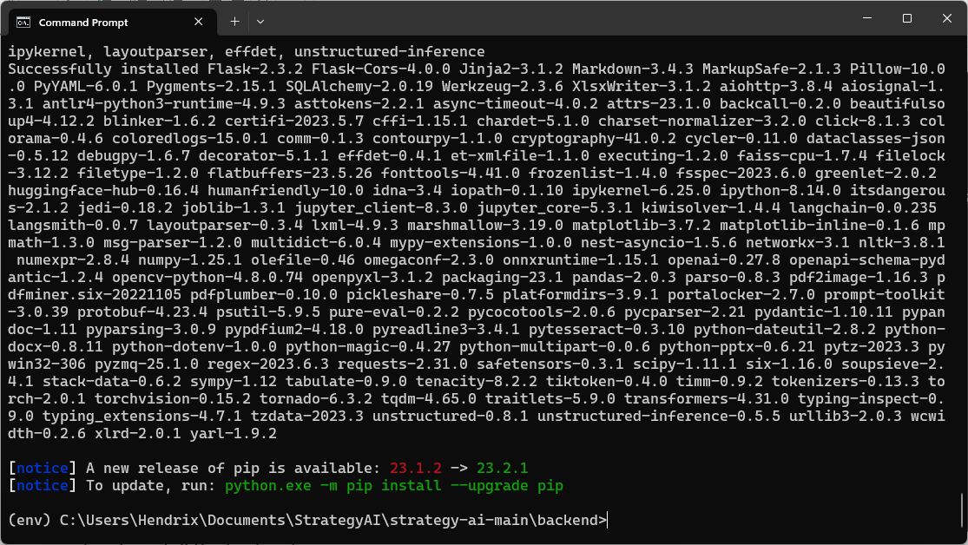
   5. You can safely ignore the notices about new updates available, they are not required
   6. now you need to input your OpenAI api key
      1. If you do not have an OpenAI api key:
         1. Go here: <https://platform.openai.com/account/api-keys>
         2. Either log in or create an account
         3. Once logged in you will see this page: A screenshot of a computer

            Description automatically generated
         4. Click the button to create a new secret key
         5. Copy the secret key
      2. Back to your command prompt, it should have been at the directory: 
      3. In the command prompt, type: echo OPEN_AI_API_KEY=”your api key” > .env
      4. Where you paste your actual api key within the quotes
      5. the press “Enter”
      6. then in the command prompt, type: type .env
      7. Press “Enter”
      8. This will display your OpenAI API Key that you just inputted
      9. your command prompt should look like this: A screenshot of a computer

         Description automatically generated
      10. to change your api key in the future you can either repeat this process from steps ii to viii, or you can change it by opening the file "<your chosen directory>\strategy-ai\backend\.env" with notepad and pasting a different key within the quotes

**The installation is now complete!**