Table of Contents

1. Main page 2

2. Editing and adding people 5

3. Menu Bar 7

4. Other views 10

5. Non web information 14

1. Main page

The main page is located at <http://localhost:8084/FamilyTree/index.xhtml>.

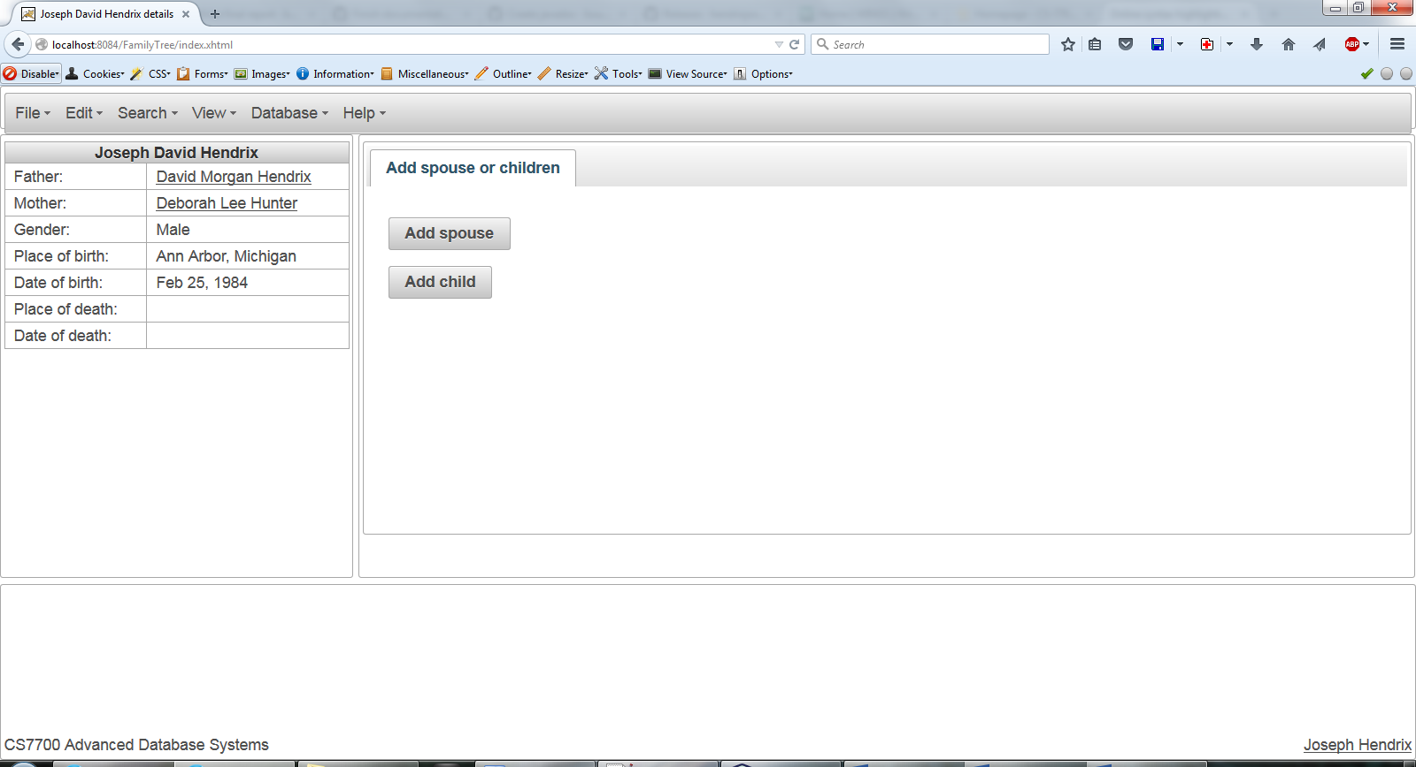

This page will always display the default person. Currently the default person is the person with the lowest internal id number, but future versions will let the default person be set manually, as the last person viewed, the last person edited, or any other number of options.

The display to the left shows the person’s details, which include the person’s father, mother, gender, place of birth, date of birth, place of death, and date of death. Click on either parent’s name to go to that person’s page.

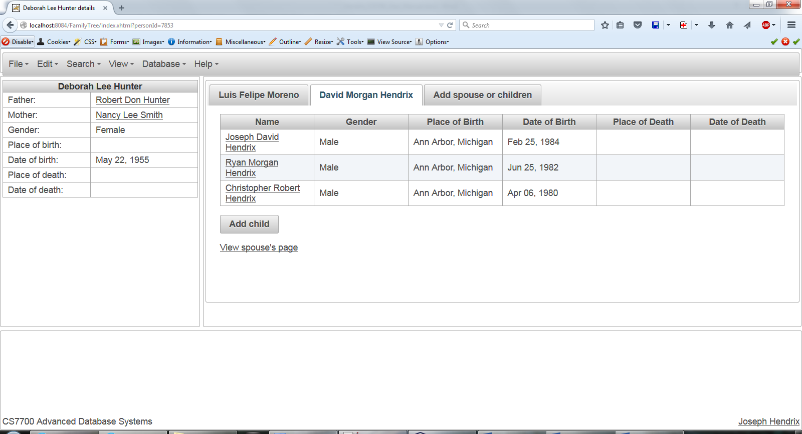

This person has more information available on the right. There is a tab for each spouse of the person, with a table showing basic information for each child of the person and their spouse. Click on a child’s name to visit that page. Click on “View spouse’s page” to view the page of the spouse. Click “Add child” to add a child associated with that person and that spouse.

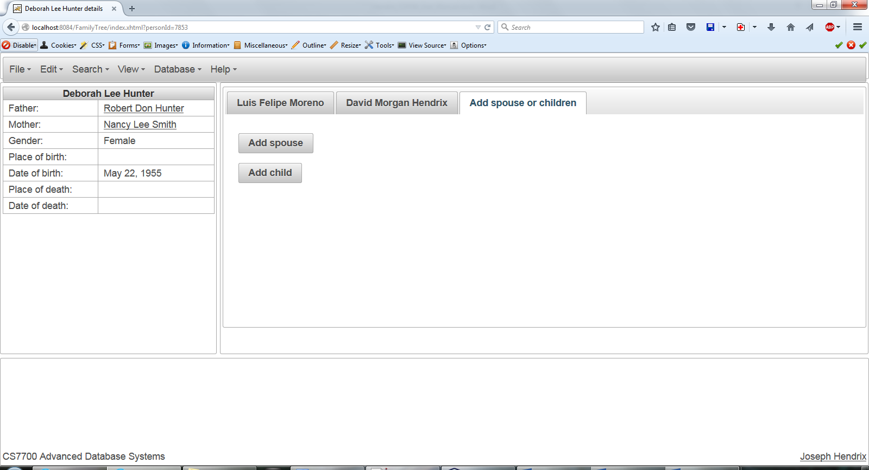

The “Add spouse or children” tab allows a new spouse, or a child with no affiliated spouse, to be added to the person. Simply click on “Add spouse” or “Add child” to perform the associated action.

Note the url of this page. In the above example, the url is <http://localhost:8084/FamilyTree/index.xhtml?personId=7853>. Bookmarking this url in the browser will allow you to quickly return to any person, or (if this application ever reaches production) you could send the link to a friend.

1. Editing and adding people

To add a person, click anytime you see a button labeled “Add person”, where person could be a father, mother, child, or spouse. For instance:

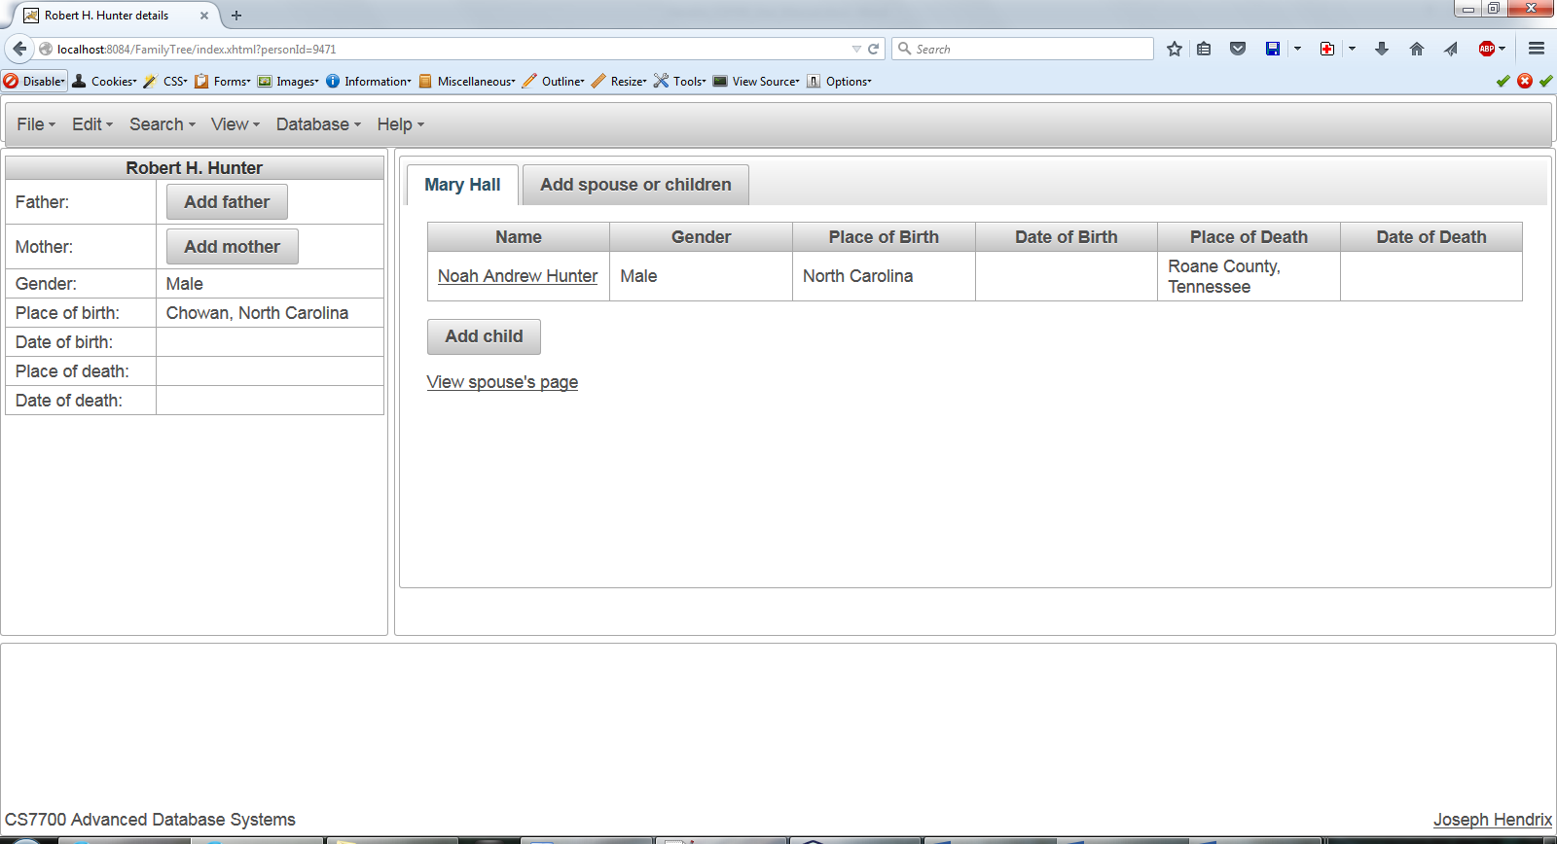

Here we can see buttons for adding a father, mother, and child.

To edit the current individual, select “Edit” then “Edit Individual” from the menu bar:

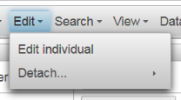

The edit dialog will appear:

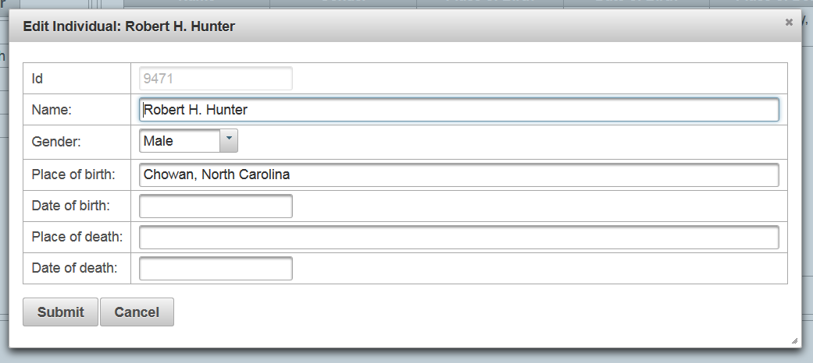

Make your changes and then click “Submit.” The page will refresh and your changes will appear.

The add person dialogs look very similar:

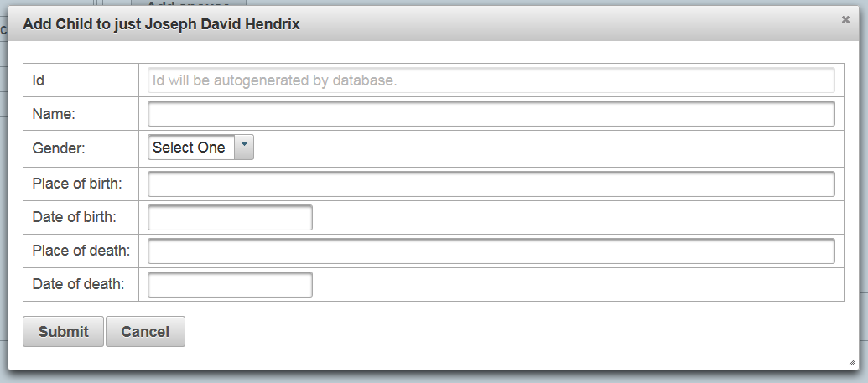

1. Menu Bar

The menu bar has a number of options:



* 1. File Menu

The File menu has three options:

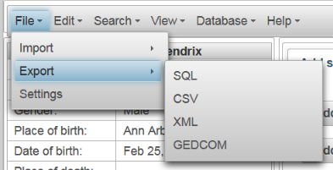

None of these are implemented yet. Future releases will allow you to import data from a variety of sources, including sql, csv, xml, and gedcom files.

Settings is not implemented either, but clicking it will bring up a non-functional settings dialog.

* 1. Edit, Search, and Database Menus

The edit menu was displayed previously. The search and database menus currently are not implemented.

* 1. View Menu

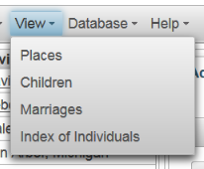

The view menu displays the list of available views. The current view is not listed, however.

* 1. Help Menu

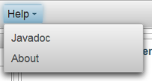

The help menu contains the link to the last generated JavaDoc (generated by the javadoc.exe tool) and the about dialog (see next page).

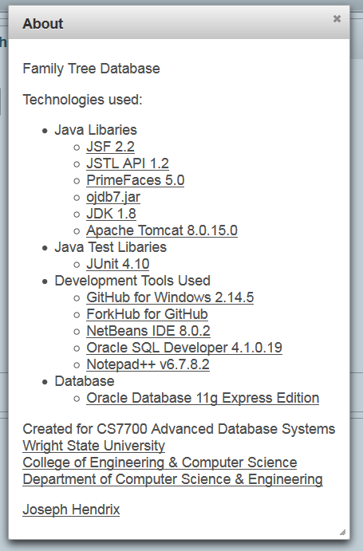

1. Other views

Most views display a list of data. Views are currently typically limited to ten records to prevent the web browser from crashing.

* 1. Places (<http://localhost:8084/FamilyTree/places.xhtml>)

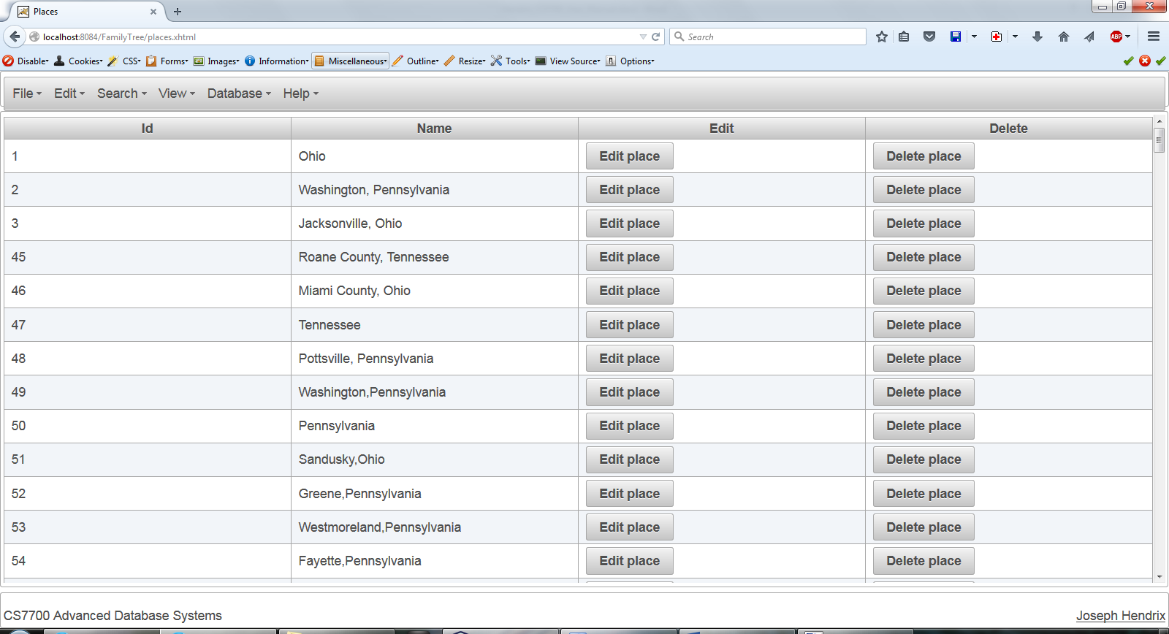

* 1. Children (<http://localhost:8084/FamilyTree/children.xhtml>)

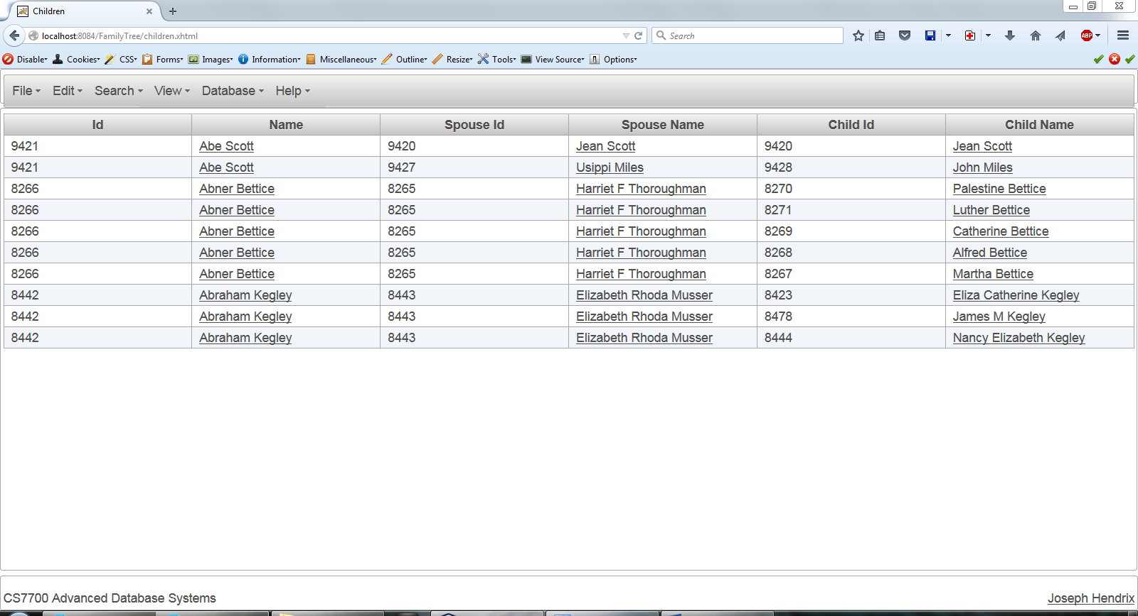

Click on any person’s name in this view to go to their record.

* 1. Marriages (<http://localhost:8084/FamilyTree/marriages.xhtml>)

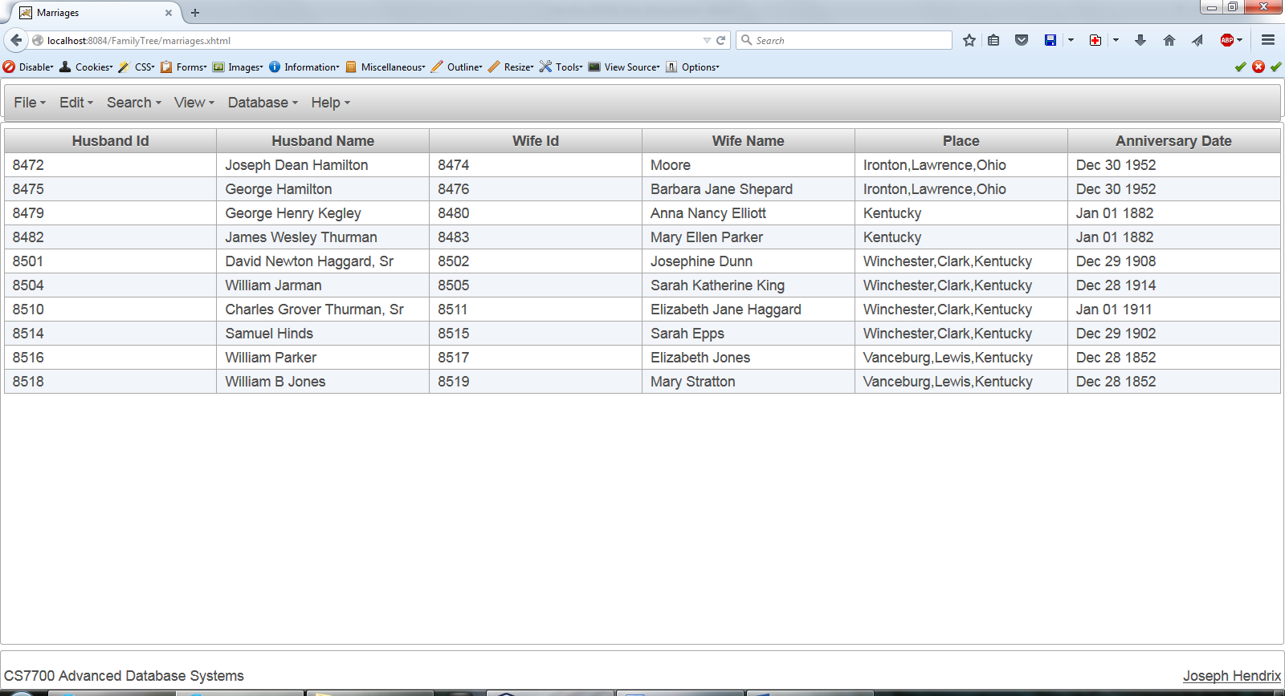

* 1. Index of Individuals (<http://localhost:8084/FamilyTree/persons.xhtml>)

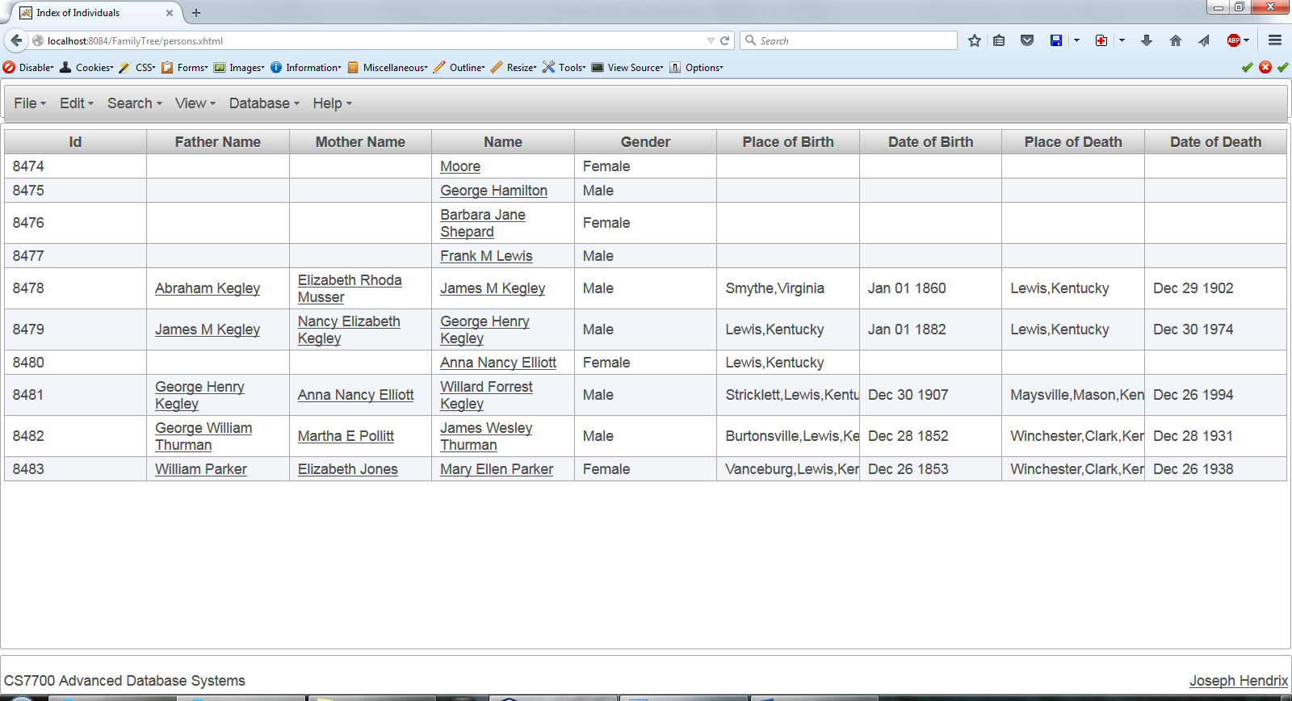

Clicking on a name should bring up that person’s details, but there is currently a bug where clicking on a parent’s name does not work as expected.

1. Non web information
   1. database.propetries

This is a standard Java properties file, read with the standard java.util.Properties package. The properties it should include are dbpassword, database, and dbuser. For instance:

|  |
| --- |
| dbpassword=pass  database=jdbc\:oracle\:thin\:@localhost\:1521\:XE  dbuser=joe |

* 1. GedcomImporter.java in package edu.wright.hendrix11.familyTree.database.imports

This class reads in a standard gedcom file. Currently there is a main class for testing purposes, but this will be removed in future versions,