DEPLOYMENT: Lesson HandsOn 2

App connects to the EC2…

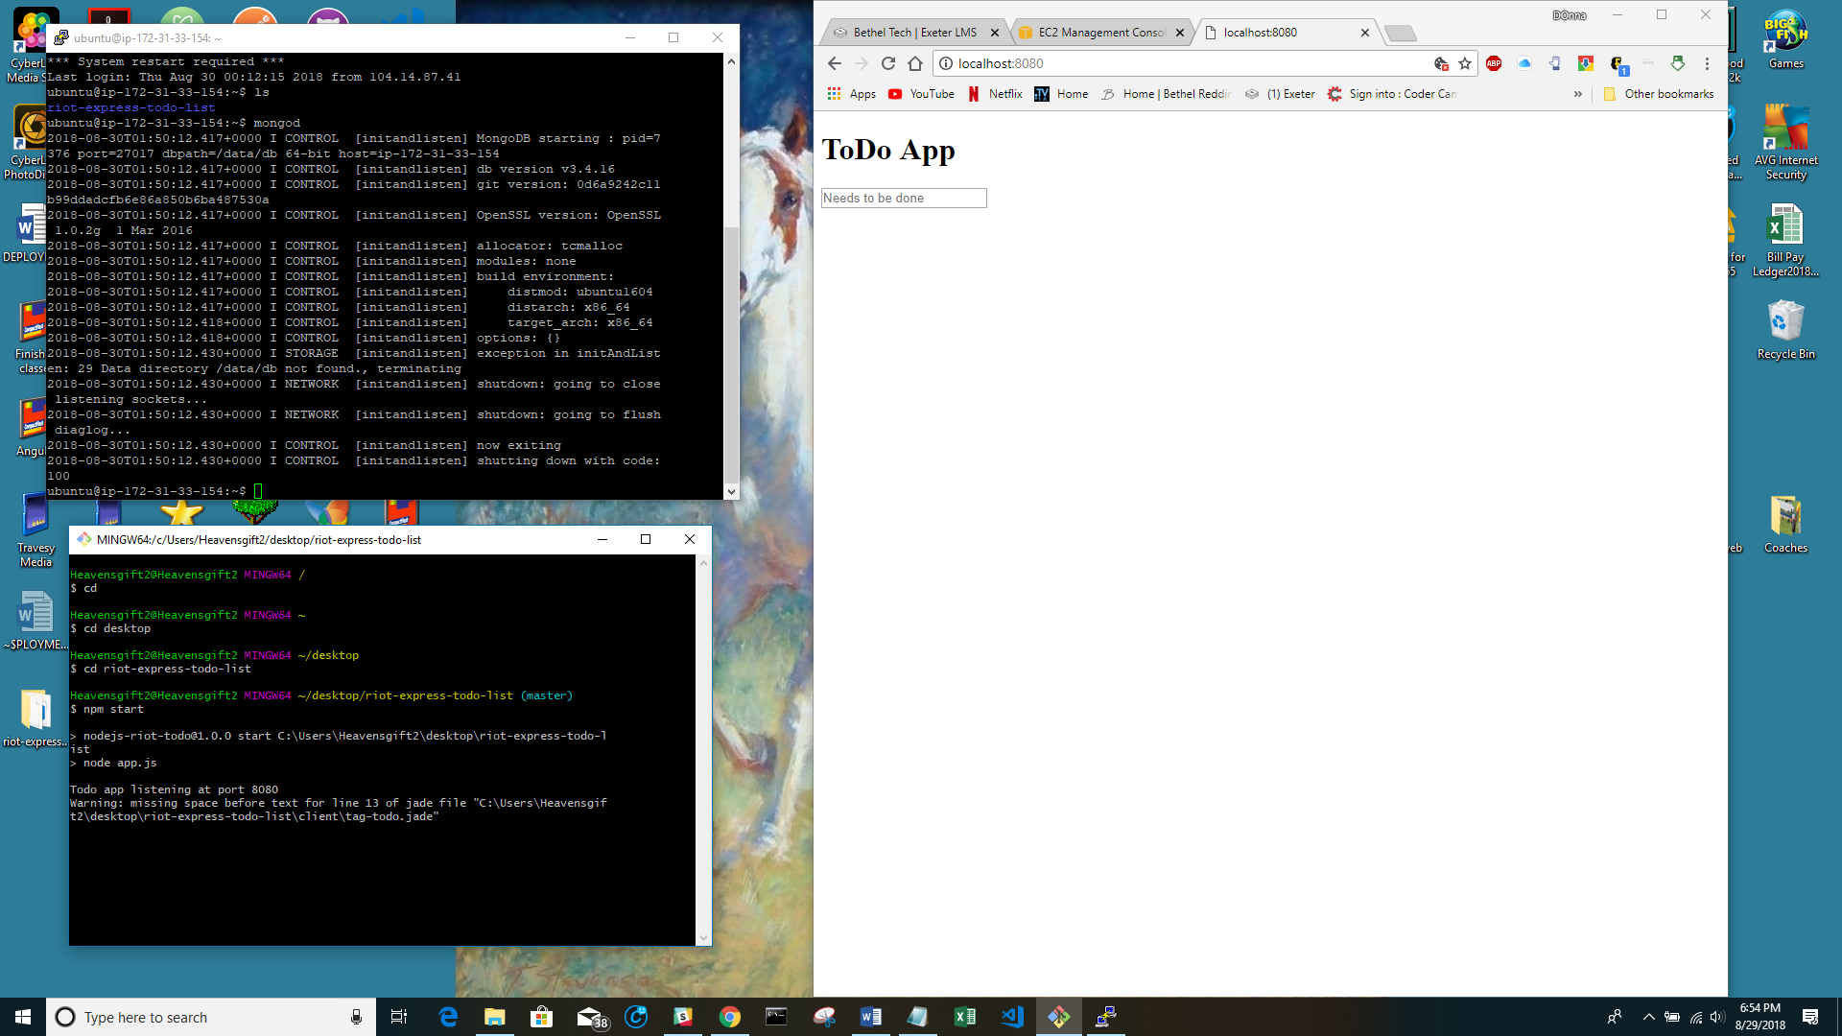

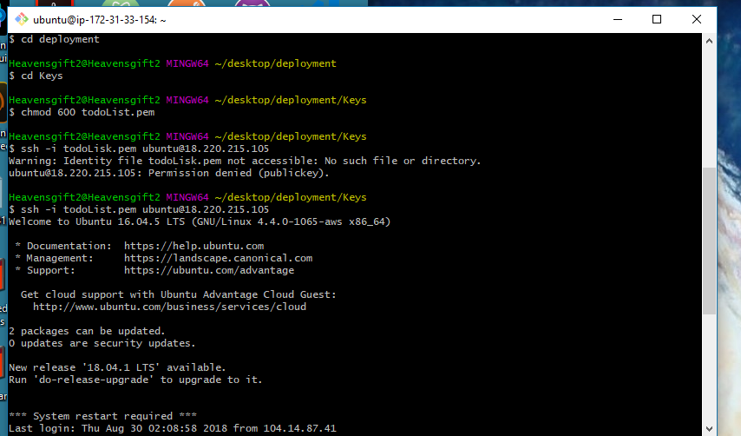

Nothing I do gets the file on the ec2

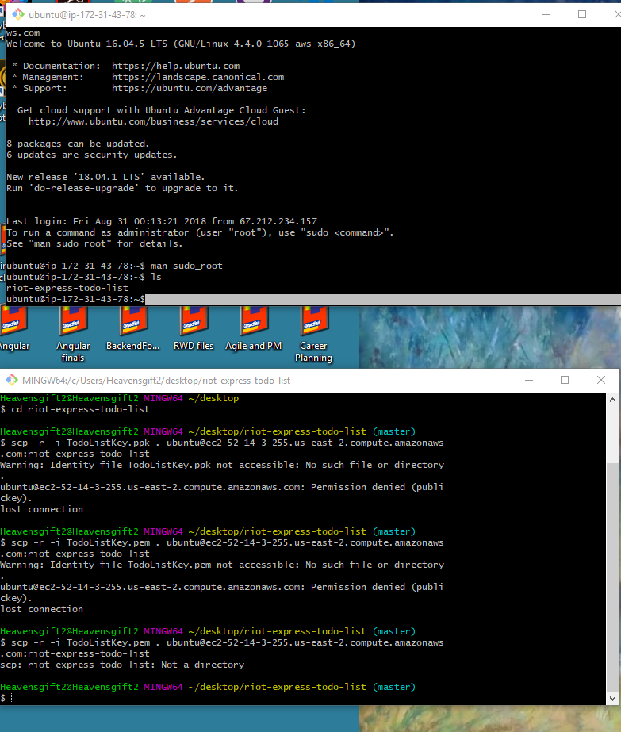

After numerous attempts I have started over again.

Got it to connect:

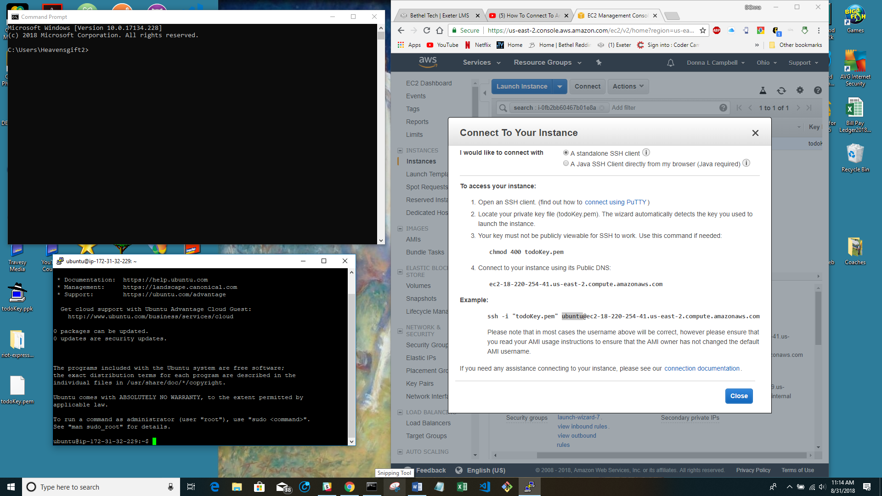

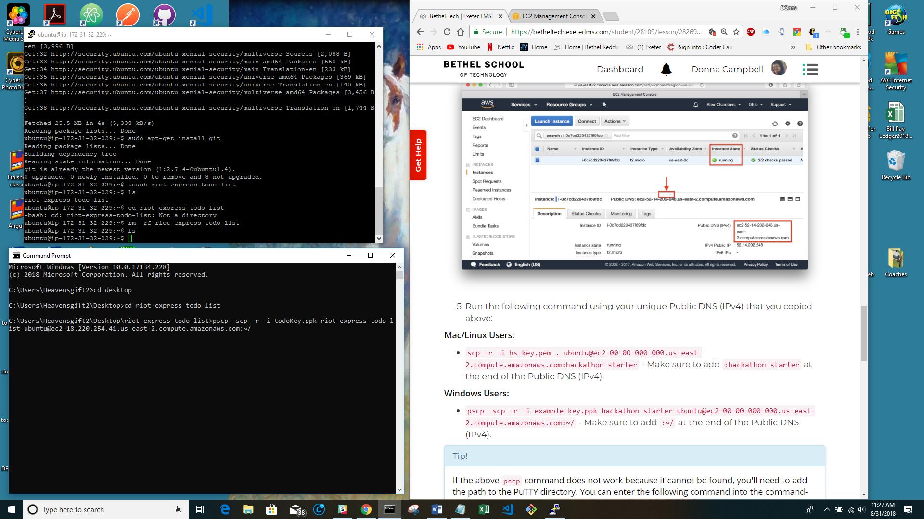

Ready to transfer file….no such file or directory:

Mkdir riot-express-todo-list on EC2 instance:

Host does not exist:

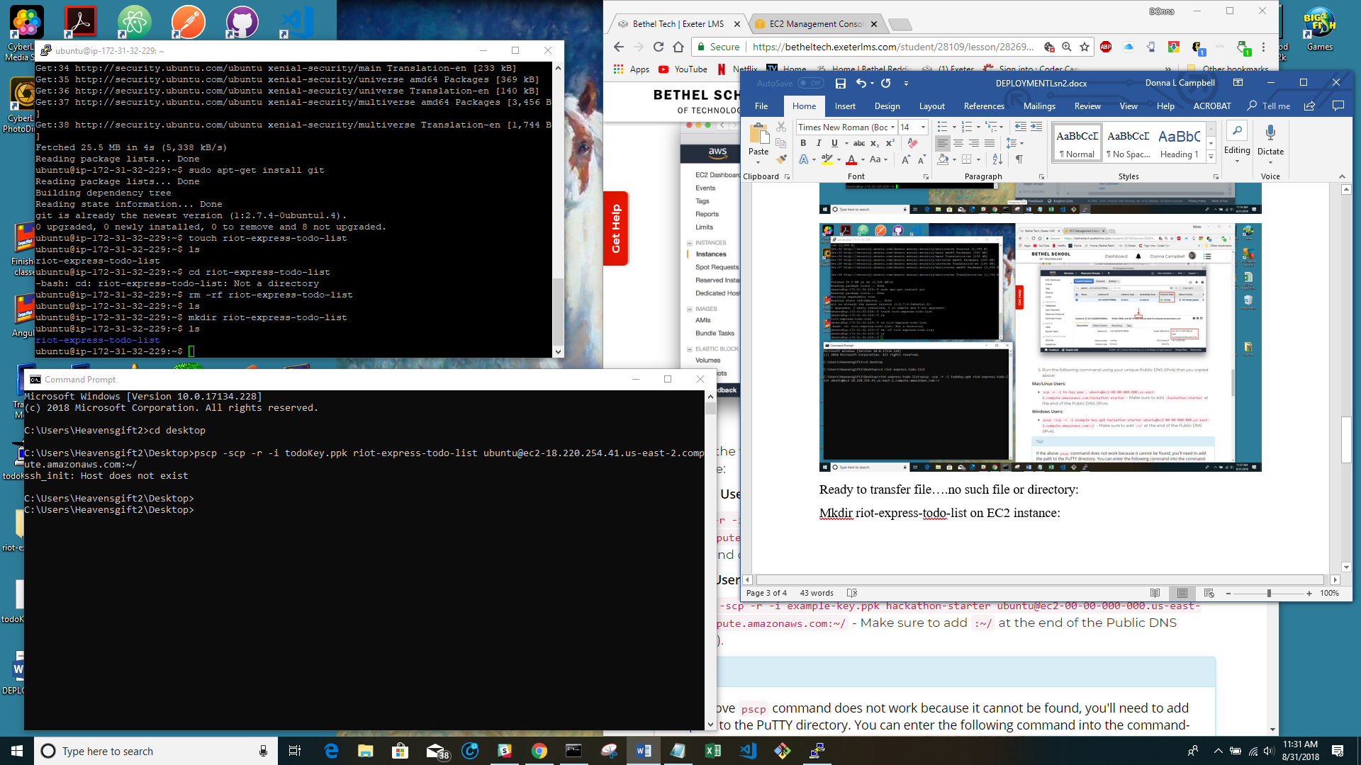

Tried cloning…host does not exist.. 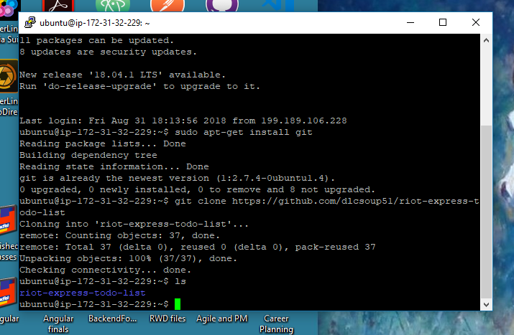

Trying again:

Got it to clone:

Okay, for time sake, I am leaving the clone, and going on to updating the cloned files on the EC2 instance with the new deploy.js file. And from there finish the lesson.

Getting ready to update EC2

Got it! 