$$x=re^{iθ}+re^{-iθ}=2r\cos{θ}$$

$$p=-i\left(b-b^{+}\right)=2r\sin{θ}$$

$$dx/$$

$$\int{f\left(r,θ\right)dr}$$

$$\frac{x+ip}{2}=re^{iθ}$$

$$\frac{x-ip}{2}=re^{-iθ}$$

$$r=\frac{1}{2}\sqrt{x^{2}+p^{2}}$$

$$\cos{2θ}+i\sin{2θ}=e^{2iθ}=\frac{x+ip}{x-ip}\frac{x+ip}{x+ip}=\frac{x^{2}-p^{2}}{x^{2}+p^{2}}+i\frac{2xp}{x^{2}+p^{2}}$$

$$θ=\frac{1}{2}\cos^{-1}\left(\frac{x^{2}-p^{2}}{x^{2}+p^{2}}\right)$$

For a certain $θ$, then, we integrate along a straight line $s$ of constant $θ$ which starts from the origin and goes all the way until the point parameterized by $x_{end}$ or the other way around.

$$s=\frac{1}{2}\left(x,p\right)=\frac{1}{2}\left(x, x\tan{θ}\right)$$

$$s^{'}=\frac{1}{2}\left(1,\tan{θ}\right)$$

$$ds=\left|s^{'}\right|dx=\frac{1}{2}\sqrt{1+\tan^{2}{θ}}dx=\frac{\sec{θ}}{2}dx$$

$$\int_{s}{W\left(x,p\right)ds}=\frac{\sec{θ}}{2}\int_{0}^{x_{end}}{W\left(x,x\tan{θ}\right)}dx$$

The factor $1/2$ comes from the relations above. But a problem exists when $θ=π/2$, i.e. when $\tan{θ}→∞$. To circumvent this problem, we can divide the plane into four intervals: $I=\left[-π/4,π/4\right)$, $II=\left[π/4,3π/4\right)$, $III=\left[3π/4,5π/4\right),IV=\left[5π/4,7π/4\right)$. Here the choice of bound inclusion is arbitrary.

For $I$ and $III$ we can use the result above.

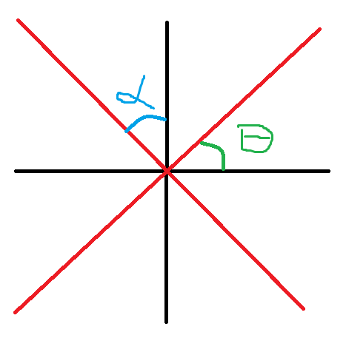

Our problem lies in $II$ and $IV$. To circumvent this, we instead write

$$s=\frac{1}{2}\left(x,p\right)=\frac{1}{2}\left(p\tan{α}, p\right)$$

where $α=θ-π/2$. This gives

$$ds=\left|s^{'}\right|dp=\frac{1}{2}\sqrt{1+\tan^{2}{α}}dp=\frac{\sec{α}}{2}dp$$

For the given $α$, we integrate from $0$ until $p_{end}$:

$$\int_{s}{W\left(x,p\right)}ds=\frac{\sec{α}}{2}\int_{0}^{p_{end}}{W\left(p\tan{α}, p\right)}dp$$