**Vision**

**To be the leading innovative retirement benefit software solutions provider of choice**

**Our mission**

**To provide innovative software solution to the retirement industry using the state of art technologies, industry best practices and motivated human resource**

**Core values**

**Passion for excellence**

**Product differentiation**

**Delight our customer**

**Positive-can-do attitude**

**Always and steadily becoming**

**Isaiah 45:2-3**

**I will go before you and will level the mountains**

**I will break down gates of bronze and cut through bars of iron**

**I will give you hidden treasure riches stored in secret**

**So that you may know that you may know that I am the lord the God of israel**

**Personality test.**

**Sentinel** -Careful and consistent, **Sentinel personalities** tend to be self-motivated. This means that they rarely need external inspiration to be productive and focused. They work hard and aim never to let anyone down, and they expect other people to embrace this same ethic as well.

Careful and consistent

Tend to be self-motivated

We rarely need external inspiration to be productive

We work hard and aim never to let anyone down

We also expect other people to embrace this same

Turbulent we are success driven, eager to improve

Feeling decision tend to be based on the well-being of others

Weakness they become excessive in their concern for others

Extraverted tend to be manifested in outgoing, talkative, energetic behavior

Observant their energy is very

Judging feel most

Traits

Extraverted- tends to be manifested in outgoing, talkative, energetic behavior, whereas introversion is manifested in more reflective and reserved behavior

Observant- are often a steadying force that tends to get things done. Their energy is very “hands-on” in the sense of working on real things in real-time.

Feeling- For those with the **Feeling trait**, decisions tend to be based on the well-being of others. However, people with the **Feeling** personality **trait** often find they become excessive in their concern for others.

Judging- **trait** feel most comfortable when the course ahead is well-marked. ... Preferring to consider their options ahead of time, personality types with this **trait** prefer clarity and closure, sticking with the plan rather than going with the flow.

Turbulent- individuals are success-driven, perfectionistic, and eager to improve. They are always trying to counterbalance their self-doubts by achieving more

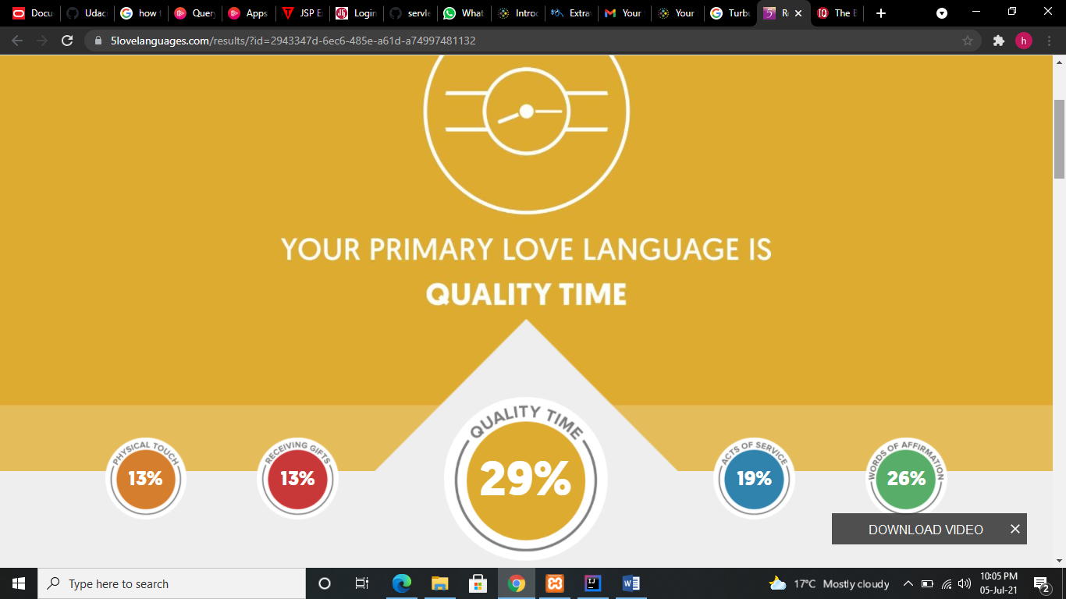

In the vernacular of Quality Time, nothing says, "I love you," like full, undivided attention. Being there for this type of person is critical, but really being there – with the TV off, fork and knife down, and all chores and tasks on standby – makes your significant other feel truly special and loved. Distractions, postponed dates, or the failure to listen can be especially hurtful. Quality Time also means sharing quality conversation and quality activities.

**Intuitive communicator**

What does that mean? You like the big picture, you avoid getting bogged down in details, and you cut right to the chase. You don’t need to hear things in perfect linear order, in fact, you’re okay with skipping right to the end. For example, some people, like Functional communicators, will tell you things step-by-step (they start with A, then go to B, then C, then D, then E, etc.). But this can drive you nuts; you’d rather skip right to Z. The plus of being an Intuitive communicator is that your communication is quick and to the point. You don’t get bogged down in too many details, and you’re comfortable with big ideas and out-of-the-box thinking. Because you’re good with thinking big, you can also enjoy challenging convention. The potential downside is that you may not always have enough patience when you’re in a situation that actually requires getting down into nitty-gritty detail (and you may risk missing an important point). Typically, Intuitive communicators have the most difficulty dealing with Functional communicators (those are the 'process-driven' people, they’re very methodical, walk through things step-by-step, and like nitty-gritty detail).

Four pernality

Analyst category

Architect

Commanders

Loggains

Second category

Advocates

Mediator

Got agonist

Lofistian

Defender

Cnsol

Explores categories

Viruso

Adventure

Entrepreneur

Entertainer

Love languages

Word of affirmation

Quality time

Acts of service

Physical touch

Communication style.

Analytical communicators-

Intuitive communicators-communicate anyhow without emotions.

Functional communicators – have feeling you say things as they are

Personal communicators-emotional

Grooming –is art of cleaning and maintaining parts of the body

Types of grooming

-human

-animals:

-birds

-insects,dogs,cats,insects, fly. Dragon fly

Importance of grooming

-personal hygiene

-health

-attraction

-identity

The picture you create will greatly influence your chances on how your

Most people form an impression during the first seven second of the meeting.

Not match is said in this short time

Early judgement is based strictly on appearance

Aspects of grooming include:

Hair

Nails

Body ardor

Grooming

Some basic guidelines to follow when it comes to hygiene be clean and neat.

No visible body piercing.

Wear minimum jewelry and colon

Wear a smile

Demonstrate a positive attitude

Good manners thank you, please

Don’t interrupt don’t argue

The cloths you wear affect all your attitudes and confidence level when people tend to take time.

Common sense and good taste are the best guide in selecting what you wear.

Jewelry should be conservative and set to a minimum clothing fit comfortably.

You want your employer to focus on your skills not your cloths.

Personal grooming is as important as what you where you may select the right cloth but neglate the hygiene and neglect the image you wanted to describe.

1. Hair-Clean or neatly combed or arranged
2. Facial hair- freshly shaved and mustache and beard neatly groomed
3. Finger nails neat clean and trimmed
4. Teeth brushed and fresh breath.
5. Breath-be where of foods which may leave odor use breath mint if needed
6. Body freshly bathed or showered remove body piercing tongue rings and cover tattoo
7. Make up use sparingly and be natural looking.
8. Perfumes colon and after shaves use sparingly or none at all your scent should not linger after you live.

Grooming and integrity

This may appear insignificant but is important and says a lot about you over and above looking good speak English keep time be a man or woman of your word.

Clothing.

For a man a well-fitting trouser a good shoes and a watch

For women where well-fitting cloths watch the length of your skirt watch the depth of your cleavage watch your hair

Johari’s window

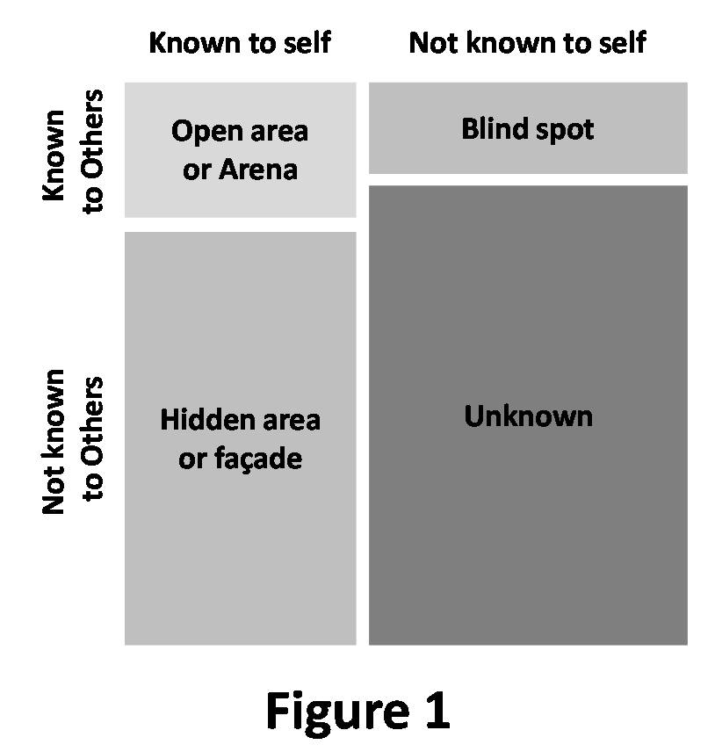

**Time management**

There are three things that can never get back.

1. Spoken word
2. Lost opportunity-
3. Lost time –be in the moment (be prepared for the best and expect the worst)

**Tips to manage your time.**

-Record your current schedule.

-Set aside 30 minutes at the begin of each day to plan make a to do list.

-Delegate some work

-Butch similar task

-Use waiting time effectively make it count

-Ignore some phone calls do not be needlessly interrupted

-Minimize meeting time

-Block social media

Eat that frog “” if the first thing to do in the morning is to eat a live frog .one can go through the day with satisfaction that is the worst thing that have happened to you that day. If you have two frogs, you eat the ugly one first.

If you have to live it

Theft of time management.

Procrastination-

Certification

Build my problem solving technique

Become the software I have desired

Potion myself well when

**COMMUNICATION**.

What is communication

Is simply the act of transferring information from one place person group to another, every communication involves at least one sender a message and the recipient?

The sender of a message is required to conceive the message he or she wishes to send and code this message and then transmit, the receiver is required to receive the message decode it and clarify his or her understanding of the message.

Type of communication

1. Verbal communication- occurs when we engaged in speaking to others can be face-to-face, through zoom

Some verbal communication can be verbal or informal

A part from the formal it’s about the caliber of the words

If its face-to-face observe the non-verbal

1. Non-verbal communication- what we do when we speak says more than words non-verbal includes facial expression, posture, eye contact, hand movement and a touch.
2. Written communication-weather it’s an email, a twit all form of written communication are meant to disseminate information in clear or concise manner.

Poor writing skills often lead to confusion and embracement or even potential legal jeopardy.

Things to remember when writing;

-write well poorly constructed sentences and mistakes make you look bad.

-ensure the content of the message is something to promote or be associated with for a long term.

1. Listening- the act of listening does not often make its way on the list of types of communication however active listening is the one of the most important type of communication.
2. Visual communication- Facebook, Instagram (we are visual society).

Type of communication skills.

Modes of communiction

written

spoken

55% is non-verbal

38% is tone of voice

5% is spoken word.

Communication can be a mix of any of the following

Some major areas of non-verbal to keep are:

-facial expression

-body posture

-gestures

Non-verbal communication refers to the messages we give and receive through facial expression and body language. (nodding, shaking hands)

When someone approaches:

-disengage and face the person

-do not answer the phone before you answer it ask for a permission.

-ask questions

-do not think a head

-summarize

Things to avoid when communicating.

-frauning

-shifty eyes and fidgeting

-speaking in a very soft or high voice

-sleeping or yarning

-burping

It’s not only what you say is important but it’s how you say it that what make a remarkable difference.

Open vs closed body language.

**Phone etiquette**

**-**defined salutation and identity to help

-speak clearly right tone volume pitch

-avoid jargon

-do not use speaker phone unless it’s a conference

-transfer or putting someone on hold

**EMAIL DO AND DON’T.**

Use greeting and closing

Check spelling grammar and punctuation

Put yourself in your leader’s situation

**Don’t**

Don’t use capital letters

Don’t include confidential and personal information

Don’t send the message while you are angry

Don’t forward the message unless you are that the original sender will not feel bad

Don’t say anything negative about someone in an email

**LISTEN TO YOUR CUSTOMER**

If one speaks and

Start by not being preoccupied be open minded and non-defensive, remain uninterrupted actively listening, understanding the message and relating to it probing.

Effective communicator.

To be and effective communicator remember to be aware of what you are saying

Apply the sane process you use in writing communication when communicating orally

Before you speak thing about your purpose your main idea and your customer.

Organize your thoughts in logical way

Decide on the style that best suits the occasion and the edit the remarks

Us you speak the other person to see whether the message is making the desired impression if not reverse it and try again.

**Customer care and team management.**

Customer is a person who buys from a person or business

They are people who buys from us

Customer care is how you treat the people who support our business they depend on us for guidance, information, services, products or social support.

In exchange of what they provide they want something back

There four things that customers want.

* They want to be understood
* Feel welcomed example (in a hotel and no one is talking to you won’t by)
* They want to feel important.
* They want to feel comfortable

When you get a job listen to one FM WII (what is in for me) make you feel better about your job.

-Make you feel better about yourself.

-if you don’t service customers well you may lose your job.

Service is a philosophy not a department or program or policy-it means exceeding customer expectation, doesn’t happen automatically

**Why provide good customers service**.

-improves trust

-enhances the value you offer

Customers are all around us.

Meeting customer expectations.

* Time lines -respond to their question, give them what they want when they want it.
* Quality –make sure your service or products delivers on promise.
* Consistency don’t come up with unexpected surprise’s
* First impression -is the longest lasting.

Types of customers. Brittam, Kenya power, UAP, NICO, PPS

internal customers and external customers.

External customers are those outside the organization with whom we do business.

Internal customer is an organizations employee that are directly or indirectly affiliated in the organization.

**Types of service**

* Personal service is a key element that contributes to customer satisfaction and long term customer loyalty.
* Material services
* A moment of truth (moment of truth) is any point in the interaction during which the customer has the opportunity to form an impression to service provided in the organization.

**Types of MOT**

* Dull MOT feeling negative, dissatisfied
* Shinning MOT, you can tell feeling positive pleasantly surprised satisfied.

Components of customer service.

1. Telephone
2. Appearance of facilities
3. Appearance of self
4. Face-to-face contact.
5. Social-media or cyber space.

Types of customer.

1. Talkative buyer –you tactfully keep the conversation on progress
2. Scared buyer –make the decision for him reassure him be warm accommodate dispel there fear by giving facts.
3. Too busy buyer – you acknowledge he is busy admire him and ask him how he does it all.
4. Tacitus buyer-asks open ended questions to get them talking.
5. The bluffer – work with the present deal
6. Miss composes –give them significance.
7. Mr. shy –don’t talk too much and ask involving or too much questions
8. Sarcastic buyer –persist without losing your temper.
9. The .com buyer-you approach him with a learn of his attitude and admire his achievements will to learn.
10. Old and experienced buyer –respect him don’t push him show willingness to learn from him.

Behaviors to avoid when dealing with customers.

1. Confrontational conversation
2. Entering their personal space
3. Defensive body language
4. Raising your voice
5. Bad language

**Dealing with difficult callers.**

1. The abrupt callers speak quickly and skip orders what we do: - listen to what they have to say be service oriented and focus on what you can do to them speak quietly and be firm.
2. Abusive callers launch personal attack on ethnic background, age, sex, position
3. May use profanity – be quick refuse to justify, stay calm a diffuse anger. If the anger escalates put your manager onboard.
4. Angry caller- what they do –demand immediate action often laud tone or voice

What we do; - listen closely to the problem

-apologize

-ask open ended question

-remain courteous

1. Arrogant caller they exhibit the superior attitude what we do know your job and do it well

-know your product and services’

-be professional and courteous

1. Bully or bossy caller- they enjoy betting or tossing they may insult your products or services.

What we do:

-be firm stick to business ask closed question to redirect their task.

1. Close minded caller- what they do:

-put up barrier to understanding

-display and prove it to me

-often have hidden agenda

What we do:

-listen

-ask question for hidden reasons

-acknowledge and emphasize their concerns.

Team work