1. Open the URL

<https://api.slack.com/bot-users>

Click on

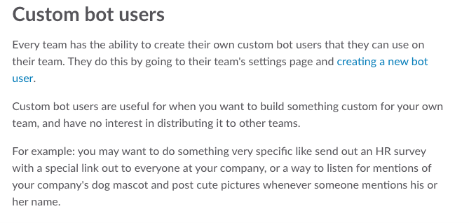

Click on “creating a new bot”

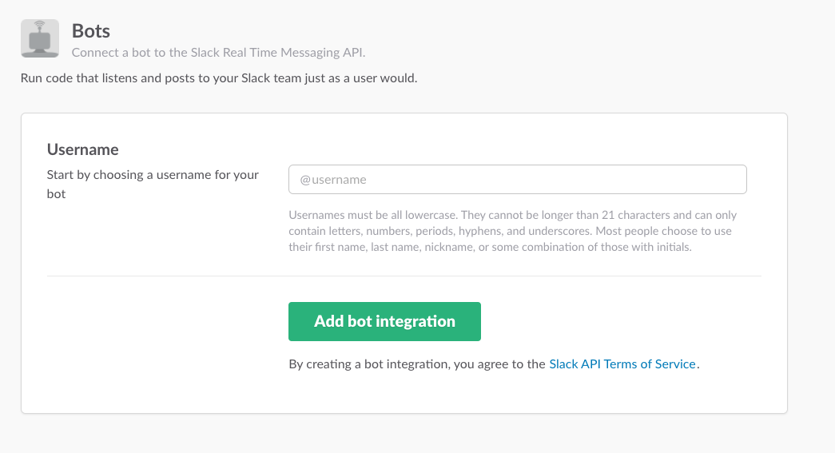

To View all the configured Bot

Click on - Manage

