H

Sean Hinchee

HW2

10/08/17

1.

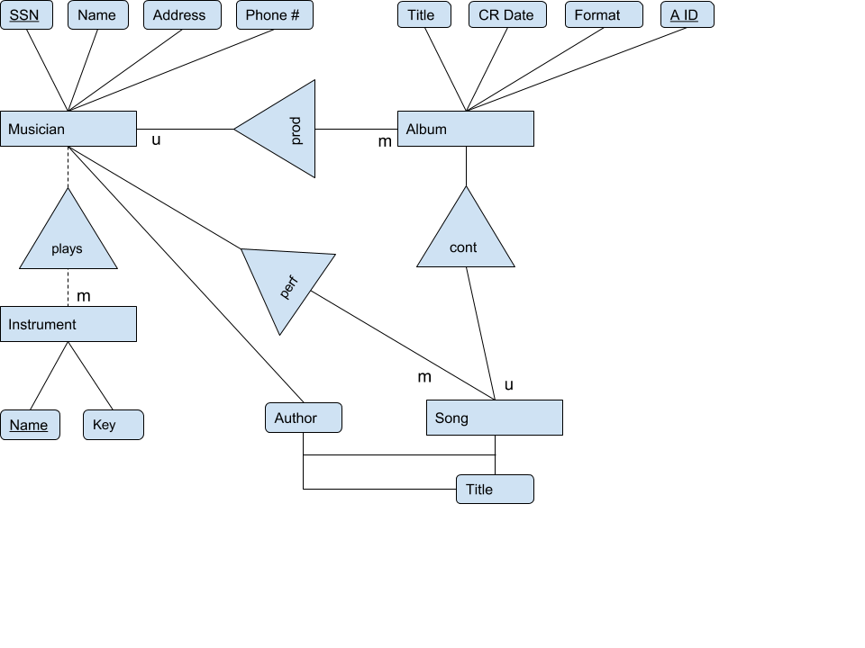

i)

It is difficult to capture the explicit one or more phrasing as well as the may appear on more than one phrasing.

ii)

I did not add any features to the diagram in my case, but I did use a angled triangle, which I felt bad about.

2.

Musician(Name, SSN, Address, Phone #, []Instruments, []Songs);

Album(Title, CR Date, Format, A ID, Producer → Musician[Name], []Songs);

Instrument(Name, Key);

Song(Title, Author, Album);

Author(Song, Title, Artist → Musician[Name]);

Note: It is difficult to signify performs, produces, and plays. These are deltas that would be reflected better in an actual language not of the query variety and reflect intended usage more than structure.