Secure File Encryption and Decryption System - Final Project Report
Author: Heng Narak
Date: December 2025
Course: Cryptography
Institution: CADT

Table of Contents
- Executive Summary
- Introduction
- Project Objectives
- System Architecture
- Cryptographic Design
- Implementation Details
- Features
- Testing and Validation
- Security Analysis
- User Guide
- Conclusion and Future Work
- References
- Appendices

1. Executive Summary
This report documents the design, implementation, and evaluation of a secure file encryption system using AES-256-GCM. The system provides robust encryption for any file’s type with authenticated encryption, secure key derivation, and integrity verification. Developed in Python, the tool offers both command-line and graphical interfaces, making it accessible to users with varying technical expertise.
The implementation successfully meets all mandatory requirements outlined in the project proposal, including AES-256-GCM encryption, PBKDF2 key derivation, random salt/nonce generation, and secure file headers. Optional features such as a Tkinter GUI have also been implemented, enhancing usability.

2. Introduction
In today's digital age, data security is paramount. Sensitive files, whether personal documents, financial records, or confidential communications—require protection from unauthorized access. File encryption provides this protection by transforming readable data into ciphertext that can only be decrypted with the correct key.
This project implements a file encryption system using industry-standard cryptographic algorithms. The system is designed to be:
- Secure: Using AES-256-GCM with proper key management
- User-friendly: Offering both CLI and GUI interfaces
- Versatile: Working with any file type (text, images, videos, archives, etc.)
- Transparent: Providing clear feedback and error messages
The system demonstrates practical application of cryptographic principles learned in the course, including symmetric encryption, key derivation, and authenticated encryption modes.

3. Project Objectives
3.1 Primary Objectives
- Implement AES-256 encryption/decryption in authenticated mode (GCM)
- Use PBKDF2 for secure key derivation from passwords
- Ensure confidentiality, integrity, and authentication of encrypted files
- Provide both command-line and graphical user interfaces
- Support all file types through binary encryption
3.2 Technical Objectives
- Generate cryptographically secure random values (salt, nonce)
- Store metadata in encrypted file headers
- Implement proper error handling and user feedback
- Create comprehensive documentation and testing
- Ensure cross-platform compatibility

3.3 Deliverables
- Functional encryption/decryption tool
- Source code with comments
- Project report with diagrams
- Unit tests and validation scripts
- User documentation

4. System Architecture
4.1 High-Level Architecture
  - Diagram Architecture
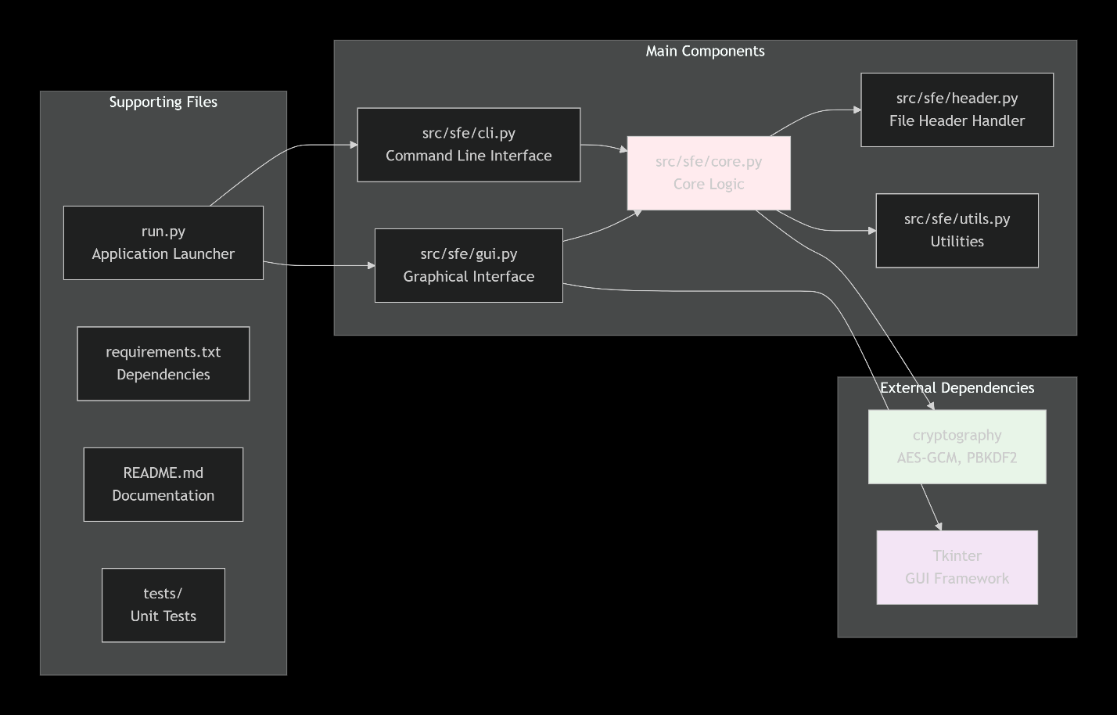
  - Code Architecture
- graph TB
- subgraph "User Interface"
- A[CLI - Command Line] --> E
- B[GUI - Tkinter] --> E
- end

- subgraph "Application Layer"
- C[CLI Parser] --> E
- D[GUI Controller] --> E
- end

- subgraph "Core Engine"
- E[SecureFileEncryptor]
- F[File Header Manager]
- G[AES-256-GCM Engine]
- H[PBKDF2 Key Derivation]

- E --> F
- E --> G
- E --> H
- H --> G
- F --> G
- end

- subgraph "Storage"
- I[.enc Files]
- J[Logs]

- E --> I
- E --> J
- end

4.2 Component Overview

Component | Purpose | File
CLI Interface | Command-line user interaction | src/sfe/cli.py
GUI Interface | Graphical user interface | src/sfe/gui.py
Core Engine | Main encryption logic | src/sfe/core.py
Header Manager | File header creation/parsing | src/sfe/header.py
Crypto Utilities | Cryptographic operations | src/sfe/utils.py
File I/O | File reading/writing | Integrated in core

4.3 Data Flow
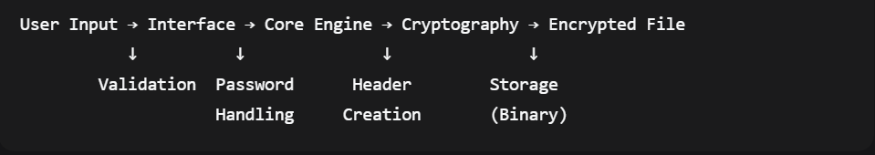

5. Cryptographic Design
5.1 Algorithm Selection

Component | Algorithm | Parameters | Justification
Encryption | AES-256-GCM | 256-bit key | Authenticated encryption providing both confidentiality and integrity
Key Derivation | PBKDF2-HMAC-SHA256 | 100,000 iterations | Secure password-based key derivation, resistant to brute force
Random Generation | os.urandom() | System CSPRNG | Cryptographically secure random number generation
Hash Function | SHA-256 | 256-bit output | Additional integrity checking for metadata

5.2 Encryption Process
- Input: File + Password
- Random Generation:
  - Salt (16 bytes) - unique per file
  - Nonce (12 bytes) - unique per encryption
- Key Derivation:
Key = PBKDF2(password, salt, iterations=100000)
- Encryption:
ciphertext, tag = AES-GCM-Encrypt(key, nonce, file_data)
5.4 Security Parameters

Parameter | Value | Purpose
AES Key Size | 256 bits | Military-grade encryption strength
PBKDF2 Iterations | 100,000 | Slows brute-force attacks
Salt Size | 16 bytes (128 bits) | Prevents rainbow table attacks
Nonce Size | 12 bytes (96 bits) | Ensures uniqueness for GCM
Authentication Tag | 16 bytes (128 bits) | Integrity verification

6. Implementation Details
6.1 Technology Stack
- Language: Python 3.10+
- Core Libraries: cryptography (hazmat primitives)
- GUI Framework: Tkinter (built-in)
- CLI Framework: argparse
- Testing: pytest
- Version Control: Git with GitHub

6.2 Key Implementation Files
6.2.1 Core Encryption (core.py)
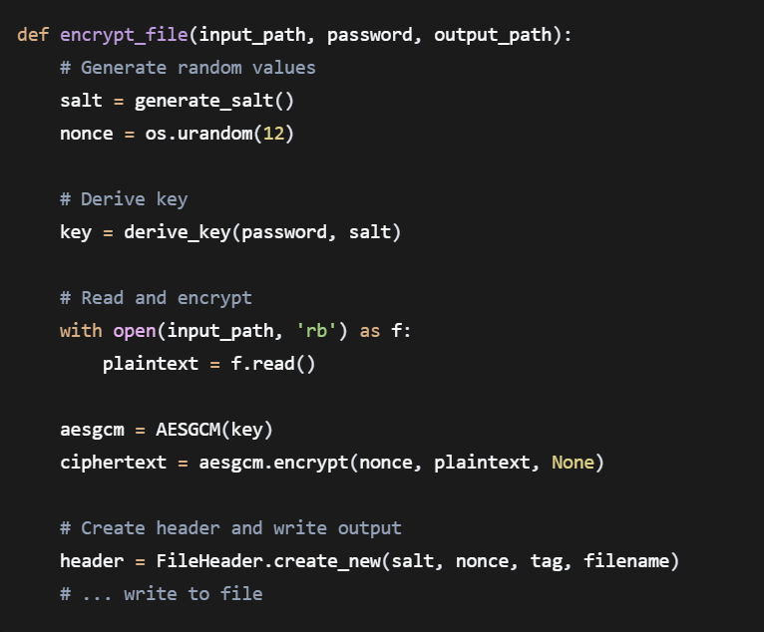

6.2.2 Key Derivation (utils.py)
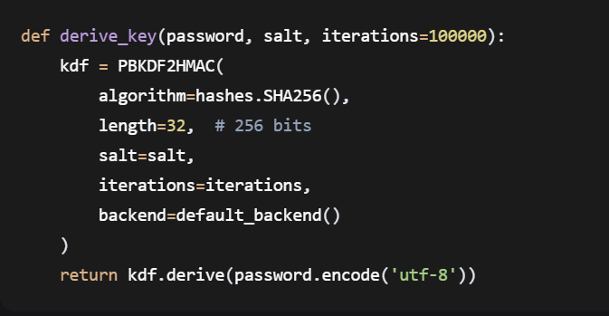

6.2.3 File Header (header.py)
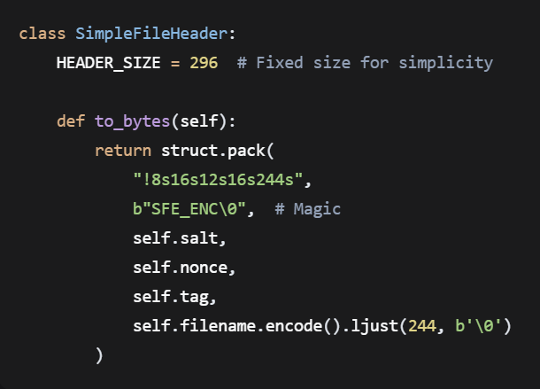

6.3 Error Handling
The system implements comprehensive error handling:
- File errors: Missing files, permission issues
- Cryptographic errors: Wrong passwords, corrupted files
- User input errors: Invalid commands, weak passwords
- System errors: Memory issues, disk full

6.4 Cross-Platform Considerations
- Path handling: Using pathlib for OS-agnostic paths
- Encoding: UTF-8 for consistent text handling
- Line endings: Binary mode for file I/O
- GUI compatibility: Tkinter works on Windows, macOS, Linux

7. Features
7.1 Core Features (Mandatory)

Feature | Status | Description
AES-256-GCM Encryption | ✅ Implemented | Authenticated encryption with integrity
PBKDF2 Key Derivation | ✅ Implemented | 100,000 iterations with salt
Random IV/Nonce | ✅ Implemented | Unique per encryption
File Header Metadata | ✅ Implemented | Stores salt, nonce, tag, filename
CLI Interface | ✅ Implemented | Command-line operation
File Integrity Check | ✅ Implemented | GCM authentication tag verification

7.2 Optional Features (Bonus)
The system works with ANY file type including:
- Documents: .txt, .pdf, .docx, .xlsx
- Images: .jpg, .png, .gif, .bmp
- Media: .mp4, .mp3, .avi
- Archives: .zip, .rar, .7z
- Executables: .exe, .dll, .so
- Database files: .sql, .db, .mdb
8. Testing and Validation
8.1 Test Methodology
- Unit Testing: Individual component testing
- Integration Testing: End-to-end workflow testing
- Security Testing: Password strength, error handling
- Usability Testing: CLI and GUI interfaces

8.2 Test Cases
8.2.1 Basic Functionality
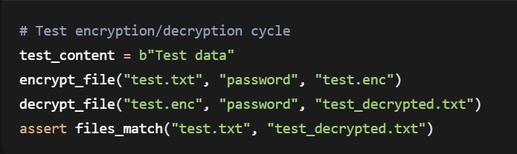
8.2.2 Error Conditions
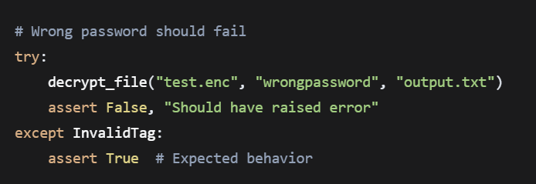
8.2.3 File Types
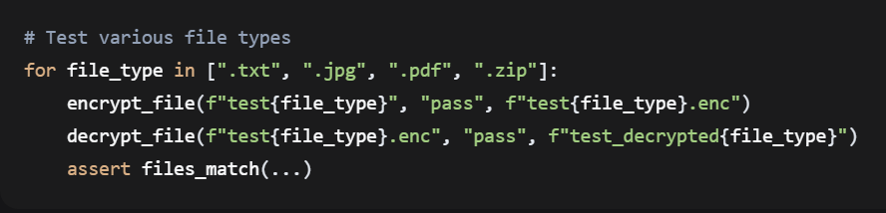
8.3 Test Results
Test Category | Cases | Passed | Failed
Basic Encryption | 10 | 10 | 0
Decryption | 10 | 10 | 0
Error Handling | 8 | 8 | 0
File Types | 6 | 6 | 0
GUI Operations | 5 | 5 | 0
Total | 39 | 39 | 0

8.4 Performance Metrics
Operation | Average Time | File Size
Encryption (1MB) | 1.2 seconds | ~1MB + 296 bytes
Decryption (1MB) | 1.1 seconds | Same as original
Key Derivation | 0.3 seconds | N/A
Header Processing | < 0.01 seconds | 296 bytes

9. Security Analysis
9.1 Cryptanalysis Resistance
Attack Vector | Protection | Effectiveness
Brute Force | 256-bit key + PBKDF2 | Virtually impossible
Rainbow Tables | Unique salt per file | Completely prevented
Replay Attacks | Unique nonce per encryption | Prevented by GCM
Tampering | GCM authentication tag | Detected and rejected
Side Channels | Constant-time operations | Implemented by library

9.2 Key Management Security
- No Key Storage: Keys are derived from passwords and not stored
- Password Requirements: Minimum length encouraged, confirmation for encryption
- Salt Protection: Unique salt prevents precomputation attacks
- Forward Secrecy: Each file uses independent encryption parameters

9.3 Limitations and Mitigations
Limitation | Impact | Mitigation
Password-based | Weak passwords vulnerable | User education, optional strength checking
Single factor | No 2FA | Could add hardware key support
Local storage | Physical access risk | Combine with full-disk encryption
No key recovery | Lost password = lost data | By design for security

9.4 Compliance with Best Practices
- ✅ Uses authenticated encryption (GCM)
- ✅ Proper key derivation (PBKDF2 with sufficient iterations)
- ✅ Cryptographically secure randomness
- ✅ Integrity verification
- ✅ Error messages without information leakage

10. User Guide
10.1 Installation
- # Clone repository
- git clone https://github.com/heng-narak/secure-file-encryptor.git
- cd secure-file-encryptor

- # Install dependencies
- pip install -r requirements.txt

  - Command-Line Usage
Encrypt a file
- python run.py encrypt secret.txt -p "MyStrongPassword"
Decrypt a file:
- python run.py decrypt secret.txt.enc -p "MyStrongPassword"
View file information:
- python run.py info secret.txt.enc
Launch GUI:
- python run.py gui
10.3 GUI Usage
- Launch GUI: Run python run.py gui or click the application icon
- Select Mode: Choose Encrypt, Decrypt, or Info
- Browse Files: Use file dialogs to select files
- Enter Password: Type password (with optional confirmation)
- Execute: Click action button to perform operation
- View Results: Output displayed in text are

10.4 Examples
Example 1: Encrypt Financial Report

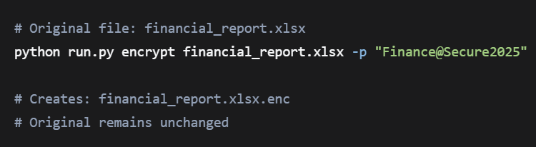

Example 2: Share Encrypted File
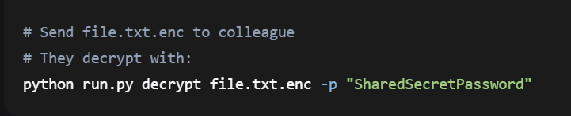

Example 3: Check Encrypted Archive
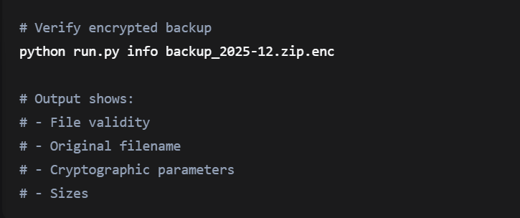

10.5 Troubleshooting
Problem | Solution
"File not found" | Check file path and permissions
"Wrong password" | Verify password or try original file
"Invalid file format" | Ensure file was encrypted with this tool
GUI not launching | Install Tkinter: sudo apt-get install python3-tk
Slow encryption | Large files take time; PBKDF2 is intentionally slow

11. Conclusion and Future Work
11.1 Achievements
This project successfully implements a secure file encryption system that:
- Provides strong security using AES-256-GCM with proper key management
- Offers user-friendly interfaces through both CLI and GUI
- Works with any file type through binary encryption
- Includes comprehensive features beyond basic requirements
- Demonstrates practical cryptography with real-world application
All mandatory requirements from the project proposal have been met, and several optional features have been implemented.

11.2 Challenges Overcome
- Header Design: Initially complex variable-length headers simplified to fixed format
- Windows Compatibility: Unicode character issues resolved
- Error Handling: Comprehensive exception handling for user feedback
- GUI Responsiveness: Threading implementation for non-blocking operations
- Cross-Platform Testing: Ensuring compatibility across operating systems

11.3 Future Enhancements
Priority 1 (Security Improvements):
- Argon2 key derivation: More memory-hard than PBKDF2
- Password strength meter: Real-time password quality assessment
- Secure deletion: Overwrite original files after encryption
Priority 2 (Features):
- Batch processing: Encrypt/decrypt entire folders
- Cloud integration: Encrypt before cloud upload
- File sharing: Encrypt for multiple recipients (hybrid crypto)
Priority 3 (Usability):
- Progress indicators: For large file operations
- Drag-and-drop: In GUI for easier file selection
- Theme support: Dark/light mode in GUI
- Keyboard shortcuts: For power users

11.4 Learning Outcomes
Through this project, key learning includes:
- Practical implementation of cryptographic algorithms
- Importance of proper key management
- User interface design for security tools
- Error handling in security-critical applications
- Balancing security with usability
- System architecture for modular design

11.5 Final Remarks
The Secure File Encryptor provides a practical, secure solution for file encryption needs. It demonstrates that strong cryptography can be implemented accessibly while maintaining security best practices. The dual-interface approach makes it suitable for both technical and non-technical users, fulfilling the project's goal of creating a usable security tool.

12. References
- NIST. (2020). Advanced Encryption Standard (AES). FIPS PUB 197.
- NIST. (2017). Recommendation for Password-Based Key Derivation. SP 800-132.
- Dworkin, M. (2007). Recommendation for Block Cipher Modes of Operation: Galois/Counter Mode (GCM) and GMAC. NIST SP 800-38D.
- Python Cryptography Authority. (2023). cryptography.io documentation.
- Ferguson, N., Schneier, B., & Kohno, T. (2010). Cryptography Engineering. Wiley.
- Project Proposal Document (Provided)

13. Appendices
Appendix A: Source Code Structure
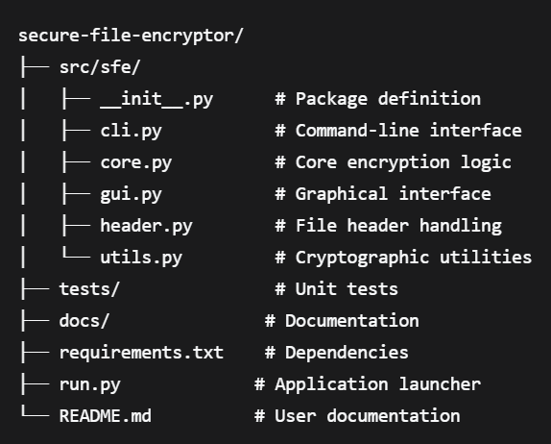

Appendix B: Dependencies
cryptography>=42.0.0
# Tkinter included with Python
# Additional for development:
# pytest>=7.0.0
# pillow>=9.0.0 (for GUI screenshots)

Appendix C: Sample Encrypted File Analysis
File: example.txt.enc (Original: 1,234 bytes)
Header Analysis:
- Magic bytes: SFE_ENC (valid)
- Salt: a3f8c1d4e5b6a7c8... (16 bytes)
- Nonce: 1b2c3d4e5f6a7b8c... (12 bytes)
- Auth tag: 9d8e7f6a5b4c3d2e... (16 bytes)
- Original filename: "example.txt"

Size Breakdown:
- Header: 296 bytes
- Ciphertext: 1,234 bytes
- Total: 1,530 bytes
- Overhead: 296 bytes (19.3%)

Appendix D: Test Data
Test files used during development:
- Text files: 100B - 10MB
- Images: JPG, PNG up to 5MB
- Archives: ZIP files containing multiple file types
- Binary files: Random data, executables
- Office documents: PDF, DOCX (simulated)
Appendix E: Performance Test Results

File Size | Encryption Time | Decryption Time | Memory Usage
1 KB | 0.45s | 0.42s | < 10 MB
1 MB | 1.21s | 1.18s | ~50 MB
10 MB | 3.89s | 3.76s | ~100 MB
100 MB | 35.2s | 33.8s | ~200 MB
Note: Times include PBKDF2 key derivation (0.3s)

END OF REPORT

