实 验 报 告（二）
实验名称 | 从NFA到DFA的转化 |  |  | 专 业 | 计算机科学与技术
课程名称 | 编译原理 | 指导老师 | 赵智超 | 班 级 | 三
姓 名 | 孔伟恒 | 学 号 | 18100140316 | 评 分
实验地点 | 1C06217 | 实验日期 | 2019/10/17 | 评 分
一、实验目的
- 了解NFA和DFA的概念
- NFA和DFA之间的联系
- 从NFA到DFA的转化程序编写
二、实验内容（含实验原理介绍）
1.NFA
NFA(nondeterministic finite-state automata)即非确定有限自动机, 一个非确定的有限自动机NFA M’是一个五元式:
NFA M’=(S, Σ∪{ε}, δ, S0, F)
其中 S—有限状态集
Σ∪{ε}—输入符号加上ε,即自动机的每个结点所射出的弧可以是Σ中一个字符或是ε.
S0—初态集 F—终态集
δ—转换函数 S×Σ ∪{ε} →2S
(2S --S的幂集—S的子集构成的集合）
2.DFA
DFA(deterministic finite-state automata)即确定有限自动机，一个确定的有限自动机DFA M是一个五元式:
M=(S, Σ，δ, S0, Z)
其中:
S —有限状态集
Σ —输入字母表
δ —映射函数(也称状态转换函数)
S×Σ→S
δ(s,a)=S’ , S, S’ ∈S, a∈Σ
S0 —初始状态 S0 ∈S
Z—终止状态集 Z⊆S
3. NFA和DFA之间的联系
在非确定的有限自动机NFA中,由于某些状态的转移需从若干个可能的后续状态中进行选择，故一个NFA对符号串的识别就必然是一个试探的过程。这种不确定性给识别过程带来的反复，无疑会影响到FA的工作效率。而DFA则是确定的,将NFA转化为DFA将大大提高工作效率,因此将NFA转化为DFA是有其一定必要的。

三、实验过程及步骤（包含使用软件或实验设备等情况）
#include <iostream>
#include <algorithm>
#include <cstring>
#include <cstdlib>
#include <vector>
#include <set>
using namespace std;

const int MAX = 100;

struct edge {
char preNode;
char nextNode;
char tchar;
};

struct newJ {
string setJ;
};

struct relation {
newJ* preJ;
char jchar;
newJ* nextJ;
};

void getEClosure (const edge *e, int cntEdge, newJ *st) {
for (int i = 0; i < st -> setJ.length (); i++) {
for (int j = 0; j < cntEdge; j++) {
if (e[j].preNode == st -> setJ[i] && e[j].tchar == '0') {
st -> setJ += e[j].nextNode;
}
}
}
}

void move (char ttchar, edge *e, int cntEdge, newJ *source, newJ *dest) {
for (int i = 0; i < source -> setJ.length (); i++) {
for (int j = 0; j < cntEdge; j++) {
if (e[j].preNode == source -> setJ[i] && e[j].tchar == ttchar) {
dest -> setJ += e[j].nextNode;
}
}
}
}

bool isInsert (vector <newJ*> allSet, newJ *newSet) {
bool b = true;
for (int k = 0; k < allSet.size (); k++) {
if (allSet.at (k) -> setJ == newSet -> setJ) {
b = false;
}
}
return b;
}

bool isInsertForRel (vector <relation*>relVec, newJ* preJ, char jchar, newJ* nextJ) {
bool isIn = true;
for (int i = 0; i < relVec.size (); i++) {
if (relVec.at(i) -> preJ -> setJ == preJ -> setJ && relVec.at (i) -> nextJ -> setJ == nextJ -> setJ && relVec.at (i) -> jchar == jchar) {
isIn = false;
}
}
return isIn;
}

void uniqueChars (char *arr, int n, char *outs) {
memset (outs, 0, sizeof (char) *n);
char first = arr[0];
for (int i = 0; i < n; i++) {
outs[arr[i] - first] = arr[i];
}
}

void changeName (vector <newJ*>allSet, newJ *tJ, string& newStr) {
newJ *tmpJ = new newJ();
for (int i = 0; i < allSet.size (); i++) {
if (tJ -> setJ == allSet.at(i) -> setJ) {
tmpJ -> setJ = 'A' + i;
}
}
newStr = tmpJ -> setJ;
}

int main () {
edge* e = new edge[MAX];
int cntEdge = 0;
char staNode;
string endNode;
string Node;

cout << "请输入NFA的总状态数：" << endl;
int m;
char a[15];
cin >> m;
cout << "请依次输入NFA的状态名称：" << endl;
for (int i = 0; i < m; i++) {
cin >> a[i];
}

int cntRealEdge[MAX] = {0};
int n;
cout << "请输入NFA的边数：";
cin >> n;
cout << n << endl;
cout << "请分别输入 起始状态，接受状态 和 到达状态：<同组数据请依次用空格隔开>" << endl;
cout<< "如果转换字符为空， 则用 '0' 表示" << endl;
for (int i = 0; i < MAX; i++) {
cin >> e[i].preNode;
if ((e[i].preNode) == '$') break;
cin >> e[i].tchar >> e[i].nextNode;
if (e[i].tchar == '0') cntRealEdge[cntEdge] = 1;
cntEdge++;
}

for (int i = 0; i < cntEdge; i++) {
char preTmp = e[i].preNode;
char nextTmp = e[i].nextNode;
if (Node.find (preTmp) > Node.length ()) {
Node += preTmp;
}
if (Node.find (nextTmp) > Node.length ()) {
Node += nextTmp;
}
}
cout << "输入初始点字符" << endl;
cin >> staNode;
while (Node.find (staNode) == string :: npos) {
cout << "初始化状态输入错误" << endl;
cin >> staNode;
}
cout << "输入终点字符 (若有多个终结状态，直接写成字符串形式)" << endl;
cin >> endNode;
bool inputStatus = true;
while (inputStatus) {
for (int i = 0; i < endNode.length (); i++) {
if (Node.find (endNode[i]) == string :: npos) {
cout << "终结状态输入错误" << endl;
cout << "请重新输入:" << endl;
cin >> endNode;
}
}
inputStatus = false;
}
newJ *newSet = new newJ ();
newSet -> setJ = staNode;
getEClosure (e, cntEdge, newSet);
vector <newJ*>allSet (1, newSet);
vector <newJ*> :: iterator iter;
int sizeOfStrVec = 1;

vector <newJ*>strVec (1, newSet);
vector <relation*>relVec;
while (sizeOfStrVec) {
int oldAllSet = allSet.size();
for (int j = 0; j < sizeOfStrVec; j++) {
for (int i = 0; i < cntEdge; i++) {
newJ *dest = new newJ();
if (!cntRealEdge[i]) {
move (e[i].tchar, e, cntEdge, strVec.at(j), dest);

getEClosure (e, cntEdge, dest);
if (isInsert (allSet, dest) && dest -> setJ != "") {
allSet.push_back (dest);
}

if (dest -> setJ != "") {
relation* relDest = new relation ();
relDest -> preJ = strVec.at(j);
relDest -> jchar = e[i].tchar;
relDest -> nextJ = dest;
bool isIn = isInsertForRel (relVec, relDest -> preJ, relDest -> jchar, relDest -> nextJ);
if (isIn) {
relVec.push_back (relDest);
}
}
}
}
}
strVec.clear();
int newAllSet = allSet.size();
for (int i = oldAllSet; i < allSet.size(); i++) {
newJ *dest = new newJ ();
dest = allSet.at(i);
strVec.push_back (dest);
}

sizeOfStrVec = strVec.size(); //239
}
char upperChars[26];
memset (upperChars, 0, sizeof (char) * 26);
cout << "状态转换为: " << endl;
for (int i = 0; i < allSet.size(); i++) {
upperChars[i] = 'A' + i;
cout << upperChars[i] << ":" << allSet.at(i) -> setJ << endl;
}

vector <relation*> newRelVec;
for (int i = 0; i < relVec.size(); i++) {
relation* newRel = new relation ();
string preNew, nextNew;
changeName (allSet, relVec.at(i) -> preJ, preNew);
changeName (allSet, relVec.at(i) -> nextJ, nextNew);
newJ* tpreJ = new newJ (); //266
newJ* tnextJ = new newJ ();
newRel -> preJ = tpreJ;
newRel -> nextJ = tnextJ;
newRel -> preJ -> setJ = preNew;
newRel -> nextJ -> setJ = nextNew;
newRel -> jchar = relVec.at (i) -> jchar;
newRelVec.push_back (newRel);
}
cout << "转化后的DFA为：" << endl;
vector <relation *> :: iterator newRelIter;
for (newRelIter = newRelVec.begin (); newRelIter != newRelVec.end(); newRelIter++) {
cout << '\n' << (*newRelIter) -> preJ -> setJ << " " << (*newRelIter) -> jchar << " " << (*newRelIter) -> nextJ -> setJ << endl; //278
}

return 0;
}
四、实验结果（含算法说明、程序、数据记录及分析等，可附页）

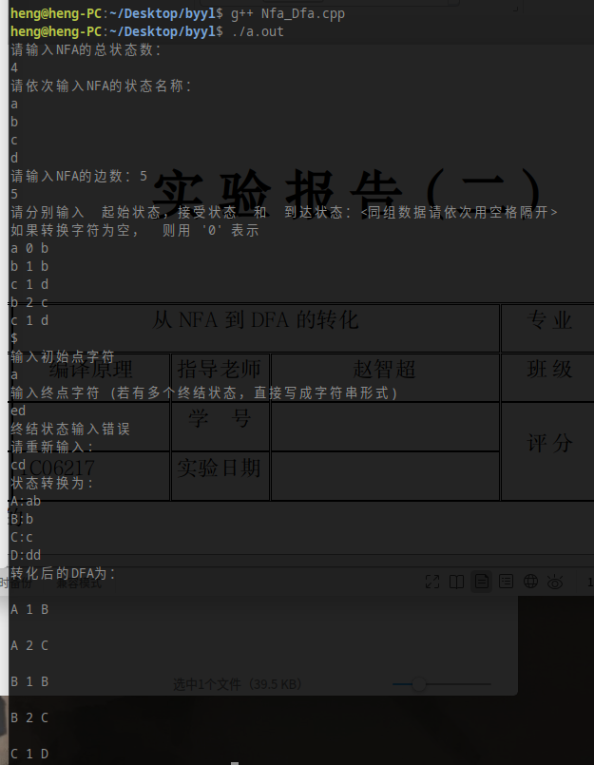

五、实验思考题
１、NFA和DFA有什么区别？

２、在实验过程中遇到了什么问题，是怎么解决的？

六、实验总结（含实验心得体会，收获与不足等）

注：双面打印

