**Introduction to Algorithm**

**Exercise #3**

1. Environment
   1. How to run your program

OS: Windows

Compiler Version: g++

IDE: visual studio 2019

1. Results
2. Method or Solutions

**Header file:**

Using the header file.

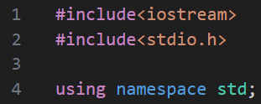

**Global Variable Declarations:**

* Profit: To store profit tables.
* Sum: Calculating temporary total profits for different course combinations with number of days.
* score: Stores the maximum profit for a given number of days.

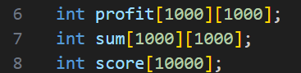

**‘dp’ Function:**

* initializes the score array. Then, it calculates the maximum profit when only the first stage courses are considered.
* Computing the maximum profit for each new stage of courses, considering the previous stages.
* Traversing the sum array and updating the score array to reflect the maximum profit.
* The function returns the maximum profit for the given number of days.

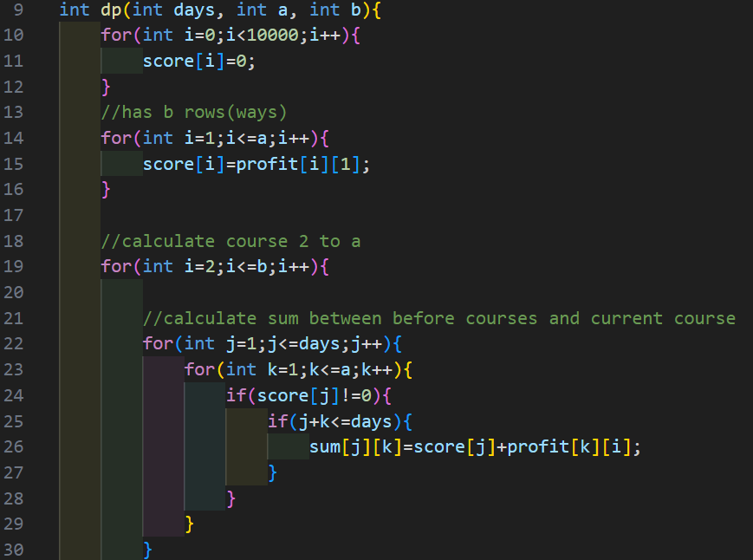

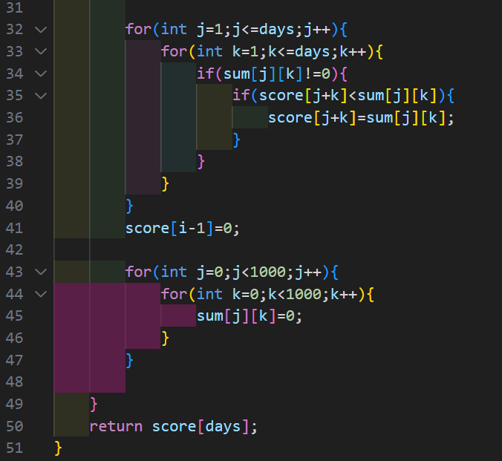

**‘main’ Function:**

* Reads the number of sets of profit tables.
* For each profit table, it reads its dimensions (a and b), and then populates the profit array.
* Reads the number of query.
* For each query, it reads the number of days to be queried and calls the calculate function to find out the maximum profit, and outputs the result.

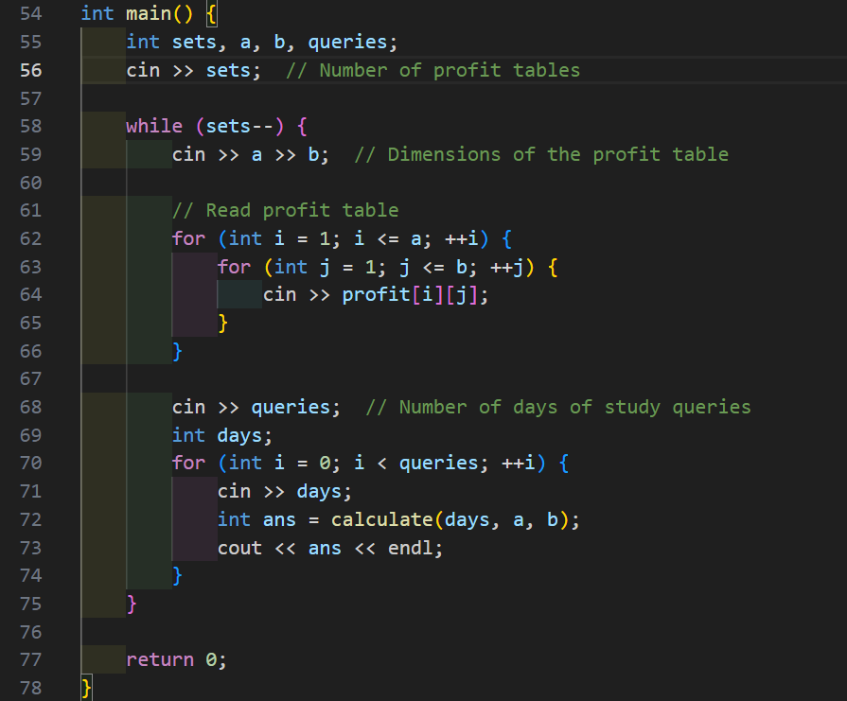

1. Anything you want to share

In this exercise, I practiced the dynamic programming to solve the problem. In this way, I combine this knowledge of the algorithm that professor teaches in class with the C++ programming. As a result, this is a treasured opportunity to learn the algorithm by hand.