Crime Trends and Socioeconomic Differences Across U.S. States

Prepared for: | Anya Mendenhall
Prepared by: | Luca Guerra
 | Armin Soroosh
 | Heng-Jui Chu
 | Alex Biuckians

March 20, 2026

Table of Contents

Introduction and Background 2
Research Questions 3
Datasets 4
Data Story and Visualizations 5
Q1: National Crime Trend Over Time (1979 - 2019) 5
Q2: Average Crime Rate by State (1979 - 2019) 6
Q3: Crime Composition by State – Top 10 (2005 - 2015) 7
Q4: Unemployment vs. Crime Rate (2005 - 2015) 9
Q5: GDP per Capita vs. Crime Rate (2005 - 2015) 10
Q6: Median Age vs. Crime Rate - Top 10 (2005 - 2015) 11
Q7: Median Age vs. Crime Rate - Bottom 10 (2005 - 2015) 12
Tableau Dashboard 13
Summary and Conclusions 14
Limitations 15
References 15
Contribution 16

Introduction and Background

Over the past four decades, the United States has experienced a dramatic shift in its criminal landscape, most notably the "Great Crime Decline" that began in the early 1990s and continued through the 2010s. While national aggregates suggest a general trend toward safety, these figures often ignore significant regional variations. According to Steven Levitt (2004, understanding these trends requires looking beyond simple policing strategies to investigate a combination of demographic shifts, economic conditions, and changes in the illegal drug markets.
Motivation and Project Goal: The motivation for this project stems from the need to understand crime not as an isolated phenomenon, but as a byproduct of environmental and economic "shocks." Economic theory suggests that individuals weigh the benefits of criminal activity against the potential costs and legal alternatives. Specifically, Becker’s (1968) economic model of crime posits that when legitimate employment opportunities diminish, or economic productivity (GDP) falters, the relative incentive for property crimes like larceny increases. Furthermore, criminologists have long identified an "age-crime curve," where criminal involvement peaks in late adolescence and decreases as populations mature (Hirschi & Gottfredson, 1983).
This project seeks to visualize these theoretical relationships using empirical data. By integrating a longitudinal FBI dataset (1979–2019) with state-level socioeconomic indicators (2005–2015), we aim to explore how Unemployment, GDP per Capita, and Median Age relate to the crime rates observed across different U.S. states. Through this data-driven approach, we provide a comprehensive look at how the "wealth of a state" and the "age of its people" may serve as predictors for its safety.

Research Questions
- National Crime Trend Over Time (1979 - 2019) (Line Chart)
To understand how crime has changed over time.
- Average Crime Rate by State (1979 - 2019) (Map)
To find out whether crime levels vary across locations.
- Crime Composition - Top 10 States (Bar Chart)
To find out which types of crime contribute most to high crime states.
- Unemployment vs. Crime Rate (Scatter Plot)
To find out whether economic difficulties are related to crime.
- GDP per Capita vs. Crime Rate (Scatter Plot)
To find out whether wealthier states tend to have lower crime levels.
- Median Age vs. Crime Rate - Top 10 (Table)
To investigate whether younger populations are associated with higher crime rates.
- Median Age vs. Crime Rate - Bottom 10 (Table)
To further examine demographic differences.

Datasets
Dataset A - estimated_crimes_1979_2019
The primary dataset is “US Estimated Crimes (1979 - 2019)”, obtained from Kaggle.
Link: https://www.kaggle.com/datasets/tunguz/us-estimated-crimes
The data were collected by the Federal Bureau of Investigation (FBI). The dataset was created to monitor national crime patterns and support law enforcement analysis and public policy decisions.
Variables Description
Original variables
- State: U.S. state
- Year: year of the observation
- Population: state population
Derived variables
A pivot transformation was performed in Tableau Prep to restructure crime categories.
This created two new variables:
- Crime_type: type of crime
- Crime_count: number of crimes
Each row now represents one crime type in one state in one year, following the tidy data principle.
A standardized crime rate variable was also created:
- Crime_rate: crime_rate = (crime_count / population) × 100,000
This standardizes crime counts per 100,000 people to allow comparisons across states.
Dataset Size
- 2,116 rows, 13columns
Time Coverage
- 1979 - 2019
Geographic Coverage
- All U.S. states

Dataset B - Annual state-level income of USA
The second dataset is “Annual state-level income of USA”, obtained from Kaggle.
Link: https://www.kaggle.com/datasets/karicare/annual-statelevel-income-of-usa
The dataset was collected by Karicare and contains state-level socioeconomic indicators such as income and employment. It provides additional economic context for the analysis.
Variables Description
- GDP per capita: economic output per person
- Unemployment rate: unemployment percentage
Dataset Size
- 550 rows, 14 columns
Time Coverage
- 2005 - 2015
Geographic Coverage
- All U.S. states

Data Integration
The two datasets are connected in Tableau using a relationship join based on State and Year.

Data Story and Visualizations

Q1: National Crime Trend Over Time (1979 - 2019)
To understand how crime has evolved over time.
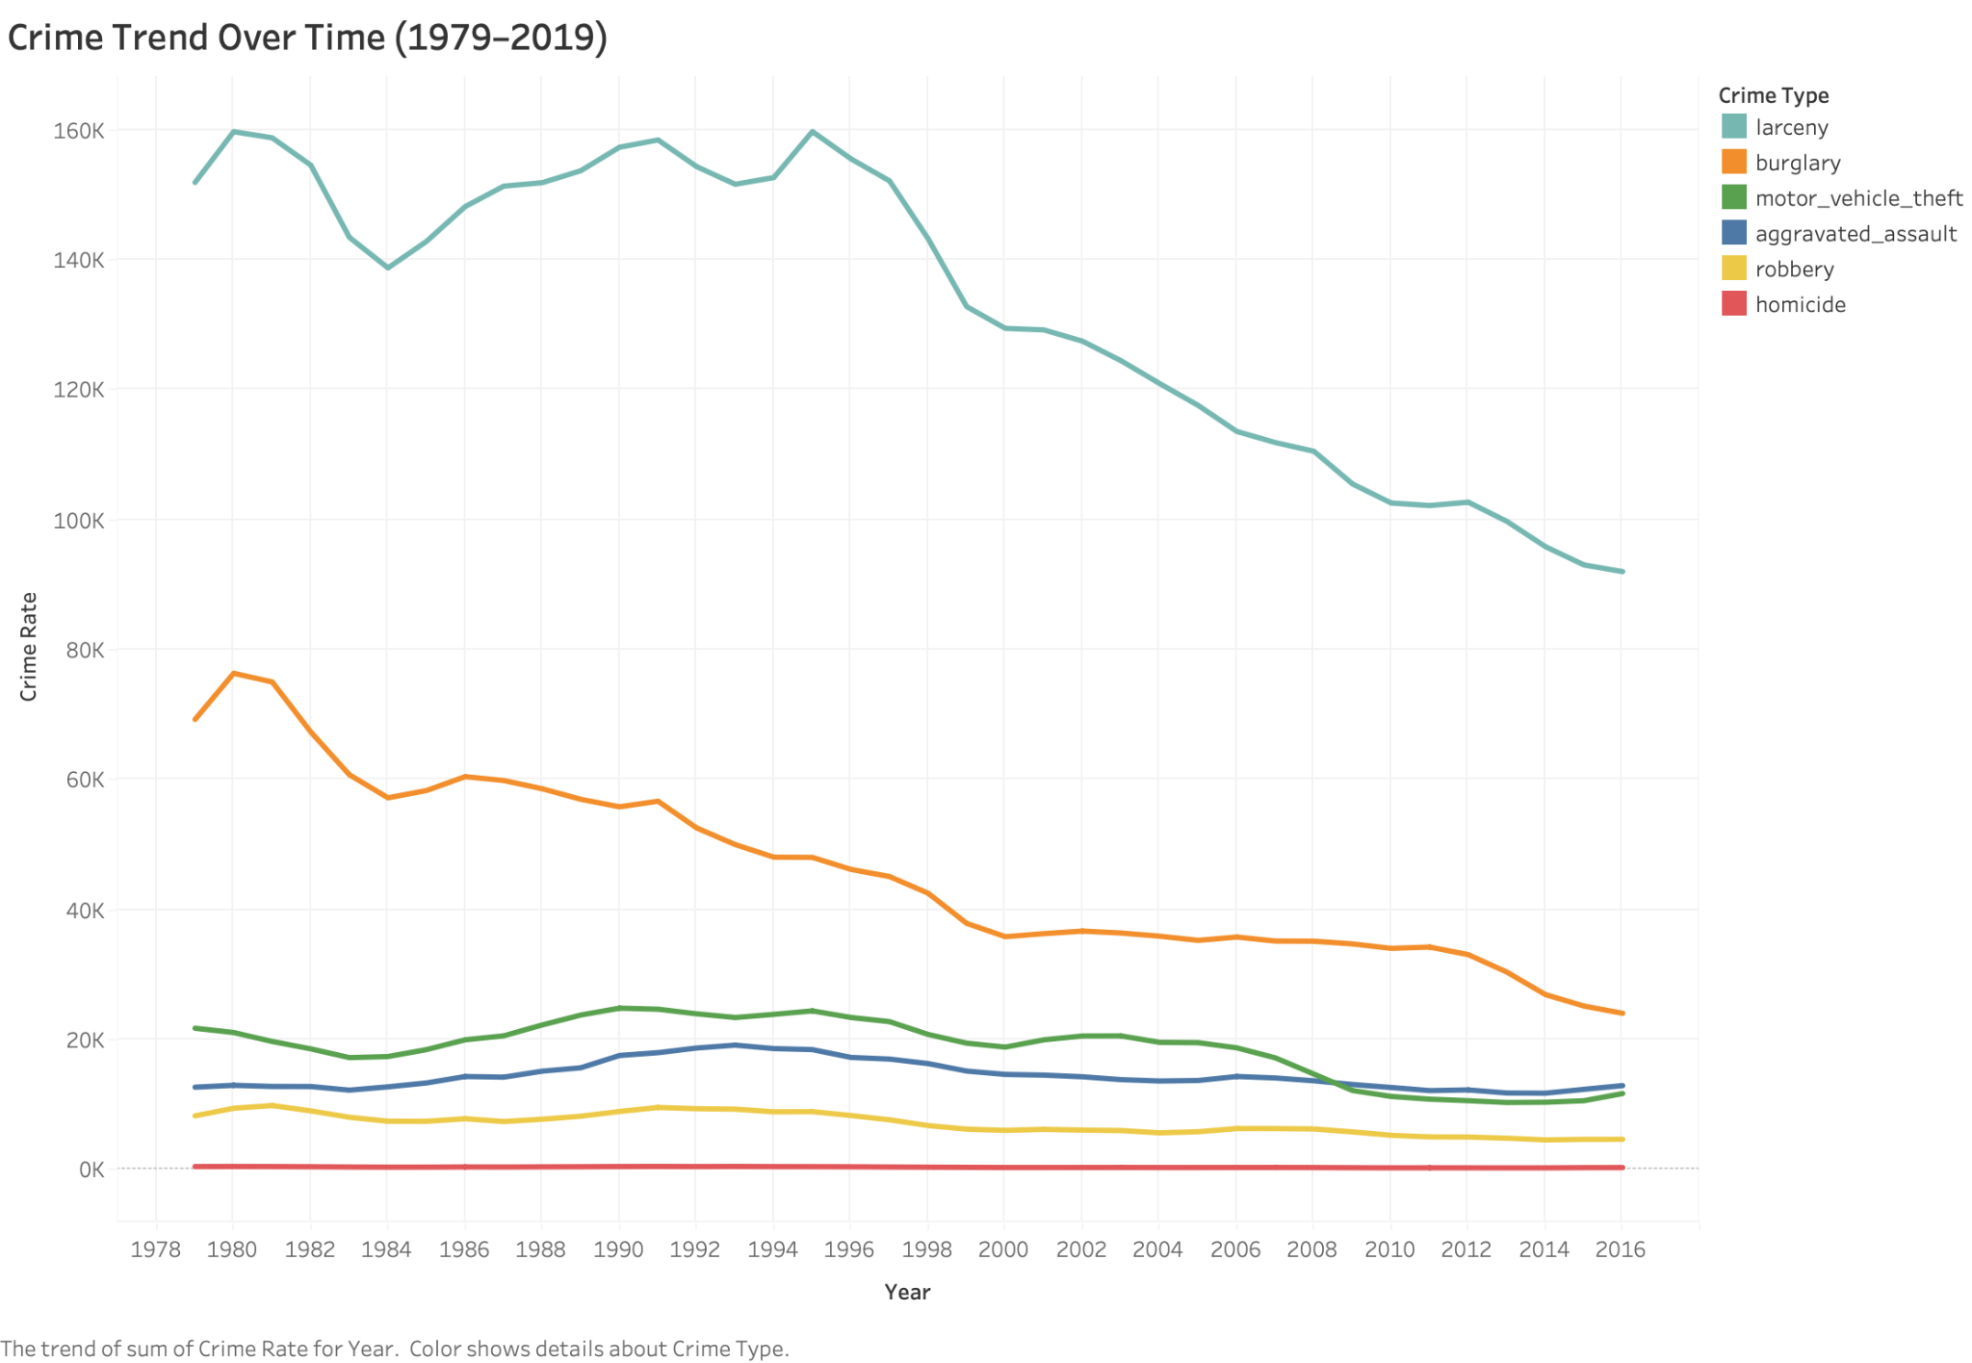
This line chart uses Year as the column variable and Crime Rate as the row variable. Different crime categories are distinguished by Crime Type, which is encoded by color. Across the entire period, larceny consistently has the highest crime rate, while homicide remains the lowest. Overall, most crime categories show a gradual decline over time.
While this chart shows how crime has changed over time nationally, it does not reveal how crime varies geographically across states.

Q2: Average Crime Rate by State (1979 - 2019)
After examining the national trend, the analysis shifts to geographic patterns to find out whether crime rates vary across states. 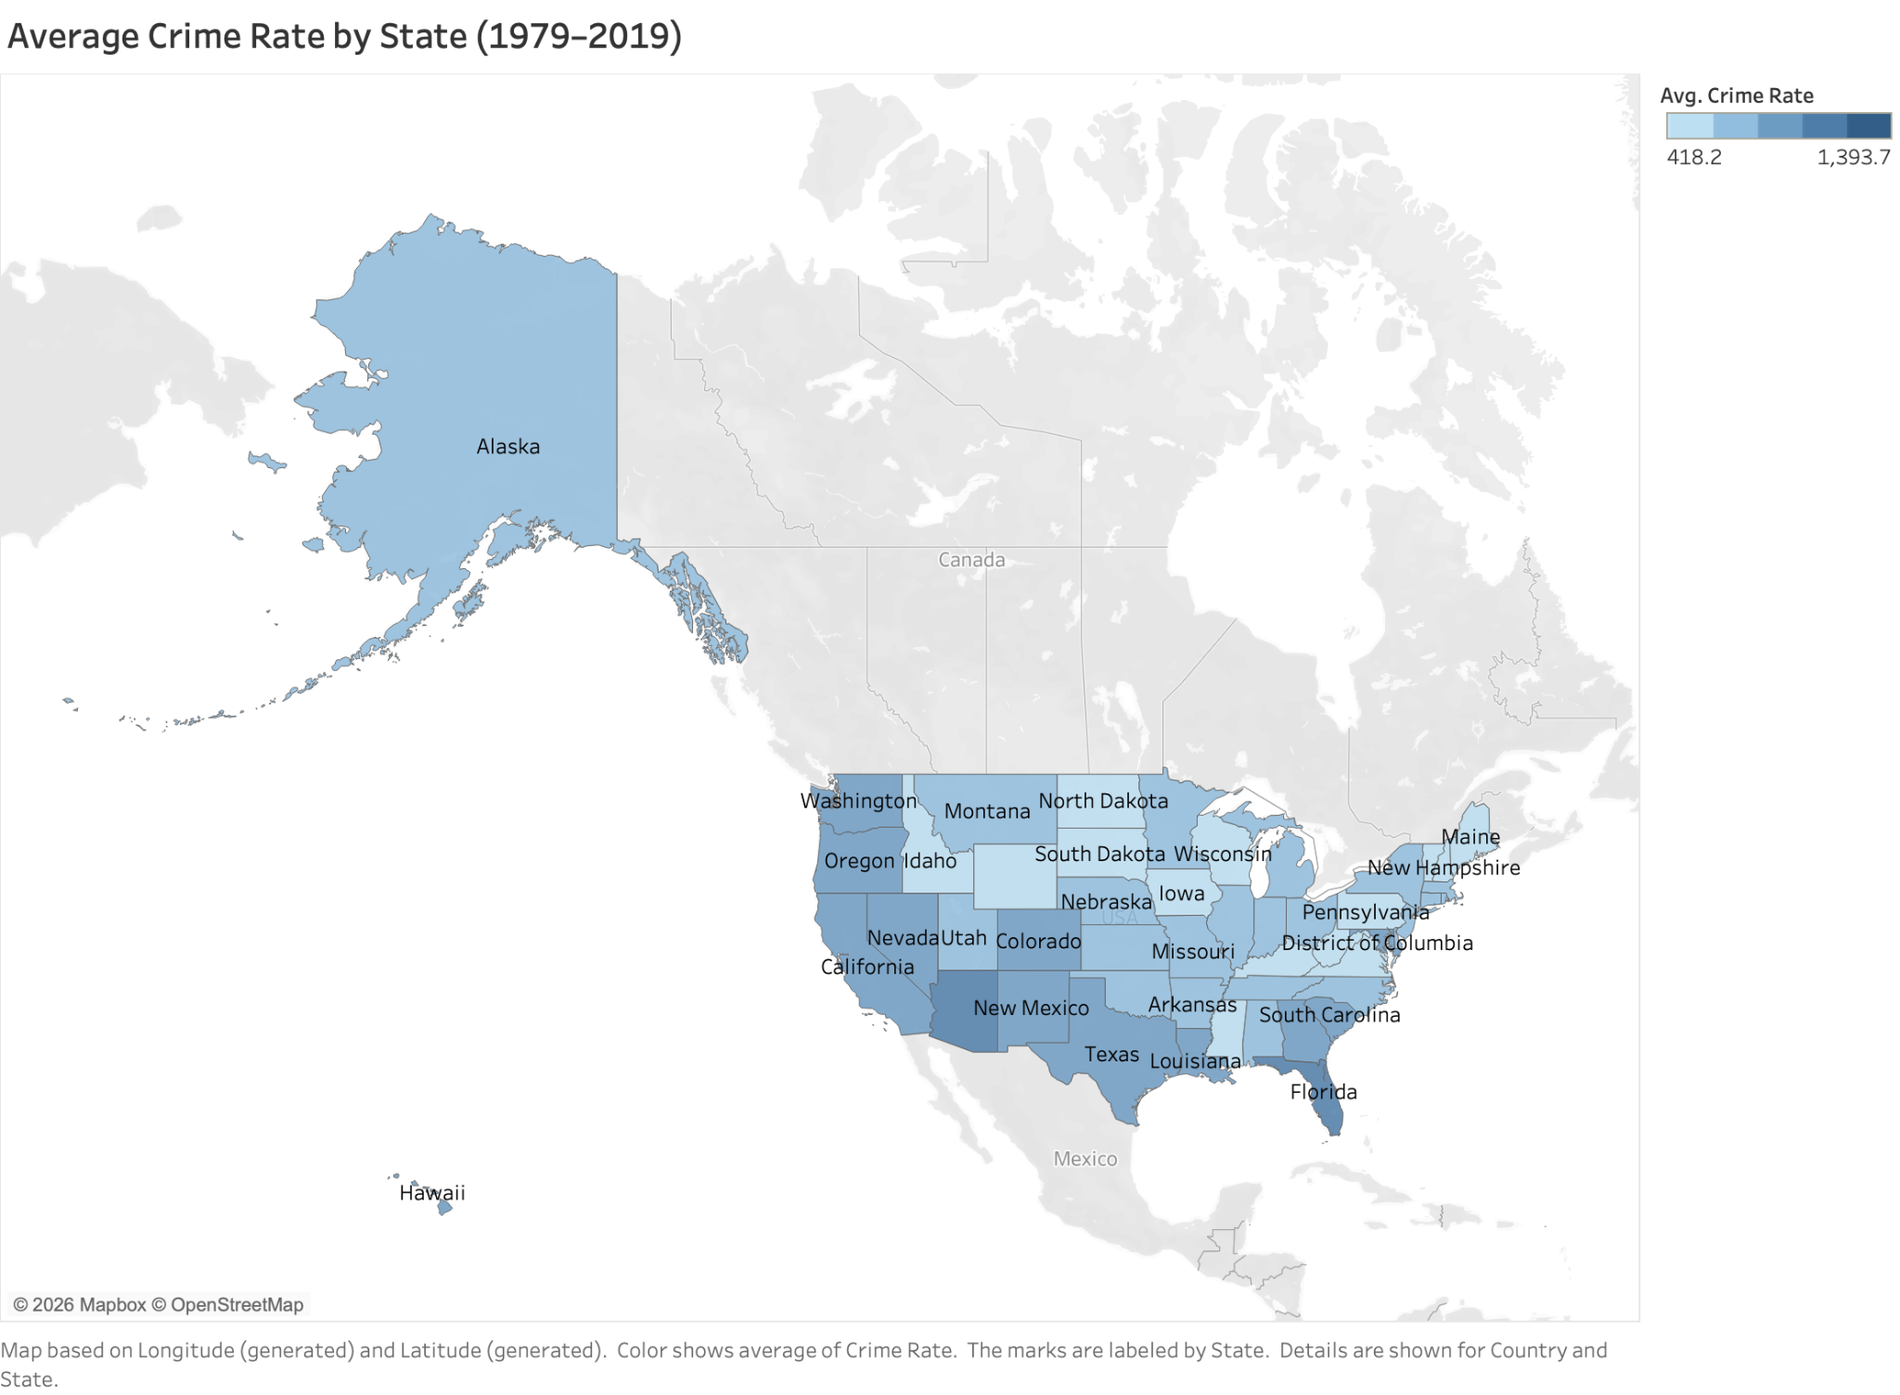
This map uses Crime Rate as the color encoding to represent the average crime rate across states from 1979 to 2019. The state is used as the geographic dimension and label.
The visualization reveals geographic variation in crime levels, with Florida and Arizona showing relatively higher crime rates, while many Northeastern states exhibit lower crime rates.

Q3: Crime Composition by State – Top 10 (2005 - 2015)
After examining the geographic patterns, the analysis shifts to understand what drives high crime levels.
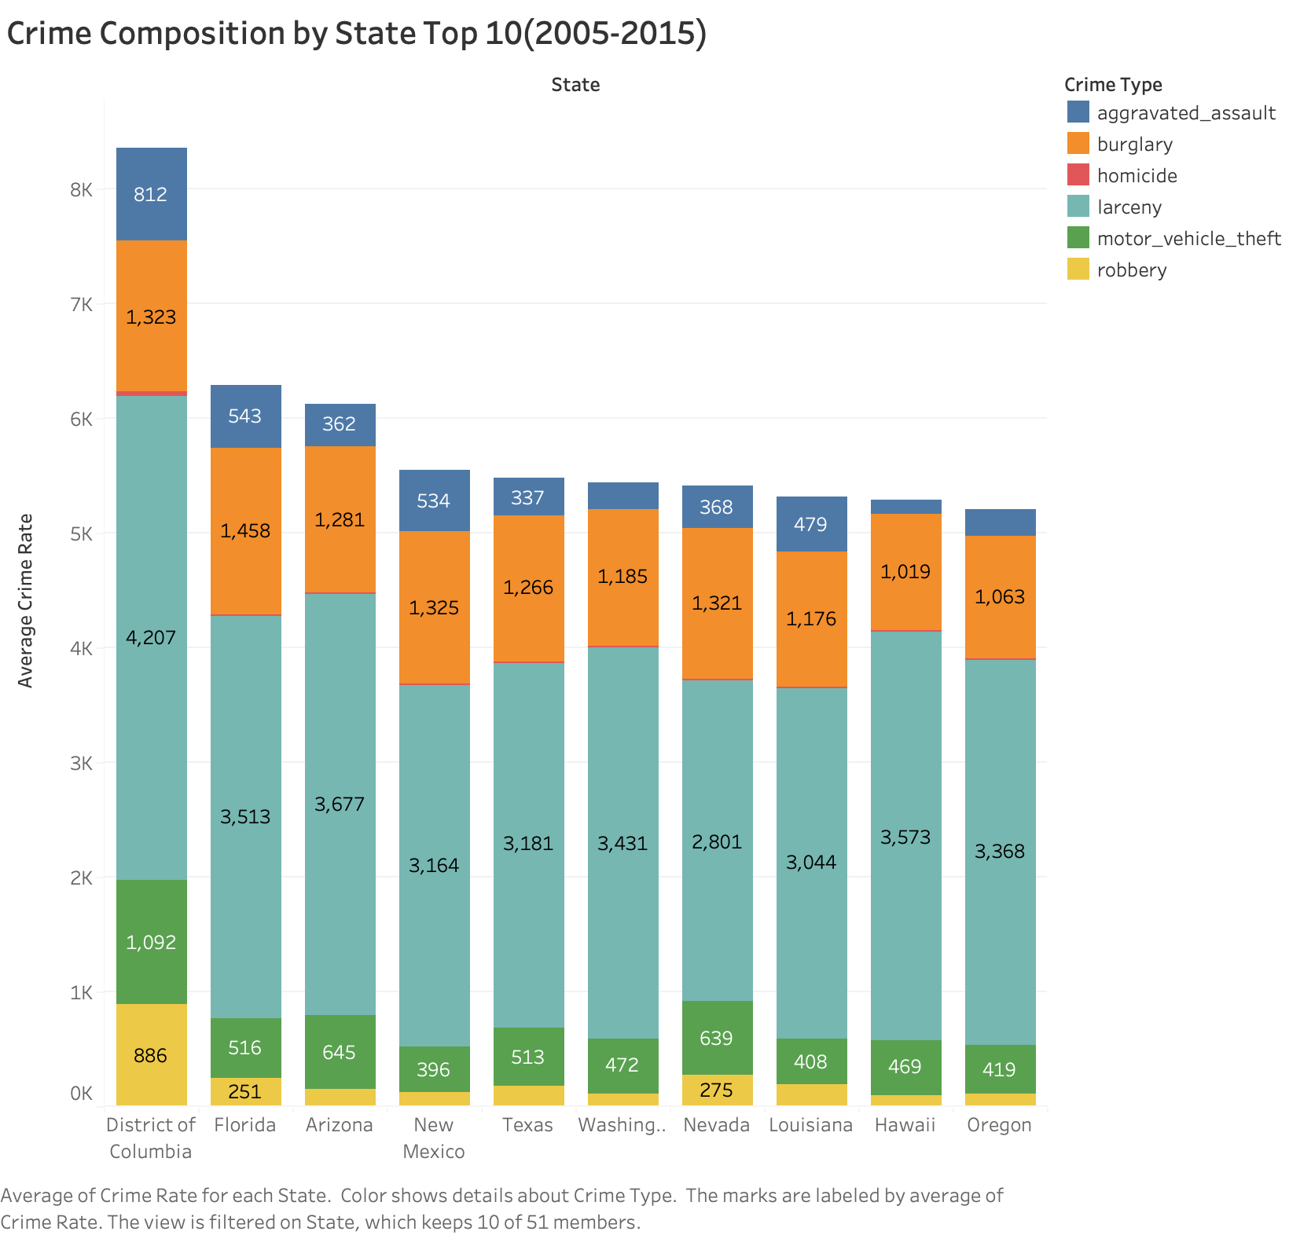
This bar chart shows the crime composition for the ten states with the highest average crime rates between 2005 and 2015. State is used as the column variable, while Crime Rate is used as the row variable. Different crime categories are represented by Crime Type, which is encoded by color.
The chart shows that the crime composition is relatively similar across these high-crime states. In most states, larceny accounts for the largest share of crime, while homicide consistently represents the smallest portion. This pattern is consistent with the overall trend observed in Figure 1.
​

Q4: Unemployment vs. Crime Rate (2005 - 2015)
After examining the crime composition, the analysis shifts to explore whether economic hardship contributes to crime.
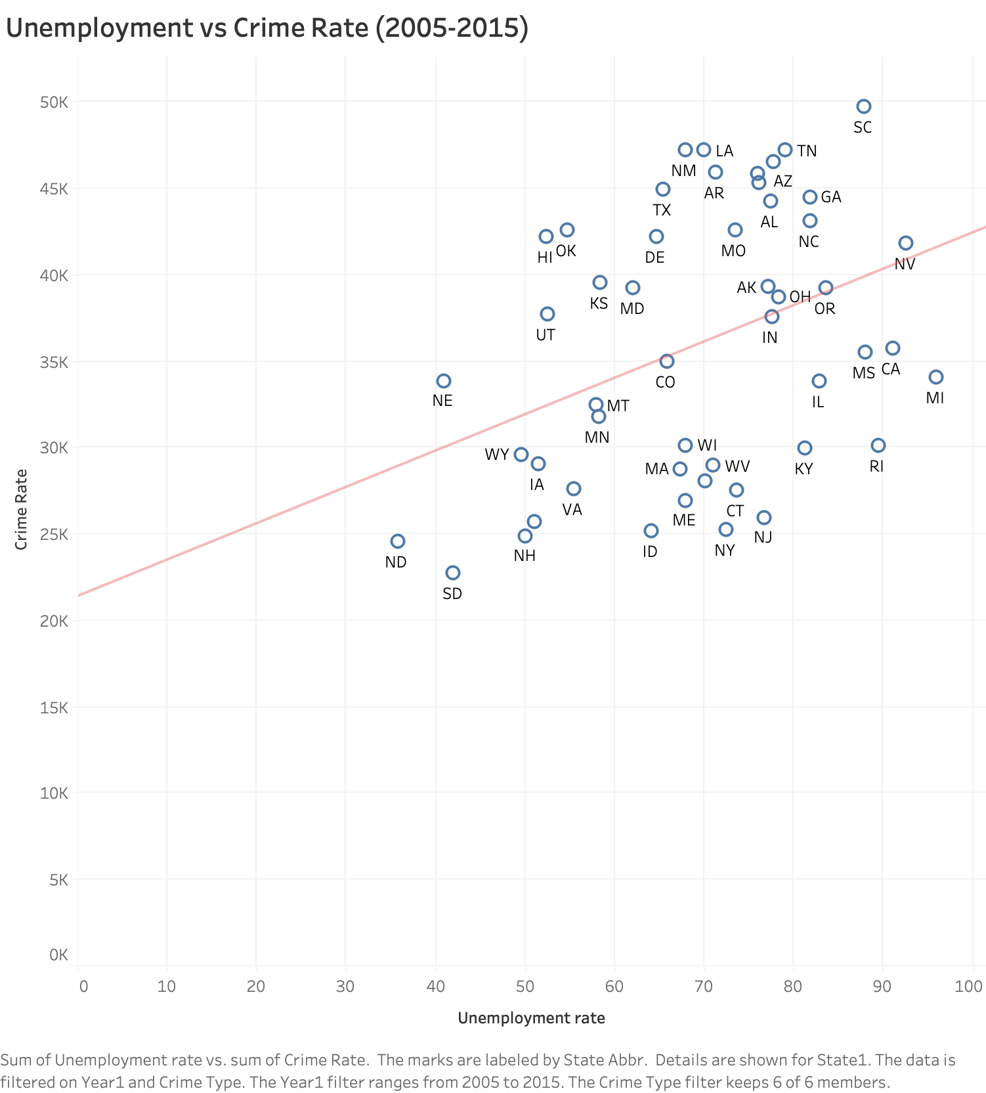

This scatter plot shows the relationship between Unemployment Rate and Crime Rate between 2005 and 2015. Unemployment Rate is used as the column variable, while Crime Rate is used as the row variable. Each point represents a state observation.
The trend line indicates a positive relationship between unemployment and crime rates, suggesting that states with higher unemployment tend to have higher crime levels.

Q5: GDP per Capita vs. Crime Rate (2005 - 2015)
To further investigate economic influences, this chart compares GDP per capita with crime rates to determine whether wealthier states tend to experience lower crime levels.
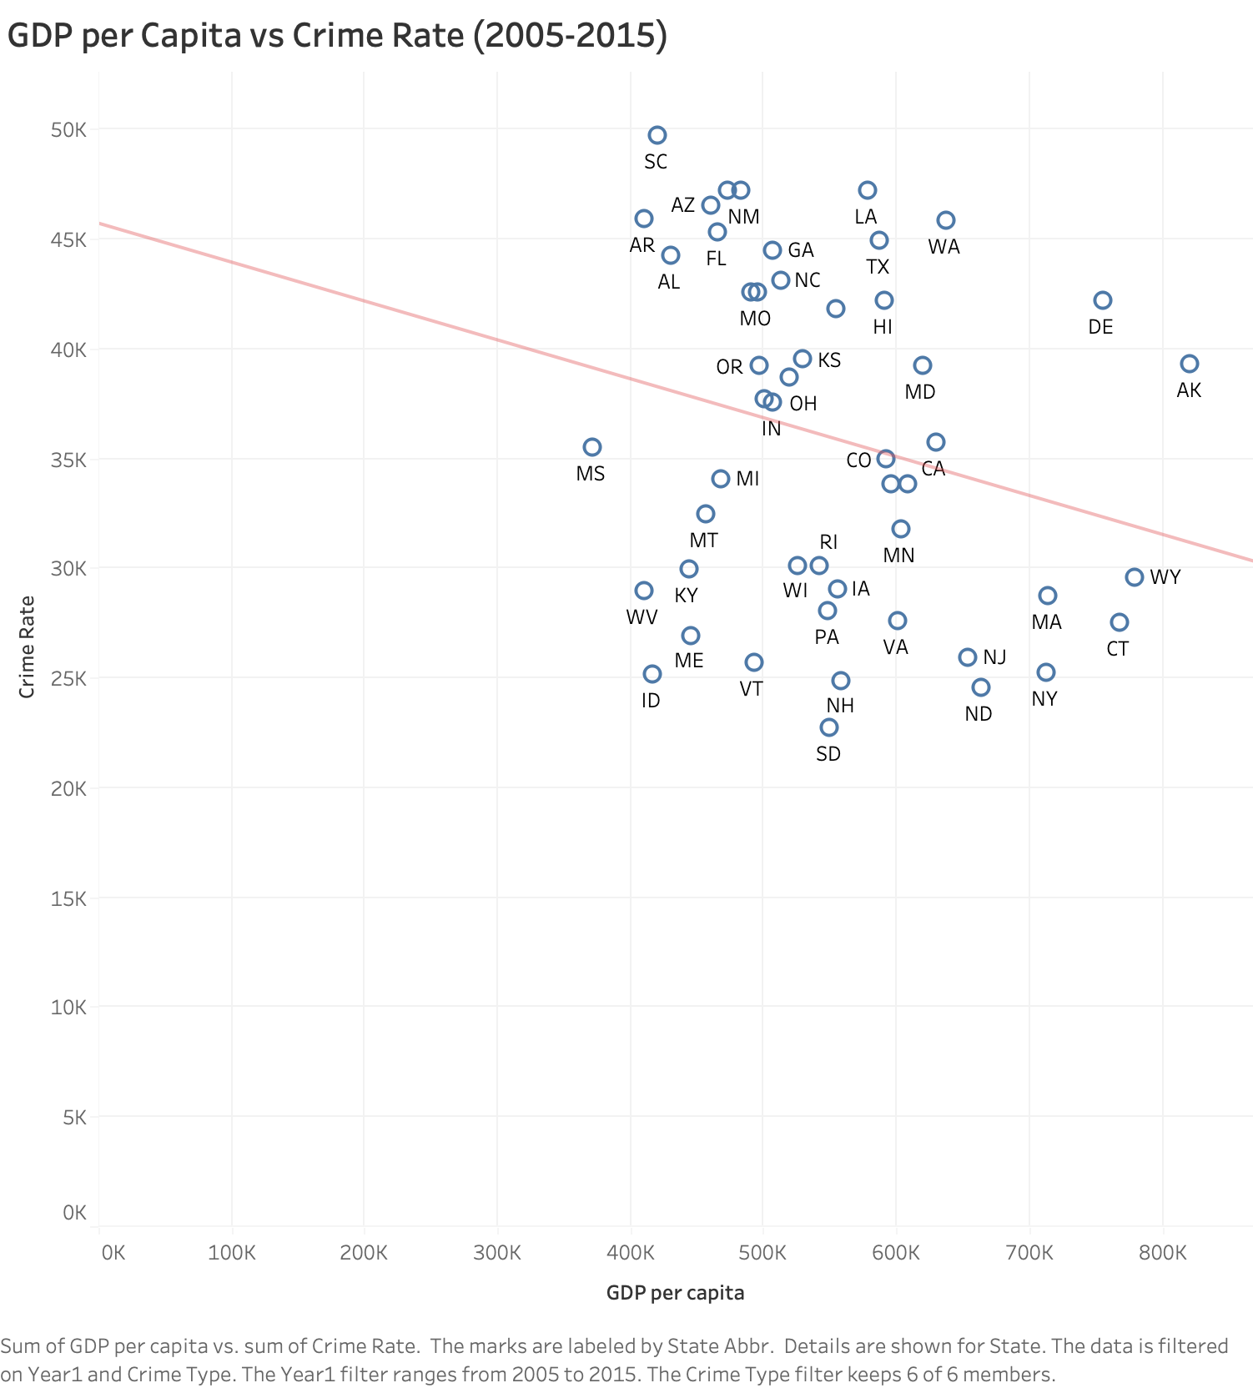
This scatter plot examines the relationship between GDP per Capita and Crime Rate between 2005 and 2015. GDP per Capita is used as the column variable, while Crime Rate is used as the row variable. Each point represents a state observation.
The trend line indicates a negative association between GDP per capita and crime rates, suggesting that states with higher economic prosperity tend to have lower crime levels.

Q6: Median Age vs. Crime Rate - Top 10 (2005 - 2015)
Finally, the analysis shifts to investigate demographic influences.
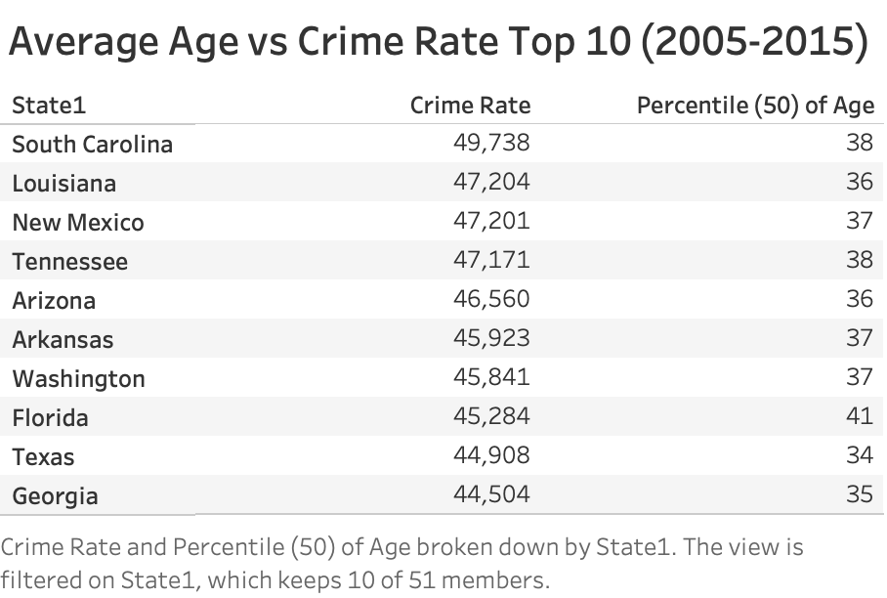
This table compares Crime Rate and Median Age for the ten states with the highest crime rates between 2005 and 2015. State is used as the row variable, while Crime Rate and Age are displayed as text values for comparison.
The result shows that the median age in these high-crime states generally falls between 35 and 40 years old, suggesting relatively similar demographic structures across these states.

Q7: Median Age vs. Crime Rate - Bottom 10 (2005 - 2015)
This table compares the median age of the ten states with the lowest crime rates to identify demographic differences between high-crime and low-crime states.
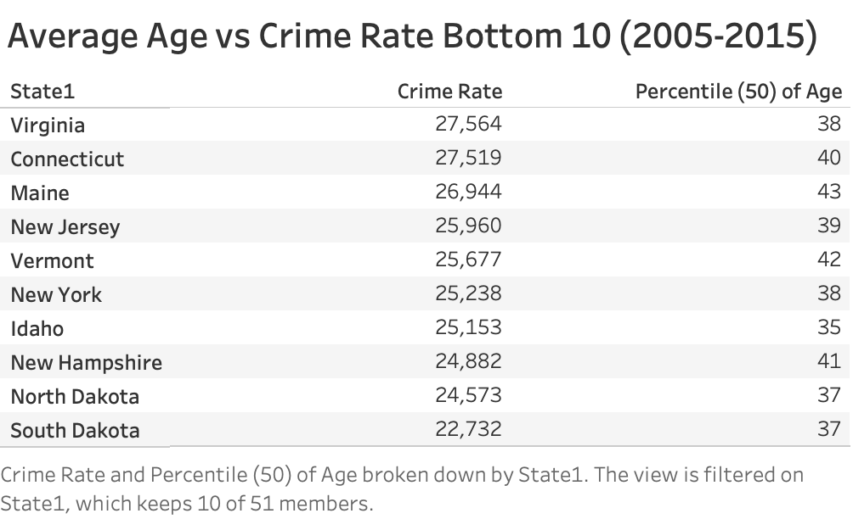
This table presents the Crime Rate and Median Age for the ten states with the lowest crime rates between 2005 and 2015. State is used as the row variable, while Crime Rate and Age are displayed as text values for comparison.
Compared with the high-crime states shown in Q6, the median age in these lower-crime states tends to be slightly higher, ranging from 37 to 43. This suggests that states with older populations may experience relatively lower crime rates.

Tableau Dashboard

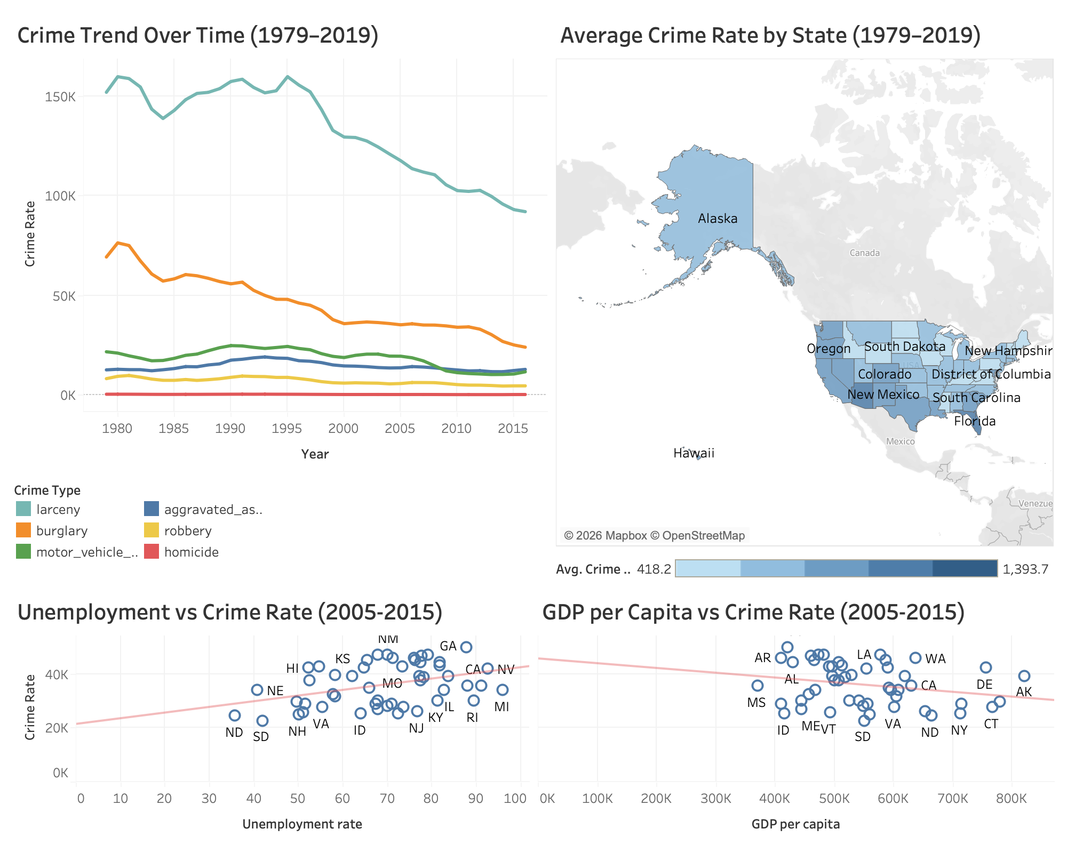

This dashboard combines time trend, geographic, and economic visualizations to provide an integrated view of crime patterns in the United States. The line chart shows national crime trends over time, the map highlights geographic differences across states, and the scatter plots explore the relationship between crime and economic factors such as unemployment and GDP.

Summary and Conclusions
This project explored crime patterns across U.S. states by analyzing national crime data from 1979 to 2019 and examining how socioeconomic factors relate to crime rates. The visualizations revealed several important patterns. First, national crime trends show that most crime categories have generally declined over time, although larceny consistently remains the most common type of crime while homicide remains the least frequent. Recent national reporting also corroborated this analysis. For example, a 2025 FBI report found that violent crimes in the US declined by 4.5% in 2024, with murders dropping roughly 15% and property crime also decreasing nationwide (Winter, 2025).This trend continued through 2025, as the rate of homicides is 21% fewer in 2025 than in 2019 (Lopez, 2026). Geographic analysis further demonstrated that crime rates range significantly across states, with some states like Florida and Arizona showed relatively higher average crime rates compared to many Northeastern states.
Economic indicators also appear to have meaningful relationships with crime levels. The analysis showed a positive relationship between unemployment and crime rates, suggesting that states with higher unemployment tend to experience higher levels of crime. In contrast, GDP per capita showed a negative relationship with crime rates, indicating that states with stronger economic prosperity generally experience lower crime levels. This relationship is supported by data from the Federal Reserve Bank of St. Louis (2024), which describes that regions with consistent growth in real GDP per capita often possess the social infrastructure necessary to ease the economic desperation that drives property crimes (Federal Reserve Bank of St. Louis, 2024). Demographic comparisons also suggest that states with slightly older populations tend to have lower crime rates than states with younger populations. Though these relationships do not imply direct causation, they do however provide insight on potential influence of economic and demographic conditions on crime patterns.
In conclusion, the integrated dashboard demonstrates how combining time trends, geographic comparisons, and socioeconomic indicators can provide a more comprehensive understanding of crime patterns in the United States. These findings suggest that crime is influenced by multiple interconnected factors, including economic conditions and demographic characteristics. Future analyses incorporating additional variables such as education level, urbanization, and policing strategies could further improve our understanding of the complex drivers behind crime trends.

Limitations
The datasets used in this study cover different time ranges. While the crime dataset spans from 1979 to 2019, the economic and demographic datasets are only available from 2005 to 2015. This limits the time period for comparative analysis across variables.
Other potentially important factors such as education levels, law enforcement policies, urbanization, and social inequality were not included in the analysis. These factors may also influence crime patterns and could provide additional insights for future research.

References

Becker, G. S. (1968). Crime and punishment: An economic approach. Journal of Political Economy, 76(2), 169–217. https://doi.org/10.1086/259394
Federal Bureau of Investigation. (n.d.). Estimated crimes in the United States (1979-2019) [Data set]. Kaggle. https://www.kaggle.com/datasets/tunguz/us-estimated-crimes
Federal Reserve Bank of St. Louis. (2024). Real Gross Domestic Product per Capita by State. FRED Economic Data. https://fred.stlouisfed.org/series/NYRGSPPC
Hirschi, T., & Gottfredson, M. (1983). Age and the explanation of crime. American Journal of Sociology, 89(3), 552–584. https://doi.org/10.1086/227905
Karicare. (n.d.). Annual state-level income of USA [Data set]. Kaggle. https://www.kaggle.com/datasets/karicare/annual-statelevel-income-of-usa
Levitt, S. D. (2004). Understanding why crime fell in the 1990s: Four factors that explain the decline and six that do not. Journal of Economic Perspectives, 18(1), 163–190. https://doi.org/10.1257/089533004773633440
Lopez, E., & Boxerman, B. (2026, January 6). Crime trends in U.S. cities: Year-end 2025 update. Council on Criminal Justice. https://counciloncj.org/crime-trends-in-u-s-cities-year-end-2025-update/
Winter, J. (2025, August 5). US violent crime fell 4.5% in 2024, down for second year running, FBI says. Reuters. https://www.reuters.com/world/us/us-violent-crime-fell-45-2024-down-second-year-running-fbi-says-2025-08-05/

Contribution

Luca Guerra | Unemployment vs Crime Rate (Scatter Chart)  GDP per Capita vs Crime Rate (Scatter Chart)  Word (Introduction and two graphs)
Armin Soroosh | Average Age vs Crime Rate Top 10 (Table)  Average Age vs Crime Rate Bottom 10 (Table)  Word (Summary, Conclusion and two graphs)
Heng-Jui Chu | Data Collecting  Data Preprocessing  Crime Trend Over Time (Line Chart)  Word (Dataset and one graph)
Alex Biuckians | Average Crime Rate by State (Map)  Crime Composition (Bar Chart)  Word (Summary, Conclusion and two graphs)

