Crime Trends and Socioeconomic Differences Across U.S. States

Prepared for: | Anya Mendenhall
Prepared by: | Luca Guerra
 | Armin Soroosh
 | Heng-Jui Chu
 | Alex Biuckians

GitHub: https://github.com/hengjuichu/Data-visualization-project
April 12, 2026

Table of Contents

Introduction and Background 2
Research Questions 3
Differences from Project 1 3
Datasets 4
Data Story and Visualizations 6
Q1: Temporal fluctuations in crime rates (year-over-year change) (Line chart) 6
Q2: Average Crime Rate by State with Crime Selector (1979–2019) (Map) 7
Q3: Crime Composition by State – Top 10 (2005 - 2015) (Bar chart) 8
Q4: Unemployment vs. Crime Rate (2005–2015) (Scatter Plot) 9
Q5: GDP per Capita vs. Crime Rate (2005–2015) (Scatter Plot) 10
Q6: Education Level by State (Bar Chart) 11
Q7: Median Age vs. Crime Rate – Top 10 States (Table) 12
Tableau Dashboard 13
Summary and Conclusions 14
Limitations 15
References 15
Contribution 16

Introduction and Background

In Project 1, the main question was to understand how crime rates vary across states, over time, and across different types of crime. The analysis showed that crime trends generally declined over time, but there were clear differences across states and crime categories.
In Project 2, we extend this analysis by exploring how socioeconomic and demographic factors, such as unemployment, GDP, and maternal education level, are related to crime rates. The goal is to better understand not only how crime changes, but also what factors may help explain these patterns.
Compared to Project 1, this project adds deeper analysis by using year-over-year (YoY) changes, incorporating a new dataset to include maternal education level, and introducing interactive features such as filters and parameter controls. These improvements allow for a more detailed and flexible exploration of crime patterns.
We chose Track A (Tableau) because it provides strong support for interactive visualizations, calculated fields, and dashboard design. This makes it easier to present complex relationships in a clear way.
This project benefits the audience by allowing them to explore crime patterns across time, location, and socioeconomic conditions, helping them better understand how different factors may influence crime rates.

Research Questions
- Year-over-Year Crime Trend (1979–2019) (Line Chart)
To examine how crime rates change over time by focusing on year-over-year variations rather than absolute levels.
- Average Crime Rate by State with Crime Selector (1979–2019) (Map)
To explore geographic variations in crime rates and allow dynamic comparison across different crime types using an interactive selector.
- Crime Composition – Top 10 States (2005–2015) (Bar Chart)
To identify which types of crime contribute most to states with the highest crime rates.
- Unemployment vs. Crime Rate (2005–2015) (Scatter Plot)
To analyze the relationship between unemployment and crime rates, with population size and crime intensity represented visually, and filters for crime type and year.
- GDP per Capita vs. Crime Rate (2005–2015) (Scatter Plot)
To investigate whether wealthier states tend to have lower crime rates, with interactive filtering and enhanced visual encoding.
- Education Level by State (2016–2021)(Bar Chart)
To examine how maternal education levels vary across states and provide additional socioeconomic context for understanding differences in crime rates.
- Median Age vs. Crime Rate – Top 10 States (2005–2015) (Table)
To explore whether states with the highest crime rates share similar age characteristics, with enhanced color encoding and filtering by crime type.

Differences from Project 1
- Added a new dataset (US Births 2016–2021) to incorporate maternal education level as a demographic factor.
- Performed additional data preprocessing in Tableau Prep, including removing missing values and integrating multiple datasets.
- Transformed maternal education into meaningful categories by grouping 8 levels into Low, Medium, and High Education.
- Enhanced the time-series analysis by using year-over-year (YoY) change instead of absolute crime rates.
- Improved geographic analysis by introducing a Crime Type Selector, allowing dynamic comparison across different crime categories.
- Refined the bar chart by improving label design and readability.
- Added a new visualization (Maternal Education Level by State) to provide a deeper socioeconomic context.
- Enhanced tables with color encoding and interactive crime type filters for better comparison.
- Upgraded scatter plots by incorporating population as size, crime rate as color, and adding interactive filters (year & crime type).
- Improved dashboard interactivity through actions and parameter controls, enabling a more user-driven exploration experience.

Datasets
Dataset A - estimated_crimes_1979_2019
The primary dataset is “US Estimated Crimes (1979 - 2019)”, obtained from Kaggle.
Link: https://www.kaggle.com/datasets/tunguz/us-estimated-crimes
The data were collected by the Federal Bureau of Investigation (FBI). The dataset was created to monitor national crime patterns and support law enforcement analysis and public policy decisions.
Variables Description
Original variables
- State: U.S. state
- Year: year of the observation
- Population: state population
Derived variables
A pivot transformation was performed in Tableau Prep to restructure crime categories.
This created two new variables:
- Crime_type: type of crime
- Crime_count: number of crimes
Each row now represents one crime type in one state in one year, following the tidy data principle.
A standardized crime rate variable was also created:
- Crime_rate: crime_rate = (crime_count / population) × 100,000
This standardizes crime counts per 100,000 people to allow comparisons across states.
Dataset Size
- 2,116 rows, 13columns
Time Coverage
- 1979 - 2019
Geographic Coverage
- All U.S. states

Dataset B - Annual state-level income of USA
The second dataset is “Annual state-level income of USA”, obtained from Kaggle.
Link: https://www.kaggle.com/datasets/karicare/annual-statelevel-income-of-usa
The dataset was collected by Karicare and contains state-level socioeconomic indicators such as income and employment. It provides additional economic context for the analysis.
Variables Description
- GDP per capita: economic output per person
- Unemployment rate: unemployment percentage
Dataset Size
- 550 rows, 14 columns
Time Coverage
- 2005 - 2015
Geographic Coverage
- All U.S. states

Dataset C - US Births by Year, State, and Education Level
The third dataset is “Annual education of the USA”, obtained from Kaggle.
Link: https://www.kaggle.com/datasets/danbraswell/temporary-us-births
The dataset was obtained from Kaggle and is based on U.S. birth records (2016–2021) collected from official vital statistics systems. It includes demographic information such as maternal education and is commonly used to study population and fertility patterns. In this project, it is used to provide an education-related socioeconomic context for crime analysis.
Variables Description
- Education Level Code:
Code | Mother's Education Level
1 | 8th grade or less
2 | 9th through 12th grade with no diploma
3 | High school graduate or GED completed
4 | Some college credit, but not a degree
5 | Associate degree (AA, AS)
6 | Bachelor's degree (BA, AB, BS)
7 | Master's degree (MA, MS, MEng, MEd, MSW, MBA)
8 | Doctorate (PhD, EdD) or Professional Degree (MD, DDS, DVM, LLB, JD)

The original eight-level education variable was grouped into three categories: Low (codes 1–2), Medium (codes 3–5), and High (codes 6–8) to simplify interpretation and improve comparability.
Dataset Size
- 5496 rows, 9 columns
Time Coverage
- 2016 - 2021
Geographic Coverage
- All U.S. states

Data Integration
The three datasets are connected in Tableau using a relationship join based on State and Year.

Data Story and Visualizations

Q1: Temporal fluctuations in crime rates (year-over-year change) (Line chart)
To examine how crime rates evolve by focusing on year-over-year changes rather than absolute levels.

This line chart uses Year on the x-axis and the year-over-year percentage change in crime rate on the y-axis. Different crime types are shown using different colors.
Compared to Project 1, this chart does not show the actual crime level, but instead shows how much crime increases or decreases each year. We can see that crime rates do not change smoothly. Instead, they go up and down over time.
Some crime types, like homicide and motor vehicle theft, have bigger changes, while others are more stable.

Q2: Average Crime Rate by State with Crime Selector (1979–2019) (Map)
After examining the national trend, the analysis shifts to geographic patterns to find out whether crime rates vary across states.
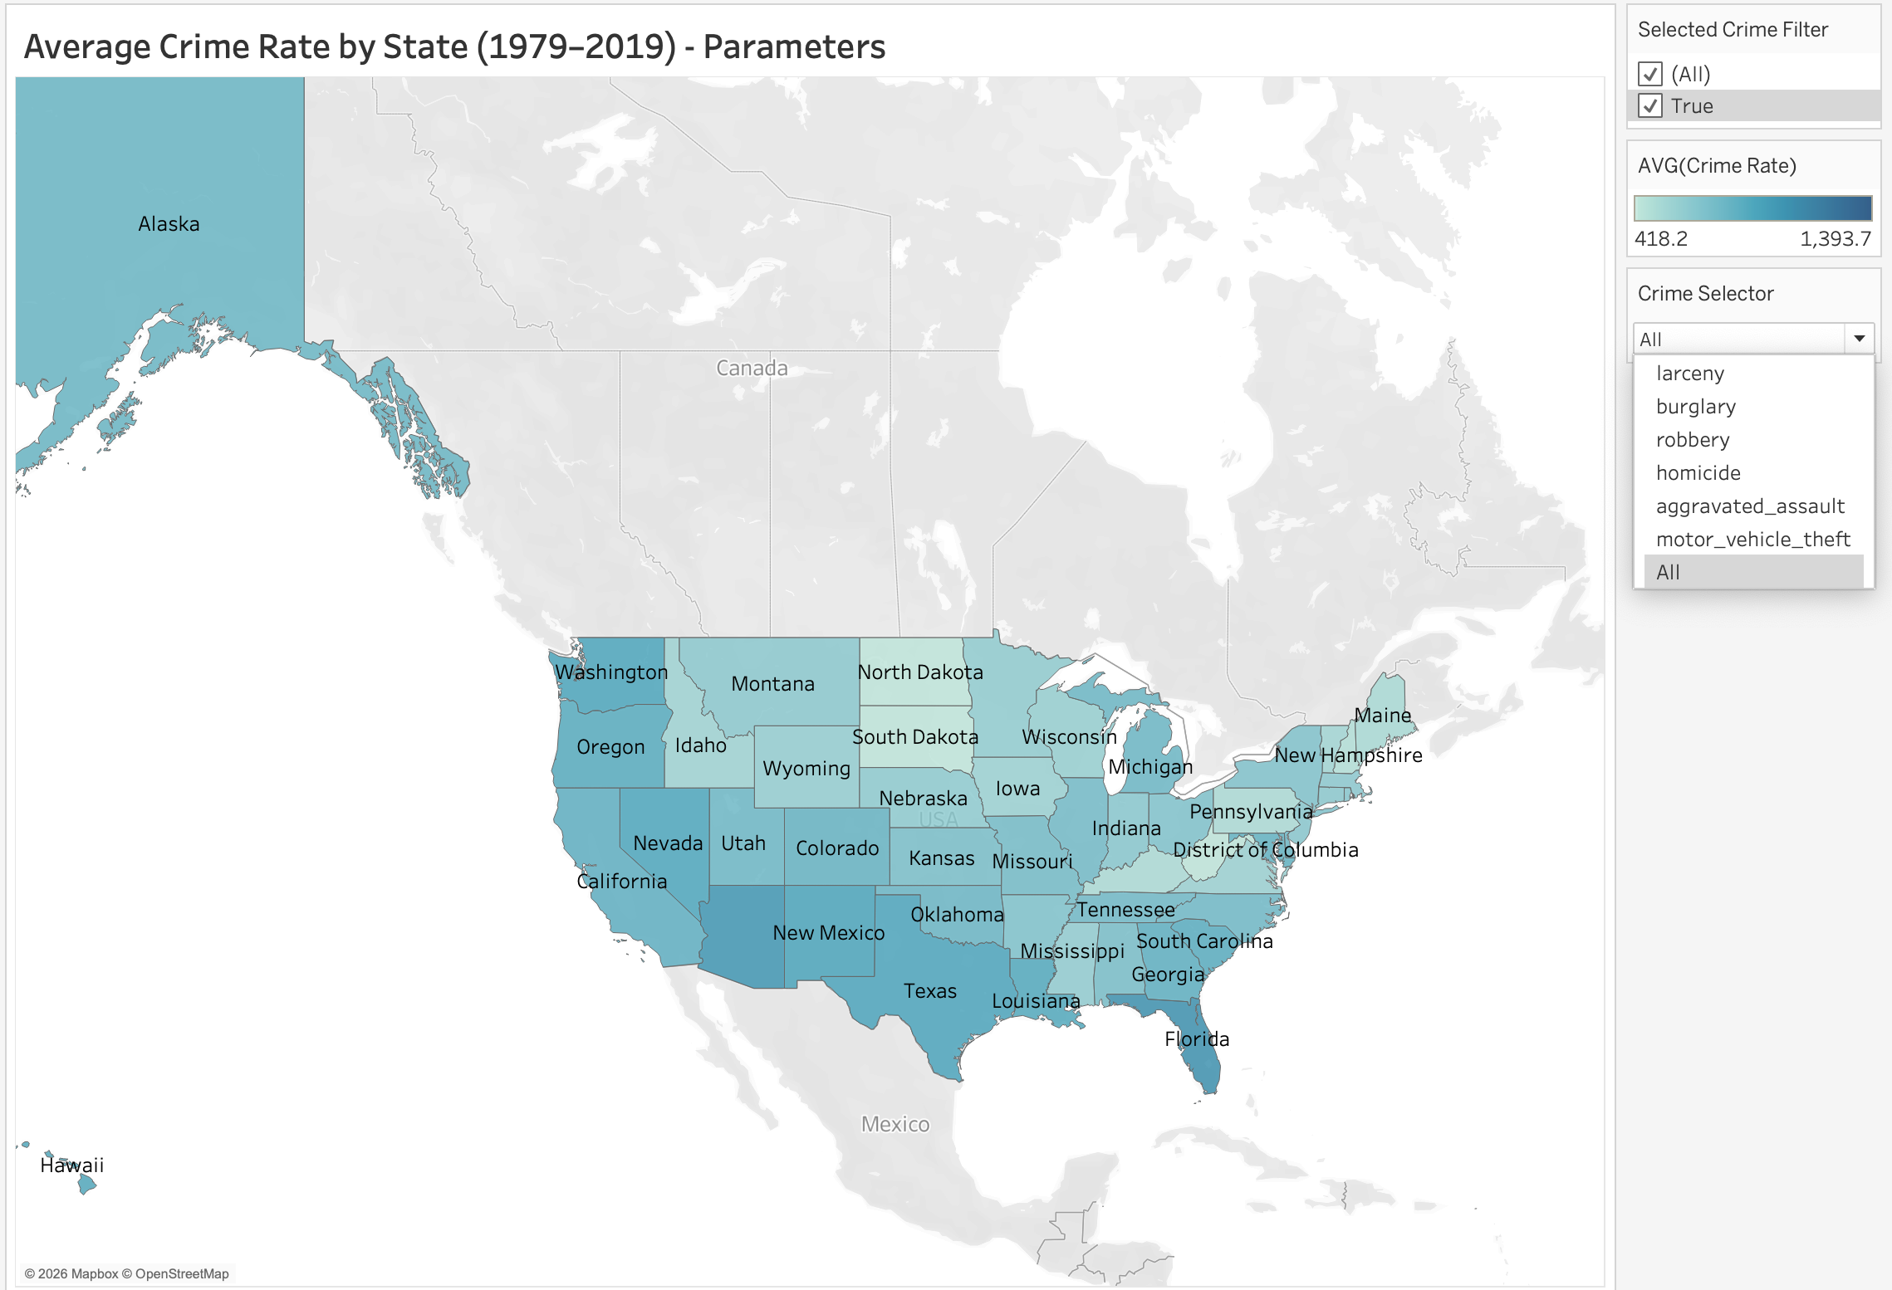
This map uses the average crime rate (per 100,000 population) from the FBI crime dataset as the color encoding to show differences across states from 1979 to 2019. The state is used as the geographic dimension and label.
Compared to Project 1, this visualization includes a Crime Selector parameter, which allows users to switch between different crime types. This makes the map more interactive and helps users compare patterns across crime categories more easily.
The map shows clear geographic variation in crime rates. States such as Florida and New Mexico have relatively higher crime rates, while many Northeastern states tend to have lower crime rates.
However, this map only shows spatial differences and does not explain why crime rates vary. Additional charts are needed to explore economic and demographic factors behind these patterns.

Q3: Crime Composition by State – Top 10 (2005 - 2015) (Bar chart)
After examining geographic patterns, the analysis shifts to explore how different types of crime contribute to high crime levels in each state.
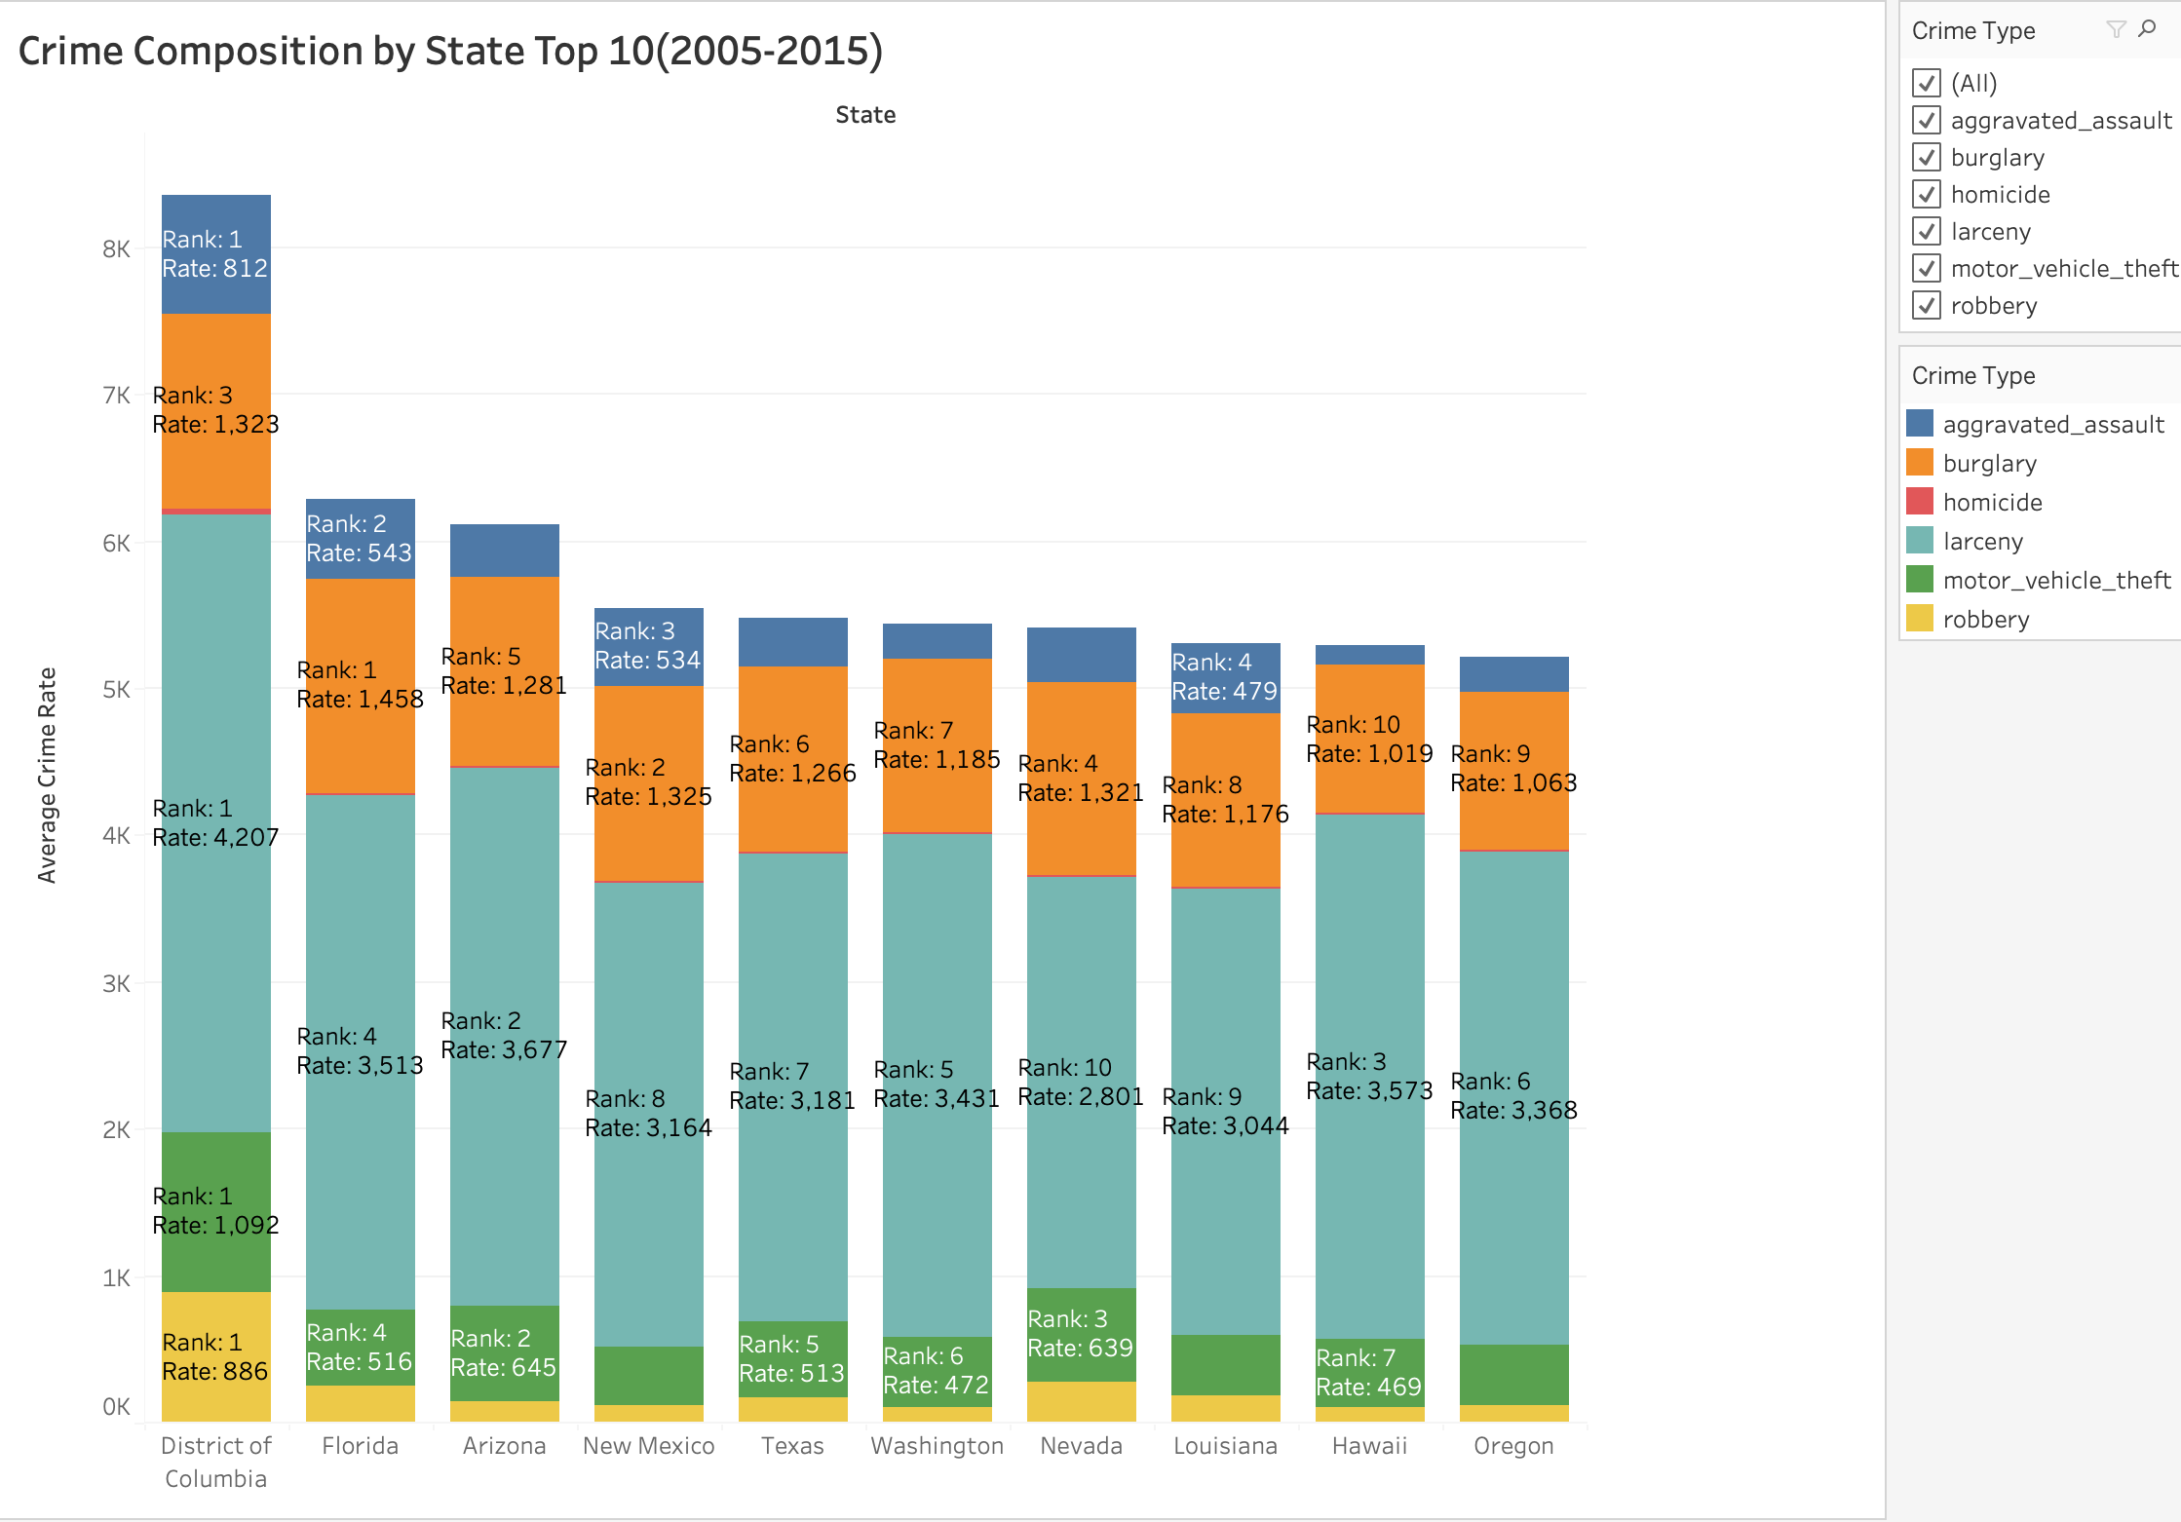
This bar chart shows the crime composition for the ten states with the highest average crime rates between 2005 and 2015. The data comes from the FBI crime dataset, where the crime rate is measured per 100,000 population. State is used as the column variable, and the average crime rate is used as the row variable. Different crime categories are represented by Crime Type, which is encoded by color.
Compared to Project 1, this chart improves readability by adding custom labels, which include both rank and crime rate values for each segment. This makes it easier to compare the importance of each crime type within and across states.
The chart shows that crime composition is relatively similar across high-crime states. In most states, larceny contributes the largest portion, while homicide remains the smallest.
In addition, a Crime Type filter is added to improve analysis. Since homicide values are much smaller than those of other crime types, they are difficult to observe in the stacked bar. By using the filter, users can isolate specific crime types and better understand their patterns.
However, this chart focuses on composition within high-crime states and does not explain why these patterns occur. Further analysis is needed to explore economic and demographic factors.​

Q4: Unemployment vs. Crime Rate (2005–2015) (Scatter Plot)
After examining the crime composition, the analysis shifts to explore whether economic hardship contributes to crime.
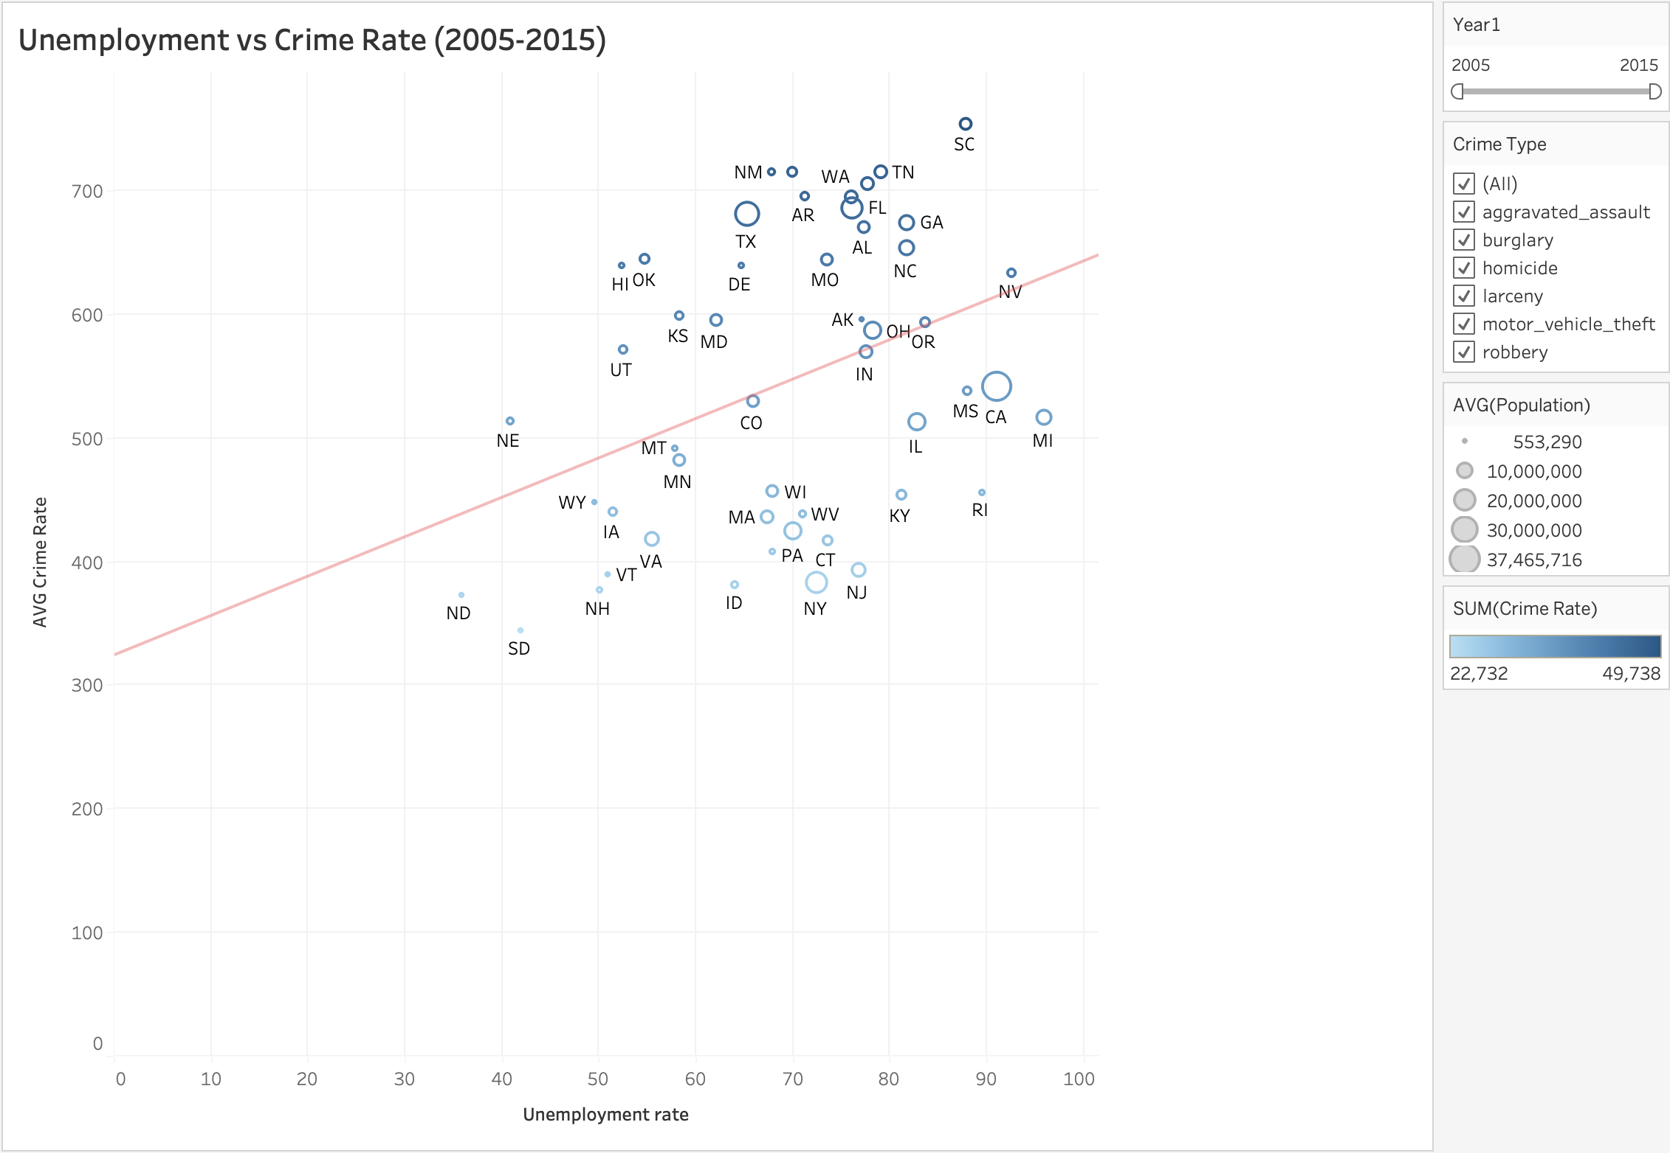
This scatter plot shows the relationship between unemployment rate and average crime rate (per 100,000 population) from 2005 to 2015, based on the unemployment dataset and FBI crime dataset. The unemployment rate is used as the x-axis, while the crime rate is used as the y-axis. Each point represents a state.
Compared to Project 1, this chart is improved by adding more visual encodings. Population is represented by the size of each point, and crime rate is also encoded by color, which helps highlight differences more clearly. In addition, filters for crime type and year are included, allowing users to explore specific patterns and focus on different subsets of data.
The trend line shows a positive relationship between unemployment and crime rates, suggesting that states with higher unemployment tend to have higher crime levels. However, there is still some variation, meaning that unemployment alone cannot fully explain crime differences.

Q5: GDP per Capita vs. Crime Rate (2005–2015) (Scatter Plot)
To further investigate economic influences, this chart compares GDP per capita with crime rates to determine whether wealthier states tend to experience lower crime levels.
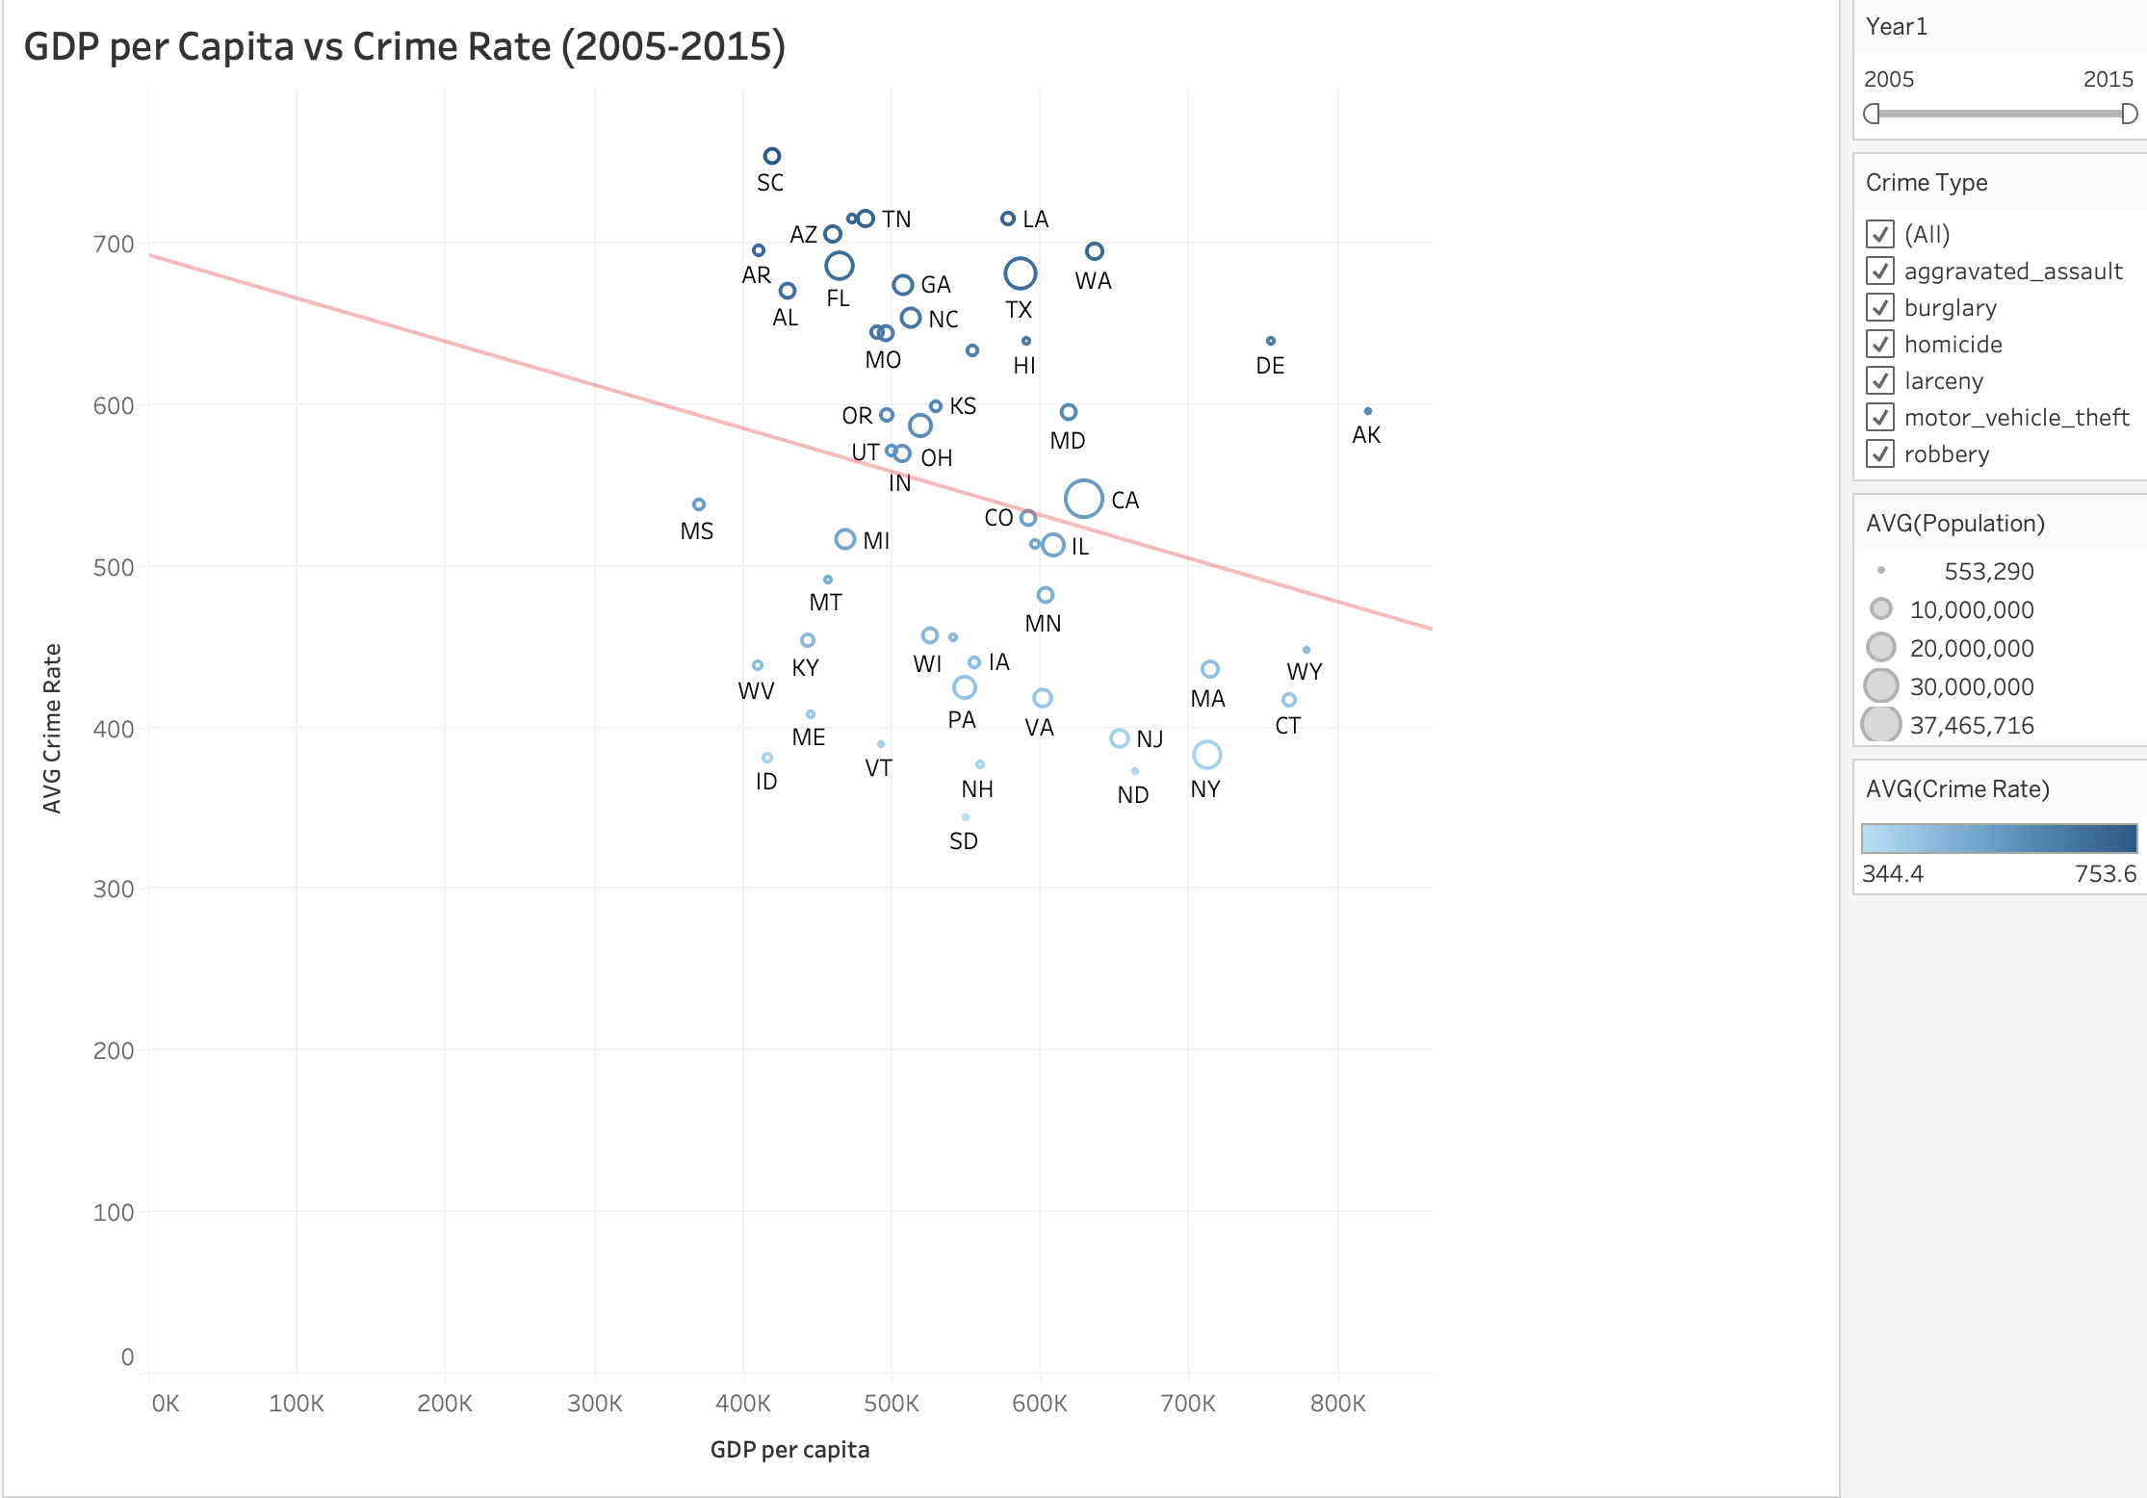
This scatter plot shows the relationship between GDP per capita and average crime rate (per 100,000 population) from 2005 to 2015, based on the GDP dataset and FBI crime dataset. GDP per capita is used as the x-axis, while crime rate is used as the y-axis. Each point represents a state.
Similar to the previous scatter plot, this chart is improved by adding multiple visual encodings. Population is represented by the size of each point, and crime rate is also shown using color, making it easier to compare states. In addition, filters for crime type and year are included, allowing users to explore different patterns across subsets of data.
The trend line shows a negative relationship between GDP per capita and crime rates, suggesting that states with higher economic prosperity tend to have lower crime levels. However, the relationship is not very strong, and there is still variation across states.
This chart focuses on economic factors, but it does not include demographic variables such as education, which may also help explain differences in crime rates.

Q6: Education Level by State (Bar Chart)
After examining economic factors such as unemployment and GDP, the analysis further explores demographic characteristics to better understand differences in crime rates.
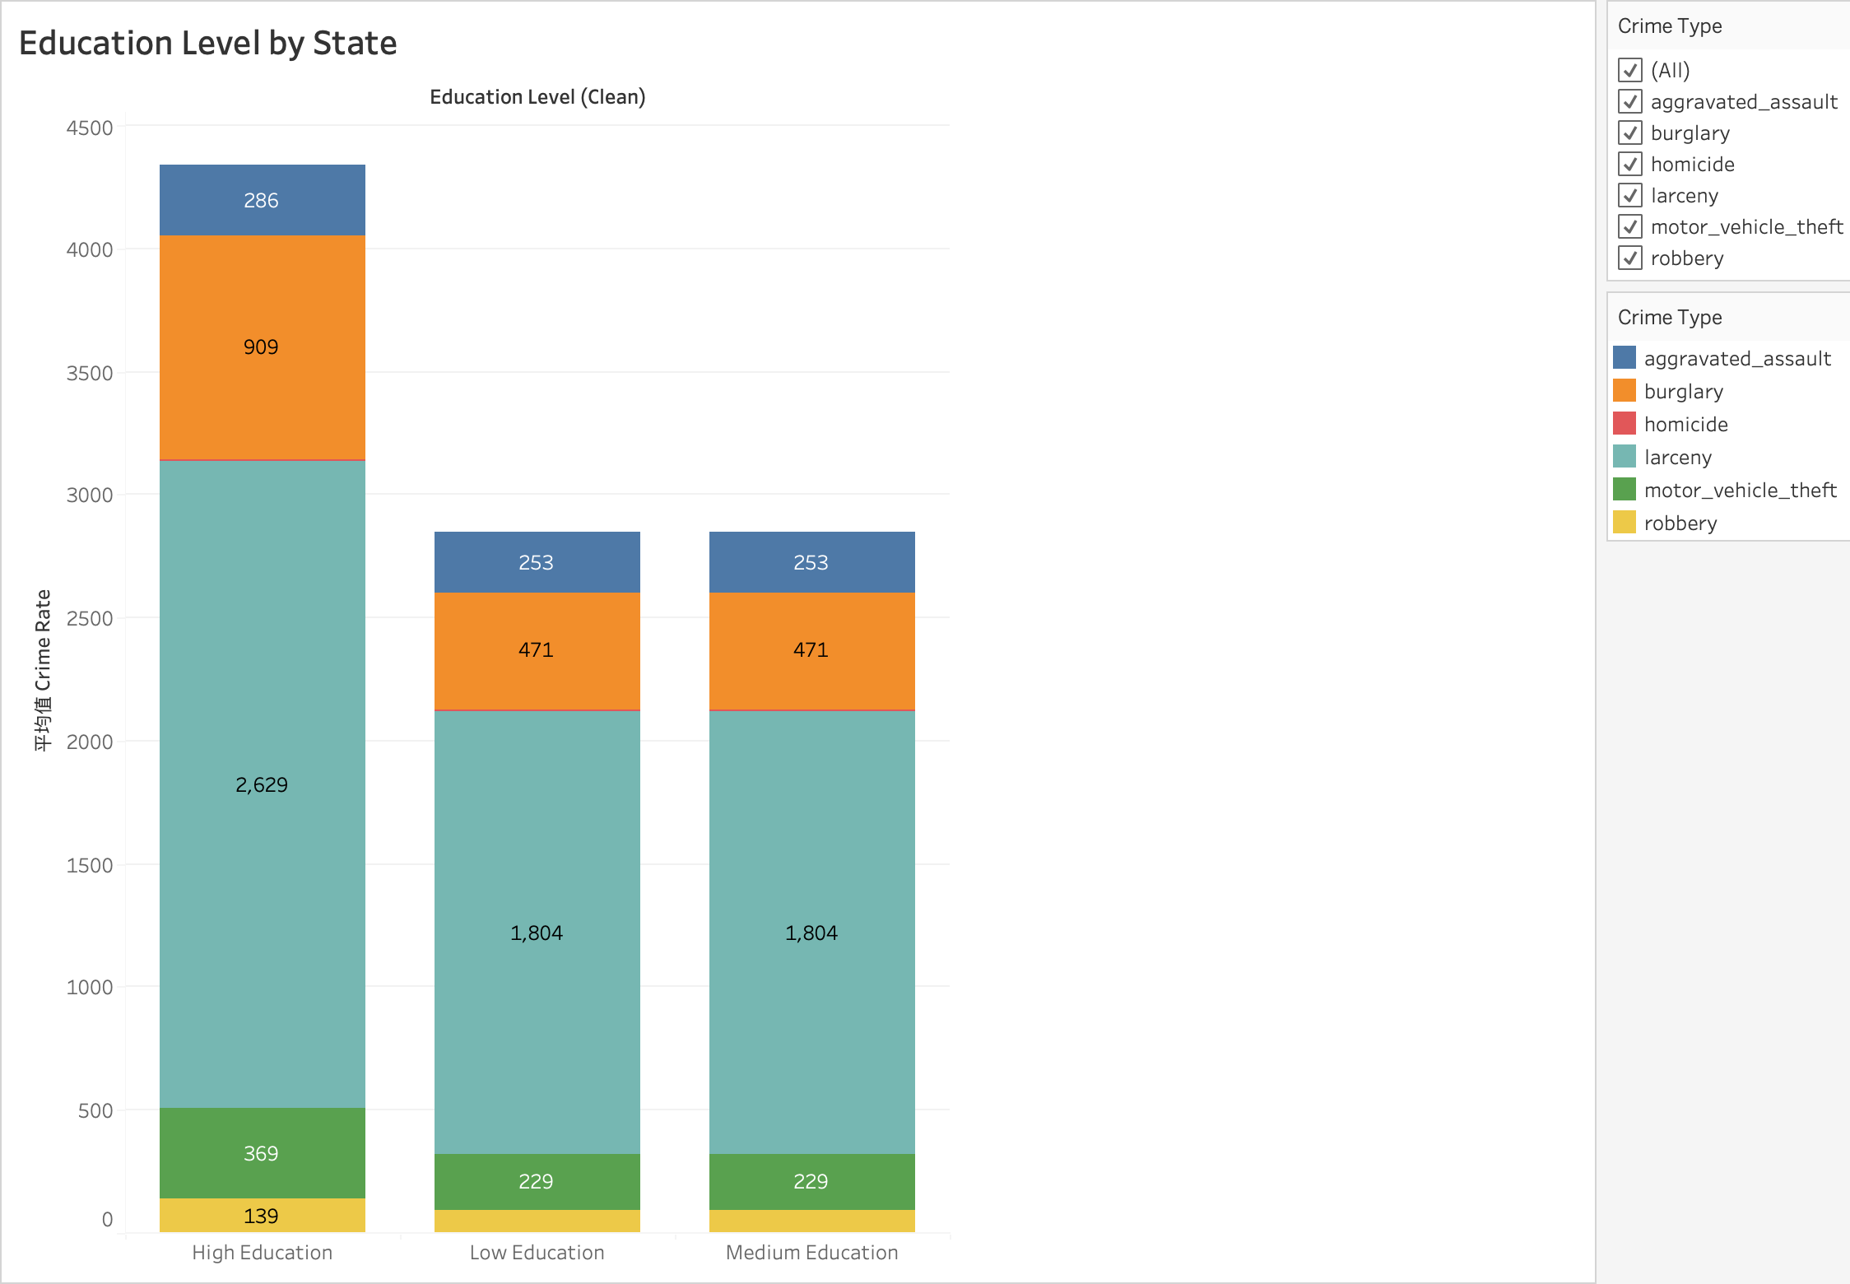
This bar chart shows the relationship between maternal education level and average crime rate (per 100,000 population) using the birth dataset and the FBI crime dataset. Maternal education is grouped into Low, Medium, and High levels, and crime types are shown by color.
Compared to Project 1, this chart adds maternal education as a demographic factor and includes labels to improve readability.
The results show that states with higher maternal education levels tend to have higher reported crime rates, while low and medium education levels are similar and lower. This is different from common expectations.
One possible explanation is that higher-education states may also have larger populations or more urban areas, so maternal education alone cannot fully explain differences in crime.

Q7: Median Age vs. Crime Rate – Top 10 States (Table)
This table shows the median age of the ten states with the highest crime rates to examine demographic characteristics in high-crime states.
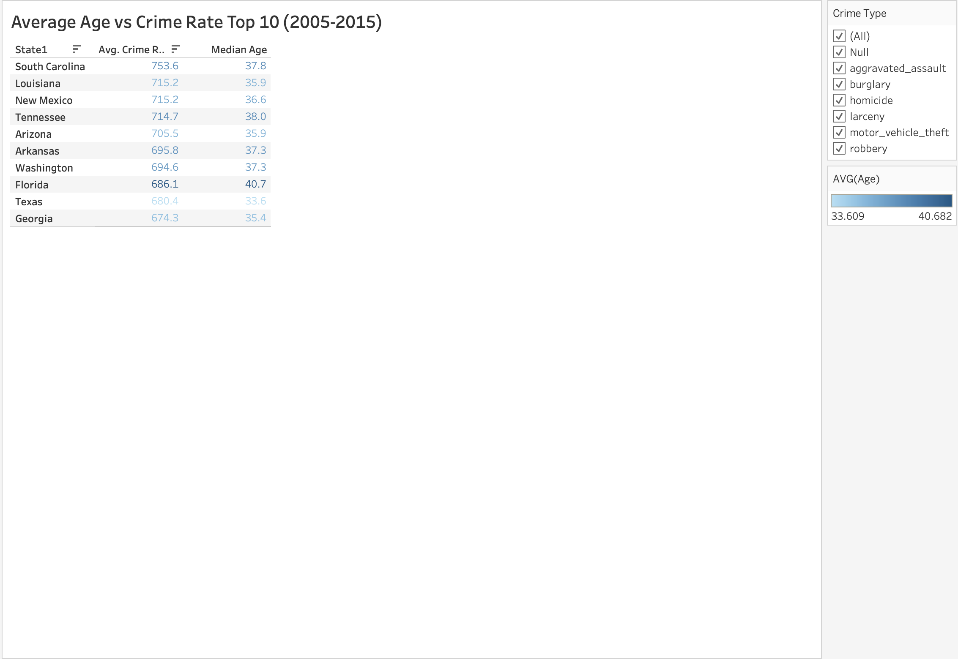
This table shows the average crime rate (per 100,000 population) and median age for the ten states with the highest crime rates from 2005 to 2015, based on the FBI crime dataset and demographic data. State is used as the row variable, while crime rate and age are displayed for comparison.
Compared to Project 1, this table is improved by adding color encoding and a crime type filter, which helps users focus on specific patterns more clearly.
The results show that the median age in these high-crime states is generally between 33 and 38, suggesting that these states tend to have relatively younger populations.

Tableau Dashboard
This dashboard shows crime patterns from different views, including time, location, and economic factors.
The top-left chart shows the year-over-year change in crime rate, so we can see how crime goes up and down over time. The map on the top-right shows average crime rate by state, and users can use the Crime Selector to switch between different crime types.
The two charts at the bottom show relationships between crime and economic factors. The left one shows unemployment vs crime rate, and the right one shows GDP vs crime rate. In both charts, size shows population and color shows crime rate, which makes it easier to compare states.
This dashboard also includes interactive filters, parameters, and dashboard actions. Users can click on one chart to highlight or filter other charts, which helps them explore the data more easily. Filters for crime type and year also allow users to focus on specific conditions.
Compared to Project 1, this dashboard is more interactive and allows users to explore the data in more detail.
As a result, the dashboard helps users understand crime from time, location, and economic perspectives in a clear way.

Summary and Conclusions
This project explored crime patterns across U.S. states by analyzing national crime data from 1979 to 2019 and examining how socioeconomic and demographic factors relate to crime rates. Compared to Project 1, this analysis focused on year-over-year (YoY) changes and incorporated additional variables such as unemployment, GDP per capita, and maternal education level to provide a more detailed understanding of crime patterns (Federal Bureau of Investigation, n.d.).
The visualizations revealed several important patterns. First, the YoY analysis shows that crime rates fluctuate over time rather than change smoothly, with some crime types showing larger variations than others. Geographic analysis also indicates that crime rates vary significantly across states, but spatial differences alone cannot explain these patterns.
Economic indicators show partial relationships with crime. Unemployment has a positive relationship with crime rates, which is consistent with economic theories of crime, suggesting that financial pressure may increase criminal behavior (Becker, 1968). In contrast, GDP per capita shows a weak negative relationship with crime rates, indicating that regions with stronger economic conditions may experience slightly lower crime levels (Federal Reserve Bank of St. Louis, 2024). However, these factors alone are not sufficient to fully explain differences across states.
The addition of maternal education provides further insight, although the results suggest that higher maternal education levels are associated with higher reported crime rates in this dataset. This finding may be influenced by other underlying factors such as urbanization and population density, rather than maternal education itself. Demographic analysis also shows that higher-crime states tend to have relatively younger populations, which is consistent with prior research linking age to crime patterns (Hirschi & Gottfredson, 1983).
As a result, the findings suggest that crime patterns are influenced by multiple interconnected factors, including time, location, economic conditions, and demographic characteristics. Future analysis incorporating additional variables could further improve the understanding of crime patterns.

Limitations
The datasets used in this study cover different time ranges. While the crime dataset spans from 1979 to 2019, the economic and demographic datasets, including unemployment, GDP, and birth-related data, are only available for more recent years (primarily 2005 to 2015, with some demographic data extending to 2016–2021). As a result, the analysis that combines multiple variables is restricted to overlapping time periods, which limits the ability to examine long-term relationships across all factors.
Although maternal education is incorporated as a proxy for socioeconomic background, other potentially important factors—such as law enforcement policies, urbanization, and social inequality—were not included in the analysis. These factors may also influence crime patterns and could provide additional insights for future research.

References

Becker, G. S. (1968). Crime and punishment: An economic approach. Journal of Political Economy, 76(2), 169–217. https://doi.org/10.1086/259394
Federal Bureau of Investigation. (n.d.). Estimated crimes in the United States (1979–2019) [Data set]. Kaggle. https://www.kaggle.com/datasets/tunguz/us-estimated-crimes
Federal Reserve Bank of St. Louis. (2024). Real gross domestic product per capita by state. FRED Economic Data. https://fred.stlouisfed.org/series/NYRGSPPC
Hirschi, T., & Gottfredson, M. (1983). Age and the explanation of crime. American Journal of Sociology, 89(3), 552–584. https://doi.org/10.1086/227905
Karicare. (n.d.). Annual state-level income of USA [Data set]. Kaggle. https://www.kaggle.com/datasets/karicare/annual-statelevel-income-of-usa
https://www.kaggle.com/datasets/karicare/annual-statelevel-income-of-usa
Braswell, D. (n.d.). US births 2016–2021 [Data set]. Kaggle. https://www.kaggle.com/datasets/danbraswell/temporary-us-births

Contribution

Luca Guerra | - Improve Unemployment vs Crime Rate (Scatter Chart)  - Improve GDP per Capita vs Crime Rate (Scatter Chart)  - Word (Introduction and two graphs)
Armin Soroosh | - Improve Average Age vs Crime Rate Top 10 (Table)  - Add Maternal Education Level by State (Bar Chart)  - Word (Summary, Conclusion, and two graphs)  - Add references
Heng-Jui Chu | - Third Dataset Collecting  - Data Preprocessing  - Improve Crime Trend Over Time (Line Chart)  - Word (Describe the dataset and one graph)
Alex Biuckians | - Improve Average Crime Rate by State (Map)  - Improve Crime Composition (Bar Chart)  - Word (Summary, Conclusion, and two graphs)  - Add references

