CURRICULUM VITAE

PERSONAL DATA

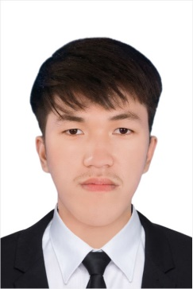
Name : HENG LONGCHHOR
Sex : Male
Place of Birth : Kampong Thom Province Marital Status : Single
Nationality : Cambodian
Current Address : Tuek Thla,Sen Sok, Phnom Penh
Mobile Phone : (+855) 017463243
Telegram Number : (+855) 017463243
E-mail : henglongchhor@gmail.com

EDUCATION BACKGROUND

2011-2017 : Study at Kampong Chheulteal Primary School, Kampong Thom
2017-2020 : Study at Prasat Sambor Secondary School, Kampong Thom 2020-2023 : Study at Kampong Chheuteal Hight School, Kampong Thom 2024-2025 : Royal University of Phnom Peng
EXPERIENCES

No previous experience

PROFESSIONAL SKILL

Khmer : Mother Tongue
English : Medium at writing, listening, Speaking and Reading Computer : M.s office (Word, Excel, PowerPoint)
INTEREST

Characteristic : Honest, hardworking, good communication, friendly good
teamwork, respect, and patience.
HOBBIES : Reading watching news and research internet listen to music
and taking photos participating in conferences and meeting.

