|  |
| --- |
| Namco |
| Pacman |
| **Game Document** |
| Version #01  All work Copyright © 2017 by Namco Games.  All rights reserved. |
| **Heng Cheang** |
|  |

|  |
| --- |
| February 7th 2017 |

**Game Overview** **3**

**Game Play Mechanic** **3**

**Camera** **4**

**Controls** **4**

**Saving and Loading** **4**

**Interface Sketch** **4**

**Menu and Screen Descriptions** **5**

**Game World** **5**

**Levels** **5**

**Game Progression** **5**

**Characters** **5**

**Enemies** **5**

**Items** **6**

**Future Features** **6**

# Game Overview

*The player controls the main character Pac-Man. Pac-Man traverses through a maze to collect dots avoiding ghosts. Once all dots are collected the goal is reached and the stage is completed. Ghosts start from a box located at the center of the stage and are released when the game starts.*

# Game Play Mechanic

*Pac-Man will move in one direction until another directional input is given. Pac-Man has a certain amount of lives and loses a life when he is caught by a ghost. Pac-Man is caught when a ghost occupies the same space as Pac-Man. Once all lives are depleted the player loses. There are cherries within the maze that allow Pac-Man to turn the make Pac-Man invulnerable, reverses the direction the ghosts walk and lets him eat ghosts. When eaten the ghosts return to the center box to recover and chase Pac-Man again after fully recovering.*

# Camera

*Top down 2D game.*

# Controls

*The game will be compatible with any controllers with some kind of directional input. Only requires up, down, left, right, and a key to confirm.*

# Saving and Loading

*The game has no save points. Players can save their initials if they make a highscore.*

# Interface Sketch

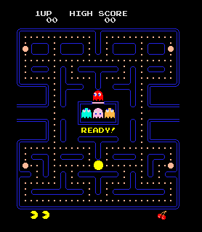

# Menu and Screen Descriptions

*(Include additional screen shots and accompanying descriptions for any menus and additional screen)*

# Game World

*The environment is a maze created in a black void.*

# Levels

*All levels include the same map.*

# Game Progression

In later levels the Pac-Man will no longer be able to eat the ghosts when a cherry is obtained, however the ghosts will still reverse directions.

# Characters

*Pac-Man is a yellow circle that has a mouth that opens and closes as the player moves.*

# Enemies

*FOur ghosts each a different colour that pursues Pac-Man.*

# Items

*Cherries that empower Pac-Man allowing him to modify the behaviour of the ghosts.*

# Future Features

* *Different maps*
* *More power ups*
* *Different enemies*