Heng Zhou

EECE 5644

Fall 2019

Homework 4

**Q1**

**Bird Image**

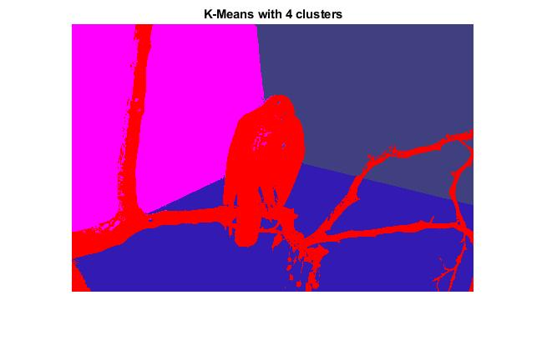

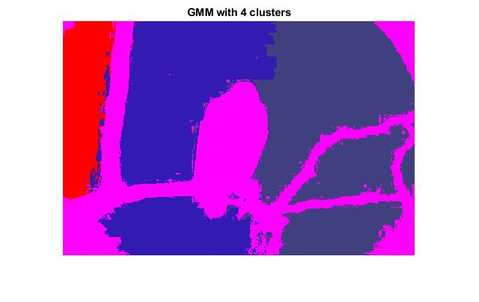

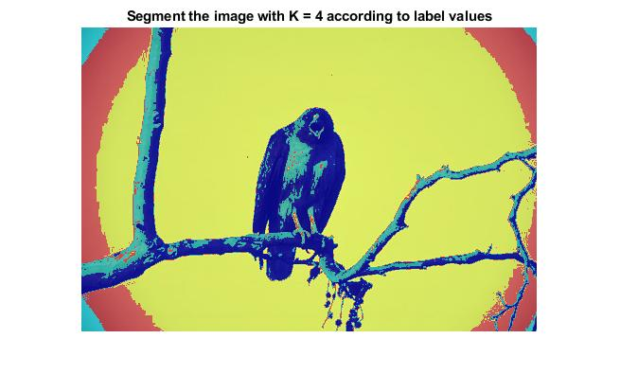

**Plane Image**

K-means with 4 clusters

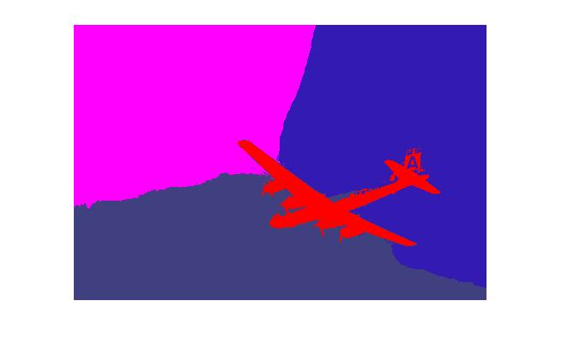

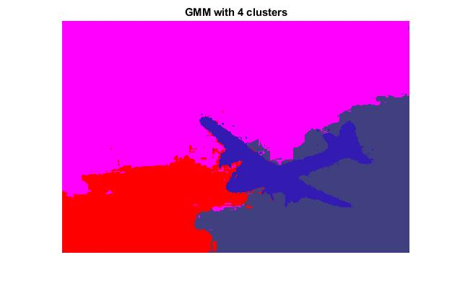

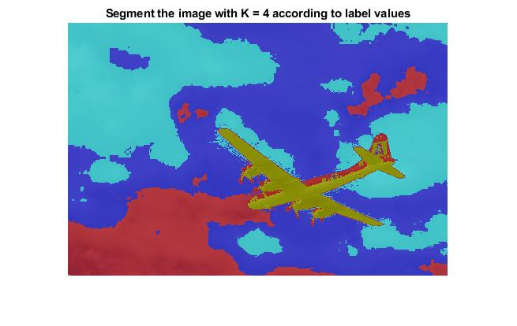

Above are the images produced by K-means and GMM-based clustering. Segment number K is 4 here and image results with other K values can be generated in my code.

We can see the images produced by the GMM-based algorithm is a little bit different from the imaged produced by the K-means: Boarders between segments in K-means is clearer while boarders between segments produced by GMM-based algorithm is more complex and have a bit more noise. This may because Gaussian distribution can produce some abnormal points randomly.