The program that I used was RAxML-NG and I created a phylogenetic tree from a DNA alignment using the provided data on primates. I used the all-in-one which does a ML search + bootstrapping. I told it to run the parsimony 10 times and bootstrapping 200 times. I ran the code using shell in R studio and the code I used is below:

/Applications/raxml-ng_v1.2.1_macos_M1/raxml-ng \

--all \

--msa primate.phy \

--model GTR+G \

--prefix T1 \

--tree pars{10} \

--bs-trees 200 \

--data-type DNA \

--msa-format PHYLIP

To open up the output file I used Figtree and rerooted the tree from the lemur/tarsier node. I also displayed the the support values on the tree.

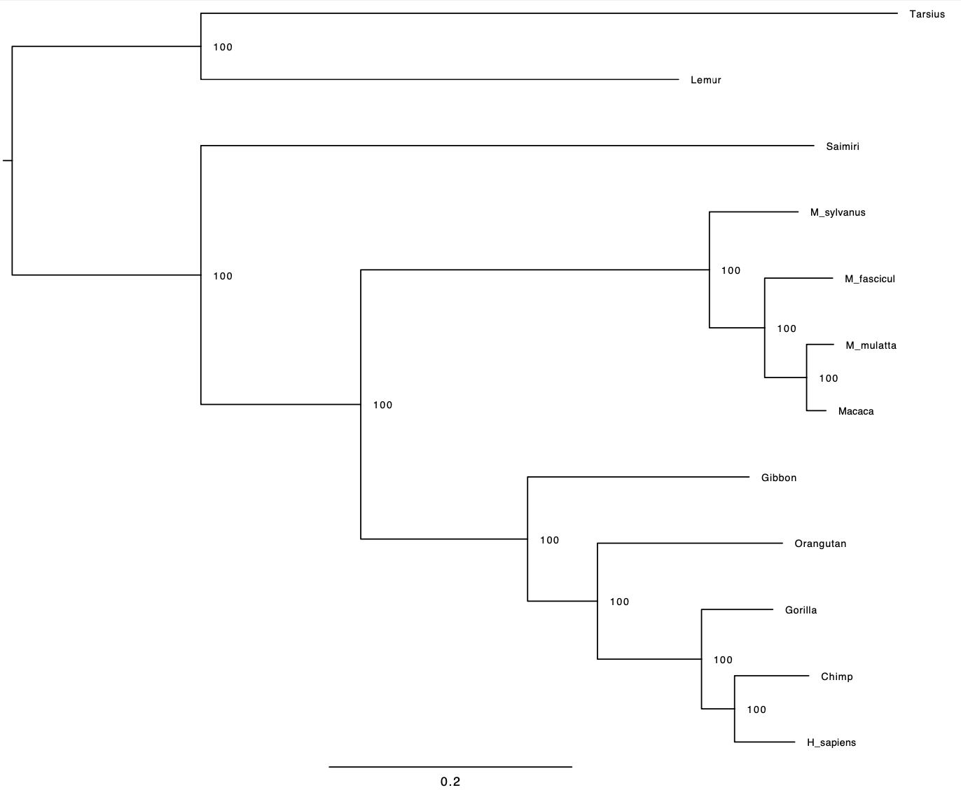

The image above is the tree I made. Notice the nodes each have a 100 supporting value. Meaning this is a relatively good tree.