Table of Contents
1. Introduction 2
2. Project Background And Rationale 3
2.1 Background 3
3. Problem Description And Analysis 5
3.1 The Community Problem 5
3.2 People Affected 5
11. Flowchart Design 19
11.1 Main System Flowchart 19
11.2 Priority Decision Flowchart 22
11.3 How to Make the Flowcharts Clear for Submission 23
12. Variables, Constants And Data Types 24
12.1 Constants 25
13. Decision Structures, Boolean Logic And Repetition 26
13.1 Decision Structures 26
13.2 Boolean Logic 26
13.3 Repetition Structures 27
13.4 Importance of These Structures 27
14. Modular Design And Functions 27
15.3 Scenario Three: Incomplete Complaint 30
16. Testing And Validation 32
16.1 Validation Rules 33
17. SUSTAINABLE DEVELOPMENT GOALS (SDGs) 33
21.5 README.md Content 41
21.6 GitHub Evidence Required in the Report 43
22. Limitations And Recommendations 43
22.1 Limitations 43
22.2 Recommendations 44
Conclusion 45
Reference…...…………………………………………………………………………………………………..46

1. Introduction
Waste management is an important issue affecting many communities in Sierra Leone. In some neighborhoods, waste is not collected regularly, rubbish is dumped in open spaces, and drainage channels become blocked by plastic bags, food remains and other unwanted materials. These problems can make the environment unpleasant and contribute to flooding, poor sanitation and the spread of disease.
Although waste collection requires physical workers, vehicles and disposal facilities, proper organization and information management can help make the process more effective. A simple digital system can help residents report waste problems, help collection teams organize their work and allow local authorities to monitor reported complaints.
This assignment proposes a Community Waste Management and Collection System (CWMCS) for Sierra Leone. The project focuses on designing the logical operation of the system rather than writing a computer program.
The design uses computational thinking, algorithms, pseudocode, flowcharts, decision structures, repetition structures, functions and modular design. It also explains how Open Source Software and Digital Public Goods can support community development and contribute to the United Nations Sustainable Development Goals.

2. Project Background And Rationale

2.1 Background
A clean environment is necessary for the health and well-being of every community. Households, markets, schools, restaurants and businesses produce waste every day. If waste is not properly stored, collected and disposed of, it can accumulate along roads, in public spaces and near residential buildings.
In Sierra Leone, waste management can be challenging in densely populated communities where collection services, disposal facilities and public awareness may be limited. Poorly managed waste can also block drainage systems, particularly during periods of heavy rainfall.
Traditional reporting methods may depend on residents visiting a local office, contacting a community leader or informing a waste collector directly. Such reports can be forgotten, duplicated or difficult to track. Collection teams may also find it difficult to decide which locations need urgent attention when they do not have an organised record of reported problems.
A simple and affordable information system could improve how these reports are recorded, prioritized, assigned and monitored.

2.2 Rationale for the Project
I selected this topic because waste management is a practical community challenge that can be addressed through better organization and logical decision-making. The proposed system does not claim that technology alone can solve the problem. Instead, it provides a way to support the people and organizations responsible for waste collection.
The system will allow a resident or community representative to submit a waste complaint by providing the location, waste category, description and date of the report. The system will validate the information, assign a reference number and classify the complaint according to its urgency.
For example, a report about rubbish blocking a drainage channel before heavy rainfall should receive greater attention than a report about a small quantity of litter in a location that does not present an immediate risk. The system will use simple rules to identify these differences.
Once a complaint has been accepted, it will be placed in a list for the responsible collection team. The team can update its status when the waste is being handled or when the task has been completed. If the report contains missing information, the system will ask for correction rather than accepting an incomplete complaint.
The proposed design will also keep a record of completed and pending reports. This can help community leaders identify frequently affected locations, review service performance and make better decisions about where collection resources are needed.

2.3 Importance to Sierra Leone
The project is relevant to Sierra Leone because a cleaner environment supports public health, safer neighborhoods and improved community living conditions. It is particularly useful as a proposed model for a local council, community organization or waste collection group that wants to improve its reporting process.
The system is designed to be simple enough for users with different levels of digital experience. It could eventually support mobile phones, a web interface and assisted reporting through community representatives.
The design also recognizes that some residents may not have smartphones, reliable internet access or sufficient digital literacy. For this reason, the proposed service should allow an authorized community representative to record a report on behalf of a resident. Offline collection of reports and later synchronization could also be considered during future development.

2.4 Expected Community Benefits
The proposed system is expected to:
• | Make it easier for residents to report waste problems.
• | Reduce the risk of complaints being forgotten or lost.
• | Help collection teams priorities urgent locations.
• | Improve communication between residents and local authorities.
• | Provide records for monitoring collection activities.
• | Encourage residents to participate in keeping their surroundings clean.
• | Support better planning and responsible use of waste management resources.
These are expected benefits of the proposed design. Actual improvements would depend on implementation, staff availability, collection vehicles, disposal facilities, funding and community participation.

3. Problem Description And Analysis

3.1 The Community Problem
The main problem is the difficulty of organising, prioritising and monitoring reports of uncollected waste in local communities.
When waste complaints are handled informally, there may be no consistent way to record their locations, determine their urgency, assign them to collection teams or confirm that the problem has been resolved.

3.2 People Affected
The people and organisations affected include:
• | Residents: They may live near accumulated rubbish or blocked drains.
• | Market traders: Waste from trading activities may accumulate if collection is delayed.
• | Schools and health centres: Poor sanitation around these facilities can create an unpleasant environment.
• | Waste collection workers: They may receive unclear instructions or travel unnecessarily between locations.
• | Local councils and community leaders: They may lack organised information for planning and monitoring services.
• | The wider community: Everyone benefits from cleaner public spaces and better environmental management.

3.3 Why the Problem Exists
Possible contributing factors include irregular collection schedules, limited waste collection resources, inadequate public awareness, poor reporting procedures, limited coordination and the absence of a shared complaint record.
These factors can differ from one community to another. The proposed system addresses the information and coordination aspects of the problem, while recognising that physical waste collection and disposal still require appropriate resources.

3.4 Proposed Problem Statement
Residents and community leaders need a simple and organised way to report uncollected waste, identify urgent cases, assign collection tasks and track progress. Without a consistent reporting and monitoring process, waste complaints may be delayed or overlooked.
The proposed Community Waste Management and Collection System will provide a logical process for recording complaints, checking their validity, assigning priorities, monitoring their status and producing summary reports.

4. Aim And Objectives

4.1 Aim
The aim of this project is to design a logical and accessible system that improves the reporting, prioritisation and monitoring of community waste collection activities in Sierra Leone.

4.2 Specific Objectives
The objectives are to:
1. | Identify the main information required when a waste complaint is submitted.
2. | Validate complaints before accepting them into the system.
3. | Assign a unique reference number to each accepted complaint.
4. | Classify reports according to urgency using clear decision rules.
5. | Organise accepted complaints for collection teams.
6. | Track reports from submission to completion.
7. | produce simple reports showing pending, urgent and completed complaints.
8. | Demonstrate computational thinking and structured algorithm design.
9. | Explain how open technologies and Digital Public Goods could support future development.
10. | Align the proposed system with relevant Sustainable Development Goals.

5. Scope Of The Proposed System
The proposed system will focus on the reporting and coordination of community waste collection.
Included in the design
• | Recording waste complaints.
• | Checking whether required information has been supplied.
• | Categorising the type of waste.
• | Identifying urgent complaints.
• | Assigning accepted complaints to a collection team.
• | Updating complaint status.
• | Repeating the process for multiple complaints.
• | Producing summary reports.
Not included in the initial design
• | Controlling waste collection vehicles.
• | Processing online payments.
• | Automatically detecting rubbish through cameras or artificial intelligence.
• | Replacing the responsibilities of local councils.
• | Guaranteeing that a collection team has a vehicle or disposal facility available.
• | Providing live GPS tracking.
These features may be considered in future versions if funding, infrastructure and technical capacity are available.

6. Proposed Solution
The proposed Community Waste Management and Collection System will follow a straightforward process.
First, a resident or authorised representative submits a complaint. The information includes the location, type of waste, a description of the problem and whether the report indicates a blocked drain or another immediate environmental concern.
Second, the system checks whether the required fields are complete. If information is missing, the report is returned for correction. If the information is complete, the system generates a reference number and stores the complaint.
Third, the system determines the complaint's priority. A complaint involving a blocked drainage channel or another defined urgent hazard is marked as high priority. Other valid reports are marked as normal priority.
Fourth, the complaint is added to the list of tasks for the responsible collection team. The team updates the complaint as pending, in progress, completed or referred for further attention.
Finally, the system produces a summary showing the number of reports received, the number awaiting collection, the number marked urgent and the number completed.
The system will support human decision-making rather than replacing it. A supervisor should be able to review an urgent classification, correct inaccurate information and refer complaints that require services beyond ordinary waste collection.

7. Computational Thinking Process
Computational thinking involves breaking a problem into manageable parts and developing a logical method for solving it.

7.1 Decomposition
The overall problem is divided into smaller tasks:
1. | Receive a waste complaint.
2. | Validate the information.
3. | Generate a reference number.
4. | Determine the complaint priority.
5. | Assign the task to a collection team.
6. | Update the complaint status.
7. | Produce a summary report.
Each task can be designed and checked independently.

7.2 Pattern Recognition
Different complaints may share similar characteristics. For example, reports can be grouped into categories such as household waste, market waste, plastic waste, illegal dumping and blocked drainage.
Recognising these patterns helps the system apply consistent rules and identify locations that repeatedly experience problems.

7.3 Abstraction
The system does not need to record every detail about a resident or every item of rubbish. It only needs information relevant to the collection process.
The main information is the complaint reference number, location, waste category, description, urgency, date and current status. Personal information should be limited to what is necessary for communication and service delivery.

7.4 Algorithmic Thinking
Algorithmic thinking involves arranging instructions in the correct order. The proposed system first validates a complaint, then records it, determines its priority, assigns it and tracks its progress.
This order prevents incomplete complaints from being treated as valid collection tasks.

7.5 Evaluation
The proposed design can be evaluated by checking whether it:
• | Rejects incomplete reports and asks for corrections.
• | Correctly identifies urgent cases.
• | Gives accepted reports unique reference numbers.
• | Processes multiple complaints.
• | Updates complaint status accurately.
• | Produces correct summary totals.

8. System Requirements

8.1 Functional Requirements
The system must:
1. | Accept a complaint from a resident or authorised representative.
2. | Check the location, waste category and description.
3. | Request missing information when a complaint is incomplete.
4. | Generate a unique reference number for each accepted complaint.
5. | Identify urgent complaints according to predefined rules.
6. | Store valid complaints and their status.
7. | Allow an authorised worker to update the status.
8. | Repeat the process until there are no more complaints to process.
9. | Display a summary of complaints by status and priority.

8.2 Non-Functional Requirements
The proposed system should be:
• | Easy to use: Instructions should be clear and simple.
• | Accessible: The design should consider users with disabilities and limited digital literacy.
• | Affordable: It should minimise unnecessary licensing and maintenance costs.
• | Reliable: Complaint records should be protected against accidental loss.
• | Secure: Only authorised users should be allowed to change official records.
• | Privacy-conscious: Personal details should not be published unnecessarily.
• | Maintainable: Future developers should be able to understand and improve the system.
• | Adaptable: It should be possible to use the design in different communities.

9. Algorithm Design

9.1 Main Algorithm
Algorithm name: Manage Community Waste Complaints
Purpose: To receive, validate, prioritise and track waste complaints.
Inputs: Location, waste category, description, blocked-drain indicator and complaint status.
Processing: Validate information, generate a reference number, determine priority, assign the task and update records.
Outputs: A complaint reference number, validation message, priority classification, task status and summary report.
Step-by-step algorithm
1. | Start the system.
2. | Set the complaint counter to zero.
3. | Set the pending, urgent and completed totals to zero.
4. | Ask whether a new complaint is available.
5. | If no complaint is available, proceed to the summary report.
6. | If a complaint is available, collect the required information.
7. | Check whether the required information is complete.
8. | If the information is incomplete, request correction.
9. | Repeat the validation process until the information is corrected or the submission is cancelled.
10. | Generate a unique complaint reference number.
11. | Determine whether the complaint meets the urgent-priority rules.
12. | If it is urgent, mark it as high priority; otherwise, mark it as normal priority.
13. | Record the complaint and assign it to the responsible collection team.
14. | Update the complaint status when the team begins work.
15. | Update the status again when the work is completed or referred for further attention.
16. | Update the relevant totals.
17. | Ask whether another complaint needs to be processed.
18. | Repeat the process while more complaints are available.
19. | Produce a summary report.
20. | End the process.

9.2 Algorithm for Validating a Complaint
1. | Receive the complaint details.
2. | Check whether the location is provided.
3. | Check whether the waste category is selected.
4. | Check whether a description has been entered.
5. | If any required field is missing, return an incomplete-report message.
6. | If all required fields are present, accept the complaint for processing.
7. | Return the validation result.

9.3 Algorithm for Determining Priority
1. | Receive a validated complaint.
2. | Check whether the complaint reports a blocked drain or a defined immediate environmental hazard.
3. | If the condition is true, classify the complaint as high priority.
4. | Otherwise, classify it as normal priority.
5. | Store the priority and display the result.

10. Pseudocode
The following pseudocode describes the logical operation of the proposed system. It is not a computer program and is not intended to be executed.

10.1 Main System Pseudocode
BEGIN CommunityWasteManagementSystem
SET ComplaintCounter = 0
SET PendingCount = 0
SET UrgentCount = 0
SET CompletedCount = 0
INPUT MoreComplaints
WHILE MoreComplaints = TRUE
CALL CollectComplaintDetails
CALL ValidateComplaint
IF ComplaintIsValid = TRUE THEN
ComplaintCounter = ComplaintCounter + 1
CALL GenerateReferenceNumber
CALL DeterminePriority
CALL AssignCollectionTeam
SET ComplaintStatus = "Pending"
PendingCount = PendingCount + 1
DISPLAY "Complaint accepted"
DISPLAY ComplaintReference
DISPLAY ComplaintPriority
DISPLAY ComplaintStatus
ELSE
DISPLAY "Required information is missing"
DISPLAY "Please correct the complaint"
ENDIF
INPUT MoreComplaints
ENDWHILE
CALL GenerateSummaryReport
DISPLAY "Total Complaints: ", ComplaintCounter
DISPLAY "Pending Complaints: ", PendingCount
DISPLAY "Urgent Complaints: ", UrgentCount
DISPLAY "Completed Complaints: ", CompletedCount
END CommunityWasteManagementSystem

10.2 Complaint Validation Pseudocode
FUNCTION ValidateComplaint
SET ComplaintIsValid = TRUE
IF Location IS EMPTY THEN
SET ComplaintIsValid = FALSE
ENDIF
IF WasteCategory IS EMPTY THEN
SET ComplaintIsValid = FALSE
ENDIF
IF Description IS EMPTY THEN
SET ComplaintIsValid = FALSE
ENDIF
RETURN ComplaintIsValid
END FUNCTION

10.3 Priority Classification Pseudocode
FUNCTION DeterminePriority
IF BlockedDrain = TRUE
OR ImmediateHazard = TRUE THEN
SET ComplaintPriority = "High"
UrgentCount = UrgentCount + 1
ELSE
SET ComplaintPriority = "Normal"
ENDIF
RETURN ComplaintPriority
END FUNCTION

10.4 Collection Status Pseudocode
FUNCTION UpdateComplaintStatus
INPUT NewStatus
IF NewStatus = "In Progress" THEN
SET ComplaintStatus = "In Progress"
ELSE IF NewStatus = "Completed" THEN
SET ComplaintStatus = "Completed"
CompletedCount = CompletedCount + 1
ELSE IF NewStatus = "Referred" THEN
SET ComplaintStatus = "Referred"
ELSE
DISPLAY "Invalid status"
DISPLAY "Please select a valid status"
ENDIF
RETURN ComplaintStatus
END FUNCTION

10.5 Important Logical Note
In an actual system, a complaint should not be counted as completed more than once. When its status changes from pending or in progress to completed, the system should update the totals once only. Similarly, urgent and pending totals should be recalculated or updated when complaint statuses change.
The pseudocode above introduces the required programming logic, but these counting rules must be handled carefully during a future implementation to prevent inaccurate reports.

11. Flowchart Design
A flowchart is a diagram that represents the steps and decisions in an algorithm. It uses standard shapes to show the beginning and end of a process, inputs and outputs, processing steps and decision points.
The following flowchart represents the main complaint-handling process.

11.1 Main System Flowchart
Copy this diagram into a Mermaid-compatible editor, or recreate it in diagrams.net (Draw.io), for a clean, high-resolution figure.
A([Start]) --> B[Initialise counters]
B --> C[/Ask if a complaint is available/]
C --> D{Complaint available?}
D -- No --> M[Generate summary report]
M --> N[/Display totals/]
N --> O([End])
D -- Yes --> E[/Enter location, category and description/]
E --> F{Required fields complete?}
F -- No --> G[/Request missing information/]
G --> E
F -- Yes --> H[Generate reference number]
H --> I{Blocked drain or immediate hazard?}
I -- Yes --> J[Set priority to High]
I -- No --> K[Set priority to Normal]
J --> L[Record complaint and assign team]
K --> L
L --> P[Set status to Pending]
P --> Q[/Display reference and status/]
Q --> R{More complaints?}
R -- Yes --> E
R -- No --> M
classDef startend fill:#e8f5e9,stroke:#237a3b,color:#12351b,stroke-width:2px
classDef decision fill:#fff4d6,stroke:#a66b00,color:#543500,stroke-width:2px
classDef process fill:#eaf2ff,stroke:#3267a8,color:#152f52
classDef io fill:#f2eaff,stroke:#7650a6,color:#34204e
class A,O startend
class D,F,I,R decision
class B,H,J,K,L,P,M process
class C,E,G,N,Q io
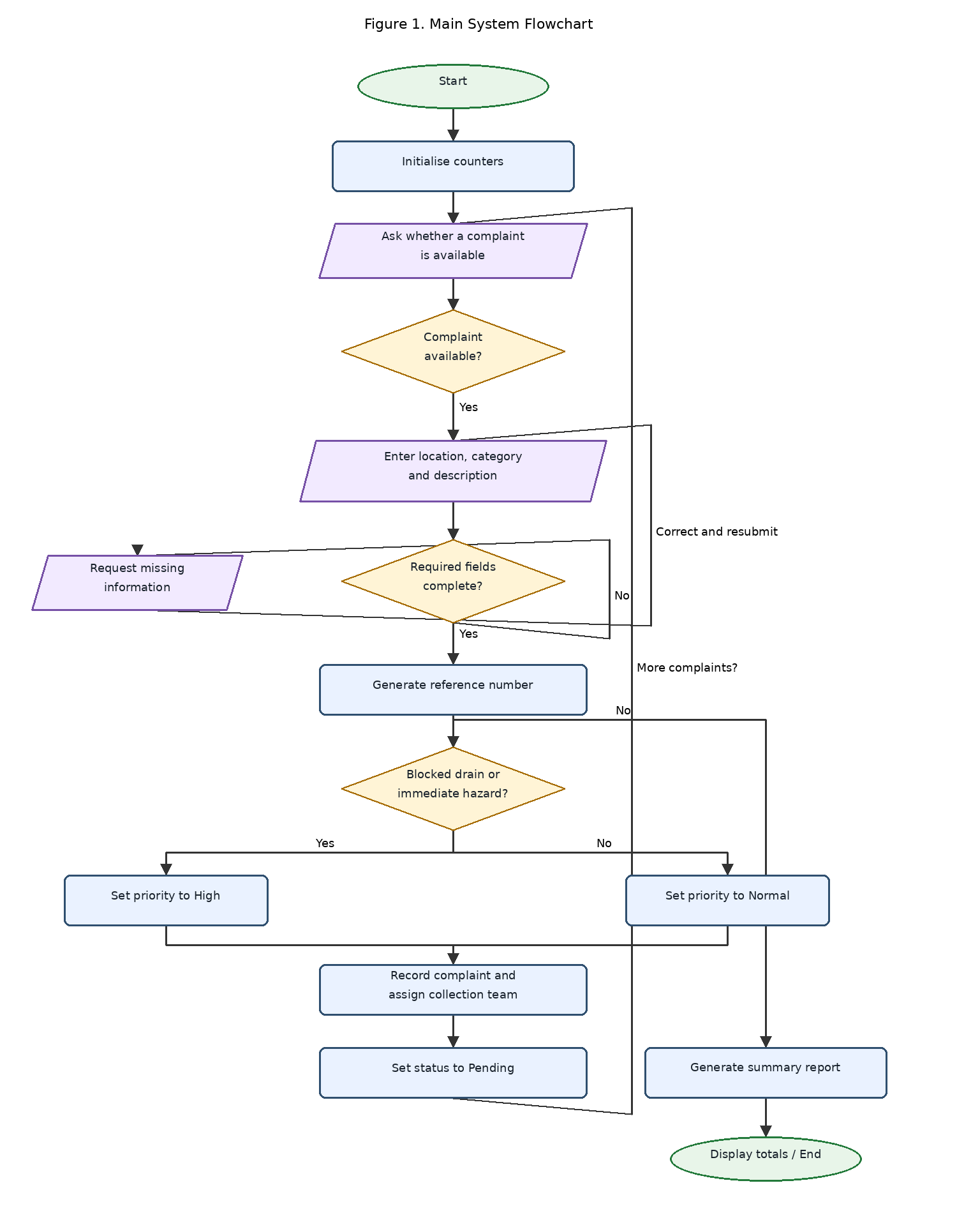
Figure 1: Main flowchart for the Community Waste Management and Collection System.
Explanation of the Flowchart
• | The oval shapes show the start and end of the process.
• | The rectangles represent processing activities.
• | The diamond shapes represent decisions.
• | The input/output shapes show where information is entered or displayed.
• | The arrows show the direction of the process.
• | The loop allows the system to handle more than one complaint.
• | If required information is missing, the process returns to the input stage.
• | If no further complaints are available, the system produces a summary report.

11.2 Priority Decision Flowchart
A([Start]) --> B[/Receive validated complaint/]
B --> C{Blocked drain or immediate hazard?}
C -- Yes --> D[Set priority to High]
C -- No --> E[Set priority to Normal]
D --> F[Save priority]
E --> F
F --> G([End])
style A fill:#e8f5e9,stroke:#237a3b,stroke-width:2px
style G fill:#e8f5e9,stroke:#237a3b,stroke-width:2px
style C fill:#fff4d6,stroke:#a66b00,stroke-width:2px
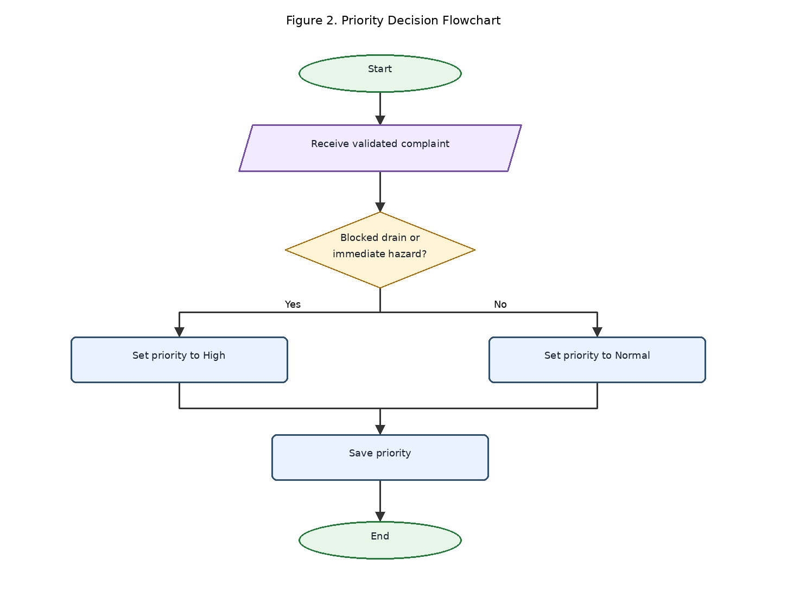
Figure 2: Flowchart showing the priority classification process.

11.3 How to Make the Flowcharts Clear for Submission
1. | Open diagrams.net (Draw.io).
2. | Create a new blank diagram.
3. | Use the flowcharts above as the reference for drawing the shapes and arrows.
4. | Arrange the flow vertically and avoid crossing lines wherever possible.
5. | Use readable text, consistent shapes and a plain white background.
6. | Keep decision labels such as Yes and No close to their arrows.
7. | Export the final diagrams as PNG or PDF at high resolution.
8. | Insert the diagrams into the report and label them Figure 1 and Figure 2.
9. | Check that all text remains readable when printed on A4 paper.
10. | Include the original editable diagram file in the GitHub repository.
The diagrams should be redrawn or exported from the diagram editor for the final submission. The text versions above are clear design references, not evidence that a diagram has already been created in Draw.io.

12. Variables, Constants And Data Types
Variables store information that can change while the system operates. Constants represent values that remain fixed during a particular operation. Data types identify the kind of information being stored.
Variable or constant | Data type | Purpose
ComplaintCounter | Integer | Stores the number of accepted complaints
PendingCount | Integer | Stores the number of pending complaints
UrgentCount | Integer | Stores the number of urgent complaints
CompletedCount | Integer | Stores the number of completed complaints
ComplaintReference | String | Stores the unique complaint identifier
Location | String | Stores the reported waste location
WasteCategory | String | Stores the category of waste
Description | String | Stores a short explanation of the problem
BlockedDrain | Boolean | Indicates whether a drain is blocked
ImmediateHazard | Boolean | Indicates whether an immediate hazard is reported
ComplaintIsValid | Boolean | Indicates whether required information is complete
ComplaintPriority | String | Stores High or Normal priority
ComplaintStatus | String | Stores Pending, In Progress, Completed or Referred
MoreComplaints | Boolean | Controls whether the system processes another complaint
MAX_DESCRIPTION_LENGTH | Integer constant | Defines the permitted maximum description length
The description length is an example of a rule that would be selected by the project team. Its actual value should be agreed before implementation.

12.1 Constants
Possible constants include:
• | STATUS_PENDING = "Pending"
• | STATUS_IN_PROGRESS = "In Progress"
• | STATUS_COMPLETED = "Completed"
• | STATUS_REFERRED = "Referred"
• | PRIORITY_HIGH = "High"
• | PRIORITY_NORMAL = "Normal"
These constants reduce spelling errors and keep the system's decisions consistent.

13. Decision Structures, Boolean Logic And Repetition

13.1 Decision Structures
Decision structures allow the system to choose an action based on a condition.
For example:
IF ComplaintIsValid = TRUE THEN
Accept complaint
ELSE
Request correction
ENDIF
This decision prevents incomplete complaints from being processed as valid reports.

13.2 Boolean Logic
Boolean values can be either TRUE or FALSE.
The system uses Boolean conditions to determine whether information is complete, whether an urgent hazard has been reported and whether another complaint should be processed.
The priority rule uses the logical OR operator:
IF BlockedDrain = TRUE OR ImmediateHazard = TRUE THEN
ComplaintPriority = "High"
ELSE
ComplaintPriority = "Normal"
ENDIF
The OR operator means that either condition can trigger high priority.

13.3 Repetition Structures
A repetition structure allows an action to be performed more than once.
The main algorithm uses a WHILE loop:
WHILE MoreComplaints = TRUE
Collect complaint details
Validate complaint
Determine priority
Record complaint
ENDWHILE
The loop continues while there are more complaints to process. It stops when the user indicates that there are no further complaints.
The validation process may also repeat when the user needs to correct missing information.

13.4 Importance of These Structures
Decision structures make the system responsive to different situations. Boolean logic makes its rules explicit, while repetition allows it to process many complaints without rewriting the same instructions for every report.
Together, these concepts demonstrate the core principles of programming logic and design without requiring source code.

14. Modular Design And Functions
Modular design divides a large task into smaller, related components. Each module has a specific responsibility and can be designed, checked and improved separately.

14.1 Proposed System Modules
Module | Responsibility | Input | Output
Complaint Input Module | Collects complaint information | Location, category, description | Complaint details
Validation Module | Checks required fields | Complaint details | Valid or invalid result
Reference Module | Generates an identifier | Accepted complaint | Complaint reference
Priority Module | Determines urgency | Hazard indicators | High or Normal
Assignment Module | Selects the responsible collection team | Location and category | Assigned team
Status Module | Updates progress | New status | Updated complaint record
Reporting Module | Calculates and displays totals | Complaint records | Summary report

14.2 Functions
A function performs a defined task and may return a result.
The proposed system includes the following functions:
• | ValidateComplaint() — checks whether required information is complete.
• | GenerateReferenceNumber() — produces a unique complaint reference.
• | DeterminePriority() — classifies a complaint as High or Normal.
• | AssignCollectionTeam() — identifies the appropriate collection team.
• | UpdateComplaintStatus() — changes the status of a complaint.
• | GenerateSummaryReport() — produces totals and a summary of complaint records.

14.3 Benefits of Modular Design
Modular design makes the proposed system easier to understand, test and maintain. If the priority rules change, the priority module can be updated without redesigning the entire system.
It also supports teamwork because different people can review individual modules and suggest improvements. Each module should have clear inputs and outputs so that its work can be connected to the rest of the system.

15. Expected Outputs And Sample Scenarios
The following scenarios demonstrate how the proposed logical design should behave. They are illustrative examples, not actual field results.

15.1 Scenario One: Urgent Complaint
Input
• | Location: Example Street, Freetown
• | Waste category: Mixed waste
• | Description: Rubbish is blocking the drainage channel.
• | Blocked drain: TRUE
• | Immediate hazard: TRUE
Expected output
Complaint accepted.
Reference: CWM-0001
Priority: HIGH
Status: Pending
Action: Refer to the responsible collection team
Explanation: The report contains the required information and identifies a blocked drain. The system accepts it, generates a reference and classifies it as high priority.

15.2 Scenario Two: Normal Complaint
Input
• | Location: Example Market Area
• | Waste category: Market waste
• | Description: Waste has accumulated near a collection point.
• | Blocked drain: FALSE
• | Immediate hazard: FALSE
Expected output
Complaint accepted.
Reference: CWM-0002
Priority: NORMAL
Status: Pending
Action: Add to the collection team's task list
Explanation: The report is complete but does not meet the defined urgent-priority rules. It is accepted as a normal-priority complaint.

15.3 Scenario Three: Incomplete Complaint
Input
• | Location: Not provided
• | Waste category: Plastic waste
• | Description: Rubbish is on the roadside.
Expected output
Complaint not accepted yet.
Reason: Required location is missing.
Action: Please provide the location and submit again.
Explanation: The system requests the missing information before generating a final complaint reference. This reduces the risk of collection teams receiving reports they cannot locate.

15.4 Scenario Four: Completed Complaint
Input
• | Reference: CWM-0002
• | Previous status: In Progress
• | New status: Completed
Expected output
Complaint Reference: CWM-0002
Previous Status: In Progress
New Status: Completed
Confirmation: Status updated successfully.
Explanation: An authorised worker updates the complaint after the collection task has been completed. The reporting module should reflect the change.

15.5 Example Summary Report
Suppose the system has processed ten valid complaints in an illustrative test. The following totals could be displayed if the underlying records support them.
Report item | Example total
Total valid complaints | 10
High-priority complaints | 3
Normal-priority complaints | 7
Pending complaints | 4
In-progress complaints | 2
Completed complaints | 3
Referred complaints | 1
Consistency check: The status totals add up to ten, and the priority totals also add up to ten. The totals are examples only; actual values must be calculated from the stored complaint records.

16. Testing And Validation
Testing is necessary to confirm that the logical design behaves as expected in different situations.
Test | Test condition | Expected result
1 | All required fields are complete | Complaint is accepted
2 | Location is missing | System requests correction
3 | Waste category is missing | System requests correction
4 | Blocked drain is TRUE | Complaint receives High priority
5 | No urgent condition is reported | Complaint receives Normal priority
6 | A new complaint is submitted | A unique reference is generated
7 | Status is changed to Completed | Complaint record is updated
8 | An invalid status is entered | System rejects the status and requests a valid one
9 | More complaints are available | Processing loop continues
10 | No more complaints are available | Summary report is produced

16.1 Validation Rules
The proposed design should follow these rules:
• | Required fields must not be empty.
• | Each accepted complaint must have a unique reference number.
• | Only permitted status values should be accepted.
• | Only authorised users should update official complaint records.
• | A complaint should not be counted as completed more than once.
• | The number of complaints in each status category should agree with the total number of valid complaints.
• | Urgent classifications should be based on documented rules and reviewed where necessary.
These checks help prevent inaccurate records and improve the reliability of the final report.

17. SUSTAINABLE DEVELOPMENT GOALS (SDGs)
The proposed project supports the United Nations Sustainable Development Goals, particularly SDG 11 and SDG 12.

17.1 SDG 11: Sustainable Cities and Communities
SDG 11 aims to make cities and human settlements inclusive, safe, resilient and sustainable. Its targets include improving urban living conditions and strengthening the management of human settlements.
The proposed system contributes to this goal by improving how residents report waste problems and how collection teams organise their activities. Better coordination may support cleaner public spaces and more responsive local services.
Official source: United Nations — Sustainable Development Goal 11

17.2 SDG 12: Responsible Consumption and Production
SDG 12 promotes responsible consumption and production patterns.
The proposed system can support this goal by recording recurring waste problems and helping community organisations identify where better waste handling, separation, recycling or public education may be needed.
However, a complaint-management system alone does not guarantee recycling or responsible disposal. These outcomes require suitable collection facilities, public participation and effective waste management policies.
Official source: United Nations — Sustainable Development Goal 12

17.3 SDG 3: Good Health and Well-Being
SDG 3 aims to promote healthy lives and well-being for all.
By helping communities report waste accumulation and potential environmental hazards, the proposed system may support activities that contribute to healthier surroundings. The system itself is not a medical service and cannot guarantee reductions in disease.
Official source: United Nations — Sustainable Development Goal 3

18. Open Source Software Justification

18.1 Meaning of Open Source Software
Open Source Software is software distributed under a licence that allows users to access its source code and exercise specified rights to use, study, modify and redistribute it.
For the proposed Community Waste Management and Collection System, an open-source approach would allow qualified developers, educational institutions, local councils and community organisations to inspect and improve the system.

18.2 Why the System Should Be Open Source
The system should be considered for open-source development because it is intended to support a community service. Making its design and source code available under an appropriate licence could reduce dependence on a single supplier and allow local developers to adapt the system to different community needs.
Open licensing could also encourage independent review, which is useful for identifying errors and improving security. However, open source does not mean that hosting, training, support, maintenance and equipment are automatically free.

18.3 Benefits for Sierra Leone
The potential benefits include:
• | Lower software licensing costs.
• | Opportunities for local students and developers to gain experience.
• | Easier adaptation to local languages and reporting procedures.
• | Collaboration between universities, councils and community groups.
• | Reduced dependence on a single software provider.
• | Greater transparency about how complaint priorities are determined.
• | Opportunities to reuse the system in other communities.

18.4 Potential Community Contributions
Community members and technical contributors could help by:
• | Translating user instructions into locally useful languages.
• | Reviewing the clarity of complaint categories.
• | Reporting errors and suggesting improvements.
• | Improving accessibility for people with disabilities.
• | Updating documentation.
• | Testing the system with realistic scenarios.
• | Reviewing privacy and security practices.
Contributions should be reviewed before being accepted into the main project. The system should also have a clear maintenance plan and responsible project owners.

18.5 Suggested Open-Source Licence
If the system is developed, the project team could consider an OSI-approved licence such as the MIT License or GNU General Public License (GPL), depending on its sharing and reuse objectives.
The final choice should be made by the project owner before publication. A licence should not be claimed until it has actually been selected and included in the repository.

19. Digital Public Goods Justification

19.1 Meaning of Digital Public Goods
Digital Public Goods (DPGs) are digital resources, such as open-source software, open data, open AI systems, open standards and open content, that can contribute to sustainable development while respecting privacy, applicable laws and other relevant safeguards.
The Digital Public Goods Alliance provides a standard for evaluating whether a digital solution meets the requirements for recognition as a Digital Public Good.
Official source: Digital Public Goods Alliance — Digital Public Goods Standard

19.2 How the Proposed System Could Become a Digital Public Good
The proposed system could be developed with the intention of becoming a Digital Public Good by following several principles.
Open licensing: Its software should use an appropriate approved open licence.
Public benefit: The system should address a genuine community need and demonstrate relevance to one or more SDGs.
Accessibility: Its interface and documentation should be understandable and usable by people with different abilities and levels of digital experience.
Privacy: Personal information should be limited to what is necessary, and complaint records should be protected from unauthorised access.
Documentation: The project should include clear instructions, system requirements, logical diagrams and maintenance guidance.
Interoperability: Where practical, it should use open standards that make it easier to exchange appropriate information with other systems.
Community participation: Residents, local authorities, developers and civil society organisations should be able to suggest improvements through a transparent contribution process.

19.3 Accessibility, Openness and Public Benefit
The system could be made more accessible by supporting mobile-friendly interfaces, simple language and assisted reporting for residents who cannot use the digital service independently.
Openness would allow other organisations to study the system and adapt it for their own communities, subject to its licence and applicable laws.
Its public benefit would come from improving the organisation of waste complaints and supporting better service planning.

19.4 Important Qualification
The proposed design is not automatically a recognised Digital Public Good simply because it is intended for community use or because it may become open source. It would need to be developed, documented and assessed against the applicable Digital Public Goods Standard before it could be described as an officially recognised DPG.

20. Community Impact And Long-Term Sustainability

20.1 Expected Impact
The proposed system is expected to make reporting more organised and help collection teams identify the locations and complaints that require attention.
If implemented effectively, it could improve communication between residents and service providers, support monitoring of collection activities and provide information for local planning.
Its actual impact should be evaluated after a pilot project by measuring indicators such as the number of complaints received, the percentage of complaints resolved, the time taken to address urgent cases and the number of repeated complaints from the same location.

20.2 Beneficiaries
The main beneficiaries are residents, market traders, community representatives, waste collection workers, local councils, schools and other organisations that rely on clean surroundings.
The wider community may also benefit if better reporting and coordination contribute to more consistent waste collection and improved environmental awareness.

20.3 Long-Term Sustainability
For the system to remain useful, the responsible organisation must identify who will maintain it, manage its records and respond to reports.
A practical sustainability plan should include:
• | Training for collection workers and community representatives.
• | A designated person or team responsible for maintaining the system.
• | A realistic budget for devices, hosting, support and maintenance.
• | Regular backups and appropriate access controls.
• | Periodic review of priority rules and reporting categories.
• | Community education about responsible waste disposal.
• | Monitoring of performance indicators.
• | A process for handling complaints that cannot be resolved through ordinary collection.
The project should begin with a small pilot in one selected community. Feedback can then be used to improve the design before expanding to other locations.

21. Github And Version Control
GitHub will be used to store the assignment documents, pseudocode, flowcharts and project documentation. Git will help record changes made during the development of the assignment.

21.1 Repository Naming Convention
The repository should follow the required naming convention:
PROG101_Assignment1_StudentName_StudentID
For example, if the student's name and identification number match the details provided on the cover page, the name should be completed using the student's actual full name and verified student ID.

21.2 Recommended Repository Structure
PROG101_Assignment1_StudentName_StudentID/
│
├── README.md
├── LICENSE
├── Report/
│ └── PROG101_Assignment_Report.pdf
├── Algorithms/
│ └── Waste_Management_Algorithm.md
├── Pseudocode/
│ └── Waste_Management_Pseudocode.md
├── Flowcharts/
│ ├── Main_System_Flowchart.png
│ ├── Priority_Flowchart.png
│ └── Editable_Flowcharts.drawio
├── Screenshots/
│ └── Repository_Screenshot.png
└── References/
└── References.md
The LICENSE file should only be included once the project licence has been selected. Students may also adjust the folder structure to match their lecturer's requirements.

21.3 Steps to Create the Repository
1. | Visit GitHub and sign in or create an account.
2. | Select the option to create a new repository.
3. | Enter the repository name using the required naming convention.
4. | Add a short description of the project.
5. | Select the repository visibility required by the lecturer.
6. | Add a README file.
7. | Upload the assignment report, pseudocode, algorithms and flowcharts.
8. | Commit the files with meaningful descriptions.
9. | Continue committing changes as the assignment improves.
10. | Copy the actual repository URL into the final report.
Official guide: GitHub Docs — Quickstart for Repositories

21.4 Example Commit History
The following is a suggested sequence of commits. These are examples of messages, not evidence of commits that have already been made.
Commit message | Purpose
Create project repository and README | Establish the project documentation
Add problem analysis and project rationale | Record the problem and proposed solution
Add main algorithm and pseudocode | Document the logical process
Add main system flowchart | Include the complaint-handling diagram
Add priority classification flowchart | Document the priority decision
Add SDG and open-source discussion | Complete the sustainability sections
Revise report and add references | Improve the final report
Add final submission screenshots | Include genuine repository evidence

21.5 README.md Content
The following text can be used as the starting point for the repository's README file.
# Community Waste Management and Collection System
## Course
PROG101 - Principles of Programming Logic and Design
## Project Description
This project presents the logical design of a proposed
Community Waste Management and Collection System for Sierra Leone.
## Project Purpose
The system is designed to organise waste complaints, validate
reports, classify urgency, assign collection tasks and track status.
## Assignment Scope
This is a system-design assignment. It includes algorithms,
pseudocode, flowcharts, modular design, decision structures,
repetition structures and sample outputs. It does not include
a working software application.
## Project Files
- Report: Full assignment report
- Algorithms: Step-by-step system algorithms
- Pseudocode: Logical system descriptions
- Flowcharts: System diagrams
- References: Sources used in the assignment
## Sustainable Development Goals
The project is designed to support SDG 11 and SDG 12,
with potential links to SDG 3.
## Status
Logical design and documentation project.
## Author
[Insert Student's Full Name]
## Student ID
[Insert Verified Student ID]

21.6 GitHub Evidence Required in the Report
Before submission, insert genuine evidence showing:
• | The actual repository URL.
• | A screenshot of the repository homepage.
• | A screenshot of the files uploaded to the repository.
• | A screenshot of the commit history.
• | The README.md file displayed in the repository.
The report must not present example commit messages or placeholder URLs as proof of completed GitHub work. These items should be replaced with evidence from the student's actual account.

22. Limitations And Recommendations

22.1 Limitations
The proposed system has some limitations.
First, it cannot physically remove rubbish. It only helps organise reports and collection tasks.
Second, the system depends on accurate information from residents and representatives. Incorrect locations or misleading descriptions could delay collection.
Third, a digital service may exclude people who lack reliable internet access, suitable devices or digital skills.
Fourth, the system cannot guarantee that collection teams have enough vehicles, workers, fuel or disposal facilities.
Finally, its effectiveness depends on responsible staff members updating complaint records and responding to reports.

22.2 Recommendations
The following actions are recommended:
1. | Consult residents, waste workers and local authorities before implementation.
2. | Pilot the system in one community before expanding it.
3. | Provide training for authorised users.
4. | Establish clear rules for urgent and normal complaints.
5. | Protect personal information and restrict access to official records.
6. | Provide an assisted reporting method for residents who cannot use digital tools.
7. | Monitor collection performance and use feedback to improve the system.
8. | Consider integration with existing local waste collection procedures where appropriate.
9. | Maintain the system through a clear budget and assigned responsibilities.
10. | Evaluate whether the system contributes to measurable improvements in complaint handling and waste collection.

Conclusion
This assignment has presented the logical design of a proposed Community Waste Management and Collection System for Sierra Leone. The project addresses the need for a more organised way to report waste problems, determine their urgency, assign collection tasks and monitor progress.
The design demonstrates computational thinking through decomposition, pattern recognition, abstraction and algorithmic thinking. It also applies algorithms, pseudocode, flowcharts, variables, constants, data types, decision structures, Boolean logic, repetition structures, functions and modular design.
The sample scenarios show how the system should respond to urgent complaints, normal complaints, incomplete reports and completed tasks. Testing and validation rules are included to help ensure that the logical process behaves consistently.
The project also explains how Open Source Software could encourage local participation and reduce dependence on a single provider. It considers how the system might contribute to SDG 11, SDG 12 and SDG 3, and how it could be developed towards the Digital Public Goods Standard.
In conclusion, the proposed system is a practical example of how programming logic and design can be applied to a community challenge without writing source code. With proper planning, community participation, responsible maintenance and adequate waste collection resources, it could support more organised and responsive waste management services.

References
Digital Public Goods Alliance. (n.d.). Digital Public Goods Standard. Retrieved October 19, 2026, from https://www.digitalpublicgoods.net/standard
GitHub. (n.d.). Quickstart for repositories. GitHub Docs. Retrieved October 19, 2026, from https://github.com/github/docs/blob/main/content/repositories/creating-and-managing-repositories/quickstart-for-repositories.md
GitHub. (n.d.). About the README file. GitHub Docs. Retrieved October 19, 2026, from https://docs.github.com/en/repositories/managing-your-repositorys-settings-and-features/customizing-your-repository/about-readmes
United Nations. (n.d.). Goal 3: Good health and well-being. Sustainable Development Goals. https://sdgs.un.org/goals/goal3
United Nations. (n.d.). Goal 11: Sustainable cities and communities. Sustainable Development Goals. https://sdgs.un.org/goals/goal11
United Nations. (n.d.). Goal 12: Responsible consumption and production. Sustainable Development Goals. https://sdgs.un.org/goals/goal12
Additional course reference: PROG101 assignment brief, Principles of Programming Logic and Design: Designing Logical Solutions for Sierra Leone Community Challenges, supplied by the course examiner

