QUIZ APPLICATION DIAGRAMS

- CASE DIAGRAM :-

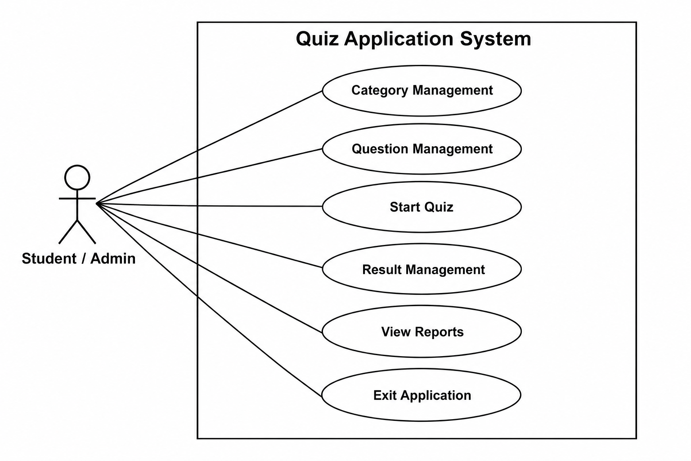
- ER DIAGRAM :-

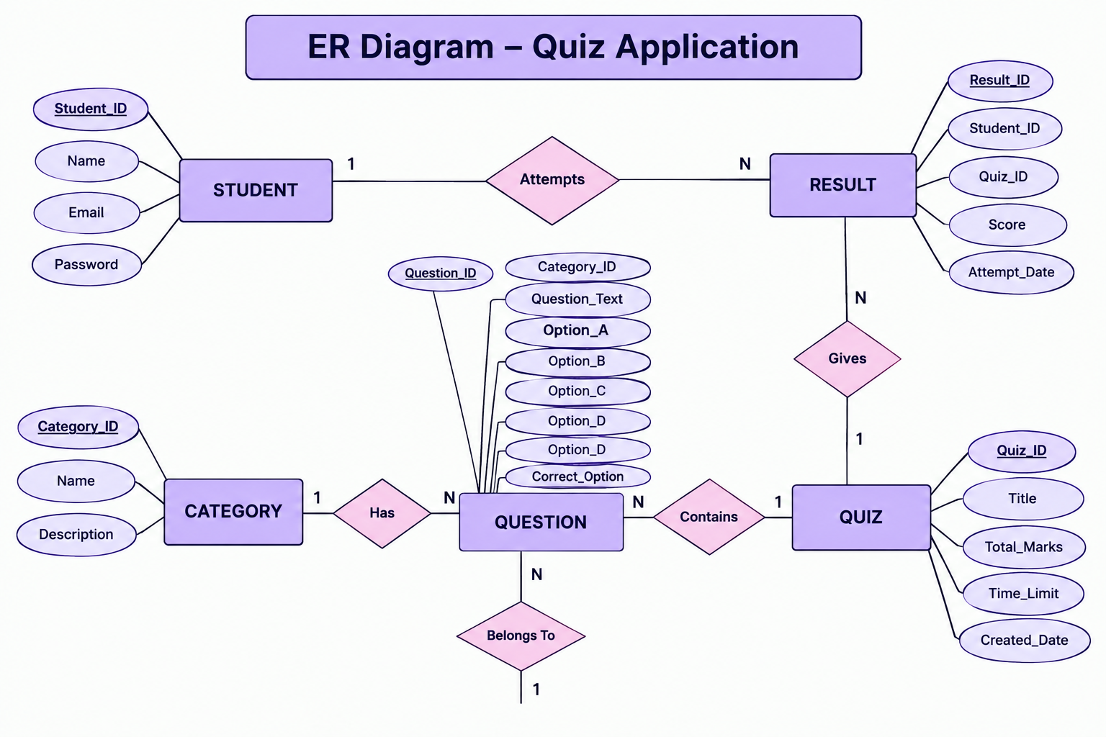
3.CLASS DIAGRAM :-

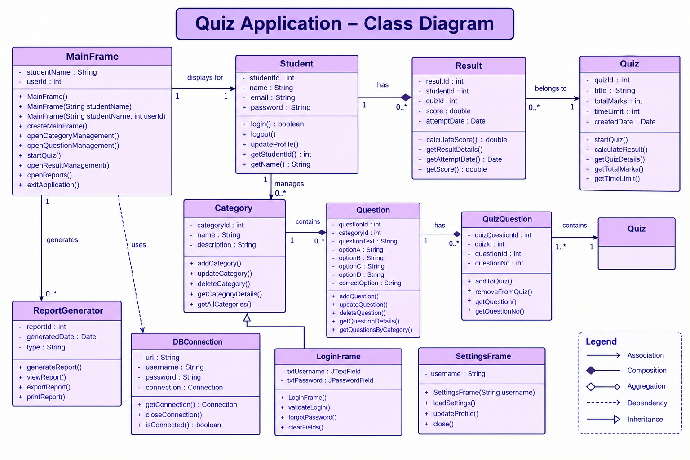
4. DFD LEVEL 0 DIAGRAM :-

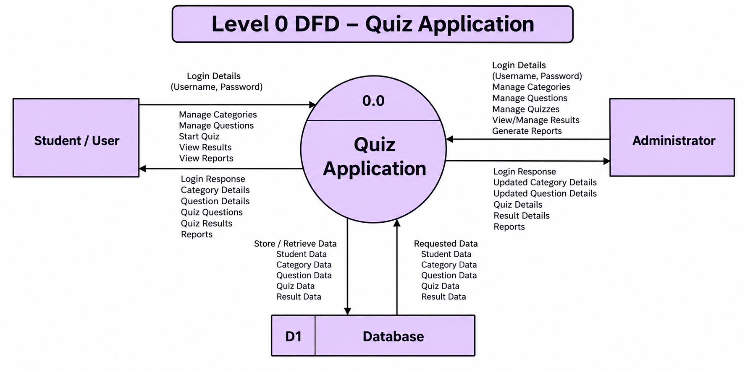

5. DFD 1 LEVEL DIAGRAM :-

