

Institute Of technology,Nirma University

Project Report of
Design and Implementation of a 16-bit ALU with Status Flags using Verilog HDL on FPGA

Submitted to:
Prof.Rutul Patel
Prof. Aakash Mecwan

Submitted By:
Manash Gusani(25BEC505)
Henil Patel(25BEC518)

Subject:FPGA
Semester:4th
Batch:DtoD
Date:13/03/2026

Design and Implementation of a 16-bit ALU with Status Flags using Verilog HDL on FPGA

1. Aim

To design and implement a 16-bit Arithmetic Logic Unit (ALU) using Verilog HDL, simulate its functionality using ModelSim, and implement it on an FPGA board using Quartus.

2. Objectives

To understand the working of an Arithmetic Logic Unit.

To design combinational logic using Verilog HDL.

To verify the ALU operations using RTL simulation.

To implement the ALU on FPGA hardware.

To observe arithmetic and logical operations using FPGA switches and LEDs.

3. Theory
An Arithmetic Logic Unit (ALU) is the fundamental computational component of a processor. It performs arithmetic operations such as addition and subtraction and logical operations such as AND, OR, and XOR.
The ALU takes two input operands and performs the operation selected by a control signal. In this design, a 4-bit selection input (ALU_Sel) determines which operation is performed.
The ALU also generates status flags indicating the condition of the result.

4.Status Flags Generated by the ALU

The ALU produces six status flags that describe the condition of the result after performing arithmetic or logical operations. These flags are important in processors because they help control conditional operations and detect arithmetic conditions such as overflow or zero results.

Flag | Name | Description
CF | Carry Flag | Indicates carry out of the most significant bit during addition or borrow during subtraction
OF | Overflow Flag | Indicates overflow in signed arithmetic operations
PF | Parity Flag | Set when the least significant byte of the result contains an even number of 1s
SF | Sign Flag | Indicates the sign of the result (MSB of the result)
ZF | Zero Flag | Set when the result of the operation is zero
AF | Auxiliary Carry Flag | Indicates carry from bit 3 to bit 4 (used in BCD arithmetic)

5. Code
module ALU(
input [1:0] A_in, // user gives 2 MSB bits
input [1:0] B_in, // user gives 2 MSB bits
input [3:0] ALU_Sel,
input notA,
input notB,
output reg [15:0] Result,
output reg CF, ZF, SF, OF, PF, AF );
// Construct full 16-bit operands
Result = temp[15:0];
CF = temp[16];
AF = (A[3] & B[3]) | ((A[3] ^ B[3]) & ~Result[3]);
OF = (A[15] == B[15]) && (Result[15] != A[15]);
end
4'b0001: begin // SUB
temp = A - B;
Result = temp[15:0];
CF = temp[16];
AF = (A[3] ^ B[3] ^ Result[3]);
OF = (A[15] != B[15]) && (Result[15] != A[15]);
end
4'b0010: Result = A & B; // AND
4'b0011: Result = A | B; // OR
4'b0110: Result = A ^ B; // XOR
4'b0111: Result = ~(A^B); // XNOR
4'b1000: Result = ~(A & B); // NAND
4'b1001: Result = ~(A | B); // NOR
4'b1010: begin // Increment
temp = A + 1;
Result = temp[15:0];
CF = temp[16];
end
4'b1011: begin // Decrement
temp = A - 1;
Result = temp[15:0];
end
4'b1100: Result = A << 1; // Shift Left
4'b1001: Result = A >> 1; // Shift Right
default: Result = 16'b0;
endcase
// Zero Flag
ZF = (Result == 16'b0);
// Sign Flag
SF = Result[15];
// Parity Flag
PF = ~^Result[7:0];
end
end
endmodule

wire [15:0] A;
wire [15:0] B;
assign A = {A_in, 14'b00000000000000};
assign B = {B_in, 14'b00000000000000};
reg [16:0] temp;
always @(*)
begin
Result = 16'b0;
CF = 0;
OF = 0;
AF = 0;
ZF = 0;
SF = 0;
PF = 0;
if (notA)
begin
Result = ~A;
end
else if (notB)
begin
Result = ~B;
end
else
begin
case(ALU_Sel)
4'b0000: begin // ADD
temp = A + B;
4'b1101: Result = A >> 1; // Shift Right
default: Result = 16'b0;
endcase
// Zero Flag
ZF = (Result == 16'b0);
// Sign Flag
SF = Result[15];
// Parity Flag
PF = ~^Result[7:0];
end
end
endmodule

6. ALU Operation Selection Table
Sr. No. | Operation | ALU_Sel (4-bit)
1 | ADD | 0000
2 | SUB | 0001
3 | AND | 0010
4 | OR | 0011
5 | NOT A | (SW[8] = 1)
6 | NOT B | (SW[9] = 1)
7 | XOR | 0110
8 | XNOR | 0111
9 | NAND | 1000
10 | NOR | 1001
11 | INC | 1010
12 | DEC | 1011
13 | SHIFT LEFT | 1100
14 | SHIFT RIGHT | 1101

7.RTL VIEW
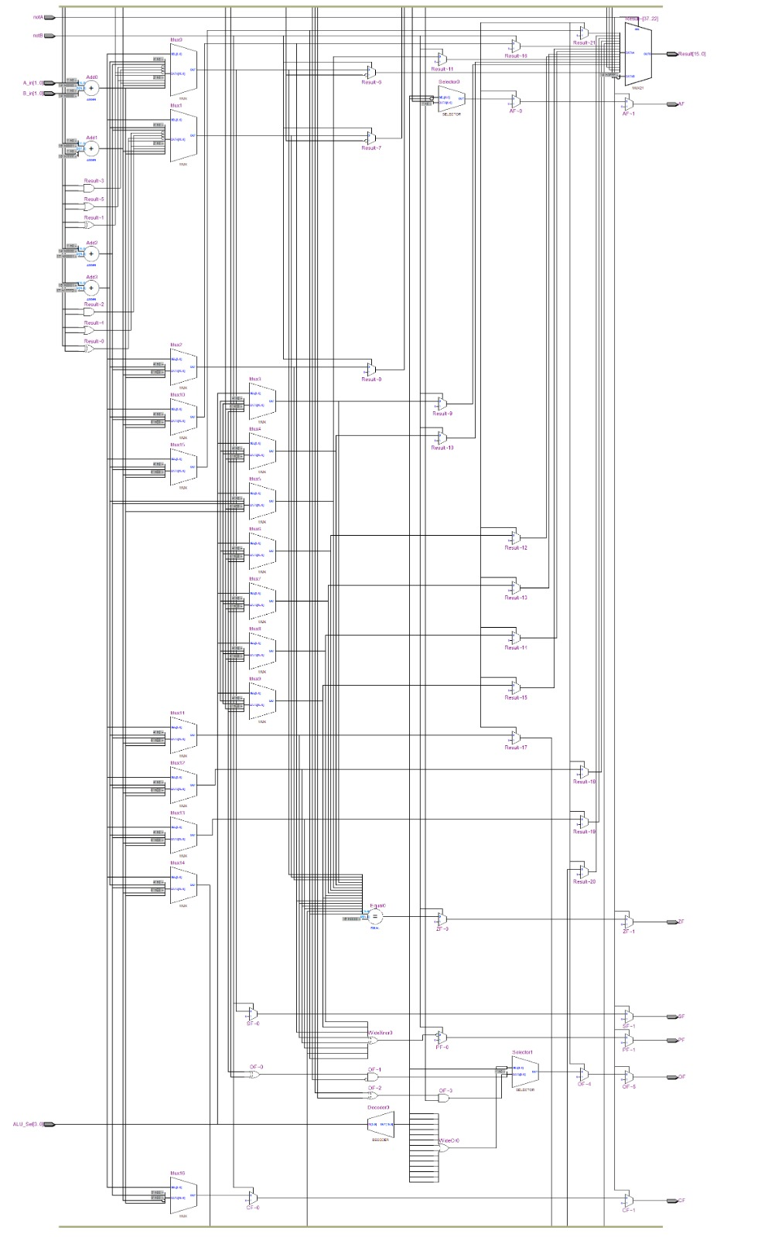
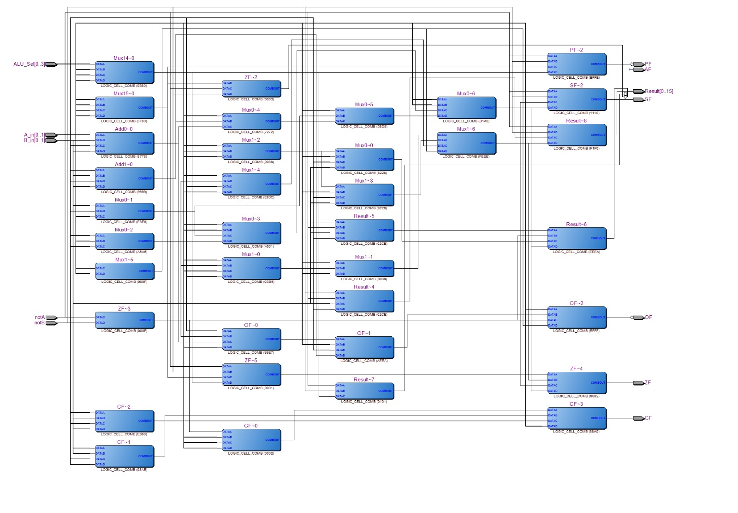
8.TTL VIEW

9. OUTPUT
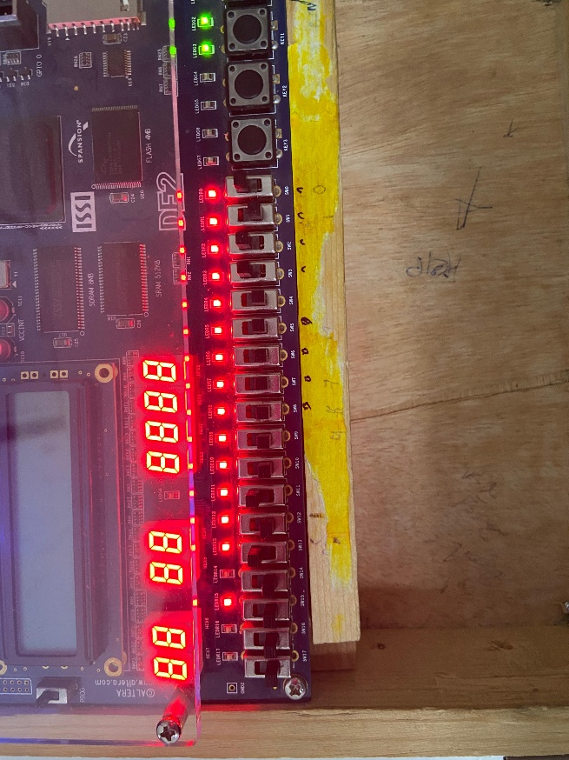
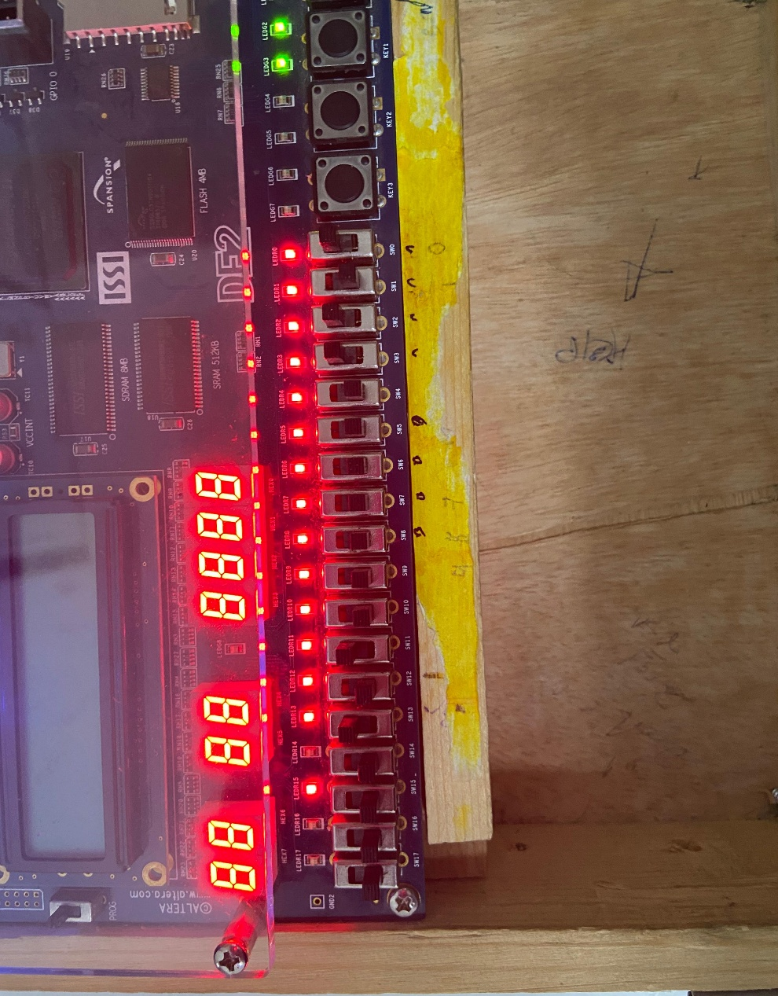

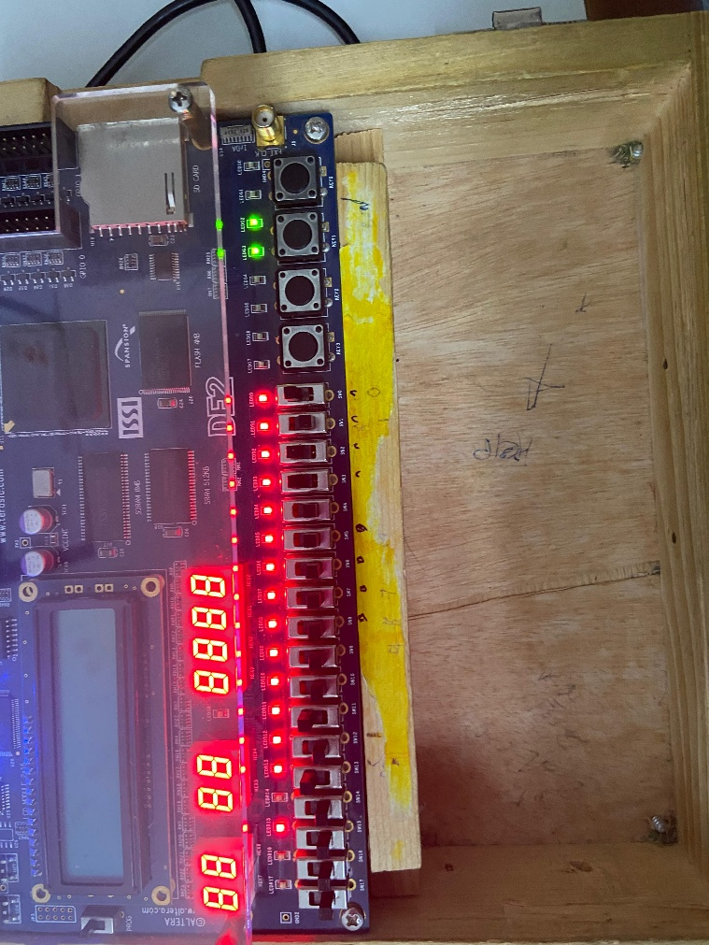

https://drive.google.com/file/d/1C3430nCYWdqU_0969zL4QbFIdnLu5Fef/view?usp=drive_link

Conclusion
The 16-bit Arithmetic Logic Unit (ALU) was successfully designed using Verilog HDL and its functionality was verified through RTL simulation. Various arithmetic, logical, and shift operations were implemented using the 4-bit control signal ALU_Sel. The simulation results confirmed that all operations produced the correct outputs. The ALU also generated the status flags CF, OF, PF, SF, ZF, and AF, which indicate the condition of the result. The design was then synthesized and implemented on the FPGA board using Quartus. FPGA switches were used to provide input values and select operations, while LEDs displayed the output results. Both simulation and hardware implementation confirmed the correct operation of the ALU. Therefore, the designed ALU can be used as an important building block in digital systems and processor architectures.

