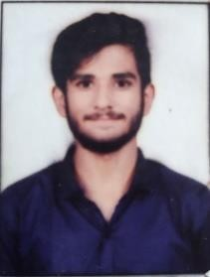HENIL KAMESHKUMAR MEHTA

# [henilmehta5@gmail.com](mailto:henilmehta5@gmail.com) 9724291053

TEHNICAL SKILLS

# INTREST

* - **Proficient:** Microsoft Office Word, Excel, Powerpoint.
* **Programming Languages:** (C, C++, Python, PHP, Data Structure, SQL, Java, Javascript, HTML, CSS, Bootstrap) and Basic.
* **Operating Systems:** Windows.
  + Web design
  + Web development
  + Software

|  |  |  |  |  |
| --- | --- | --- | --- | --- |
| Degree/ Course | Institute/ College | University/ Board | Percentage/ CGPA | Year of Passing |
| S.S.C | **ShishuVhar**  **vidhalaya** | G.S.E.B | 65.23 % | 2019 |
| H.S.C | **ShishuVhar vidhalaya** | G.H.S.E.B | 68.96 % | 2021 |
| BCA | C.B.Patel Computer college | Veer narmad  South gujrat University | FY sem-1  7.13 | 2022 |
| BCA | C.B.Patel Computer college | Veer narmad South gujrat  University | FY sem-2  6.83 | 2022 |
| BCA | C.B.Patel Computer college | Veer narmad South gujrat  University | FY sem-3  6.17 | 2022 |
| BCA | C.B.Patel Computer college | Veer narmad South gujrat  University | FY sem-4  7.65 | 2023 |

Experience

# Compney: Kian Technology

|  |  |  |  |
| --- | --- | --- | --- |
|  |  | | |
| Experience: |  |  | 7 Month |
| Role: |  |  | laravel developer |



Address 108, Ranchhodji park soc-2 ,Katargam ,Surat. Surat, Gujarat, 395004

Date of Birth 03/03/2004

Gender male

Nationality Indian

Marital Status Single

Languages Known Gujrati, Hindi, English

I Here By Declare That The Above Furnished Details Are Accurate And True To The Best Of My Knowledge

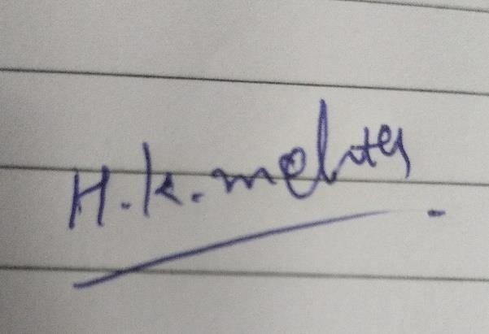

Henil Kameshkumar Mehta