**Seminar Report**

**On**

**Raspberry Pi**

**In partial fulfillment for the award of the degree**

**Of**

**BACHELOR OF COMPUTER APPLICATION**

**[B.C.A]**

**Year 2022-2023**

**SUBMITTED BY: GUIDED BY:**

**Chaudhary Vishal Dilipbhai Asst. Prof. Sweety Patel**

**BCA-6th SEMESTER**

**Submitted to:**



**SHRI SHAMBHUBHAI V. PATEL COLLEGE OF**

**COMPUTER SCIENCE & BUSINESS**

**MANAGEMENT**

Affiliated to

**Veer Narmad South Gujarat University**

INDEX

|  |  |  |
| --- | --- | --- |
| **Sr.No** | **Topics** | **Page No** |
| **1** | **History** | **5** |
| **2** | **Introduction** | **6** |
| **3** | **Details** | **10** |
| **4** | **Applications** | **15** |
| **5** | **Examples** | **18** |
| **6** | **Comparation** | **24** |
| **7** | **Advantages & Disadvantages** | **28** |
| **8** | **Future Enhancement** | **31** |
| **9** | **Conclusion** | **32** |
| **10** | **References** | **33** |

Raspberry Pi

# Abstract

# Raspberry Pi is a credit-card-sized single-board computer that was developed by the Raspberry Pi Foundation in the United Kingdom. It was initially created to promote the teaching of basic computer science in schools and developing countries, and has since gained widespread popularity among hobbyists, educators, and professionals in various industries.

# The Raspberry Pi comes equipped with a variety of ports a

# nd components, including HDMI, USB, Ethernet, GPIO, and a microSD card slot. It can run various operating systems, including a version of Linux called Raspbian, which is specifically designed for the Raspberry Pi.

# One of the main advantages of the Raspberry Pi is its low cost, which makes it accessible to a wide range of users. It is also highly customizable and can be used in a variety of projects, from simple DIY electronics to complex robotics and automation systems. Additionally, the Raspberry Pi has a large and supportive community, with many online resources and forums available for users to share their knowledge and projects.

# However, the Raspberry Pi also has some limitations and disadvantages, such as its relatively low processing power compared to more advanced computers, limited RAM and storage capacity, and lack of support for some software and applications.

# Despite these drawbacks, the Raspberry Pi continues to be a popular and versatile tool for learning, experimentation, and innovation in the fields of computer science, engineering, and technology. Its potential applications are almost endless, and its low cost and ease of use make it an attractive option for both beginners and experienced users alike.

# History

The Raspberry Pi Foundation has also continued to develop and improve the device, releasing new models with more powerful processors, more RAM, and additional features such as Wi-Fi and Bluetooth connectivity.

The Raspberry Pi is a small, low-cost, single-board computer developed in the United Kingdom by the Raspberry Pi Foundation. It was created to promote the teaching of basic computer science in schools and developing countries and to offer an affordable solution for enthusiasts to experiment with programming and hardware projects.

The idea for the Raspberry Pi was conceived in 2006 by Eben Upton, a computer science lecturer at the University of Cambridge, and a group of colleagues who were concerned about the declining number of students applying for computer science courses at the university. They believed that the high cost of computer hardware was a significant barrier to entry for many students and that a low-cost, highly accessible platform could help to address this issue.

In 2008, the team formed the Raspberry Pi Foundation, a registered charity with the aim of promoting the study of computer science and related subjects, especially at school level. The foundation's primary objective was to create a low-cost, highly portable, and user-friendly computer that could be used in education and by enthusiasts.

The first Raspberry Pi model, known as the Raspberry Pi 1 Model B, was released in February 2012. It was a credit card-sized computer that featured a Broadcom BCM2835 system-on-chip with a 700 MHz ARM1176JZF-S processor, 256 MB of RAM, and a video core capable of decoding 1080p video. It also had two USB ports, an HDMI port, an Ethernet port, and a 3.5 mm audio jack.

The Raspberry Pi 1 was an immediate success, selling out within hours of its release. Its low cost, small form factor, and versatility made it a popular platform for a wide range of projects, from media centers and retro gaming consoles to robotics and home automation.

Since the release of the Raspberry Pi 1, several new models have been introduced, each with improved specifications and capabilities. The Raspberry Pi 2, released in February 2015, featured a quad-core 900 MHz ARM Cortex-A7 CPU, 1 GB of RAM, and improved connectivity options, including four USB ports and a 10/100 Ethernet port. The Raspberry Pi 3, released in February 2016, further improved on these specifications, adding built-in Wi-Fi and Bluetooth connectivity.

In addition to its hardware advancements, the Raspberry Pi ecosystem has grown significantly over the years, with a vast community of users and developers contributing to the development of software and projects. Several operating systems, including Raspbian, Ubuntu MATE, and Windows 10 IoT Core, have been developed specifically for the Raspberry Pi, and thousands of applications and libraries are available to users.

The Raspberry Pi was created with the aim of promoting the teaching of basic computer science and providing an affordable and accessible platform for enthusiasts to experiment with programming and hardware projects. Since its release in 2012, it has become a popular platform for a wide range of projects, and its versatility and community support continue to make it a powerful tool for education and innovation.

# Introduction

# What is a Raspberry Pi?

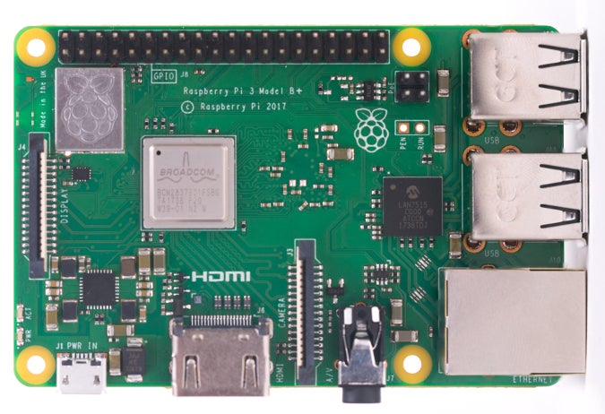

2.1 Raspberry Pi

Raspberry Pi is the name of a series of single-board computers made by the [Raspberry Pi Foundation](https://www.raspberrypi.org/about/), a UK charity that aims to educate people in computing and create easier access to computing education.

The Raspberry Pi launched in 2012, and there have been several iterations and variations released since then. The original Pi had a single-core 700MHz CPU and just 256MB RAM, and the latest model has a quad-core CPU clocking in at over 1.5GHz, and 4GB RAM. The price point for Raspberry Pi has always been under $100 (usually around $35 USD), most notably the Pi Zero, which costs just $5.

All over the world, people use the Raspberry Pi to learn programming skills, build hardware projects, do home automation, [implement Kubernetes clusters](https://opensource.com/article/20/6/kubernetes-raspberry-pi) and [Edge computing](https://enterprisersproject.com/article/2019/7/edge-computing-explained-plain-english), and even use them in industrial applications.

The Raspberry Pi is a very cheap computer that runs Linux, but it also provides a set of GPIO (general purpose input/output) pins, allowing you to control electronic components for physical computing and explore the Internet of Things (IoT).

Raspberry Pi is a credit card-sized single-board computer designed to promote the teaching of basic computer science in schools and developing countries. It was created by the Raspberry Pi Foundation, a UK-based charity organization, with the aim of providing an affordable and accessible computing platform to students and enthusiasts around the world. Since its release in 2012, Raspberry Pi has become one of the most popular and versatile computing devices, with a wide range of applications in various fields.

Raspberry Pi is based on the ARM processor architecture and runs on various operating systems, including Raspbian (a Debian-based Linux distribution), Ubuntu, Windows 10 IoT Core, and others. It has a wide range of input/output (I/O) options, including USB, Ethernet, HDMI, audio, and GPIO (General Purpose Input/Output) pins, which allow for the connection of various peripherals and devices.

The Raspberry Pi Foundation has released several models of the device over the years, each with improved specifications and features. The latest model, Raspberry Pi 4, was released in 2019 and features a 1.5 GHz quad-core ARM Cortex-A72 processor, up to 8 GB of RAM, Gigabit Ethernet, USB 3.0 ports, and 4K video support.

Raspberry Pi has gained a large and enthusiastic community of users, who have developed a wide range of projects and applications using the device. These include media centers, game consoles, home automation systems, robotics projects, and many others. Raspberry Pi has also been used in various educational and research projects, and has been adopted by many organizations and businesses for prototyping and product development.

In this seminar documentation, we will explore the various aspects of Raspberry Pi, including its components, programming languages, operating systems, applications, advantages, disadvantages, and future enhancements. We will also compare Raspberry Pi with other similar devices, such as Arduino and BeagleBone, and provide resources for further learning and exploration.

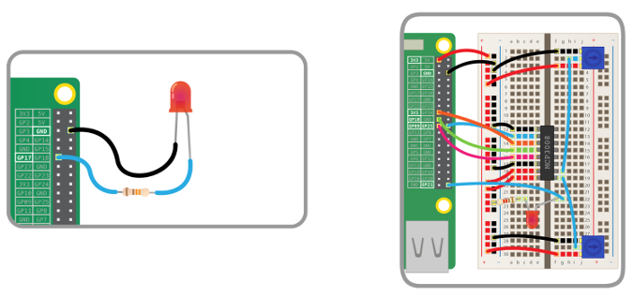

* 1. Raspberry Pi’s GPIO pins

## **What Raspberry Pi models have been released?**

There have been many generations of the Raspberry Pi line: from Pi 1 to 4, and even a [Pi 400](https://opensource.com/article/21/3/raspberry-pi-400-review). There has generally been a Model A and a Model B of most generations. Model A has been a less expensive variant, and tends to have reduced RAM and fewer ports (such as USB and Ethernet). The Pi Zero is a spinoff of the original (Pi 1) generation, made even smaller and cheaper. Here's the lineup so far:

* Pi 1 Model B (2012)
* Pi 1 Model A (2013)
* Pi 1 Model B+ (2014)
* Pi 1 Model A+ (2014)
* Pi 2 Model B (2015)
* Pi Zero (2015)
* Pi 3 Model B (2016)
* Pi Zero W (2017)
* Pi 3 Model B+ (2018)
* Pi 3 Model A+ (2019)
* Pi 4 Model A (2019)
* Pi 4 Model B (2020)
  + Pi 400 (2021)

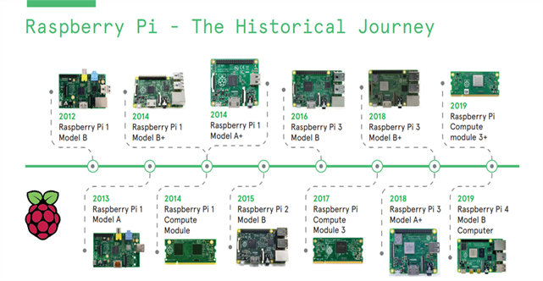

* 1. Various Models of Raspberry Pi
* **What's the Raspberry Pi Foundation ?**

The Raspberry Pi Foundation works to put the power of computing and digital making into the hands of people all over the world. It does this by providing low-cost, high-performance computers that people use to learn, solve problems, and have fun. It provides outreach and education to help more people access computing and digital making—it develops free resources to help people learn about computing and making things with computers and also trains educators who can guide other people to learn.

[Code Club](https://www.codeclubworld.org/) and [CoderDojo](https://coderdojo.com/) are part of the Raspberry Pi Foundation, although these programs are platform-independent (they're not tied to Raspberry Pi hardware). The Raspberry Pi Foundation promotes these clubs and helps grow the network around the world in order to ensure every child has access to learning about computing. Similarly, [Raspberry Jams](https://www.raspberrypi.org/jam/) are Raspberry Pi-focused events for people of all ages to come together to learn about Raspberry Pi and share ideas and projects.

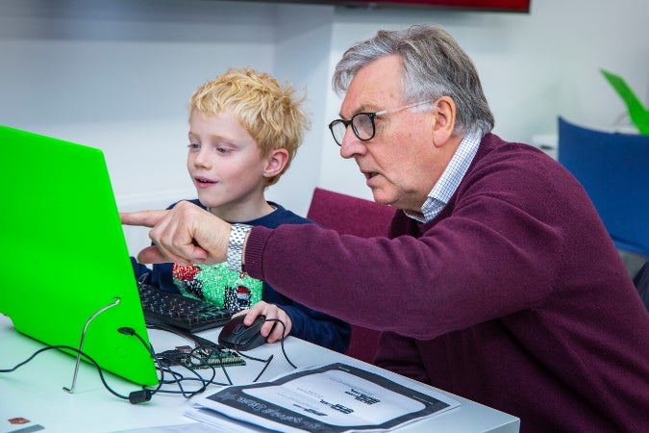

## **Is** **the** **Raspberry** **Pi** **open** **source**?

The Raspberry Pi operates in the open source ecosystem: it runs Linux (a variety of distributions), and its main supported operating system, Pi OS, is open source and runs a suite of open source software. The Raspberry Pi Foundation contributes to the Linux kernel and various other open source projects as well as releasing much of its own software as open source.

The Raspberry Pi's [schematics](https://www.raspberrypi.org/documentation/hardware/raspberrypi/schematics/README.md) are regularly released as documentation, but the board is not open hardware.

The Raspberry Pi Foundation relies on income from the sale of Raspberry Pi units to do its charitable work in the education sector.

## **What can you do with a Raspberry Pi ?**

Some people buy a Raspberry Pi to learn to code, and people who can already code use the Pi to learn to code electronics for physical projects. The Raspberry Pi can open opportunities for you to create your own home automation projects, which is popular among people in the open source community because it puts you in control, rather than using a proprietary closed system.

# Details

# Components

# Processor & RAM :

# Raspberry Pi is based on an ARM processor. The latest version of Raspberry Pi 4 B comes with Broadcom BCM2711, Quad core Cortex-A72 (ARM v8) 64-bit SocC @ 1.5GHz and 2GB, 4GB or 8GB LPDDR4-3200 SDRAM (depending on model).

# USB Ports :

# Raspberry Pi comes with two USB 2.0 ports. The USB ports on Raspberry Pi can provide a current upto 100mA. For connecting devices that draw current more than 100mA, an external USB powered hub is required.

# Ethernet Ports :

# Raspberry Pi comes with a standard RJ45 Ethernet port. You can connect an Ethernet cable or a USB Wifi adapter to provide internet connectivity.

# 

# 3.1 Raspberry Pi Components

# HDMI Output:

# The HDMI port on raspberry Pi provides both video and audio output. You can connect the Raspberry Pi to a monitor using as HDMI cable. For monitors that have DVI port but no HDMI to DVI adapter/cable.

# Conposite Video Output:

# Raspberry Pi comes with a composite video output with an RCA jack that supports both PAL and NTSC video output. The RCA jack can be used to connect old televisions that have an RCA input only.

# Audio Output:

# Raspberry Pi has a 3.5 mm audio output jack. This audio jack is used for providing audid output to old televisions along with the RCA jack for video. The audio quality from tis jack is inferior to the HDMI output.

# GPIO Pins :

# Raspberry Pi comes with a 40 number of General Purpose Input / Output pins. Figure 3.2 shows the Raspberry Pi GPIO headers. There are four types of pins on Raspberry Pi GPIO pins, I2C interface pins, SPI interface pins and serial Rx and Tx pins.

# Introduction to the Raspberry Pi GPIO and Physical Computing - SparkFun Learn

# 3.2 GPIO Pins

# Display Serial Interface(DSI):

# The DSI interface can be used to connect and LCD panel to Raspberry Pi.

# Camera Serial Interface (CSI) :

# The CSI interface can be used to connect a camera module to Raspberry Pi.

# Status LEDs :

# Raspberry Pi has five status LEDs.

# SD Card Slot :

# Raspberry Pi does not have built in operating system and storage. You can plug-in an SD card loaded with a Linux image to the SD card slot.

# Power Input :

# Raspberry Pi has a micro – USB Connector for Power Input.

# Programming Languages

# Raspberry Pi can be programmed using a variety of programming languages, making it a versatile platform for different types of projects. Here are some of the most popular programming languages used with Raspberry Pi:

# Python:

# Python is a popular high-level programming language that is easy to learn and use. It is the most widely used language on Raspberry Pi and is recommended for beginners. Python is versatile and can be used for a wide range of applications, including web development, data analysis, and machine learning. Python is used for developing web applications, scientific computing, and data analysis. Python is an interpreted language, meaning that it doesn't need to be compiled before it is run. Raspberry Pi comes with Python pre-installed, making it an easy language to get started with.

# Scratch:

# Scratch is a visual programming language that is designed to teach programming concepts to young children. It uses a block-based interface that allows users to drag and drop blocks to create programs. Scratch is a great way to introduce kids to programming and can be used to create simple games and animations. Scratch is a visual programming language developed by the Massachusetts Institute of Technology (MIT) that is designed to teach programming concepts to children. Scratch is included with Raspberry Pi OS, making it an easy way for beginners to get started with programming.

# C/C++:

# C and C++ are low-level programming languages that provide direct access to computer hardware. They are commonly used for embedded systems and real-time applications, making them a good choice for projects that require high performance. C and C++ are powerful programming languages that are commonly used for system programming, embedded systems, and developing applications that require high performance. These languages are compiled, meaning that they need to be compiled before they can be run on the Raspberry Pi.

# Java:

# Java is a widely used programming language that is known for its portability and platform independence. It can be used to develop a wide range of applications, from desktop software to web applications. Java cross-platform capabilities, making it an excellent choice for developing applications that need to run on multiple platforms. Java applications can run on the Raspberry Pi using the Java Virtual Machine (JVM).

# These are just a few of the programming languages that can be used with Raspberry Pi. The choice of programming language will depend on the type of project you are working on and your personal preferences.

# Operating Systems

# Raspberry Pi can run a variety of operating systems (OS) including Linux, Windows 10 IoT Core, and Android. However, the most commonly used operating system for Raspberry Pi is Raspbian, a free and open-source Debian-based OS optimized for the Raspberry Pi hardware.

# Raspbian is pre-installed with a wide range of software, including a web browser, media player, and programming tools such as Python, Scratch, and Node-RED. It is also optimized for use with the Raspberry Pi's hardware components, including the GPIO pins, camera module, and display.

# Raspberry Pi is compatible with a variety of operating systems that can be installed on its microSD card. The operating system can be selected based on the intended use of the Raspberry Pi. Here are some of the operating systems that can be used with Raspberry Pi:

# Raspbian:

# Raspbian is the official operating system for Raspberry Pi. It is a variant of the popular Debian operating system and is optimized for the Raspberry Pi's hardware. It is free, open-source, and comes with a suite of software tools and applications, including the Chromium web browser, Python programming language, and the LibreOffice suite.

# Ubuntu MATE:

# Ubuntu MATE is a lightweight version of Ubuntu that is optimized for the Raspberry Pi's hardware. It provides a user-friendly desktop environment and comes with a variety of software tools and applications, including the Firefox web browser, Python programming language, and the LibreOffice suite.

# Windows 10 IoT Core:

# Windows 10 IoT Core is a version of Windows 10 that is designed for use with embedded systems, including the Raspberry Pi. It is a free operating system and provides access to the full suite of Windows 10 development tools, including Visual Studio.

# 3.3 Operating System

# RetroPie:

# RetroPie is an operating system that is designed to turn the Raspberry Pi into a retro gaming console. It comes with a suite of emulators and game engines, including the popular RetroArch and EmulationStation.

# Pi-hole:

# Pi-hole is an operating system that is designed to act as a network-wide ad blocker. It can be installed on a Raspberry Pi and provides ad-blocking functionality for all devices on a network.

# Kali Linux:

# Kali Linux is a specialized operating system that is designed for use in penetration testing and security auditing. It comes with a suite of security tools and applications, including the Metasploit framework, Nmap network scanner, and Wireshark network analyzer.

# These operating systems can be downloaded from their respective websites and installed on the Raspberry Pi's microSD card. They can be easily switched out depending on the intended use of the Raspberry Pi.

# Applications

Raspberry Pi is a versatile and affordable credit card-sized computer that has gained immense popularity among educators, hobbyists, and developers. Here are some of the key purposes and applications of Raspberry Pi:

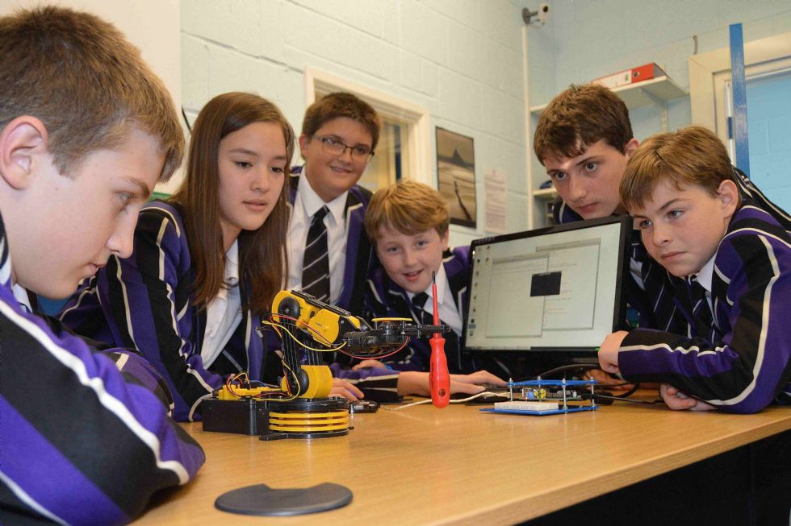**Education:**

# 4.1 Education

One of the primary purposes of Raspberry Pi is to promote computer science education and programming skills. Its low cost and compact size make it an accessible tool for teachers and students to learn coding, electronics, and robotics. Raspberry Pi Foundation has created a range of educational resources, including the free online course "Introduction to Computer Science" and a dedicated educational operating system called Raspberry Pi OS for students and teachers.

**Home automation:**

# 4.2 Home Automation

Raspberry Pi can be used to automate and control various aspects of a home, including lighting, heating, and security. The Raspberry Pi can be connected to sensors and other devices, such as cameras and motion detectors, to create a smart home system. It can be controlled using a web interface or smartphone app, making it easy to manage and monitor the home from anywhere.

**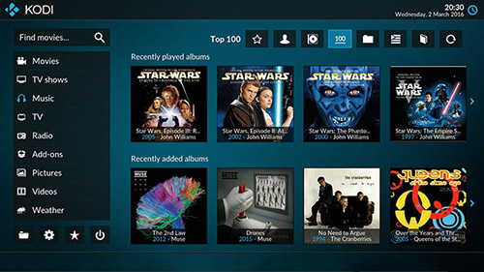Media centers:**

# 4.3 Media Centers

Raspberry Pi can be used as a media center to stream and play music, videos, and other multimedia content. It can be connected to a TV or other display and used to access online content, such as YouTube and Netflix, as well as local media files. Various media center software options are available for Raspberry Pi, including Kodi, OSMC, and Plex.

**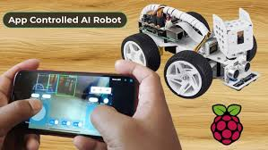Robotics:**

# 4.4 Robotics

Raspberry Pi is also a popular platform for building robots and automation systems. Its small size, low power consumption, and powerful processing capabilities make it an ideal brain for DIY robots and drones. Robotics enthusiasts can program their Raspberry Pi using languages such as Python, Scratch, or C++ to control motors, sensors, and other components.

**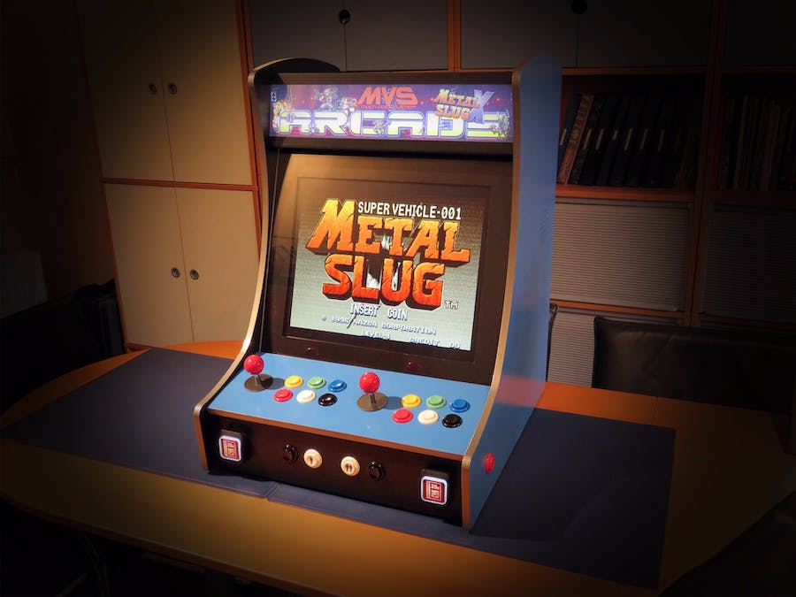Retro gaming:**

# 4.4 Retro Gaming

With Raspberry Pi, users can build their own retro gaming console using emulators and ROMs of classic video games. The device's HDMI output and USB ports allow users to connect it to a TV and game controllers, creating a low-cost alternative to commercial game consoles.

**IoT (Internet of Things):**

Raspberry Pi can be used to build various IoT applications, such as smart home devices, environmental monitoring systems, and industrial automation solutions. Its connectivity options, including Wi-Fi, Bluetooth, and Ethernet, make it easy to connect to other devices and the internet.

**Prototyping:**

Raspberry Pi can be used as a prototyping platform for testing and developing new ideas and concepts. Its versatility and compatibility with various sensors, actuators, and other components make it a popular choice for makers and DIY enthusiasts.

Overall, Raspberry Pi's low cost, versatility, and accessibility make it an ideal tool for learning, experimentation, and prototyping across various fields and applications.

# Examples

* **VoiceGPT :**

VoiceGPT is a voice assistant that leverages the powerful ChatGPT chatbot to answer your questions.

What if you could verbally ask ChatGPT for advice, and it would talk back to you? Raspberry Pi owners rejoice! You can have the world’s most famous chatbot talk to you. Besides your trusty Pi, you’ll need a microphone, a speaker, and [the code **Nick Bild** wrote](https://www.hackster.io/nickbild). You speak your prompts aloud, the Raspberry Pi does the speech-to-text / text-to-speech conversions, and the entity called “VoiceGPT” responds with realistic, synthesized speech.

Things used in this project

|  |  |  |  |  |  |
| --- | --- | --- | --- | --- | --- |
| Hardware components | | | | | |
| Raspberry Pi 4 Model B | |  | | --- | | [Raspberry Pi 4 Model B](https://www.hackster.io/raspberry-pi/products/raspberry-pi-4-model-b?ref=project-f88f8f) | |  | |  |  |  |  |

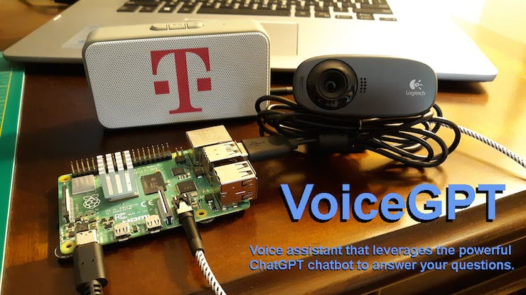VoiceGPT is a voice assistant that leverages the powerful ChatGPT chatbot to answer your questions. You speak the requests, and VoiceGPT responds with realistic, synthesized speech.

# 5.1 VoiceGPT

How It Works



I chose a Raspberry Pi 4 single board computer to host the project, because it runs Linux and provides a lot of versatility. A custom [Python script](https://github.com/nickbild/voice_chatgpt/blob/main/voice_chat.py)collects audio of a speaker's voice using a USB microphone. The Google Cloud Speech-to-Text API is then used to convert that audio file into text. The text is then queried against ChatGPT using an [unofficial API](https://github.com/acheong08/ChatGPT-lite)that returns a text string of ChatGPT's response. That

response is then processed by Google Cloud's Text-to-Speech API to turn it into realistic, synthetic speech that the Raspberry Pi can play through a speaker.

The concept of a voice assistant is well established (e.g. Google Home, Amazon Alexa), but this proof of concept shows how a voice assistant can use ChatGPT, which, in my opinion, provides a far better experience than anything currently on the market.

In the future, I may add a keyword spotting algorithm to the project so that it can always run in the background, waiting for a keyword (e.g. "Hey, ChatGPT") to wake up. Before I have the chance to do much of anything else, there will probably be a commercial product including ChatGPT on the backend — then I'll just buy that because it will be smaller and better. :)

More information: [hackster.io](https://www.hackster.io/nickbild/voicegpt-f88f8f).

* [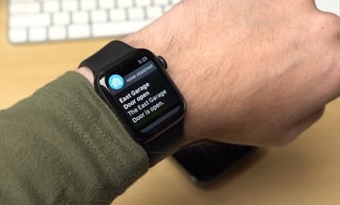](https://github.com/geerlingguy/pico-w-garage-door-sensor/)[**Smart-Home Garage Door Sensor**](https://github.com/geerlingguy/pico-w-garage-door-sensor/) **:**

# 5.2 Smart Home Garage Door Sensor

A nice way of checking the status of your garage door.

Maker **Jeff Geerling** has a garage, and like all garages, it has a door – a door that not everyone remembers to close when they’re done with it. The solution: A sensor that tracks the door’s status. “If I wanted some sort of cloud integration, I could pay for the kit that connects to my garage door opener,” Geerling explains, “but since the cloud is just someone else’s computer, and I’d rather not rely on some company’s weak security to protect data about my home… I want it all local.” For that, Geerling purchased low-cost, rugged garage door sensors and linked them to a Raspberry Pi Pico W – which, in turn, connected them to his local network and a Home Assistant smart-home installation. Now, whenever the door is opened or closed, Geerling receives a push notification – with historical events logged for posterity.

**More information:** [GitHub](https://github.com/geerlingguy/pico-w-garage-door-sensor/)

* **[Cashierless Grocery System](https://www.hackster.io/s4muela/smart-cashier-with-edge-impulse-fomo-317edd" \t "_blank) :**

Self checkout smart cashier using object detection to calculate number of items and total price for your purchase.

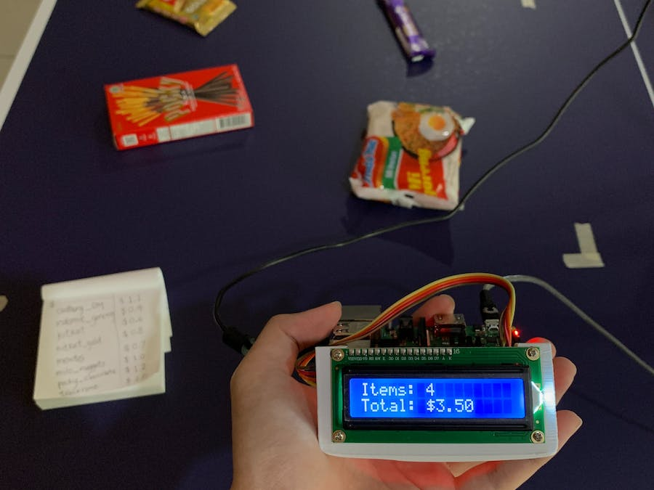

# 5.3.1 Cashierless Grocery System

Raspberry Pi, meet noodles. Noodles, meet Raspberry Pi.

Companies around the world are turning to machine learning to make a visit to the grocery store more convenient. Why queue up to check out when cameras can keep track of your goods and charge you as you leave? Millions of dollars in research and development have been spent on the technology to make cashierless stores a reality, but [**Samuel Alexander**](https://www.hackster.io/s4muela)**‘s** implementation needs only a Raspberry Pi 4, any USB webcam, and a two-line LCD display.

Using Edge Impulse Studio, images of groceries are captured by the camera and used to train **the FOMO algorithm** – such that the Raspberry Pi can recognize them as they whizz past the camera. Then the total is automatically totted up, a great introduction to real-world machine learning and computer vision concepts.

Things used in this project

|  |  |  |  |  |  |
| --- | --- | --- | --- | --- | --- |
| Hardware components | | | | | |
| Raspberry Pi 4 Model B | |  | | --- | | [Raspberry Pi 4 Model B](https://www.hackster.io/raspberry-pi/products/raspberry-pi-4-model-b?ref=project-317edd) | |  | |  |  |  |  |
| RGB Backlight LCD - 16x2 | |  | | --- | | [Adafruit RGB Backlight LCD - 16x2](https://www.hackster.io/adafruit/products/rgb-backlight-lcd-16x2?ref=project-317edd) | |  | |  |  |  |  |
|  | |  | | --- | | USB webcam (generic) | |  | |  |  |  |  |
| Software apps and online services | | | | | |
| Edge Impulse Studio | |  | | --- | | [Edge Impulse Studio](https://www.hackster.io/EdgeImpulse/products/edge-impulse-studio?ref=project-317edd) | |  | |  | |  |  |
|  | |  | | --- | | Raspberry Pi OS | |  | |  | |  |  |
| Hand tools and fabrication machines | | | | | |
| 3D Printer (generic) | |  | | --- | | 3D Printer (generic) | |  | |  | |  |  |

# 5.3.2 Chesierless Grocery System

In this project I’m taking advantage of **FOMO (Faster Objects, More Objects) algorithm** that’s really fast and efficient in object detection. The algorithm is suitable for recognizing the different types of objects that’s placed on the cashier table without the use of barcode and is able to output the total price of items. 96x96 pixel and grayscale color depth provides enough data to make this project work. The model is exported into a Python program which is deployed to a Raspberry Pi, so it can be run locally. By running the machine learning model on the edge, this device will use less energy, less human labour, and cut down hardware cost overall. This concept can be further developed with more data variation, camera, and different cashier environment and lighting conditions to improve its accuracy in the real-world application.

For the image collection I took some pictures using the USB webcam using the Raspberry Pi that’s connected to the Edge Impulse Studio and some other pictures are taken from a smartphone camera. The

position and orientation of the items are shifted between pictures to help the ML model recognize the object later in the process.

The photos are taken using a tripod so that the size of the objects placed on the table will not change too much when it’s captured as an image. (This is especially important for FOMO algorithm, FOMO doesn’t perform well with different object sizes). The total object input is 408 items which consists of 8 different objects (snacks).

* **Fast Video Doorbell / Intercom on Raspberry Pi :**

[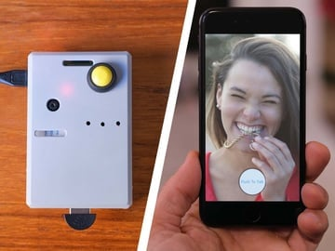](https://www.hackster.io/sneaky/fast-video-doorbell-intercom-on-raspberry-pi-63b063)

# 5.4 Video doorbell

**[SneakyHacker](https://www.hackster.io/sneaky" \t "_blank)** shared a neat 2-way video/audio doorbell using a Raspberry Pi. The project isn’t complicated, you just need some basic soldering skills to finish it off, and the good news is that all the components fit in a small case. There’s one drawback, though, and that’s that up until now, the notification system for your smartphone can only be sent via a Mac.

Things used in this project

|  |  |  |  |  |  |
| --- | --- | --- | --- | --- | --- |
| Hardware components | | | | | |
| Raspberry Pi 3 Model B | |  | | --- | | [Raspberry Pi 3 Model B](https://www.hackster.io/raspberry-pi/products/raspberry-pi-3-model-b?ref=project-63b063) | |  | |  |  |  |  |
|  | |  | | --- | | MicroSD memory card | |  | |  |  |  |  |
|  | |  | | --- | | Power supply for Raspberry Pi 3 | |  | |  |  |  |  |
|  | |  | | --- | | Plastic case with camera module opening | |  | |  |  |  |  |
|  | |  | | --- | | Video camera module for Pi | |  | |  |  |  |  |
|  | |  | | --- | | Speaker with built-in amplifier | |  | |  |  |  |  |
|  | |  | | --- | | 3-pin to female socket cable for speaker | |  | |  |  |  |  |
|  | |  | | --- | | Mini USB microphone | |  | |  |  |  |  |
|  | |  | | --- | | Button on-off switch | |  | |  |  |  |  |
|  | |  | | --- | | Jumper wires | |  | |  |  |  |  |
| Software apps and online services | | | | | |
|  | |  | | --- | | Seajei SDK | |  | |  | |  |  |
|  | |  | | --- | | Raspbian Stretch | |  | |  | |  |  |
|  | |  | | --- | | Raspberry Pi Imager | |  | |  | |  |  |
| Hand tools and fabrication machines | | | | | |
|  | |  | | --- | | Soldering iron kit | |  | |  | |  |  |

I came across some nice software to make a fast video / 2-way audio doorbell with a Raspberry Pi, and found a way to fit all the components in a small case.

I will show you how to build it, including how to make push notifications work when you press the button.

The hardware build requires a bit of drilling and soldering. The software portion is pretty straightforward with no coding required (unless you want to customize the sample programs). But it does require a Mac and XCode.

**More information:**[hackster.io](https://www.hackster.io/sneaky/fast-video-doorbell-intercom-on-raspberry-pi-63b063).

# Comparation

Raspberry Pi can be compared to other similar single-board computers such as Arduino and BeagleBone. Here are some comparisons:

**Arduino vs Raspberry Pi:**

# 6.1 Raspberry Pi VS Arduino

Arduino is a microcontroller board while Raspberry Pi is a single-board computer. Arduino is more suitable for low-level hardware applications, whereas Raspberry Pi is better suited for complex software applications. Arduino is cheaper and consumes less power compared to Raspberry Pi.

| **Basis** | **Arduino** | **Raspberry Pi** |
| --- | --- | --- |
| **License** | Arduino is an open-source project. Both its software and hardware design are open source. | Both hardware and software of Raspberry Pi are closed source. |
| **Control Unit** | From Atmega Family | From ARM Family |
| **Clock Frequency** | 16 MHz (Arduino UNO) | Up to 1.5 GHz in Raspberry Pi 4 B |
| **RAM** | Requires less RAM (2kB) | Requires large RAM (more than 1 GB) |
| **CPU Architecture** | 8-bit | 64-bit |
| **Logic level** | Arduino’s logic level is 5V. | Raspberry Pi’s logic level is 3V. |
| **Power Consumption** | Consumes about 200 MW of power | Consumes about 700 MW of power |
| **Based on** | Arduino is a Microcontroller | Raspberry Pi is based on a microprocessor |
| **Hardware Structure** | Simple hardware structure | Complex hardware Structure |
| **Software** | Arduino boards are programmable using C/C++ languages. | Raspberry Pi supports its own Linux-based operating system Raspberry Pi OS. You can also install the OS you like. |
| **Internet** | Arduino does not have internet support. You need additional modules or shields to connect it to the internet. | Raspberry Pi has a built-in Ethernet port and WiFi support. |
| **Cost** | Arduino boards are cheaper. | Raspberry Pi boards are expensive. |
| **How they handle power drop** | Arduino devices begin executing code when they are turned on. Therefore, when power is turned off, abruptly, you won’t end up with a corrupt operating system or errors. The code will simply start again when plugged in. | Raspberry Pi requires the same care as a PC. You have to shut the operating system down properly. |
| **Current drive strength** | Higher current drive strength | Lower current drive strength |
| **Capability** | Arduino is generally used to perform single (and simple) tasks repeatedly. | Raspberry Pi can perform multiple tasks simultaneously. |
| **Wireless connectivity** | Arduino does not support Bluetooth or WiFi. | Raspberry Pi supports Bluetooth and WiFi. |
| **Applications** | Traffic light countdown timer, Parking lot counter, Weighing machines, etc. | Robot controller, Game servers, Stop motion cameras, etc. |

Arduino is a microcontroller board designed for small, standalone projects. It is easy to program and can be used for a wide range of applications, such as home automation, robotics, and IoT devices. It has a low power consumption and is typically used for simple projects that don't require a lot of processing power.

Raspberry Pi, on the other hand, is a fully functional computer with a more powerful processor and operating system. It can be used for more complex projects that require more processing power, such as media centers, game consoles, and web servers. It also has more input/output options, making it a more versatile choice for advanced projects.

In summary, Arduino is a good choice for simple, standalone projects that require low power consumption, while Raspberry Pi is better suited for more complex projects that require more processing power and versatility.

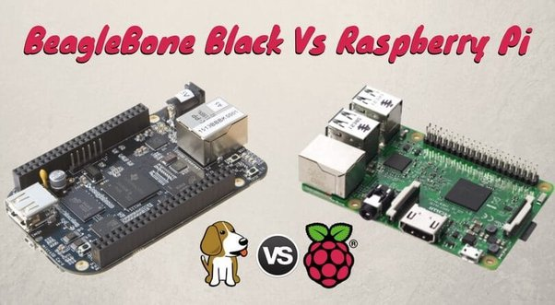**BeagleBone vs Raspberry Pi:**

# 6.1 Raspberry Pi VS BeagleBone

Both BeagleBone and Raspberry Pi are single-board computers with a similar price range. However, BeagleBone has more input/output pins and supports more programming languages compared to Raspberry Pi. On the other hand, Raspberry Pi has more processing power and a larger community of developers, which means it has more support and resources available.

| **Parameter** | **RASPBERRY PI** | **BEAGLEBONE BLACK** |
| --- | --- | --- |
| **Model Tested** | It uses Model B version. | It uses Rev A5 version. |
| **Processor Type** | It uses ARM11 processor. | It uses ARM Cortex-A8 processor. |
| **RAM** | For the functioning of raspberry pi, 512 MB SDRAM is used. | For the functioning of beaglebone black, 512 MB DDR3L is used. |
| **Processor Speed** | It uses 700 MHz for processing. | It uses 1 GHz for its processing. |
| **Flash** | It has dedicated SD Card socket for loading operating system. | It uses 4GB (micro SD) for loading OS and data storage. |
| **Min Power** | It requires a power supply of 700mA (3.5W). | It requires min power of 210mA (1.05W) for its functioning. |
| **GPIO Pins** | It has 12 GPIO pins. | It has 69 GPIO pins. |
| **Dev IDE** | It uses IDLE, Scratch, Squeak/Linux to perform tasks. | It uses Python, Scratch, Squeak, Cloud9/Linux to perform a particular task. |
| **USB Master** | It has 2 USB 2.0 on board. | It has 1 USB 2.0 on its board. |
| **Audio Output** | Supports HDMI, Analog audio output | It uses Analog output for audio. |
| **Video Output** | It supports HDMI, Composite output for video. | No such specific video output. |
| **No. of I/O pins** | It has 8 Digital, 0 Analog pins. | It has 65 Digital, 7 Analog pins. |

**Jetson Nano vs Raspberry Pi:**

Jetson Nano is a single-board computer designed for artificial intelligence and machine learning applications, while Raspberry Pi is a general-purpose computer. Jetson Nano has more processing power and a dedicated GPU, which makes it better suited for AI applications. However, Jetson Nano is more expensive compared to Raspberry Pi.

**Odroid vs Raspberry Pi:**

Odroid is another single-board computer that is similar to Raspberry Pi. Odroid has more processing power and supports 4K resolution, which makes it suitable for media applications. However, Odroid is more expensive compared to Raspberry Pi and has a smaller community of developers.

Overall, Raspberry Pi is a versatile single-board computer that is suitable for a wide range of applications. Its low cost, small size, and low power consumption make it an attractive option for hobbyists, students, and professionals alike.

# Advantages & Disadvantages

# 

# 7.1 Advantages And Disadvantages of Raspberry Pi

# Advantages :

small single-board computer that has gained immense popularity due to its versatility, affordability, and accessibility. Here are some advantages of Raspberry Pi:

**Low cost :**

Raspberry Pi is an inexpensive computer that costs a fraction of what a typical desktop computer would cost. This low cost makes it accessible to a wide range of users, including students, hobbyists, and educators.

**Versatility:**

Raspberry Pi is highly versatile and can be used for a wide range of projects, including media centers, home automation, robotics, and more. Its GPIO (General Purpose Input/Output) pins make it easy to connect to various electronic components, and its modular design allows for easy customization.

**Small size:**

Raspberry Pi is compact and has a small form factor, which makes it easy to integrate into projects with limited space. Its small size also means it consumes less power than a typical desktop computer.

**Low power consumption:**

Raspberry Pi is designed to consume minimal power, making it ideal for projects that run continuously, such as home automation systems or media centers.

**Easy to set up:**

Raspberry Pi is easy to set up and does not require any special technical skills. The official Raspberry Pi website provides a wealth of resources, including tutorials and step-by-step guides, to help users get started.

**Community support:**

Raspberry Pi has a large and active community of users who are constantly creating new projects, sharing ideas, and providing support to others. This community-driven approach ensures that Raspberry Pi users have access to a vast pool of knowledge and resources.

**Educational value:**

Raspberry Pi was originally designed to promote the teaching of basic computer science in schools and developing countries. As such, it has a strong educational focus and is an excellent tool for teaching programming, electronics, and other STEM subjects.

In conclusion, Raspberry Pi's low cost, versatility, small size, low power consumption, ease of setup, community support, and educational value make it an excellent choice for a wide range of projects and applications.

# Disadvantages :

# The Raspberry Pi has some disadvantages that are worth considering before deciding whether it is the right device for a particular project. Some of these disadvantages include:

# Limited Processing Power:

# Although the Raspberry Pi is a powerful device for its size, it is not as powerful as a full-size desktop or laptop computer. This can limit the types of applications and tasks it can handle, especially those that require high processing power or memory.

# Limited Graphics Capabilities:

# The Raspberry Pi's graphics capabilities are limited compared to those of a desktop or laptop computer. This means that it may not be the best choice for tasks that require high-quality graphics, such as gaming or video editing.

# Limited RAM:

# The Raspberry Pi comes with a limited amount of RAM, which can limit its ability to handle multiple tasks or large datasets. This can also limit the types of applications it can run, especially those that require large amounts of memory.

# Limited Storage:

# The Raspberry Pi typically uses an SD card for storage, which has limited capacity compared to a hard drive or solid-state drive. This can limit the amount of data that can be stored on the device and may require frequent backup and transfer of data to external storage devices.

# Limited Connectivity:

# Although the Raspberry Pi has built-in Ethernet and Wi-Fi connectivity, it does not support cellular or Bluetooth connectivity. This can limit its ability to communicate with other devices or access the internet in certain situations.

# Limited Compatibility:

# Some software and peripherals may not be compatible with the Raspberry Pi due to its unique architecture and hardware specifications. This can limit its ability to work with certain devices or software applications.

# Learning Curve:

# While the Raspberry Pi is designed to be accessible to beginners, it still requires some technical knowledge and experience to get the most out of it. This can be a disadvantage for those who are not familiar with programming or electronics.

# It is important to keep these disadvantages in mind when considering whether the Raspberry Pi is the right device for a particular project. However, despite these limitations, the Raspberry Pi remains a powerful and versatile device with a wide range of applications.

# Future Enhancement

# Improved processing power: The current Raspberry Pi models are already powerful, but there is always room for improvement. Future models may feature faster processors with more cores, allowing for even more complex and demanding applications to be run.

# Increased memory and storage capacity: As technology continues to advance, memory and storage capacity for computers generally increases. The Raspberry Pi is no exception, and future models may feature larger amounts of RAM and built-in storage.

# Better connectivity options: While the Raspberry Pi already has a range of connectivity options, including Wi-Fi, Bluetooth, and Ethernet, there is always the potential for new and improved options. For example, future models may support faster Wi-Fi standards or new forms of wireless connectivity like 5G.

# More advanced sensors and hardware: The Raspberry Pi is often used in projects that involve sensors and other hardware components. Future models may feature more advanced sensors with greater accuracy and precision, making it possible to build even more sophisticated projects.

# Enhanced AI and machine learning capabilities: As AI and machine learning become increasingly important in a range of industries, it is possible that future Raspberry Pi models may be optimized to support these technologies. This could include improvements in processing power, memory, and connectivity, as well as the inclusion of specialized hardware components like GPUs.

# Overall, the Raspberry Pi has already proven to be a highly versatile and capable computer, and future enhancements are likely to only increase its potential.

# Conclusion

# Raspberry Pi is a versatile and affordable credit-card sized computer that can be used for a wide range of projects. Its compact size and low power consumption make it an attractive choice for DIY enthusiasts, hobbyists, educators, and professionals.

# Raspberry Pi is a powerful and versatile computer that has been designed for both educational and practical use. It is a low-cost, credit card-sized device that is packed with features and is capable of running a wide range of operating systems, making it an attractive option for hobbyists, educators, and professionals alike.

# In conclusion, Raspberry Pi offers many advantages including its low cost, flexibility, versatility, and ease of use. It is an ideal platform for learning to code and for building simple projects, as well as for more advanced applications such as robotics, home automation, and media centers.

# However, it is not without its drawbacks, including limited processing power, lack of built-in storage, and the need for additional accessories such as a keyboard, mouse, and monitor. Additionally, it may not be the best choice for complex projects that require high processing power and advanced graphics capabilities.

# Overall, Raspberry Pi has revolutionized the world of computing by making powerful technology more accessible and affordable than ever before. It is an excellent tool for learning, experimentation, and prototyping, and has opened up new opportunities for innovation and creativity in a wide range of fields.

# Some key points to remember about Raspberry Pi are:

# Raspberry Pi is a low-cost, small-sized computer that can run a variety of operating systems and software.

# It is designed to promote the teaching of computer science and programming in schools and developing countries.

# Raspberry Pi has a wide range of applications, from home automation and robotics to media centers and gaming devices.

# It supports multiple programming languages, including Python, C++, and Java.

# Raspberry Pi is an excellent tool for prototyping and testing projects before moving onto a more expensive system.

# With the availability of online resources, tutorials, and forums, it is easy to get started with Raspberry Pi and explore its potential uses. Whether you are a beginner or an experienced programmer, Raspberry Pi offers endless possibilities for learning, experimenting, and creating.

# References

# Raspberry Pi official website : <https://www.raspberrypi.org/>

# Raspberry Pi Foundation's online learning platform : <https://www.raspberrypi.org/training/>

# Official Raspberry Pi YouTube channel : <https://www.youtube.com/c/RaspberryPiOrg>

# Raspberry Projects : https://all3dp.com/1/best-raspberry-pi-projects/