Hennie Francis – Belt Exam #2

# GitHub Project

Project Cloning and Branch Management

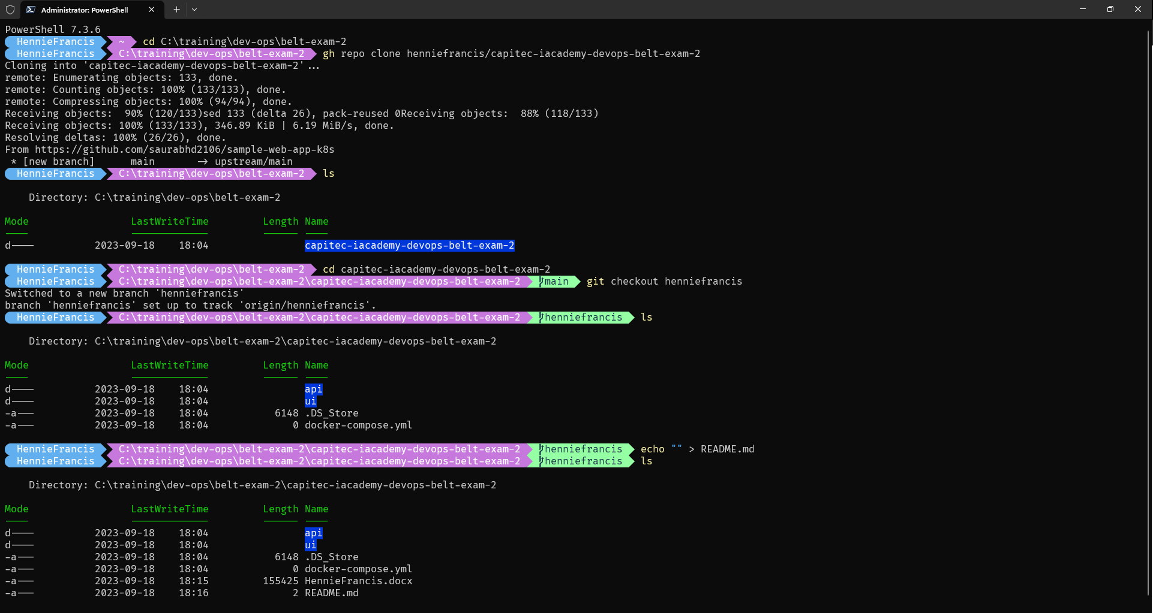

# Question 1:

## DockerFile for Backend Application

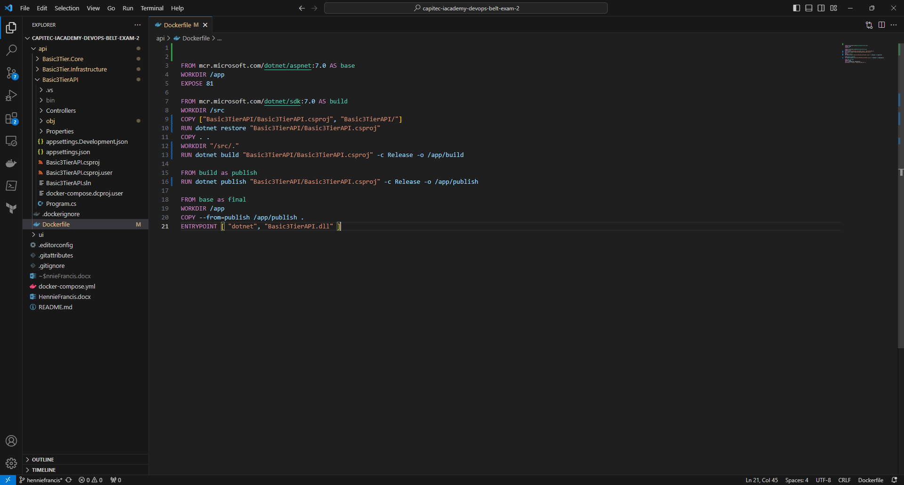

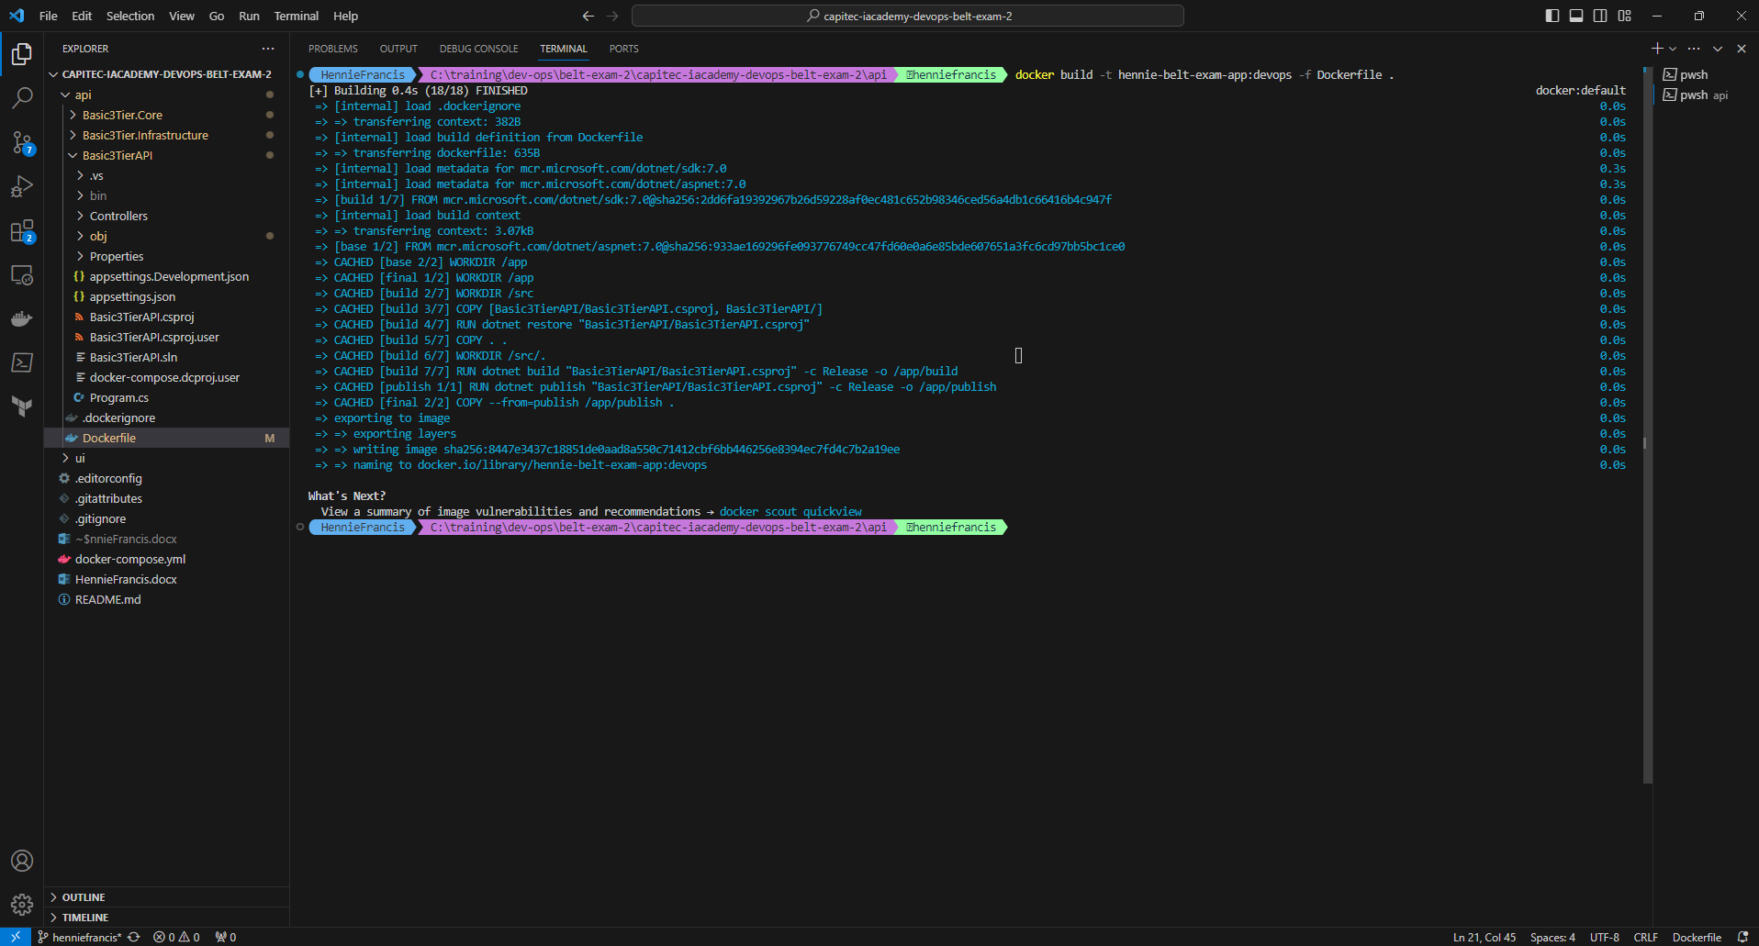

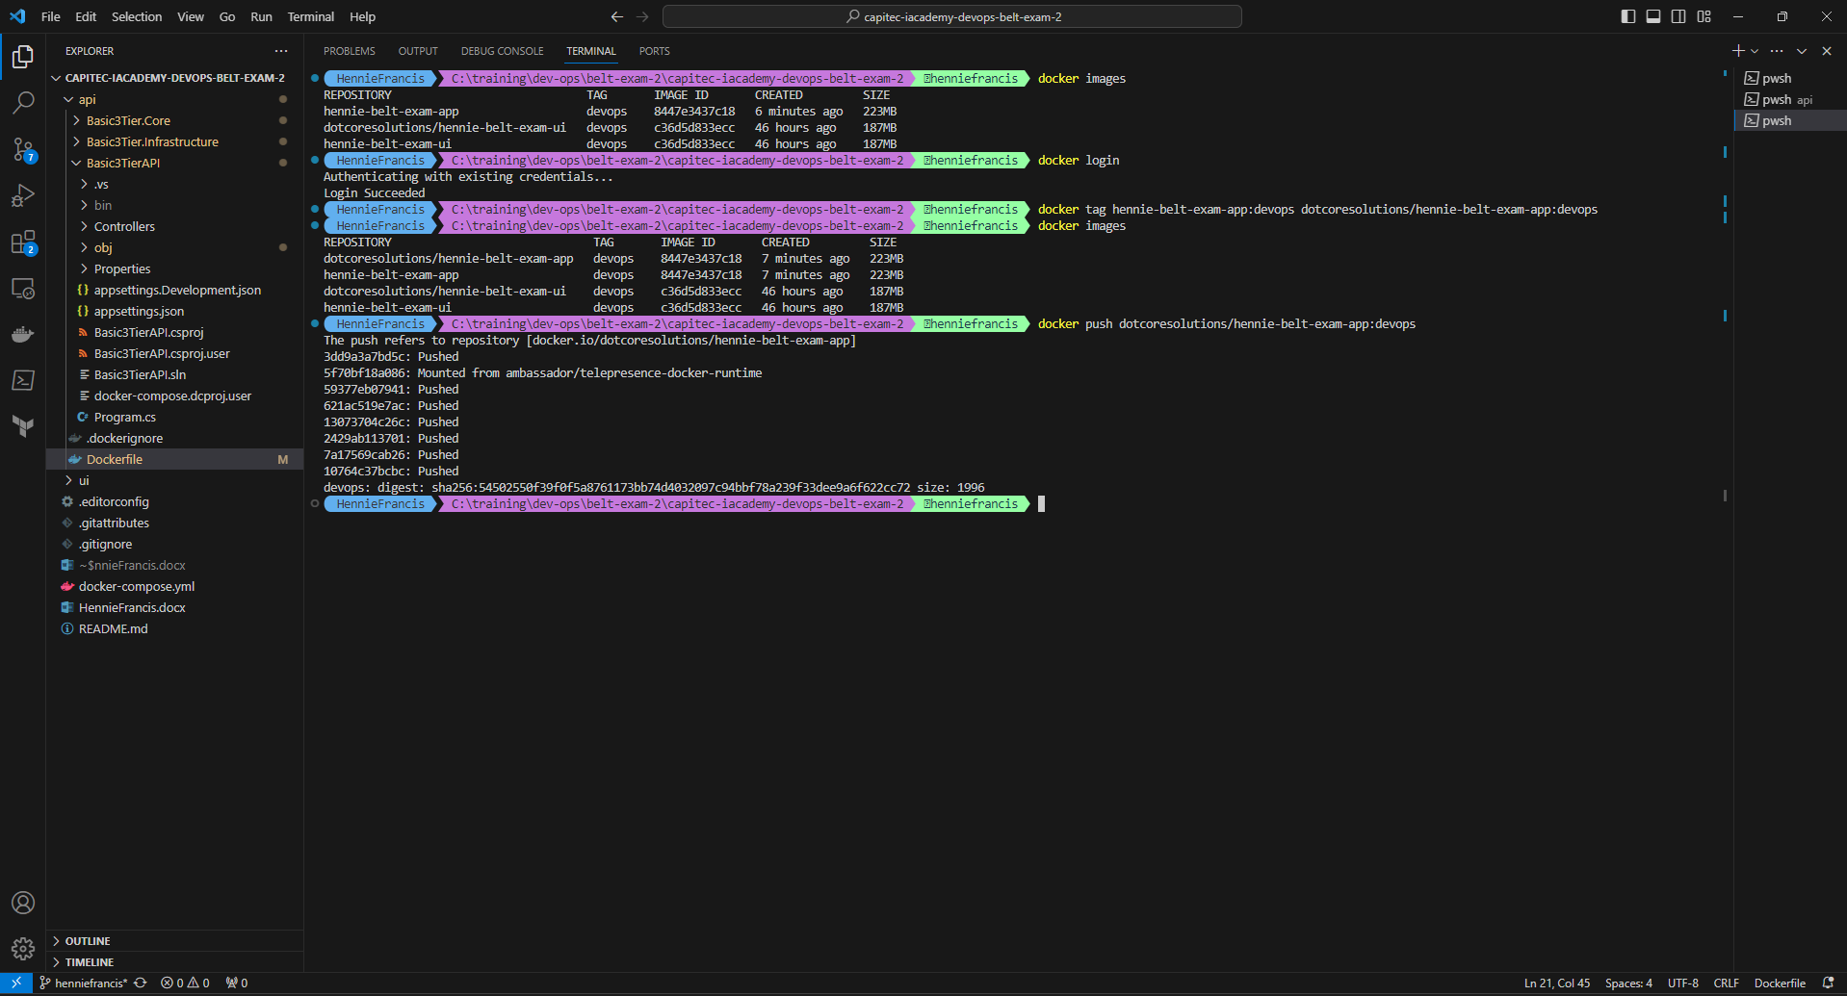

## Dockerfile for Frontend Application

## Deployment of Database Container

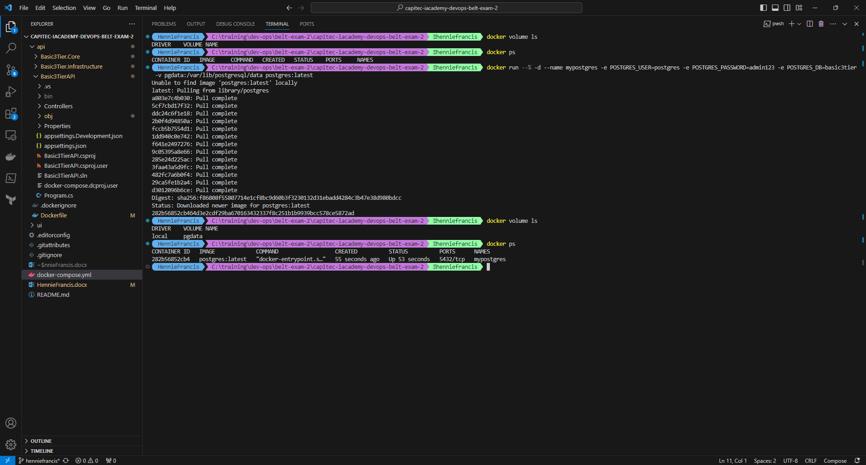

## Deploy PGAdmin

## Deploy the frontend application

**PLEASE NOTE MY PORT 80 is already consumed, will deploy on port 82.**

## Deploy the backend application

## Network requirements

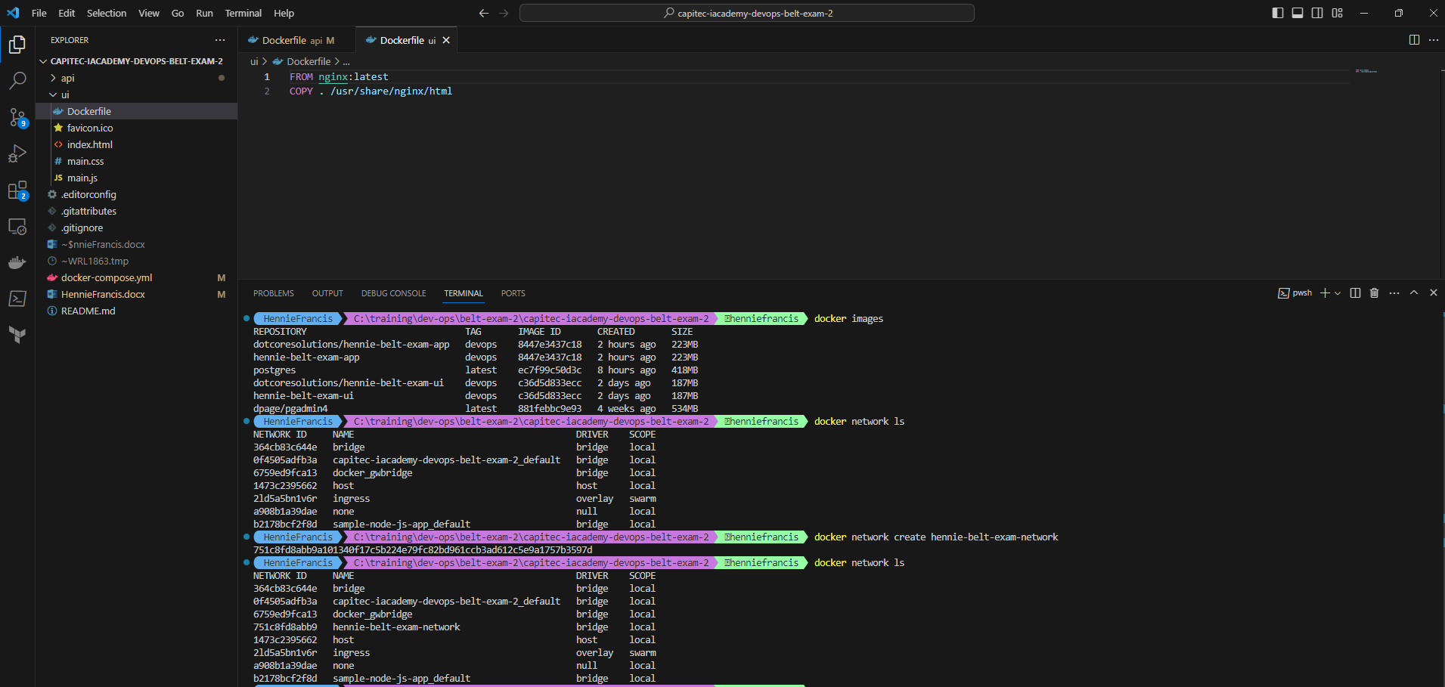

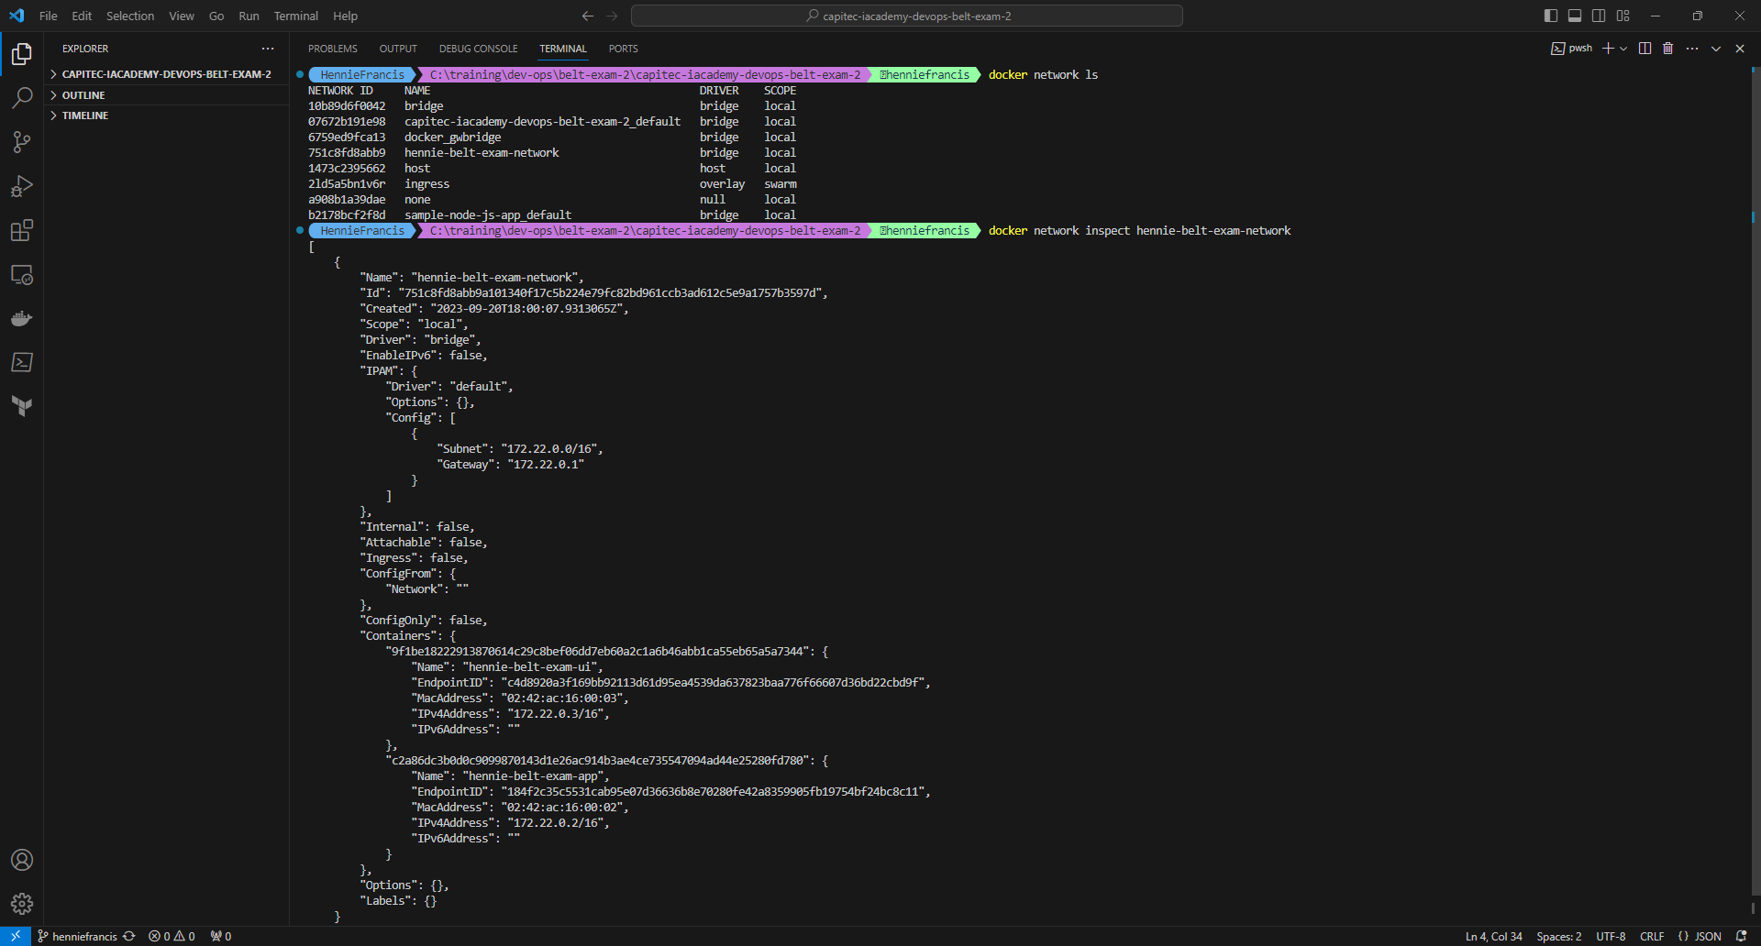

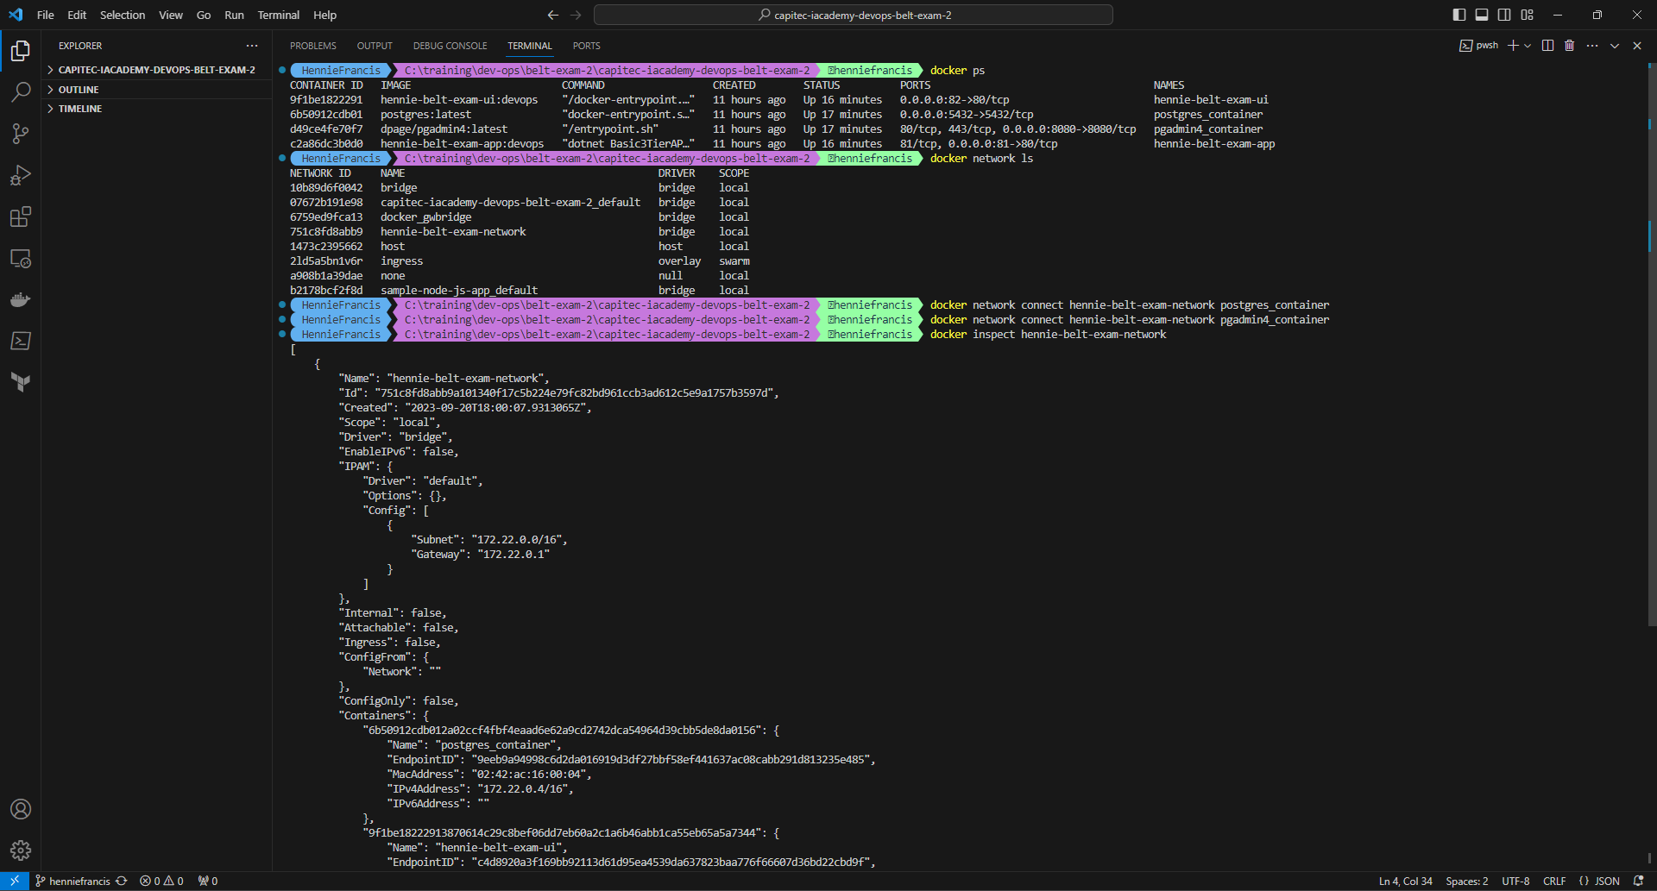

## Verification that Application is Running

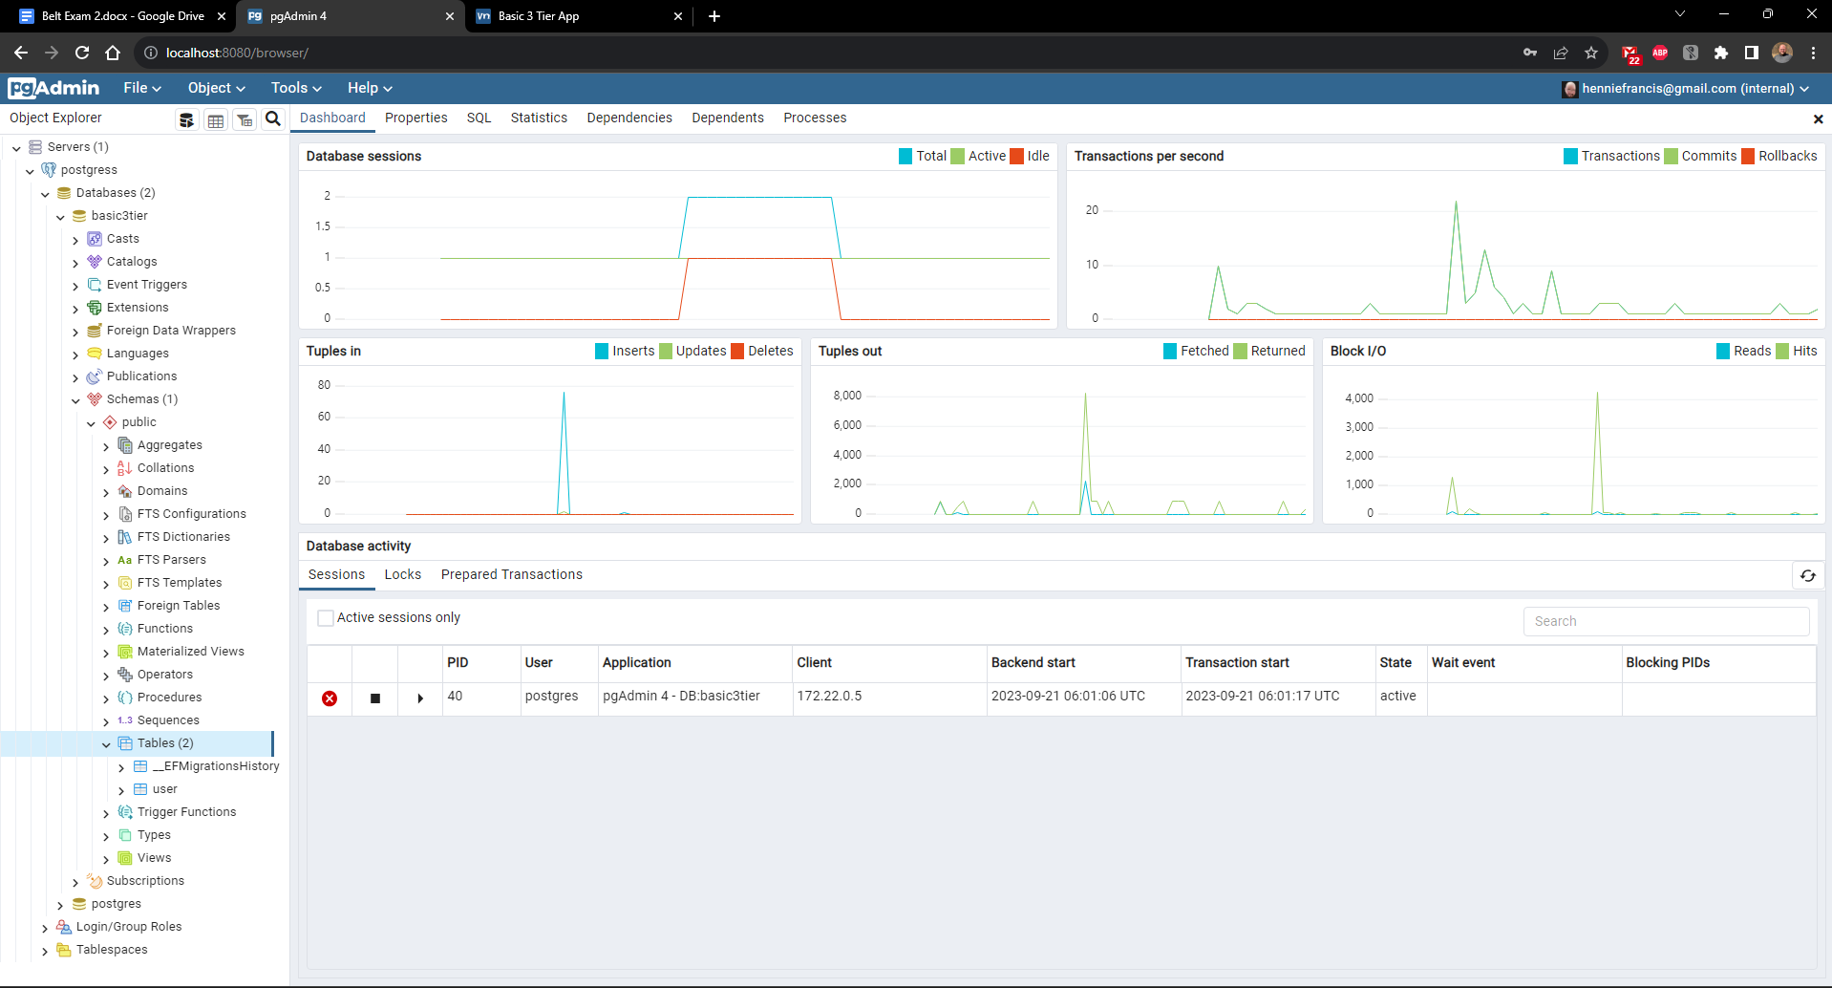

# Question 2:

## Deploy the whole Application using Docker-compose

Solution inside the docker-compose.yml