-YAMAHA GS1 ENSEMBLE EFFECT-

Disclaimer! These are my thoughts and opinions, so it may not be accurate at all but the effect I have been able to create using this info is close
Enough for me. And if at least one person finds this at all useful that is really enough for me. I'm not used to writing such long things so hopefully
It's somewhat readable. Enjoy!

A with and without comparison of the effect that I programmed is available here also.

The Yamaha GS1 has a very nice sounding ensemble effect and I have been deeply fascinated by the GS1 for a long time. Sadly, due to its rarity most people won't ever see one in person (Me included). But after a lot of research and looking at the service manual I think I have been able to emulate the effect to a very good degree. I won't share any code because it's terrible, but I will go into detail about how it works. I want to make it easy for other people to either write plugins and also make hardware versions as well. A few of the original parts are no longer available/proprietary, but due to the effects simplicity replacements are relatively easy to create.

I will try to provide as much information as possible both images, waveforms, timings etc.
In the hope that someone more skilled than me at programming can create a true plugin or an effects pedal.

(Full-Schematic)

In the image above is the full schematic of the GS1 Ensemble effect. It looks very daunting at first but it is actually
a lot more straightforward than many other chorus effects. The effect is based on 3 BBD delay lines that are mixed into
two stereo channels, The only tricky parts to figure out are the SEC II(Symphonic Ensemble Control) and the Clock Generator.
First of all I have heard rumors that the clock gen was made by R.ohm, This is supported by the Yamaha IC Guide Book.
It seems to have been made only for Yamaha, luckily all it really does is to oscillate at a certain frequency and properly
drive the BBDs. The thing that makes this clock gen different from a more standard BBD driver is that it is a VCO
(Voltage Controlled Oscillator) Design. This means that its oscillation frequency can deviate higher or lower
depending on a control voltage. I found a mention of this chip in a Yamaha IC Guide Book as seen below:
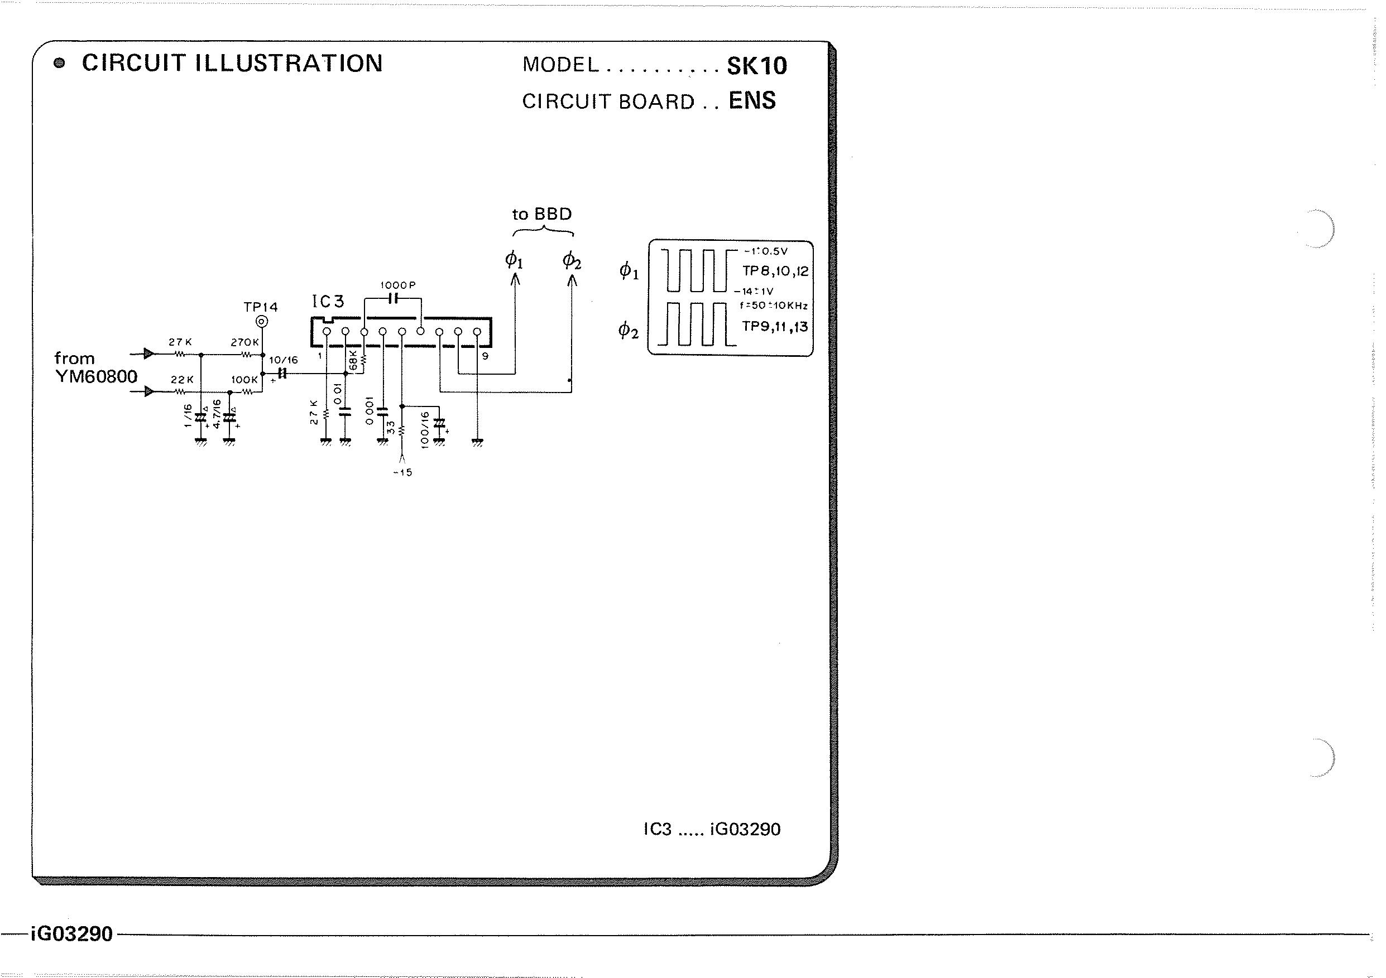
(ClockGen)

As you can see we can learn quite a lot from this little information. It is the same chip but also the oscillation frequency
and deviation. So according to the Guide Book if we use 27kOhm and 1nF we should expect 50kHz (f.dev +-10kHz), however in the GS1 the values
560pF and 33kOhm is used. Therefore I make the assumption that the true frequency in the GS1 is closer to double (100kHz), I am
however unsure what this does to the deviation but I think it stays similar. Now we at least know the ballpark that we are working in, but
before we continue with what signal is modulating the Clock Gen i think we first should understand what may appear to be the most mysterious chip
the SEC II
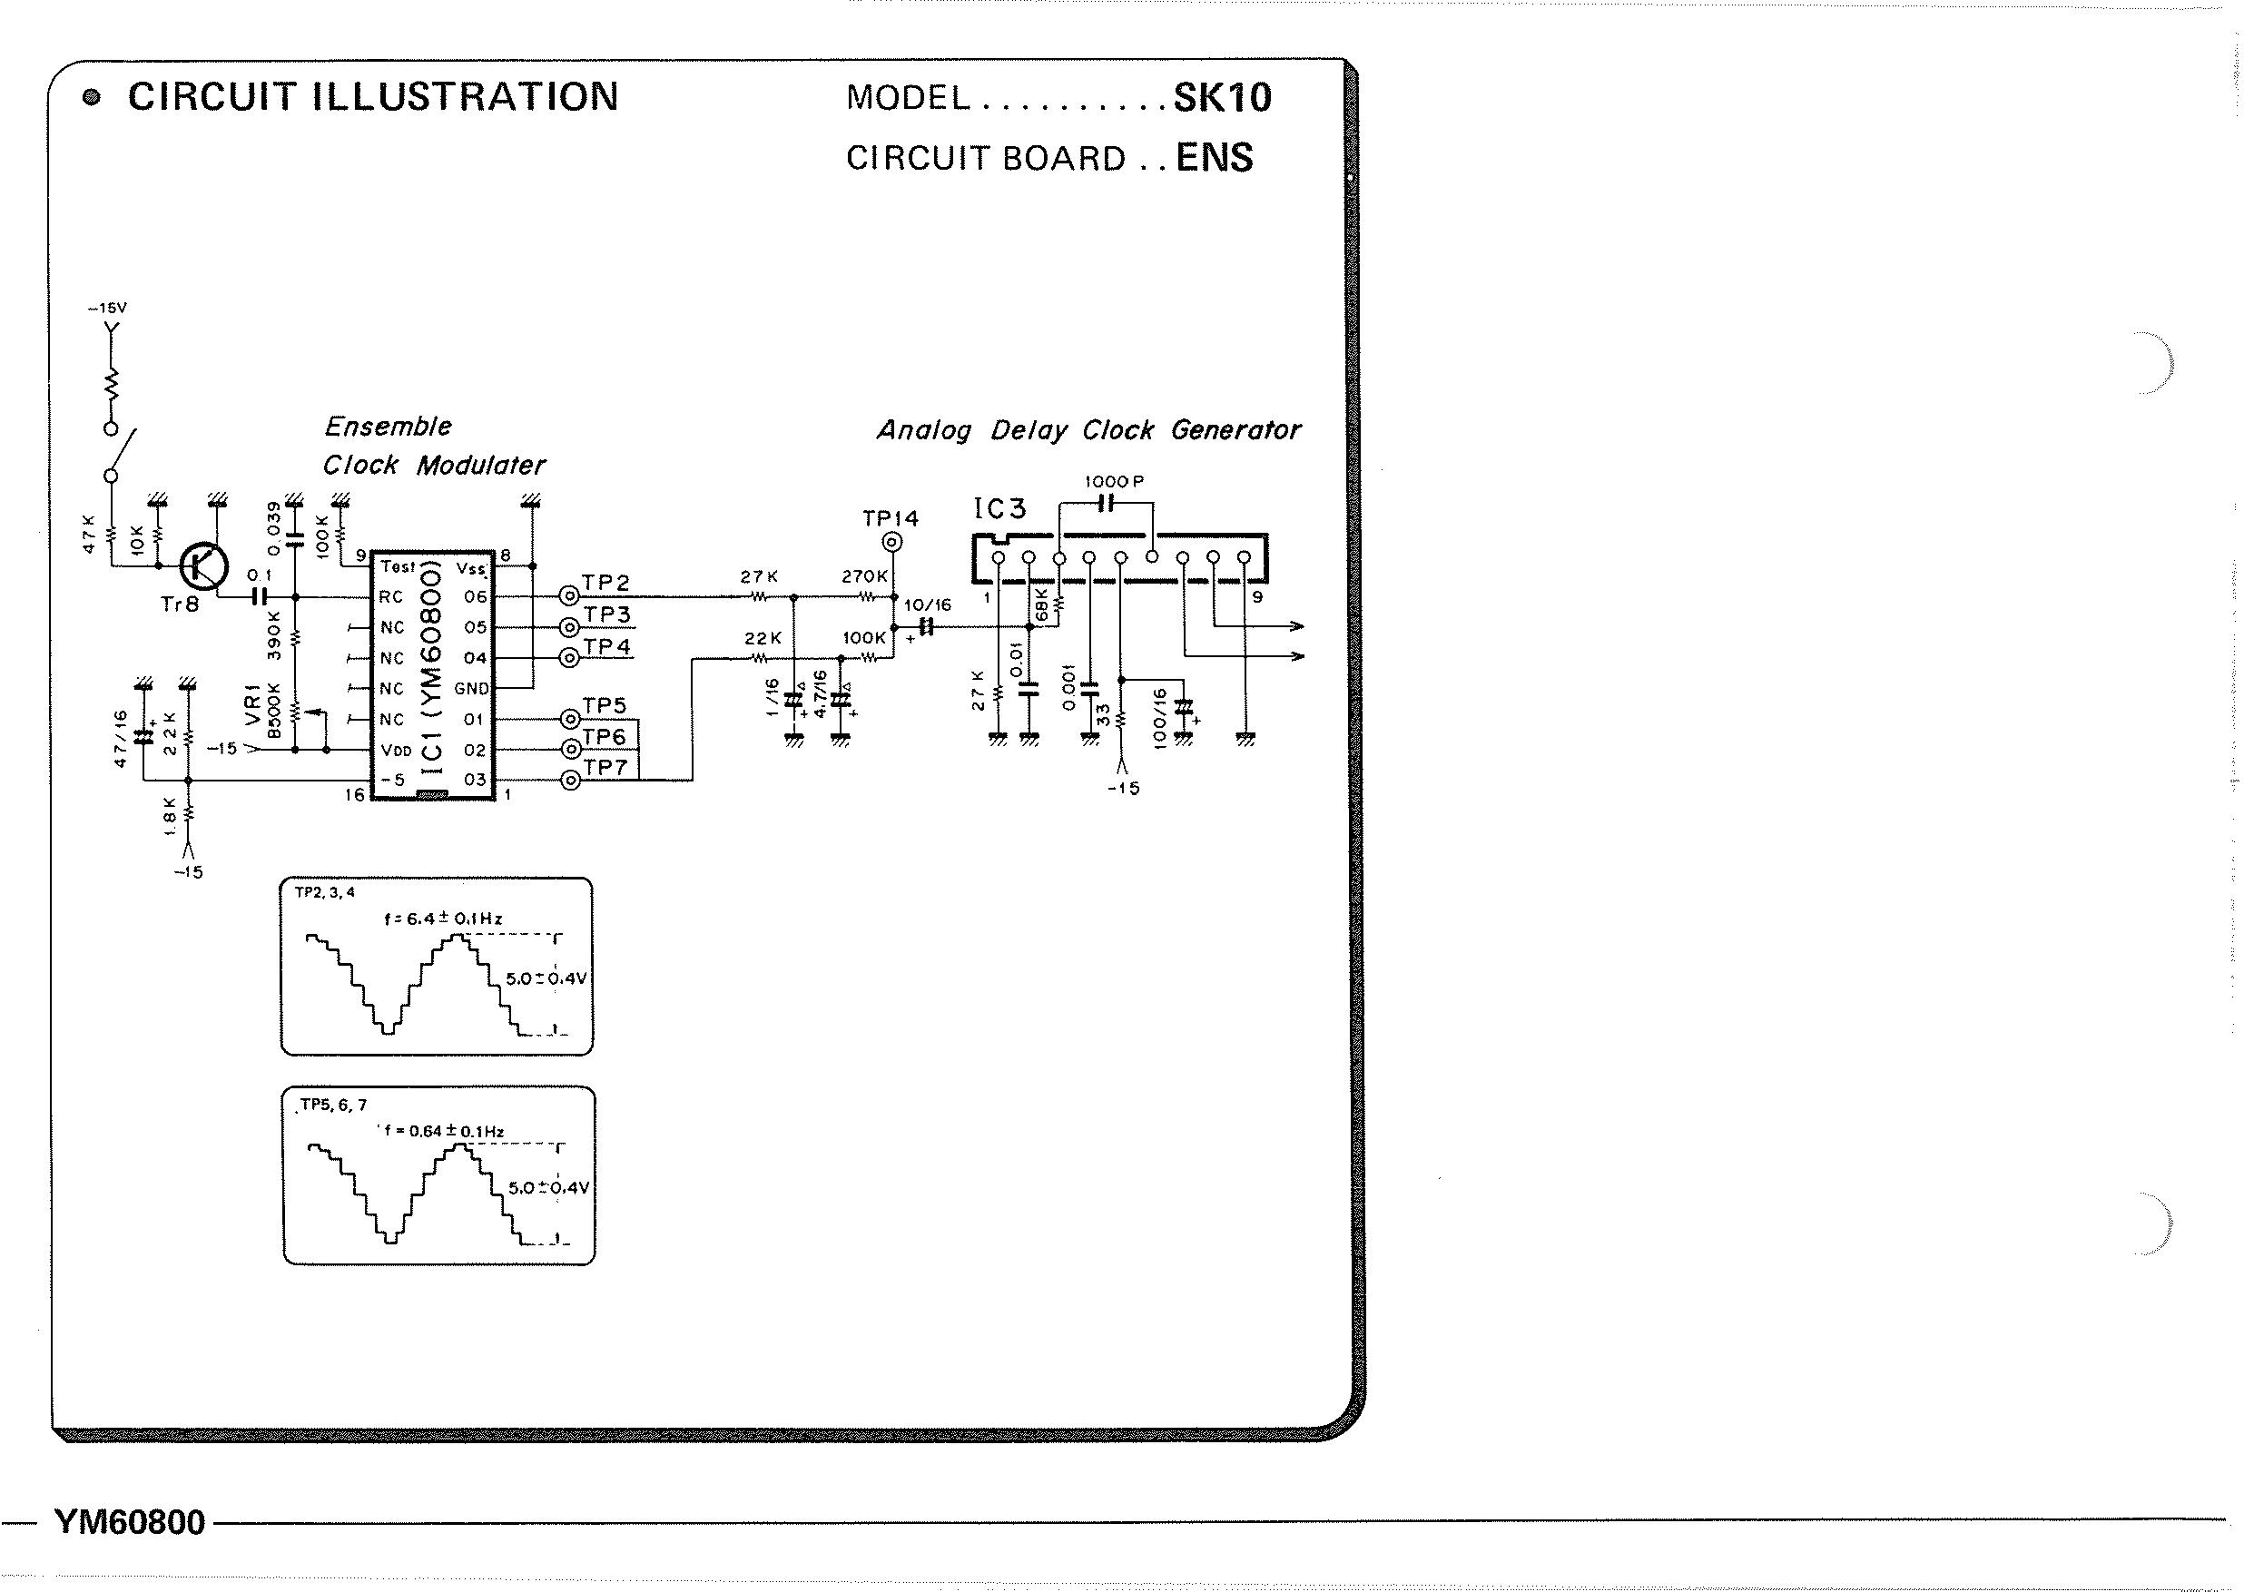
IMG(SEC II)

As we can see on the schematic for the effect, the SEC II outputs 6 signals. 3 Signal are at a frequency of 6.4Hz and the other 3 at 0.64Hz,
Thankfully both voltage and shape have been illustrated, so we can easily figure out what's going on. The Voltage is 5 Volts (Not too important),
the shape however is very recognizable. It seems to be an approximation of a sinewave (3bits?), the output of one 6.4Hz output and one 0.64Hz
output is mixed and low pass filtered. This is to remove the steps and make a decent looking sinewave. The mixing ratio is about 2.7:1 where the
0.64Hz signal is making up the majority of the output. So I'm assuming the now mixed sine waves are modulating an oscillator between 90kHz to 110kHz
and this is driving the BBDs. The three different outputs of the same frequency from the SEC II is assumed to be 90 degrees apart. I believe this
complex modulation of the 3 BBDs is the reason for its special sound.

The BBDs.

The BBDs are standard 256 steps. And this can be used to now calculate how much the signal is delayed. At 90kHz the BBD delays by
(1/90000)*256 = 2.84mS, and at 110kHz the BBD delays by 2.33mS. Because all of this is speculation for the most part, experimentation may
have to be used in order to find what depth(deviation) and delay(frequency) emulates the GS1 best.

Input and Output.

The Ensemble effect works on a mono signal so left and right from the GS1 is first mixed before the effect. The stereo output is created by mixing
one BBD output with another one, both left and right BBD is mixed with what we can call the center BBD. The mixing with the center BBD is about 1:2.2
where the majority of the output is the right/left BBD respectively. Both outputs and inputs are low pass filtered to remove aliasing but
the cutoff frequency is not too critical to the sound.

This has mostly been my theories and opinions so all of it is probably not accurate, but the effect sounds very close and thats enough for me.

