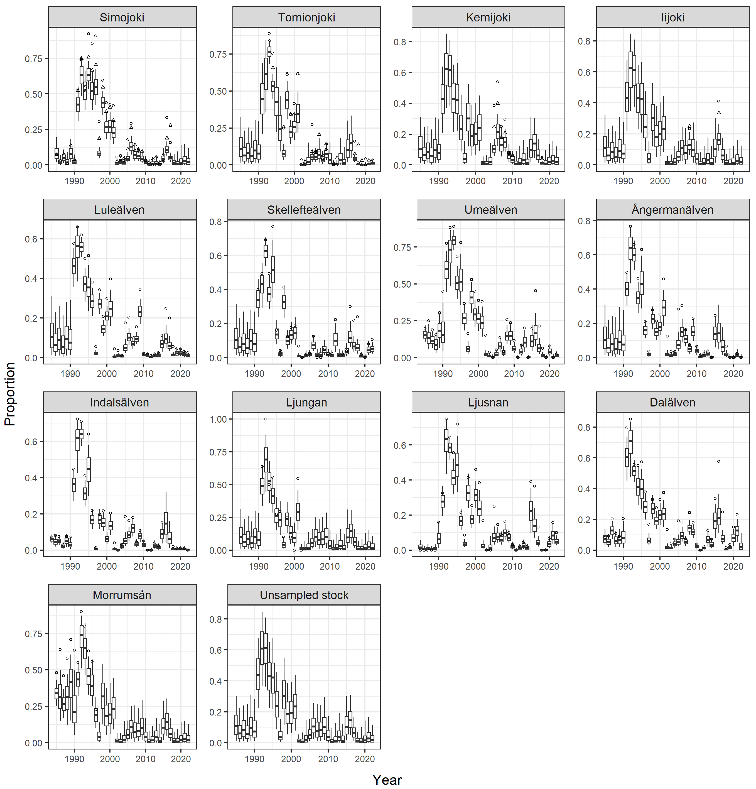

**Figure 4.2.2.1. M74 mortality among Atlantic salmon stocks within the Baltic Sea by spawning year class in 1985–2022. Boxplots illustrate medians, 50% and 95% probability intervals of the estimated M74 mortality. Open circles illustrate the proportion of females with offspring affected by M74 and triangles the total average yolk-sac-fry mortality among offspring.**