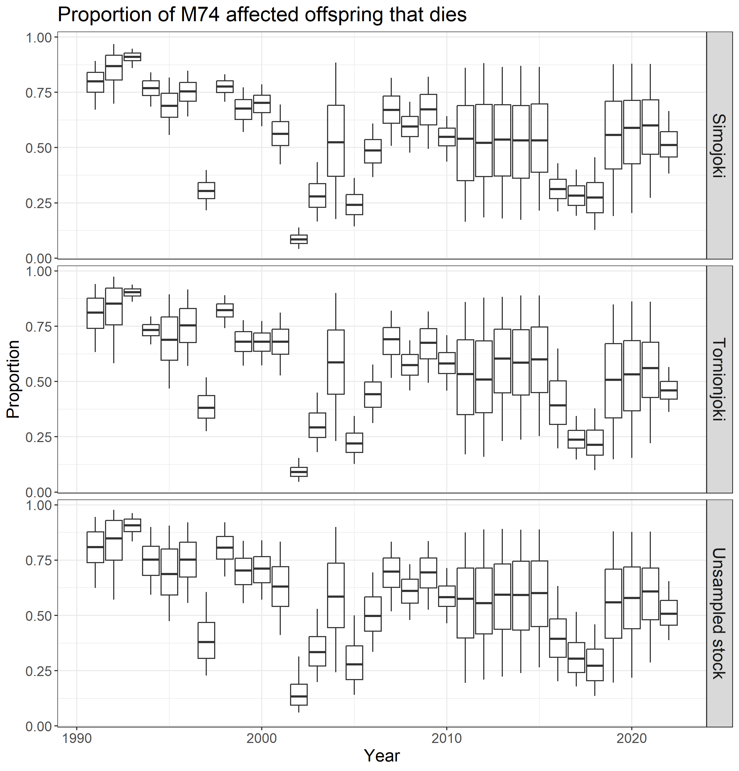

**Figure 4.2.2.2. Estimated proportion of M74-affected offspring that die (i.e. mortality among those offspring that are from M74 affected females) by spawning year class in 1985–2022. Boxplots illustrate medians and 50% and 95% probability intervals.**