# Report Homework 5

Data Mining (ID2222)

Report by Henny Selig ( hselig@kth.se ) and Ignacio Amaya de la Peña ( iadlp@kth.se )

08.01.2017

## Comparison of the graphs and algorithm

### Evaluating input parameters and effects

We have implemented the required changes of task 1. We compare the 3 graphs 3elt, add20 and facebook. The values from this execution will be the reference for future comparison and are shown in the overview below.

|  |  |  |  |
| --- | --- | --- | --- |
|  | **3elt Standard** | **Add20 Standard** | **Facebook Standard** |
| **Edge cut** | 2604 | 2095 | 134246 |
| **Swaps** | 1580209 | 1090263 | 21200364 |
| **Migrations** | 3328 | 1751 | 47763 |
| **runtime** | 33 sec. | 16 sec. | 37 min. 1 sec. |

The plots can be found in the annex.

We can see in all 3 plots that the edge cut doesn’t much decrease after a while (3elt and add20 very clear around 340).

We have then changed different parameters (one at a time) and recorded the changes. First we changed the temperature T to start with. We see that swaps go on for longer, if we increase T. The same applies when decreasing delta. This is due to the fact that the function to calculate the new T-value is linear. This changed when we implemented a new function. However, changing these parameters will have an impact on convergence of the algorithm. With these parameters we can influence the point when no bad swaps are allowed and thereby the point when the edge cut hardly decreases anymore. For example, for the 3elt graph, the point when hardly any swaps happen anymore changed from around round 350 to around round 650, when we increased T to 3. However, we can also see that this can lead to a lower edge cut, see table below.

|  |  |  |  |
| --- | --- | --- | --- |
| **Edge cut with:** | T=1.5 | **T=2 (standard)** | T=3 |
| **3elt** | 2566 | **2604** | 2449 |
| **Add20** | 2249 | **2095** | 2100 |
| **facebook** | 140011 | **134246** | 120800 |

In general, the configuration of T and delta should depend on the graph and its properties, and should fit each other as they influence the result in their combination.

Secondly, we changed the value of alpha. You can find an overview in the table below.

|  |  |  |  |
| --- | --- | --- | --- |
| **Edge cut with:** | Alpha = 1 | **Alpha = 2 (standard)** | Alpha = 3 |
| **3elt** | 2788 | **2604** | 2437 |
| **Add20** | 1797 | **2095** | 2184 |
| **facebook** | 168294 | **134246** | 131208[[1]](#footnote-1) |

We can’t really see a trend for the edge cut in this comparison. However, if we compare the evolution of the edge cut, we see major differences in the course of the graph. Alpha is the parameter used in comparing whether a swap of colour makes sense or not. It therefore, in combination with the development of T, defines how much impact a change must make to be a good swap candidate. If alpha = 1, one can say it is ignored.

One thing to note is that the number of swaps doesn’t necessarily correlate with a better edge cut. In general, there are many parameters to influence the behaviour of the algorithm. It is important to understand how they interact and influence the outcome, but they need to be adapted and tried depending on the graph. They might also impact the runtime. For the facebook graph, we have experienced runtimes between 32 minutes (with T=3), 2.5 hours (when changing alpha) and 4 hours (with T=1).

### New function for T calculation

We have implemented a new function to calculate T, as instructed. As expected, the edge cut decreases and the number of swaps increases much steeper. An overview can be found below in Fig. 1, the larger graphs can be found in the annex. We see the same effect for the other graphs as well. When running the new function, T must be set to 1 (or lower) and delta is still given as a small value (e.g. 0.1). The lowest value of T is hardcoded, currently 0.001. It might be required to change this. Also, different examples should be run with different parameters. The effect should be the same as discussed above (of course in a different scale).

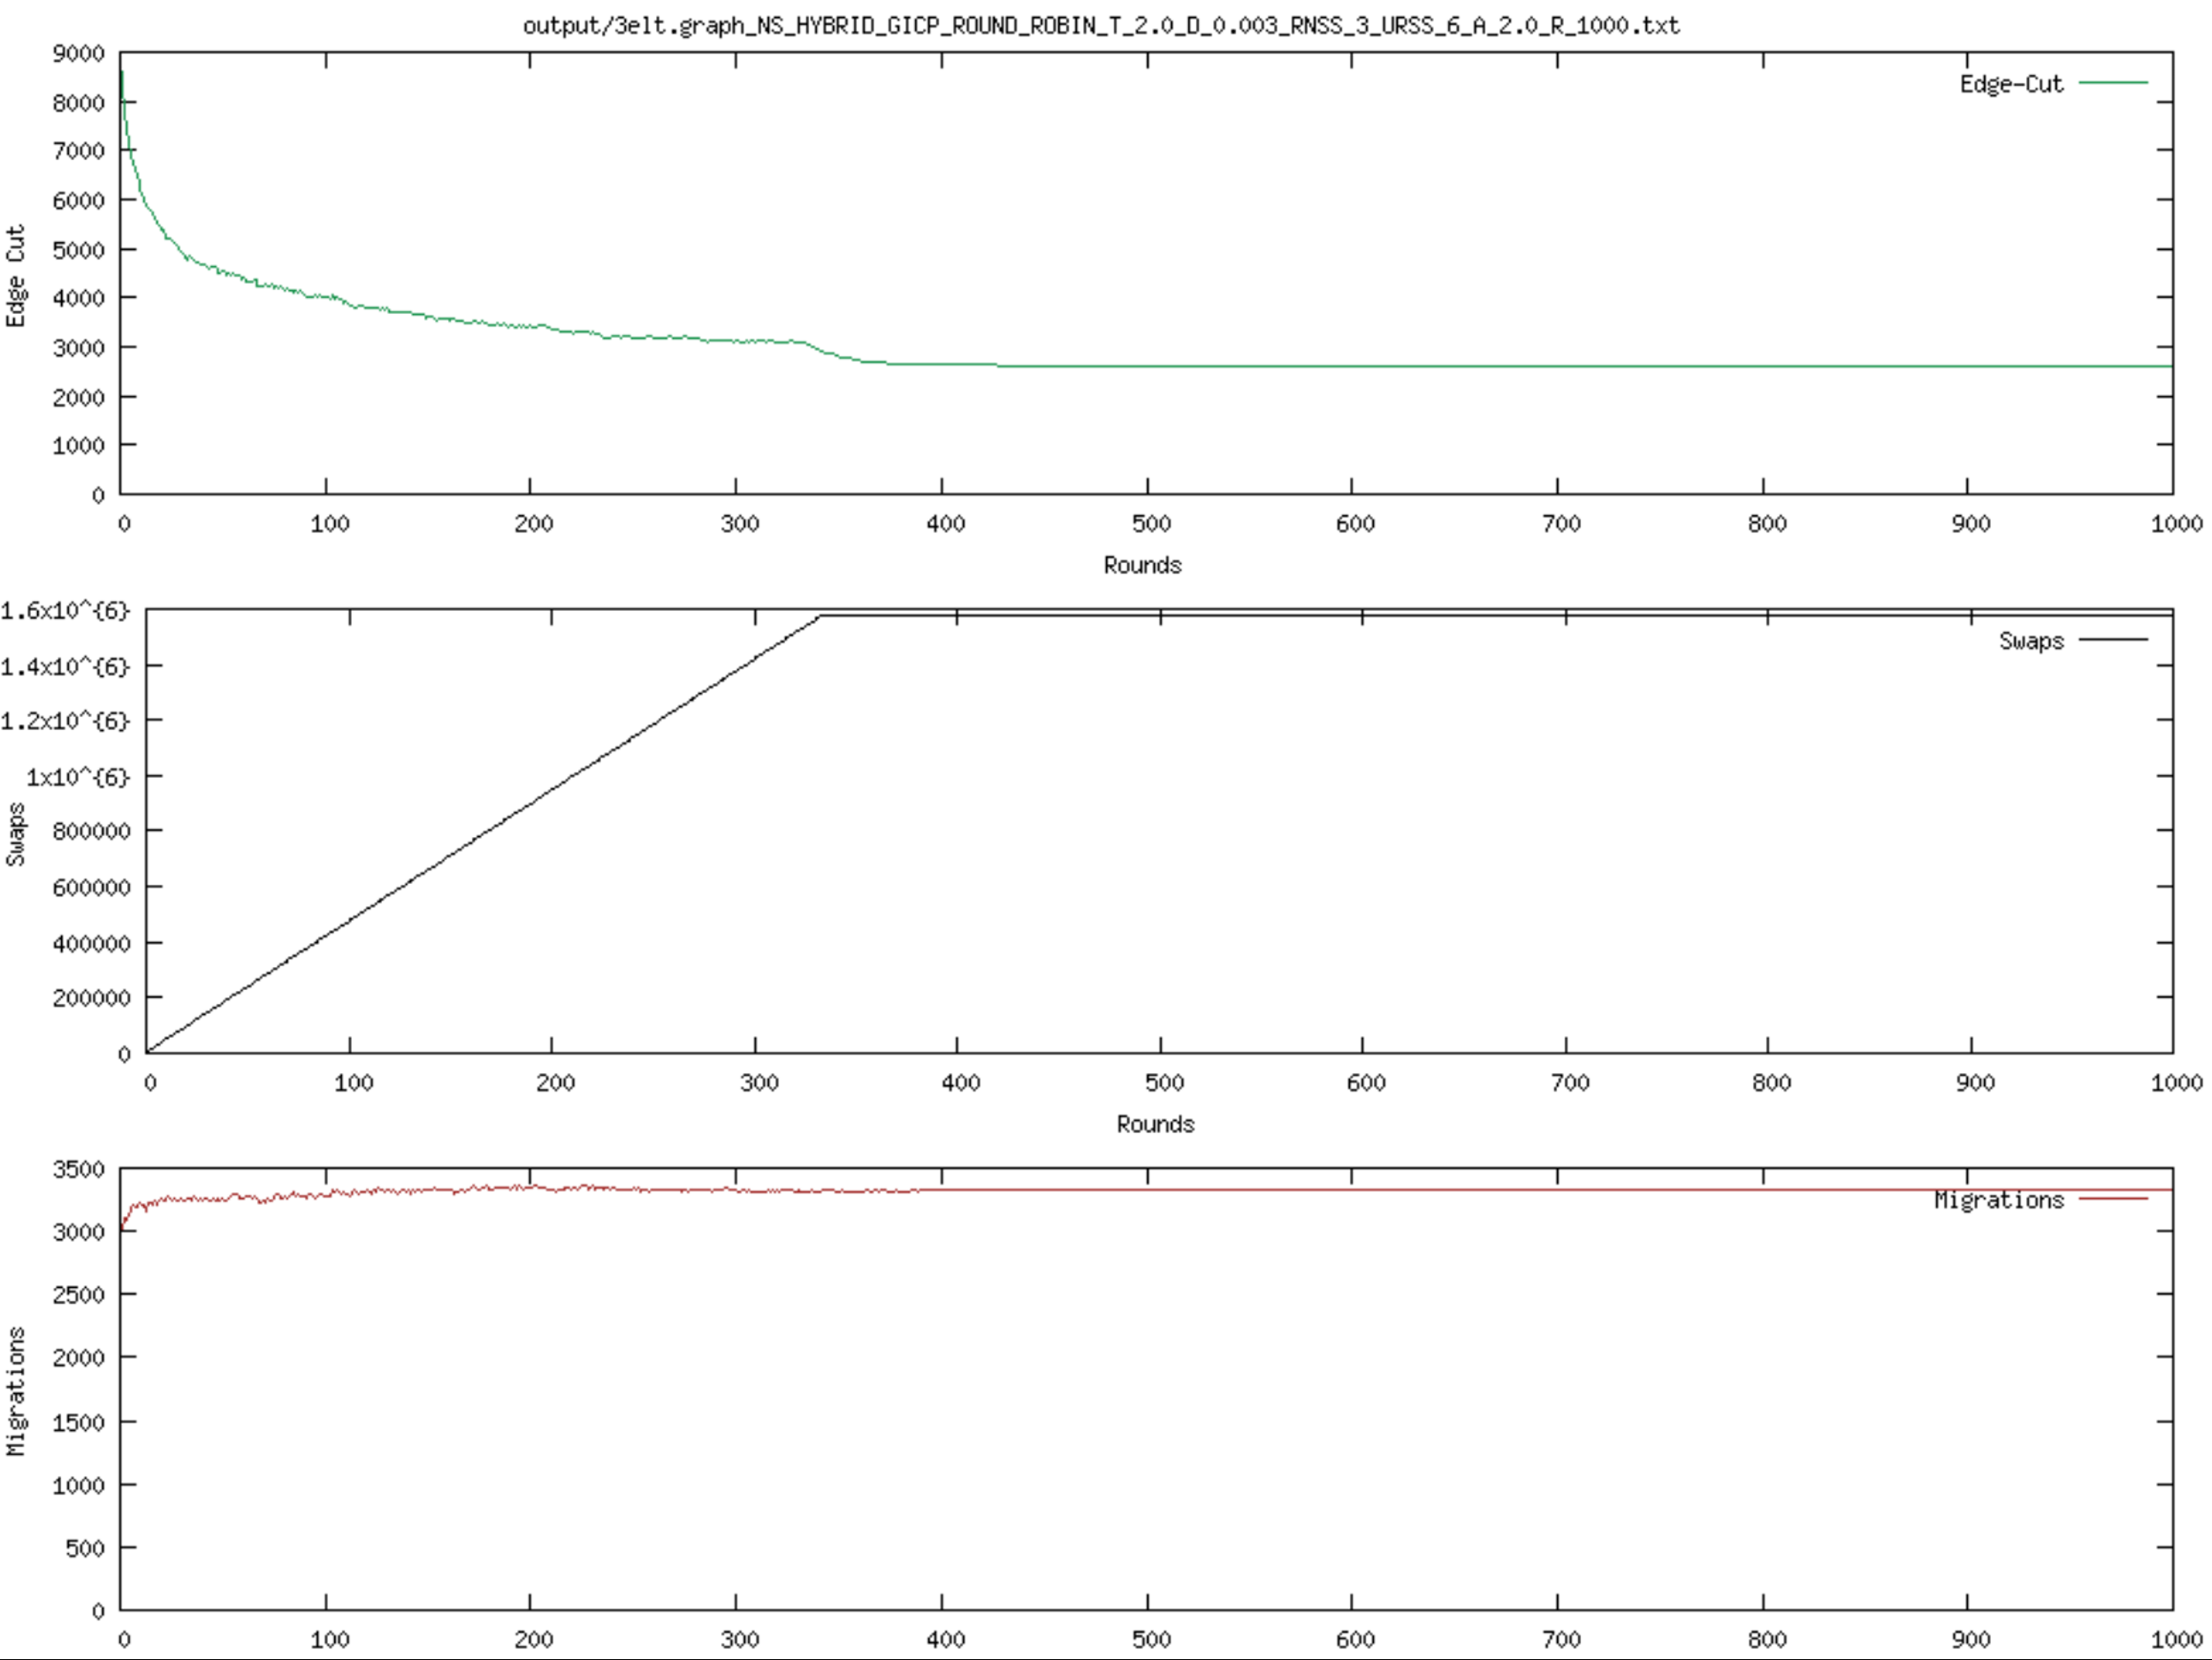Computergenerierter Alternativtext:
output,oel t. O-R-IOOO • txt 
9000 
8000 
7000 
6000 
a 5000 
4000 
3000 
2000 
1000 
0 
35000 
30000 
25000 
20000 
15000 
10000 
5000 
0 
3500 
3000 
2500 
2000 
1500 
1000 
500 
0 
100 
100 
100 
200 
200 
200 
300 
300 
300 
500 
Rounds 
500 
Rounds 
500 
Rounds 
700 
700 
700 
800 
800 
800 
900 
900 
1000 
1000 
1000 

Figure 1: Comparison of old (left) and new (right) T calculation for 3elt

### Resetting T after 400 rounds

We changed the code to reset T to its original value after round 400. We ran this with the old and the new way of calculating the new T value. In both cases, the resulting edge cut was not improved. If we allow bad swaps at a larger scale again by resetting T, the result can even be worse, as shown in the table below. As expected, the number of swaps increases, but these don’t improve much of the edge cut. It makes more sense to control the behaviour of swaps with the T and delta parameters.

|  |  |  |
| --- | --- | --- |
| **Edge cut** | **standard** | **With T-restart** |
| **3elt** | 2604 | 2622 |
| **Add20** | 2095 | 2432 |

### Additional improvements

In our case, the runtime of the facebook graph was a serious problem. As the edge cut only increases marginally after a while, we introduced a check that stops the algorithm if hardly any changes occur anymore. In our case, we hardcoded that the algorithm stops if the edgecut hasn’t improved for more than 10 rounds. This, however, could be implemented as a margin (e.g. increased x% over time) or set the 10 as a parameter, as this may depend on the graph.

With this improvement, we see the following for graph facebook:

|  |  |  |
| --- | --- | --- |
| **facebook** | **standard** | **Cut if no improvements** |
| **Edge cut** | 134246 | 134265 |
| **swaps** | 21200364 | 21200345 |
| **Migration** | 47763 | 47764 |
| **runtime** | 37 min. 1 sec. | 20 min 52 sec. |

As we see, the runtime is roughly 16 minutes faster (43%), while the edge cut is only 19 higher (0.01%). In our opinion, this is a helpful improvement if runtime matters.

## Annex

### The Standard graphs

These are the graphs used for comparison.



Figure 2: 3elt standard execution

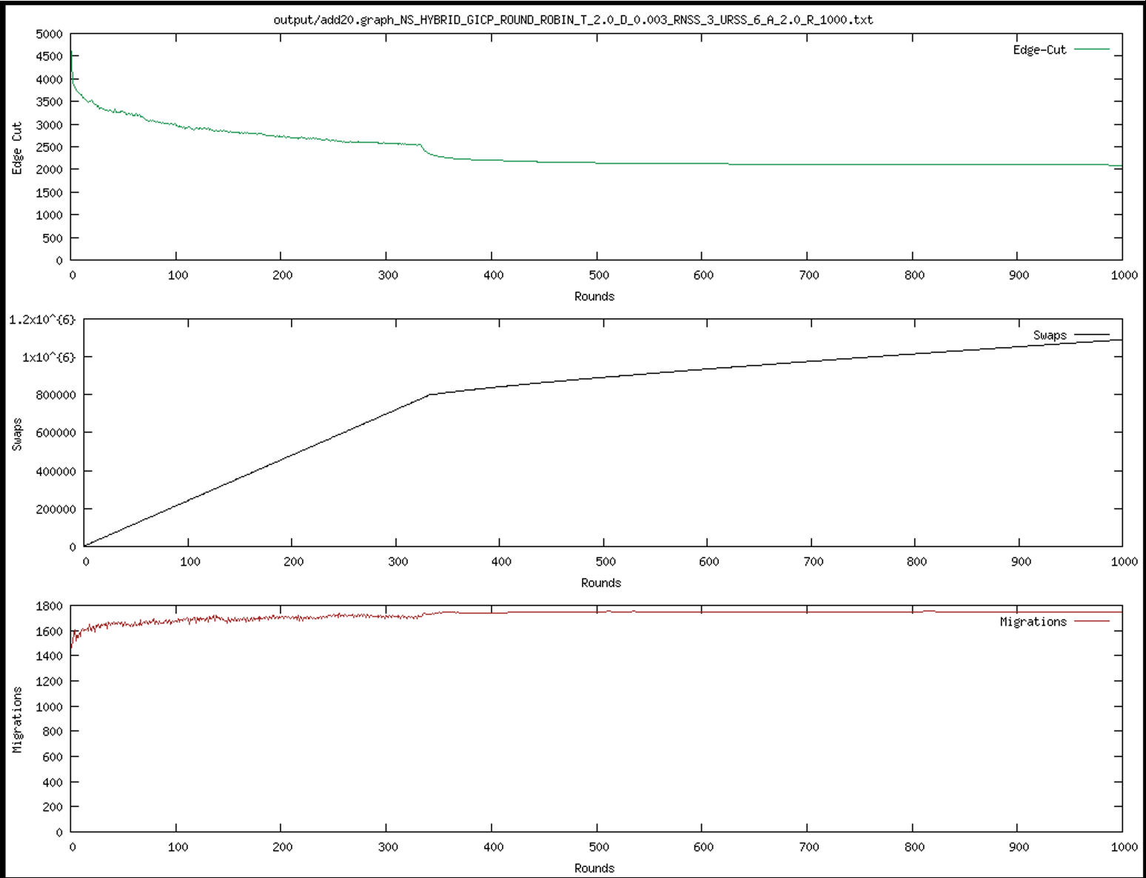

Figure 3: add20 standard execution

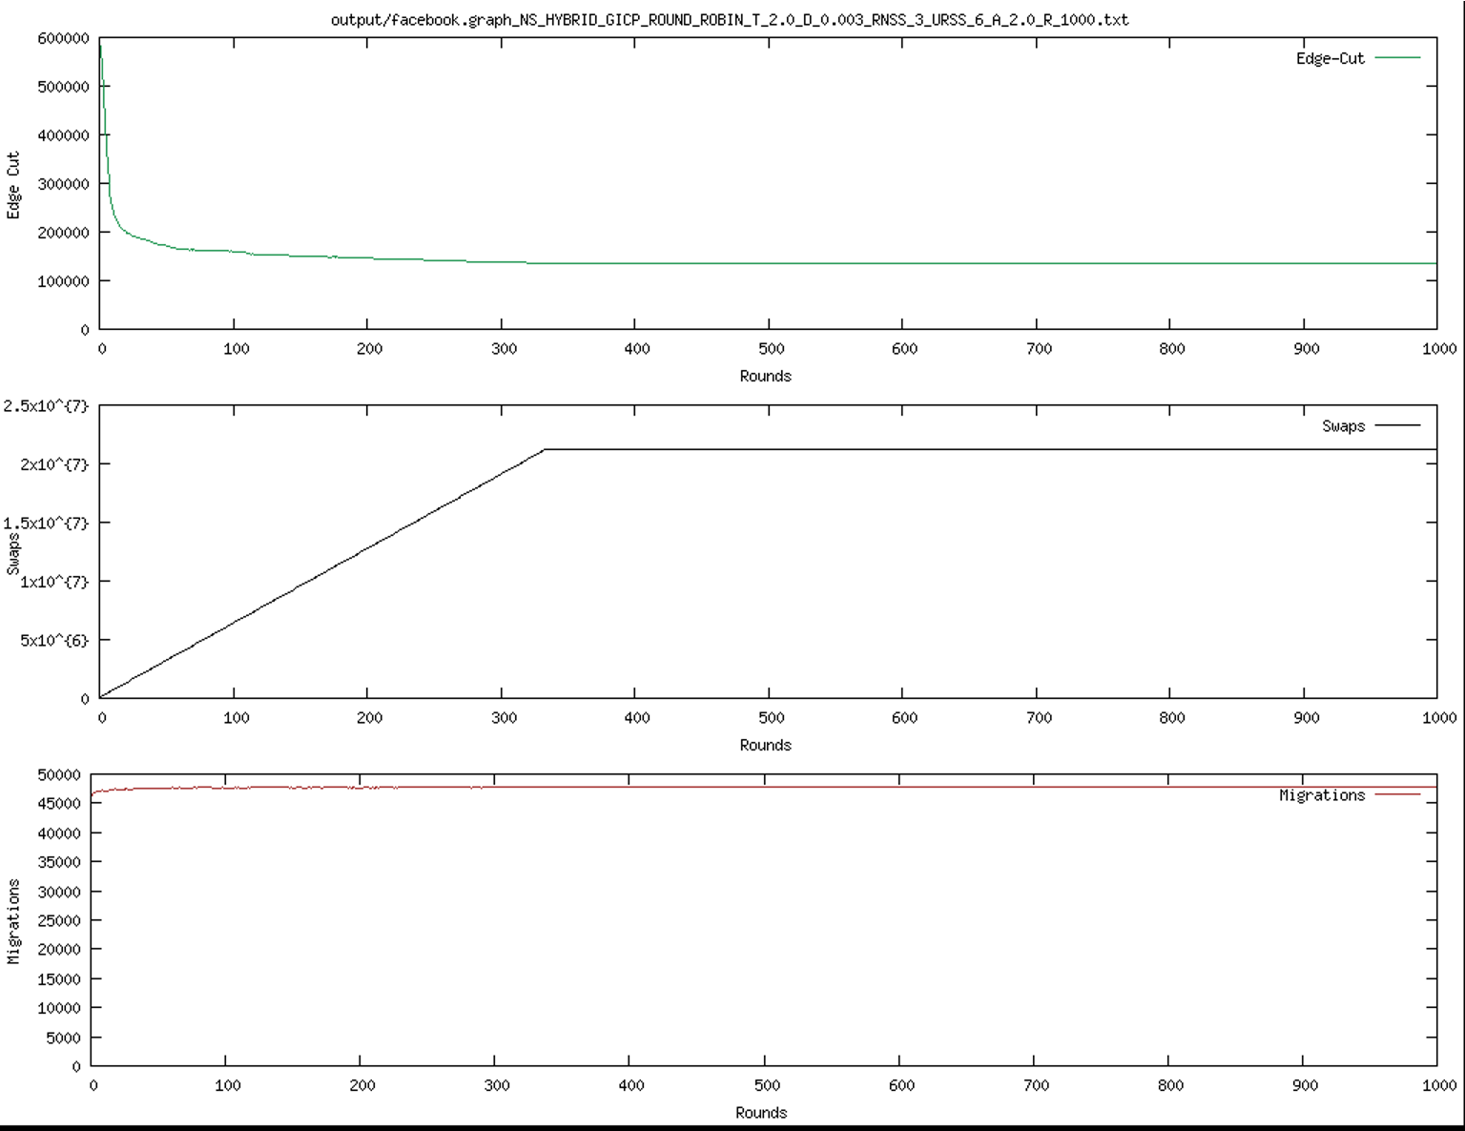

Figure : Facebook standard exection

### Alpha comparison

The following shows the edge cut for different alpha values.

Computergenerierter Alternativtext:
output/3e1t txt 
10000 
9000 
8000 
7000 
6000 
5000 
4000 
3000 
2000 
1000 
100 
1 .6x10A{6} 
1.4x10a{6} 
1 .2x10A{6} 
1x10A{6} 
800000 
600000 
400000 
200000 
100 
3500 
3000 
2500 
2000 
1500 
1000 
500 
100 
200 
200 
200 
300 
300 
300 
400 
400 
500 
Rounds 
500 
Rounds 
500 
Pounds 
600 
600 
600 
700 
700 
700 
800 
800 
800 
Edge—Cut 
900 
Swaps 
Migrations 
900 
1000 
1000 
1000 Computergenerierter Alternativtext:
output/3e1t. txt 
9000 
8000 
7000 
6000 
5000 
4000 
3000 
2000 
1000 
100 
1.6x10A{6} 
1.4x10A{6} 
1.2x10A{6} 
800000 
600000 
400000 
200000 
100 
3500 
3000 
2500 
2000 
1500 
1000 
100 
200 
200 
300 
300 
300 
400 
400 
400 
500 
Rounds 
500 
Pounds 
500 
600 
700 
700 
300 
Edge-Cut 
900 
Swaps 
900 
Migrations 
900 
1000 
1000 
1000 

Figure 5: 3elt with alpha=1 (upper) and alpha=3 (lower)

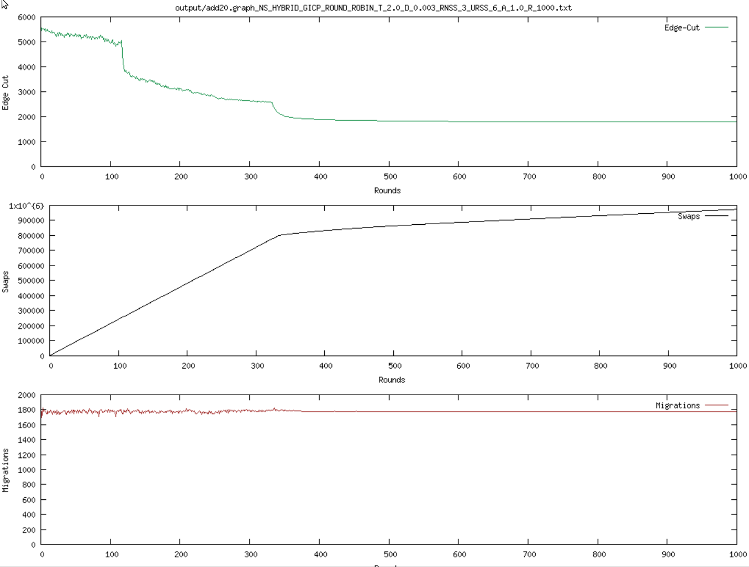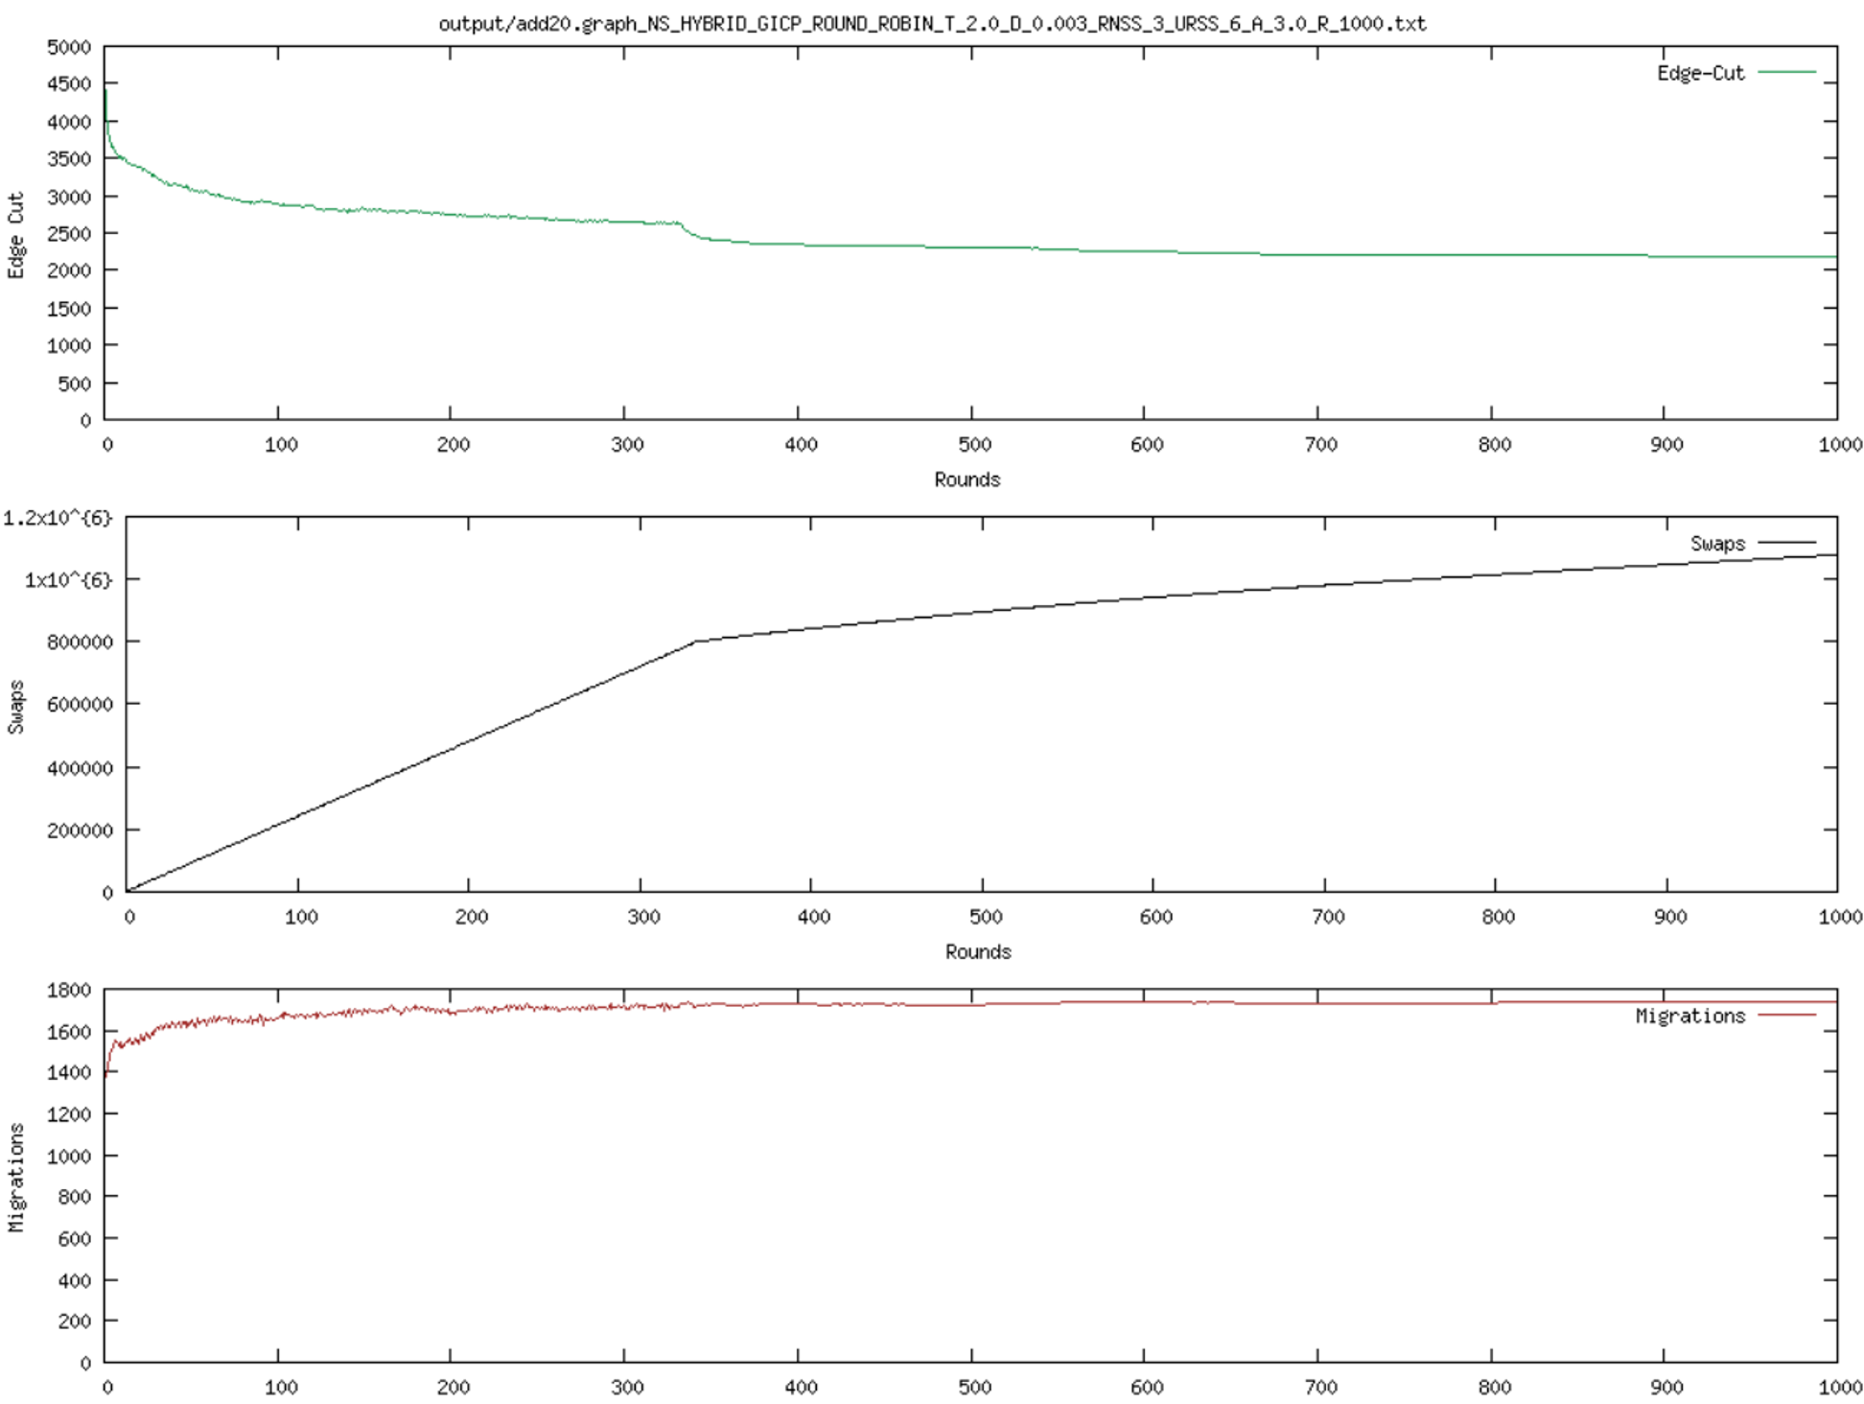

Figure 6: add20 with alpha=1 (upper) and alpha=3 (lower)

Computergenerierter Alternativtext:
output/€aceD00K .grapn_N 
R_IOOO . txt 
700000 
600000 
500000 
400000 
300000 
200000 
100000 
0 
0 
2.5x10A{7} 
1.5x10A{7} 
5xIOA{6} 
50000 
45000 
40000 
35000 
30000 
25000 
t'" 20000 
15000 
10000 
5000 
0 
0 
100 
100 
100 
200 
200 
300 
400 
500 
Rounds 
500 
Rounds 
500 
600 
600 
600 
700 
700 
800 
800 
800 
Edge-Cut 
Swaps 
Mi grat ions 
900 
1000 
1000 
1000 Computergenerierter Alternativtext:
output,'€aceb00k. O-R-IOOO • txt 
600000 
500000 
400000 
300000 
200000 
100000 
2 .5X10A{7} 
1 .5x10A{7} 
5x10A{6} 
50000 
45000 
40000 
35000 
30000 
25000 
20000 
15000 
10000 
5000 
100 
100 
100 
900 
900 
Ons 
200 
300 
300 
300 
400 
400 
500 
Rounds 
500 
Rounds 
500 
600 
600 
700 
800 
1000 
1000 
1000 

Figure 7: facebook with alpha=1 (upper) and alpha=4 (lower)

### Change of Temperature calculation

Computergenerierter Alternativtext:
output,oel t. O-R-IOOO • txt 
9000 
8000 
7000 
6000 
a 5000 
4000 
3000 
2000 
1000 
0 
35000 
30000 
25000 
20000 
15000 
10000 
5000 
0 
3500 
3000 
2500 
2000 
1500 
1000 
500 
0 
100 
100 
100 
200 
200 
200 
300 
300 
300 
500 
Rounds 
500 
Rounds 
500 
Rounds 
700 
700 
700 
800 
800 
800 
900 
900 
1000 
1000 
1000 

Figure 8: 3elt with new temperature calculation

Computergenerierter Alternativtext:
output/add20. _1. txt 
2500 
2000 
1000 
100 
600000 
500000 
400000 
300000 
200000 
100000 
100 
1400 
1000 
800 
100 
200 
200 
300 
400 
Rounds 
600 
Rounds 
400 
700 
800 
800 
800 
Edge-Cut 
900 
900 
900 
1000 
1000 
1000 

Figure 9: add20 with new temperature calculation

Computergenerierter Alternativtext:
output/Facebook . _ 1 . .003_RNss_3_URss_6_a_2. o_R_1000. txt 
450000 
Edge-Cut 
400000 
350000 
300000 
250000 
200000 
150000 
100000 
50000 
Rounds 
200000 
Swaps 
180000 
160000 
140000 
120000 
100000 
80000 
60000 
40000 
20000 
Rounds 
50000 
1 era 
45000 
40000 
35000 
30000 
25000 
20000 
15000 
10000 
1 ons 

Figure 10: with new temperature calculation (incomplete)

### Plots with resetting T

3elt and add20 with resetting T to its original value after round 400.

Computergenerierter Alternativtext:
output/3e1 t . _2 . .003_RNss_3_URss_6_a_2. o_R_1000. txt 
9000 
Edge-Cut 
7000 
3000 
2000 
1000 
1000 
Rounds 
4 . 5x10A{6} 
4x10A{6} 
3 • 5x10A{6} 
3x10A{6} 
45x10A{6} 
B2x10A{6} 
1 • 5x10A{6} 
1x10A{6} 
500000 
1000 
Rounds 
Mierations 
3000 
2000 
1500 
1000 
1000 

Figure : 3elt with restarting T

Computergenerierter Alternativtext:
5000 
4500 
4000 
3500 
3000 
2500 
2000 
1500 
1000 
500 
2 .5X10A{6} 
1 .5x10A{6} 
500000 
1800 
1600 
1400 
1200 
1000 
800 
600 
400 
200 
0 
100 
100 
100 
200 
200 
300 
300 
300 
400 
500 
Rounds 
500 
Rounds 
500 
600 
O-R-IOOO • txt 
700 
700 
800 
800 
900 
900 
M i erations 
900 
1000 
1000 
1000 

Figure : add20 with resetting T

1. Alpha = 4 for facebook graph due to mistake when running it. [↑](#footnote-ref-1)