Highway Traffic Act
Code de la route
R.R.O. 1990, REGULATION 615
SIGNS
Consolidation Period: From May 15, 2026 to the e-Laws currency date.
Last amendment: 138/26.
Legislative History: 699/92, 444/93, 519/93, 909/93, 148/97, 332/98, 380/98, 380/02, 246/03, 63/06, 175/08, 261/08, 339/09, CTR 13 JN 08 - 1, 93/15, 335/15, 407/15, 483/17, 301/18, 396/19, 462/20, 468/20, 275/25, 398/25, 138/26.
This Regulation is made in English only.
CONTENTS
 |  | Sections
 | Speed Limit Signs | 1-5.0.1.3
 | Community Safety Zone School Signs | 5.0.2-5.1.1
 | Community Safety Zone Signs | 5.2
 | Stop Signs | 6-12
 | Stopping Signs | 13-15
 | Yield Right-Of-Way Signs | 16-20.10
 | Turn Signs | 21-22
 | No U Turn Sign | 23
 | Parking Control Signs | 24-27.1
 | School Bus Loading Zone | 28-29
 | One-Way Sign | 30
 | Do Not Enter Sign | 31-32
 | Truck Sign | 33
 | Lane Designation Sign | 34
 | Do Not Pass Sign | 35
 | No Bicycles Sign | 36
 | Pedestrian Prohibition Sign | 37
 | Pedestrian and Bicycle Prohibition Sign | 38
 | Interdictory and Permissive Symbols | 39
 | Load Restriction Sign | 40-40.1
 | Gross Weight on Bridges Sign | 41
 | Construction Zone Sign | 42-42.1
 | Bicycles Excepted | 42.2
 | Buses Excepted | 43
 | Toll Highways | 43.0.1-43.4
 | General | 44-52
Speed Limit Signs
1. A speed limit sign,
(a) shall be not less than 60 centimetres in width and 75 centimetres in height;
(b) shall bear the word “maximum” in black letters not less than 10 centimetres in height on a white retro-reflective background;
(c) shall display in black numerals not less than 30 centimetres in height on a white retro-reflective background the prescribed maximum rate of speed; and
(d) may display a tab sign not less than 20 centimetres in height and not less than 60 centimetres in width immediately below the speed limit sign and the tab sign shall bear the legend “km/h” in white retro-reflective letters not less than 10 centimetres in height on a black background,
as illustrated in the following Figure:
or a speed limit sign shall,
(e) be not less than 60 centimetres in width and 90 centimetres in height;
(f) bear the word “maximum” in black letters not less than 10 centimetres in height on a white retro-reflective background;
(g) display in black numerals not less than 30 centimetres in height on a white retro-reflective background the prescribed maximum rate of speed; and
(h) bear the legend “km/h” in white retro-reflective letters not less than 7.5 centimetres in height on a black background,
as illustrated in the following Figure:
R.R.O. 1990, Reg. 615, s. 1; O. Reg. 339/09, s. 1.
2. (1) Subject to section 4, where a maximum rate of speed other than that prescribed by subsection 128 (1) of the Act is prescribed for a highway in a local municipality or built-up area, speed limit signs shall be erected on the highway, in each direction of travel,
(a) not more than 600 metres apart where the speed limit prescribed is 60 kilometres per hour or less; and
(b) not more than 900 metres apart where the speed limit prescribed is greater than 60 kilometres per hour and not more than 70 kilometres per hour. R.R.O. 1990, Reg. 615, s. 2 (1); O. Reg. 175/08, s. 1.
(2) Where the maximum rate of speed for a highway in a built-up area more than 1,500 metres in length is that prescribed by subsection 128 (1) of the Act, speed limit signs shall be erected on the highway not more than 900 metres apart. R.R.O. 1990, Reg. 615, s. 2 (2).
(3) Where the maximum rate of speed for a highway in a built-up area 1,500 metres or less in length is that prescribed by subsection 128 (1) of the Act, speed limit signs shall be erected on the highway not more than 300 metres apart. R.R.O. 1990, Reg. 615, s. 2 (3).
3. (1) The commencement of the part of a highway for which a maximum rate of speed is prescribed shall be indicated by a speed limit sign accompanied immediately below by a sign bearing the markings and having the dimensions as illustrated in the following Figure:
O. Reg. 175/08, s. 2; O. Reg. 339/09, s. 2 (1); O. Reg. 396/19, s. 1 (1).
(2) Despite subsection (1), in an area designated for the purposes of clause 5 (1) (b) of the French Language Services Act, the commencement of the part of a highway for which a maximum rate of speed is prescribed shall be indicated by a speed limit sign accompanied immediately below by a sign bearing the markings and having the dimensions as illustrated in the following Figure:
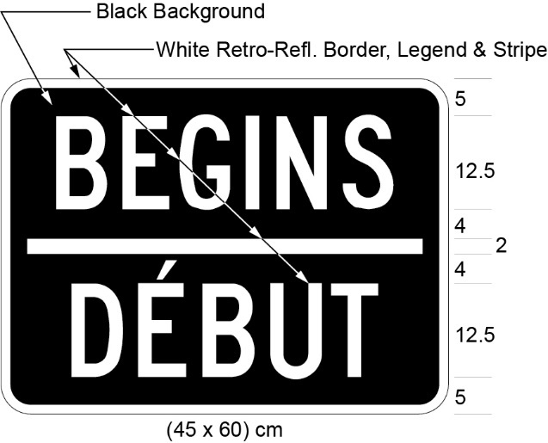
O. Reg. 175/08, s. 2; O. Reg. 339/09, s. 2 (2); O. Reg. 396/19, s. 1 (2); O. Reg. 275/25, s. 4.
4. A speed limit sign shall be erected on the right side of the highway, facing approaching traffic, not more than 4.5 metres from the roadway, and the bottom edge of the sign shall be not less than 1.5 metres or more than 2.5 metres above the level of the roadway. R.R.O. 1990, Reg. 615, s. 4.
5. (1) Where the council of a municipality designates a portion of a highway under subsection 128 (5) of the Act, a speed limit sign,
(a) that,
(i) has the dimensions and bears the markings as illustrated in Figure A,
(ii) is electrically illuminated from within the sign and legible to approaching drivers only when the sign is illuminated, or
(iii) is a mechanically operated louvered type sign which displays the prescribed markings only during the period of operation; or
(b) that,
(i) has the dimensions and bears the markings as illustrated in Figure B, or
(ii) is similar to the sign referred to in subclause (i) except that it does not include a tab sign bearing the legend “km/h”,
shall be erected in accordance with section 4 at the commencement of the portion of the highway so designated.
Figure A
Text alternative: Illustration of “school zone” sign labelled as Figure A. The top portion of the sign contains the symbol of two school children crossing. The symbol is in black and the background is fluorescent yellow-green. The bottom portion of the sign contains the words “MAXIMUM 00” in black text on a white retro-reflective background. The following measurements are written below the sign: (60 × 90) cm. The sign is surrounded by measurements of its different elements. This text alternative is provided for convenience only and does not form part of the official law.
Figure B
Text alternative: Illustration of “school zone” sign labelled as Figure B. The sign has 4 sections and a 20 cm amber lens on either side of the second section. The top section of the sign contains the symbol of two school children crossing. The symbol is in black and the background is fluorescent yellow-green. The second portion of the sign contains the words “MAXIMUM 00” in black text on a white retro-reflective background. The third section contains the text “km/h” in white lettering on a black background. The fourth section contains the words “WHEN FLASHING” in black text on a white retro-reflective background. The following measurements are written below the sign: (60 × 140) cm. The sign is surrounded by measurements of its different elements. This text alternative is provided for convenience only and does not form part of the official law.
R.R.O. 1990, Reg. 615, s. 5 (1); O. Reg. 246/03, s. 1 (1, 2); O. Reg. 175/08, s. 3 (1); O. Reg. 339/09, s. 3 (1, 2).
(1.0.1) Revoked: O. Reg. 175/08, s. 3 (7).
(1.1) Despite subsection (1), where the council of a municipality that is in an area designated for the purposes of clause 5 (1) (b) of the French Language Services Act designates a portion of a highway under subsection 128 (5) of the Act, there shall be erected in accordance with section 4 at the commencement of the designated portion a speed limit sign,
(a) that,
(i) has the dimensions and bears the markings as illustrated in Figure A to subsection (1), and
(ii) is either electrically illuminated from within and legible to approaching drivers only when illuminated or is a mechanically operated louvered type sign that displays the prescribed markings only during the period of operation; or
(b) that,
(i) has the dimensions and bears the markings as illustrated in Figure C, or
(ii) is similar to the sign in Figure C except that it does not include a tab sign bearing the legend “km/h”.
Figure C
Text alternative: Illustration of “school zone” sign labelled as Figure C. The sign has 4 sections and a 20 cm amber lens on either side of the second section. The top section of the sign contains the symbol of two school children crossing. The symbol is in black and the background is fluorescent yellow-green. The second portion of the sign contains the words “MAXIMUM 00” in black text on a white retro-reflective background. The third section contains the text “km/h” in white lettering on a black background. The fourth section contains the words “WHEN FLASHING / AU CLIGNOTEMENT” in black text on a white retro-reflective background. The following measurements are written below the sign: (60 × 170) cm. The sign is surrounded by measurements of its different elements. This text alternative is provided for convenience only and does not form part of the official law.
Figure D Revoked: O. Reg. 246/03, s. 1 (6).
O. Reg. 444/93, s. 1 (1); O. Reg. 246/03, s. 1 (4-6); O. Reg. 175/08, s. 3 (3); O. Reg. 339/09, s. 3 (3); O. Reg. 275/25, s. 4.
(1.2) Revoked: O. Reg. 175/08, s. 3 (7).
(2) A sign referred to in clause (1) (a) or (1.1) (a) shall be illuminated or actuated and legible during the hours prescribed by by-law under subsection 128 (5) of the Act. O. Reg. 468/20, s. 1.
(3) The flashing amber signals on a sign referred to in clause (1) (b) or (1.1) (b) shall be actuated during the hours prescribed by by-law under subsection 128 (5) of the Act. O. Reg. 468/20, s. 1.
(4) Revoked: O. Reg. 175/08, s. 3 (5).
(5) A sign referred to in clauses (1) (a) and (b) shall be not less than 30 centimetres in height and not less than 60 centimetres in width and bear the legend “MAXIMUM” in black letters not less than 8 centimetres in height and display the speed limit prescribed by by-law in black numerals not less than 12.5 centimetres in height on a white background. O. Reg. 246/03, 1 (7).
(5.1) A sign referred to in clauses (1.1) (a) and (b) shall be not less than 30 centimetres in height and not less than 60 centimetres in width, shall bear the legend “MAXIMUM” in black letters not less than 8 centimetres in height and shall display the speed limit prescribed by by-law in black numerals not less than 12.5 centimetres in height on a white background. O. Reg. 175/08, s. 3 (5).
(6) A speed limit sign as prescribed in section 1 shall be erected at the termination of the designated portion of the highway, except that the maximum speed shown thereon shall be the appropriate speed limit for the adjoining portion of the highway. R.R.O. 1990, Reg. 615, s. 5 (6).
(7) Sections 1, 2 and 3 do not apply to a sign erected under subsection (1) or (1.1). O. Reg. 444/93, s. 1 (4).
(8) Revoked: O. Reg. 175/08, s. 3 (7).
5.0.0.1 (1) A sign prescribed by this section may be erected rather than a sign prescribed by subsections 5 (1) or (1.1) at the commencement of the portion of the highway designated under subsection 128 (5) of the Act. O. Reg. 138/26, s. 1.
(2) A sign prescribed by this section shall have the dimensions and bear the markings and the legend “km/h” embedded in the sign, as illustrated in Figure A or B.
Figure A
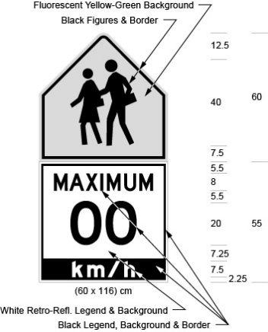
Text alternative: Illustration of “school zone” sign labelled as Figure A. The sign has 3 sections. The top section contains the symbol of two school children crossing. The symbol is in black and the background is fluorescent yellow-green. The second section contains the words “MAXIMUM 00” in black text on a white retro-reflective background. The third section contains the text “km/h” in white lettering on a black background. The following measurements are written below the sign: (60 × 116) cm. The sign is surrounded by measurements of its different elements. This text alternative is provided for convenience only and does not form part of the official law.
Figure B
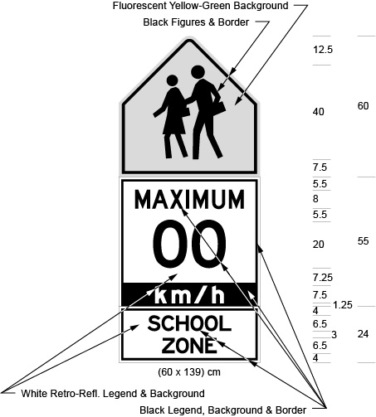
Text alternative: Illustration of “school zone” sign labelled as Figure B. The sign has 4 sections. The top section contains the symbol of two school children crossing. The symbol is in black and the background is fluorescent yellow-green. The second section contains the words “MAXIMUM 00” in black text on a white retro-reflective background. The third section contains the text “km/h” in white lettering on a black background. The fourth section contains the words “SCHOOL ZONE” in black text on a white retro-reflective background. The following measurements are written below the sign: (60 × 139) cm. The sign is surrounded by measurements of its different elements. This text alternative is provided for convenience only and does not form part of the official law.
O. Reg. 138/26, s. 1.
(3) Where the sign is in an area designated by the French Language Services Act, a sign illustrated in Figure C shall be used rather than a sign illustrated in subsection (2).
Figure C
Text alternative: Illustration of “school zone” sign labelled as Figure C. The sign has 4 sections. The top section contains the symbol of two school children crossing. The symbol is in black and the background is fluorescent yellow-green. The second section contains the words “MAXIMUM 00” in black text on a white retro-reflective background. The third section contains the text “km/h” in white lettering on a black background. The fourth section contains the words “SCHOOL ZONE / ZONE SCOLAIRE” in black text on a white retro-reflective background. The following measurements are written below the sign: (60 × 160) cm. The sign is surrounded by measurements of its different elements. This text alternative is provided for convenience only and does not form part of the official law.
O. Reg. 138/26, s. 1.
(4) A sign described in subsection (2) or (3) may include flashing amber signals, which may be 20 or 30 centimetres in diameter. O. Reg. 138/26, s. 1.
(5) If the sign includes flashing amber signals and the effective hours of the prescribed speed limit are prescribed by by-law under clause 128 (5) (b) of the Act, the signals shall only be actuated during those hours. O. Reg. 138/26, s. 1.
(6) Where subsection (5) applies, the sign shall also include a tab sign bearing the legend “WHEN FLASHING”, and have the dimensions illustrated in Figure D or Figure E.
Figure D
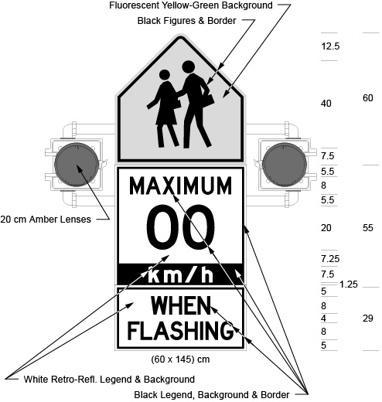
Text alternative: Illustration of “school zone” sign labelled as Figure D. The sign has 4 sections and a 20 cm amber lens on either side of the second section. The top section contains the symbol of two school children crossing. The symbol is in black and the background is fluorescent yellow-green. The second section contains the words “MAXIMUM 00” in black text on a white retro-reflective background. The third section contains the text “km/h” in white lettering on a black background. The fourth section contains the words “WHEN FLASHING” in black text on a white retro-reflective background. The following measurements are written below the sign: (60 × 145) cm. The sign is surrounded by measurements of its different elements. This text alternative is provided for convenience only and does not form part of the official law.
Figure E
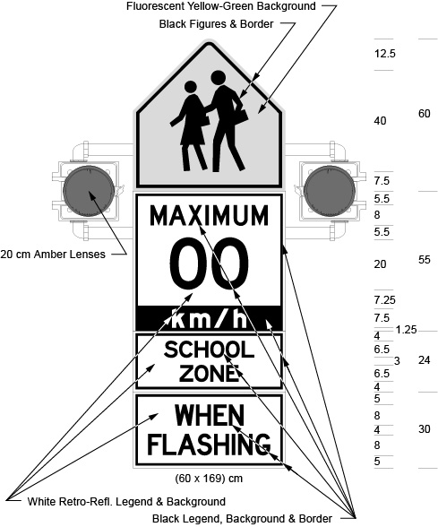
Text alternative: Illustration of “school zone” sign labelled as Figure E. The sign has 5 sections and a 20 cm amber lens on either side of the second section. The top section contains the symbol of two school children crossing. The symbol is in black and the background is fluorescent yellow-green. The second section contains the words “MAXIMUM 00” in black text on a white retro-reflective background. The third section contains the text “km/h” in white lettering on a black background. The fourth section contains the words “SCHOOL ZONE” in black text on a white retro-reflective background. The fifth section contains the words “WHEN FLASHING” in black text on a white retro-reflective background. The following measurements are written below the sign: (60 × 169) cm. The sign is surrounded by measurements of its different elements. This text alternative is provided for convenience only and does not form part of the official law.
O. Reg. 138/26, s. 1.
(7) Where subsection (5) applies and the area is designated by the French Language Services Act, the sign shall also include a tab sign bearing the legend “WHEN FLASHING / AU CLIGNOTEMENT”, and have the dimensions illustrated in Figure F or Figure G rather than Figure D or Figure E.
Figure F
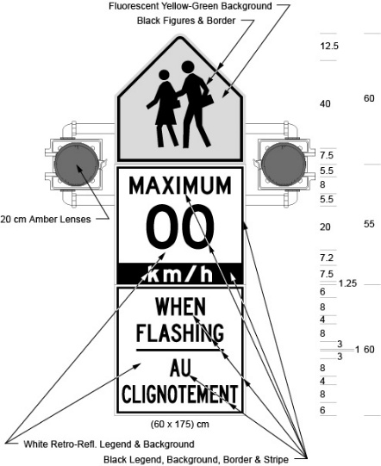
Text alternative: Illustration of “school zone” sign labelled as Figure F. The sign has 4 sections and a 20 cm amber lens on either side of the second section. The top section contains the symbol of two school children crossing. The symbol is in black and the background is fluorescent yellow-green. The second section contains the words “MAXIMUM 00” in black text on a white retro-reflective background. The third section contains the text “km/h” in white lettering on a black background. The fourth section contains the words “WHEN FLASHING / AU CLIGNOTEMENT” in black text on a white retro-reflective background. The following measurements are written below the sign: (60 × 175) cm. The sign is surrounded by measurements of its different elements. This text alternative is provided for convenience only and does not form part of the official law.
Figure G
Text alternative: Illustration of “school zone” sign labelled as Figure G. The sign has 5 sections and a 20 cm amber lens on either side of the second section. The top section contains the symbol of two school children crossing. The symbol is in black and the background is fluorescent yellow-green. The second section contains the words “MAXIMUM 00” in black text on a white retro-reflective background. The third section contains the text “km/h” in white lettering on a black background. The fourth section contains the words “SCHOOL ZONE / ZONE SCOLAIRE” in black text on a white retro-reflective background. The fifth section contains the words “WHEN FLASHING / AU CLIGNOTEMENT” in black text on a white retro-reflective background. The following measurements are written below the sign: (60 × 220) cm. The sign is surrounded by measurements of its different elements. This text alternative is provided for convenience only and does not form part of the official law.
O. Reg. 138/26, s. 1.
(8) Rather than the dimensions of the signs described in subsections (2), (3), (6) and (7), the dimensions may instead be,
(a) 90 centimetres wide and 170 centimetres high for a sign illustrated in Figure A;
(b) 90 centimetres wide and 207 centimetres high for a sign illustrated in Figure B;
(c) 90 centimetres wide and 240 centimetres high for a sign illustrated in Figure C;
(d) 90 centimetres wide and 213 centimetres high for a sign illustrated in Figure D;
(e) 90 centimetres wide and 252 centimetres high for a sign illustrated in Figure E;
(f) 90 centimetres wide and 258 centimetres high for a sign illustrated in Figure F; and
(g) 90 centimetres wide and 330 centimetres high for a sign illustrated in Figure G. O. Reg. 138/26, s. 1.
(9) Despite section 44, the dimensions of a sign shall be as prescribed in this section and shall not be proportionately increased. O. Reg. 138/26, s. 1.
5.0.0.2 (1) A sign prescribed by section 5.0.0.1 shall be erected in accordance with section 4, except that for a sign with a height of greater than 200 centimetres, the bottom edge of the sign shall be not less than 0.4 metres above the level of the roadway. O. Reg. 138/26, s. 1.
(2) Where a sign prescribed by section 5.0.0.1 is erected, a speed limit sign as prescribed in section 1 shall be erected at the termination of the portion of the highway designated under subsection 128 (5) of the Act, except that the maximum speed shown thereon shall be the appropriate speed limit for the adjoining portion of the highway. O. Reg. 138/26, s. 1.
(3) Sections 1, 2 and 3 do not apply to a sign erected under section 5.0.0.1. O. Reg. 138/26, s. 1.
5.0.0.3-5.0.0.5 Revoked: O. Reg. 138/26, s. 1.
5.0.1 (1) A sign prescribed by this section may be erected rather than a sign prescribed by subsection 5 (1) or (1.1). O. Reg. 468/20, s. 2.
(2) A sign prescribed by this section shall have the dimensions and bear the markings as illustrated in one of the following Figures:
Figure A
Text alternative: Illustration of “school zone” sign labelled as Figure A. The top section of the sign contains the symbol of two school children crossing. The symbol is in black and the background is fluorescent yellow-green. The middle section of the sign contains the words “MAXIMUM 00” in black text on a white retro-reflective background. The bottom section of the sign contains the times “7AM – 9AM / 3PM – 5 PM” over the days “MON – FRI” and months “SEPT. – JUNE” in black text on a white retro-reflective background. The following measurements are written below the sign: (60 × 170) cm. The sign is surrounded by measurements of its different elements. This text alternative is provided for convenience only and does not form part of the official law.
Figure B
Text alternative: Illustration of “school zone” sign labelled as Figure B. The top section of the sign contains the symbol of two school children crossing. The symbol is in black and the background is fluorescent yellow-green. The middle section of the sign contains the words “MAXIMUM 00” in black text on a white retro-reflective background. The bottom section of the sign contains the times “7AM – 5 PM” over the days “MON – FRI” and months “SEPT. – JUNE” in black text on a white retro-reflective background. The following measurements are written below the sign: (60 × 155) cm. The sign is surrounded by measurements of its different elements. This text alternative is provided for convenience only and does not form part of the official law.
O. Reg. 468/20, s. 2.
(3) Despite subsection (2), in an area designated for the purposes of clause 5 (1) (b) of the French Language Services Act, the zone sign may instead be accompanied immediately below by a sign having the dimensions and bearing the markings as illustrated in the following Figures:
Figure C
Text alternative: Illustration of “school zone” sign labelled as Figure C. The top section of the sign contains the symbol of two school children crossing. The symbol is in black and the background is fluorescent yellow-green. The middle section of the sign contains the words “MAXIMUM 00” in black text on a white retro-reflective background. The bottom section of the sign contains the times “7AM – 9AM / 3PM – 5 PM” over the days “MON – FRI / LUN - VEN” and months “SEPT. – JUNE / SEPT. – JUIN” in black text on a white retro-reflective background. The following measurements are written below the sign: (60 × 180) cm. The sign is surrounded by measurements of its different elements. This text alternative is provided for convenience only and does not form part of the official law.
Figure D
Text alternative: Illustration of “school zone” sign labelled as Figure D. The top section of the sign contains the symbol of two school children crossing. The symbol is in black and the background is fluorescent yellow-green. The middle section of the sign contains the words “MAXIMUM 00” in black text on a white retro-reflective background. The bottom portion of the sign contains the times “7AM – 5 PM” over the days “MON – FRI / LUN – VEN” and months “SEPT. – JUNE / SEPT. – JUIN” in black text on a white retro-reflective background. The following measurements are written below the sign: (60 × 180) cm. The sign is surrounded by measurements of its different elements. This text alternative is provided for convenience only and does not form part of the official law.
O. Reg. 468/20, s. 2; O. Reg. 275/25, s. 4.
(4) A sign referred to in subsection (2) or (3) shall not be illuminated by flashing signals and shall not be accompanied by a tab sign bearing the words “when flashing”. O. Reg. 468/20, s. 2.
(5) The times, days and months shown on the signs prescribed in this section shall be the times that have been prescribed by by-law under subsection 128 (5) of the Act. O. Reg. 468/20, s. 2.
(6) Where all the months of the year are prescribed by by-law under subsection 128 (5) of the Act, the signs prescribed in this section may omit a reference to months and the dimensions of the sign may be reduced accordingly. O. Reg. 468/20, s. 2.
(7) Sections 1, 2 and 3 do not apply to a sign erected under this section. O. Reg. 468/20, s. 2.
5.0.1.1 (1) A sign prescribed by this section may be erected rather than a sign prescribed by section 5.0.1 at the commencement of the portion of the highway designated under subsection 128 (5) of the Act. O. Reg. 138/26, s. 2.
(2) A sign prescribed by this section shall have the dimensions and bear the markings and the legend “km/h” embedded in the sign, as illustrated in Figure A, or the sign may also bear the legend “SCHOOL ZONE”, as illustrated in Figure B.
Figure A
Text alternative: Illustration of “school zone” sign labelled as Figure A. The sign has 4 sections. The top section contains the symbol of two school children crossing. The symbol is in black and the background is fluorescent yellow-green. The second section contains the words “MAXIMUM 00” in black text on a white retro-reflective background. The third section contains the text “km/h” in white lettering on a black background. The fourth section contains the times “7 AM – 5 PM” over the days “MON – FRI” and months “SEPT. – JUNE” in black text on a white retro-reflective background. The following measurements are written below the sign: (60 × 155) cm. The sign is surrounded by measurements of its different elements. This text alternative is provided for convenience only and does not form part of the official law.
Figure B
Text alternative: Illustration of “school zone” sign labelled as Figure B. The sign has 5 sections. The top section contains the symbol of two school children crossing. The symbol is in black and the background is fluorescent yellow-green. The second section contains the words “MAXIMUM 00” in black text on a white retro-reflective background. The third section contains the text “km/h” in white lettering on a black background. The fourth section contains the words “SCHOOL ZONE” in black text on a white retro-reflective background. The fifth section contains the times “7 AM – 5 PM” over the days “MON – FRI” and months “SEPT. – JUNE” in black text on a white retro-reflective background. The following measurements are written below the sign: (60 × 179) cm. The sign is surrounded by measurements of its different elements. This text alternative is provided for convenience only and does not form part of the official law.
O. Reg. 138/26, s. 2.
(3) Rather than the dimensions shown on a sign described in subsection (2), the dimensions may instead be,
(a) 90 centimetres wide and 232.5 centimetres high for a sign illustrated in Figure A; and
(b) 90 centimetres wide and 271.5 centimetres high for a sign illustrated in Figure B. O. Reg. 138/26, s. 2.
(4) Where the area is designated by the French Language Services Act, a sign illustrated in Figure C or Figure D shall be used rather than a sign described in subsection (2).
Figure C
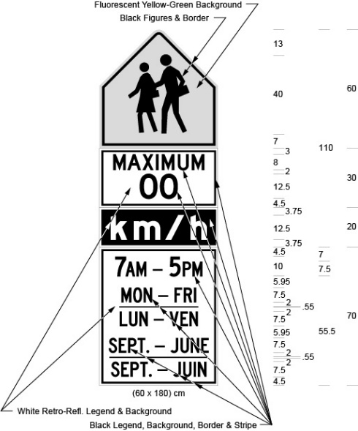
Text alternative: Illustration of “school zone” sign labelled as Figure C. The sign has 4 sections. The top section contains the symbol of two school children crossing. The symbol is in black and the background is fluorescent yellow-green. The second section contains the words “MAXIMUM 00” in black text on a white retro-reflective background. The third section contains the text “km/h” in white lettering on a black background. The fourth section contains the times “7 AM – 5 PM” over the days “MON – FRI / LUN – VEN” and months “SEPT. – JUNE / SEPT. – JUIN” in black text on a white retro-reflective background. The following measurements are written below the sign: (60 × 180) cm. The sign is surrounded by measurements of its different elements. This text alternative is provided for convenience only and does not form part of the official law.
Figure D
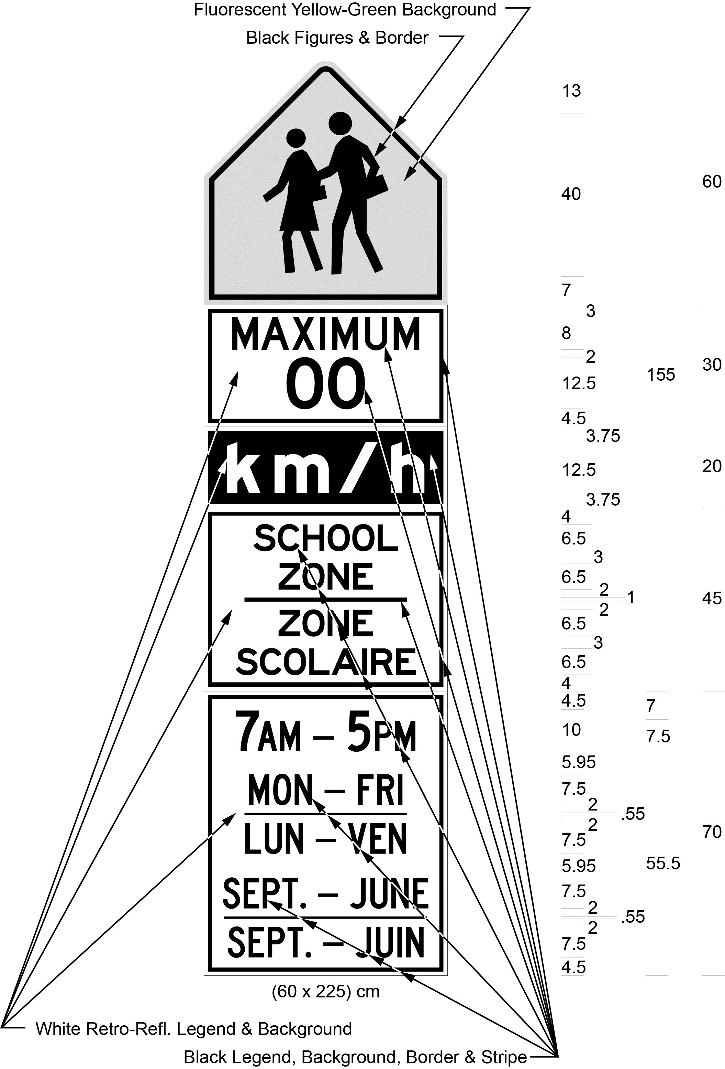
Text alternative: Illustration of “school zone” sign labelled as Figure D. The sign has 5 sections. The top section contains the symbol of two school children crossing. The symbol is in black and the background is fluorescent yellow-green. The second section contains the words “MAXIMUM 00” in black text on a white retro-reflective background. The third section contains the text “km/h” in white lettering on a black background. The fourth section contains the words “SCHOOL ZONE / ZONE SCOLAIRE” in black text on a white retro-reflective background. The fifth section contains the times “7 AM – 5 PM” over the days “MON – FRI / LUN – VEN” and months “SEPT. – JUNE / SEPT. – JUIN” in black text on a white retro-reflective background. The following measurements are written below the sign: (60 × 225) cm. The sign is surrounded by measurements of its different elements. This text alternative is provided for convenience only and does not form part of the official law.
O. Reg. 138/26, s. 2.
(5) Rather than the dimensions shown on a sign described in subsection (4), the dimensions may be,
(a) 90 centimetres wide and 240 centimetres high for a sign illustrated in Figure C; and
(b) 90 centimetres wide and 312 centimetres high for a sign illustrated in Figure D. O. Reg. 138/26, s. 2.
(6) Despite section 44, the dimensions of a sign shall be as prescribed in this section and shall not be proportionately increased. O. Reg. 138/26, s. 2.
5.0.1.2 (1) Where a sign prescribed by section 5.0.1.1 is erected, a speed limit sign as prescribed in section 1 shall be erected at the termination of the portion of the highway designated under subsection 128 (5) of the Act, except that the maximum speed shown thereon shall be the appropriate speed limit for the adjoining portion of the highway. O. Reg. 138/26, s. 2.
(2) A sign prescribed by section 5.0.1.1 shall be erected in accordance with section 4, except that for a sign with a height of greater than 200 centimetres, the bottom edge of the sign shall be not less than 0.4 metres above the level of the roadway. O. Reg. 138/26, s. 2.
(3) Sections 1, 2 and 3 do not apply to a sign erected under section 5.0.1.1. O. Reg. 138/26, s. 2.
5.0.1.3 Revoked: O. Reg. 138/26, s. 2.
Community Safety Zone School Signs
5.0.2 (1) A sign illustrated in Figure A to subsection 5 (1) or a sign prescribed by section 5.0.0.1 may be erected in accordance with subsection (3) on a highway adjacent to a school where the school is in a community safety zone. O. Reg. 138/26, s. 3.
(2) A sign referred to in subsection (1) shall not include embedded text or a tab sign bearing the legend “SCHOOL ZONE”, or “SCHOOL ZONE / ZONE SCOLAIRE” where the area is designated by the French Language Services Act. O. Reg. 138/26, s. 3.
(3) A sign referred to in subsection (1) may be erected by a municipality along the portion of a highway under its jurisdiction that adjoins the entrance to or exit from a school and that is within 150 metres along the highway in either direction beyond the limits of the land used for the purposes of the school. O. Reg. 138/26, s. 3.
(4) A sign referred to in subsection (1) shall be erected in accordance with section 4, except that for a sign with a height exceeding 200 centimetres, the bottom edge of the sign shall be not less than 0.4 metres above the level of the roadway. O. Reg. 138/26, s. 3.
(5) Where a sign referred to in subsection (1) is erected in accordance with subsection (3), a speed limit sign as prescribed in section 1 shall be erected at the termination of the portion of the highway described under subsection (3), except that the maximum speed shown thereon shall be the appropriate speed limit for the adjoining portion of the highway. O. Reg. 138/26, s. 3.
(6) Sections 1, 2 and 3 do not apply to a sign erected under this section. O. Reg. 138/26, s. 3.
(7) Where a sign prescribed by section 5.0.0.1 includes flashing amber signals and the effective hours of the prescribed speed limit are prescribed by by-law, the signals shall only be actuated during those hours. O. Reg. 138/26, s. 3.
(8) Where subsection (7) applies, the sign shall include a tab sign bearing the legend “WHEN FLASHING” or, where the area is designated by the French Language Services Act, bearing the legend “WHEN FLASHING / AU CLIGNOTEMENT”. O. Reg. 138/26, s. 3.
5.1 (1) If the Minister prescribes a rate of speed of 60 kilometres per hour for motor vehicles driven on a portion of the King’s Highway adjacent to a school, a speed limit sign shall be erected in accordance with section 4 at the start of the portion of the highway designated and have the dimensions and bear the markings as illustrated in the following Figure:
Text alternative: Illustration of “school zone” sign. The sign has 4 sections and a 20 cm amber lens on either side of the second section. The top section of the sign contains the symbol of two school children crossing. The symbol is in black and the background is fluorescent yellow-green. The second portion of the sign contains the words “MAXIMUM 60” in black text on a white retro-reflective background. The third section contains the text “km/h” in white lettering on a black background. The fourth section contains the words “WHEN FLASHING” in black text on a white retro-reflective background. The following measurements are written below the sign: (90 × 210) cm. The sign is surrounded by measurements of its different elements. This text alternative is provided for convenience only and does not form part of the official law.
O. Reg. 519/93, s. 1; O. Reg. 175/08, s. 4 (1); O. Reg. 339/09, s. 4 (1).
(1.1) Despite subsection (1), if the Minister prescribes a rate of speed of 60 kilometres per hour for motor vehicles driven on a portion of the King’s Highway adjacent to a school that is in an area designated for the purposes of clause 5 (1) (b) of the French Language Services Act, a speed limit sign shall be erected in accordance with section 4 at the start of the portion of the highway designated and have the dimensions and bear the markings as illustrated in the following Figure:
Text alternative: Illustration of “school zone” sign. The sign has 4 sections and a 20 cm amber lens on either side of the second section. The top section of the sign contains the symbol of two school children crossing. The symbol is in black and the background is fluorescent yellow-green. The second portion of the sign contains the words “MAXIMUM 60” in black text on a white retro-reflective background. The third section contains the text “km/h” in white lettering on a black background. The fourth section contains the words “WHEN FLASHING / AU CLIGNOTEMENT” in black text on a white retro-reflective background. The following measurements are written below the sign: (90 × 255) cm. The sign is surrounded by measurements of its different elements. This text alternative is provided for convenience only and does not form part of the official law.
O. Reg. 246/03, s. 2 (1); O. Reg. 175/08, s. 4 (2); O. Reg. 339/09, s. 4 (2); O. Reg. 275/25, s. 4.
(1.2) Revoked: O. Reg. 175/08, s. 4 (4).
(2) If a sign referred to in subsection (1) or (1.1) is erected, the flashing amber signals on the sign shall be actuated between the hours specified in section 7 of Regulation 619 of the Revised Regulations of Ontario, 1990. O. Reg. 468/20, s. 3.
(3) A sign referred to in subsection (1) or (1.1) shall be not less than 210 centimetres in height and not less than 90 centimetres in width, bear the legend “MAXIMUM” in black letters not less than 10 centimetres in height and display in black numerals not less than 30 centimetres in height on a white background the numerals “60”. O. Reg. 519/93, s. 1; O. Reg. 246/03, s. 2 (3).
(4) A speed limit sign as prescribed in section 1 shall be erected at the end of the designated portion of the highway, except that the maximum speed shown shall be the appropriate speed limit for the adjoining portion of the highway. O. Reg. 519/93, s. 1.
(5) Sections 1, 2 and 3 do not apply to a sign erected under subsection (1) or (1.1). O. Reg. 519/93, s. 1; O. Reg. 246/03, s. 2 (4).
(6) Revoked: O. Reg. 175/08, s. 4 (4).
5.1.1 (1) For the purposes of subsection 128 (2.1) of the Act, a speed limit sign as prescribed in section 1 shall be erected indicating the commencement of a designated area within which a maximum rate of speed for all highways within that area has been prescribed to be a rate of speed lower than that specified in clause 128 (1) (a) of the Act. O. Reg. 301/18, s. 1.
(2) The speed limit sign shall be erected on each highway that enters the designated area at the boundary of the designated area. O. Reg. 301/18, s. 1.
(3) The speed limit sign shall be accompanied immediately below by a sign bearing the markings and having the dimensions as illustrated in the following Figure:
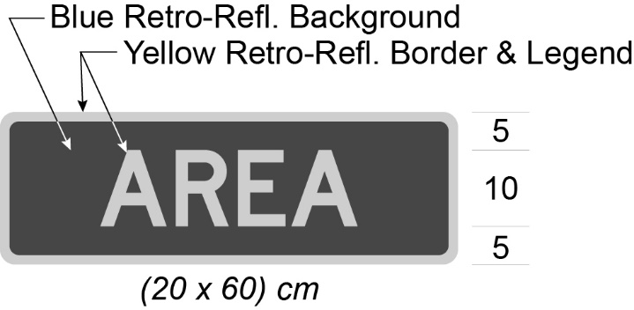
O. Reg. 301/18, s. 1.
(4) Despite subsection (3), in an area designated for the purposes of clause 5 (1) (b) of the French Language Services Act, the speed limit sign shall be accompanied immediately below by a sign bearing the markings and having the dimensions as illustrated in the following Figure:
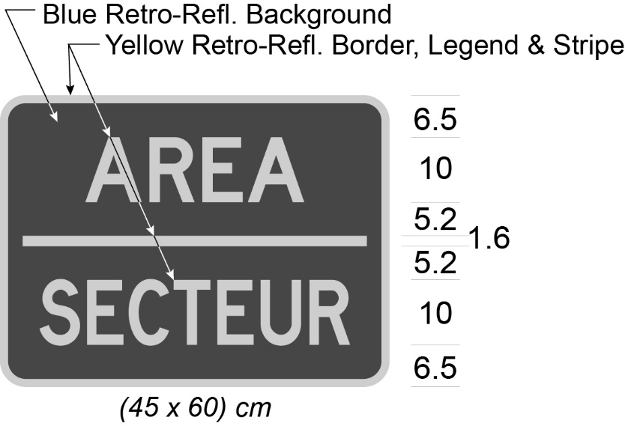
O. Reg. 301/18, s. 1; O. Reg. 275/25, s. 4.
(5) The speed limit sign and sign required by subsection (3) shall be accompanied immediately below by a sign described in subsection 3 (1). O. Reg. 301/18, s. 1.
(6) Despite subsection (5), in an area designated for the purposes of clause 5 (1) (b) of the French Language Services Act, the speed limit sign and sign required by subsection (4) shall be accompanied immediately below by a sign described in subsection 3 (2). O. Reg. 301/18, s. 1; O. Reg. 275/25, s. 4.
(7) Where the designated area referred to in subsection (1) comes to an end, a speed limit sign described in subsection (1) shall be erected and shall be accompanied immediately below by a sign required by subsection (3) and by a sign bearing the markings and having the dimensions as illustrated in the following Figure:
O. Reg. 301/18, s. 1.
(8) Despite subsection (7), in an area designated for the purposes of clause 5 (1) (b) of the French Language Services Act, where the designated area referred to in subsection (1) comes to an end, a speed limit sign described in subsection (1) shall be erected and shall be accompanied immediately below by a sign required by subsection (4) and by a sign bearing the markings and having the dimensions as illustrated in the following Figure:
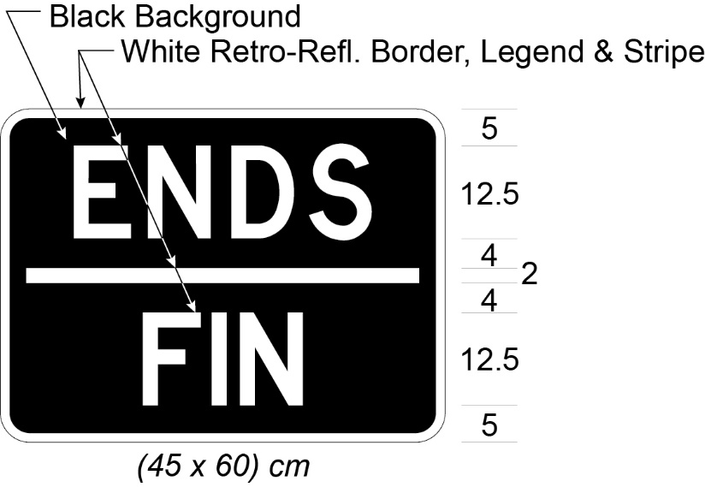
O. Reg. 301/18, s. 1; O. Reg. 275/25, s. 4.
(9) Where a speed limit sign is erected within a designated area other than at the boundary and the sign indicates the rate of speed that is prescribed for the area, it shall be accompanied immediately below by a sign required by subsection (3) or, in an area designated for the purposes of clause 5 (1) (b) of the French Language Services Act, by a sign required by subsection (4). O. Reg. 301/18, s. 1; O. Reg. 275/25, s. 4.
(10) Section 2 does not apply to a sign erected under this section. O. Reg. 301/18, s. 1.
Community Safety Zone Signs
5.2 (1) Where a part of a highway is designated as a community safety zone under subsection 214.1 (1) or (2) of the Act, signs shall be erected in accordance with this section. O. Reg. 380/98, s. 1.
(2) A sign shall be erected at the commencement of the community safety zone that,
(a) faces approaching traffic on the right side of the highway at the commencement of the portion of the highway so designated;
(b) is not less than 60 centimetres in width and 90 centimetres in height; and
(c) bears the markings and has the dimensions as illustrated in the following Figure:
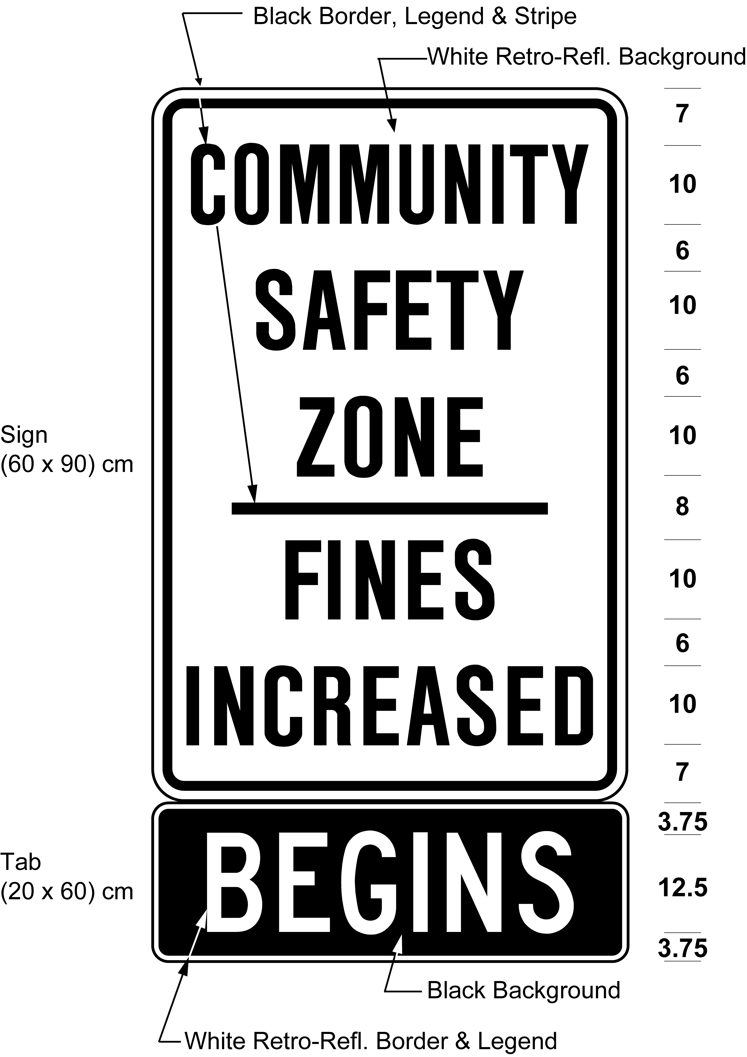
O. Reg. 380/98, s. 1; O. Reg. 339/09, s. 5 (1).
(3) In an area designated for the purposes of clause 5 (1) (b) of the French Language Services Act, an additional sign shall be erected at the commencement of the community safety zone that,
(a) faces approaching traffic on the right of, or above or below, the sign prescribed in subsection (2);
(b) is not less than 75 centimetres in width and 90 centimetres in height; and
(c) bears the markings and has the dimensions as illustrated in the following Figure:
O. Reg. 380/98, s. 1; O. Reg. 339/09, s. 5 (2); O. Reg. 468/20, s. 4 (1); O. Reg. 275/25, s. 4.
(4) A sign shall be erected at the end of the community safety zone that,
(a) faces approaching traffic on the right side of the highway at the end of the portion of the highway so designated;
(b) is not less than 60 centimetres in width and 90 centimetres in height; and
(c) bears the markings and has the dimensions as illustrated in the following Figure:
O. Reg. 380/98, s. 1; O. Reg. 339/09, s. 5 (3).
(5) In an area designated for the purposes of clause 5 (1) (b) of the French Language Services Act, an additional sign shall be erected at the end of the community safety zone that,
(a) faces approaching traffic on the right of, or above or below, the sign prescribed in subsection (4);
(b) is not less than 75 centimetres in width and 90 centimetres in height; and
(c) bears the markings and has the dimensions as illustrated in the following Figure:
O. Reg. 380/98, s. 1; O. Reg. 339/09, s. 5 (4); O. Reg. 468/20, s. 4 (2); O. Reg. 275/25, s. 1.
(6) If the part of the highway designated as a community safety zone is 1,000 metres long or more, additional signs shall be erected in accordance with subsection (8) that,
(a) face approaching traffic in each direction of travel on the right side of the highway;
(b) are not less than 60 centimetres in width and 90 centimetres in height; and
(c) bear the markings and have the dimensions as illustrated in the following Figure:
O. Reg. 380/98, s. 1; O. Reg. 339/09, s. 5 (5); O. Reg. 396/19, s. 2.
(7) If the part of the highway designated as a community safety zone is 1,000 metres long or more in an area designated for the purposes of clause 5 (1) (b) of the French Language Services Act, additional signs shall be erected in accordance with subsection (8) that,
(a) face approaching traffic on the right of, or above or below, each sign prescribed in subsection (6);
(b) are not less than 75 centimetres in width and 90 centimetres in height; and
(c) bear the markings and have the dimensions as illustrated in the following Figure:
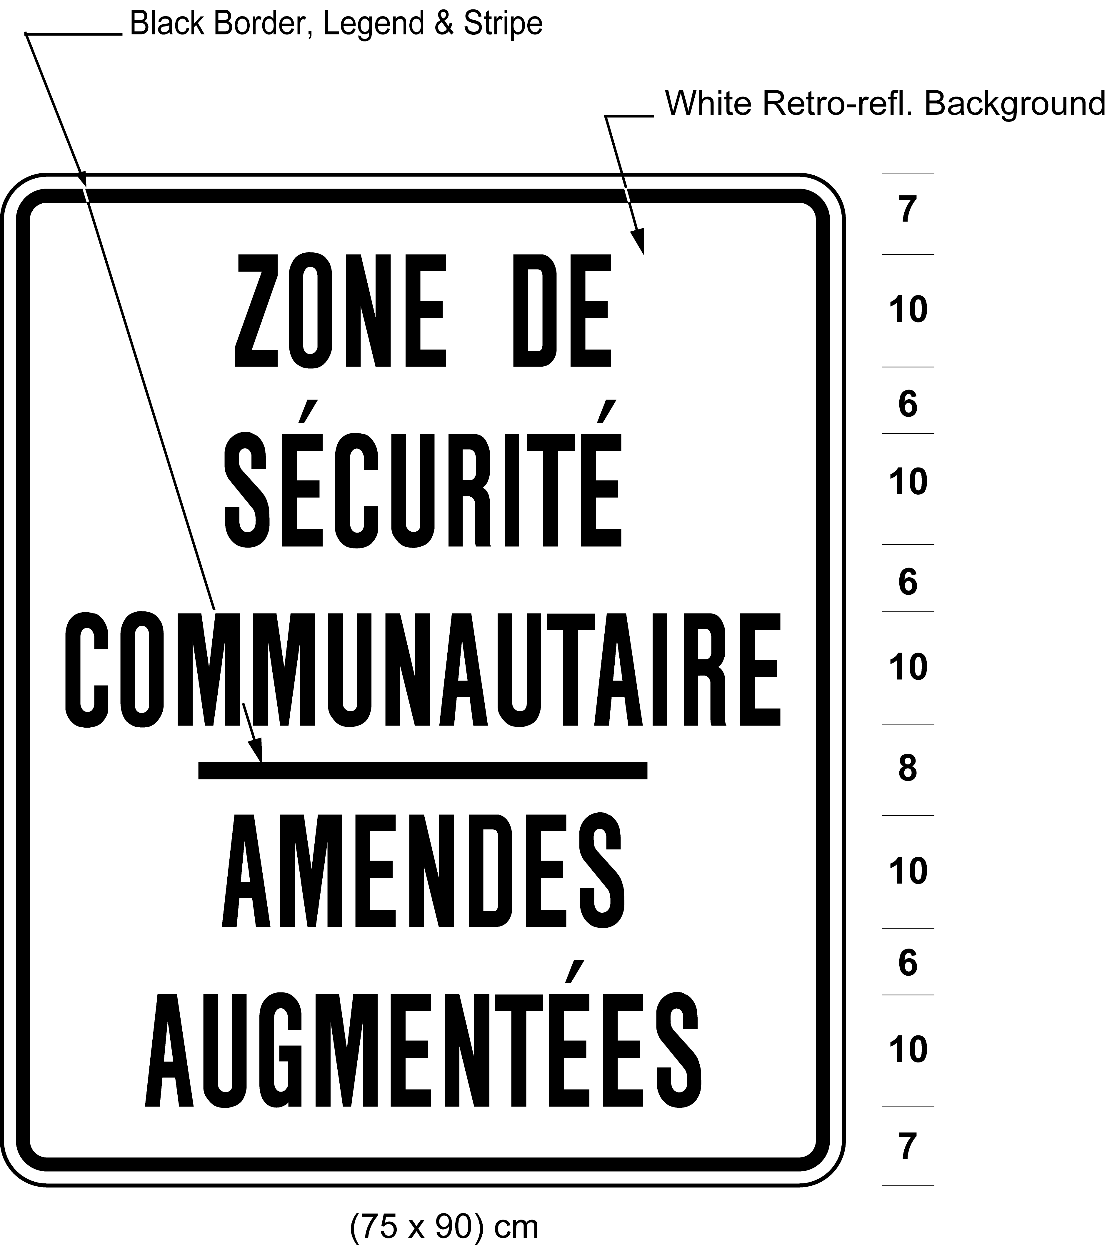
O. Reg. 380/98, s. 1; O. Reg. 339/09, s. 5 (6); O. Reg. 468/20, s. 4 (3); O. Reg. 275/25, s. 1.
(8) Signs erected under subsections (6) and (7) shall be not more than 300 metres apart from each other where the speed limit for the part of the highway on which the sign is erected is 60 kilometres an hour or less, and not more than 2 kilometres apart from each other where the speed limit for the part of the highway on which the sign is erected is more than 60 kilometres an hour. O. Reg. 380/98, s. 1.
Stop Signs
6. (1) A stop sign erected before August 1, 1993 shall,
(a) be octagonal in shape, not less than 60 centimetres in height and width and bear the word “stop” in white retro-reflective letters not less than 20 centimetres in height on a background of red retro-reflective material; or
(b) be octagonal in shape, not less than 60 centimetres in height and width and bear the words “stop” and “arrêt” in white retro-reflective letters on a background of red retro-reflective material. O. Reg. 444/93, s. 2.
(2) A stop sign erected on or after August 1, 1993 shall be as described in clause (1) (a) and illustrated in the following Figure:
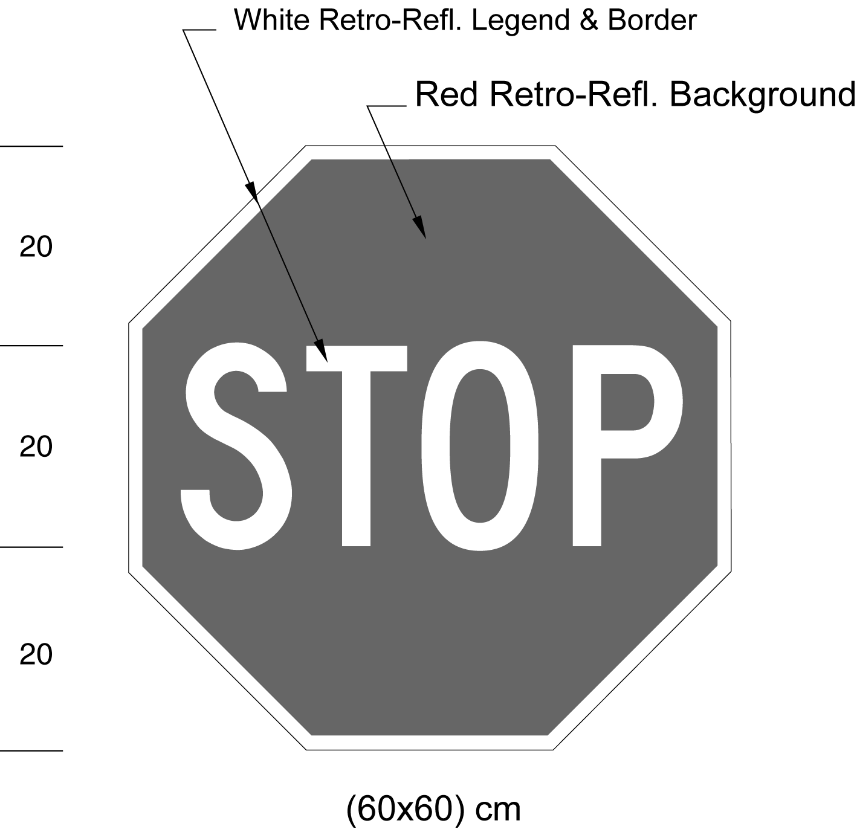
O. Reg. 444/93, s. 2; O. Reg. 339/09, s. 6.
(3) On or after August 1, 2015, no stop sign shall be valid except as described and illustrated in subsection (2). O. Reg. 261/08, s. 1.
7. A stop sign shall be erected on the right side of the highway, facing approaching traffic, at a point not less than 1.5 metres and not more than 15 metres from the intersecting roadway or the nearest rail at a railway crossing. R.R.O. 1990, Reg. 615, s. 7; O. Reg. 63/06, s. 1.
8. A stop sign shall be erected so that the left edge of the sign shall be not more than 4 metres from the edge of the roadway. O. Reg. 63/06, s. 2.
9. A stop sign shall be erected so that the bottom edge is not less than 1.5 metres and not more than 2.5 metres above the level of the roadway. R.R.O. 1990, Reg. 615, s. 9.
10. When all approaches to an intersection are controlled by stop signs, an All-Way tab sign,
(a) as illustrated in the following Figure, may be appended to the stop signs directly below them:
or,
(b) as illustrated in the following Figure, may be appended to the stop signs, directly below them, in an area designated for the purposes of clause 5 (1) (b) of the French Language Services Act:
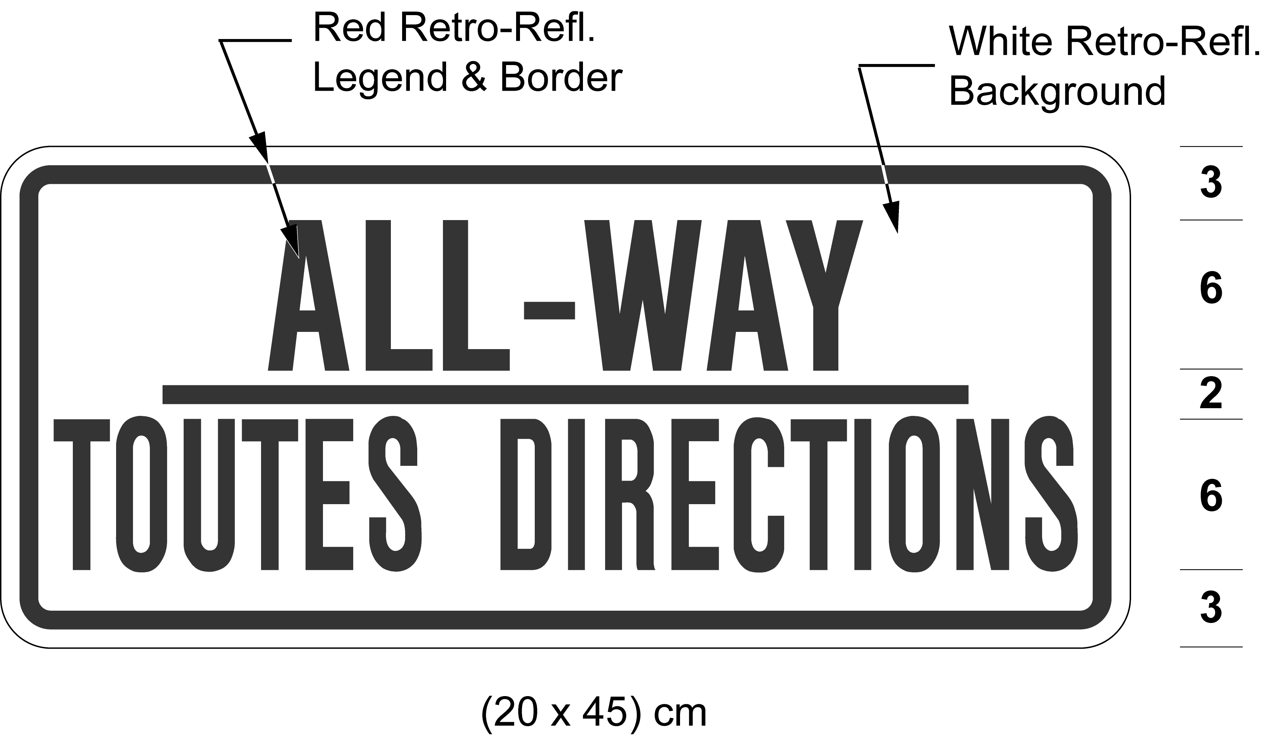
O. Reg. 444/93, s. 3; O. Reg. 339/09, s. 7; O. Reg. 275/25, s. 4.
11. (1) A school crossing stop sign shall be octagonal in shape, not less than 30 centimetres in height and not less than 30 centimetres in width. O. Reg. 380/02, s. 1.
(2) Each face of a school crossing stop sign shall bear the word “stop” in white retro-reflective letters not less than 12.5 centimetres in height on a background of red retro-reflective material. O. Reg. 380/02, s. 1.
(3) Each face of a school crossing stop sign may bear a single flashing red light centred above or below the word “stop” that is visible to the traffic approaching the sign. O. Reg. 380/02, s. 1; O. Reg. 63/06, s. 3.
12. Sections 45 and 46 do not apply to a school crossing stop sign. R.R.O. 1990, Reg. 615, s. 12.
Stopping Signs
13. A sign prohibiting stopping shall,
(a) be not less than 30 centimetres in height and not less than 30 centimetres in width; and
(b) bear the markings and have the dimensions prescribed in the following Figure:
Text alternative: Illustration of “no stopping” sign with a black stop symbol inside of a red circle with an interdictory stroke indicating no stopping and black arrows pointing left and right. The measurements are written below the sign: (30 × 30) cm. This text alternative is provided for convenience only and does not form part of the official law.
R.R.O. 1990, Reg. 615, s. 13; O. Reg. 339/09, s. 8.
14. (1) A sign restricting stopping shall,
(a) be not less than 45 centimetres in height and not less than 30 centimetres in width; and
(b) bear the markings and indicate the times at which stopping is prohibited and have the dimensions as prescribed in the following Figure:
Text alternative: Illustration of “no stopping” sign with a black stop symbol inside of a red circle with an interdictory stroke indicating no stopping and the text “9 AM - 4 PM” and “MON-FRI”, with black arrows pointing left and right. The measurements are written below the sign: (30 × 45) cm. This text alternative is provided for convenience only and does not form part of the official law.
R.R.O. 1990, Reg. 615, s. 14; O. Reg. 339/09, s. 9 (1).
(2) Despite subsection (1), in an area designated for the purposes of clause 5 (1) (b) of the French Language Services Act, a sign restricting stopping shall be as described in clause (1) (a) and bear the markings and indicate the times at which stopping is prohibited and have the dimensions as prescribed in the following Figure:
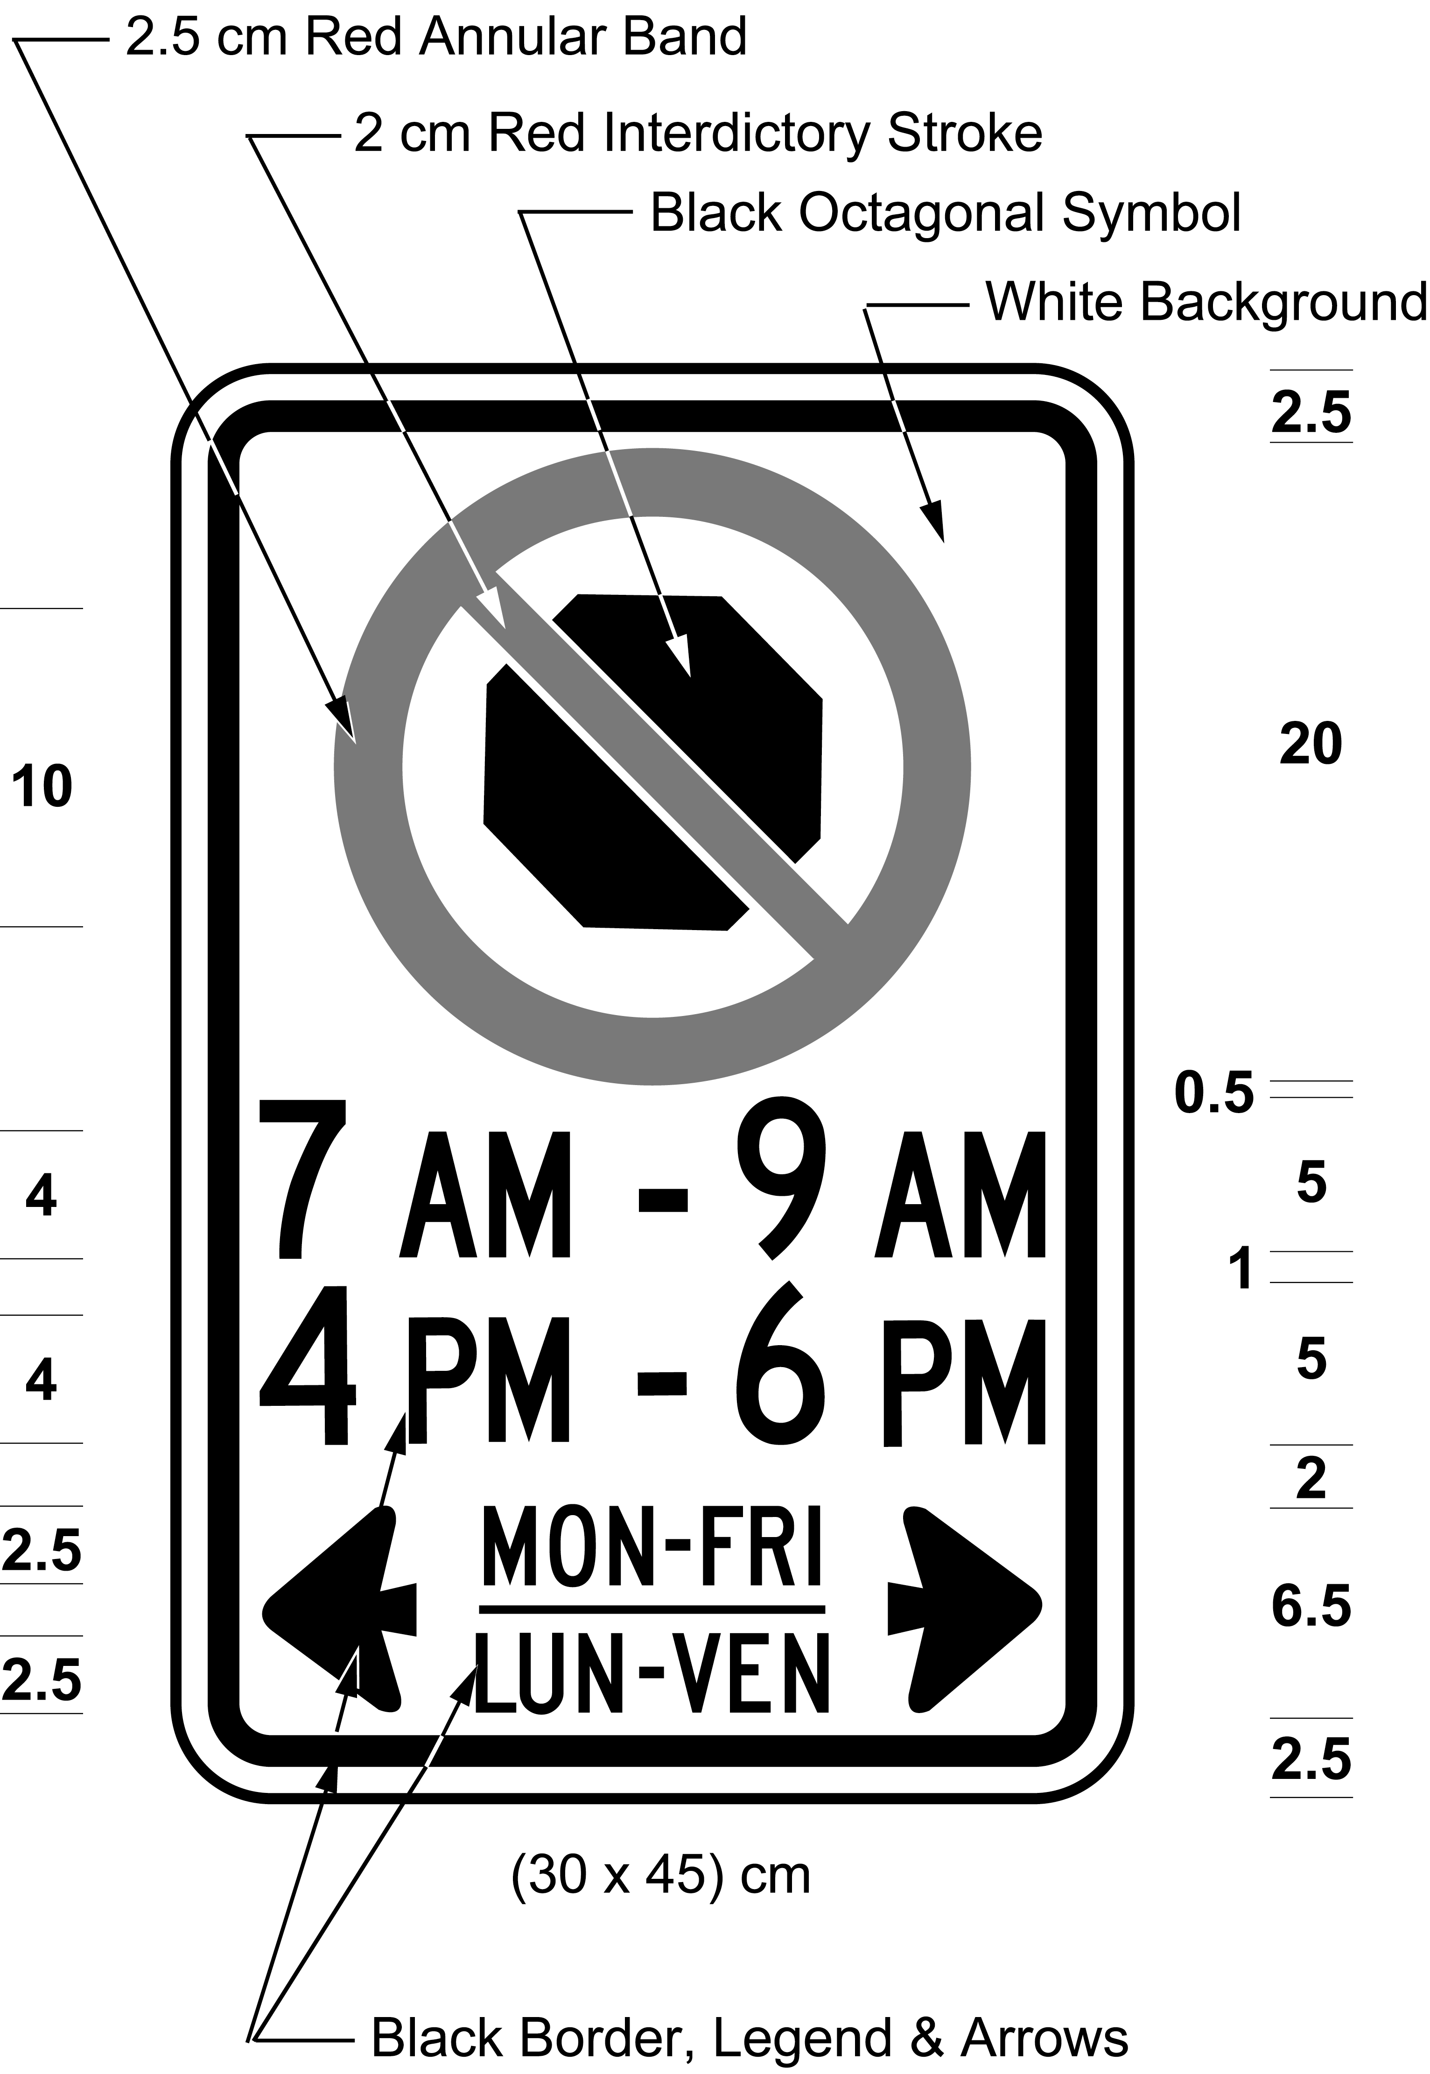
Text alternative: Illustration of “no stopping” sign with a black stop symbol inside of a red circle with an interdictory stroke indicating no stopping and the text “9 AM - 4 PM”, “4 PM - 6 PM”, and “MON-FRI / LUN-VEN”, with black arrows pointing left and right. The measurements are written below the sign: (30 × 45) cm. This text alternative is provided for convenience only and does not form part of the official law.
O. Reg. 444/93, s. 4; O. Reg. 339/09, s. 9 (2); O. Reg. 275/25, s. 4.
15. (1) Every sign erected on or after the 28th day of March, 1986 that prohibits standing shall,
(a) be not less than 30 centimetres in height and 30 centimetres in width; and
(b) bear the markings and have the dimensions as illustrated in the following Figure:
Text alternative: Illustration of “no standing” sign with red text “NO STANDING” on a white background with black arrows pointing left and right. The measurements are written below the sign: (30 × 30) cm. This text alternative is provided for convenience only and does not form part of the official law.
R.R.O. 1990, Reg. 615, s. 15 (1); O. Reg. 339/09, s. 10 (1).
(1.1) Despite subsection (1), in an area designated for the purposes of clause 5 (1) (b) of the French Language Services Act, a sign that prohibits standing shall,
(a) be not less than 60 centimetres in height and not less than 30 centimetres in width; and
(b) bear the markings and have the dimensions as illustrated in the following Figure:
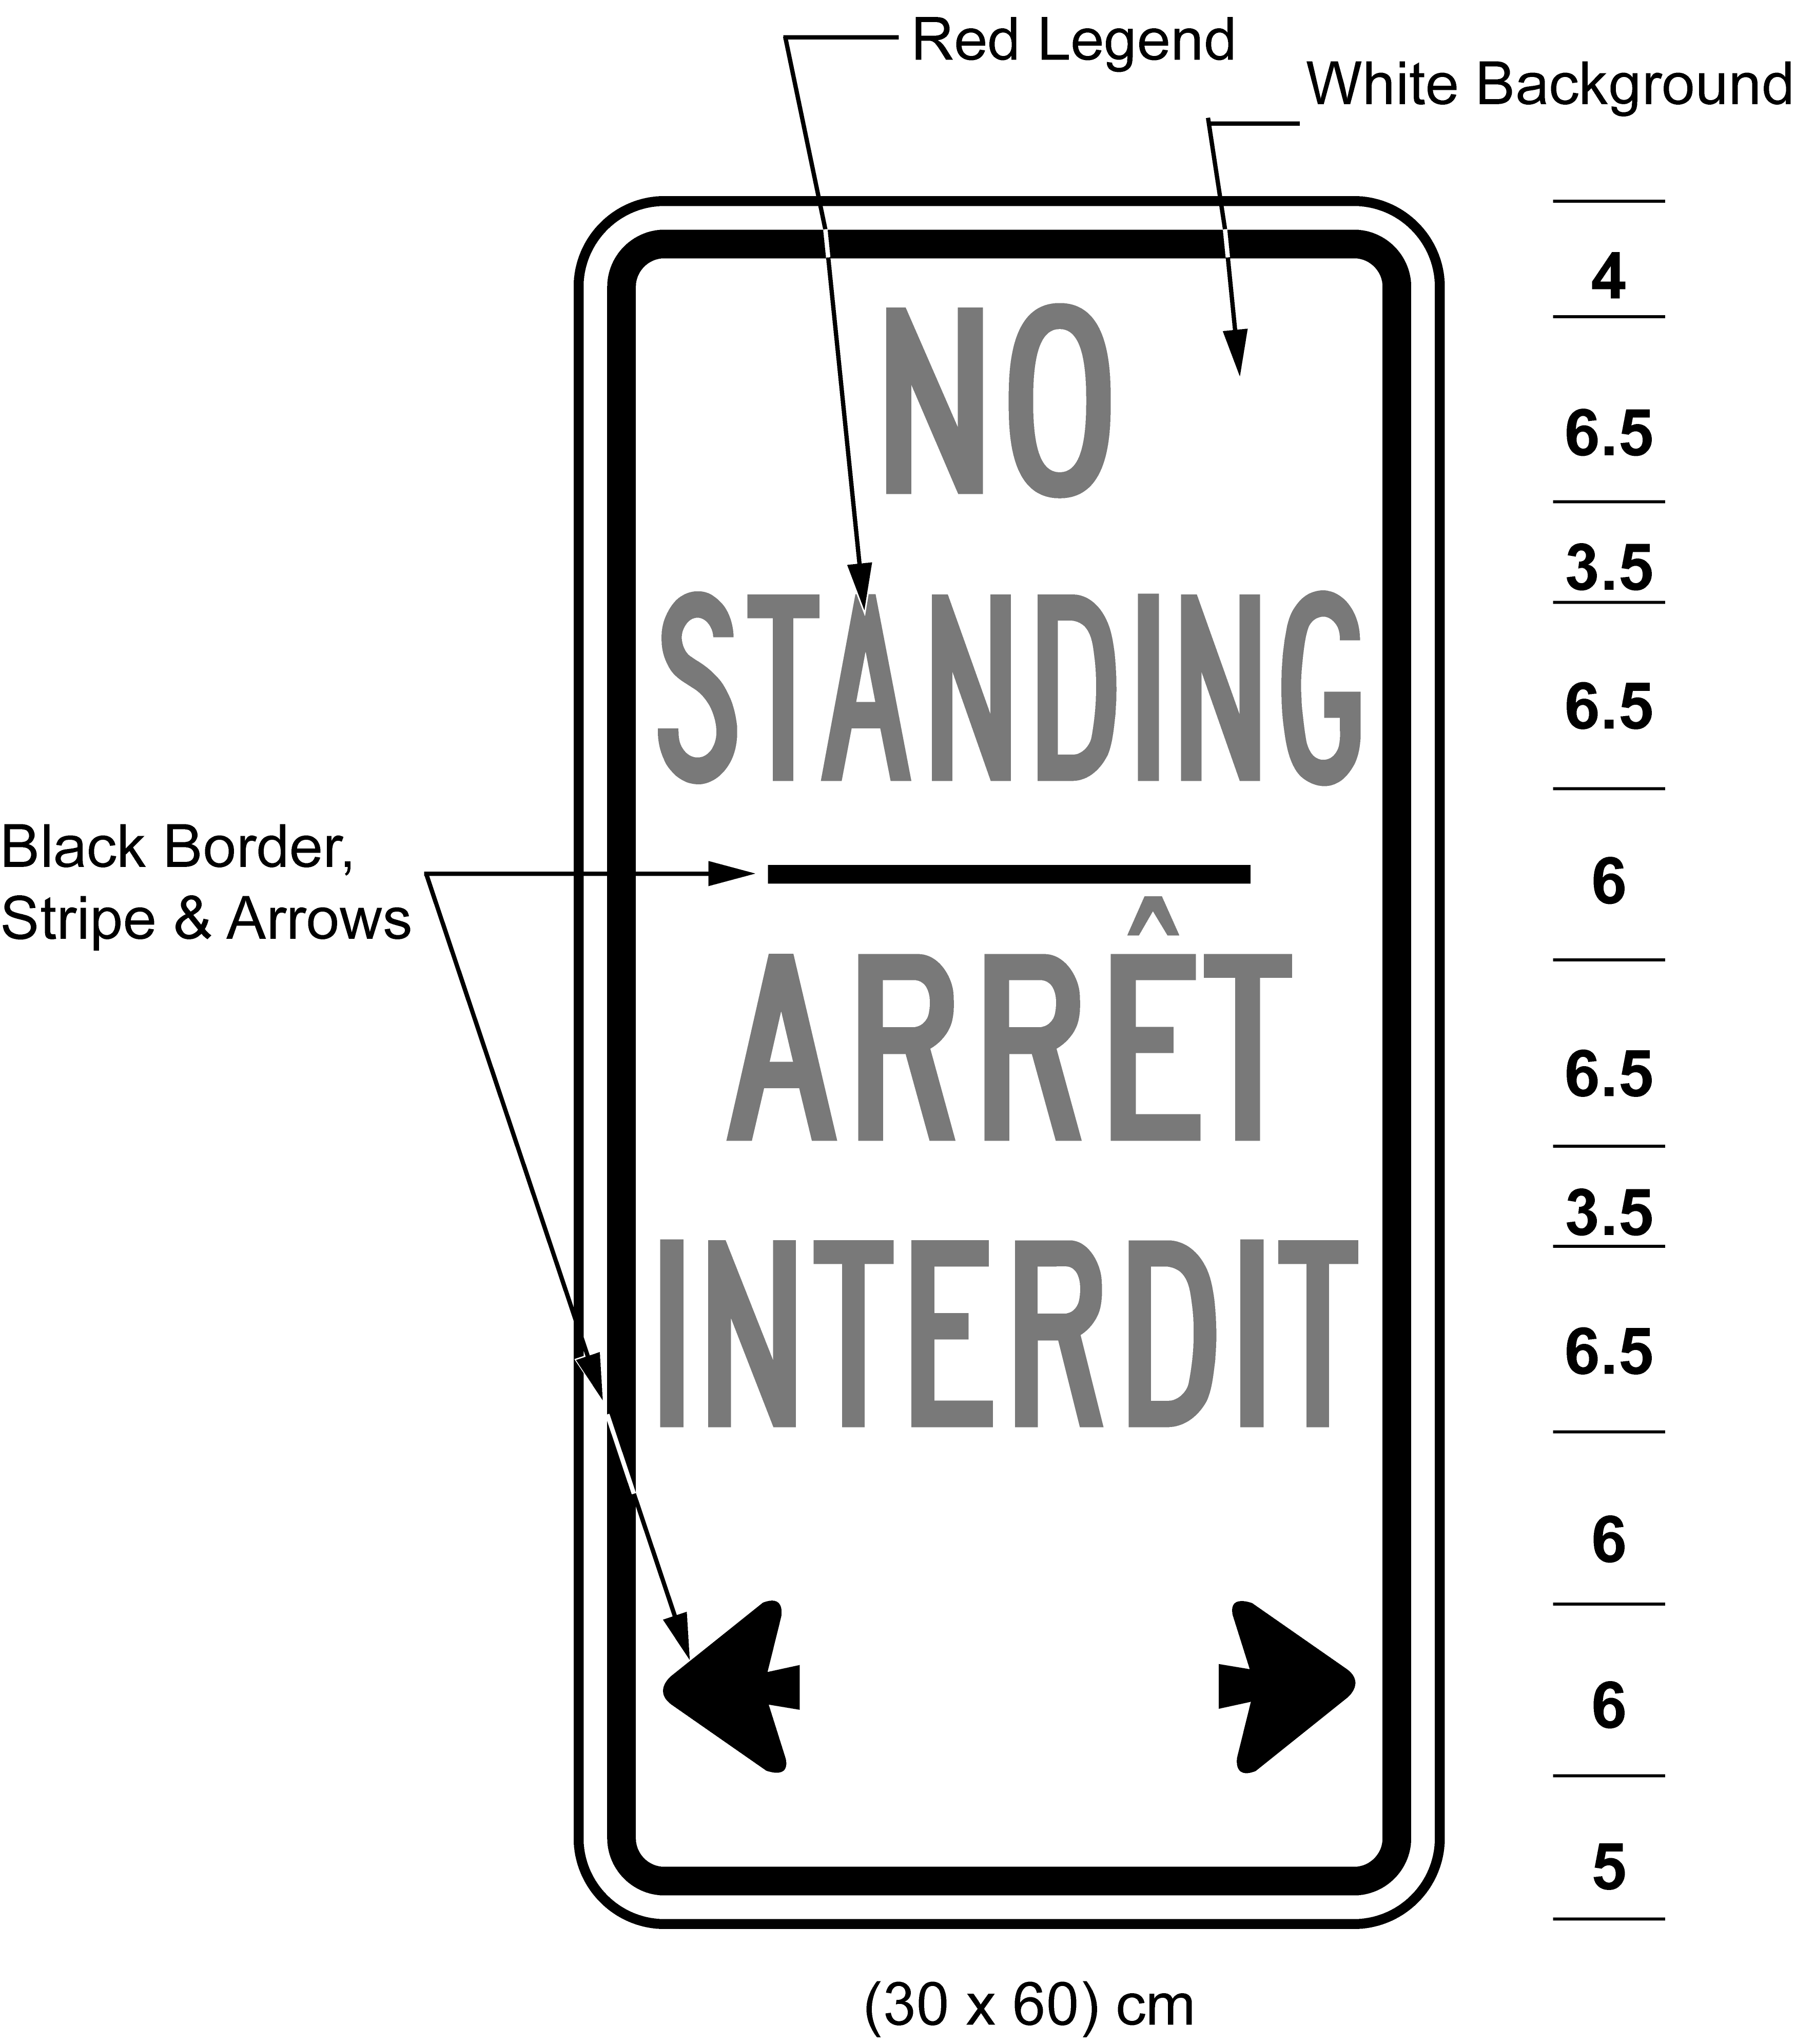
Text alternative: Illustration of “no standing” sign with red text “NO STANDING / ARRÊT INTERDIT” on a white background with black arrows pointing left and right. The measurements are written below the sign: (30 × 60) cm. This text alternative is provided for convenience only and does not form part of the official law.
O. Reg. 444/93, s. 5; O. Reg. 339/09, s. 10 (2); O. Reg. 275/25, s. 4.
(2) Every sign erected on or after the 28th day of March, 1986 that restricts standing shall,
(a) be not less than 45 centimetres in height and not less than 30 centimetres in width; and
(b) bear the markings, indicating the times at which standing is prohibited and have the dimensions as illustrated in the following Figure:
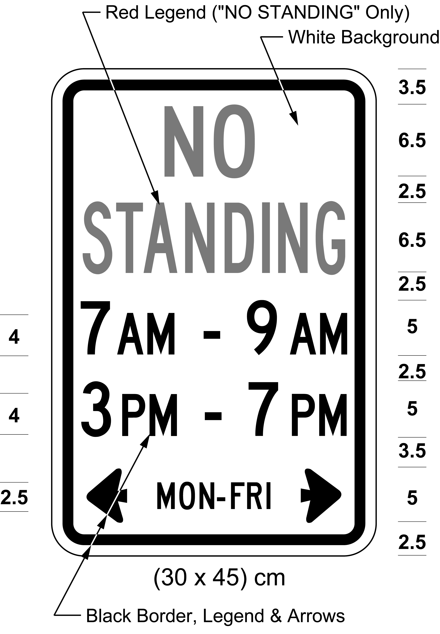
Text alternative: Illustration of “no standing” sign with red text “NO STANDING” on a white background and the text “7 AM - 9 AM”, “3 PM - 7 PM”, and “MON-FRI”, with black arrows pointing left and right. The measurements are written below the sign: (30 × 45) cm. This text alternative is provided for convenience only and does not form part of the official law.
R.R.O. 1990, Reg. 615, s. 15 (2); O. Reg. 339/09, s. 10 (3).
(2.1) Despite subsection (2), in an area designated for the purposes of clause 5 (1) (b) of the French Language Services Act, a sign that restricts standing shall,
(a) be not less than 75 centimetres in height and not less than 30 centimetres in width; and
(b) bear the markings and indicate the times at which standing is prohibited and have the dimensions as illustrated in the following Figure:
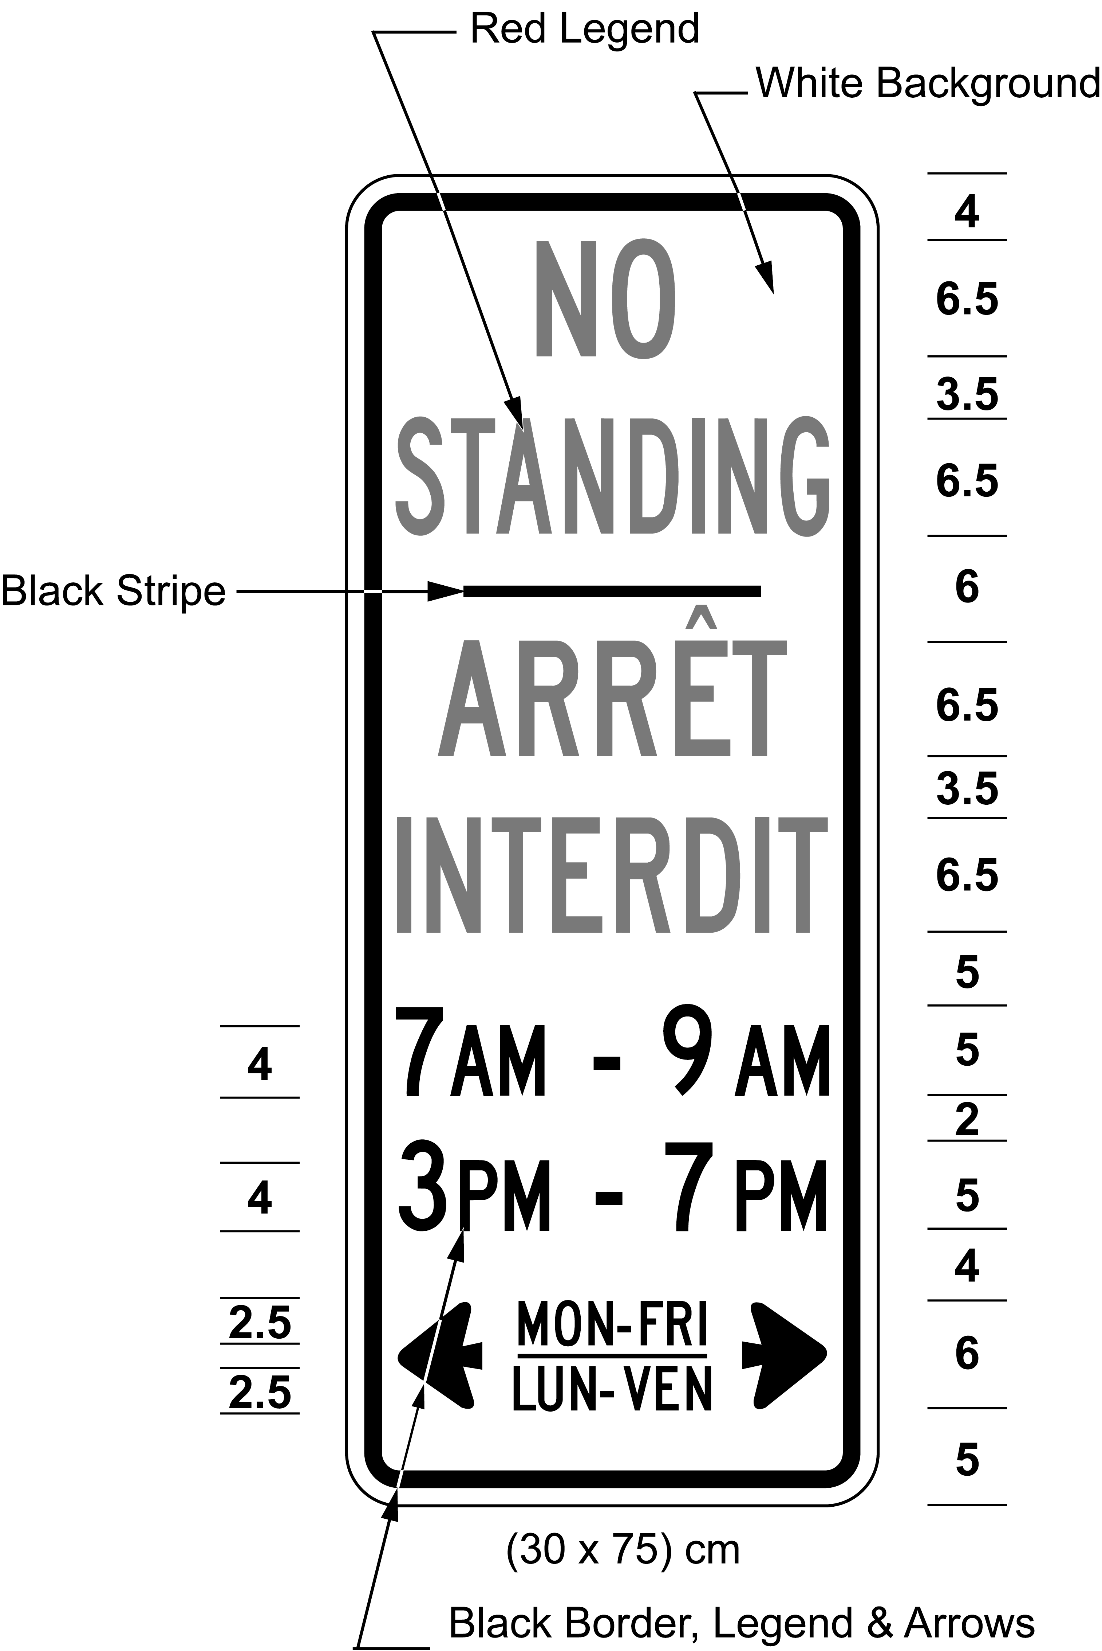
Text alternative: Illustration of “no standing” sign with red text “NO STANDING / ARRÊT INTERDIT” on a white background and the text “7 AM - 9 AM”, “3 PM - 7 PM”, and “MON-FRI / LUN-VEN”, with black arrows pointing left and right. The measurements are written below the sign: (30 × 75) cm. This text alternative is provided for convenience only and does not form part of the official law.
O. Reg. 444/93, s. 5; O. Reg. 339/09, s. 10 (4); O. Reg. 275/25, s. 4.
(3) On or after the 1st day of December, 1992, no sign restricting or prohibiting standing shall be valid except as prescribed and illustrated in subsection (1) or (2). O. Reg. 699/92, s. 1.
Yield Right-Of-Way Signs
16. A yield right-of-way sign may be erected on a highway that intersects another highway. R.R.O. 1990, Reg. 615, s. 16.
17. A yield right-of-way sign shall,
(a) be in the shape of an equilateral triangle with sides not less than 75 centimetres in length;
(b) bear the marking and have the dimensions as prescribed and illustrated in the following Figure:
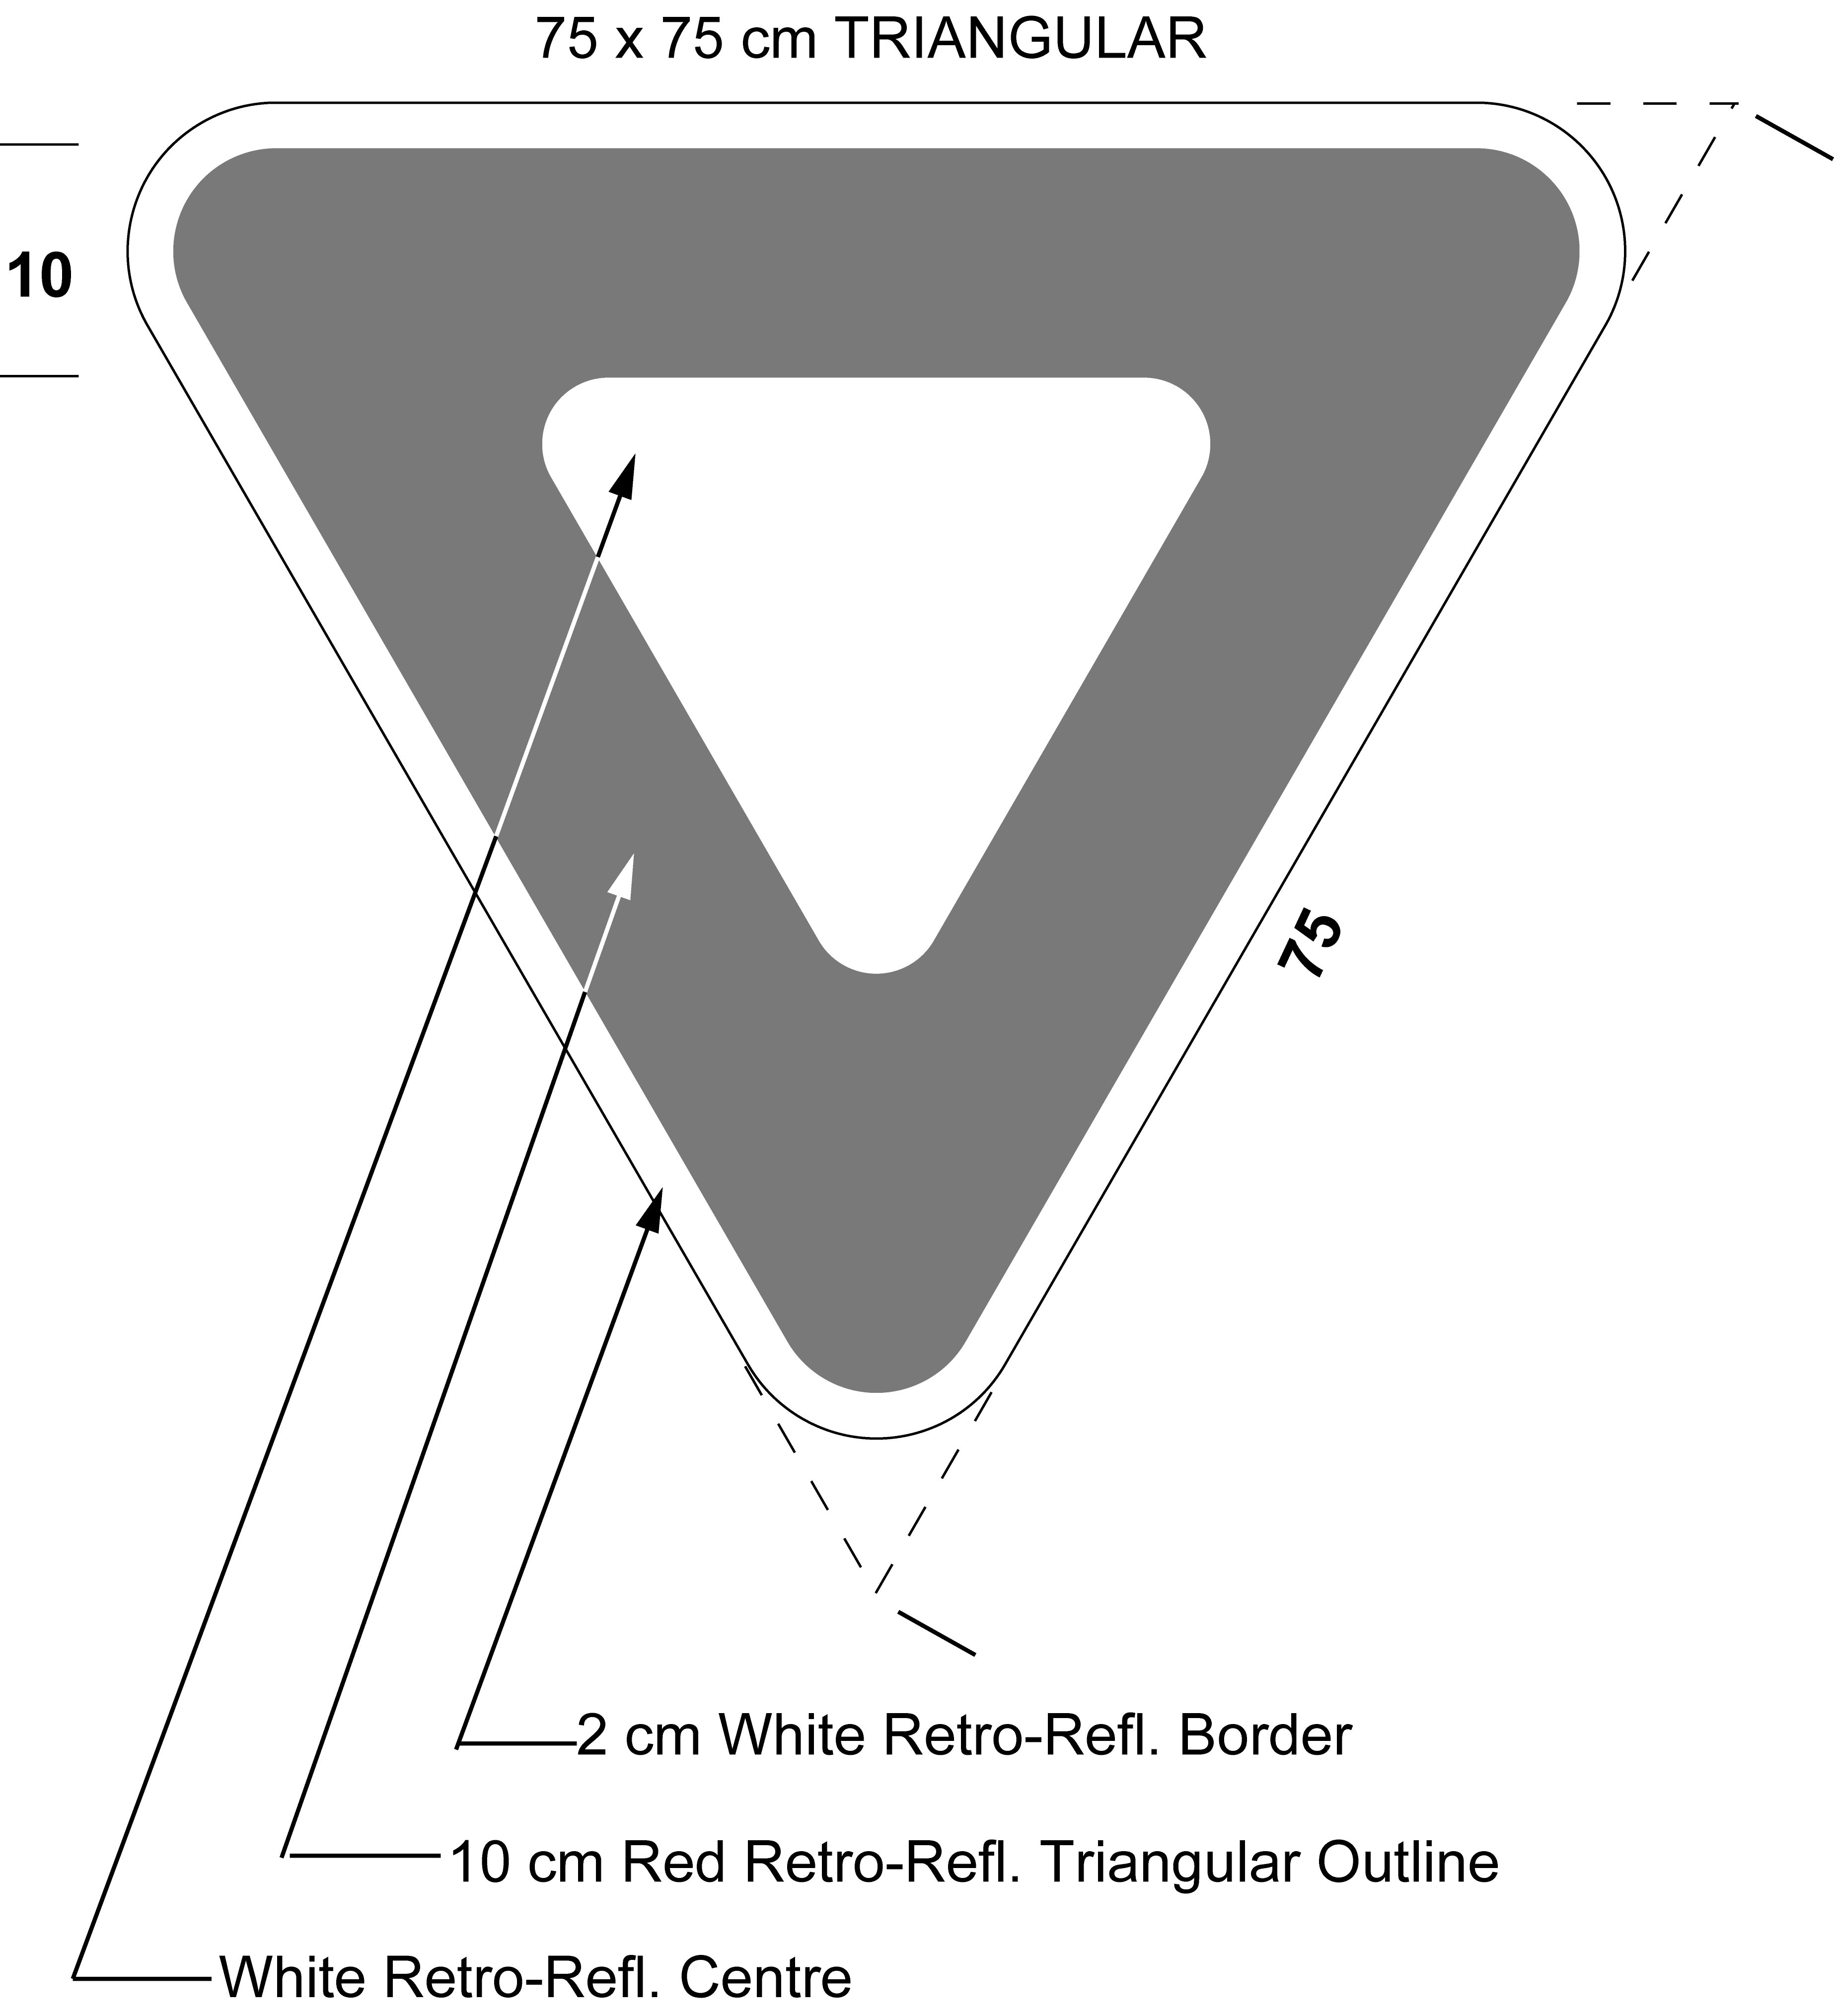
Text alternative: Illustration of yield right-of-way sign, with a white equilateral triangle inside a red equilateral triangle with a white retro-reflective border. This text alternative is provided for convenience only and does not form part of the official law.
(c) be erected so that the bottom point is not less than 1.5 metres and not more than 2.5 metres above the level of the roadway; and
(d) be erected facing approaching traffic on the right side of the highway at a point not less than 1.5 metres and not more than 15 metres from the roadway of the intersecting highway or on a median not less than 1.5 metres and not more than 15 metres from a roadway of the intersecting divided highway. R.R.O. 1990, Reg. 615, s. 17; O. Reg. 339/09, s. 11.
18. (1) A yield right-of-way sign referred to in section 17 may be accompanied immediately below by a tab sign bearing the markings and having the dimensions as illustrated in the following Figure:
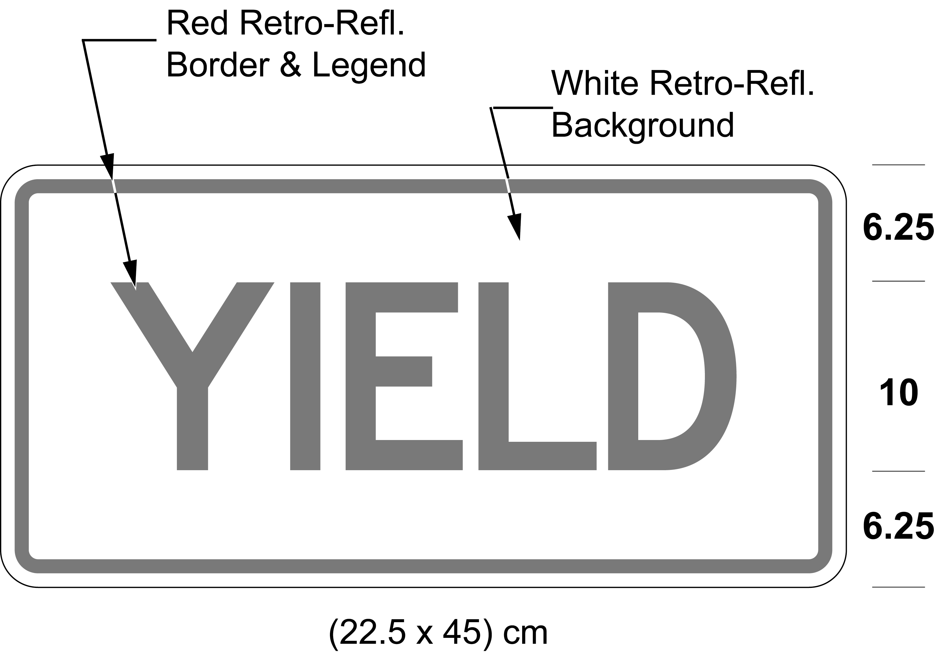
Text alternative: Illustration of yield right-of-way sign with red text “YIELD” on a white retro-reflective background with a red border. Sign size indicated (22.5 × 45) cm. This text alternative is provided for convenience only and does not form part of the official law.
R.R.O. 1990, Reg. 615, s. 18; O. Reg. 339/09, s. 12 (1).
(2) In an area designated for the purposes of clause 5 (1) (b) of the French Language Services Act, a yield right-of-way sign referred to in section 17 may be accompanied immediately below by a tab sign bearing the markings and having the dimensions as illustrated in the following Figure:
Text alternative: Illustration of yield right-of-way sign with red text “YIELD / CÉDEZ” on a white retro-reflective background with a red border. Sign size indicated (30 × 45) cm. This text alternative is provided for convenience only and does not form part of the official law.
O. Reg. 444/93, s. 6; O. Reg. 339/09, s. 12 (2); O. Reg. 275/25, s. 4.
19. A yield right-of-way sign shall be erected so that the left edge of the sign is not more than 4 metres from the edge of the roadway. O. Reg. 175/08, s. 5.
20. Revoked: R.R.O. 1990, Reg. 615, s. 20.10.
20.1-20.3 Revoked: O. Reg. 407/15, s. 1.
20.4-20.6 Revoked: R.R.O. 1990, Reg. 615, s. 20.10.
20.7-20.9 Revoked: O. Reg. 175/08, s. 8.
20.10 Revoked: O. Reg. 407/15, s. 1.
Turn Signs
21. (1) A no right turn sign shall,
(a) be not less than 60 centimetres in height and not less than 60 centimetres in width; and
(b) include the markings and the dimensions as described and illustrated in the following Figure:
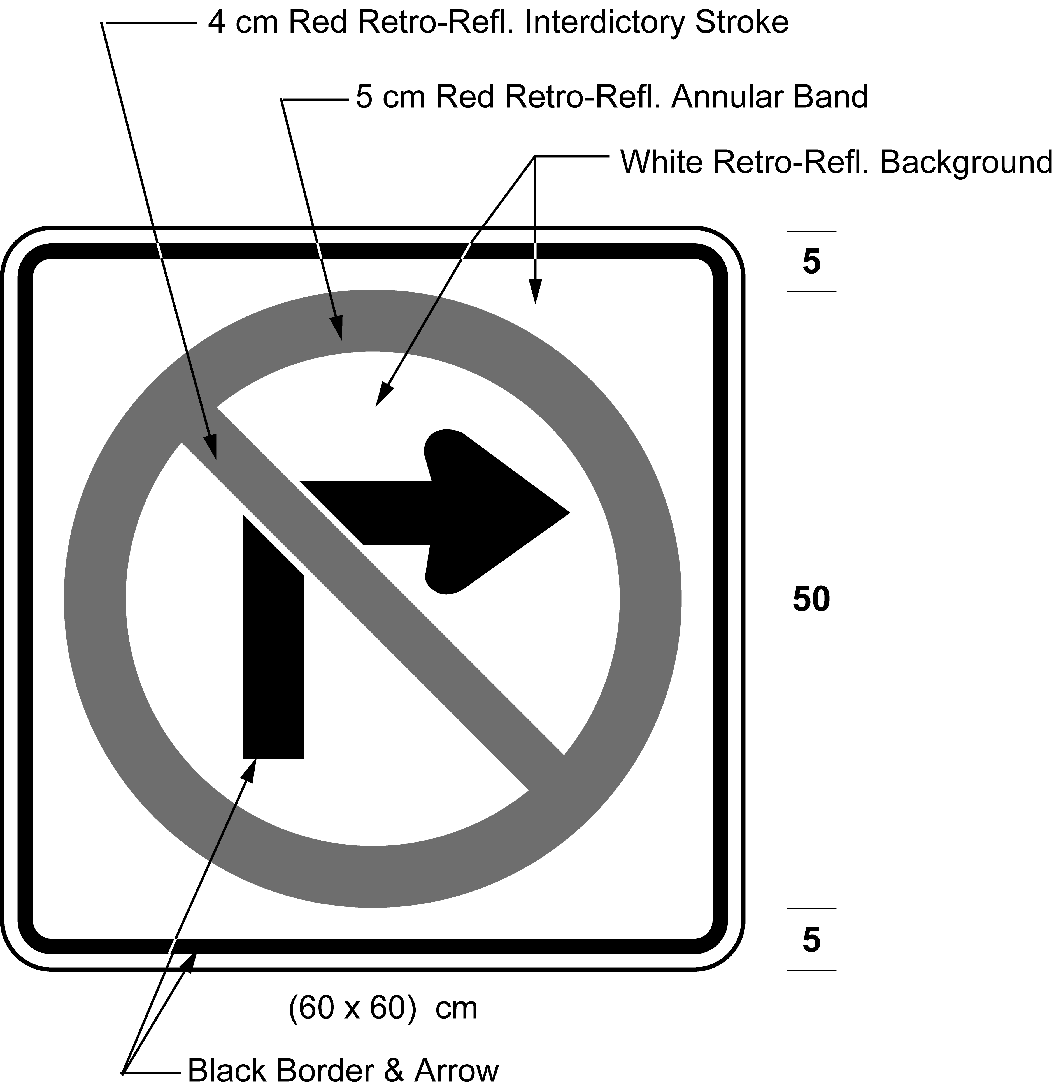
Text alternative: Illustration of a sign with a no right turn symbol consisting of a right turn black arrow inside a red circle with an interdictory stroke, on white retro-reflective background with a black border. Size indicated (60 × 60) cm. This text alternative is provided for convenience only and does not form part of the official law.
R.R.O. 1990, Reg. 615, s. 21 (1); O. Reg. 339/09, s. 15 (1).
(2) Every sign that restricts a right turn shall,
(a) be not less than 90 centimetres in height and not less than 60 centimetres in width; and
(b) bear the markings and indicate the times at which a right turn is prohibited and have the dimensions as illustrated in the following Figure:
Text alternative: Illustration of a sign with a no right turn symbol consisting of a right turn black arrow inside a red circle with an interdictory stroke, on white retro-reflective background with a black border and the text “7 AM - 9 AM”, “4 PM - 6 PM”, “MON-FRI”. Size indicated (60 × 90) cm. This text alternative is provided for convenience only and does not form part of the official law.
R.R.O. 1990, Reg. 615, s. 21 (2); O. Reg. 332/98, s. 2 (1); O. Reg. 339/09, s. 15 (2); O. Reg. 93/15, s. 1 (2).
(2.1) Despite subsection (2), a sign that restricts a right turn in an area designated for the purposes of clause 5 (1) (b) of the French Language Services Act shall be as described in clause (2) (a) and bear the markings and indicate the times at which a right turn is prohibited and have the dimensions as illustrated in the following Figure:
Text alternative: Illustration of a sign with a no right turn symbol consisting of a right turn black arrow inside a red circle with an interdictory stroke, on white retro-reflective background with a black border and the text “7 AM - 9 AM”, “4 PM - 6 PM”, “MON-FRI / LUN-VEN”. Size indicated (60 × 90) cm. This text alternative is provided for convenience only and does not form part of the official law.
O. Reg. 444/93, s. 9 (1); O. Reg. 339/09, s. 15 (3); O. Reg. 93/15, s. 1 (1); O. Reg. 275/25, s. 4.
(3) Every sign erected on or after September 1, 1998 that prohibits a vehicle from making a right turn at a signalized intersection when the signal indication is red shall,
(a) be not less than 90 centimetres in height and not less than 60 centimetres in width; and
(b) include the markings and dimensions as illustrated in the following Figure:
Text alternative: Illustration of a sign with a no right turn symbol consisting of a black right turn arrow inside a red circle with an interdictory stroke on white background above a symbol of a traffic signal light with the red light on. Size indicated (60 × 90) cm. This text alternative is provided for convenience only and does not form part of the official law.
O. Reg. 332/98, s. 2 (2); O. Reg. 339/09, s. 15 (4).
(3.1) On or after January 1, 2003, no sign prohibiting a right turn at a signalized intersection when the signal indication is red shall be valid except as prescribed and illustrated in subsection (3). O. Reg. 332/98, s. 2 (2).
(3.2) Before January 1, 2003, no sign prohibiting a right turn at a signalized intersection when the signal indication is red, other than a sign as prescribed and illustrated in subsection (3), shall be valid unless it was authorized by this Regulation immediately before September 1, 1998. O. Reg. 332/98, s. 2 (2).
(3.3) Revoked: O. Reg. 332/98, s. 2 (2).
(4) A no left turn sign shall,
(a) be not less than 60 centimetres in height and not less than 60 centimetres in width; and
(b) include the markings and the dimensions as described and illustrated in the following Figure:
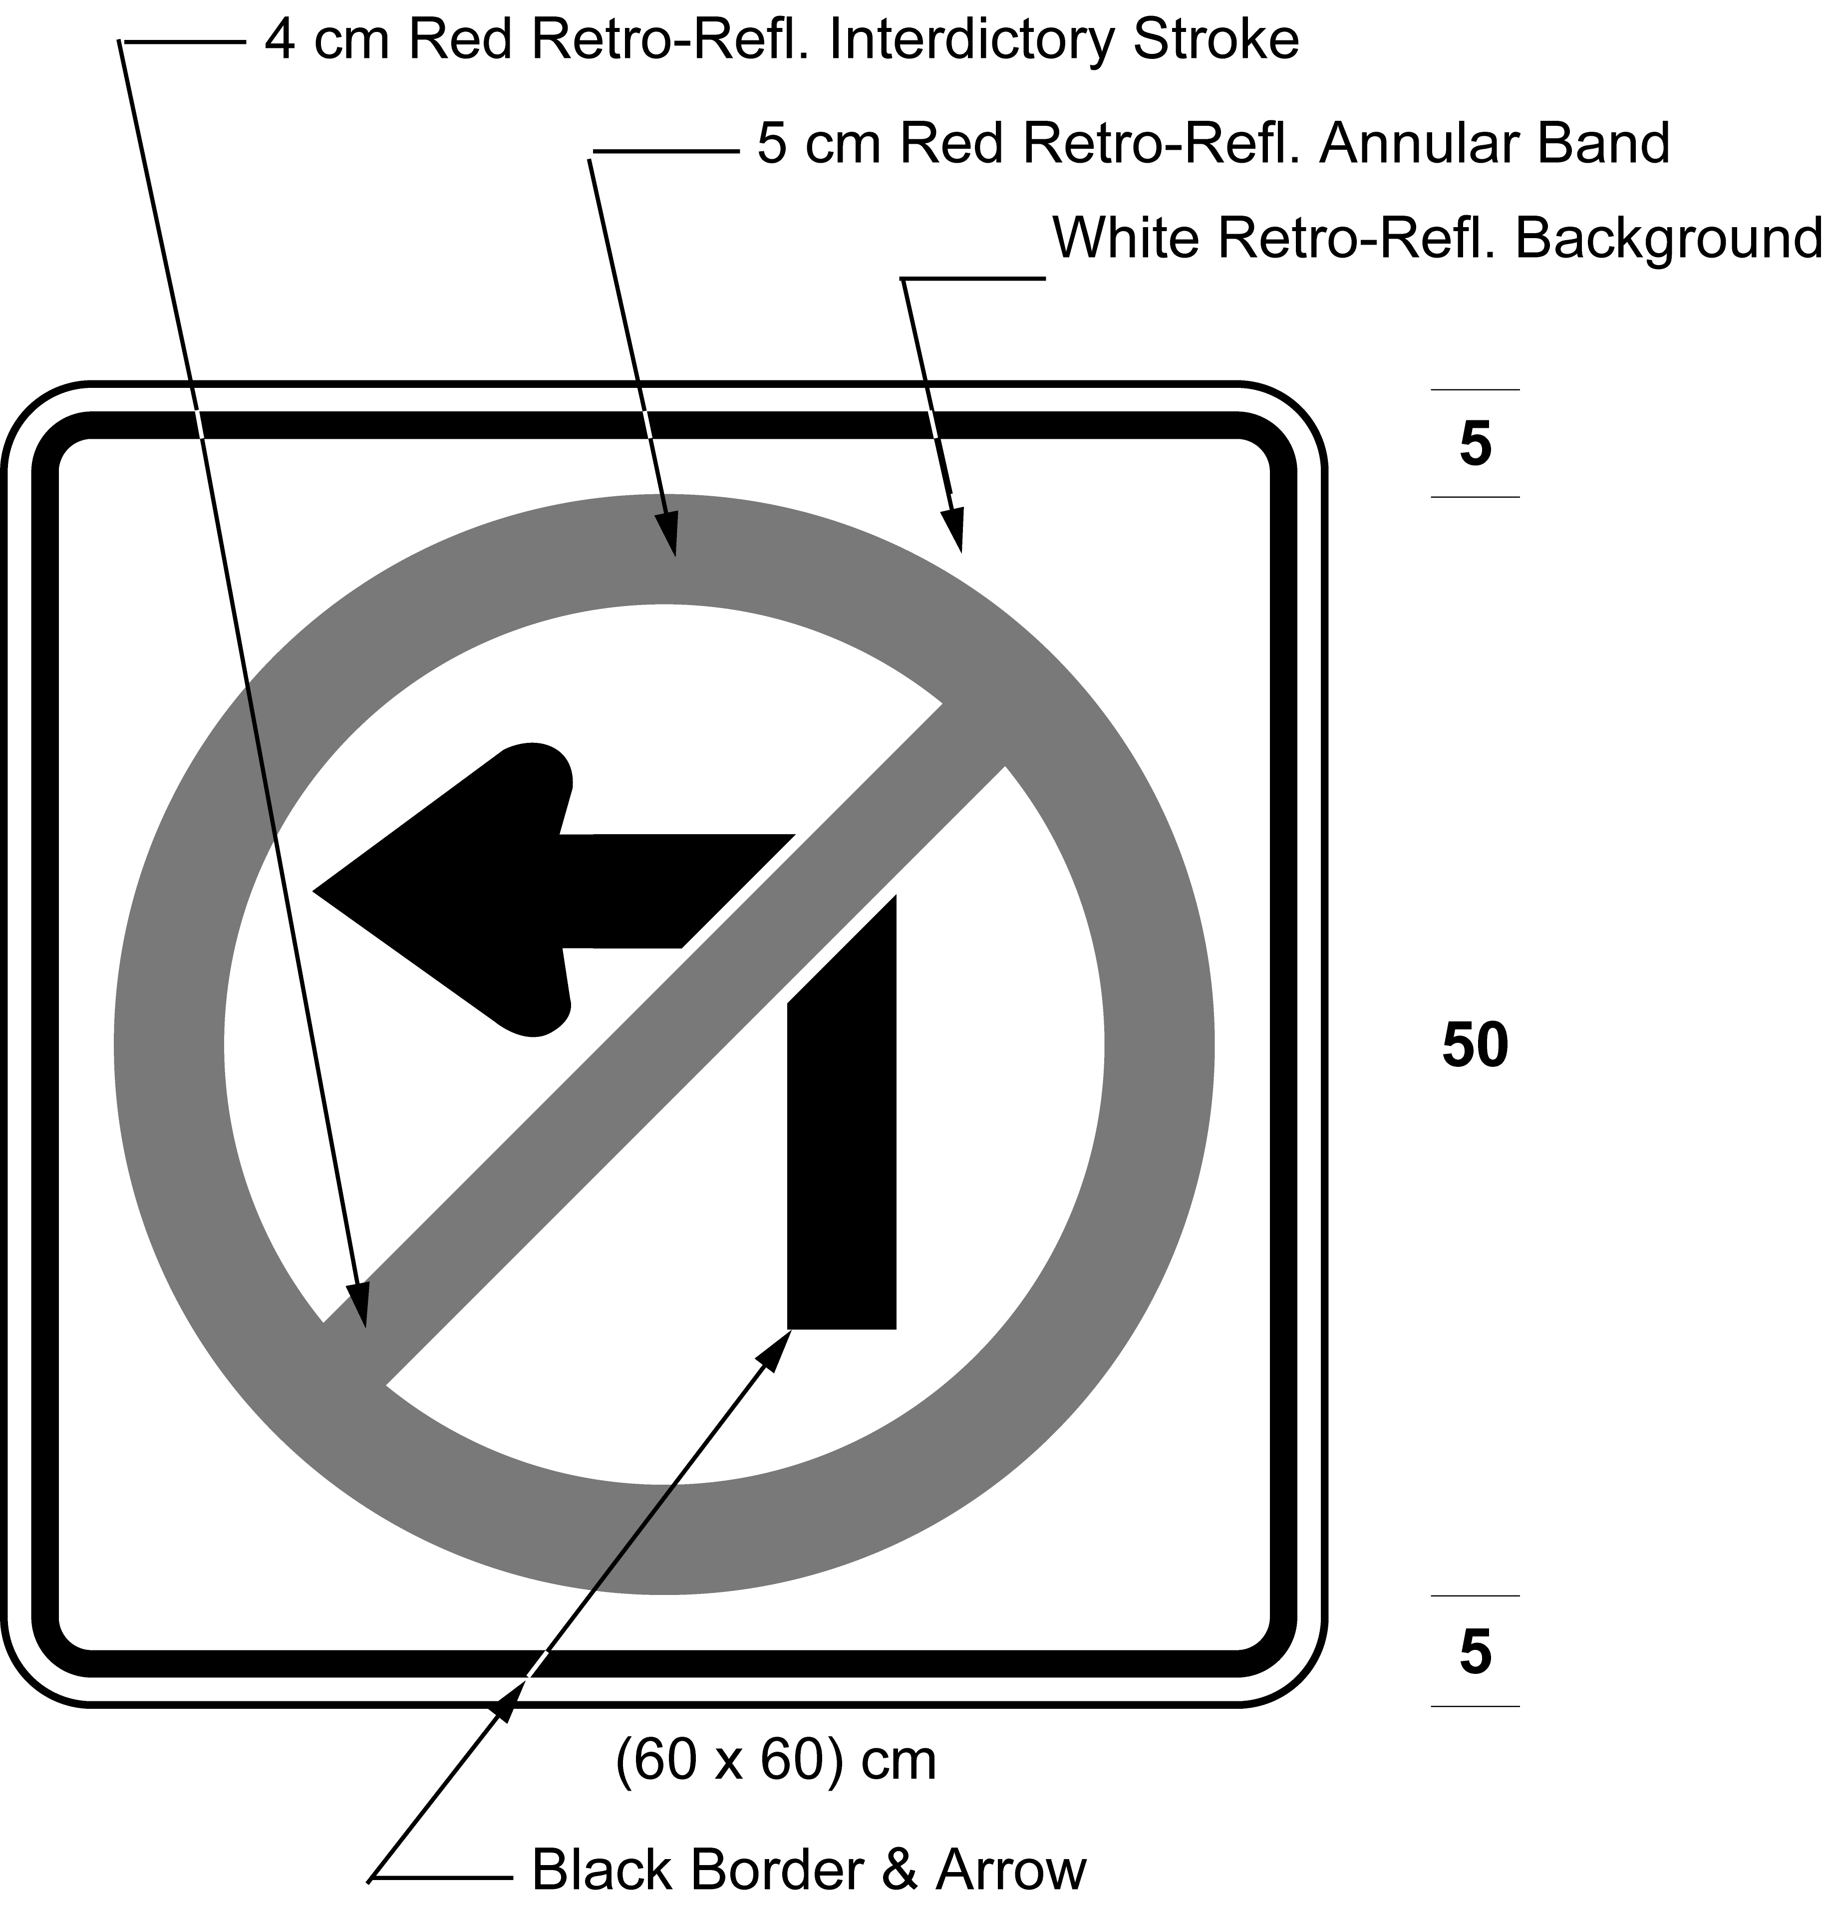
Text alternative: Illustration of a sign with a no left turn symbol consisting of a left turn black arrow inside a red circle with an interdictory stroke, on white retro-reflective background with a black border. Size indicated (60 × 60) cm. This text alternative is provided for convenience only and does not form part of the official law.
R.R.O. 1990, Reg. 615, s. 21 (4); O. Reg. 339/09, s. 15 (5).
(5) Every sign that restricts a left turn shall,
(a) be not less than 90 centimetres in height and not less than 60 centimetres in width; and
(b) bear the markings and indicate the times at which a left turn is prohibited and have the dimensions as illustrated in the following Figure:
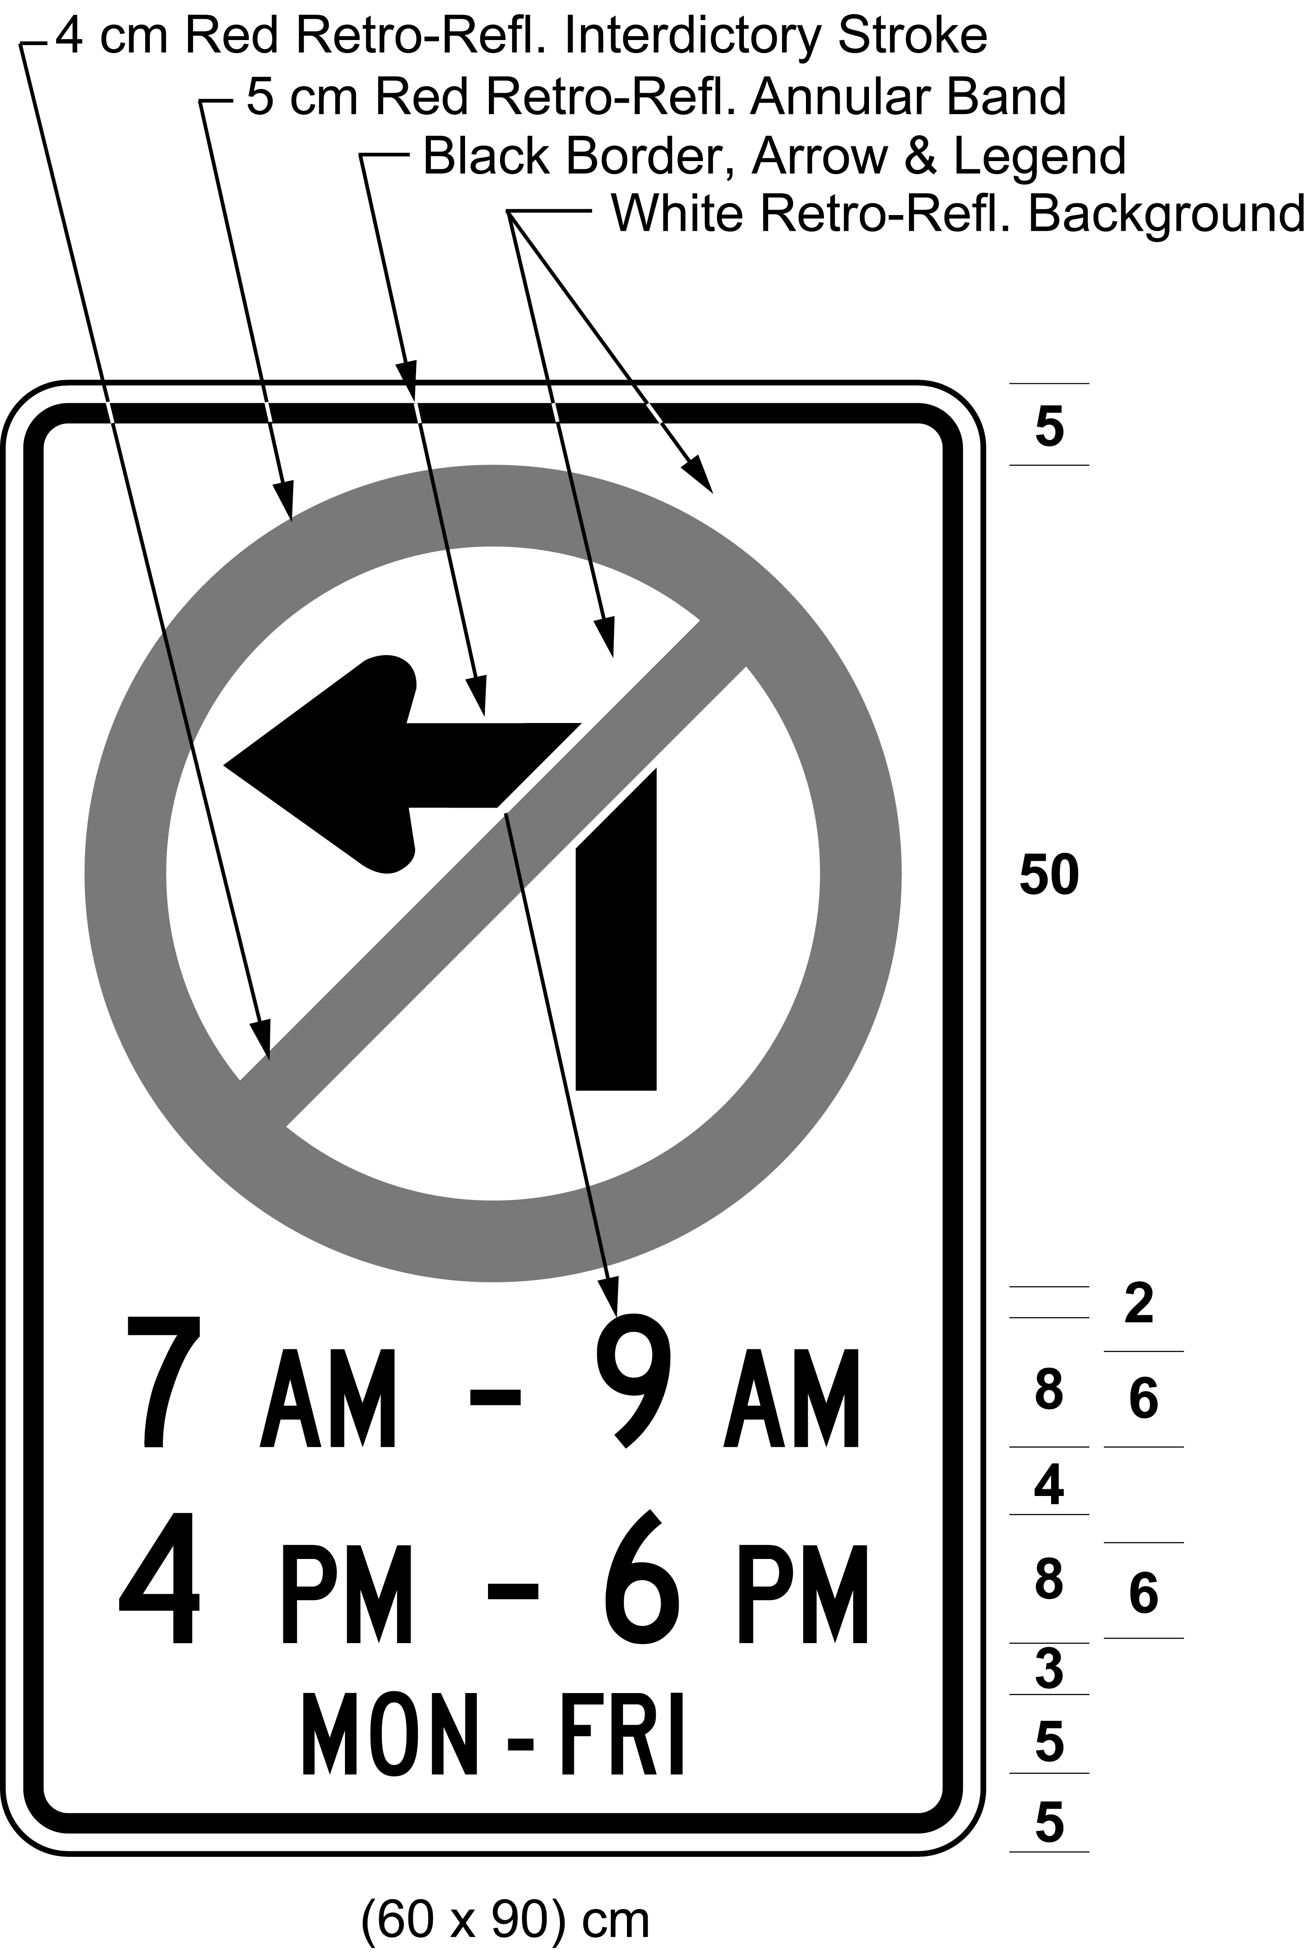
Text alternative: Illustration of a sign with a no left turn symbol consisting of a left turn black arrow inside a red circle with an interdictory stroke, on white retro-reflective background with a black border and the text “7 AM - 9 AM”, “4 PM - 6 PM”, “MON-FRI”. Size indicated (60 × 90) cm. This text alternative is provided for convenience only and does not form part of the official law.
R.R.O. 1990, Reg. 615, s. 21 (5); O. Reg. 332/98, s. 2 (3); O. Reg. 339/09, s. 15 (6).
(5.1) Despite subsection (5), a sign that restricts a left turn in an area designated for the purposes of clause 5 (1) (b) of the French Language Services Act shall,
(a) be not less than 90 centimetres high and not less than 60 centimetres wide; and
(b) bear the markings and indicate the times at which a left turn is prohibited and have the dimensions as illustrated in the following Figure:
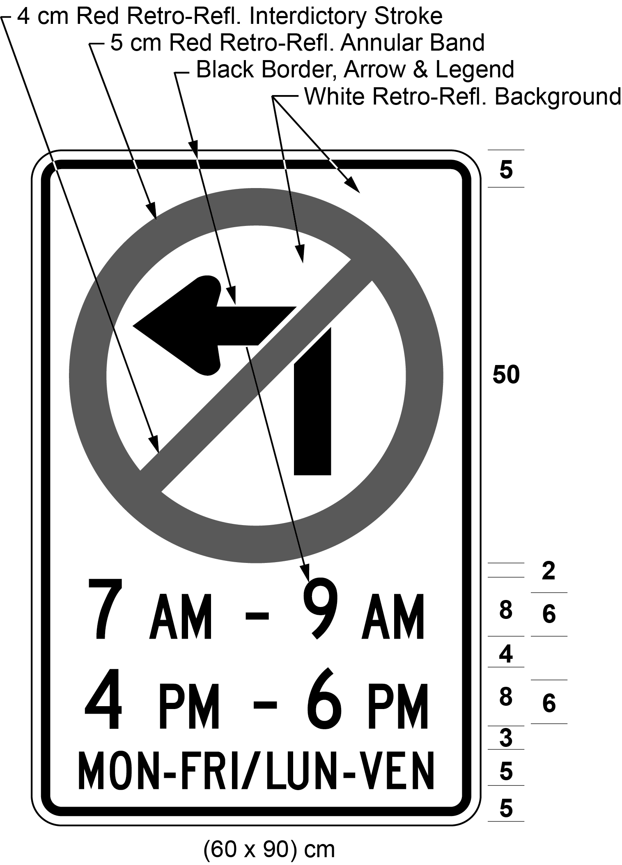
Text alternative: Illustration of a sign with a no left turn symbol consisting of a left turn black arrow inside a red circle with an interdictory stroke, on white retro-reflective background with a black border and the text “7 AM - 9 AM”, “4 PM - 6 PM”, “MON-FRI / LUN-VEN”. Size indicated (60 × 90) cm. This text alternative is provided for convenience only and does not form part of the official law.
O. Reg. 444/93, s. 9 (2); O. Reg. 339/09, s. 15 (7); O. Reg. 93/15, s. 1 (3); O. Reg. 275/25, s. 4.
(6) Every sign erected on or after September 1, 1998 that prohibits a vehicle from making a left turn at a signalized intersection when the signal indication is red shall,
(a) be not less than 90 centimetres in height and not less than 60 centimetres in width; and
(b) include the markings and dimensions as illustrated in the following Figure:
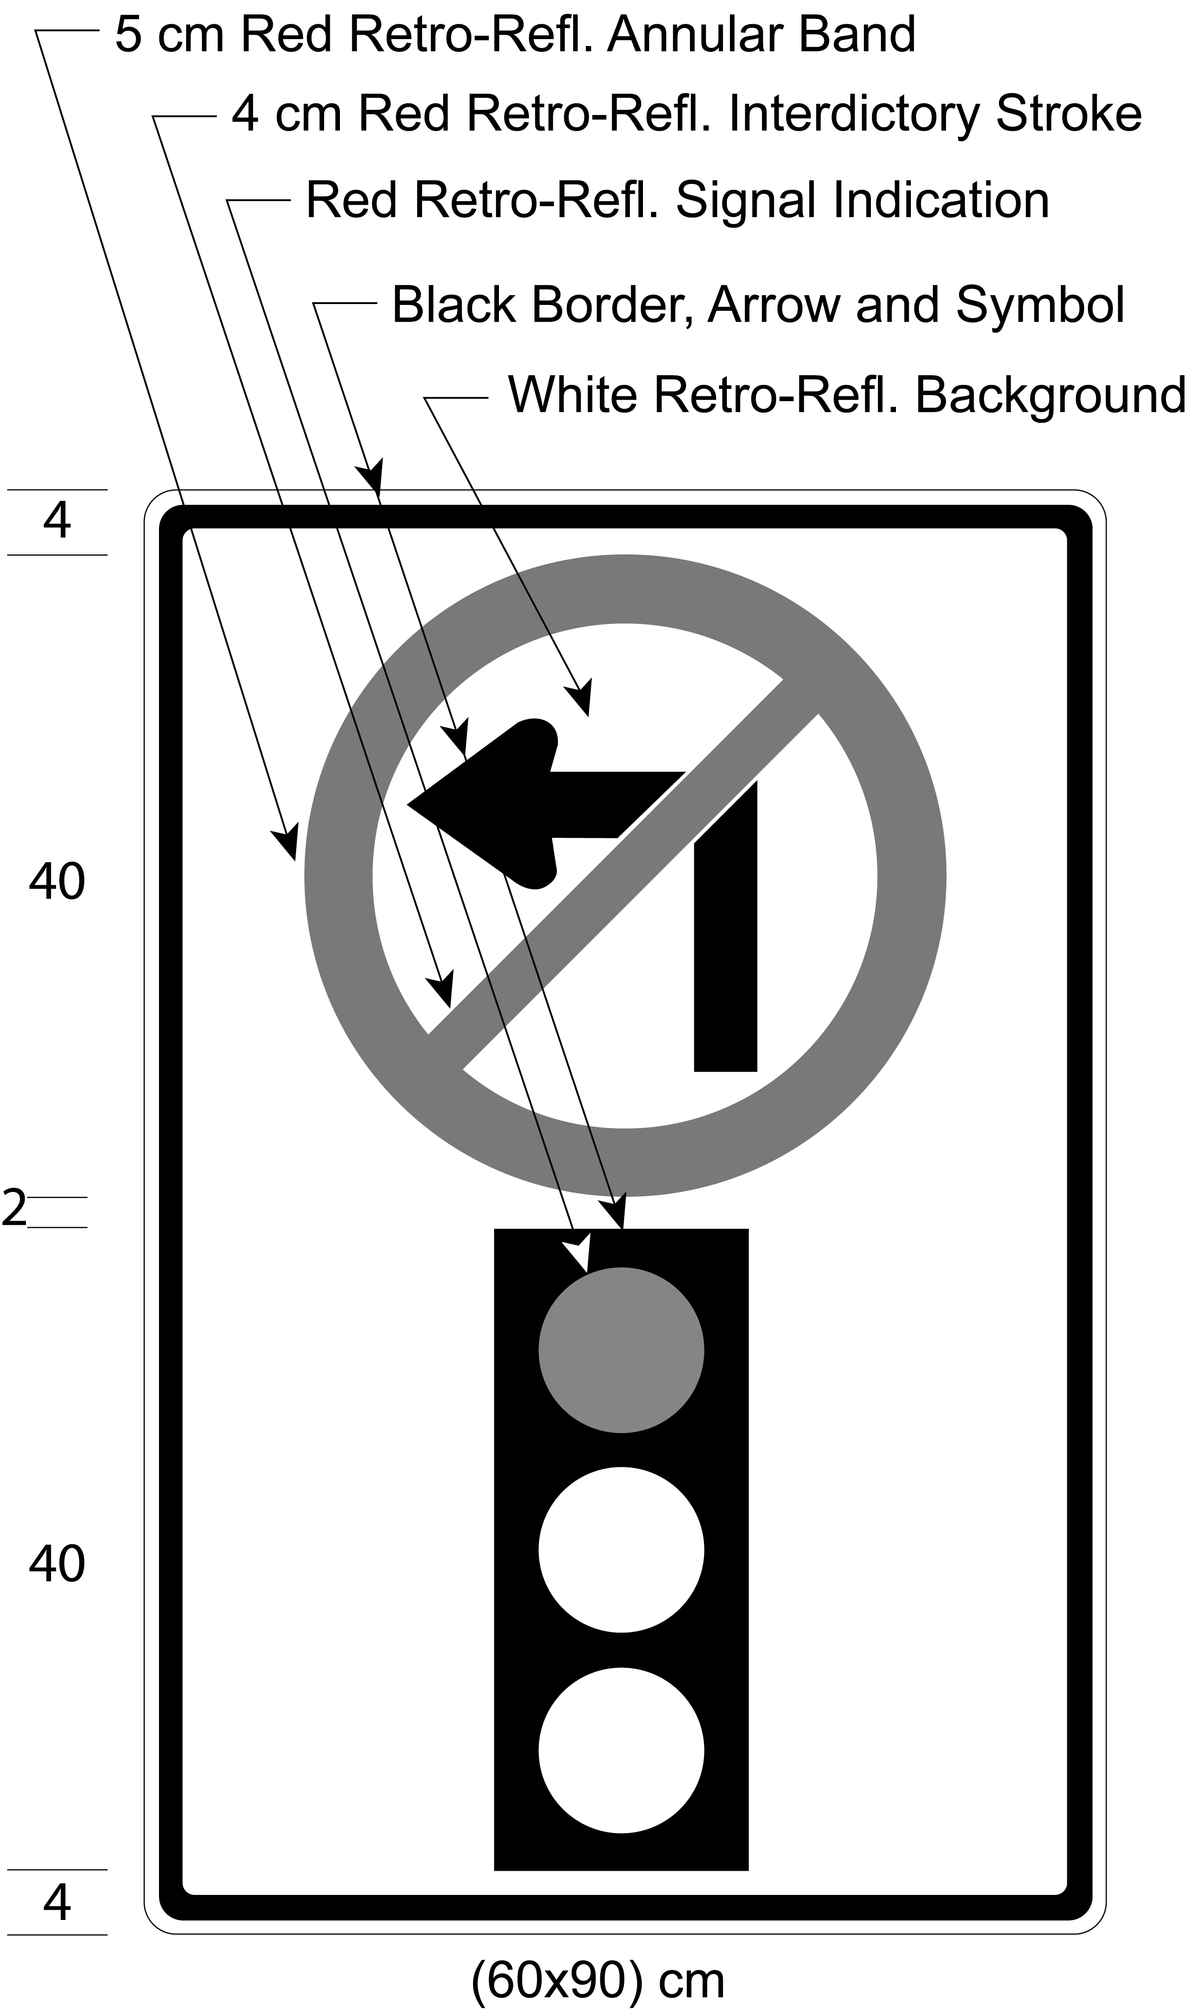
Text alternative: Illustration of a sign with a no left turn symbol consisting of a black left turn arrow inside a red circle with an interdictory stroke on white background above a symbol of a traffic signal light with the red light on. Size indicated (60 × 90) cm. This text alternative is provided for convenience only and does not form part of the official law.
O. Reg. 332/98, s. 2 (4); O. Reg. 339/09, s. 15 (8).
(6.1) On or after January 1, 2003, no sign prohibiting a left turn at a signalized intersection when the signal indication is red shall be valid except as prescribed and illustrated in subsection (6). O. Reg. 332/98, s. 2 (4).
(6.2) Before January 1, 2003, no sign prohibiting a left turn at a signalized intersection when the signal indication is red, other than a sign as prescribed and illustrated in subsection (6), shall be valid unless it was authorized by this Regulation immediately before September 1, 1998. O. Reg. 332/98, s. 2 (4).
(6.3) Revoked: O. Reg. 332/98, s. 2 (4).
(7) Revoked: O. Reg. 699/92, s. 3 (2).
22. (1) A sign that prohibits a vehicle from making a right turn or proceeding straight through an intersection shall,
(a) be not less than 60 centimetres in height and not less than 60 centimetres in width; and
(b) include the markings and the dimensions as described and illustrated in the following Figure:
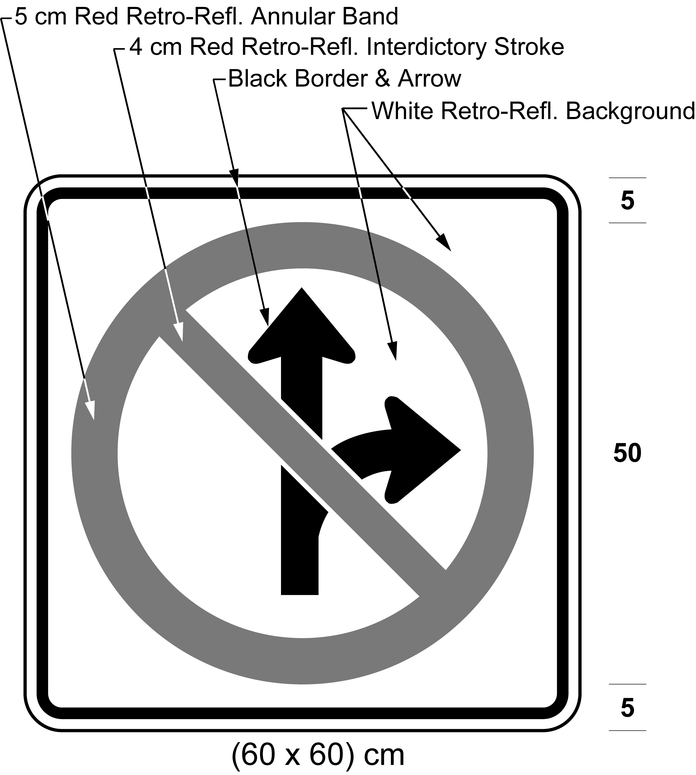
Text alternative: Illustration of a sign with a “No right turn or proceeding straight” symbol consisting of branching black arrows curving right and proceeding straight, inside a red a circle with an interdictory stroke on white retro-reflective background with a black border. Indicated sign size (60 × 60) cm. This text alternative is provided for convenience only and does not form part of the official law.
R.R.O. 1990, Reg. 615, s. 22 (1); O. Reg. 332/98, s. 3 (1); O. Reg. 339/09, s. 16 (1).
(2) A sign that prohibits a vehicle from making a left turn or proceeding straight through an intersection shall,
(a) be not less than 60 centimetres in height and not less than 60 centimetres in width; and
(b) include the markings and the dimensions as described and illustrated in the following Figure:
Text alternative: Illustration of a sign with a “No left turn or proceeding straight” symbol consisting of branching black arrows curving left and proceeding straight, inside a red a circle with an interdictory stroke on white retro-reflective background with a black border. Indicated sign size (60 × 60) cm. This text alternative is provided for convenience only and does not form part of the official law.
R.R.O. 1990, Reg. 615, s. 22 (2); O. Reg. 332/98, s. 3 (2); O. Reg. 339/09, s. 16 (2).
(3) A no turn sign shall,
(a) be not less than 60 centimetres in height and not less than 60 centimetres in width; and
(b) include the markings and the dimensions as described and illustrated in the following Figure:
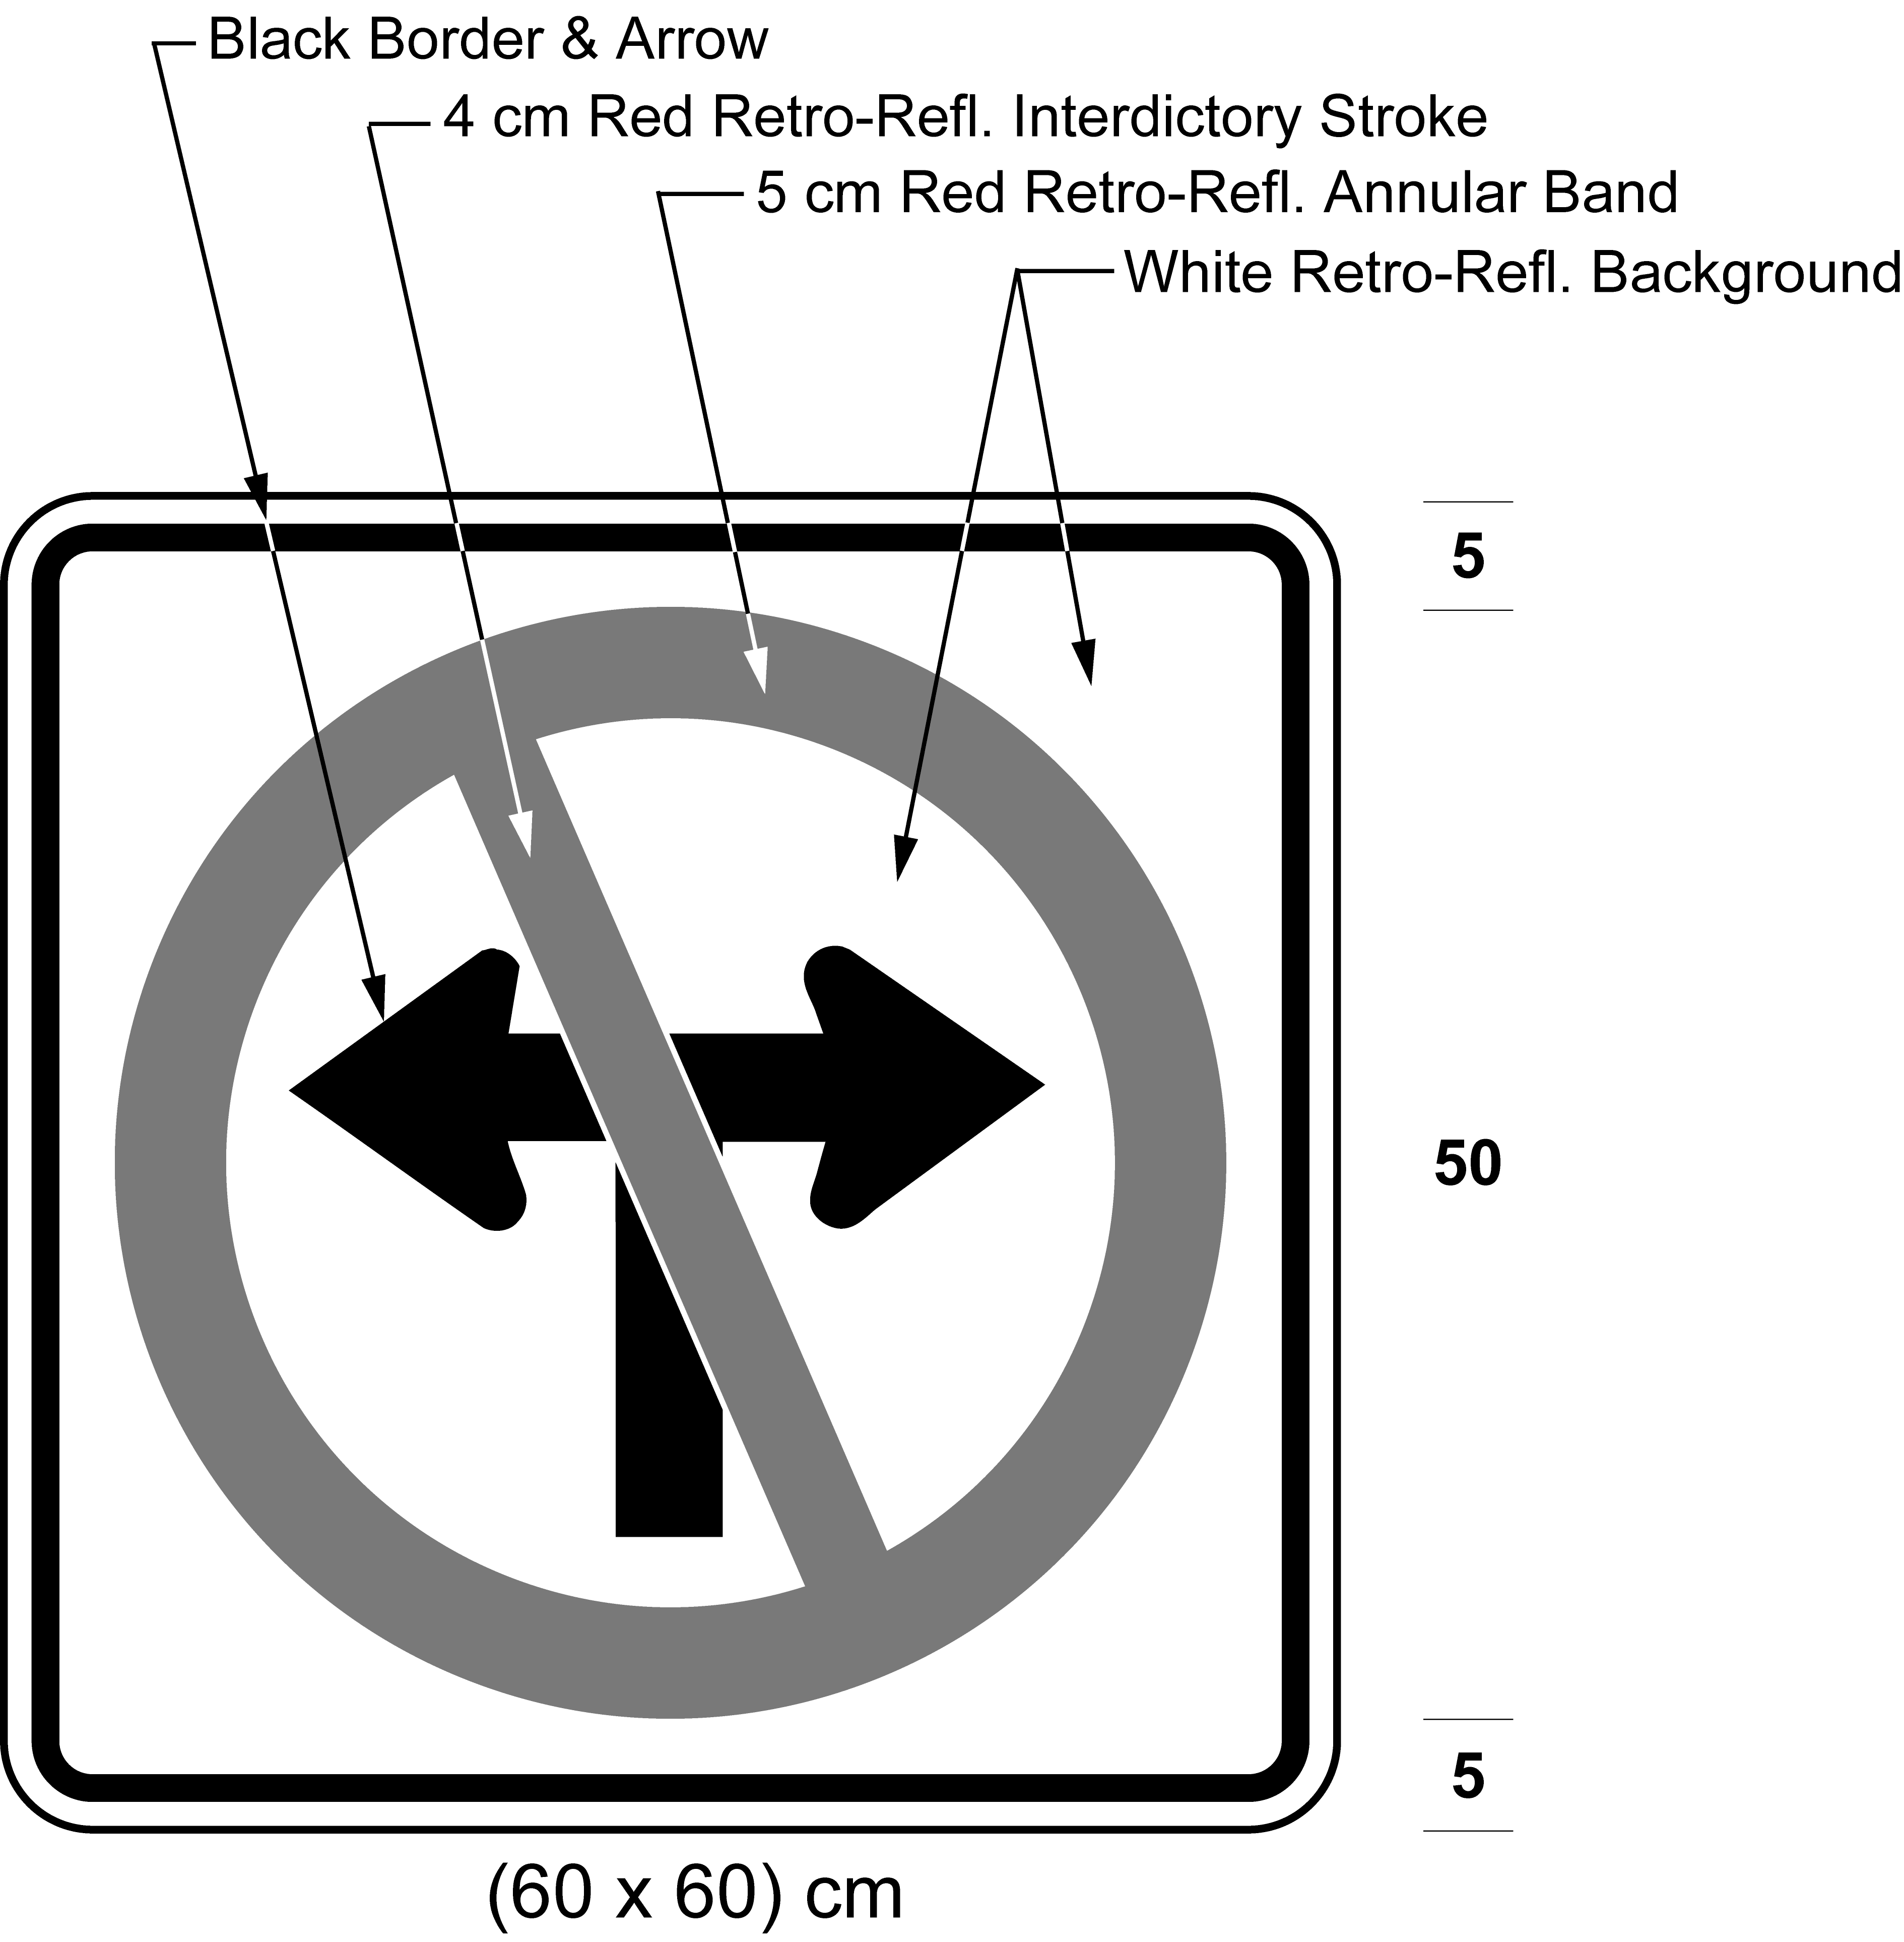
Text alternative: Illustration of a sign with a “No left turn or right turn” symbol consisting of branching black arrows curving left and curving right, inside a red a circle with an interdictory stroke on white retro-reflective background with a black border. Indicated sign size (60 × 60) cm. This text alternative is provided for convenience only and does not form part of the official law.
R.R.O. 1990, Reg. 615, s. 22 (3); O. Reg. 332/98, s. 3 (3); O. Reg. 339/09, s. 16 (3).
(4) No sign that,
(a) prohibits a vehicle from making a right turn or proceeding straight through an intersection shall be valid except as prescribed and illustrated in subsection (1);
(b) prohibits a vehicle from making a left turn or proceeding straight through an intersection shall be valid except as prescribed and illustrated in subsection (2); and
(c) prohibits both a left and a right turn shall be valid except as prescribed and illustrated in subsection (3). R.R.O. 1990, Reg. 615, s. 22 (4).
(5) Every sign that prohibits a vehicle from proceeding straight through an intersection shall,
(a) be not less than 60 centimetres in height and not less than 60 centimetres in width; and
(b) include the markings and the dimensions as described and illustrated in the following Figure:
Text alternative: Illustration of a sign with a “No proceeding straight” symbol consisting of a black arrow proceeding straight, inside a red a circle with an interdictory stroke on white retro-reflective background with a black border. Indicated sign size (60 × 60) cm. This text alternative is provided for convenience only and does not form part of the official law.
R.R.O. 1990, Reg. 615, s. 22 (5); O. Reg. 332/98, s. 3 (4); O. Reg. 339/09, s. 16 (4).
(6) Subsection (5) does not apply to a DO NOT ENTER sign as prescribed and illustrated in section 31. R.R.O. 1990, Reg. 615, s. 22 (6).
(7) Every sign that restricts a vehicle from proceeding straight through an intersection shall,
(a) be not less than 90 centimetres in height and not less than 60 centimetres in width; and
(b) include the markings and the dimensions as illustrated in the following Figure:
Text alternative: Illustration of a sign with a no proceeding straight symbol consisting of a black arrow proceeding straight, inside a red a circle with an interdictory stroke on white retro-reflective background with a black border, and the text “7 AM - 9 AM”, “4 PM - 6 PM”, and “MON-FRI”. Indicated size (60 × 90) cm. This text alternative is provided for convenience only and does not form part of the official law.
R.R.O. 1990, Reg. 615, s. 22 (7); O. Reg. 332/98, s. 3 (5); O. Reg. 339/09, s. 16 (5); O. Reg. 93/15, s. 2 (1).
(7.1) Despite subsection (7), a sign erected in an area designated for the purposes of clause 5 (1) (b) of the French Language Services Act that restricts a vehicle from proceeding straight through an intersection shall,
(a) be not less than 90 centimetres in height and not less than 60 centimetres in width; and
(b) include the markings and the dimensions as illustrated in the following Figure:
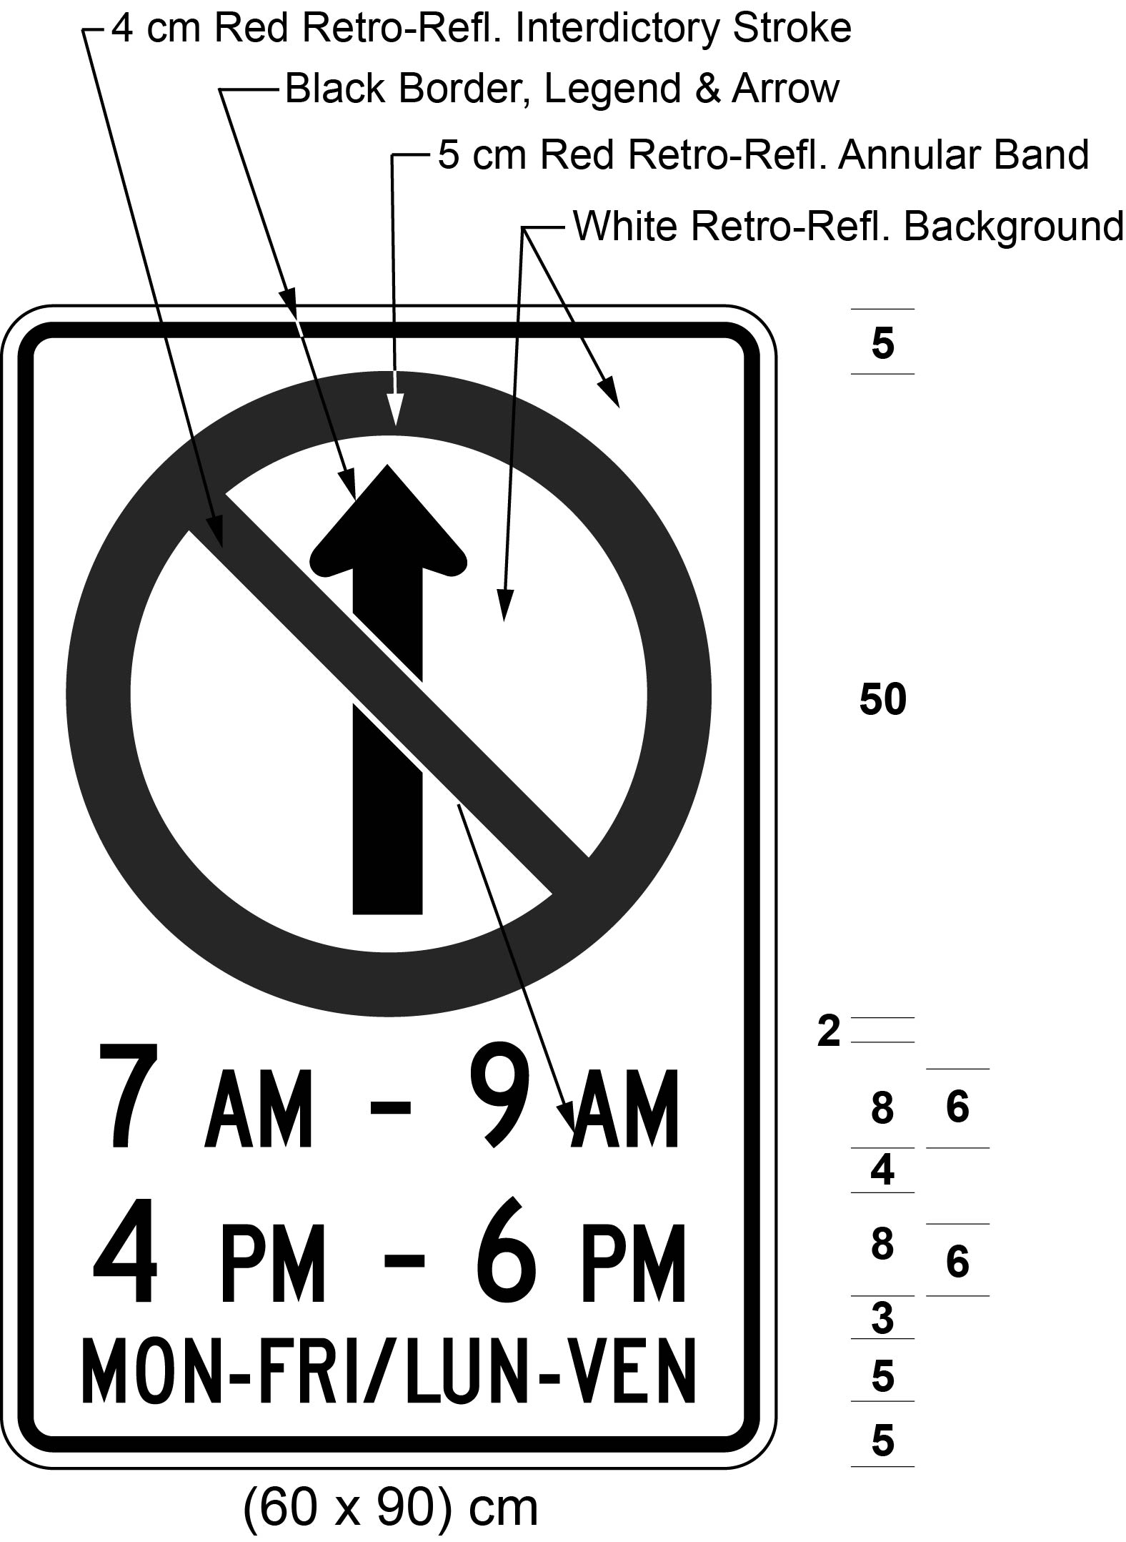
Text alternative: Illustration of a sign with a no proceeding straight symbol consisting of a black arrow proceeding straight, inside a red a circle with an interdictory stroke on white retro-reflective background with a black border, and the text “7 AM - 9 AM”, “4 PM - 6 PM”, and “MON-FRI / LUN-VEN”. Indicated size (60 × 90) cm. This text alternative is provided for convenience only and does not form part of the official law.
O. Reg. 444/93, s. 10 (1); O. Reg. 339/09, s. 16 (6); O. Reg. 93/15, s. 2 (2); O. Reg. 275/25, s. 4.
(8), (9) Revoked: O. Reg. 332/98, s. 3 (6).
No U Turn Sign
23. A no U Turn sign shall,
(a) be rectangular in shape and shall be not less than 60 centimetres in height and not less than 60 centimetres in width; and
(b) bear the markings and have the dimensions as prescribed and illustrated in the following Figure:
Text alternative: Illustration of a sign with a “No U-turn” symbol consisting of a curving u-shaped black arrow inside a red circle with an interdictory stroke, on white retro-reflective background with a black border. Indicated size (60 × 60) cm. This text alternative is provided for convenience only and does not form part of the official law.
R.R.O. 1990, Reg. 615, s. 23; O. Reg. 339/09, s. 17.
Parking Control Signs
24. A sign prohibiting parking shall,
(a) be not less than 30 centimetres in height and not less than 30 centimetres in width; and
(b) bear the markings and have the dimensions as described and illustrated in the following Figure:
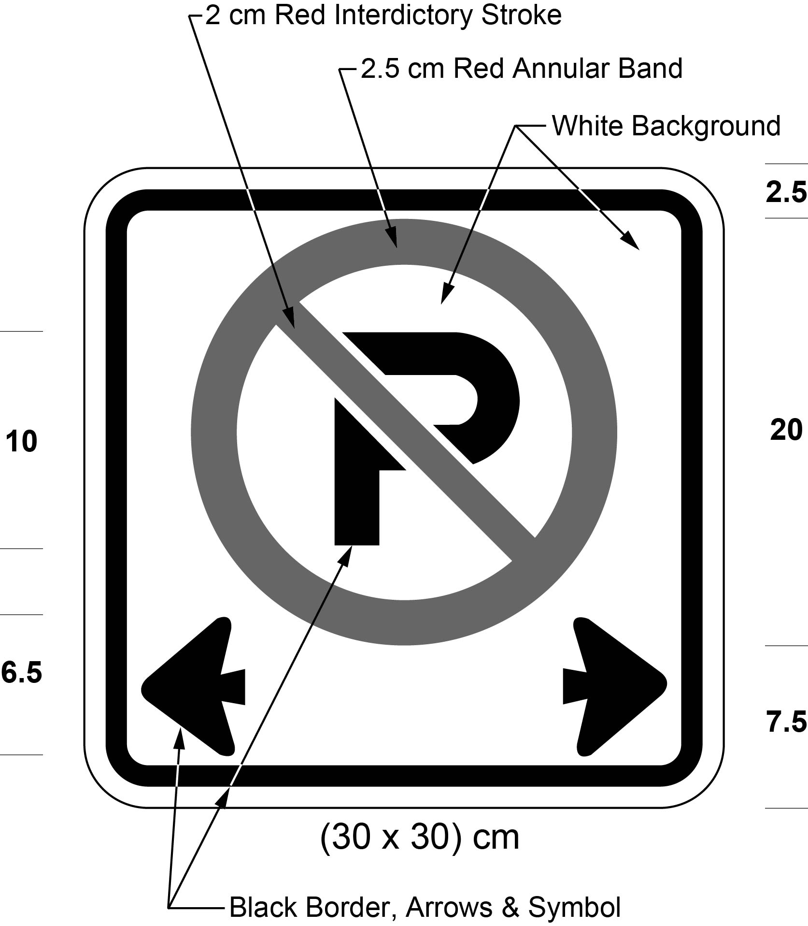
Text alternative: Illustration of a sign with a no parking symbol consisting of a black letter “P” inside a red circle with an interdictory stroke above two black arrows pointing left and right, on a white background with a black border. Indicated size (30 × 30) cm. This text alternative is provided for convenience only and does not form part of the official law.
R.R.O. 1990, Reg. 615, s. 24; O. Reg. 339/09, s. 18; O. Reg. 93/15, s. 3.
25. (1) A sign restricting parking shall,
(a) be not less than 45 centimetres in height and not less than 30 centimetres in width; and
(b) bear the markings and indicate the times at which parking is prohibited and have the dimensions as described in the following Figure:
Text alternative: Illustration of a sign with a “No parking” symbol consisting of a black letter “P” inside a red circle with an interdictory stroke above the text “9 AM - 4 PM”, “MON-SAT”, with left and right black arrows, on a white background with a black border. Indicated size (30 × 45) cm. This text alternative is provided for convenience only and does not form part of the official law.
R.R.O. 1990, Reg. 615, s. 25; O. Reg. 339/09, s. 19 (1).
(2) Despite subsection (1), a sign erected in an area designated for the purposes of clause 5 (1) (b) of the French Language Services Act that restricts parking shall be as described in clause (1) (a), bear the markings and indicate the times at which parking is prohibited and have the dimensions as illustrated in the following Figure:
Text alternative: Illustration of a sign with a “No parking” symbol consisting of a black letter “P” inside a red circle with an interdictory stroke above the text “9 AM - 4 PM”, “MON-SAT / LUN-VEN”, with left and right black arrows, on a white background with a black border. Indicated size (30 × 45) cm. This text alternative is provided for convenience only and does not form part of the official law.
O. Reg. 444/93, s. 11; O. Reg. 339/09, s. 19 (2); O. Reg. 275/25, s. 4.
26. (1) A sign permitting parking for a specified period of time shall,
(a) be not less than 45 centimetres in height and not less than 30 centimetres in width; and
(b) bear the markings, indicate the times at which parking is permitted, the maximum period during which a vehicle may be parked and have the dimensions as prescribed in the following Figure:
Text alternative: Illustration of a sign with a “Parking” symbol consisting of a black letter “P” inside a green permissive circle and the text “30 min”, “9 AM - 6 PM”, “MON-FRI”, with left and right black arrows, on a white retro-reflective background with a black border. Indicated size (30 × 45) cm. This text alternative is provided for convenience only and does not form part of the official law.
R.R.O. 1990, Reg. 615, s. 26; O. Reg. 63/06, s. 4 (1); O. Reg. 339/09, s. 20 (1).
(2) Despite subsection (1), a sign erected in an area designated for the purposes of clause 5 (1) (b) of the French Language Services Act that permits parking for a specified period of time shall be as described in clause (1) (a) and bear the markings, indicate the times at which parking is prohibited, indicate the maximum period during which a vehicle may be parked and have the dimensions as prescribed in the following Figure:
Text alternative: Illustration of a sign with a “Parking” symbol consisting of a black letter “P” inside a green permissive circle and the text “30 min”, “9 AM - 6 PM”, “MON-FRI / LUN-VEN”, with left and right black arrows, on a white retro-reflective background with a black border. Indicated size (30 × 45) cm. This text alternative is provided for convenience only and does not form part of the official law.
O. Reg. 444/93, s. 12; O. Reg. 63/06, s. 4 (2); O. Reg. 339/09, s. 20 (2); O. Reg. 275/25, s. 4.
27. (1) A sign prohibiting parking except in an emergency shall,
(a) be not less than 90 centimetres in height and not less than 60 centimetres in width; and
(b) bear the markings and have the dimensions as described and illustrated in the following Figure:
Text alternative: Illustration of a sign with a “No parking” symbol consisting of a black letter “P” inside a red circle with an interdictory stroke, above the text “EMERGENCY PARKING ONLY”, on white retro-reflective background with a black border. Indicated size (60 × 90) cm. This text alternative is provided for convenience only and does not form part of the official law.
R.R.O. 1990, Reg. 615, s. 27; O. Reg. 339/09, s. 21 (1).
(2) Despite subsection (1), a sign erected in an area designated for the purposes of clause 5 (1) (b) of the French Language Services Act that prohibits parking except in an emergency shall be as described in clause (1) (a), be erected in combination with it, below it or to the right of it or up to 100 metres beyond it, and have the dimensions as illustrated in the following Figure:
Text alternative: Illustration of a sign with a no parking symbol consisting of a black letter “P” inside a red circle with an interdictory stroke, above the text “STATIONNEMENT D’URGENCE SEULEMENT”, on white retro-reflective background with a black border. Indicated size (60 × 90) cm. This text alternative is provided for convenience only and does not form part of the official law.
O. Reg. 444/93, s. 13; O. Reg. 339/09, s. 21 (2); O. Reg. 93/15, s. 4; O. Reg. 275/25, s. 4.
27.1 (1) Subject to subsection (2), a sign identifying an electric vehicle charging station for the purpose of section 30.2 of the Act shall be not less than 45 centimetres in height and not less than 30 centimetres in width and bear the markings and have the dimensions as described and illustrated in Figure 1. O. Reg. 462/20, s.1.
(2) A sign described in subsection (1) that is erected in an area designated for the purposes of clause 5 (1) (b) of the French Language Services Act shall bear the markings and have the dimensions as described and illustrated in Figure 2. O. Reg. 462/20, s.1.
Figure 1
Text alternative: An illustration of an electric vehicle charging parking sign. At the top of the sign, a large letter “P” inside a “no” symbol appears. Below this, a symbol of an electric vehicle charging station appears. Below this, at the bottom of the sign, the phrase “EXCEPT WHILE CHARGING” appears. The following measurements are written below the sign: (30 x 45) cm. The sign appears in black and white, but is surrounded by arrows pointing to its different elements indicating the colours in which they must appear, and arrows identifying the size measurements of the elements of the sign and the distance between the elements. This text alternative is provided for convenience only and does not form part of the official law.
Figure 2
Text alternative: An illustration of an electric vehicle charging parking sign. At the top of the sign, a large letter “P” inside a “no” symbol appears. Below this, a symbol of an electric vehicle charging station appears. Below this, at the bottom of the sign, the phrase “EXCEPT WHILE CHARGING/EXCEPTÉ EN RECHARGE” appears. The following measurements are written below the sign: (30 x 60) cm. The sign appears in black and white, but is surrounded by arrows pointing to its different elements indicating the colours in which they must appear, and arrows identifying the size measurements of the elements of the sign and the distance between the elements. This text alternative is provided for convenience only and does not form part of the official law.
O. Reg. 462/20, s. 1; O. Reg. 275/25, s. 4.
School Bus Loading Zone
28. School bus loading zones may be designated only,
(a) on one side of a highway; and
(b) on the side of the highway on which,
(i) a school is situated, or
(ii) a building or facility is situated which is frequently visited by school children under supervision of their teachers. R.R.O. 1990, Reg. 615, s. 28.
29. (1) A school bus loading zone sign shall,
(a) be not less than 45 centimetres in height and not less than 30 centimetres in width;
(b) bear the words “school bus loading zone” in black letters not less than 4 centimetres in height on a white retro-reflective background; and
(c) bear a single headed or double headed arrow in black not less than 5.5 centimetres in height,
as illustrated in the following Figure:
Text alternative: Illustration of sign with the text “SCHOOL BUS LOADING ZONE” above a black arrow pointing right, on a white background with a black border. Indicated size (30 × 45) cm. This text alternative is provided for convenience only and does not form part of the official law.
R.R.O. 1990, Reg. 615, s. 29 (1); O. Reg. 339/09, s. 22 (1).
(1.1) Despite subsection (1), a school bus loading zone sign erected in an area designated for the purposes of clause 5 (1) (b) of the French Language Services Act shall,
(a) be not less than 45 centimetres in height and not less than 60 centimetres in width;
(b) bear the words “school bus loading zone – zone d’arrêt des autobus scolaires” in black letters not less than 4 centimetres in height on a white retro-reflective background;
(c) bear two single headed arrows in black not less than 5.5 centimetres in height; and
(d) be as illustrated in the following Figure:
Text alternative: Illustration of sign with the text “SCHOOL BUS LOADING ZONE / ZONE D'ARRÊT DES AUTOBUS SCOLAIRES” above black arrows pointing right, on a white background with a black border. Indicated size (45 × 60) cm. This text alternative is provided for convenience only and does not form part of the official law.
O. Reg. 444/93, s. 14; O. Reg. 339/09, s. 22 (2); O. Reg. 275/25, s. 4.
(2) One sign with a single headed arrow pointing towards the loading zone shall be erected at each end of a school bus loading zone and, where the length of the loading zone exceeds 60 metres, signs with double headed arrows shall be erected at intervals of no more than 45 metres. R.R.O. 1990, Reg. 615, s. 29 (2).
One-Way Sign
30. (1) A One-Way sign shall,
(a) be rectangular in shape and shall be not less than 30 centimetres in height and not less than 90 centimetres in width; and
(b) bear the marking and have the dimensions as prescribed and illustrated in the following Figure:
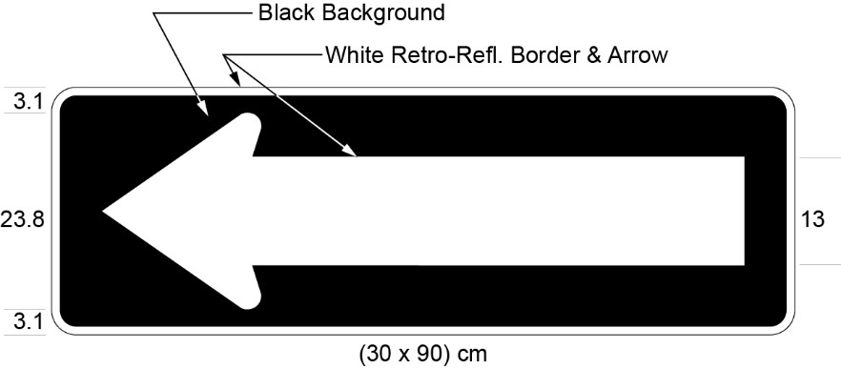
R.R.O. 1990, Reg. 615, s. 30 (1); O. Reg. 339/09, s. 23; O. Reg. 93/15, s. 5; O. Reg. 396/19, s. 3.
(2) A One-Way sign shall be used, with the arrow pointing in the appropriate direction, to indicate the highways upon which traffic is allowed to travel in one direction only. R.R.O. 1990, Reg. 615, s. 30 (2).
Do Not Enter Sign
31. A Do Not Enter sign shall,
(a) be rectangular in shape and shall be not less than 60 centimetres in width and 60 centimetres in height; and
(b) bear the markings and have the dimensions as prescribed and illustrated in the following Figure:
R.R.O. 1990, Reg. 615, s. 31; O. Reg. 339/09, s. 24.
32. (1) A sign referred to in section 31 may be accompanied immediately below by a tab bearing the markings and having the dimensions as illustrated in the following Figure:
R.R.O. 1990, Reg. 615, s. 32; O. Reg. 339/09, s. 25 (1); O. Reg. 93/15, s. 6.
(2) A sign referred to in section 31 that is erected in an area designated for the purposes of clause 5 (1) (b) of the French Language Services Act may be accompanied immediately below by a tab sign bearing the markings and having the dimensions as illustrated in the following Figure:
O. Reg. 444/93, s. 15; O. Reg. 339/09, s. 25 (2); O. Reg. 275/25, s. 4.
Truck Sign
33. A No Heavy Trucks sign shall,
(a) be not less than 60 centimetres in width and not less than 60 centimetres in height; and
(b) bear the markings and have the dimensions as prescribed and illustrated in the following Figure:
Text alternative: Illustration of a no heavy trucks sign consisting of a truck symbol inside a red circle with an interdictory stroke, on a white retro-reflective background with a black border. Indicated size (60 × 60) cm. This text alternative is provided for convenience only and does not form part of the official law.
R.R.O. 1990, Reg. 615, s. 33; O. Reg. 339/09, s. 26.
Lane Designation Sign
34. (1) A Lane Designation sign shall be used to indicate by means of a single arrow or a combination of arrows the only permitted movement or movements by vehicles on one or more lanes of a highway marked with the sign. R.R.O. 1990, Reg. 615, s. 34 (1).
(2) A Lane Designation sign shall,
(a) in the case of Figures 1 to 6 and Figure 8, be not less than 60 centimetres in height and not less than 60 centimetres in width;
(b) in the case of Figure 7, be not less than 90 centimetres in height and not less than 90 centimetres in width;
(c) in the case of Figures 9 and 10, be not less than 150 centimetres in height and not less than 90 centimetres in width; and
(d) bear the markings and have the dimensions as prescribed and illustrated in one of the following Figures:
Figure 1
Figure 2
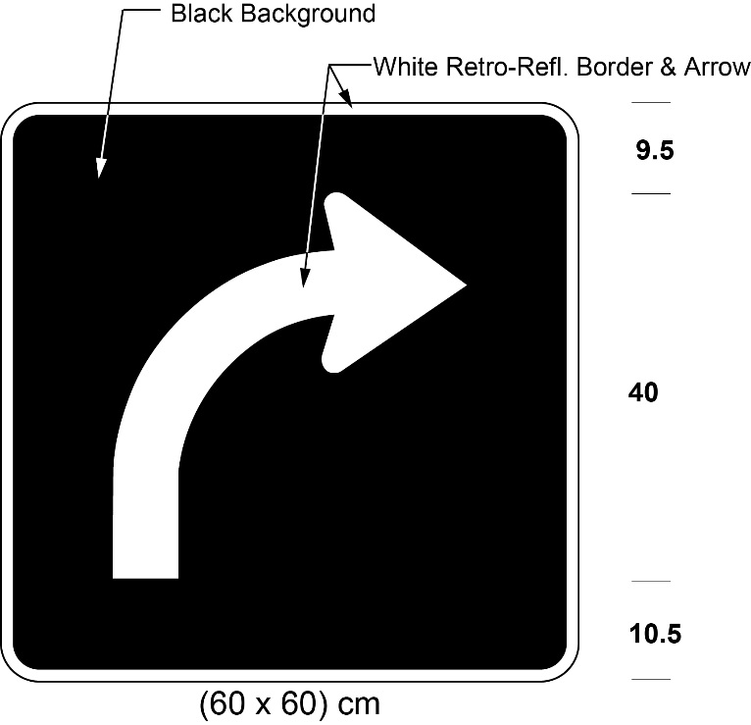
Figure 3
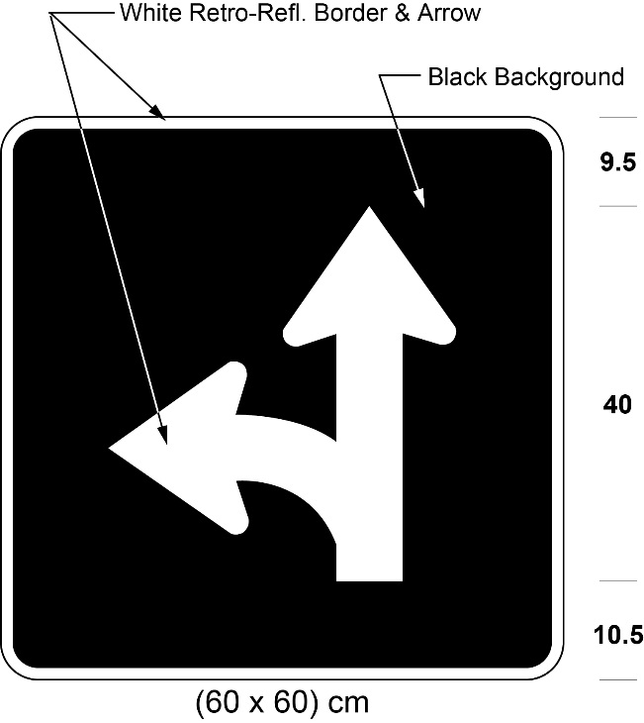
Figure 4
Figure 5
Figure 6
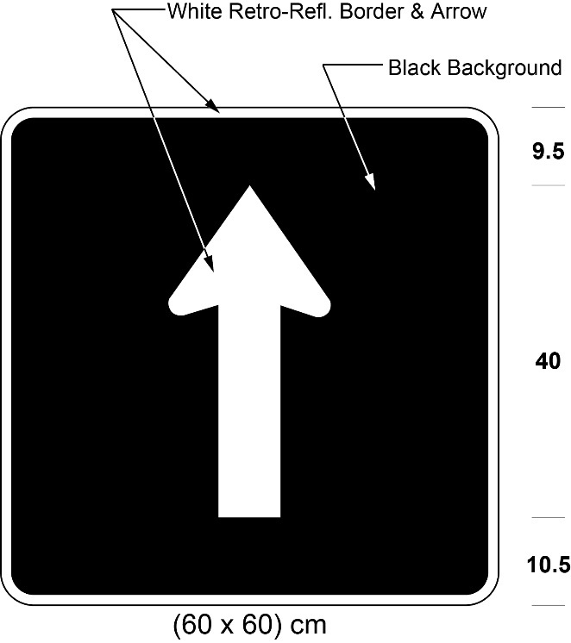
Figure 7
Figure 8
Figure 9
Figure 10
R.R.O. 1990, Reg. 615, s. 34 (2); O. Reg. 444/93, s. 16 (1, 2); O. Reg. 339/09, s. 27 (1); O. Reg. 93/15, s. 7 (1); O. Reg. 396/19, s. 4.
(3) A Lane Designation sign in Figure 7 signifies that the lane marked with the sign shall be used by a vehicle for the purpose only of making a left turn. R.R.O. 1990, Reg. 615, s. 34 (3).
(4) A Lane Designation sign,
(a) may, in the case of Figures 1 to 6 and Figure 8, be erected over the lane or be ground mounted;
(b) shall, in the case of Figure 7, be erected directly over a two-way left turn lane;
(c) shall, in the case of Figure 9, be ground mounted to the right of the highway, facing the approaching traffic; and
(d) shall, in the case of Figure 10, be ground mounted to the right of the highway, facing the approaching traffic, directly below or up to 100 metres beyond the sign in Figure 9. R.R.O. 1990, Reg. 615, s. 34 (4); O. Reg. 444/93, s. 16 (3).
(5) Figures 1 and 2 of clause (2) (d) may display a tab sign not less than 30 centimetres in height and not less than 60 centimetres in width immediately below Figures 1 and 2 and shall,
(a) in the case of Figure 1, bear the legend “Left Lane”; and
(b) in the case of Figure 2, bear the legend “Right Lane”.
Figure 1
Figure 2
R.R.O. 1990, Reg. 615, s. 34 (5); O. Reg. 339/09, s. 27 (2).
(6) In an area designated for the purposes of clause 5 (1) (b) of the French Language Services Act, Figures 1 and 2 of clause (2) (d) may display a tab sign not less than 45 centimetres in height and not less than 60 centimetres in width immediately below those Figures that,
(a) in the case of Figure 1, bears the legend “Left Lane – Voie de gauche”; and
(b) in the case of Figure 2, bears the legend “Right Lane – Voie de droite”.
Figure 1
Figure 2
O. Reg. 444/93, s. 16 (4); O. Reg. 909/93, s. 1; O. Reg. 339/09, s. 27 (3); O. Reg. 93/15, s. 7 (2); O. Reg. 275/25, s. 4.
Do Not Pass Sign
35. A Do Not Pass sign erected on or after the 28th day of March, 1986 shall,
(a) be not less than 60 centimetres in height and not less than 60 centimetres in width; and
(b) bear the markings and have the dimensions illustrated in the following Figure:
R.R.O. 1990, Reg. 615, s. 35; O. Reg. 339/09, s. 28; O. Reg. 93/15, s. 8.
No Bicycles Sign
36. A Bicycle Prohibition sign erected on or after the 28th day of March, 1986 shall,
(a) be not less than 60 centimetres in height and not less than 60 centimetres in width; and
(b) bear the markings and have the dimensions as illustrated in the following Figure:
R.R.O. 1990, Reg. 615, s. 36; O. Reg. 339/09, s. 29; O. Reg. 93/15, s. 9.
Pedestrian Prohibition Sign
37. A Pedestrian Prohibition sign erected on or after the 28th day of March, 1986 shall,
(a) be not less than 60 centimetres in height and not less than 60 centimetres in width; and
(b) bear the markings and have the dimensions as illustrated in the following Figure:
R.R.O. 1990, Reg. 615, s. 37; O. Reg. 339/09, s. 30.
Pedestrian and Bicycle Prohibition Sign
38. A Pedestrian and Bicycle Prohibition sign erected on or after the 28th day of March, 1986 shall,
(a) be not less than 60 centimetres in height and not less than 60 centimetres in width; and
(b) bear the markings and have the dimensions as illustrated in the following Figure:
R.R.O. 1990, Reg. 615, s. 38; O. Reg. 339/09, s. 31.
Interdictory and Permissive Symbols
39. (1) An annular red band with a diagonal red stroke running through the centre of the band at 45 degrees to the horizontal, as illustrated in the following Figures or as close to as practicable so as not to obliterate the symbol, is an interdictory symbol and where an interdictory symbol is used on the sign prescribed by this Regulation, the symbol signifies that whatever is depicted within the symbol is prohibited:
R.R.O. 1990, Reg. 615, s. 39 (1); O. Reg. 339/09, s. 32 (1).
(2) An annular green band as illustrated in the following Figure is a symbol that when used on a sign prescribed by this Regulation signifies that whatever is depicted within the symbol is permitted.
R.R.O. 1990, Reg. 615, s. 39 (2); O. Reg. 339/09, s. 32 (2).
Load Restriction Sign
40. (1) A Load Restriction sign erected on or after January 1, 2015 shall bear the markings and have the dimensions as illustrated in the following Figure:
O. Reg. 339/09, s. 33 (1); O. Reg. 396/19, s. 5 (1).
(2) A Load Restriction sign described in subsection (1) shall have one or both of the following Figures appended to it:
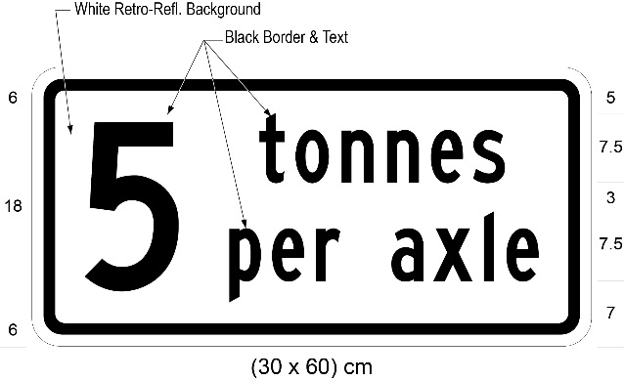
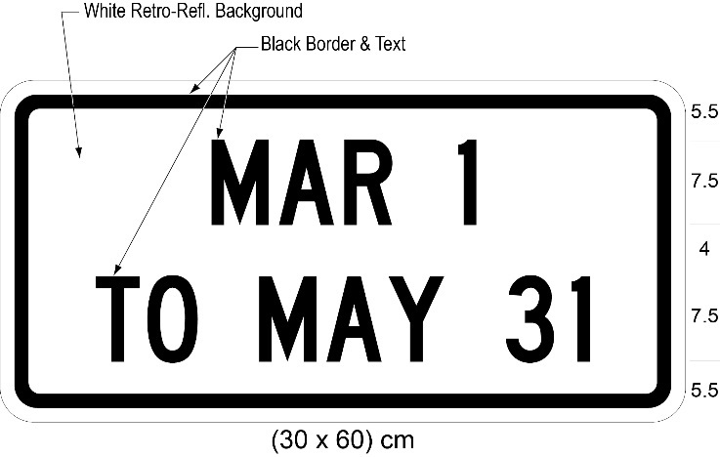
O. Reg. 175/08, s. 9 (1); O. Reg. 339/09, s. 33 (2); O. Reg. 396/19, s. 5 (2).
(3) Revoked: O. Reg. 175/08, s. 9 (3).
(4) On and after January 1, 2015, every Load Restriction sign shall bear the markings and have the dimensions as prescribed and illustrated in subsection (1). O. Reg. 339/09, s. 33 (5).
40.1 (1) A Load Restriction sign erected on or after January 1, 2015 in an area designated for the purposes of clause 5 (1) (b) of the French Language Services Act shall bear the markings and have the dimensions as prescribed and illustrated in subsection 40 (1). O. Reg. 339/09, s. 34 (1); O. Reg. 275/25, s. 4.
(2) A Load Restriction sign described in subsection (1) shall have one or both of the following Figures appended to it:
O. Reg. 175/08, s. 10 (1); O. Reg. 339/09, s. 34 (2); O. Reg. 396/19, s. 6.
(3) Revoked: O. Reg. 175/08, s. 10 (3).
O. Reg. 175/08, s. 10 (1); O. Reg. 339/09, s. 34 (3, 4).
(4) On and after January 1, 2015, every Load Restriction sign in an area designated for the purposes of clause 5 (1) (b) of the French Language Services Act shall bear the markings and have the dimensions as prescribed and illustrated in subsection 40 (1). O. Reg. 339/09, s. 34 (5); O. Reg. 275/25, s. 4.
Gross Weight on Bridges Sign
41. (1) A gross weight on bridges sign shall,
(a) in the case of Figure 1,
(i) be not less than 75 centimetres in height and not less than 60 centimetres in width,
(ii) bear the word “MAXIMUM” and indicate the prescribed maximum gross vehicle weight in tonnes of a vehicle or combination of vehicles permitted on the bridge, and
(iii) bear the markings and have the dimensions as prescribed and illustrated in Figure 1:
Figure 1
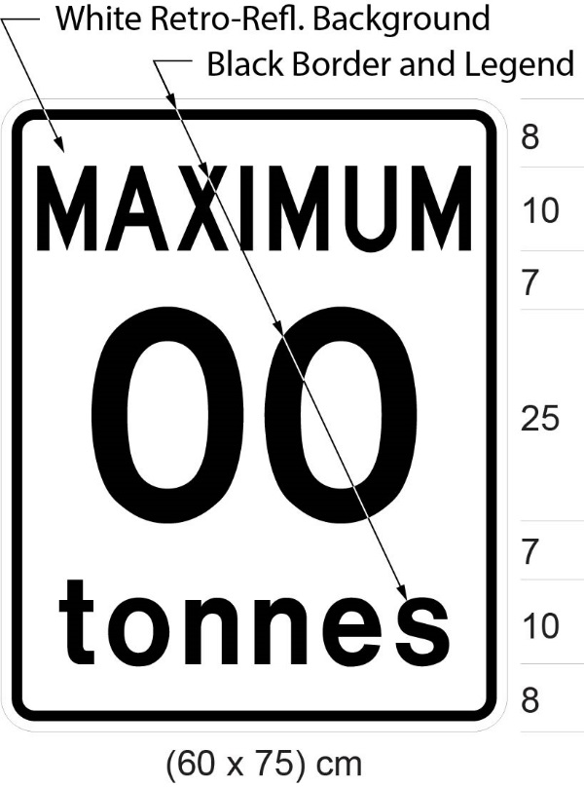
(a.1) Revoked: O. Reg. 246/03, s. 3 (3).
Figure 1.1 Revoked: O. Reg. 246/03, s. 3 (3).
(b) in the case of Figure 2,
(i) be not less than 120 centimetres in height and not less than 90 centimetres in width,
(ii) bear the word “MAXIMUM”,
(iii) indicate the prescribed maximum gross vehicle weight in tonnes of a single vehicle permitted on the bridge, opposite the marking of a single vehicle,
(iv) indicate the prescribed maximum gross vehicle weight in tonnes of a combination of two vehicles permitted on the bridge, opposite the marking of a combination of two vehicles,
(v) indicate the prescribed maximum gross vehicle weight in tonnes of a combination of three vehicles permitted on the bridge, opposite the marking of a combination of three vehicles, and
(vi) bear the markings and have the dimensions prescribed and illustrated in Figure 2:
Figure 2
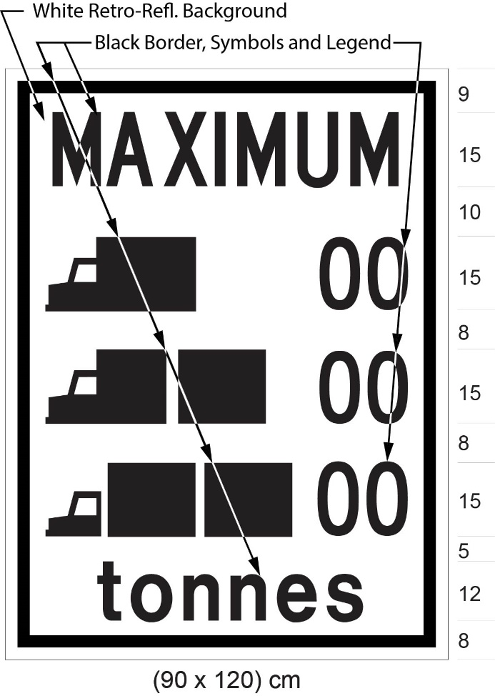
(b.1) Revoked: O. Reg. 246/03, s. 3 (6).
Figure 2.1 Revoked: O. Reg. 246/03, s. 3 (6).
R.R.O. 1990, Reg. 615, s. 41 (1); O. Reg. 444/93, s. 18; O. Reg. 246/03, s. 3 (1-6); O. Reg. 339/09, s. 35; O. Reg. 93/15, s. 10; O. Reg. 396/19, s. 7.
(1.1) Revoked: O. Reg. 175/08, s. 11 (2).
(2) The prescribed maximum gross vehicle weight indicated on a sign prescribed by this section shall be such weight as is prescribed by a regulation or by-law made under section 123 of the Act. R.R.O. 1990, Reg. 615, s. 41 (2).
Construction Zone Sign
42. (1) A part of a highway that has been designated as a construction zone shall be marked at the commencement and at the end of the construction zone with construction zone signs erected on the right side of the highway, facing approaching traffic and not more than 4.5 metres from the roadway, with the bottom edge of the sign not less than 1.5 metres or more than 2.5 metres above the level of the roadway. O. Reg. 63/06, s. 5.
(2) The commencement of a designated construction zone shall be indicated by a sign that has the dimensions and bears the markings as illustrated in the following Figure:
O. Reg. 63/06, s. 5; O. Reg. 175/08, s. 12 (1); O. Reg. 339/09, s. 36 (1); O. Reg. 93/15, s. 11 (1).
(3) Despite subsection (2), in an area designated for the purposes of clause 5 (1) (b) of the French Language Services Act, the commencement of a designated construction zone shall be indicated by a sign that has the dimensions and bears the markings as illustrated in the Figure to subsection (2) and a sign that has the dimensions and bears the markings as illustrated in the following Figure:
O. Reg. 63/06, s. 5; O. Reg. 175/08, s. 12 (2); O. Reg. 339/09, s. 36 (2); O. Reg. 93/15, s. 11 (2); O. Reg. 275/25, s. 2.
(4) The end of a designated construction zone shall be indicated by a sign that has the dimensions and bears the markings as illustrated in the following Figure:
O. Reg. 63/06, s. 5; O. Reg. 175/08, s. 12 (3); O. Reg. 339/09, s. 36 (3).
(5) Despite subsection (4), in an area designated for the purposes of clause 5 (1) (b) of the French Language Services Act, the end of a designated construction zone shall be indicated by a sign that has the dimensions and bears the markings as illustrated in the Figure to subsection (4) and a sign that has the dimensions and bears the markings as illustrated in the following Figure:
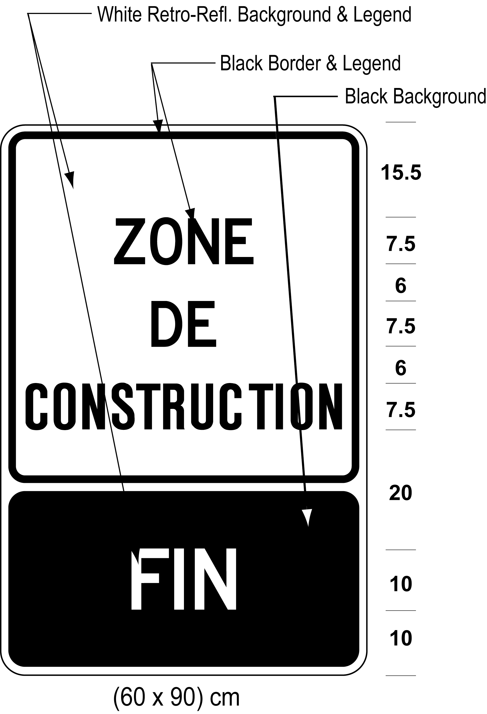
O. Reg. 63/06, s. 5; O. Reg. 175/08, s. 12 (4); O. Reg. 339/09, s. 36 (4); O. Reg. 275/25, s. 2.
42.1 (1) A traffic control stop or slow sign used by a traffic control person or a firefighter in accordance with section 146.1 of the Act shall,
(a) be octagonal in shape;
(b) measure 450 millimetres between opposite sides;
(c) be mounted on a pole that is 1.2 metres long;
(d) be made of material with at least the rigidity of plywood that is six millimetres thick; and
(e) be maintained in a clean and legible condition. O. Reg. 63/06, s. 5.
(2) One side of a traffic control stop or slow sign shall be high-intensity retro-reflective grade red in colour with the word “stop” in the centre of the sign written in legible high-intensity retro-reflective grade white upper case letters 150 millimetres high. O. Reg. 63/06, s. 5.
(3) The other side of a traffic control stop or slow sign shall be retro-reflective fluorescent yellow-green in colour with a black diamond-shaped border that is at least 317 millimetres by 317 millimetres and the word “slow” in the centre of the sign written in legible black upper case letters 120 millimetres high. O. Reg. 175/08, s. 13.
Bicycles Excepted
42.2 (1) A Bicycles Excepted tab sign shall,
(a) be not less than 30 centimetres in height and not less than 60 centimetres in width; and
(b) bear the markings and have the dimension as illustrated in the following Figure:
O. Reg. 396/19, s. 8.
(2) Despite subsection (1), a Bicycles Excepted tab sign in an area designated for the purposes of clause 5 (1) (b) of the French Language Services Act shall,
(a) be not less than 60 centimetres in height and not less than 60 centimetres in width; and
(b) bear the markings and have the dimensions as illustrated in the following Figure:
O. Reg. 396/19, s. 8; O. Reg. 275/25, s. 4.
(3) A Bicycles Excepted tab sign as prescribed and illustrated in subsection (1) or (2) may be erected immediately below a sign prescribed in section 21, 22, 31 or 34. O. Reg. 396/19, s. 8.
Buses Excepted
43. (1) A Buses Excepted tab sign erected on or after the 28th day of March, 1986 shall,
(a) be not less than 30 centimetres in height and not less than 60 centimetres in width; and
(b) bear the markings and have the dimensions as illustrated in the following Figure:
R.R.O. 1990, Reg. 615, s. 43 (1); O. Reg. 339/09, s. 37 (1).
(1.1) Despite subsection (1), a Buses Excepted tab sign in an area designated for the purposes of clause 5 (1) (b) of the French Language Services Act shall,
(a) be not less than 60 centimetres in height and not less than 60 centimetres in width; and
(b) bear the markings and have the dimensions as illustrated in the following Figure:
O. Reg. 444/93, s. 19; O. Reg. 339/09, s. 37 (2); O. Reg. 275/25, s. 4.
(2) A Buses Excepted tab sign as prescribed and illustrated in subsection (1) or (1.1) may be erected immediately below a sign prescribed in section 21, 22, 31 or 34. O. Reg. 396/19, s. 9.
Toll Highways
Definition
43.0.1 In sections 43.1, 43.2, 43.3, 43.3.1 and 43.4,
“heavy vehicle” means a vehicle that has a gross weight or a registered gross weight greater than 5,000 kilograms. O. Reg. 335/15, s. 1; O. Reg. 483/17, s. 1
43.1 (1) A sign on a controlled-access highway requiring that a heavy vehicle be equipped with a valid toll device on Highway 407 shall,
(a) be not less than 244 centimetres in height and not less than 549 centimetres in width, and
(b) bear the markings and have the dimensions as illustrated in Figure 1. O. Reg. 148/97, s. 1; O. Reg. 335/15, s. 2 (1); O. Reg. 396/19, s. 10 (1).
(2) In addition to the sign referred to in subsection (1), in an area designated for the purposes of clause 5 (1) (b) of the French Language Services Act, a sign on a controlled-access highway requiring that a heavy vehicle be equipped with a valid toll device on Highway 407 shall,
(a) be not less than 244 centimetres in height and not less than 793 centimetres in width, and
(b) bear the markings and have the dimensions as illustrated in Figure 2. O. Reg. 148/97, s. 1; O. Reg. 335/15, s. 2 (2); O. Reg. 396/19, s. 10 (2); O. Reg. 275/25, s. 4.
(3) A sign on a highway other than a controlled-access highway requiring that a heavy vehicle be equipped with a valid toll device on Highway 407 shall,
(a) be not less than 120 centimetres in height and not less than 240 centimetres in width; and
(b) bear the markings and have the dimensions as illustrated in Figure 3. O. Reg. 148/97, s. 1; O. Reg. 335/15, s. 2 (3).
(4) In addition to the sign referred to in subsection (3), in an area designated for the purposes of clause 5 (1) (b) of the French Language Services Act, a sign on a highway other than a controlled-access highway requiring that a heavy vehicle be equipped with a valid toll device on Highway 407 shall,
(a) be not less than 180 centimetres in height and not less than 240 centimetres in width; and
(b) bear the markings and have the dimensions as illustrated in Figure 4. O. Reg. 148/97, s. 1; O. Reg. 335/15, s. 2 (4); O. Reg. 275/25, s. 4.
(5) Revoked: O. Reg. 335/15, s. 2 (5).
Figure 1
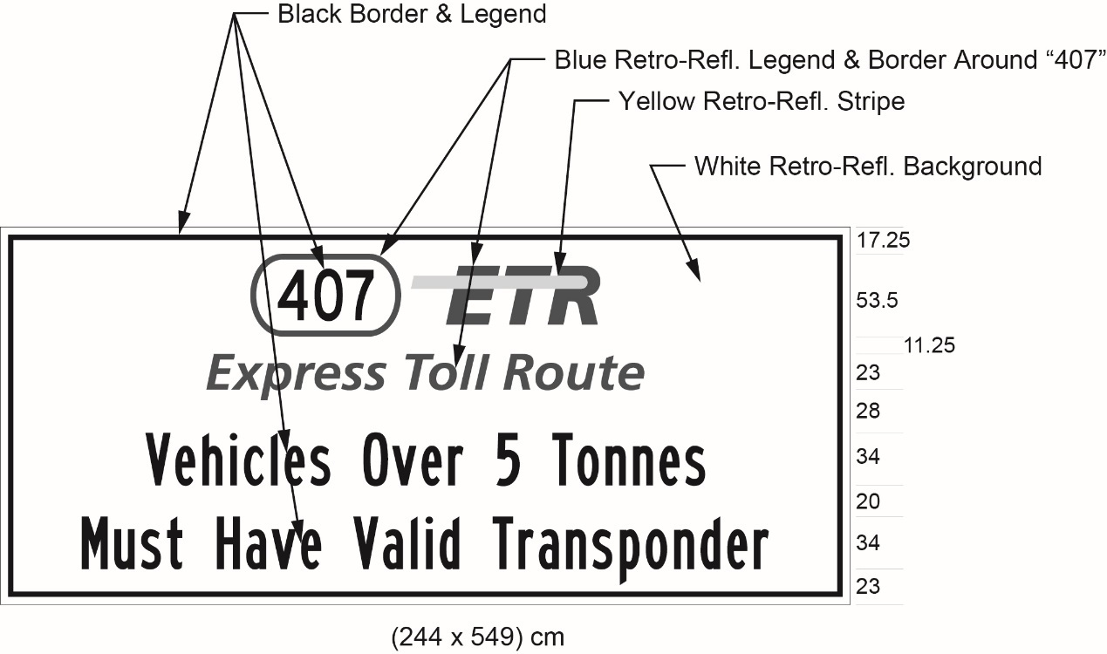
Text alternative: Illustration of sign with “407 ETR” symbol above the words “Express Toll Route” and the text “Vehicles Over 5 Tonnes Must Have Valid Transponder”, on a white retro-reflective background with a black border. Indicated sign size: (244 × 549) cm. This text alternative is provided for convenience only and does not form part of the official law.
Figure 2
Text alternative: Illustration of sign with 407 ETR symbol above the words “Express Toll Route” and the text “Transpondeur valide obligatoire pour véhicules dépassant 5 tonnes”, on a white retro-reflective background with a black border. Indicated sign size: (244 × 793) cm. This text alternative is provided for convenience only and does not form part of the official law.
Figure 3
Text alternative: Illustration of sign with “407 ETR” symbol above the words “Express Toll Route” and the text “Vehicles Over 5 Tonnes Must Have Valid Transponder”, on a white retro-reflective background with a black border. Indicated sign size: (120 × 240) cm. This text alternative is provided for convenience only and does not form part of the official law.
Figure 4
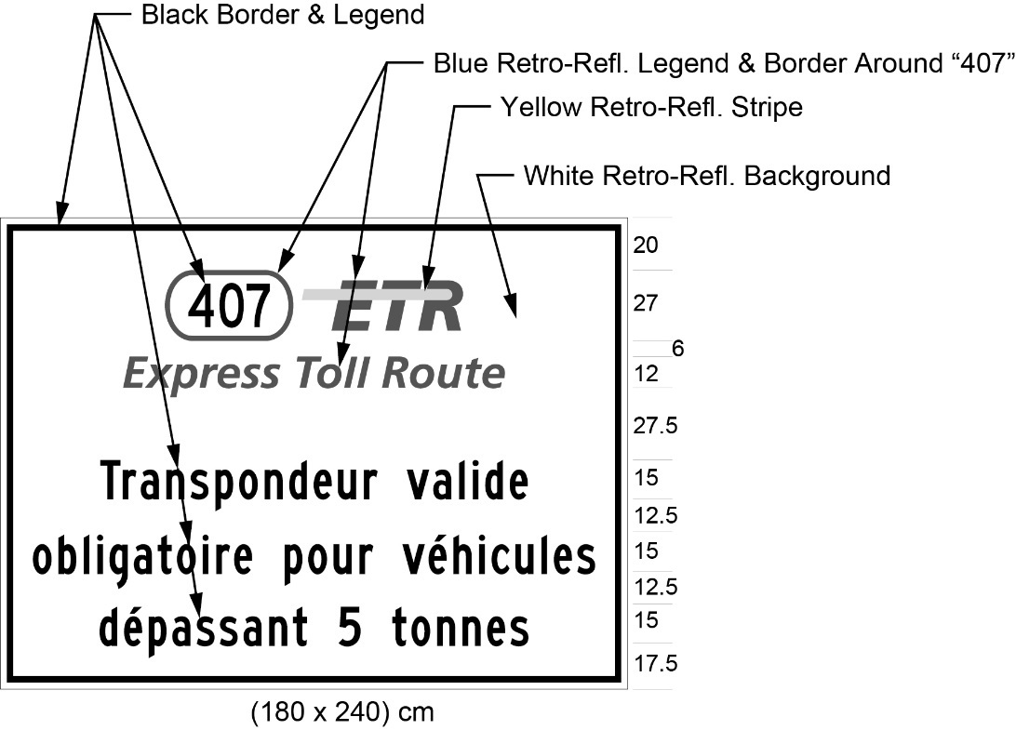
Text alternative: Illustration of sign with “407 ETR” symbol above the words “Express Toll Route” and the text “Transpondeur valide obligatoire pour véhicules dépassant 5 tonnes”, on a white retro-reflective background with a black border. Indicated sign size: (180 × 240) cm. This text alternative is provided for convenience only and does not form part of the official law.
O. Reg. 148/97, s. 1; O. Reg. 339/09, s. 38; O. Reg. 93/15, s. 12; O. Reg. 396/19, s. 10 (3).
43.2 (1) A sign on a controlled-access highway other than Highway 35/115 requiring that a heavy vehicle be equipped with a valid toll device on Highway 407 East shall,
(a) be not less than 274.5 centimetres in height and not less than 549 centimetres in width; and
(b) bear the markings and have the dimensions as illustrated in the following Figure:
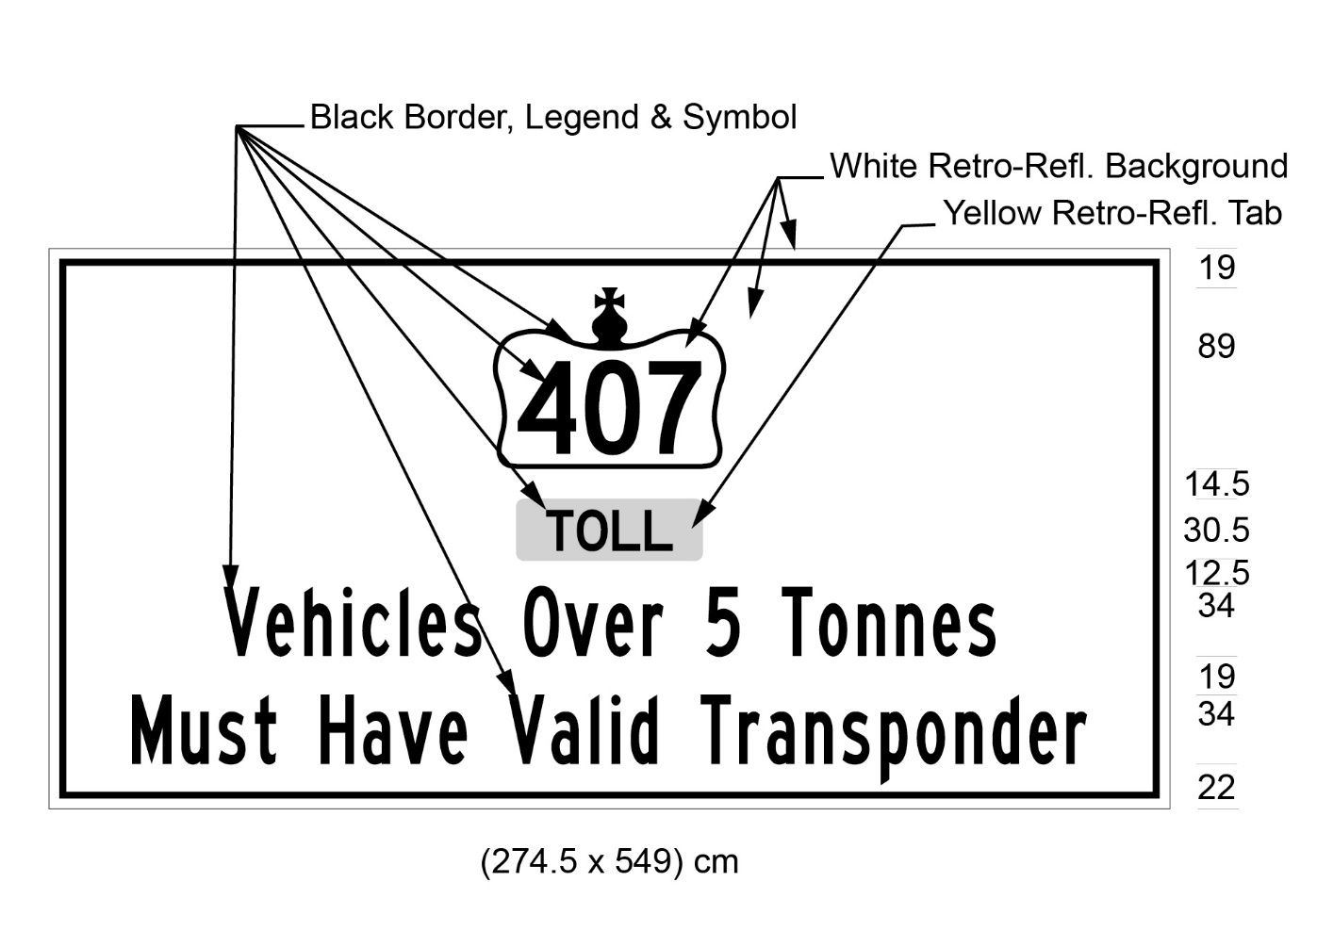
Text alternative: Illustration of sign with “407” inside a Crown symbol above the word “Toll” and the text “Vehicles Over 5 Tonnes Must Have Valid Transponder”. The word “Toll” is on a yellow retro-reflective background and the rest of the sign is a white retro-reflective background with a black border. Indicated sign size: (274.5 × 549) cm. This text alternative is provided for convenience only and does not form part of the official law.
O. Reg. 335/15, s. 3; O. Reg. 483/17, s. 2 (1).
(1.1) A sign on Highway 35/115 requiring that a heavy vehicle be equipped with a valid toll device on Highway 407 East shall,
(a) be not less than 274.5 centimetres in height and not less than 549 centimetres in width; and
(b) bear the markings and have the dimensions as illustrated in the following Figure:
Text alternative: Illustration of sign with “407” inside a Crown symbol above the words “Toll / Péage” and the text “Vehicles Over 5 Tonnes Must Have Valid Transponder”. The words “Toll / Péage” are on a yellow retro-reflective background and the rest of the sign is a white retro-reflective background with a black border. Indicated sign size: (274.5 × 549) cm. This text alternative is provided for convenience only and does not form part of the official law.
O. Reg. 483/17, s. 2 (2).
(2) A sign on a highway other than a controlled-access highway requiring that a heavy vehicle be equipped with a valid toll device on Highway 407 East shall,
(a) be not less than 180 centimetres in height and not less than 240 centimetres in width; and
(b) bear the markings and have the dimensions as illustrated in the following Figure:
Text alternative: Illustration of sign with “407” inside a Crown symbol above the word “Toll” and the text “Vehicles Over 5 Tonnes Must Have Valid Transponder”. The word “Toll” is on a yellow retro-reflective background and the rest of the sign is a white retro-reflective background with a black border. Indicated sign size: (180 × 240) cm. This text alternative is provided for convenience only and does not form part of the official law.
O. Reg. 335/15, s. 3.
43.3 (1) A sign on a controlled-access highway requiring that a heavy vehicle be equipped with a valid toll device on Highway 412 shall,
(a) be not less than 274.5 centimetres in height and not less than 549 centimetres in width; and
(b) bear the markings and have the dimensions as illustrated in the following Figure:
Text alternative: Illustration of sign with “412” inside a Crown symbol above the word “Toll” and the text “Vehicles Over 5 Tonnes Must Have Valid Transponder”. The word “Toll” is on a yellow retro-reflective background and the rest of the sign is a white retro-reflective background with a black border. Indicated sign size: (274.5 × 549) cm. This text alternative is provided for convenience only and does not form part of the official law.
O. Reg. 335/15, s. 3.
(2) A sign on a highway other than a controlled-access highway requiring that a heavy vehicle be equipped with a valid toll device on Highway 412 shall,
(a) be not less than 180 centimetres in height and not less than 240 centimetres in width; and
(b) bear the markings and have the dimensions as illustrated in the following Figure:
Text alternative: Illustration of sign with “412” inside a Crown symbol above the word “Toll” and the text “Vehicles Over 5 Tonnes Must Have Valid Transponder”. The word “Toll” is on a yellow retro-reflective background and the rest of the sign is a white retro-reflective background with a black border. Indicated sign size: (180 × 240) cm. This text alternative is provided for convenience only and does not form part of the official law.
O. Reg. 335/15, s. 3.
43.3.1 (1) A sign on a controlled-access highway requiring that a heavy vehicle be equipped with a valid toll device on Highway 418 shall,
(a) be not less than 274.5 centimetres in height and not less than 549 centimetres in width; and
(b) bear the markings and have the dimensions as illustrated in the following Figure:
Text alternative: Illustration of sign with “418” inside a Crown symbol above the word “Toll” and the text “Vehicles Over 5 Tonnes Must Have Valid Transponder”. The word “Toll” is on a yellow retro-reflective background and the rest of the sign is a white retro-reflective background with a black border. Indicated sign size: (274.5 × 549) cm. This text alternative is provided for convenience only and does not form part of the official law.
O. Reg. 483/17, s. 3.
(2) A sign on a highway other than a controlled-access highway requiring that a heavy vehicle be equipped with a valid toll device on Highway 418 shall,
(a) be not less than 180 centimetres in height and not less than 240 centimetres in width; and
(b) bear the markings and have the dimensions as illustrated in the following Figure:
Text alternative: Illustration of sign with “418” inside a Crown symbol above the word “Toll” and the text “Vehicles Over 5 Tonnes Must Have Valid Transponder”. The word “Toll” is on a yellow retro-reflective background and the rest of the sign is a white retro-reflective background with a black border. Indicated sign size: (180 × 240) cm. This text alternative is provided for convenience only and does not form part of the official law.
O. Reg. 483/17, s. 3.
43.4 (1) A sign on Highway 401 requiring that a heavy vehicle be equipped with a valid toll device on Highway 407 East and on Highway 412 shall
(a) be not less than 274.5 centimetres in height and not less than 549 centimetres in width; and
(b) bear the markings and have the dimensions as illustrated in the following Figure:
Text alternative: Illustration of sign with “407” and “412”, each inside a Crown symbol and each above the words “Toll / Péage” and the text “Vehicles Over 5 Tonnes Must Have Valid Transponder”. The words “Toll / Péage” are on a yellow retro-reflective background and the rest of the sign is a white retro-reflective background with a black border. Indicated sign size: (274.5 × 549) cm. This text alternative is provided for convenience only and does not form part of the official law.
O. Reg. 335/15, s. 3; O. Reg. 483/17, s. 4 (1).
(2) A sign on Highway 401 requiring that a heavy vehicle be equipped with a valid toll device on Highway 407 East and on Highway 418 shall
(a) be not less than 274.5 centimetres in height and not less than 549 centimetres in width; and
(b) bear the markings and have the dimensions as illustrated in the following Figure:
Text alternative: Illustration of sign with “407” and “418”, each inside a Crown symbol and each above the words “Toll / Péage” and the text “Vehicles Over 5 Tonnes Must Have Valid Transponder”. The words “Toll / Péage” are on a yellow retro-reflective background and the rest of the sign is a white retro-reflective background with a black border. Indicated sign size: (274.5 × 549) cm. This text alternative is provided for convenience only and does not form part of the official law.
O. Reg. 483/17, s. 4 (2).
General
44. The dimensions of a sign may be greater than the dimensions prescribed and illustrated in this Regulation so long as each dimension is increased and, when increased, has the same relation to the other dimensions of the sign as the dimensions prescribed and illustrated in this Regulation have to each other. R.R.O. 1990, Reg. 615, s. 44.
45. A sign prescribed by this Regulation, other than a sign prescribed by section 13, 14, 15, 24, 25, 26 or 27, shall be so placed as to be visible at all times for a distance of at least 60 metres to the traffic approaching the sign. O. Reg. 175/08, s. 15.
46. No person, other than a municipal corporation or other authority having jurisdiction over a highway, shall erect or maintain a sign prescribed by the Act and regulations. R.R.O. 1990, Reg. 615, s. 46.
47. Where the characteristics of a highway make it impracticable to place a sign or pavement markings as specified in this Regulation, the sign or pavement markings shall be placed so as to comply as nearly as practicable with those requirements. O. Reg. 699/92, s. 5.
48. No speed limit sign bearing the words “speed limit” is valid. R.R.O. 1990, Reg. 615, s. 48.
49. Where a sign is erected in accordance with sections 21, 22, 23 and 34, the sign is internally illuminated, or changed by means of dot or disc matrix or louvers, the sign shall only be legible to approaching drivers during the time of operation and shall comply as nearly as practicable with those requirements and dimensions as prescribed. R.R.O. 1990, Reg. 615, s. 49.
50. (1) A sign prescribed by a provision of this Regulation may show days and times other than those shown in the Figure to that provision. O. Reg. 175/08, s. 16.
(2) A sign prescribed by a provision of this Regulation shall show the prescribed speed and not 00 km/h, if that is the speed shown in the Figure to that provision. O. Reg. 175/08, s. 16.
(3) The signs prescribed by clauses 41 (1) (a) and (b) shall show the prescribed number of tonnes and not 00 tonnes as shown in the Figures to those clauses. O. Reg. 175/08, s. 16.
51. Revoked: O. Reg. 275/25, s. 3.
52. A municipality situated in an area designated for the purposes of clause 5 (1) (b) of the French Language Services Act is not required to comply with the sign requirements for such areas unless it has passed a by-law under section 14 of that Act. O. Reg. 444/93, s. 20; O. Reg. 275/25, s. 4.

Back to top

