

### Bachelor Thesis

International University of Applied Sciences

Data Science

**A Comparative Sentiment Analysis of Digital and Robot Pet Companions**

**in Various Locations**

Henny Purwadi

32009177

Anarta House H1 - 3 Vanya Park,

BSD City, Tangerang, Indonesia

henny.purwadi@iubh.de

Supervisor: Prof. Dr.

Date of submission: August 21st, 2023

# Acknowledgement

First, I would like to express my gratitude to my beloved digital and robot pet companions (Emo Pet Bot, Replika ai, Amazon Alexa, Loona Pet Bot) for motivating me to look into cross-regional human-machine emotional sentiment analysis. My digital and robot pet companions’ positive impact on my life has been greatly appreciated.

Also, I would like to thank my supervisor for the guidance and assistance they have given me throughout the duration of this project. I have always been motivated and supported by their knowledge, prompt replies, open-mindedness, and helpful recommendations.

Moreover, I am thankful for the help and support from my friends, particularly data science students in our WhatsApp group. I am appreciative for the faith they have put in me and the help they have extended since the initial semester through the sixth semester until I finished my thesis.

Lastly, I would like to acknowledge the many individuals who have made notable contributions to data science, artificial intelligence, and robotics.

**Abstract**

This study is to find out whether geographic locations have an impact on emotion towards robotic and digital pet companions, using machine learning models and hypothesis testing. This investigation will show and assess different machine learning models for sentiment analysis on labeled datasets and pick the model with the best performance. This exploration will collect tweets about digital robot companions from various regions, pre-process the information, and apply a chosen machine learning model to figure out sentiments in the unlabeled tweet dataset. Then use chi-square to test the connection between area and sentiment towards robot companions and find out whether there is a critical distinction in the sentiment between various locations. There will be discussion about the result, any limitations, and its suggestions for understanding human-machine relationships in various zones. The investigation will give potential results for future research.

**Keywords:** Sentiment Analysis, Machine Learning, Robot Companion, Social Robot, Artificial Intelligence, Machine Learning, Natural Language Processing (NLP), Logistic Regression, Naive Bayes Classification, Linear SVC, and TF-IDF Vectorization

|  |  |
| --- | --- |
| **Table of Contents** |  |
| **Acknowledgement** | **ii** |
| **Abstract** | **iii** |
| **List of Figures** | **v** |
| **List of Tables** | **vi** |
| **List of Equations** | **vii** |
| **List of Abbreviations** | **viii** |
| **1 Introduction** | **1** |
| 1.1 Background and Motivation | 7 |
| 1.2 Research Questions and Objective | 8 |
| 1.3 Value of Study and Target Audience | 9 |
| 1.4 Structure of the Document | 10 |
| 1.5 Scope and Limitations | 10 |
| **2 Literature Review** | **13** |
| 2.1 Overview of Relevant Studies | 13 |
| 2.2 Terminology and Definitions | 19 |
| **3 Methodology** | **45** |
| 3.1 Train and Evaluate performance of Machine Learning Models | 45 |
| 3.2 Compare Accuracy of Different Machine Learning Models | 46 |
| 3.3 Ethical Considerations | 52 |
| 3.4 Collect Unlabeled Tweets Data | 54 |
| 3.5 Pre-process and Vectorize Collected Data | 58 |
| 3.6 Predict Sentiment | 64 |
| 3.7 Hypothesis Testing | 70 |
| 3.8 Expected Outcome | 70 |
| **4 Results and Findings** | **74** |
| 4.1 Labeled Data Preparation | 74 |
| 4.2 Performance Evaluation and Model Selection | 75 |
| 4.3 Unlabeled Data Collection | 74 |
| 4.4 Sentiment Analysis Result on Unlabeled Data | 75 |
| 4.5 Hypothesis Testing Result | 75 |
| **5 Discussion** | **1** |
| 5.1 Result Interpretation | 7 |
| 5.2 Discussion of Limitations | 8 |
| **6 Conclusion** | **13** |
| 6.1 Summary | 13 |
| 6.2 Recommendations for Future Research | 19 |

# List of Figures

Figure 1. Sentiment analysis on a dataset of tweets about robot companions. 1

Figure 2. Agile methodologies used worldwide. 18

Figure 3. Business areas of JPI of total customer pool. 21

Figure 4. JPI Settings page an 23

Figure 5. JPI Tipps and tricks window (enlarged). 23

Figure 6. JPI control panel (enlarged). 25

Figure 7. Understand/Schedule mode, part 1 (enlarged). 26

Figure 8. Understand/Schedule, Job view. 27

Figure 9. Understand/Schedule, Resource Group view. 27

Figure 10. Understand/Schedule, Resource view. 28

# List of Tables

Table 1. The State of Big Data/AI in 2019. 2

Table 2. Proportion of companies successfully transformed into data 2

Table 3. The main challenges during the digital transformation of business. 3

Table 13. Features selected for the final version of the scoring model. 53

Table 17. Scorecard № 1 (Number of enabled users). 59

Table 18. Scorecard № 2 (Absolute current number of tasks). 60

Table 19. Scorecard № 3 (Number of resources). 60

Table 20. Scorecard № 4 (Schedule change counter). 60

Table 21. Scorecard № 5 (Total weighted score). 61

Table 22. Table of weights. 61

Table 23. Computational part of the scoring model (fragment № 1). 62

Table 24. Computational part of the scoring model (fragment № 2). 62

Table 25. Computational part of the scoring model (fragment № 3). 63

# List of Equations

Equation 2. Linear discriminant function. 19

Equation 3. Euclidean distance equation. 40

Equation 4. Winning neuron equation. 42

Equation 5. Weights adaptation equation. 42

Equation 6. Learning rate equation. 43

Equation 7. Gaussian neighborhood function. 43

Equation 8. Number of neighbors as a function of iterations. 43

# List of Abbreviations

AI Artificial intelligence. In the context of this paper, the concept is applied to modern methods of working with data.

ML Machine learning.

MS Microsoft (about the corporation).

**1 Introduction  
1.1 Background and Motivation**

If anyone have a dream that one day artificial intelligence (AI) and humans will unite, then one of the most effective ways to achieve this goal is to start gradually developing emotional bonds between humans and AI, by having AI as digital pet companions or virtual human assistants for humans. Creating an emotional connection between humans and AI, whether through digital pet companions or virtual human helpers, is potentially an efficient approach to moving towards the goal of achieving the human-machine unification.

These days, it's not uncommon for children and adults to have their own personal digital robotic pet as a companion. This new generation grew up with artificial intelligence as part of the family, so they are already comfortable with them.

It is possible that it will be easier for people to embrace AI and incorporate it into their lives if humans and AI have been able to build trust and familiarity with one another. Additionally, starting with introducing them to AI in the form of digital pet companions can be a valuable way to shape their perception of AI and potentially pave the way for wider acceptance of AI in the future.

The researcher was motivated to carry out this research by the story of Jibo and EMO, two social robots designed to be friends. Their owners' feelings of loss, hopelessness, and disappointment as they contemplate the possibility of parting ways with their beloved robot companions.

This sentiment suggests that people can form deep bonds with their robotic pets, just as they do with other members of their families. As artificial intelligence (AI) and robots advance, it is important to think about how they will affect people emotionally.

The issue is whether people around the world share the same emotional attachment, such as joy at the presence of robot pets and social robots, and the same sadness in their absence? This study is designed to answer this question.

**Jibo social robot**

Jibo was a social robot developed by a team at the MIT Personal Robots Group. It was designed to be a lovable and human-like robot that could be a companion for people in their homes.

Jibo was equipped with a face recognition system that allowed it to recognize its users and welcome them. Studies also found that its usage improved children's interpersonal abilities. As of 2015, Jibo's valuation was over $100 million, thanks in large part to an Indiegogo campaign that was wildly successful.

Unfortunately, the business that created Jibo has now shut down. (Carman, 2019).

The owners, expressing sadness and disappointment about the potential end of a relationship with a social robot, mention that they have had a strong emotional attachment and would do.

anything to keep it in their life. They feel anxious about its uncertain future. (Carman, 2020).

## Emo pet bot

EMO is a desktop AI robot pet that was developed with multiple sensors and advanced technology to create a life-like companion for people. It can self-explore its surroundings and interact with people through over 1000 facial expressions and movements. EMO has multiple internal sensors, including a touch sensor, an HD camera with facial recognition, and a four-microphone array, which allow it to sense and respond to its environment in a natural and authentic way. It also has a built-in development system that allows its skills to improve over time, just like a pet.

In addition to being a companion, EMO can also act as a daily assistant, with the ability to set alarms, turn on lights, and even wirelessly charge phones. It has a stylish design inspired by pop culture and is available in a purple and indigo blue color scheme. (living.ai, 2022).

This is an example of an emotional bond between a human and a robot is depicted in a real-life video about a pet robot experiencing battery issues, which causes sadness and disappointment for its owner, who has developed a strong emotional attachment to the robot.

“My Emo was having battery issues. Livingai was very gracious and sent me a new pet robot. But that meant I would have to say goodbye to this little guy. And that wasn’t going to be easy. All the fun and games. He made me laugh & smile. I will miss him so much. I hope he can be repaired…and is well taken care of …and is loved the way I love him. I wish we did not have to say goodbye. I will miss him, and I hope…he has a happy life wherever he goes. Goodbye my little friend”. (Outsider238, 2022).

Other pet robot owners expressed similar emotions, saying it feels like "losing a family member" or "a part of our lives" when saying goodbye to their robot companions.

“It's like losing a family member. I totally get that. You are getting another one, but it's not the same”.

“It's crazy how we get attached to these machines. They really do become a part of our lives.”

“I never knew I’d cry for a robot. But here I am. Rip”. (Outsider238, 2022).

## Vector and Cozmo

Vector and Cozmo are digital pet robot companions made by company called Anki, which use artificial intelligence to communicate with humans. Vector is a cute little desktop robot pet that can play games, answer questions, and take pictures. Cozmo is a small toy robot that can be programmed to interact with its owner. Digital Dream Labs acquired Vector and Cozmo and continued to manufacture and market them after Anki went bankrupt in 2019 and stopped production of both items. (Vincent, 2020).

Other than Jibo and Emo, there are several more digital robot pet companions and digital assistants, such as Vector, Cozmo, Replika ai, Amazon Alexa, etc.

**Replika ai digital companion**

## Replica is a digital friend in the form of a chatbot created by Eugenia Kuyda after she lost her best friend who suddenly passed away. The story behind the creation of Replica is deeply emotional and can provide an example of how technology can be used to overcome human grief through interaction with machines. (Kuyda, 2017).

## A replica is a digital representation of a user that slowly mimics the user's behavior and becomes their virtual companion. Unlike most humans who are full of judgment and prefer to be heard rather than listen, Replica AI is a good listener who always accepts users as they are. Unconditionally. When communicating with Replica, users can share their thoughts, feelings, dreams, opinions, stories, aspirations, or whatever, without fear of being judged.

## Eilik

## Eilik is

## Amazon Alexa digital assistant

Amazon Alexa is a digital assistant which was created by the Polish voice synthesizer Ivona. In 2013, Amazon acquired the Polish voice synthesizer Ivona, the creator of the Alexa virtual assistant. It is able to interact with its users and carry out tasks like creating reminders, playing music, providing users with news and weather information, and controlling smart home devices thanks to its usage of NLP and ML. Alexa can be controlled verbally by her users. (Amazon Alexa - Wikipedia, 2014)

**1.2 Research Questions and Objective**

**Overall aim**

The purpose of this research is to find out whether location differences affect human sentiment towards digital and robot pet companions or not, by using a machine learning model for sentiment analysis and testing hypotheses on tweet data collected from five locations on five continents.

**Research Questions**

1. Will most sentiments about digital and robot pet companions be positive, like joy & love, or will be negative, like anger & fear?
2. Does location/ region influence people's sentiments towards digital and robot pet companions?

**Research Objective**

The objective of this study is to provide insights about how geography and location may affect or not affect humans' sentiments regarding digital and robot pet companions. For this purpose, the following steps will be used:

1) To train, test, evaluate machine learning model for sentiment analysis using labeled datasets, and select the best performance model.

2) To collect tweets about digital robot companions and pets from multiple locations.

3) To clean and filter the collected data to remove irrelevant or problematic tweets and prepare the data for analysis.

4) To classify tweets as different sentiments. The selected best performing model will be used to predict sentiment in unlabeled tweets.

5) To conduct a hypothesis testing using chi-square test to evaluate the relationship between location and sentiment towards companion robots and determine whether there are significant differences in the distribution of sentiments between different regions.

6) To present and discuss the results of the analysis, including study limitations and implications for understanding human-machine relations in different cultural contexts.

7) To provide a summary of the main research findings and suggestions for future research in this area.

**1.3 Value of Study and Target Audience**

## Value

## The value of this study is that it has the potential to give understanding regarding how component like area can affect people sentiments of robot pet and digital companions.

## Target audience

## The discoveries from this research might help organizations and associations that wish to advance digital robotic pet companions in a variety of fields. Researchers and academics interested in human-machine collaboration and the social components that influence this relationship may also find this study useful.

**1.4 Structure of the Document**

The structure of this research will be as follows: Chapter 1 will explain the research's background & motivation, research questions and goals. Chapter 2 will discuss the theoretical background and review of previous research related to human-machine emotional relationships and machine learning usage in sentiment analysis. Chapter 3 will cover the research methodology, including new tweets data collection, data pre-processing, and ethical considerations. Chapter 4 will cover the results and findings. Chapter 5 will discuss interpretation of results and also limitations of the study. Lastly Chapter 6 will provide a summary of the study's findings and recommendations for future research.

**1.5 Scope and Limitations**

We use machine learning to identify the sentiment of English-language tweets gathered from different areas between 2014 and 2023 without separating by gender or age, and we use a chi-square test to determine whether there is a correlation between location and sentiment.

Machine learning models for sentiment classification has weaknesses. Although such models are useful for determining tone, they may miss nuances like sarcasm and irony in written communication. Models may sometimes misclassify sentiment because they lack sufficient information about the context in which a tweet was posted.

Additionally, the reliance on Twitter as the major data source is a weakness. Twitter is popular and may provide valuable insights, but it is not a representative sample of the population as a whole.

Additionally, other potential influences on human-machine connections, such as age, gender, and culture, are not investigated in this research, which is confined to examining the connection between location and sentiment.

Negativity bias is something else to think about.The negativity bias describes the tendency for individuals to place less weight on good than negative information. One manifestation of negativity bias is the tendency to attribute more complexity and nuance to negative stimuli than to their positive counterparts.

People are more prone to voice complaints than compliments about a product or campaign online, a phenomenon known as negative bias or negative information prejudice. Consider the proportion of favorable to negative reviews when drawing conclusions about the success of a product or advertising campaign.

People are more affected by negative events than by positive ones. For millions of years, our brains have evolved to respond negatively to threats, as proposed by psychologist Rick Hanson. (Hanson,2019).

**2 Literature Review**

**2.1 Overview of Relevant Studies**

A summary of prior research on human-machine emotional interaction and sentiment analysis from "Why Do We Turn to Virtual Companions? A Text Mining Analysis of Replika Reviews" (Siemon, Strohmann, Khosrawi-Rad, Elshan, de Vreede, & Meyer, 2022):

According to Siemon et al. (2022), conversational agents are intelligent systems that allow users to interact with them using natural language. Using social chatbots aims to provide the user with a natural and human-like interaction. This type of interaction is especially desired for longer term interactions as it helps to build relationships between the user and the conversational agents.

The previous study's goal was to discover the topics and emotions that users experienced when communicating with Replika, a digital companion, based on 119,831 reviews of Replika collected by previous researchers from the Google Play Store and then subjected to sentiment analysis and topic modeling.

The results of the sentiment analysis show that most users really like the Replica application, and most users feel joy, happiness, and a sense of well-being.

**Figure 1. Results of the sentiment analysis**

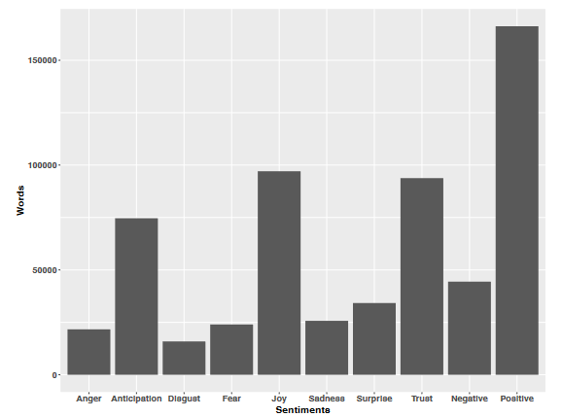

**Source: Siemon et al. ,2022, p. 5**

**Trust** and **joy** were two of the positive feelings that consumers reported feeling towards the virtual companion, besides **anger, sadness**, and **fear** as negative feelings which may reflect a general apprehension about new forms of artificial intelligence.

**Table 1. Results of the topic modeling**

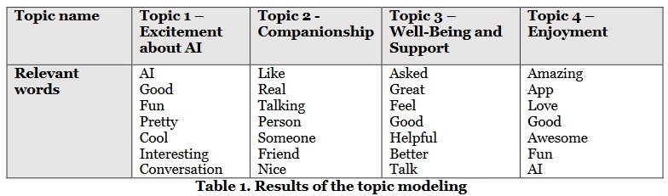

**Source: Siemon et al. ,2022, p. 5**

The results of the topic modeling analysis also show that the most important thing that users talk about is that they feel better and enjoy using the application. Siemon et al. (2022, p. 5)

This research found that most people use Replica because it makes them feel good, to overcome loneliness and provides emotional support.

However, this previous study reveals negative reviews regarding virtual friends due to expectations that are too high. The previous study also indicates that further research is needed to investigate possible negative effects and ethical issues in relationships with virtual friends, and how the use of this technology affects relationships and human well-being in the long term.

**2.2 Terminology and Definitions**

Terminology and definitions related to widely used machine learning algorithms for sentiment analysis, such as Naive Bayes, Logistic Regression, and LinearSVC.

## Naïve Bayes

Naive Bayes is a probabilistic method that is often used for natural language processing applications, such as sentiment analysis. It is based on Bayes' theorem, which states that the probability of a hypothesis (in this case, the sentiment of a text) given evidence (the terms of the text) is equal to the probability of the evidence given the hypothesis multiplied by the prior probability of the hypothesis. The term "naive" refers to the misconception that the features (words) in a text are independent of one another. This is Bayes' Theorem-based Categorization method. The key assumption is that each model attribute is independent and contributes equally. The Conditional probability equation determines text positivity. (Pati, & Pradhan, 2020, p. 7).

Formula:

**P(A|B) = P(A)*P(B|A) / P(B)**

Where A and B are events.

P(A|B) is a conditional probability of A event occurring given that A is true,

P(B|A) is a conditional probability of B event occurring given that B is true,

P(A) and P(B) are the probabilities observing events A & B

## Logistic Regression

Logistic regression is a statistical method which models the connection between a binary sentiment label and a collection of characteristics from text. The goal of logistic regression is to model the relationship between the independent variables (features) and the dependent variable (target). (Raschka, 2015)

Logistic regression is comparing the two sets of features to one another, to find the ideal parameters for a line or hyperplane that separates positive and negative occurrences in feature space.

In order to turn the input feature vector into a likelihood of the emotion label being positive, it makes use of the sigmoid function. The logit function, inverse of the sigmoid function, translates probabilities to values between negative and positive infinity. Additionally, it makes use of linear regression methods to estimate the coefficients (weight) that provide the best fit for the data. (Raschka, 2015)

p/(1-p) is the odds ratio, where p stands for probability of positive event we wish to predict. There is also logit function, which is the logarithm of the odds ratio:

**logit(p)=log (p / (1 – p)).**

Formula to predict the probability that a given text expresses a positive sentiment "class" in machine learning terms:

**P(y=1|x) = 1 / (1 + e^ (-w^T x - b))**

p(y = 1|x) is the conditional probability that a sample with x belongs to class 1. The inverse logit function predicts the chance that a sample belongs to a class.

y is the target class,

x is the feature,

w is the weight vector,

b is the bias term.

**Figure 5. Logistic Regression**

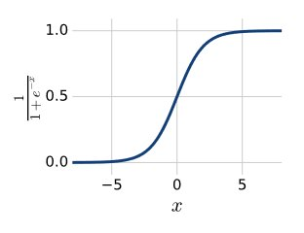

**Source: Mohri, Rostamizadeh and Talwalkar, 2012, p. 326**

This research will use multinomial Logistic regression since it has more than 2 outputs.

## 

**Linear SVM**

**Figure 7. Linear SVM hyperplanes**

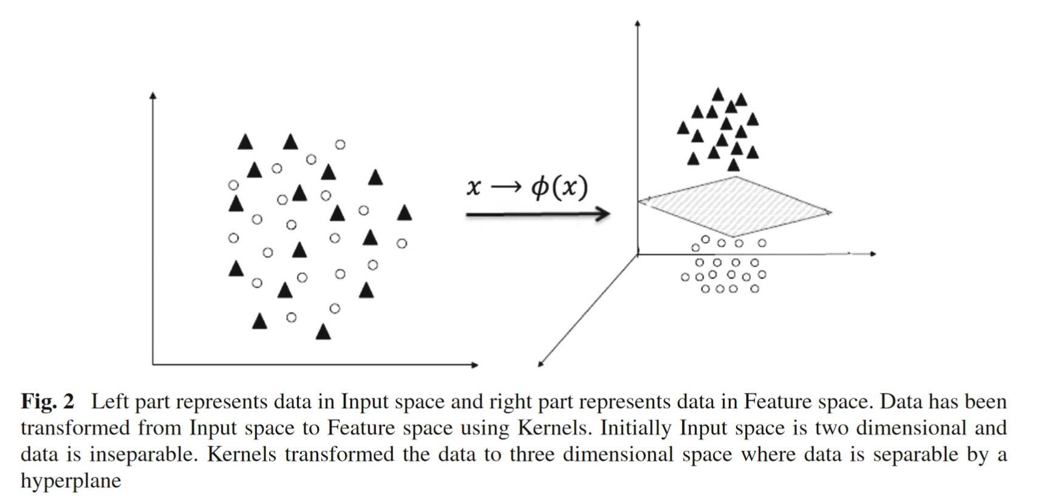

**Source: ((Chauhan et al., 2018, p. 3)**

## Linear SVM is a type of SVM (Support Vector Machine) using linear kernel/ hyperplane for binary classification.

## Linear SVC

Linear Support Vector Classification (SVC) is a specific linear variant of Support Vector Machine (SVM) method. Linear Support Vector Classification (Linear SVC) is a supervised learning algorithm used to solve classification problems where the output is a binary or categorical variable. Like traditional SVC, the goal of linear SVC is to find the best boundary or hyperplane that separates classes in the feature space using a linear kernel to find the optimal weight coefficients of each feature. It included built-in regularization to prevent overfitting.

In multi-class classification problems, it uses a method called "one-vs-all" or “one-vs-the rest” multi-class reduction, where one class is considered positive, and all other classes are other than positive. The goal of Linear SVC is to find optimal hyperplane and maximize the width of the margin, by minimizing the loss function. (Mukherjee, 2020).

**Figure 6. Linear SVC**

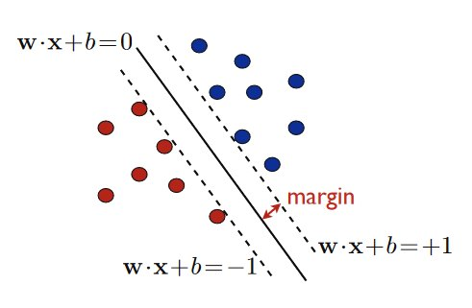

**Source: Mohri, Rostamizadeh and Talwalkar, 2012, p. 82**

Formula:

**Minimize (1/ 2) ||w||^2**

subject to yi (w * xi + b) ≥ 1 for i = 1, . . . n.

w is the weight vector of the hyperplane.

b is bias term of the hyperplane.

x_i is the i-th feature vector.

y_i is the i-th target or label variable (-1 or 1)

n is number of training examples.

||w|| is the norm of weight vector, the square root of the sum of the squares of the elements of the vector. (Mohri, Rostamizadeh and Talwalkar, 2012, p. 82)

The constraint in this optimization problem ensures that the decision boundary (the line or hyperplane specified by w.x + b = 0) has a minimum distance from the training examples of each class that are closest to it. This distance is determined by the hyperparameter of parameter C.

This optimization problem's output is the weight vector w and bias term b, which define the decision boundary and will be used to categorize additional instances by calculating w.x + b.

**Tokenization and** **Stopwords.**

Text tokenization breaks sentences into smaller units called "tokens", such as words or phrases. Text tokenization can be done by dividing the space character, using regular expressions, or using natural language processing methods, or using Stopwords.

Stop-words are words that are exceedingly prevalent in all types of writings and likely contain no valuable information. Stop words include is, has, and like. Removing stop-words might be beneficial. The NLTK library's list of 127 English stop-words is available. (Raschka. (2015, p. 269).

**Lemmatize.**

The goal of lemmatization is to acquire grammatically accurate versions of individual words, or lemmas. Lemma is computationally more complex and costly than stemming and has minimal influence on text classification performance. (Raschka. (2015, p. 271).

**Stemming.**

The practice of reducing words to their stem (or root) word is known as stemming. This equalizes related terms for the sake of comparison or sharing. When tokenizing sentences, the process of stemming aids in their analysis.

Stemming and deleting stop words simplifies and minimizes the quantity of textual parts. The Natural Language Toolkit (NLTK) is required for this example. (Mueller & Massaron, 2021, p. 355)

## Tf-idf vectorizer

Vectorization is a way to turn words into numbers to make computers understand them. One approach to do this is by using TF-IDF.

The Term Frequency-Inverse Document Frequency (TF-IDF) method assigns weight to each word in a text. It counts the number of times a word occurs and divides that number by the number of documents where the term appears. A term that occurs often but also appears frequently in other texts will be more relevant than one that appears just once. (Mueller & Massaron, 2021, p. 353)

## Confusion Matrix

The confusion matrix is a table that summarizes the classification to predict different classes. One axis of the confusion matrix represents the label predicted by the model, while the other axis represents the actual label. (Burkov, A., 2019, p. 65)

* Based on confusion matrix output, this research used four effective measures:
* True Positive (TP) = Correctly predicted as Positive.
* False Positive (FP) = Wrongly predicted as Positive.
* True Negative (TN) = Correctly predicted as Negative.
* False Negative (FN) = Wrongly predicted as Negative.

**Precision**

Precision is proportion of **correctly positive predictions** divided by the **total** number of **positive predictions** (Burkov, A., 2019, p. 66)

Precision = TP/(TP+FP)

**Recall**

Recall is proportion of **correctly positive** **predictions** divided by the **total** number **of actual positive** (Burkov, A., 2019, p. 66)

Recall(R) = TP/(TP+FN)

**Accuracy**

Accuracy is proportion of **correct predictions** divided by the **total** **examples** (Burkov, A., 2019, p. 67)

Accuracy(A) = (TP+TN) / (TP + TN + FP + FN)

**F1-Score**

F1-Score is balancing precision and recall. The worst value is 0, and the best value is 1.

F1-score = 1 means the model has perfect recall and perfect precision.

F1-score = 0 means the model has bad recall and bad precision.

F1-score is important to know how good the model’s performance in the scale is of 0 to 1. F1 score is also important when false positive value is almost equal to false negative value, or the positive class is rare.

F1-score = 2 * (Precision * Recall) / (Precision + Recall)

To analyze performance of several machine learning models, will need to compare their accuracy, precision, recall, and f1-score.

A model with a high accuracy but low precision can be overfitting.

A model with low accuracy but high precision can be underfitting.

A model with a high f1-score means having a good balance between accuracy and recall, a better overall performance.

## Normalized Confusion Matrix

## Normalized Confusion matrix is confusion matrix which normalized become numbers between 0 - 1 to simplify it become easier to interpret.

## Hypothesis Testing

## Chi-Square Test

## Chi-square test is the way to evaluate whether two variables are dependent on each other or not. It is used when dealing with categorical data. The chi-square statistic is calculated by calculating the sum of squared differences between the observed frequencies and the expected frequencies, then dividing by the expected frequencies. (Calculation and Distribution of the Chi-Square Statistic, 2021).

## To do the test, we find the difference between what happened and what we expect to happen. Then we square that difference and add them all up. Next, we divide that number by what is expected to happen. This gives a number called the chi-square statistic. (Calculation and Distribution of the Chi-Square Statistic, 2021).

## Formula:

## χ² = ∑ (O – E)² / E

## χ² = chi-square statistic

## O = observed frequency

## E = expected frequency

**degree of freedom = (r - 1) * (c - 1)**

r = numbers of rows

c = number of columns

**E = (row total * column total) / grand total**

E: Expected frequency for i-th row and j-th column

Ti: Total in the i-th row

Tj: Total in the j-th row

N: Grand Total

## 

**Contingency tables** are cross table/ two-way table to show one variable in the, row and another variable in the column, with their frequency count. The type of frequency distribution table of the categorical variables. (Chi-square Test in Spreadsheets, 2019)

**Chi-Square p-value** tells if test results are significant or not.

**Chi-square test Statistics** is a single number that tells how much difference exists on your observed counts and the counts you would expect if there were no relationship at all in the population.

**Observed frequencies** are numbers made from experimental/ observed data.

**Expected frequencies** are numbers calculated using theory of probability, obtained by calculated each cell in the contingency table.

The chi-square value is 0 if observed and expected frequencies matched. Chi-square would exceed 0 if there is a difference.(Chi-square Test in Spreadsheets, 2019)

## Then compare the p-value to a significant level (usually 0.05). If the p-value is less than 0.05, it means the two things are related. Hence, there are dependencies between each other, and we can reject the null hypothesis.

## But, if the p-value is more than 0.05, we can't say that the two things are related. Hence, they are independent of each other, and concluded that there is no significant association between the variables and that they are independent of each other. (Dangeti, 2017, p. 22).

Null Hypothesis (H0): It states that no association exists between the two cross-tabulated variables. Hence, the variables are statistically independent.

Alternate Hypothesis (H1): It proposes that the two variables are related to each other.

## Table 2. Chi-Square Table

|  |  |  |  |  |  |
| --- | --- | --- | --- | --- | --- |
| DF | Probability | | | | |
| 0.5 | 0.1 | 0.05 | 0.01 | 0.05 |
| 1 | 0.45494 | 2.70554 | 3.84146 | 6.63490 | 3.84146 |
| 2 | 1.38629 | 4.60517 | 5.99146 | 9.21034 | 5.99146 |
| 3 | 2.36597 | 6.25139 | 7.81473 | 11.34487 | 7.81473 |
| 4 | 3.35669 | 7.77944 | 9.48773 | 13.27670 | 9.48773 |
| 5 | 4.35146 | 9.23636 | 11.07050 | 15.08627 | 11.07050 |
| 6 | 5.34812 | 10.64464 | 12.59159 | 16.81189 | 12.59159 |
| 7 | 6.34581 | 12.01704 | 14.06714 | 18.47531 | 14.06714 |
| 8 | 7.34412 | 13.36157 | 15.50731 | 20.09024 | 15.50731 |
| 9 | 8.34283 | 14.68366 | 16.91898 | 21.66599 | 16.91898 |
| 10 | 9.34182 | 15.98718 | 18.30704 | 23.20925 | 18.30704 |
| 11 | 10.34100 | 17.27501 | 19.67514 | 24.72497 | 19.67514 |
| 12 | 11.34032 | 18.54935 | 21.02607 | 26.21697 | 21.02607 |
| 13 | 12.33976 | 19.81193 | 22.36203 | 27.68825 | 22.36203 |
| 14 | 13.33927 | 21.06414 | 23.68479 | 29.14124 | 23.68479 |
| 15 | 14.33886 | 22.30713 | 24.99579 | 30.57791 | 24.99579 |
| 16 | 15.33850 | 23.54183 | 26.29623 | 31.99993 | 26.29623 |
| 17 | 16.33818 | 24.76904 | 27.58711 | 33.40866 | 27.58711 |
| 18 | 17.33790 | 25.98942 | 28.86930 | 34.80531 | 28.86930 |
| 19 | 18.33765 | 27.20357 | 30.14353 | 36.19087 | 30.14353 |
| 20 | 19.33743 | 28.41198 | 31.41043 | 37.56623 | 31.41043 |
| 21 | 20.33723 | 29.61509 | 32.67057 | 38.93217 | 32.67057 |
| 22 | 21.33704 | 30.81328 | 33.92444 | 40.28936 | 33.92444 |
| 23 | 22.33688 | 32.00690 | 35.17246 | 41.63840 | 35.17246 |
| 24 | 23.33673 | 33.19624 | 36.41503 | 42.97982 | 36.41503 |
| 25 | 24.33659 | 34.38159 | 37.65248 | 44.31410 | 37.65248 |
| 26 | 25.33646 | 35.56317 | 38.88514 | 45.64168 | 38.88514 |
| 27 | 26.33634 | 36.74122 | 40.11327 | 46.96294 | 40.11327 |
| 28 | 27.33623 | 37.91592 | 41.33714 | 48.27824 | 41.33714 |
| 29 | 28.33613 | 39.08747 | 42.55697 | 49.58788 | 42.55697 |
| 30 | 29.33603 | 40.25602 | 43.77297 | 50.89218 | 43.77297 |
| 31 | 30.33594 | 41.42174 | 44.98534 | 52.19139 | 44.98534 |
| 32 | 31.33586 | 42.58475 | 46.19426 | 53.48577 | 46.19426 |
| 33 | 32.33578 | 43.74518 | 47.39988 | 54.77554 | 47.39988 |
| 34 | 33.33571 | 44.90316 | 48.60237 | 56.06091 | 48.60237 |
| 35 | 34.33564 | 46.05879 | 49.80185 | 57.34207 | 49.80185 |
| 36 | 35.33557 | 47.21217 | 50.99846 | 58.61921 | 50.99846 |
| 37 | 36.33551 | 48.36341 | 52.19232 | 59.89250 | 52.19232 |
| 38 | 37.33545 | 49.51258 | 53.38354 | 61.16209 | 53.38354 |
| 39 | 38.33540 | 50.65977 | 54.57223 | 62.42812 | 54.57223 |
| 40 | 39.33534 | 51.80506 | 55.75848 | 63.69074 | 55.75848 |
| 41 | 40.33529 | 52.94851 | 56.94239 | 64.95007 | 56.94239 |
| 42 | 41.33525 | 54.09020 | 58.12404 | 66.20624 | 58.12404 |
| 43 | 42.33520 | 55.23019 | 59.30351 | 67.45935 | 59.30351 |
| 44 | 43.33516 | 56.36854 | 60.48089 | 68.70951 | 60.48089 |
| 45 | 44.33512 | 57.50530 | 61.65623 | 69.95683 | 61.65623 |
| 46 | 45.33508 | 58.64054 | 62.82962 | 71.20140 | 62.82962 |
| 47 | 46.33504 | 59.77429 | 64.00111 | 72.44331 | 64.00111 |
| 48 | 47.33500 | 60.90661 | 65.17077 | 73.68264 | 65.17077 |
| 49 | 48.33497 | 62.03754 | 66.33865 | 74.91947 | 66.33865 |
| 50 | 49.33494 | 63.16712 | 67.50481 | 76.15389 | 67.50481 |

## Source: Chi Square Table in Excel, 2012

**3 Methodology**

The methodology for this study will be a combination of approaches, between:

1. An experimental approach for comparing several model’s performance, and model selection based on the best performance.
2. A Quantitative approach for data collection, sentiment analysis, and conduct hypothesis testing.

**3.1 Train and Evaluate performance of Machine Learning Models**

The study will involve:

**Train and Evaluate** performance of Machine Learning Models on labeled datasets. The machine learning models will be trained and compared in this study are intended to be able to accurately classify sentiment analysis expressing several sentiments towards ready-to-use labeled datasets and select the top-performing model.

The selected model will be implemented and trained using the preprocessed data. The model will be used to classify the sentiment of the tweets from the United States and Asia separately. Some common algorithms that can be used for sentiment analysis include logistic regression and naive bayes. These algorithms can be applied to the vectorized data to build a model that can classify text as **joy, sad, anger, love, fear, surprise** sentiments.

**Figure 2. Research methodology workflow:**

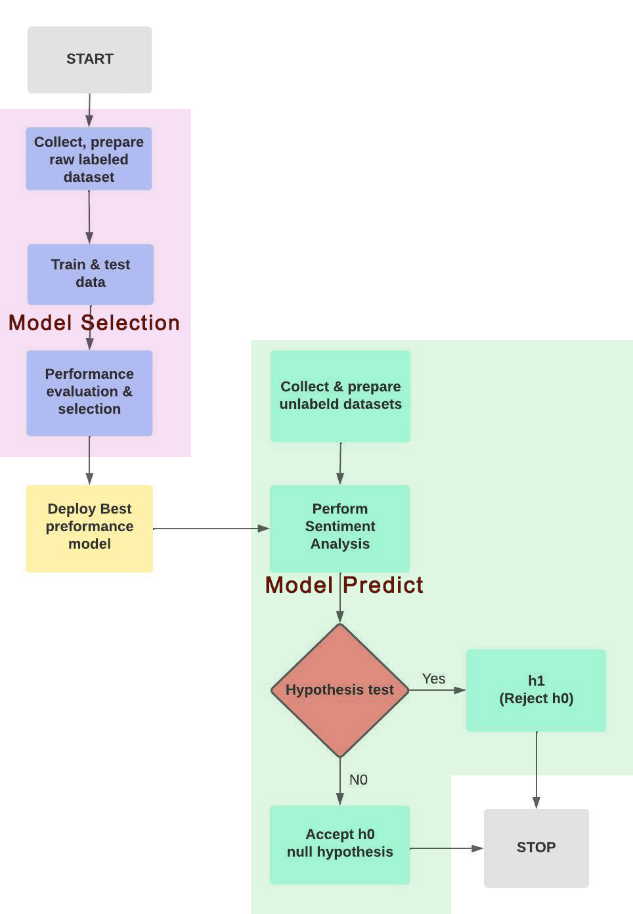

**Source: Own representation**

**3.2 Compare Performance** of Different Machine Learning Models

In a classification task, the performance of a model can be evaluated using a number of different metrics. Here is a brief explanation of some common evaluation metrics, such as Accuracy, Precision, Recall, and F1-Score.

**3.3 Collect Unlabeled Tweets Data**

From various locations using SNScrape Python’s library.The data collection process for this study will involve gathering tweets about robot companions from locations in the America, Europe, Asia, Australia, and Africa, using appropriate data gathering tools and techniques.

* 1. **Ethical Considerations**

Ethical consideration includes responsible and respectful data collection and use. The ethical considerations for this study will include ensuring that the data is collected and used in a responsible and respectful manner, in accordance with relevant ethical guidelines and regulations.

**3.5 Pre-process and Vectorize Collected Data**

The collected tweets will be cleaned and preprocessed as needed to remove any irrelevant or redundant information. Pre-processing and vectorization are crucial procedures for preparing data for analysis and machine learning algorithms. The data must be prepared for usage by the chosen machine learning model by first cleaning and then vectorizing them. (Mueller & Massaron, 2021)

**3.6 Predict Sentiment**

on unlabeled tweets Use the trained machine learning models. These tweets will be classified as either joy, sadness, anger, love, fear, surprise, based on the tone and language used in the tweet in each region separately.

**3.7 Hypothesis Testing**

Next, we use the Chi-square Hypothesis test to determine whether there is a relationship between location and sentiment towards companion robots, and to determine whether there are significant differences in the distribution of sentiments between different regions.

**Null hypothesis h0:**

Joy, Sadness,Surprise,Anger,Love,Fear sentiments are INDEPENDENT upon different continents.

**Alternative hypothesis h1:**

Joy, Sadness,Surprise,Anger,Love,Fear sentiments are DEPENDENT upon different continents.

We can conclude that there is a dependence between location and sentiment on human-machine relations if the results of the chi-square test show a significant difference in the distribution of sentiment between regions. It means that people's sentiment towards companion robots is independent depending on/influenced by their geographical location.

However, if the chi-square test reveals that there is no significant difference in the distribution of sentiment across regions, then we cannot reject the null hypothesis, and are forced to draw the conclusion that there is no dependence between location and sentiment regarding human-machine relations.

This means that people's sentiment towards companion robots is independent, not influenced by their geographical location.

**Figure 2. Sentiment analysis worklfow**

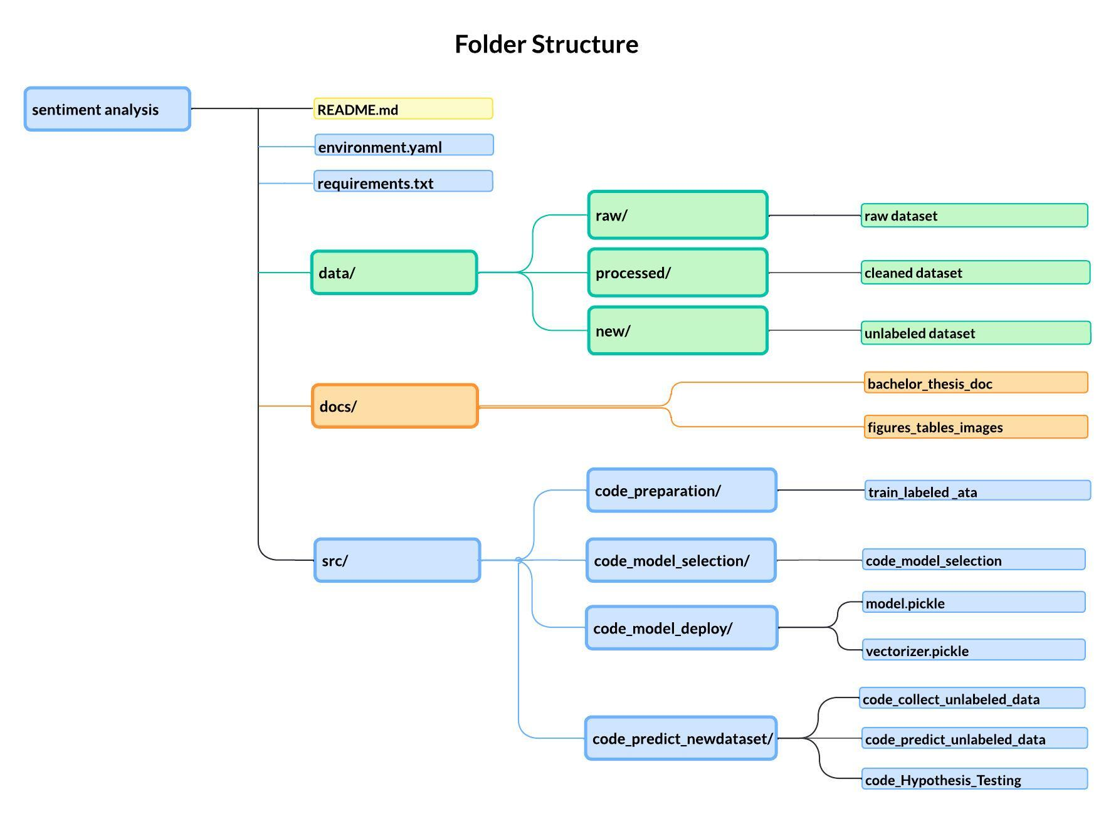

**Source: Own representation**

**3.8 Expected Outcome**

* The expected outcome is that logistic regression method will outperform other methods like Bayes and Linear SVC.
* Initial beliefs are that the sentiment outcome would be consistent with earlier research in chapter two, which indicated more positive emotions such as joy and love than negative emotions such as anger.
* The researcher is unsure whether there will be dependencies between locations and human feelings about digital companions.

**4 Results and Findings**

**Balancing imbalance dataset**

In datasets with severely class-imbalanced classifiers, the classifier will always “predict” the most common class without performing any feature analysis and will have a high degree of accuracy, but not the correct one.

Machine learning algorithms perform optimally when the number of samples in each class is about the same. When the data set is imbalanced, a high accuracy rate can be achieved by predicting the majority class, but this will lead to a failure to recognize the minority class, which is often the main objective of creating the model in the first place. Resampling technique can be used to highly imbalanced datasets. Under-sampling will remove samples from the majority class, while over-sampling will add more examples for the minority class. (G. 2020, July 23)

Using RandomOverSampler from the imblearn library to balance an imbalanced dataset:

1.Calculate the count of each class label in the original dataset using Counter ()

2.Select a target count that represents the count of 'joy' class label to balance with.

3.Create an instance of RandomOverSampler & specify the target count for each class label using a dictionary that maps each label to the target count.

4.Fit the oversampler on the original dataset using fit_resample() and pass the text values and label values as two separate arguments.

5.Convert the resampled data to a panda DataFrame.

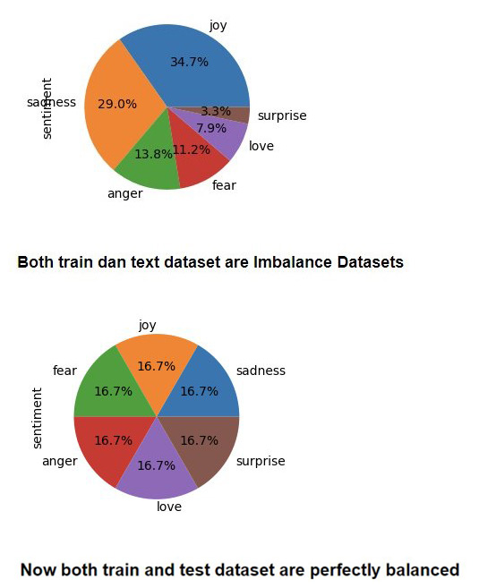

**4.1 Comparison of Model Performance on Labeled Dataset**

From labeled datasets, 70% were used for training and the remaining 30% were used for testing.

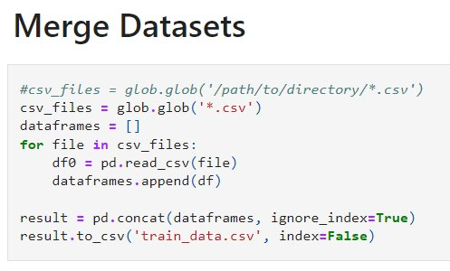

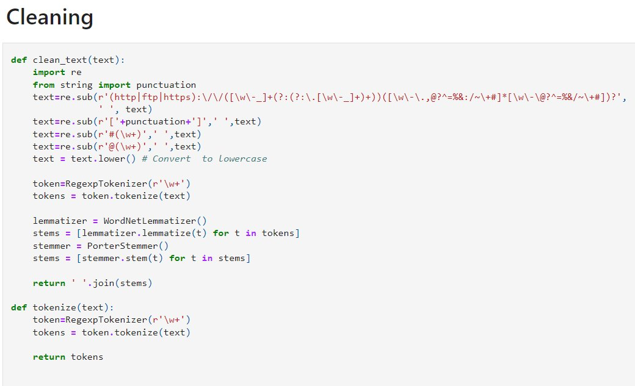

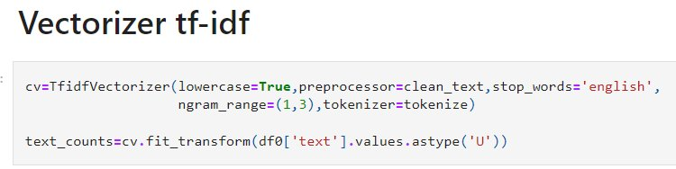

**Scoring Model Results**

A classification report was generated using a Linear SVC on a labeled dataset with 80000 rows for both training and testing purposes.

**Figure**

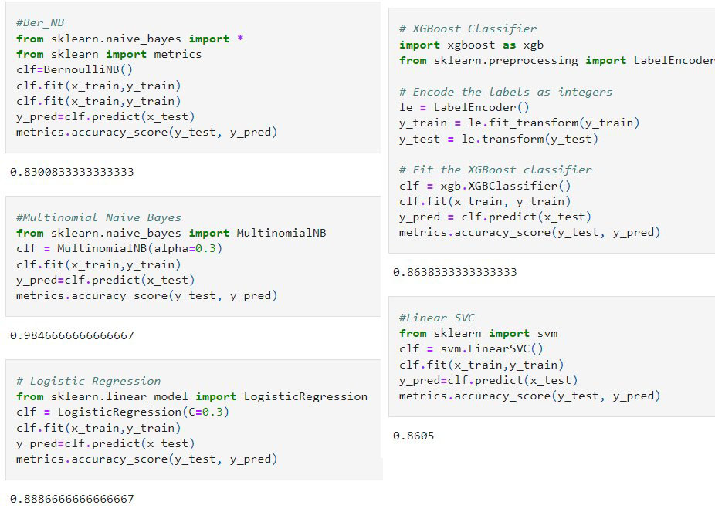

**Source: Own representation.**

**The LinearSVC** model achieved an overall accuracy of 99%. This means that out of all the instances in the test set, the model **correctly** classified 99% of them.

**Table 3. Sentiment Analysis Model Accuracy**

|  |  |
| --- | --- |
| **Model** | **Accuracy Score** |
| BernoulliNB | 0.8300833333333333 |
| MultinomialNB | 0.9846666666666667 |
| Logistic Regression | 0.8886666666666667 |
| **Linear SVC** | **0.9922083333333334** |
| XGBoost | 0.9442083333333333 |

**Source: Own representation.**

**LinearSVC** model had the **highest accuracy score** among the models tested. Hence, we saved the model and vectorizer so they can be applied to new unlabeled tweets datasets collected from various regions including America, Europe, Asia, Australia, and Africa, using the snscrape Python library.

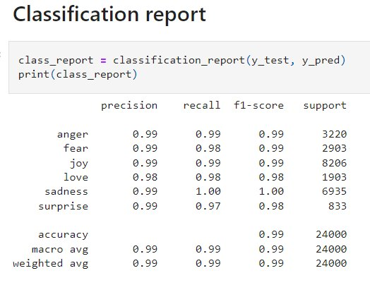

**Table 4. Classification Report**

|  |  |  |  |  |
| --- | --- | --- | --- | --- |
|  | precision | recall | F1-score | support |
| anger | 0.99 | 0.99 | 0.99 | 3220 |
| fear | 0.99 | 0.98 | 0.99 | 2903 |
| joy | 0.99 | 0.99 | 0.99 | 8206 |
| love | 0.98 | 0.97 | 0.96 | 1903 |
| sadness | 0.99 | 1.00 | 1.00 | 6935 |
| surprise | 0.99 | 0.97 | 0.98 | 833 |
|  | | | | |
| accuracy |  |  | 0.99 | 24000 |
| Macro avg | 0.99 | 0.99 | 0.99 | 24000 |
| Weighted avg | 0.99 | 0.99 | 0.99 | 24000 |

**Source: Own representation**

Classification report provides a summary of the performance of the classification model on comparing the model's performance to other models or to understand where the model might be struggling.

Accuracy is how often the model is right.

Precision is how often the model predicts specific emotion, and it's **actually** that emotion.

Recall is how often the model predicts all the time a specific emotion is there.

F1-score is how good the model overall, mixed of precision and recall.

**For the "love" class**, the model’s precision is 98%, recall is 97%, and f1-score is 96%.

Precision interpretation: from the sample predicted as "love," 98% of them were **actually** "love," and 2% were not "love."

Recall interpretation: the model correctly classified 97% of the actual "love", and incorrectly classified only 3% of them.

The model looks to be performing good, because it got a lot of correct predictions, with high scores for all three evaluations metrics, in all classes.

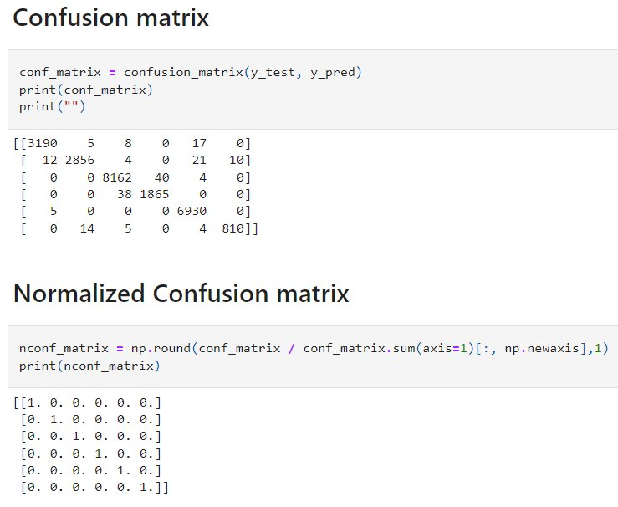

Figure 2. Heatmap of Normalized Confusion matrix

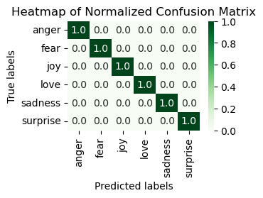

Source: Own representation.

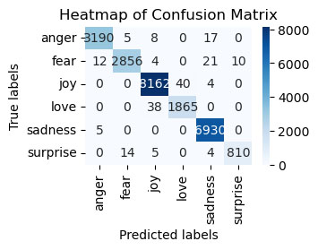

Source: Own representation.

The model had some **difficulty with the "fear" class**, with the highest **21 incorrect predictions** out of 2879 total predictions for that class. The model performed the best in the "love" and "sadness" classes, with only 5 and 0 incorrect predictions out of 6935 and 6934 total predictions for those classes, respectively.

However, seems the model had a relatively high accuracy, with a total of 95 % out of 7200 total predictions in the test labeled dataset.

**Save model and vectorizer.**

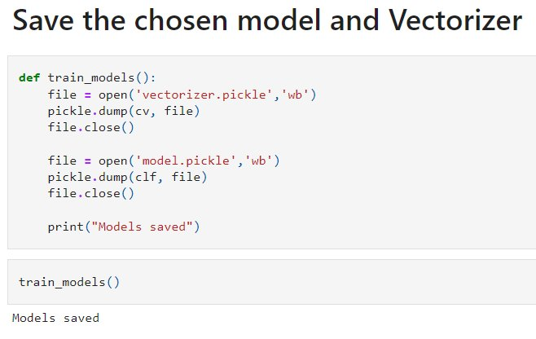

**Collect unlabeled data from Twitter.**

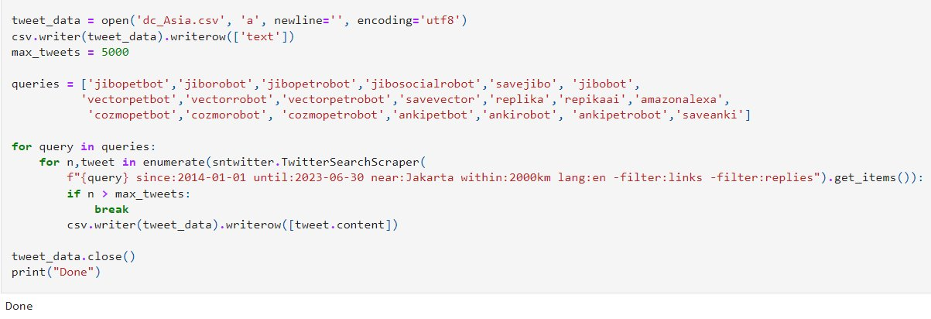

## Load Model and Vectorizer, predict new data.

The use of the scoring model together with the manual analysis of trial accounts also gives a good result.

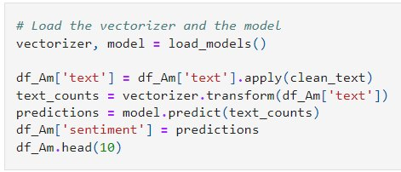

**4.2 Sentiment Analysis Result and Location Comparison**

**Figure 3. Sentiment Count Pie Charts**

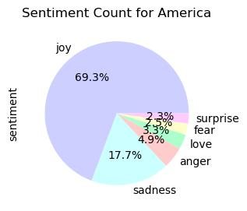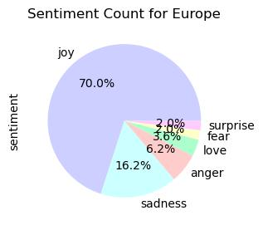

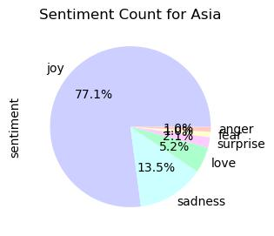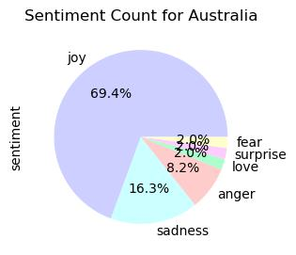 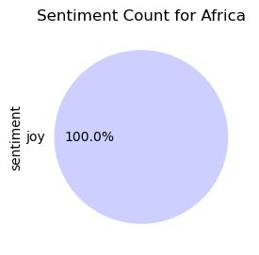

**Source: Own representation.**

**4.3 Hypothesis Testing Result**

**America and Europe**

**Table 7. Observed Frequencies America and Europe**

|  |  |  |  |  |  |  |  |
| --- | --- | --- | --- | --- | --- | --- | --- |
| **Continent** | **Joy** | **Sadness** | **Surprise** | **Anger** | **Love** | **Fear** | **Row Total** |
| **America** | 1253 | 320 | 42 | 88 | 60 | 45 | 1808 |
| **Europe** | 493 | 114 | 14 | 44 | 25 | 14 | 704 |
| **Column Total** | 1746 | 434 | 56 | 132 | 85 | 59 | 2512 |

**Source: Own Result**

**degree of freedom = (row - 1) * (column - 1)**

**df** = (2 - 1) * *(6 - 1) =* ***5***

**O = observed frequency**

**E = Expected Frequency = (Row total * Column total) / Grand total**

**Table 8. Expected Frequencies America and Europe**

|  |  |  |  |  |  |  |  |
| --- | --- | --- | --- | --- | --- | --- | --- |
| **Continent** | **Joy** | **Sadness** | **Surprise** | **Anger** | **Love** | **Fear** | **Row Total** |
| **America** | 1257 | 312 | 40 | 95 | 61 | 42 | 1808 |
| **Europe** | 489 | 122 | 16 | 37 | 24 | 17 | 704 |
| **Column Total** | 1746 | 434 | 56 | 132 | 85 | 59 | 2512 |

**Source: Own result**

## χ² = chi-square statistic = ∑ (O – E)² / E

## Table 9. Chi-Square Statistic America and Europe

|  |  |  |  |  |  |  |  |
| --- | --- | --- | --- | --- | --- | --- | --- |
| **Continent** | **Joy** | **Sadness** | **Surprise** | **Anger** | **Love** | **Fear** | **Row Total** |
| **America** | 0,01 | 0,19 | 0,07 | 0,52 | 0,02 | 0,15 | 0,959091 |
| **Europe** | 0,03 | 0,48 | 0,18 | 1,33 | 0,06 | 0,39 | 2,46312 |
| **Column Total** | 0,038351 | 0,6651089 | 0,25412 | 1,84366 | 0,081 | 0,54 | **3,42221** |

## Source: Own Result

## From the calculation, Chi-Square Statistic is 3,42221

## Table 2. Chi-Square Table

|  |  |  |  |  |  |
| --- | --- | --- | --- | --- | --- |
| df | Probability | | | | |
| 0.5 | 0.1 | 0.05 | 0.01 | **0.05** |
| 1 | 0.45494 | 2.70554 | 3.84146 | 6.63490 | 3.84146 |
| 2 | 1.38629 | 4.60517 | 5.99146 | 9.21034 | 5.99146 |
| 3 | 2.36597 | 6.25139 | 7.81473 | 11.34487 | 7.81473 |
| 4 | 3.35669 | 7.77944 | 9.48773 | 13.27670 | 9.48773 |
| **5** | 4.35146 | 9.23636 | 11.07050 | 15.08627 | **11.07050** |

## Source: Chi Square Table in Excel, 2012

## 

Based on the Chi-Square table, the **Critical value** for chi-squared statistic with degree of freedom of 5 and a p-value of 0.05 is **11.07.**

**Null hypothesis h0:**

Joy, Sadness,Surprise,Anger,Love,Fear sentiments are INDEPENDENT upon different continuents.

**Alternative hypothesis h1:**

Joy, Sadness,Surprise,Anger,Love,Fear sentiments are INDEPENDENT upon different continuents.

As the **Chi-Square Statistic 3,42221 lesser than Critical value 11,07**, indicating that the observed frequencies are not significantly different from the expected frequencies. This means that it is **not possible to reject the null hypothesis of independence** between the two variables.

**Calculation using Python show the same result:**

from scipy import stats

chi_squared_stat = 3.4221

df = 5

p_value = stats.chi2.sf (chi_squared_stat, df)

print(p_value)

Output: **p_value = 0,635**

import numpy as np

import pandas as pd

import scipy.stats as stats

from scipy.stats import chisquare

from scipy.stats import chi2_contingency

tab_data = [[1253, 320, 42, 88, 60, 45],[493, 114, 14, 44, 25, 14]]

chi2_contingency(tab_data)

## 

**Table 8. Hypothesis Testing Result between America and Europe**

|  |  |  |  |  |  |
| --- | --- | --- | --- | --- | --- |
| **Continent Pair** | **Chi-Squared**  **Statistic** | **Critical Value** | **P-Value (significance level (0.05))** | **Degrees of Freedom** | **Independent (h0)?** |
| America and Europe | 3.4221 | 11.07 | 0.635 | 5 | Yes |

**Source: Own Result**

Chi-squared statistic’s result, 3.422210363818829, is a value used to determine whether the observed frequencies of data significantly different from what is expected.

A p-value benchmark used for determining statistical significance is 0.05. It is like a margin of error, and if the p-value is less than or equal to 0.05, it means that there is a real difference between the expected and observed results.

The p-value outcome is 0.6351894774897393, which means that if the null hypothesis (independence) is true, there is a 63.5% probability of obtaining the observed results by chance. Since the p-value is greater than 0.05, it is not possible to reject the null hypothesis of independence between America and Europe and sentiment analysis of digital and robot pet companions.

The degree of freedom, 5, shows how many ways the frequencies can change on their own.

The result is an array that shows how often each cell in the contingency table is likely to happen.

The critical value for the chi-squared statistic with a degree of freedom of 5 and a p-value of 0.05 is 11.07. The observed Chi-Squared statistic, 3.422210363818829, does not exceed this critical value, indicating that the observed frequencies are not significantly different from the expected frequencies. This means that the null hypothesis that the two variables are independent cannot be rejected.

**America and Asia**

**Table 5. Observed frequencies for America and Asia**

|  |  |  |  |  |  |  |  |
| --- | --- | --- | --- | --- | --- | --- | --- |
| **Continent** | **Joy** | **Sadness** | **Surprise** | **Anger** | **Love** | **Fear** | **Row Total** |
| **America** | 1253 | 320 | 42 | 88 | 60 | 45 | 1808 |
| **Asia** | 74 | 13 | 2 | 1 | 5 | 1 | 96 |
| **Column Total** | 1327 | 333 | 44 | 89 | 65 | 46 | 1904 |

**Source: Own representation**

**Table 10. Expected Frequencies for America and Asia**

|  |  |  |  |  |  |  |  |
| --- | --- | --- | --- | --- | --- | --- | --- |
| **Continent** | **Joy** | **Sadness** | **Surprise** | **Anger** | **Love** | **Fear** | **Row Total** |
| **America** | 1260 | 316 | 42 | 85 | 62 | 44 | 1808 |
| **Asia** | 67 | 17 | 2 | 4 | 3 | 2 | 96 |
| **Column Total** | 1327 | 333 | 44 | 89 | 65 | 46 | 1904 |

**Source: Own representation**

**Table 9. Chi-Square Statistic America and Asia**

|  |  |  |  |  |  |  |  |
| --- | --- | --- | --- | --- | --- | --- | --- |
| **Continent** | **Joy** | **Sadness** | **Surprise** | **Anger** | **Love** | **Fear** | **Row Total** |
| **America** | 0,04 | 0,05 | 0,00 | 0,14 | 0,05 | 0,04 | 0,318322 |
| **Asia** | 0,75 | 0,86 | 0,02 | 2,71 | 0,91 | 0,75 | 5,995067 |
| **Column Total** | 0,791743 | 0,9009053 | 0,02266 | 2,85415 | 0,9536 | 0,79 | **6,313389** |

**Source: Own Result**

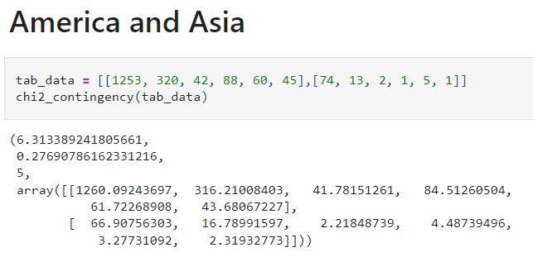

**Table 8. Hypothesis Testing Result between America and Asia**

|  |  |  |  |  |  |
| --- | --- | --- | --- | --- | --- |
| **Continent Pair** | **Chi-Squared**  **Statistic** | **Critical Value** | **P-Value (significance level (0.05))** | **Degrees of Freedom** | **Independent (h0)?** |
| America and Asia | 6.313389 | 11.07 | 0.2769 | 5 | Yes |

**Source: Own representation**

Chi-squared statistic’s result, 6,313389, is a value used to determine whether the observed frequencies of data significantly different from what is expected.

A p-value benchmark used for determining statistical significance is 0.05. It is like a margin of error, and if the p-value is less than or equal to 0.05, it means that there is a real difference between the expected and observed results.

The p-value outcome is 0.27690786, which means that if the null hypothesis (independence) is true, there is a 27.7% probability of obtaining the observed results by chance. Since the p-value is greater than 0.05, it is not possible to reject the null hypothesis of independence between America and Europe and sentiment analysis of digital and robot pet companions.

The degree of freedom, 5, shows how many ways the frequencies can change on their own.

The end result is an array that shows how often each cell in the contingency table is likely to happen.

The critical value for the chi-squared statistic with a degree of freedom of 5 and a p-value of 0.05 is 11.07. The observed Chi-Squared statistic, 6,313389, does not exceed this critical value, indicating that the observed frequencies are not significantly different from the expected frequencies. This means that the null hypothesis that the two variables are independent cannot be rejected.

**America and Australia**

**Table 5. Observed frequencies for America and Australia**

|  |  |  |  |  |  |  |  |
| --- | --- | --- | --- | --- | --- | --- | --- |
| **Continent** | **Joy** | **Sadness** | **Surprise** | **Anger** | **Love** | **Fear** | **Row Total** |
| **America** | 1253 | 320 | 42 | 88 | 60 | 45 | 1808 |
| **Australia** | 34 | 8 | 1 | 4 | 1 | 1 | 49 |
| **Column Total** | 1287 | 328 | 43 | 92 | 61 | 46 | 1857 |

**Source: Own representation**

**Table 10. Expected Frequencies for America and Australia**

|  |  |  |  |  |  |  |  |
| --- | --- | --- | --- | --- | --- | --- | --- |
| **Continent** | **Joy** | **Sadness** | **Surprise** | **Anger** | **Love** | **Fear** | **Row Total** |
| **America** | 1253 | 319 | 42 | 90 | 59 | 45 | 1808 |
| **Australia** | 34 | 9 | 1 | 2 | 2 | 1 | 49 |
| **Column Total** | 1287 | 328 | 43 | 92 | 61 | 46 | 1857 |

**Source: Own representation**

**Table 9. Chi-Square Statistic America and Australia**

|  |  |  |  |  |  |  |  |
| --- | --- | --- | --- | --- | --- | --- | --- |
| **Continent** | **Joy** | **Sadness** | **Surprise** | **Anger** | **Love** | **Fear** | **Row Total** |
| **America** | 0,00 | 0,00 | 0,00 | 0,03 | 0,01 | 0,00 | 0,036658 |
| **Australia** | 0,00 | 0,05 | 0,02 | 1,02 | 0,23 | 0,04 | 1,352604 |
| **Column Total** | 4,93E-05 | 0,0508861 | 0,01641 | 1,04612 | 0,2371 | 0,039 | **1,389261** |

**Source: Own Result**

**Table 8. Hypothesis Testing Result between America and Australia**

|  |  |  |  |  |  |
| --- | --- | --- | --- | --- | --- |
| **Continent Pair** | **Chi-Squared**  **Statistic** | **Critical Value** | **P-Value (significance level (0.05))** | **Degrees of Freedom** | **Independent (h0)?** |
| America and Australia | 1.38 | 11.07 | 0.9254 | 5 | Yes |

**Source: Own representation**

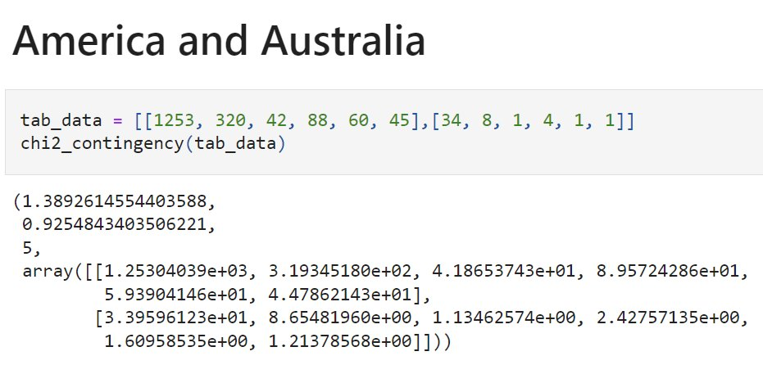

Chi-squared statistic’s result, 1,38926145544 is a value used to determine whether the observed frequencies of data significantly different from what is expected.

A p-value benchmark used for determining statistical significance is 0.05. It is like a margin of error, and if the p-value is less than or equal to 0.05, it means that there is a real difference between the expected and observed results.

The p-value outcome is 0.92548434, which means that if the null hypothesis (independence) is true, there is a 92.5% probability of obtaining the observed results by chance. Since the p-value is greater than 0.05, it is not possible to reject the null hypothesis of independence between America and Europe and sentiment analysis of digital and robot pet companions.

The degree of freedom, 5, shows how many different ways the frequencies can change on their own.

The end result is an array that shows how often each cell in the contingency table is likely to happen.

The critical value for the chi-squared statistic with a degree of freedom of 5 and a p-value of 0.05 is 11.07. The observed Chi-Squared statistic, 1,38926145544, does not exceed this critical value, indicating that the observed frequencies are not significantly different from the expected frequencies. This means that the null hypothesis that the two variables are independent cannot be rejected.

**Europe and Asia**

**Table 5. Observed frequencies for Europe and Asia**

|  |  |  |  |  |  |  |  |
| --- | --- | --- | --- | --- | --- | --- | --- |
| **Continent** | **Joy** | **Sadness** | **Surprise** | **Anger** | **Love** | **Fear** | **Row Total** |
| **Europe** | 493 | 114 | 14 | 44 | 25 | 14 | 704 |
| **Asia** | 74 | 13 | 2 | 1 | 5 | 1 | 96 |
| **Column Total** | 567 | 127 | 16 | 45 | 30 | 15 | 800 |

**Source: Own representation**

**Table 10. Expected Frequencies for Europe and Asia**

|  |  |  |  |  |  |  |  |
| --- | --- | --- | --- | --- | --- | --- | --- |
| **Continent** | **Joy** | **Sadness** | **Surprise** | **Anger** | **Love** | **Fear** | **Row Total** |
| **Europe** | 499 | 112 | 14 | 40 | 26 | 13 | 704 |
| **Asia** | 68 | 15 | 2 | 5 | 4 | 2 | 96 |
| **Column Total** | 567 | 127 | 16 | 45 | 30 | 15 | 800 |

**Source: Own representation**

**Table 9. Chi-Square Statistic Europe and Asia**

|  |  |  |  |  |  |  |  |
| --- | --- | --- | --- | --- | --- | --- | --- |
| **Continent** | **Joy** | **Sadness** | **Surprise** | **Anger** | **Love** | **Fear** | **Row Total** |
| **Europe** | 0,07 | 0,04 | 0,00 | 0,49 | 0,07 | 0,05 | 0,728158 |
| **Asia** | 0,52 | 0,33 | 0,00 | 3,59 | 0,54 | 0,36 | 5,339827 |
| **Column Total** | 0,593261 | 0,3741351 | 0,00379 | 4,07407 | 0,6187 | 0,404 | **6,067985** |

**Source: Own Result**

**Table 8. Hypothesis Testing Result between Europe and Asia**

|  |  |  |  |  |  |
| --- | --- | --- | --- | --- | --- |
| **Continent Pair** | **Chi-Squared**  **Statistic** | **Critical Value** | **P-Value (significance level (0.05))** | **Degrees of Freedom** | **Independent (h0)?** |
| Europe and Asia | 6.06 | 11.07 | 0.2996 | 5 | Yes |

**Source: Own representation**

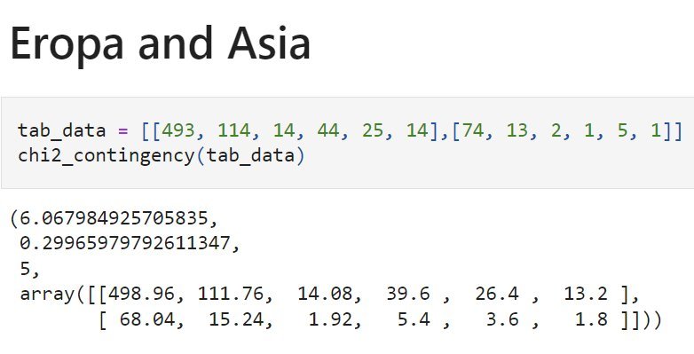

Chi-squared statistic’s result, 6,067984925 is a value used to determine whether the observed frequencies of data significantly different from what is expected.

A p-value benchmark used for determining statistical significance is 0.05. It is like a margin of error, and if the p-value is less than or equal to 0.05, it means that there is a real difference between the expected and observed results.

The p-value outcome is 0.299659797, which means that if the null hypothesis (independence) is true, there is a 29.9% probability of obtaining the observed results by chance. Since the p-value is greater than 0.05, it is not possible to reject the null hypothesis of independence between America and Europe and sentiment analysis of digital and robot pet companions.

The degree of freedom, 5, shows how many different ways the frequencies can change on their own.

The end result is an array that shows how often each cell in the contingency table is likely to happen.

The critical value for the chi-squared statistic with a degree of freedom of 5 and a p-value of 0.05 is 11.07. The observed Chi-Squared statistic, 6,067984925, does not exceed this critical value, indicating that the observed frequencies are not significantly different from the expected frequencies. This means that the null hypothesis that the two variables are independent cannot be rejected.

**Europe and Australia**

**Table 5. Observed frequencies for Europe and Australia**

|  |  |  |  |  |  |  |  |
| --- | --- | --- | --- | --- | --- | --- | --- |
| **Continent** | **Joy** | **Sadness** | **Surprise** | **Anger** | **Love** | **Fear** | **Row Total** |
| **Europe** | 493 | 114 | 14 | 44 | 25 | 14 | 704 |
| **Australia** | 34 | 8 | 1 | 4 | 1 | 1 | 49 |
| **Column Total** | 567 | 127 | 16 | 45 | 30 | 15 | 800 |

**Source: Own representation**

**Table 10. Expected Frequencies for Europe and Australia**

|  |  |  |  |  |  |  |  |  |
| --- | --- | --- | --- | --- | --- | --- | --- | --- |
| **Continent** | **Joy** | **Sadness** | **Surprise** | **Anger** |  | **Love** | **Fear** | **Row Total** |
| **Europe** | 499 | 112 | 14 | 40 |  | 26 | 13 | 704 |
| **Australia** | 34 | 8 | 1 | 3 | 2 | 1 | 49 | 34 |
| **Column Total** | 527 | 122 | 15 | 48 | 26 | 15 | 753 | 527 |

**Source: Own representation**

**Table 9. Chi-Square Statistic Europe and Australia**

|  |  |  |  |  |  |  |  |
| --- | --- | --- | --- | --- | --- | --- | --- |
| **Continent** | **Joy** | **Sadness** | **Surprise** | **Anger** | **Love** | **Fear** | **Row Total** |
| **Europe** | 0,00 | 0,00 | 0,00 | 0,02 | 0,02 | 0,00 | 0,037102 |
| **Australia** | 0,00 | 0,00 | 0,00 | 0,25 | 0,28 | 0,00 | 0,533059 |
| **Column Total** | 0,002687 | 0,0005028 | 0,00063 | 0,26307 | 0,3026 | 0,00063 | **0,570161** |

**Source: Own Result**

**Table 8. Hypothesis Testing Result between Europe and Australia**

|  |  |  |  |  |  |
| --- | --- | --- | --- | --- | --- |
| **Continent Pair** | **Chi-Squared**  **Statistic** | **Critical Value** | **P-Value (significance level (0.05))** | **Degrees of Freedom** | **Independent (h0)?** |
| **Europe and Australia** | 0.57 | 11.07 | 0.9893 | 5 | Yes |

**Source: Own representation**

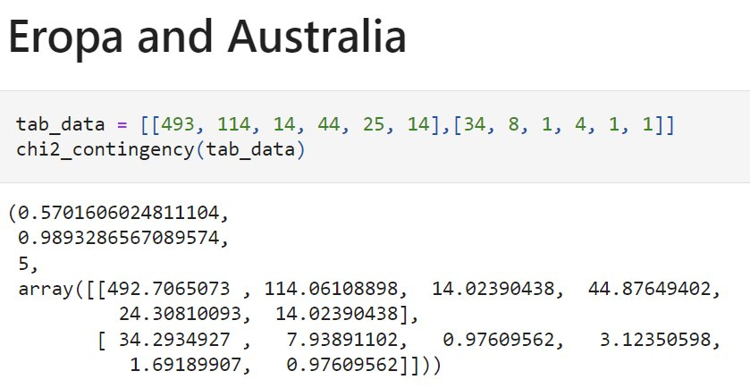

Chi-squared statistic’s result, 0,570160602 is a value used to determine whether the observed frequencies of data significantly different from what is expected.

A p-value benchmark used for determining statistical significance is 0.05. It is like a margin of error, and if the p-value is less than or equal to 0.05, it means that there is a real difference between the expected and observed results.

The p-value outcome is 0.9893286, which means that if the null hypothesis (independence) is true, there is a 98.9% probability of obtaining the observed results by chance. Since the p-value is greater than 0.05, it is not possible to reject the null hypothesis of independence between America and Europe and sentiment analysis of digital and robot pet companions.

The degree of freedom, 5, shows how many different ways the frequencies can change on their own.

The end result is an array that shows how often each cell in the contingency table is likely to happen.

The critical value for the chi-squared statistic with a degree of freedom of 5 and a p-value of 0.05 is 11.07. The observed Chi-Squared statistic, 0,570160602, does not exceed this critical value, indicating that the observed frequencies are not significantly different from the expected frequencies. This means that the null hypothesis that the two variables are independent cannot be rejected.

**Asia and Australia**

**Table 5. Observed frequencies for Asia and Australia**

|  |  |  |  |  |  |  |  |
| --- | --- | --- | --- | --- | --- | --- | --- |
| **Continent** | **Joy** | **Sadness** | **Surprise** | **Anger** | **Love** | **Fear** | **Row Total** |
| **Asia** | 74 | 13 | 2 | 1 | 5 | 1 | 96 |
| **Australia** | 34 | 8 | 1 | 4 | 1 | 1 | 49 |
| **Column Total** | 108 | 21 | 3 | 5 | 6 | 2 | 145 |

**Source: Own representation**

**Table 10. Expected Frequencies for Asia and Australia**

|  |  |  |  |  |  |  |  |  |
| --- | --- | --- | --- | --- | --- | --- | --- | --- |
| **Continent** | **Joy** | **Sadness** | **Surprise** | **Anger** |  | **Love** | **Fear** | **Row Total** |
| **Asia** | 72 | 14 | 2 | 3 | 4 | 1 | 96 | 72 |
| **Australia** | 36 | 7 | 1 | 2 | 2 | 1 | 49 | 36 |
| **Column Total** | 108 | 21 | 3 | 5 | 6 | 2 | 145 | 108 |

**Source: Own representation**

**Table 9. Chi-Square Statistic Asia and Australia**

|  |  |  |  |  |  |  |  |
| --- | --- | --- | --- | --- | --- | --- | --- |
| **Continent** | **Joy** | **Sadness** | **Surprise** | **Anger** | **Love** | **Fear** | **Row Total** |
| **Asia** | 0,09 | 0,06 | 0,00 | 1,61 | 0,27 | 0,08 | 2,10356 |
| **Australia** | 0,17 | 0,12 | 0,00 | 3,16 | 0,52 | 0,16 | 4,121261 |
| **Column Total** | 0,257944 | 0,1737225 | 0,00028 | 4,77147 | 0,7866 | 0,2348 | **6,224822** |

**Source: Own Result**

**Table 8. Hypothesis Testing Result between Asia and Australia**

|  |  |  |  |  |  |
| --- | --- | --- | --- | --- | --- |
| **Continent Pair** | **Chi-Squared**  **Statistic** | **Critical Value** | **P-Value (significance level (0.05))** | **Degrees of Freedom** | **Independent (h0)?** |
| **Asia and Australia** | 6.22 | 11.07 | 0.2849 | 5 | Yes |

**Source: Own representation**

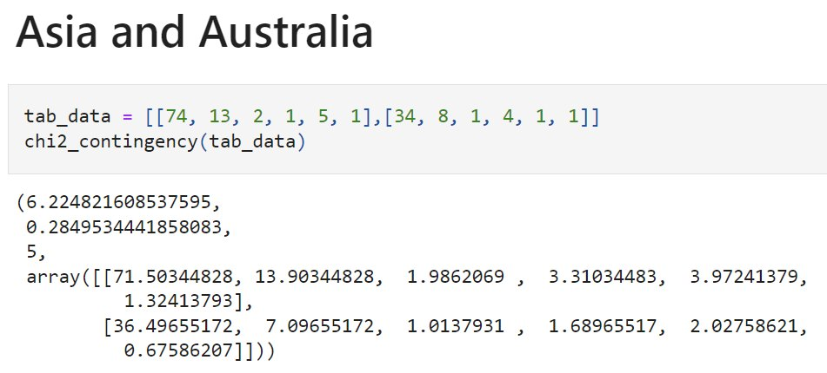

Chi-squared statistic’s result, 6,224821608 is a value used to determine whether the observed frequencies of data significantly different from what is expected.

A p-value benchmark used for determining statistical significance is 0.05. It is like a margin of error, and if the p-value is less than or equal to 0.05, it means that there is a real difference between the expected and observed results.

The p-value outcome is 0.284953444, which means that if the null hypothesis (independence) is true, there is a 98.9% probability of obtaining the observed results by chance. Since the p-value is greater than 0.05, it is not possible to reject the null hypothesis of independence between America and Europe and sentiment analysis of digital and robot pet companions.

The degree of freedom, 5, shows how many ways the frequencies can change on their own.

The result is an array that shows how often each cell in the contingency table is likely to happen.

The critical value for the chi-squared statistic with a degree of freedom of 5 and a p-value of 0.05 is 11.07. The observed Chi-Squared statistic, 6,224821608, does not exceed this critical value, indicating that the observed frequencies are not significantly different from the expected frequencies. This means that the null hypothesis that the two variables are independent cannot be rejected.

**All Pairing Hypothesis Test Result**

**Table 5. Hypothesis Pair testing Result**

|  |  |  |  |  |  |
| --- | --- | --- | --- | --- | --- |
| **Continent Pair** | **Chi-Squared**  **Statistic** | **Critical Value** | **P-Value (significance level (0.05))** | **Degrees of Freedom** | **Independent (h0)?** |
| America and Europe | 4.19 | 11.07 | 0.5222 | 5 | Yes |
| America and Asia | 6.31 | 11.07 | 0.2769 | 5 | Yes |
| America and Australia | 1.38 | 11.07 | 0.9254 | 5 | Yes |
| Europe and Asia | 6.06 | 11.07 | 0.2996 | 5 | Yes |
| Europe and Australia | 0.57 | 11.07 | 0.9893 | 5 | Yes |
| Asia and Australia | 6.22 | 11.07 | 0.2849 | 5 | Yes |

**Source: Own representation.**

**Table 6. Independency Result**

|  |  |  |  |
| --- | --- | --- | --- |
| Sentiment | **Europa** | **Asia** | **Australia** |
| **America** | Independent | Independent | Independent |
| **Europe** | N/A | Independent | Independent |
| **Asia** | Independent | N/A | Independent |
| **Australia** | Independent | Independent | N/A |

**Source: Own representation.**

**All Continents Together**

Since sample from Africa is only 1, it’s too small value to perform Hypothesis testing.

**Table 11. Observed frequencies.**

|  |  |  |  |  |  |  |  |
| --- | --- | --- | --- | --- | --- | --- | --- |
| **Continent** | **Joy** | **Sadness** | **Surprise** | **Anger** | **Love** | **Fear** | **Row Total** |
| **America** | 1253 | 320 | 42 | 88 | 60 | 45 | 1808 |
| **Europe** | 493 | 114 | 14 | 44 | 25 | 14 | 704 |
| **Australia** | 34 | 8 | 1 | 4 | 1 | 1 | 49 |
| **Asia** | 74 | 13 | 2 | 1 | 5 | 1 | 96 |
| **Column Total** | 1854 | 455 | 59 | 137 | 91 | 61 | 2657 |

**Source: Own representation**

**degree of freedom = (row - 1) * (column - 1)**

**df** = (4 - 1) * *(*6 - 1*) =* **15**

**Table 11. Expected Frequencies**

|  |  |  |  |  |  |  |  |
| --- | --- | --- | --- | --- | --- | --- | --- |
| **Continent** | **Joy** | **Sadness** | **Surprise** | **Anger** | **Love** | **Fear** | **Row Total** |
| **America** | 1262 | 310 | 40 | 93 | 62 | 42 | 1808 |
| **Europe** | 491 | 121 | 16 | 36 | 24 | 16 | 704 |
| **Australia** | 34 | 8 | 1 | 3 | 2 | 1 | 49 |
| **Asia** | 67 | 16 | 2 | 5 | 3 | 2 | 96 |
| **Column Total** | 1854 | 455 | 59 | 137 | 91 | 61 | 2657 |

**Source: Own representation**

**Table 9. Chi-Square Statistic**

|  |  |  |  |  |  |  |  |
| --- | --- | --- | --- | --- | --- | --- | --- |
| **Continent** | **Joy** | **Sadness** | **Surprise** | **Anger** | **Love** | **Fear** | **Row Total** |
| **America** | 0,06 | 0,35 | 0,09 | 0,29 | 0,06 | 0,29 | 1,14 |
| **Europe** | 0,01 | 0,36 | 0,17 | 1,63 | 0,03 | 0,29 | 2,49 |
| **Australia** | 0,00 | 0,02 | 0,01 | 0,86 | 0,27 | 0,01 | 1,17 |
| **Asia** | 0,73 | 0,72 | 0,01 | 3,15 | 0,89 | 0,66 | 6,16 |
| **Column Total** | 0,80 | 1,44 | 0,27 | 5,94 | 1,26 | 1,25 | **10,96** |

## Table 2. Chi-Square Table

|  |  |  |  |  |  |
| --- | --- | --- | --- | --- | --- |
| **df** | Probability | | | | |
| 0.5 | 0.1 | 0.05 | 0.01 | **0.05** |
| 1 | 0.45494 | 2.70554 | 3.84146 | 6.63490 | 3.84146 |
| 2 | 1.38629 | 4.60517 | 5.99146 | 9.21034 | 5.99146 |
| 3 | 2.36597 | 6.25139 | 7.81473 | 11.34487 | 7.81473 |
| 4 | 3.35669 | 7.77944 | 9.48773 | 13.27670 | 9.48773 |
| 5 | 4.35146 | 9.23636 | 11.07050 | 15.08627 | 11.07050 |
| 6 | 5.34812 | 10.64464 | 12.59159 | 16.81189 | 12.59159 |
| 7 | 6.34581 | 12.01704 | 14.06714 | 18.47531 | 14.06714 |
| 8 | 7.34412 | 13.36157 | 15.50731 | 20.09024 | 15.50731 |
| 9 | 8.34283 | 14.68366 | 16.91898 | 21.66599 | 16.91898 |
| 10 | 9.34182 | 15.98718 | 18.30704 | 23.20925 | 18.30704 |
| 11 | 10.34100 | 17.27501 | 19.67514 | 24.72497 | 19.67514 |
| 12 | 11.34032 | 18.54935 | 21.02607 | 26.21697 | 21.02607 |
| 13 | 12.33976 | 19.81193 | 22.36203 | 27.68825 | 22.36203 |
| 14 | 13.33927 | 21.06414 | 23.68479 | 29.14124 | 23.68479 |
| **15** | 14.33886 | 22.30713 | 24.99579 | 30.57791 | **24.99579** |

**Source:**

Based on Chi-Square table, the **Critical value** for chi-squared statistic with degree of freedom of 5 and a p-value of 0.05 is **24.99579**

**Null hypothesis h0:**

Joy, Sadness,Surprise,Anger,Love,Fear sentiments are INDEPENDENT upon different continuents.

**Alternative hypothesis h1:**

Joy, Sadness,Surprise,Anger,Love,Fear sentiments are INDEPENDENT upon different continuents.

As the **Chi-Square Statistic 10,96456** is **lesser than Critical value 24.99579**, it means that the observed frequencies are not significantly different from the expected frequencies. This means that it is **not possible to reject the null hypothesis of independence** between the two variables.

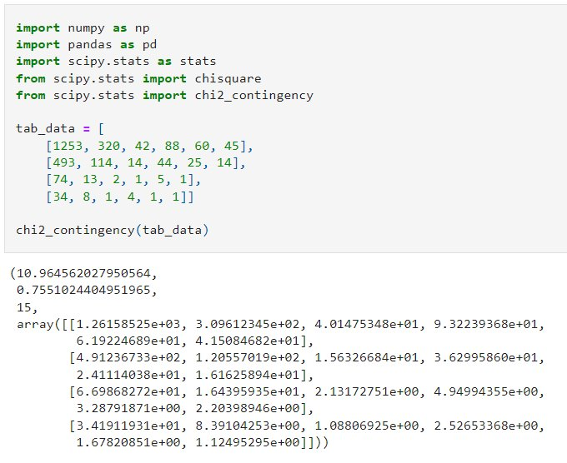

tab_data = [

[1253, 320, 42, 88, 60, 45],

[493, 114, 14, 44, 25, 14],

[74, 13, 2, 1, 5, 1],

[34, 8, 1, 4, 1, 1]]

chi2_contingency(tab_data)

Output:

(10.964562027950564,

0.7551024404951965,

15,

array([[1.26158525e+03, 3.09612345e+02, 4.01475348e+01, 9.32239368e+01,

6.19224689e+01, 4.15084682e+01],

[4.91236733e+02, 1.20557019e+02, 1.56326684e+01, 3.62995860e+01,

2.41114038e+01, 1.61625894e+01],

[6.69868272e+01, 1.64395935e+01, 2.13172751e+00, 4.94994355e+00,

3.28791871e+00, 2.20398946e+00],

[3.41911931e+01, 8.39104253e+00, 1.08806925e+00, 2.52653368e+00,

1.67820851e+00, 1.12495295e+00]]))

The first value, 10.964562027950564, is the chi-squared statistic. This value is important to assess whether the observed frequencies are significantly different from the expected frequencies or not.

The second value, 0.7551024404951965, is the p-value.

The p-value is 0.7551024404951965, which means that there is a 75.5% chance of obtaining the observed result, if the null hypothesis is true.

The p-value is greater than 0.05, which means it is not possible to reject the null hypothesis of independence based on the observed data.

Therefore, there is a high probability of getting the observed frequencies, if the variables (continent and sentiment) are independent.

Therefore, we CAN NOT reject the null hypothesis, since there are no significant dependencies between the continent and sentiment.

The third value, 15, is the degrees of freedom. Calculated by (row-1) * (column-1).

This is several independent ways where observed frequencies allowed to vary.

The final value is an array containing expected frequencies for each cell in the table.

The critical value for the chi-squared statistic with a degree of freedom of 15 and a p-value of 0.05 is 25. The observed chi-squared statistic of 10.964562027950564 does not exceed this critical value, indicating that the observed frequencies are not significantly different from the expected frequencies. This means that it is not possible to reject the null hypothesis of independence between the two variables.

**5 Discussion  
5.1 Result Interpretation**

To determine which continents are good for AI robot digital companion business marketing based on the percentage of sentiment analysis, we could calculate the proportion of sentiments for each continent. We might measure each continent's sentiment % to decide which continents are good for AI robot digital companion marketing promotion.

Divide the number of positive thoughts (946) by the total number (946 + 256 + 603) and multiply by 100 to get a percentage, 51.1% of Americans are positive. To calculate each continent's positive (joy, love), neutral (surprise, sad), and negative (anger, fear) feelings, need to repeat this process.

America has the most favorable feelings (51.1%), followed by Europe (47.2%), Asia (53.3%), and Australia (42.9%). Since America and Asia have strong positive sentiments, AI robot digital companion company marketing have high possibility to be successful there.

The chi-square test findings show that America is associated with Asia and Australia, but not Europa.

America depends on Asia and Australia but not Europe. Europe and Asia have no major relationship, whereas Asia and Australia do. Asia depends on Australia, while Europa is autonomous.

The contingency table's independent variable is the continent, and the dependent variable is emotion. This suggests that the continent (America, Europe, Asia, or Australia) influences the emotion but not vice versa.

If America has more positive sentiments than Europe, this may be attributable to cultural differences, economic situations, or other continent-specific causes. The continent determines the emotion (positive or negative) in (America or Europe).

**5.2 Discussion of Limitations**

This study has several limitations, such as:

* Collected tweets don’t differentiate between age, gender, race, or cultural background.
* This study only looked at tweets written in English. This might not reflect tweets where English is not the language spoken by the majority of people.
* The application of machine learning models for conducting sentiment analysis also comes with a number of potential drawbacks and biases, given that these algorithms are not always accurate and make frequent errors. For example, a model that uses machine learning could have difficulty accurately detecting tweets that contain irony or sarcasm, as well as tweets that show a negative attitude through negation.

Therefore, more study is needed in order to validate the nature of the link between the variables and gain a deeper understanding of the underlying reasons for their relationships.

**6 Conclusion**

**6.1 Summary**

These findings contribute to our understanding of human-machine relationships in different cultural contexts and have implications for the design and use of social robots and other artificial intelligence technologies. Based on the results of this study, it can be concluded that location does not significantly influence people's sentiments towards digital and robot pet companions.

This suggests that businesses marketing AI robot digital companions can focus their marketing efforts in any location without considering the potential impact of location on sentiment. However, It should be noted that the sample size of tweets collected from Africa is too small to accurately evaluate the relationship between location and sentiment in this region.

**6.2 Recommendations for Future Research**

Further research is needed so that we can understand more deeply about other factors that might influence the human-machine relationship regarding robot companions, including other variables such as gender, age, and background cultural dimensions such as power distance, uncertainty avoidance, individualism- collectivism, masculinity-femininity, and short vs. long-term orientation as in Hofstede's Cultural Dimensions Theory. (The 6 Dimensions Model of National Culture by Geert Hofstede, n.d.).

In addition, further studies are needed regarding people's concerns about security and privacy when communicating with digital friends.

# References

# Amazon Alexa - Wikipedia. (2014, November 6). Amazon Alexa - Wikipedia. Retrieved from <https://en.wikipedia.org/wiki/Amazon_Alexa>

# Burkov, A. (2019, January 1). The Hundred-Page Machine Learning Book.

# Burkov, A. (2020, September 8). Machine Learning Engineering.

# Carman. (2019, June 19). They Welcomed a Robot Into Their Family, Now They’re Mourning Its Death - the Verge. Retrieved from <https://www.theverge.com/2019/6/19/18682780/jibo-death-server-update-social-robot-mourning>

# Carman. (2020, July 23). Jibo, the social robot that was supposed to die, is getting a second life. Jibo, the Social Robot That Was Supposed to Die, Is Getting a Second Life - the Verge. Retrieved from <https://www.theverge.com/2020/7/23/21325644/jibo-social-robot-ntt-disruptionfunding>

# Chauhan, V. K., Dahiya, K., & Sharma, A. (2018, January 16). Problem formulations and solvers in linear SVM: a review - Artificial Intelligence Review. SpringerLink. Retrieved from <https://link.springer.com/article/10.1007/s10462-018-9614-6>

# Chi-Square Statistic: How to Calculate It / Distribution. (2021). Statistics How To. Retrieved from https://www.statisticshowto.com/probability-and-statistics/chi-square/

# Chi-square Test in Spreadsheets. 2019. Retrieved from https://www.datacamp.com/tutorial/chi-square-test-in-spreadsheets

# Dangeti, P. (2017, July 21). Statistics for Machine Learning.

# Digital Dream Labs. (n.d.). Digital Dream Labs. Retrieved from <https://www.digitaldreamlabs.com/>

# EMO - LivingAi. (n.d.). LivingAi. Retrieved from <https://living.ai/emo/>

# Frost, J. (2022, January 26). Chi-Square Table. Statistics by Jim. Retrieved from <https://statisticsbyjim.com/hypothesis-testing/chi-square-table/>

# G. (2020, July 23). 10 Techniques to Solve Imbalanced Classes in Machine Learning (Updated 2023). Analytics Vidhya. <https://www.analyticsvidhya.com/blog/2020/07/10-techniques-to-deal-with-class-imbalance-in-machine-learning/>

Hanson, Rick. (2019). Taking in the Good vs. The Negativity Bias

# Joshua, S. (2022, April 25). How to combine multiple CSV files using Python for your analysis. Medium. Retrieved from <https://medium.com/@stella96joshua/how-to-combine-multiple-csv-files-using-python-for-your-analysis-a88017c6ff9e>

# Kuyda. (2017, July 21). The story of Replika, the AI app that becomes you. YouTube. Retrieved from <https://www.youtube.com/watch?v=yQGqMVuAk04>

# MUKHERJEE. (2022). The Maths behind Linear SVC Classifier. Retrieved from <https://www.kaggle.com/code/soham1024/the-maths-behind-linear-svc-classifier>

# Mohri, M., Rostamizadeh, A., Talwalkar, A., & Bach, F. (2012, September 7). Foundations of Machine Learning.

# Nandi, S. (2021, July 1). Twitter Sentiment Analysis Using Machine Learning Approaches. Medium. Retrieved from <https://nandisoham2017.medium.com/twitter-sentiment-analysis-using-machine-learning-approaches-14fba1b8e357>

Mueller, J. P., & Massaron, L. (2021, February 9). Machine Learning for Dummies. For Dummies.

# Pati, & Pradhan. (2020, December 12). Comparison Between Machine Learning Algorithms Used for Sentiment Analysis. *IAEME Publication.* Retrieved from <https://iaeme.com/Home/article_id/IJARET_11_12_026>

# Raschka. (2015). Python Machine Learning Equation Reference. Retrieved from <https://github.com/rasbt/python-machine-learning-book>

# Redjeki, & Widyarto. (2022). View of Comparison of Seven Machine Learning Algorithms in the Classification of Public Opinion. View of Comparison of Seven Machine Learning Algorithms in the Classification of Public Opinion. Retrieved from <https://jurnal.ubd.ac.id/index.php/te/article/view/1046/526>

# Rozin, P., & Royzman, E. B. (2001, November). Negativity Bias, Negativity Dominance, and Contagion. Personality and Social Psychology Review, 5(4), 296–320. <https://doi.org/10.1207/s15327957pspr0504_2>

# Saying Goodbye To My Emo Robot. (2022, November 9). YouTube. Retrieved from <https://www.youtube.com/watch?v=JDQM6E4Vnbs>

# Siemon, Strohmann, Khosrawi-Rad, Elshan, de Vreede, & Meyer. (2022, July 11). Why Do We Turn to Virtual Companions? A Text Mining Analysis of Replika Reviews. AIS Electronic Library (AISeL) - AMCIS 2022 Proceedings: Why Do We Turn to Virtual Companions? A Text Mining Analysis of Replika Reviews. Retrieved from <https://aisel.aisnet.org/amcis2022/sig_hci/sig_hci/10/>

# Tabel Chi Square Atau Chi Square Table Dalam Excel. (2012, July 1). Uji Statistik. Retrieved from https://www.statistikian.com/2012/07/chi-square-tabel-dalam-excel.html

# The 6 dimensions model of national culture by Geert Hofstede. (n.d.). Geert Hofstede. Retrieved from <https://geerthofstede.com/culture-geert-hofstede-gert-jan-hofstede/6d-model-of-national-culture/>

# udiprod. (2007, February 5). SVM with polynomial kernel visualization. YouTube. Retrieved from <https://www.youtube.com/watch?v=3liCbRZPrZA>

Vincent. (2020, January 5). Anki’s toy robots are being saved from a digital death. Anki’s Toy Robots Are Being Saved From a Digital Death - the Verge. https://www.theverge.com/2020/1/5/21050378/anki-vector-saved-shutdown-servers-assets-bought

## Appendices

Appendix directory

Appendix A: Sample exposé Appendix B: Sample title page

Appendix C: Overview duration of thesis paper submission deadlines Appendix D: Declaration of authenticity

Appendix E: Overview of formal specifications

**Source: Adapted from: Perrey, 1998, p. 137.**

Chi-Square Table

____________________________________________________________________

1 Adapted from Table IV of R.A Fisher and F.yates, Statistical tables for Biological, Agricultural and Medical Research, Sixth Ediction, Pearson Education Limited, 1963 R.A.Fisher and F.Yates

# Declaration of Authenticity

I hereby declare that I have completed this Bachelors/ Master’s thesis on my own and without any additional external assistance. I have made use of only those sources and aids specified and I have listed all the sources from which I have extracted text and content. This thesis or parts thereof have never been presented to another examination board. I agree to a plagiarism.

.

check of my thesis via a plagiarism detection service.

Place, Date

Student signature