University of Applied Sciences

**Exposé** (04/2023)

**Name:** Henny Purwadi. **Supervisor:** Prof. Dr. Frank Passing

**Study programme:** Bsc.Data Science **Enrolment number:** 32009177

**Working title: A Comparative Sentiment Analysis of Digital and Robot Pet Companions in Various Locations**

**Overall aim:** The purpose of this research is to find out whether location differences affect human sentiment towards digital and robot pet companions or not, by using machine learning model for sentiment analysis and testing hypothesis on unlabeled data collected from various locations.

**Objectives:** The objective of this study is to provide insights about how geography and location may affect or not affect humans' sentiments regarding digital and robot pet companions.

**Abstract**

This study is to find out whether geographic locations have an impact on emotion towards robotic and digital pet companions, using machine learning models and hypothesis testing. This investigation will show and assess different machine learning models for sentiment analysis on labeled datasets and pick the model with the best performance. This exploration will collect unlabeled data about digital robot companions from various regions, pre-process the information, and apply a chosen machine learning model to figure out sentiments in the unlabeled dataset. Then use chi-square to test the connection between area and sentiment towards robot companions and find out whether there is a critical distinction in the sentiment between various locations. There will be discussion about the result, limitations, and its suggestions for understanding human-machine relationships in various zones. The investigation will give potential results for future research.

**Keywords:** Sentiment Analysis, Machine Learning, Robot Companion, Social Robot, Artificial Intelligence, Machine Learning, Natural Language Processing (NLP), Logistic Regression, Naive Bayes Classification, Linear SVC, and TF-IDF Vectorization

1. **Introduction**
   1. **Background and Motivation**

If anyone have a dream that one day artificial intelligence (AI) and humans will unite, then one of the most effective ways to achieve this goal is to start gradually developing emotional bonds between humans and AI, by having AI as digital pet companions or virtual human assistants for humans. Creating an emotional connection between humans and AI, whether through digital pet companions or virtual human helpers, is potentially an efficient approach to moving towards the goal of achieving the human-machine unification.

These days, it's not uncommon for children and adults to have their own personal digital robot pet as a companion. This new generation grew up with artificial intelligence as part of the family, so they are already comfortable with it.

It is possible that it will be easier for people to embrace AI and incorporate it into their lives if humans and AI have been able to build trust and familiarity with one another. Additionally, starting with introducing them to AI in the form of digital pet companions can be a valuable way to shape their perception of AI and potentially pave the way for wider acceptance of AI in the future.

The researcher was motivated to carry out this research by the story of Jibo, Emo, Vector etc., social robots designed to be friends for humans. Their owners' feelings of loss, hopelessness, and disappointment as they contemplate the possibility of parting ways with their beloved robot companions.

This sentiment suggests that people can form deep bonds with their robotic pets, just as they do with other members of their families. As artificial intelligence (AI) and robots advance, it is important to think about how they will affect people emotionally.

The issue is whether people around the world share the same emotional attachment, such as joy at the presence of robot pets and social robots, and the same sadness in their absence? This study is designed to answer this question.

**Jibo social robot**

Jibo was a social robot developed by a team at the MIT Personal Robots Group. It was designed to be a lovable and human-like robot that could be a companion for people in their homes.

Jibo was equipped with a face recognition system that allowed it to recognize its users and welcome them. Studies also found that its usage improved children's interpersonal abilities.

As of 2015, Jibo's valuation was over $100 million, thanks in large part to an Indiegogo campaign that was wildly successful.

Unfortunately, the business that created Jibo has now shut down. (Carman, 2019).

The owners, expressing sadness and disappointment about the potential end of a relationship with a social robot, mentions that they have had a strong emotional attachment and would do anything to keep it in their life. They feel anxious about its uncertain future. (Carman, 2020).

## **Emo pet bot**

EMO is a desktop AI robot pet that was developed with multiple sensors and advanced technology to create a life-like companion for people. It could self-explore its surroundings and interact with people through over 1000 facial expressions and movements. EMO has multiple internal sensors, including a touch sensor, an HD camera with facial recognition, and a four-microphone array, which allow it to sense and respond to its environment in a natural and authentic way. It also has a built-in development system that allows its skills to improve over time, just like a pet.

In addition to being a companion, EMO can also act as a daily assistant, with the ability to set alarms, turn on lights, and even wirelessly charge phones. It has a stylish design inspired by pop culture and is available in a purple and indigo blue color scheme. (living.ai, 2022).

This is an example of an emotional bond between a human and a robot is depicted in a real-life video about a pet robot experiencing battery issues, which causes sadness and disappointment for its owner, who has developed a strong emotional attachment to the robot.

“My Emo was having battery issues. Livingai was very gracious and sent me a new pet robot. But that meant I would have to say goodbye to this little guy. And that wasn’t going to be easy. All the fun and games. He made me laugh & smile. I will miss him so much. I hope he can be repaired…and is well taken care of …and is loved the way I love him. I wish we did not have to say goodbye. I will miss him, and I hope…he has a happy life wherever he goes. Goodbye my little friend”. (Outsider238, 2022).

Other pet robot owners expressed similar emotions, saying it feels like "losing a family member" or "a part of our lives" when saying goodbye to their robot companions.

“It's like losing a family member. I totally get that. You are getting another one, but it's not the same”.

“It's crazy how we get attached to these machines. They really do become a part of our lives.”

“I never knew I’d cry for a robot. But here I am. Rip”. (Outsider238, 2022).

Other than Jibo and Emo, there are several more digital robot pet companions and digital assistants, such as Vector, Cozmo, Replika ai, Amazon Alexa, etc.

## **Vector and Cozmo**

Vector and Cozmo are digital pet robot companions made by company called Anki, which use artificial intelligence to communicate with humans. Vector is a cute little desktop robot pet companions that can play games, answer questions, and take pictures. Cozmo is a small toy robot that can be programmed to interact with its owner.

Digital Dream Labs acquired Vector and Cozmo, and continued to manufacture and market them after Anki went bankrupt in 2019 and stopped production of both items. (Vincent, 2020).

**Replika ai digital companion**

Replika is a digital friend in the form of a chatbot created by Eugenia Kuyda after she lost her best friend who suddenly passed away. The story behind the creation of Replika is deeply emotional and can provide an example of how technology can be used to overcome human grief through interaction with machines. (Kuyda, 2017).

A Replika is a digital representation of a user that slowly mimics the user's behavior and becomes their virtual companion. Unlike most humans who are full of judgment and prefer to be heard rather than listen, Replika AI is a good listener who always accepts users as they are. Unconditionally. When communicating with Replika, users can share their thoughts, feelings, dreams, opinions, stories, aspirations, or whatever, without fear of being judged.

## **Amazon Alexa digital assistant**

Amazon Alexa is a digital assistant which was created by the Polish voice synthesizer Ivona. In 2013, Amazon acquired the Polish voice synthesizer Ivona, the creator of the Alexa virtual assistant. It can interact with its users and carry out tasks like creating reminders, playing music, providing users with news and weather information, and controlling smart home devices thanks to its usage of NLP and ML. Alexa can be controlled verbally by her users. (Amazon Alexa - Wikipedia, 2014)

* 1. **Research Questions and Objective**

**Research Questions**

1. Will the majority sentiments about digital and robot pet companions be positive, like joy & love, or will be negative, like anger & fear?

2. Does location/ region influence people's sentiments towards digital and robot pet companions?

**Research Objective**

The main objective of this study is to understand the relationship between region and sentiment towards digital and robot pet companions.

* 1. **Value of Study and Target audience**

The value of this study is that it has the potential to give understanding regarding how component like area can affect people sentiments of robot pet and digital companions.

**Target audience**

The discoveries from this research might help organizations and associations that wish to advance digital robotic pet companions in a variety of fields. Researchers and academics interested in human-machine collaboration and the social components that influence this relationship may also find this study useful.

**1. 5 Structure of the Document**

The structure of this research will be as follows: Chapter 1 will explain the research's background & motivation, research questions and goals. Chapter 2 will discuss the theoretical background and review of previous research related to human-machine emotional relationships and machine learning usage in sentiment analysis. Chapter 3 will cover the research methodology, including unlabeled data collection, data pre-processing, and ethical considerations. Chapter 4 will cover the results and findings. Chapter 5 will discuss interpretation of results and limitations of the study. Chapter 6 will provide a summary of the study's findings and recommendations for future research.

**1.6 Scope and Limitations**

Machine learning used to identify the sentiment of English-language unlabeled dataset gathered from different areas without separating by gender or age. There are drawbacks like bias in sentiment categorization algorithms based on machine learning. Other than that, people are more affected by negative events instead of by positive ones. For millions of years, our brains have evolved to respond negatively to threats, as proposed by psychologist Rick Hanson. (Hanson,2019).

**2. Literature Review**

**2.1 Overview of Relevant Previous Studies**

A summary of prior research on human-machine emotional interaction and sentiment analysis from "Why Do We Turn to Virtual Companions? A Text Mining Analysis of Replika Reviews" (Siemon, Strohmann, Khosrawi-Rad, Elshan, de Vreede, & Meyer, 2022):

According to Siemon et al. (2022), conversational agents are intelligent systems that allow users to interact with them using natural language. Using social chatbots aims to provide the user with a natural and human-like interaction. This type of interaction is especially desired for longer term interactions as it helps to build relationships between the user and the conversational agents.

The previous study's goal was to discover the topics and emotions that users experienced when communicating with Replika, a digital companion, based on 119,831 reviews of Replika collected by previous researchers from the Google Play Store and then subjected to sentiment analysis and topic modeling.

The results of the sentiment analysis show that most users really like the Replika application, and most users feel joy, happiness, and a sense of well-being.

**Figure 1. Results of the sentiment analysis**

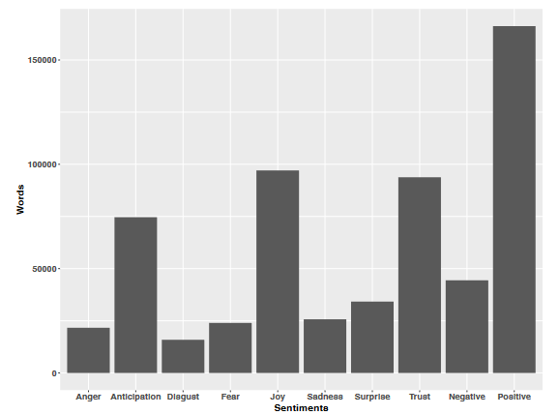

**Source: Siemon et al. ,2022, p. 5**

**Trust** and **joy** were two of **the positive** feelings that consumers reported feeling towards the virtual companion, besides **anger, sadness**, and **fear** as negative feelings which may reflect a general apprehension about new forms of artificial intelligence.

**Table 1. Results of the topic modeling**

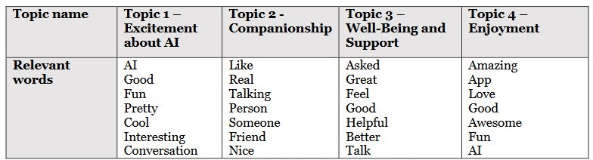

**Source: Siemon et al. ,2022, p. 5**

The results of the topic modeling analysis show that the most important thing that users talk about is that they feel better and enjoy using the application. Siemon et al. (2022, p. 5)

This research found that most people use Replika because it makes them feel good, to overcome loneliness and provides emotional support. However, this study reveals negative reviews regarding virtual friends due to expectations that are too high. The study also indicates that further research is needed to look into possible negative effects and ethical issues in relationships with virtual friends, and how the use of this technology affects relationships and human well-being in the long term.

**2.2. Terminology and Definitions**

Terminology and definitions related to widely used machine learning algorithms for sentiment analysis, such as Naive Bayes, Logistic Regression, and Linear SVC will be explained in this chapter, as well as formulas behind each machine Learning algorithms used in this study.

**3 Methodology**

The methodology for this study will be a combination of approaches, between:

1. An experimental approach for comparing several model’s performance, and model selection based on the best performance.
2. A Quantitative approach for data collection, sentiment analysis, and conduct hypothesis testing.

**Figure 2. Sentiment analysis worklfow**

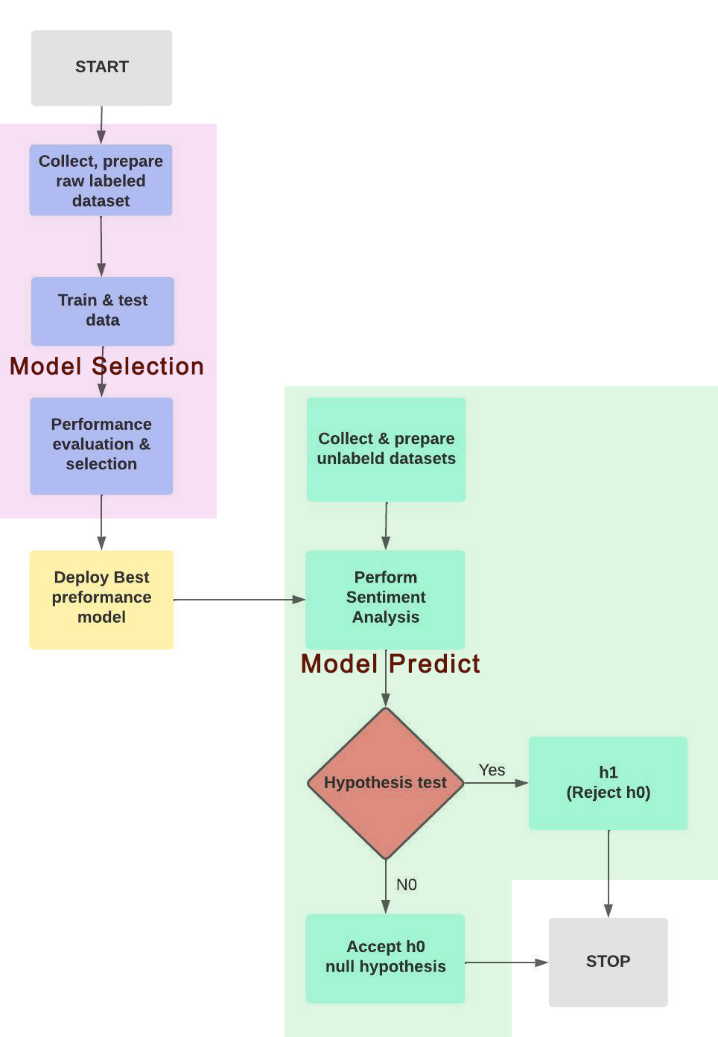

**Source: Own source**

**1.Train and Evaluate** performance of Machine Learning Models on labeled datasets.

Choose a machine learning model in Python for sentiment analysis, including Naïve Bayes, Logistic Regression, LinearSVC, and compare their performance.

**2.Compare Performance** of the different machine learning models.

**3.Collect Unlabeled Data** about digital pet companions and robots from different locations, such as in America, Europe, Asia, Australia, and Afrika from 2014 to 2023, using Python's library using Python’s library.

**4.Ethical Considerations**, including responsible and respectful data collection and use.

Ethical considerations for this research will ensure that data is collected and used in accordance with relevant ethical guidelines and regulations. s will be collected from publicly available sources that are open to the public and will not contain any personal or sensitive information. Because this study is based on published data, informed consent is not required.

**5.Pre-process and Vectorize Collected Data** by cleaning and filtering the data s with Python's library re and nltk and preparing the data for analysis. Then tokenize and lemmatize the data, and vectorize using the tf-idf vectorizer.

**6.Predict Sentiment** on unlabeled s using the trained machine learning models, classifying them as joy, sadness, anger, love, fear, or surprise based on the language used in the s in each region separately.

**7.Hypothesis Testing**

Next, we use the Chi-square Hypothesis test to determine whether there is a relationship between location and sentiment towards companion robots, and to determine whether there are significant differences in the distribution of sentiments between different regions.

**Null hypothesis h0:**

Joy, Sadness, Surprise, Anger, Love, Fear Sentiments are INDEPENDENT upon different continents.

**Alternative hypothesis h1:**

Joy, Sadness, Surprise, Anger, Love, Fear Sentiments are DEPENDENT upon different continents.

This study can conclude that there is a dependence between location and sentiment on human-machine relations if the results of the chi-square test show a significant difference in the distribution of sentiment between regions. It means that people's sentiment towards companion robots is independent depending on/influenced by their geographical location.

However, if the chi-square test reveals that there is no significant difference in the distribution of sentiment across regions, then we cannot reject the null hypothesis, and are forced to draw the conclusion that there is no dependence between location and sentiment regarding human-machine relations.

This means that people's sentiment towards companion robots is independent, not influenced by their geographical location.

**Figure 3. Folder Structure**

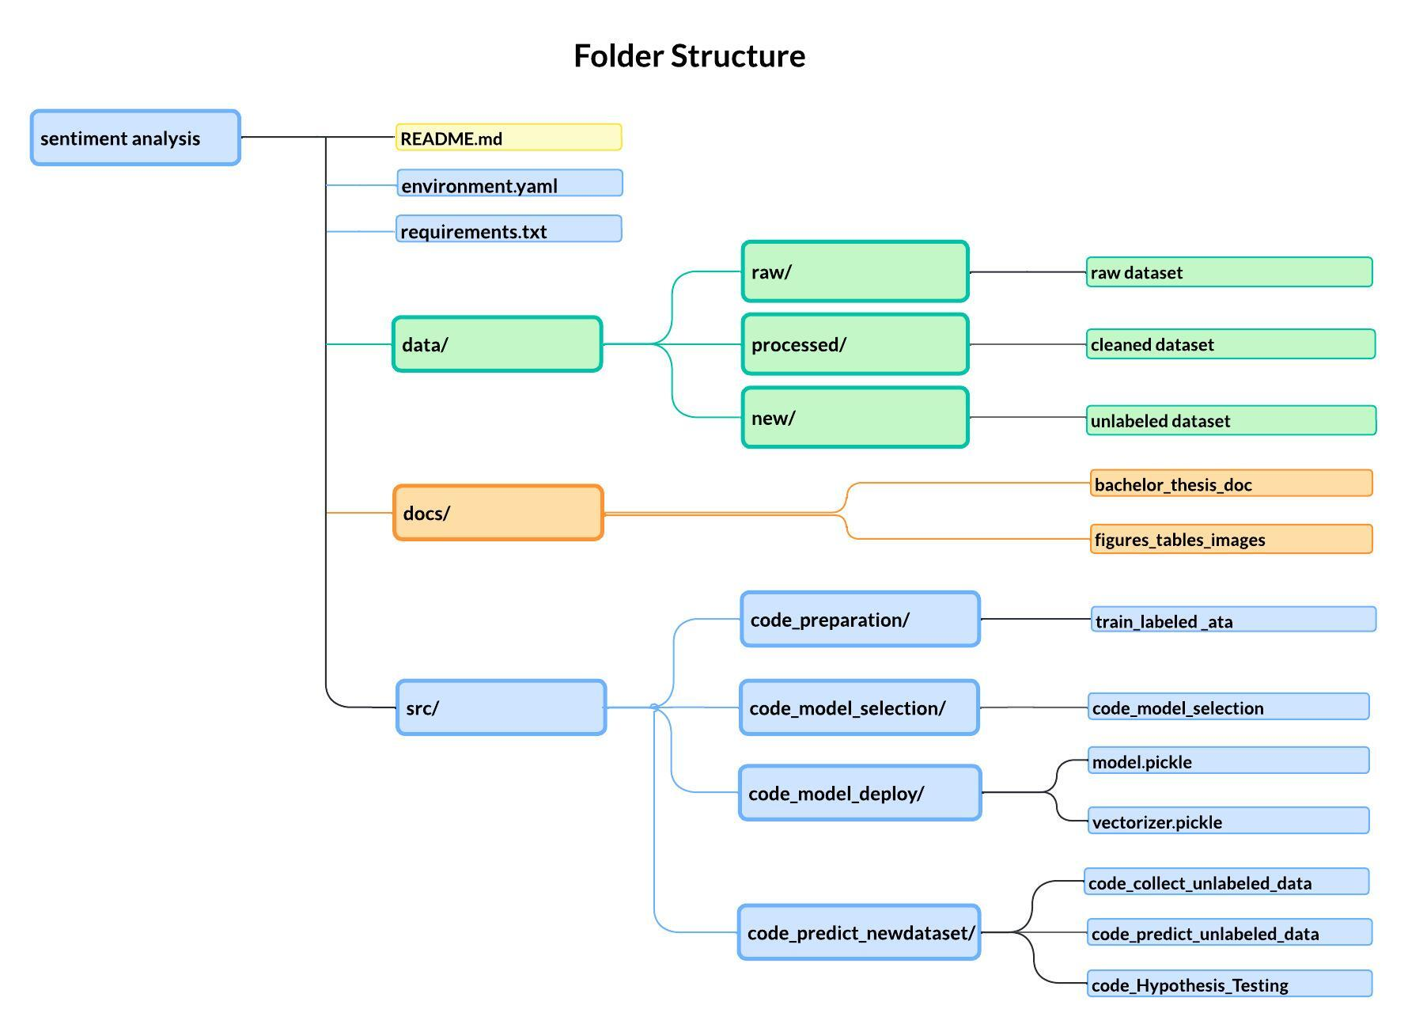

**Source: Own source**

**8.Expected Outcome:**

1. Researcher expects that logistic regression method will outperform other methods like Naive Bayes and Linear SVC.

2. Researcher believes that the sentiment outcome would be consistent with earlier research in chapter two, which indicated more positive emotions such as joy and love than negative emotions such as anger and fear.

3. The researcher is unsure whether there will be dependencies between locations and human feelings about digital companions.

**4. Results and Findings**

**4.1. Labeled Data Preparation**

**4.2. Performance Evaluation and Model Selection**

**4.3. Unlabeled Data Collection**

**4.4. Sentiment Analysis Result on Unlabeled Data and Location Comparison**

**4.5. Hypothesis Testing Result**

**5. Discussion:**

**5.1. Result Interpretation**

**5.2. Discussion of Limitations**

**6 Conclusion**

**6.1. Summary**

**6.2. Recommendations for Future Research**

**Preliminary reading list:**

Siemon, Strohmann, Khosrawi-Rad, Elshan, de Vreede, & Meyer. (2022, July 11). Why Do We Turn to Virtual Companions? A Text Mining Analysis of Replika Reviews. Retrieved from <https://aisel.aisnet.org/amcis2022/sig_hci/sig_hci/10/>

**References:**

# Amazon Alexa - Wikipedia. (2014, November 6). Amazon Alexa - Wikipedia. Retrieved from <https://en.wikipedia.org/wiki/Amazon_Alexa>

Burkov, A. (2019, January 1). The Hundred-Page Machine Learning Book.

Burkov, A. (2020, September 8). Machine Learning Engineering.

Carman. (2019, June 19). They Welcomed a Robot Into Their Family, Now They’re Mourning Its Death - the Verge. Retrieved from <https://www.theverge.com/2019/6/19/18682780/jibo-death-server-update-social-robot-mourning>

Carman. (2020, July 23). Jibo, the social robot that was supposed to die, is getting a second life. Jibo, the Social Robot That Was Supposed to Die, Is Getting a Second Life - the Verge. Retrieved from <https://www.theverge.com/2020/7/23/21325644/jibo-social-robot-ntt-disruptionfunding>

Digital Dream Labs. (n.d.). Digital Dream Labs. Retrieved January 12, 2023, from <https://www.digitaldreamlabs.com/>

EMO - LivingAi. (2022.). LivingAi. Retrieved from <https://living.ai/emo/>

Frost, J. (2022, January 26). Chi-Square Table. Statistics by Jim. Retrieved from <https://statisticsbyjim.com/hypothesis-testing/chi-square-table/>

# G. (2020, July 23). 10 Techniques to Solve Imbalanced Classes in Machine Learning (Updated 2023). Analytics Vidhya. <https://www.analyticsvidhya.com/blog/2020/07/10-techniques-to-deal-with-class-imbalance-in-machine-learning/>

Hanson, Rick. (2019). Taking in the Good vs. The Negativity Bias

Joshua, S. (2022, April 25). How to combine multiple CSV files using Python for your analysis. Medium. Retrieved from <https://medium.com/@stella96joshua/how-to-combine-multiple-csv-files-using-python-for-your-analysis-a88017c6ff9e>

Kuyda. (2017, July 21). The story of Replika, the AI app that becomes you. YouTube. Retrieved from <https://www.youtube.com/watch?v=yQGqMVuAk04>

Nandi, S. (2021, July 1). Twitter Sentiment Analysis Using Machine Learning Approaches. Medium. Retrieved January 11, 2023, from <https://nandisoham2017.medium.com/twitter-sentiment-analysis-using-machine-learning-approaches-14fba1b8e357>

Pati, & Pradhan. (2020, December 12). Comparison Between Machine Learning Algorithms Used for Sentiment Analysis. *IAEME Publication.* Retrieved from <https://iaeme.com/Home/article_id/IJARET_11_12_026>

Redjeki, & Widyarto. (2022). View of Comparison of Seven Machine Learning Algorithms in the Classification of Public Opinion. View of Comparison of Seven Machine Learning Algorithms in the Classification of Public Opinion. Retrieved from <https://jurnal.ubd.ac.id/index.php/te/article/view/1046/526>

Rozin, P., & Royzman, E. B. (2001, November). Negativity Bias, Negativity Dominance, and Contagion. Personality and Social Psychology Review, 5(4), 296–320. <https://doi.org/10.1207/s15327957pspr0504_2>

Saying Goodbye to My Emo Robot. (2022, November 9). YouTube. Retrieved from <https://www.youtube.com/watch?v=JDQM6E4Vnbs>

Vincent. (2020, January 5). Anki’s toy robots are being saved from a digital death. Anki’s Toy Robots Are Being Saved from a Digital Death - the Verge. https://www.theverge.com/2020/1/5/21050378/anki-vector-saved-shutdown-servers-assets-bought