  - Assessing the Impact of Documenting Dataset Composition for Model Training—Whether Imbalanced or Balanced—on AI Model Transparency and Fairness
  - Examines Bias and Unfairness in Explainable Artificial Intelligence (XAI) Resulting from Imbalanced Training Datasets

Henny Purwadi
MSc Artificial Intelligence
University of Hull
United Kingdom
h.purwadi-2022@hull.ac.uk

ABSTRACT
In the field of responsible AI, ensuring transparency and fairness is very important for developing ethical AI systems. Traditionally, responsible AI and explainable AI (XAI) have concentrated on explaining model decisions as well as the quality and appropriateness of data sources, including ethical, legal, and social aspects. However, they have not addressed the composition of the dataset, especially whether it is balanced or imbalanced. This paper analyzes the importance of incorporating dataset composition documentation into XAI practices, aiming for comprehensive transparency at both the data and model levels, rather than only focusing on data sources and model explainability. It is also important to explain and document the dataset composition used for model training, rather than only focusing on data source, data quality, and relevance, for AI to be open and accountable. If the training dataset is imbalanced, machine learning models can't make accurate predictions. This paper analyzed the impact of dataset composition, whether balanced or imbalanced, to reduce bias and unfairness in model predictions. This study proposes the incorporation of dataset composition documentation into responsible AI practices, with the aim of enhancing transparency at both the data and model levels, reducing biases, enhancing fairness, and increasing stakeholder trust in AI systems.

CCS CONCEPTS
• Responsible AI • Fairness and accountability •Ethics in AI

KEYWORDS
Balance Dataset, Bias Mitigation, Dataset Composition, Dataset Documentation, Ethics in AI, Explainable AI (XAI), Fairness, Imbalance Dataset, Model Transparency, Responsible AI.
1 Introduction
During several years, the growing adoption of artificial intelligence (AI) in critical decision-making processes has sparked debates about accountability, transparency, and fairness.

The Conference Board (2023) wrote about the importance of Explainable AI (XAI) for increasing trust and transparency in AI decision-making. The article highlights how XAI addresses the traditional "black box" nature of AI by providing understandable insights into the AI processes. This transparency is crucial for enhancing trust, compliance, and ethical use of AI in various industries.

The three key aspects of Explainable AI (XAI) are Trustworthiness, Equitability, and Explainability.

In Trustworthiness, XAI ensuring safeguards, privacy measures, and responsible practices to build user confidence, especially when sensitive data is involved.

For Equitability, XAI also addresses the societal and ethical aspects of AI, such as fairness, ethical concerns, legal compliance, human-computer interaction, and social impact of AI. This focus aims to ensure that AI systems are fair and equitable. In the model interpretability, much of the focus has been on explaining how models make decisions, while limited attention has been given to the dataset composition used in model training.

In Explainability, XAI focuses on making AI systems less of a "black box" by providing insights into how decisions are made. For Trustworthiness, it is ensuring the safety and trustworthiness of AI systems like privacy measures, and responsible practices to build user confidence, particularly when sensitive data is involved.

Currently, Explainability AI concerns itself with the source of data, emphasizing the quality and appropriateness of data used in AI systems. It focuses on the ethical, legal, and social aspects of AI, ensuring that the data is relevant and suitable for the intended purpose, and focuses on understanding and interpreting how AI models make decisions. However, existing Responsible AI frameworks do not explicitly address whether the datasets used are balanced or imbalanced.

This research adds a new dimension to this by documenting and analyzing the composition of training datasets—whether balanced or imbalanced—and how that affects model transparency, bias, and fairness.

The composition of a dataset, including whether it is balanced or imbalanced, can significantly impact model outcomes, potentially leading to biased or unfair predictions.

Imbalanced datasets, where certain classes are underrepresented, can result in AI models that are disproportionately optimized for the majority class, failing to accurately predict outcomes for minority classes. Such biases are particularly concerning high-stakes domains such as healthcare, hiring, and criminal justice, where fairness is imperative.
2 Literature Review
2.1 Heading Level 2

The study by Miao, Y., Cao, H., and Tang, M. (2022) presents a method for analyzing the performance impact of imbalanced binary data on machine learning models.
The authors systematically analyzed how the imbalance ratio (IR) affects model performance and stability. They employed imbalanced data augmentation algorithms to create datasets with varying imbalance ratios and used metrics like AUC, F-measure, and G-mean to evaluate model performance.
The findings reveal that as the imbalance ratio increases, model performance generally declines, with some models being more susceptible to imbalances than others. Specifically, models like Logistic Regression (LR), Decision Trees (DT), and Support Vector Classifiers (SVC) exhibited less stability, whereas Naive Bayes (BNB), Random Forests (RF), and Gradient Boosting Decision Trees (GBDT) showed relatively stable performance.
The study suggests that addressing data imbalance is very important for maintaining reliable machine learning models, especially in critical applications.

Logistic Regression Formula

(1)
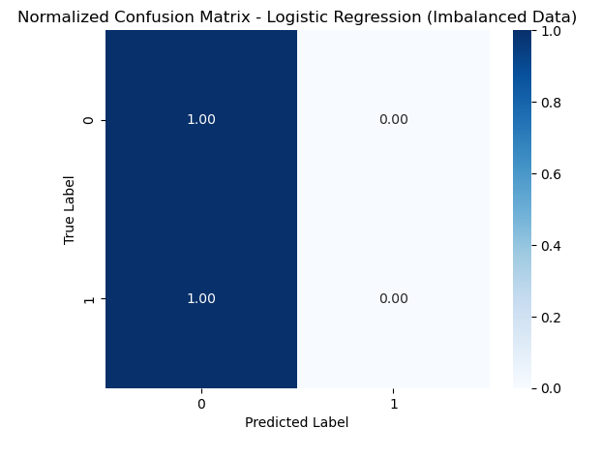
Figure 1: Normalized Confusion Matrix of Logistic Regression Model using Imbalanced Dataset

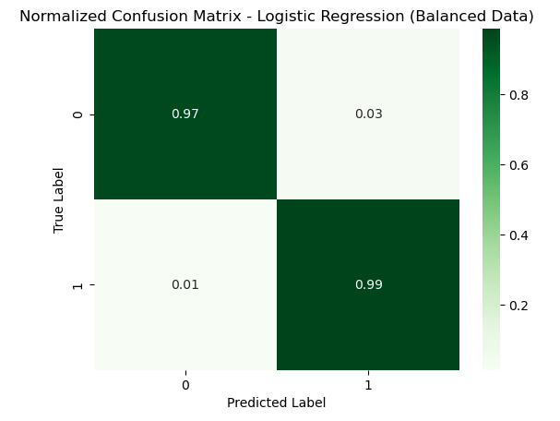
Figure 2: Normalized Confusion Matrix of Logistic Regression Model using Balanced Dataset

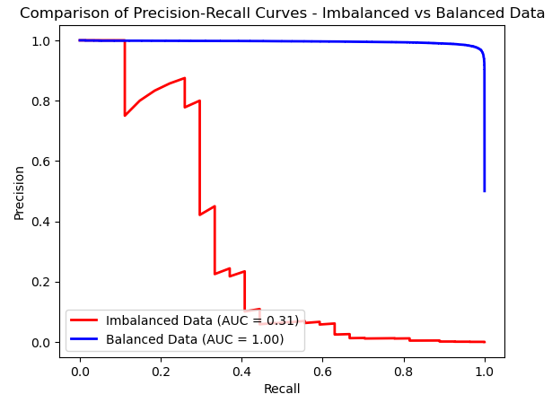
Figure 3: Comparison of Precision-Recall Curve using Imbalanced Data versus Balanced Data

1.1 Heading Level 2
In the below paragraph, it is explained how alt-txt value is placed in MS Word 2010. To add alternative text to a picture in Word 2010, follow these steps:
- In a Word 2010 document, insert a picture.
- Right click on the inserted picture and select the Format Picture option.
- Select the Alt Txt option from the left-side panel options.
- In the "Title:" and "Description:" text boxes, type the text you want to represent the picture, and then click "Close".
Below are steps to place alt-txt value in MS Word 2013/2016. To add alternative text to a picture in Word 2013/2016, follow these steps:
- In a Word 2013/2016 document, insert a picture.
- Right click on the inserted picture and select the Format Picture option.
- In the settings at the right side of the window, click on the "Layout & Properties" icon (3rd option).
- Expand Alt Txt option.
- In the "Title:" and "Description:" text boxes, type the text you want to represent the picture, and then click "Close".
1.1.1 Heading Level 3. Insert paragraph text here. Insert paragraph text here. Insert paragraph text here. Insert paragraph text here. Insert paragraph text here. Insert paragraph text here. Insert paragraph text here. Insert paragraph text here. Insert paragraph text here. Insert paragraph text here. Insert paragraph text here.
1.1.1.1 Heading Level 4. Insert paragraph text here. Insert paragraph text here. Insert paragraph text here. Insert paragraph text here. Insert paragraph text here. Insert paragraph text here. Insert paragraph text here. Insert paragraph text here. Insert paragraph text here. Insert paragraph text here. Insert paragraph text here.
ACKNOWLEDGMENTS
I would like to express my gratitude to all mentors and advisors in University of Hull for their guidance through the development of this research. I also wish to thank my colleagues at the University of Hull for their support, which really improved the quality of this work. Special thanks go to my families and friends for their understanding during this research. Thank you for inspiring me to contribute to the field of Responsible AI.
REFERENCES
[1] Dadkhahnikoo, Neama. (2019-11-11). Incident Number 92. In McGregor, S. (ed.) Artificial Intelligence Incident Database. Responsible AI Collaborative. Retrieved on October 12, 2024, from https://incidentdatabase.ai/cite/92.
[2] Hensman, P., Masko, A. 2015. Survey deep learning with class imbalance. Journal of Big Data, 2(1). DOI:
[2] Lee, Y., Sun, H. 2023. A survey on imbalanced learning: latest research, applications, and future directions. Artificial Intelligence Review, 56(4), 721–739. DOI:
[3] Murphey, Y., Anand, S. 2021. The class imbalance problem in deep learning. Machine Learning, 44(3), 123–134. DOI:
[4] Miao, Y., Cao, H., Tang, M. 2022. A method for analyzing the performance impact of imbalanced binary data on machine learning models. Axioms, 11(11), 607. DOI: https://doi.org/10.3390/axioms11110607
[5] Miao, Y., Cao, H., Tang, M. 2022. A method for analyzing the performance impact of imbalanced binary data on machine learning models. Axioms, 11(11), 607. DOI: https://doi.org/10.3390/axioms11110607
[6] NIST. 2021. Four Principles of Explainable Artificial Intelligence. National Institute of Standards and Technology (NIST) Internal Report 8312, 1–23. Available at: https://nvlpubs.nist.gov/nistpubs/ir/2021/NIST.IR.8312.pdf
[7] The Conference Board. (2023). Explainability in AI: The Key to Trustworthy AI Decisions. Retrieved from https://www.conference-board.org/publications/explainability-in-ai.

https://github.com/hennypurwadi/Imbalanced-or-Balanced-Dataset-Composition

