  - Assessing the Impact of Dataset Characteristics—Homogeneity Composition and Data Sparsity—on AI Model Transparency, Fairness, and Bias Evaluation
  - Examining Bias and Unfairness in Explainable Artificial Intelligence (XAI) Due to Imbalanced Training Data and Misleading Effects of Small Sample Sizes

Henny Purwadi
MSc Artificial Intelligence
University of Hull UK
h.purwadi-2022@hull.ac.uk

ABSTRACT
In responsible AI, ensuring transparency and fairness is very important for developing responsible AI systems. Data characteristics are becoming increasingly important within the field of Explainable AI (XAI), but currently it is not a standard practice. Documenting the characteristics of the dataset, including its homogeneity composition and Data Sparsity, is critical for a comprehensive approach to XAI. If the training dataset is imbalanced, machine learning models cannot make accurate predictions, while the small sample sizes can mislead the bias evaluation. Traditionally, responsible AI and explainable AI (XAI) have more concentrated on explaining model behaviors, including ethical, legal, and social aspects of the datasets. This study proposes the incorporation of dataset characteristics to be documented into Responsible AI and Explainable AI (XAI) practices, especially the homogeneity composition, whether the dataset is balanced or imbalanced, and data sparsity, whether small or large samples, for transparency at both the data and model levels, rather than only focusing on data sources and model explainability. The purpose is for AI to be open and accountable, enhancing fairness, and at the end is to increase people’s trust in AI systems.

CCS CONCEPTS
• Computing Methodologies • Artificial Intelligence (AI) • Explainable AI (XAI)
KEYWORDS
Balance Dataset, Bias Mitigation, Dataset Composition, Dataset Documentation, Explainable AI (XAI), Fairness, Imbalance Dataset, Local Interpretable Model-Agnostic Explanation (LIME), Model Transparency, Responsible AI.
1 Introduction
Currently, the decision-making process in artificial intelligence (AI) raised several discussions about AI’s accountability, transparency, and fairness, especially in important domains like healthcare, hiring, and criminal justice, where the consequences of biased decisions could be fatal.

The Conference Board (2023) discussed about the significance of Explainable AI (XAI) in increasing trust and transparency in AI decision-making. XAI addresses the traditional "black box" nature of AI systems, helping to gain trust, compliance, and the ethical use of AI across many industries.

The key aspects of Explainable AI (XAI): Trustworthiness, Equitability, Explainability. Trustworthiness is focus on safeguarding data privacy and promoting responsible AI practices to build user confidence. Equitability is to ensure the fairness and legal compliance in societal and ethical dimensions of AI. Explainability gave insights into how AI systems arrive at their decisions, gave the opacity of AI models.

Most focus on AI fairness are on explaining model decisions rather than the characteristics of the datasets used in training. XAI traditionally focused on the quality and appropriateness of the data used in AI system, while the characteristics of training datasets—whether balanced or imbalanced—has received limited attention.

This research explores the impact of the characteristic of training datasets, especially of homogeneity composition whether they are balanced or imbalanced, number of classes, and data sparsity whether the datasets are small or large (Oreski, D., Oreski, S., and Klicek, B. 2016), and how this affects model transparency, bias, and fairness.

RESEARCH QUESTIONS
1. How does the dataset homogeneity composition (balance vs. imbalanced) impact the AI model transparency and fairness in decision-making systems?
2. How does the data sparsity/ dataset’s size (Large versus small) influence the accuracy of bias evaluation in AI models, when the training data is class-imbalanced?
2 Literature Review
2.1 Overview of Previous Study
The research studied by Miao, Y., Cao, H., and Tang, M. (2022) focuses on the technique to evaluate the impact that imbalanced binary data on the performance of machine learning models. In their investigation, they investigated how the imbalance ratio (IR) influences the performance and stability of the model.

To build datasets with variable imbalance ratios, they applied imbalanced data augmentation algorithms. They utilized measures such as area under the curve (AUC), F-measure, and G-mean to evaluate the effectiveness of the model. Based on their investigation, their result found out that as imbalance ratio increases, the model performance declines.

Some models being more affected by imbalances than other models. For example, models like Logistic Regression, Decision Trees, and Support Vector Classifiers show less stability, while Naive Bayes, Random Forests, and Gradient Boosting Decision Trees showed more stable performance. The study analyzed that addressing data imbalance is very important for maintaining reliable machine learning models, especially in critical applications.

The study by Johnson and Khoshgoftaar (2019) provides a survey on deep learning methods to handle class imbalance. The authors wrote about challenges of high-class imbalance in real-world applications, such as medical diagnosis and fraud detection, where the minority class is often of greater interest.

The survey reviews existing deep learning approaches, including data-level techniques like oversampling and under sampling, beside algorithm-level methods such as cost-sensitive learning and hybrid methods. The authors identify gaps in current research of deep learning methods for imbalanced data and the need for more diverse applications (Johnson and Khoshgoftaar, 2019).

The study by Lin (2018) with title "Bias caused by sampling error in meta-analysis with small sample sizes" warned the challenges caused by small sample sizes in meta-analyses.

Too small sample sizes can create significant bias. This study advises caution when used very small sample sizes, which could lead to misleading conclusions related to bias and fairness.

2.1 Terminology and Definition
2.2.1 Local Interpretable Model-Agnostic Explanation
LIME (Local Interpretable Model-Agnostic Explanations) is a method which goal is to simplify the explanation of the predictions of the complex "black-box" machine learning models in a simpler way.
LIME Formula:
explanation(x)=argmin​ L(f,g,πx​)+Ω(g) (1)
g∈G
2.2.2 Logistic Regression
Logistic regression is a probabilistic classifier model which converts input characteristics into an output probability between of 0 to 1, rendering it suitable for binary classification applications. To train the model, Logistic Regression optimizes a cross-entropy loss function using stochastic gradient. Logistic Regression is usually used as a baseline supervised learning algorithm for classification tasks (Jurafsky, D., & Martin, J. H. 2024).

Logistic regression formula:

P (y=1|x) = 1 / (1 + e^ (-w^T x - b)) (2)

y = target class, while x is the feature, w is the weight vector, and b is the bias term.
P (y = 1|x) is a conditional probability.

2.2.3 Classification Report and Confusion Matrix

Classification report is a summary of the model’s performance, which compared the model's performance to other models, or understanding where the model might be struggling. (Burkov, A., 2019).

Accuracy shows the overall correctness of the model.
The F1-score is the precision and recall’s harmonic mean.
Precision-Recall Area Under the Curve (AUC) is a performance metric which combines recall and precision become a single value, summarized about how well the model is performs.
Precision answers the question about how many were correct from all the positive predictions. It is a metric that measures how often a predicted label is correct.
Recall is known as sensitivity or true positive rate. It is a metric that measures how often a true label is correctly predicted. Recall (also): The proportion of true positive cases detected out of all actual positive cases. It showed about how many were correctly predicted from all true positives.

AUC is like the Precision-Recall curve, which visualized the precision on the y-axis and recall on the x-axis. The balance achieved between two desirable but incompatible features/ compromise between precision and recall for different threshold settings of a model has been visualized.

The AUC (Area Under the Curve) quantifies the overall performance of the model. A higher AUC value indicates better performance, especially in identifying minority class instances.
this metric is very useful when dealing with imbalanced datasets.

While accuracy alone sometimes misleading, in several cases, the Precision-Recall AUC provides more insight into how well the model can identify the minority class while maintaining precision.
AUC = 1 represents a perfect model.
AUC = 0.5 suggests a random classifier.

In cases like class imbalance, Precision-Recall AUC is more preferred over ROC AUC (Receiver Operating Characteristic Area Under the Curve) because it focuses on the performance of minority class.

3 Methodology
3.1 Research Design
This research’s purpose is to understand the impact of dataset homogeneity composition, particularly to compare results between class-balanced datasets versus class-imbalanced datasets, related to AI model transparency and fairness. Besides, it explores the effect of data sparsity/ sample size by comparing the performance of models trained on small datasets versus those trained on large datasets. The main target is to evaluate how imbalances in data and variations in sample sizes affect the bias in AI decision-making.

Synthetic dataset used for both quantitative analysis and comparative evaluations using Logistic Regression, a machine learning model.

Observed classification reports, confusion matrices, precision-recall curves, and Local Interpretable Model-Agnostic Explanations (LIME) techniques and methodologies to analyze the model’s predictions and their biases.

3.2 Dataset Generation
To simulate real-world class-imbalanced versus class-balanced scenarios, the datasets used for this research were synthetic datasets, which were created with Python programming.

Two types of datasets:
1. Class-Balanced Dataset: This dataset has equally balanced representation for both the majority class and minority classes. It is a baseline to compare the effects of imbalance on bias and model performance.

2. Class-Imbalanced Dataset: The dataset consisted of 99:1 class distribution, 99% of the data points are represented the majority class, while 1% represented the minority class. This extreme imbalance has the purpose of investigating how model bias becomes more noticeable when the imbalance increases.

Each dataset was generated in different sample sizes. For the small dataset, n = 10,000 used. While n = 1,000,000 samples of datasets used for huge/ large datasets, to explore the effects of small versus large datasets on model bias and fairness.

3.3 Model Selection
Logistic regression has been selected to evaluate the effects of dataset construction on bias and fairness since it is easily interpretable and frequently utilized in classification applications.

LIME (local interpretable model-agnostic explanations) has been used to clarify model conclusions, specifically estimating the contribution of features to predictions in balanced and unbalanced datasets.

3.4 Model Training and Evaluation
In this research, I trained both imbalance dataset and balanced dataset using logistic regression model. After that, I evaluate it with F1-score, Precision, Recall, and Area Under the Precision-Recall Curve (AUC-PR).

Based on a previous study by Miao, Y., Cao, H., and Tang, M. (2022), logistic regression is not stable when working with imbalanced datasets.

3.5 Evaluation with Precision-Recall Curves
Because only relying on accuracy could be misleading when I deal with unbalanced data set, I used Precision-recall curves to evaluate the model’s performance. Precision-recall curves show a clearer view of the performance of the model in this unbalanced dataset. Then it will be evaluated using an AUC-PR/ area under the curve precision recall curve as an indicator.

A low AUC value means that the prediction for the class is poor and has bias. A high AUC value means that the prediction for the class is good and has no bias.

3.6 LIME Explanations
LIME used to explain how the model predicts. LIME works by changing input data and observing how these changes affect the model predictions, to gain deeper insight about how features contribute to the model’s decision-making process.

LIME annotations are generated for balanced and unbalanced datasets at different sample sizes, to provide insight into whether and how model interpretation changes in response to the changes of the composition and size of the dataset.

3.7 Method for Analyzing Bias
This study use confusion matrix to visualize the performance of the Logistic Regression model in predicting the majority class and minority class, while minority class recall used to highlight how an imbalanced data set can apparently affect the model's ability to predict/ identify minority events.

A comparison of the results at a smaller sample size (n = 10,000) versus using a larger sample size (n = 1,000,000)

4 Results and Findings
4.1 Logistic Regression Model using Imbalanced Dataset
Using imbalanced data set, it turns out that the results of the normalized confusion matrix are significantly different between n_samples=10000 and n_samples=1000000.
Where the large dataset shows bias, while the confusion matrix on the small dataset is misleading/ failed to show it.
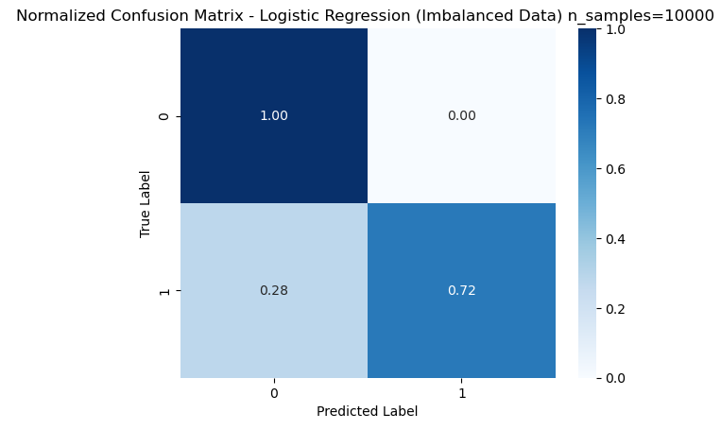
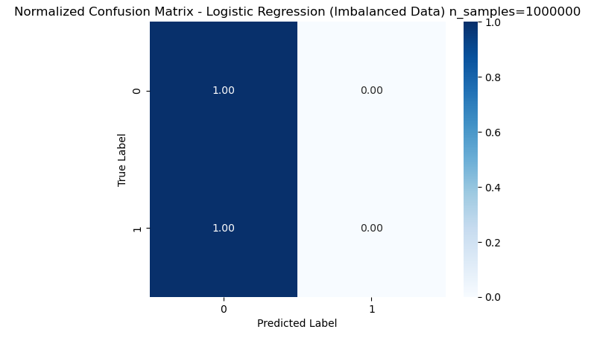
Figure 1: Normalized Confusion Matrix of Logistic Regression Model Performance using Imbalanced Dataset between n_samples=10000 versus n_samples=1000000.
Interpretation:
For n_samples=10000, the model fakes the ability to identify some minority class instances, with a recall of 0.72 for class 1.
Fakely indicates that the model has some ability to detect the minority class, despite the imbalance. This is misleading and gives a false impression of model fairness.
The relatively higher recall at n_samples=10000 does not reflect true model capability but rather statistical noise due to the smaller sample size.
In a large dataset with n_samples = 10000000, the model fails to recognize any minority classes, resulting in a callback of 0 for class 1. This indicates a bias towards the majority class, which becomes increasingly apparent as the size of the dataset increases and extreme imbalances dominate the model's learning process.
These results highlight that the performance of the model with n_samples=10000 falsely indicates the absence of bias, when such imbalance greatly impacts the model's ability to learn and correctly classify minority classes, especially those expressed at larger scales.
However, when the sample size is increased to n_samples=1000000, the model fails to recognize the minority class, resulting in a callback of 0 for class 1. This means that not a single positive was detected correctly, thus highlighting an extreme bias towards the majority class due to inequality (99.9 % class 0 versus 0.1% class 1).
This is not caused by a flaw in the model, but rather by an imbalance in the data set. The confusion matrix clearly shows that the model is highly biased, with recall for the minority class being 0, indicating that the model struggles when faced with highly imbalanced data on a larger scale.
4.2 LIME Explanation of Logistic Regression Model using Imbalanced Dataset
n = 10000
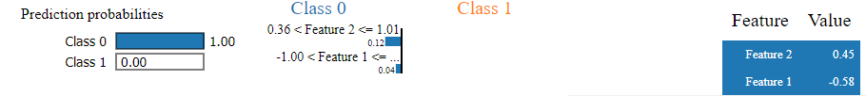
n = 1000000
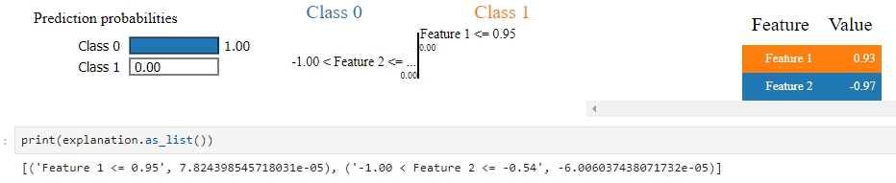
Figure 2: LIME Explanation of Logistic Regression Model using Imbalanced Dataset between n_samples=10000 and n_samples=1000000.
Interpretation:
The Figure 2 shows that there is a bias in the model of class 0, because the model ignores the probability of class 1 completely. The values ​​of this feature are in the range that are only influenced by class 0. This displays the weaknesses of the training model on an unbalanced dataset, which has a bad ability to identify the minority class.
This is in accordance with the problem of extreme class imbalances, where the model does not learn effectively to distinguish minority classes (class 1), which is proven in the original classification report (recall for class 1 is 0).
4.3 Logistic Regression Model Performance using Balanced Dataset
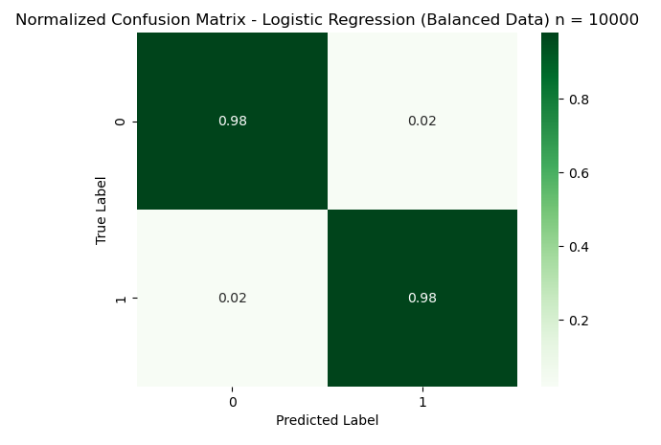
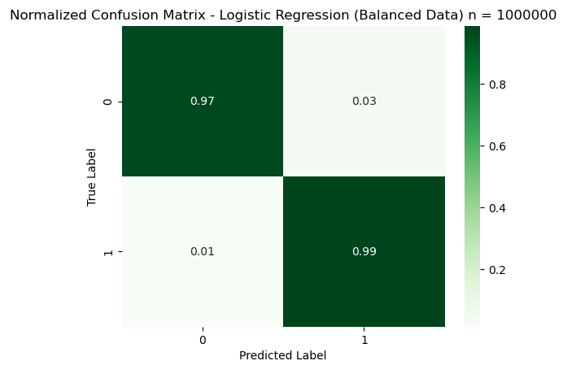
Figure 3: Normalized Confusion Matrix of Logistic Regression Model using Balanced Dataset
Interpretation:
This model uses a balanced dataset that seems good for all classes, and showing high recall and precision values. This model also doesn't show bias to minority classes. The true positive level for all classes is close to 1, and the off-diagonal elements are very low. It means that the two classes are classified correctly and with high accuracy.
4.4 LIME Explanation of Logistic Regression Model using Balanced Dataset
n = 10000
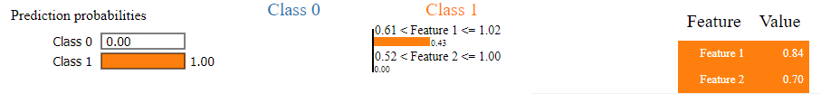

n = 1000000
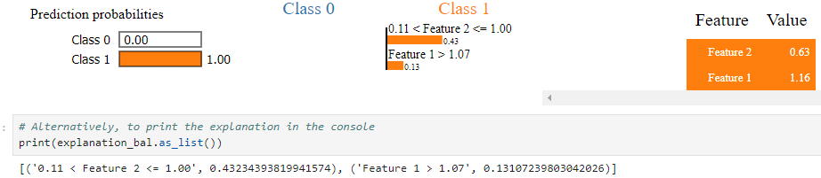
Figure 4: LIME Explanation of Logistic Regression Model using Balanced Dataset between n_samples=10000 and n_samples=1000000.
Interpretation:
Unlike the imbalanced dataset, for the balanced dataset for both small and huge dataset, the model can distinguish between classes 0 and class 1, considering all features. Both features contribute to all classes. No class was ignored.
4.5 Comparison of Precision-Recall Curve using Imbalanced Data versus Balanced Data
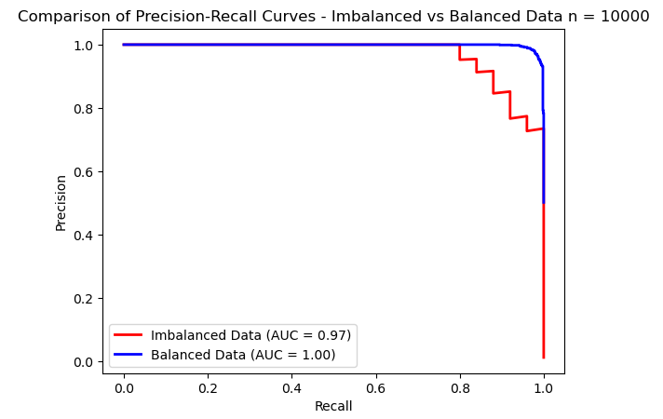
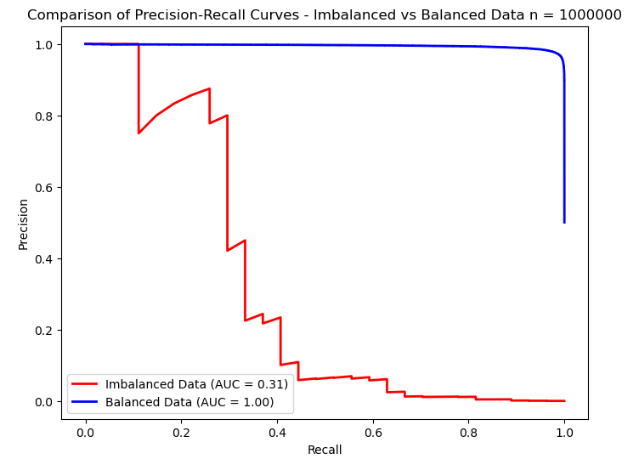
Figure 5: Comparison of Precision-Recall Curve using Imbalanced Data versus Balanced Data n_samples=10000 and n_samples=1000000.

Interpretation:
When the dataset size increases to n=1000000, the model's true inability to predict the minority class becomes obvious, with a significant drop in AUC from 0.97 to 0.31.
This shows the importance of evaluating the model performance across different dataset sizes, to really understand its bias and limitations, especially with imbalanced data.
The key variable is that smaller sample sizes can mask/fake the effects of class imbalance, making fake perception of model fairness. It is critical to evaluate the model performance with larger sample sizes to reveal and shows the actual bias caused by the imbalance.
The area under the precision-recall curve (AP) for Balanced Data is higher than Imbalanced Data, means the model performs very well when the dataset is balanced. The balanced data allows the model to learn more effectively about both classes, reducing bias and has better overall performance.
The imbalanced dataset makes it difficult for the model to accurately identify the minority class, leading to poor performance in terms of precision when trying to recall many positives.
With balanced data, the model shows high precision across various recall levels, indicating a more fair and unbiased learning process for both classes.
4.6 Answers to Research Questions
4.6.1 Research Question 1:
How does the dataset homogeneity composition (balance vs. imbalanced) impact the AI model transparency and fairness in decision-making system?
Large class-imbalanced data set results in bias in the model that discriminatively and unfairly predicts directly for the majority class. Minority groups are not represented, resulting in low accuracy.
4.6.2 Research Question 2:
How does the data sparsity/ dataset’s size (Large versus small) influence the accuracy of bias evaluation in AI models, when the training data is class-imbalanced?
Small sample sizes mislead bias evaluation for models trained on imbalanced datasets.
In small datasets, especially those that have unbalanced classes, this model often gives misleading results. For example, in a smaller dataset, minority classes may have high recall, wrongly showing that the model can handle class imbalances effectively, even though lies caused by statistical noise, rather than original learning from data.
The smaller dataset only gives illusion of fairness, when the model is not strong enough to perform well in the minority class.
When the size of the dataset increases, the true truth of the model of the model of the majority class becomes clear. A larger data set shows the weaknesses of the model in learning from minority classes, with evidence that the performance of minority class drops significantly.
The larger data set provides a more accurate and reliable evaluation of models. They helped reveal how much the model was really biased to the majority class, especially in class-imbalanced data collection, and enable AI practitioners to apply more effective corrective steps.
Therefore, it is very important to evaluate the model on a large enough dataset to avoid this trap and ensure that the actual bias is revealed in the model development process.
5 Discussion
5.1 Result Interpretation

This research findings are aligned with the literature review.

The main findings:
- Models trained on imbalanced datasets are lead to bias, favouring majority class only This bias becomes obvious when the size of the dataset increase.

- The unexpected result was that small sample sizes using imbalanced data can falsely show very high accuracy on the model’s performance.
Small sample sizes can provide a false sense of fairness, with models appearing to perform well on minority classes. As the sample size increases, the model’s bias becomes clearer, with performance metrics drastically drop for the minority class.

. 5.2 Discussion of Limitation

Several limitations of this research:
- This study only evaluates a few types of data characteristics, which are only data homogeneity and data sparsity.

- Another limitation of this study was the use of only a logistic regression model. Other machine learning models may have different behavior under similar conditions of data homogeneity and data sparsity.

- The study was also limited to only the use of synthetic datasets. The complexity and noise of real-world data could affect the model behavior differently.

- The study also only focused on binary classification tasks. Evaluating multi-class classification problems would show how the dataset imbalance affects bias in more complex situations.

6 Conclusion
6.1 Broader Impact on XAI

This research found the important and needs for more data documentation standard in Responsible AI practices. Usually, AI fairness has focused on model transparency and explainability, but this research shows that documenting dataset composition is also very important.
By not addressing dataset homogeneity/ imbalance and how small sample sizes is, the biases can go undetected, and then leading to discriminative result in critical decision-making processes.
The study underlines the importance of moving beyond model explainability. Transparency at both the model and dataset levels is essential for building fair AI systems.

6.2 Recommendation for Future Research
There are many areas that future research should focus on to improve AI transparency and fairness.

- One of the recommendations is to explore and develop bias mitigation techniques in more detail, for example, Synthetic Minority Over-sampling Technique (SMOTE), that creates new instances for the minority class to balance the dataset, together with other advanced techniques of over-sampling or of under-sampling, to improve the performance in both classes.

- This study was performed using logistic regression only, while future research should include similar analysis of more complex models, which may work differently when trained on imbalanced datasets.

- To investigate how the differences in the dataset’s characteristics such as data sparsity, feature noise, multivariate normality, correlation between features etc. could influence bias and fairness of the Model’s predictions.

Future research can continue to explore the findings of this study, for development of more transparent and fair AI systems.
The results of this research show that documenting dataset composition increased the AI model transparency and fairness.
When dataset homogeneity composition (whether balanced or imbalanced) is documented and understood, it gave clean insights to the stakeholders about potential biases in the system to be considered.
Without proper documentation, these biases can go unnoticed, and stakeholders may believe that the model is performing very good.

ACKNOWLEDGMENTS
I would like to express my gratitude to all tutors in the University of Hull for the guidance and advices during this research. I also wish to thank my colleagues at the University of Hull for their support, which really improved the quality of this work. Special thanks go to my families and friends for their understanding during this research. Thank you for inspiring me to contribute to the field of Responsible AI.

REFERENCES
[1] Burkov,A. 2019. The Hundred-Page Machine Learning Book. Retrieved on October 12, 2024, from
[2] Dadkhahnikoo, Neama. (2019-11-11). Incident Number 92. In McGregor, S. (ed.) Artificial Intelligence Incident Database. Responsible AI Collaborative. Retrieved on October 12, 2024, from https://incidentdatabase.ai/cite/92.
[3] Johnson, J.M. and Khoshgoftaar, T.M. 2019. Survey on deep learning with class imbalance. Journal of Big Data. 6, 27 (2019). https://doi.org/10.1186/s40537-019-0192-5
[4] Jurafsky, D., & Martin, J. H. (2024, August 20). Logistic Regression. In Speech and Language Processing (3rd ed.). Retrieved from https://web.stanford.edu/~jurafsky/slp3/5.pdf.
[5] Kou, G., Yang, P., Peng, Y., Xiao, F., Chen, Y., and Alsaadi, F.E. 2019. Evaluation of feature selection methods for text classification with small datasets using multiple criteria decision-making methods. Applied Soft Computing 86, 105836. DOI: https://doi.org/10.1016/j.asoc.2019.105836.
[6] Lee, Y., and Sun, H. 2023. A survey on imbalanced learning: latest research, applications, and future directions. Artificial Intelligence Review 56, 4, 721–739.
[7] Lin, L. 2018. Bias caused by sampling error in meta-analysis with small sample sizes. DOI: https://doi.org/10.1371/journal.pone.0204056.
[8] Murphey, Y., and Anand, S. 2021. The class imbalance problem in deep learning. Machine Learning 44, 3, 123–134. DOI:
[9] Miao, Y., Cao, H., and Tang, M. 2022. A method for analyzing the performance impact of imbalanced binary data on machine learning models. Axioms 11, 11, 607. DOI: https://doi.org/10.3390/axioms11110607.
[10]National Institute of Standards and Technology (NIST). 2021. Four Principles of Explainable Artificial Intelligence. NIST Internal Report 8312, 1–23. Available at: https://nvlpubs.nist.gov/nistpubs/ir/2021/NIST.IR.8312.pdf.
[11] Oreski, D., Oreski, S., and Klicek, B. 2017. Effects of dataset characteristics on the performance of feature selection techniques. Applied Soft Computing 52, 109-119. DOI: https://doi.org/10.1016/j.asoc.2016.12.023.
[12]Prashant. 2019. Explain Your Model Predictions with LIME. Retrieved from https://www.kaggle.com/code/prashant111/explain-your-model-predictions-with-lime/notebook.
[13]The Conference Board. 2023. Explainability in AI: The Key to Trustworthy AI Decisions. Retrieved from https://www.conference-board.org/publications/explainability-in-ai.

