  - Assessing the Impact of Documenting Dataset Characteristics—Homogeneity Composition and Data Sparsity—on AI Model Transparency, Fairness, and Bias Evaluation
  - Examining Bias and Unfairness in Explainable Artificial Intelligence (XAI) Due to Imbalanced Training Data and Misleading Effects of Small Sample Sizes

Henny Purwadi
MSc Artificial Intelligence
University of Hull UK
h.purwadi-2022@hull.ac.uk

ABSTRACT
In responsible AI, ensuring transparency and fairness is very important for developing responsible AI systems. Data characteristics are becoming an increasingly important focus within the field of Explainable AI (XAI), but currently it is not a standard practice. Traditionally, responsible AI and explainable AI (XAI) have more concentrated on explaining model behaviors, including ethical, legal, and social aspects of the datasets. However, addressing the characteristics of the dataset, including its homogeneity composition and Data Sparsity, is critical for a comprehensive approach to XAI. If the training dataset is imbalanced, machine learning models cannot make accurate predictions, while the small sample sizes can mislead bias evaluation by underrepresenting the true extent of the bias. This study proposes the incorporation of dataset characteristics to be documented into responsible AI practices in XAI, especially the composition, whether the dataset is balanced or imbalanced, and small or large samples, aiming for comprehensive transparency at both the data and model levels rather than only focusing on data sources and model explainability. The purpose is for AI to be open and accountable, enhancing fairness, and at the end is to increase people’s trust in AI systems.

CCS CONCEPTS
• Computing Methodologies • Artificial Intelligence (AI) • Explainable AI (XAI)
KEYWORDS
Balance Dataset, Bias Mitigation, Dataset Composition, Dataset Documentation, Explainable AI (XAI), Fairness, Imbalance Dataset, Local Interpretable Model-Agnostic Explanation (LIME), Model Transparency, Responsible AI.
1 Introduction
Nowadays, the growing of artificial intelligence (AI) in critical decision-making processes has raised multiple discussions about AI’s accountability, transparency, and fairness. These concerns are especially in the important domains like healthcare, hiring, and criminal justice, where the consequences of biased decisions could be fatal. The Conference Board (2023) discussed about the significance of Explainable AI (XAI) in increasing trust and transparency in AI decision-making.
XAI addresses the traditional "black box" nature of AI systems, helping to gain trust, compliance, and the ethical use of AI across many industries.

The three key aspects of Explainable AI (XAI) are: Trustworthiness, Equitability, and Explainability. Trustworthiness is focus on safeguarding data privacy and promoting responsible AI practices to build user confidence, particularly in sensitive applications. Equitability is to ensure the fairness and legal compliance, addressing the societal and ethical dimensions of AI. But most focus on AI fairness are on explaining model decisions rather than the composition of the datasets used in training. Explainability, on the other hand, gave insights into how AI systems arrive at their decisions, gave the opacity of AI models.
XAI traditionally focused on the quality and appropriateness of the data used in AI systems; the characteristics of training datasets—whether balanced or imbalanced—has received limited attention. This oversight poses significant risks to fairness and transparency, as imbalanced datasets where certain classes are underrepresented can lead to AI models that are optimized primarily for the majority class. Such imbalances can produce biased or unfair predictions, disproportionately affecting minority classes.

This research explores the impact of documenting and analysing the characteristic of training datasets, especially in terms of homogeneity composition whether they are balanced or imbalanced, number of classes, data sparsity whether the datasets are small or large (Oreski, D., Oreski, S., and Klicek, B. 2016),
and how this affects model transparency, bias, and fairness. Specifically, imbalanced datasets can result in models that perform well on the majority class but fail to accurately predict outcomes for underrepresented groups, raise the biases in AI decision-making.
Small sample sizes in imbalanced datasets can create problems by increasing variance in model predictions, resulting in bias and reduced model performance. These variables are essential to evaluate in high-risk applications where fairness is very important.
Chapter 4 (Results) will provide a comprehensive study of these concerns, encompassing the effects of small sample sizes and imbalanced datasets on bias and fairness, along with a discussion of the findings and data analysis.

RESEARCH QUESTIONS
- How does the documentation of dataset homogeneity composition (balance vs. imbalanced) impact the AI model transparency and fairness in decision-making systems?
- What is the relationship between data sparsity/ dataset’s size and the accuracy of bias evaluation in AI models, when the training data is imbalanced ?
- How do small sample sizes mislead bias evaluation, and what are the implications for models trained on imbalanced datasets?

2 Literature Review
2.1 Overview of Previous Study
The research studied by Miao, Y., Cao, H., and Tang, M. (2022) focuses on the technique that may be utilized to evaluate the impact that imbalanced binary data has on the performance of machine learning models. In their investigation, they investigated how the imbalance ratio (IR) influences the performance and stability of the model. To build datasets with variable imbalance ratios, they applied imbalanced data augmentation algorithms. They utilized measures such as area under the curve (AUC), F-measure, and G-mean to evaluate the effectiveness of the model. Based on their investigation, their result found out that as imbalance ratio increases, the model performance declines. Some models being more affected by imbalances than other models. For example, models like Logistic Regression, Decision Trees, and Support Vector Classifiers show less stability, while Naive Bayes, Random Forests, and Gradient Boosting Decision Trees showed more stable performance. The study analyzed that addressing data imbalance is very important for maintaining reliable machine learning models, especially in critical applications.

The study by Johnson and Khoshgoftaar (2019) provides a survey on deep learning methods to handle class imbalance. The authors wrote about challenges of high-class imbalance in real-world applications, such as medical diagnosis and fraud detection, where the minority class is often of greater interest. The survey reviews existing deep learning approaches, including data-level techniques like oversampling and under sampling, beside algorithm-level methods such as cost-sensitive learning and hybrid methods. The authors identify gaps in current research of deep learning methods for imbalanced data and the need for more diverse applications (Johnson and Khoshgoftaar, 2019).

The study by Lin (2018) with title "Bias caused by sampling error in meta-analysis with small sample sizes" warned the challenges caused by small sample sizes in meta-analyses. Too small sample sizes can create significant bias due to the intrinsic correlation between study-specific effect sizes and their within-study variances. This study advises caution when they conducted meta-analyses with very small sample sizes. Reducing confidence interval coverage can lead to misleading conclusions related to bias and fairness.

2.1 Terminology and Definition
2.2.1 Local Interpretable Model-Agnostic Explanation
LIME (Local Interpretable Model-Agnostic Explanations) is a method which goal is to simplify the explanation of the predictions of the complex "black-box" machine learning models in a simpler way. It works by generating local surrogate models which are simple, interpretable models like linear regression or decision trees, that approximate the behavior of the black-box model for a specific instance.

LIME creates a set of samples around the instance of interest, to get predictions for those samples, and then fits an interpretable model that explains how the features contribute to the original model's decision for that instance. This method will help users understand the reason behind the model’s predictions, to make the AI systems more transparent and trustworthy.
LIME Formula:
explanation(x)=argmin​ L(f,g,πx​)+Ω(g) (1)
g∈G

2.2.2 Logistic Regression
Logistic regression is a probabilistic classifier model which denotes the probability that an input parameter is related with a specific class. There is a sigmoid function which is implemented to convert input characteristics into an output probability that falls within the range of 0 to 1, rendering it suitable for binary classification applications. To train the model, Logistic Regression optimizes a cross-entropy loss function using stochastic gradient. Logistic Regression is usually used as a baseline supervised learning algorithm for classification tasks (Jurafsky, D., & Martin, J. H. 2024).

Logistic regression formula:

P (y=1|x) = 1 / (1 + e^ (-w^T x - b)) (2)

y = target class, while x is the feature, w is the weight vector, and b is the bias term.
P (y = 1|x) is a conditional probability.

2.2.3 Classification Report and Confusion Matrix

Classification report is a summary of the model’s performance, which compared the model's performance to other models, or understanding where the model might be struggling. (Burkov, A., 2019).

Accuracy shows the overall correctness of the model.
The F1-score is the precision and recall’s harmonic mean.
Precision-Recall Area Under the Curve (AUC) is a performance metric which combines recall and precision become a single value, summarized about how well the model is performs.
The details are:
Precision answers the question about how many were correct from all the positive predictions. It is a metric that measures how often a predicted label is correct.
Recall is known as sensitivity or true positive rate. It is a metric that measures how often a true label is correctly predicted. Recall (also): The proportion of true positive cases detected out of all actual positive cases. It showed about how many were correctly predicted from all true positives.

AUC is like the Precision-Recall curve, which visualized the precision on the y-axis and recall on the x-axis. The balance achieved between two desirable but incompatible features/ compromise between precision and recall for different threshold settings of a model has been visualized. The AUC (Area Under the Curve) quantifies the overall performance of the model. A higher AUC value indicates better performance, especially in identifying minority class instances.
this metric is very useful when dealing with imbalanced datasets.
While accuracy alone sometimes misleading, in several cases, the Precision-Recall AUC provides more insight into how well the model can identify the minority class while maintaining precision.
AUC = 1 represents a perfect model.
AUC = 0.5 suggests a random classifier.
In cases like class imbalance, Precision-Recall AUC is more preferred over ROC AUC (Receiver Operating Characteristic Area Under the Curve) because it focuses on the performance of minority class.

3 Methodology

3.1 Research Design
This research’s purpose is to understand the impact of dataset homogeneity composition, particularly to compare results between balanced datasets versus imbalanced datasets, related to AI model transparency and fairness. Besides, it explores the effect of data sparsity/ sample size by comparing the performance of models trained on small datasets versus those trained on large datasets. The main target is to evaluate how imbalances in data and variations in sample sizes affect the bias in AI decision-making.

I used Synthetic dataset for both quantitative analysis and comparative evaluations using Logistic Regression, a machine learning model.
This study focuses on exploring how different dataset homogeneity and different sparsity dataset influence model performance, bias evaluation, and fairness.
I observed classification reports, confusion matrices, precision-recall curves, and Local Interpretable Model-Agnostic Explanations (LIME) techniques and methodologies to analyze the model’s predictions and their biases.

3.2 Dataset Generation
To simulate real-world class imbalance versus class balance scenarios, the datasets used for this research were synthetic datasets, which were created with Python programming.

Two types of datasets:
1. Balanced Dataset: This dataset has equally balanced representation for both the majority class and minority classes. It has a purpose as a baseline for comparing the effects of imbalance on model performance and bias.
2. Imbalanced Dataset: This dataset consisted of 99:1 class distribution, where 99% of the data points represented the majority class and 1% to the minority class. This extreme imbalance has the purpose of investigating how model bias becomes more noticeable when the imbalance increases.
Each dataset was generated in different sample sizes. For the small dataset, n = 10,000 used. While n = 1,000,000 samples of datasets used for huge/ large datasets, to explore the effects of small versus large datasets on model bias and fairness.

3.3 Model Selection
Logistic regression has been selected to evaluate the effects of dataset construction on bias and fairness since it is easily interpretable and frequently utilized in classification applications. LIME (local interpretable model-agnostic explanations) has been used to clarify model conclusions, specifically estimating the contribution of features to predictions in balanced and unbalanced datasets.

3.4 Model Training and Evaluation
In this research, I trained both imbalance dataset and balanced dataset using logistic regression model. After that, I evaluate it with F1-score, Precision, Recall, and Area Under the Precision-Recall Curve (AUC-PR). The reason why I choose logistic regression is because based on a previous study by Miao, Y., Cao, H., and Tang, M. (2022), logistic regression is not stable when working with imbalanced datasets.

3.5 Evaluation with Precision-Recall Curves
Because only relying on accuracy could be misleading when I deal with unbalanced data set, I used Precision-recall curves to evaluate the model’s performance. Precision-recall curves show a clearer view of the performance of the model in this unbalanced dataset. Then it will be evaluated using an AUC-PR/ area under the curve precision recall curve as an indicator. A low AUC value means that the prediction for the class is poor and has bias. A high AUC value means that the prediction for the class is good and has no bias.

3.6 LIME Explanations for Model Interpretability
For model transparency, I will use LIME to explain how the model predicts. LIME works by changing input data and observing how these changes affect the model predictions, to gain deeper insight about how features contribute to the model’s decision-making process. LIME annotations are generated for balanced and unbalanced datasets at different sample sizes, to provide insight into whether and how model interpretation changes in response to the changes of the composition and size of the dataset.

3.7 Method for Analyzing Bias
This study uses a confusion matrix to visualize the performance of the Logistic Regression model in predicting the majority class and minority class, and minority class recall is used to highlight how an imbalanced data set can apparently affect the model's ability to predict/ identify minority events. A comparison of the results at a smaller sample size (n = 10,000) versus using a larger sample size (n = 1,000,000) provides insight into how small sample sizes can mislead the evaluation bias. In small sample size, it was not discovered that bias had occurred.

3.8 Limitations of the Methodology
Although synthetic datasets are allowed for the experiments, they do not fully capture the complexity of data from the real world, which can introduce noise and contain missing values. Also, this research only focuses on logistic regression, a simple model. These findings may not be generalizable to more complex models such as neural networks, which may behave differently under conditions of imbalance. Future work should extend these methods to more complex real-world datasets and machine learning models to validate the findings.

4 Results and Findings
4.1 Logistic Regression Model using Imbalanced Dataset
Using imbalanced data set, it turns out that the results of the normalized confusion matrix are significantly different between n_samples=10000 and n_samples=1000000.
Where the large dataset shows bias, while the confusion matrix on the small dataset is misleading/ failed to show it.
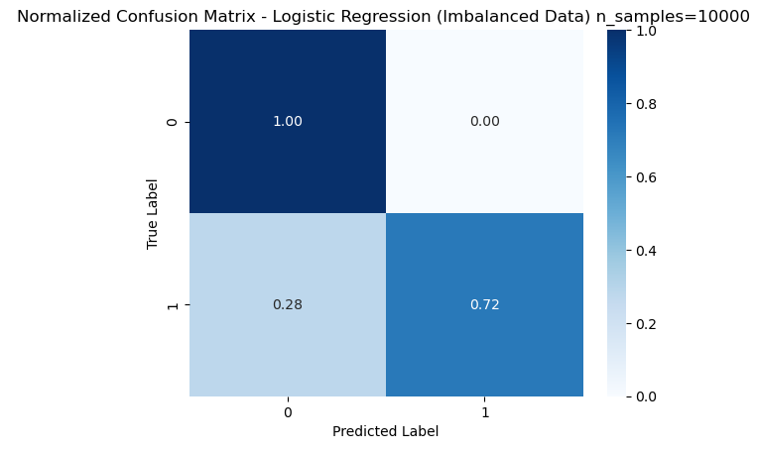
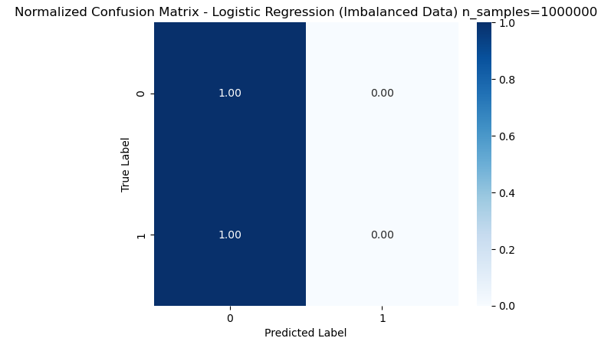
Figure 1: Normalized Confusion Matrix of Logistic Regression Model Performance using Imbalanced Dataset between n_samples=10000 and n_samples=1000000.
Interpretation:
For n_samples=10000, the model is fake the ability to identify some minority class instances, with a recall of 0.72 for class 1.
Fakely indicates that the model has some ability to detect the minority class, despite the imbalance. This is misleading and gives a false impression of model fairness.
The relatively higher recall at n_samples=10000 does not reflect true model capability but rather statistical noise due to the smaller sample size.
In a large dataset with n_samples = 10000000, the model fails to recognize any minority classes, resulting in a callback of 0 for class 1. This indicates a bias towards the majority class, which becomes increasingly apparent as the size of the dataset increases and extreme imbalances dominate the model's learning process.
These results highlight that the performance of the model with n_samples=10000 falsely indicates the absence of bias, when such imbalance greatly impacts the model's ability to learn and correctly classify minority classes, especially those expressed at larger scales.
However, when the sample size is increased to n_samples=1000000, the model fails to recognize the minority class, resulting in a callback of 0 for class 1. This means that not a single positive was detected correctly, thus highlighting an extreme bias towards the majority class due to inequality (99.9 % class 0 versus 0.1% class 1).
This is not caused by a flaw in the model, but rather by an imbalance in the data set. The confusion matrix clearly shows that the model is highly biased, with recall for the minority class being 0, indicating that the model struggles when faced with highly imbalanced data on a larger scale.
4.2 LIME Explanation of Logistic Regression Model using Imbalanced Dataset
n = 10000
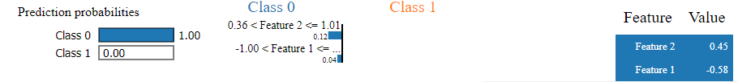
n = 1000000
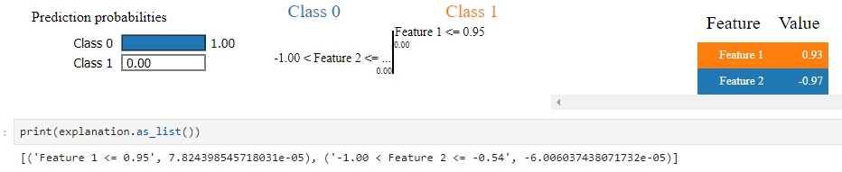
Figure 2: LIME Explanation of Logistic Regression Model using Imbalanced Dataset between n_samples=10000 and n_samples=1000000.
Interpretation:
The Figure 2 shows that there is a bias in the model of class 0, because the model ignores the probability of class 1 completely. The values ​​of this feature are in the range that are only influenced by class 0. This displays the weaknesses of the training model on an unbalanced dataset, which has a bad ability to identify the minority class.
This is in accordance with the problem of extreme class imbalances, where the model does not learn effectively to distinguish minority classes (class 1), which is proven in the original classification report (recall for class 1 is 0).
4.3 Logistic Regression Model Performance using Balanced Dataset
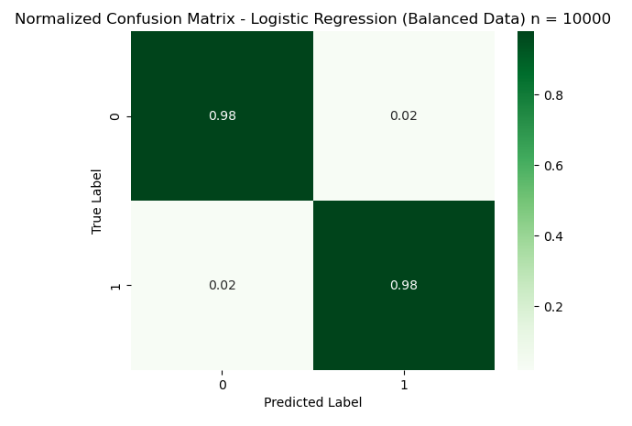
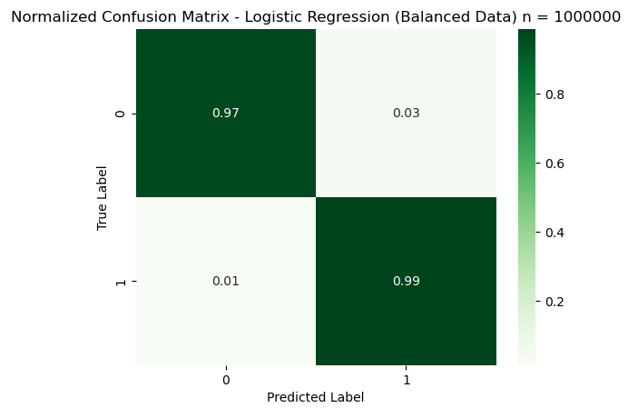
Figure 3: Normalized Confusion Matrix of Logistic Regression Model using Balanced Dataset
Interpretation:
This model uses a balanced dataset that seems good for all classes, and showing high recall and precision values. This model also doesn't show bias to minority classes. The true positive level for all classes is close to 1, and the off-diagonal elements are very low. It means that the two classes are classified correctly and with high accuracy.
4.4 LIME Explanation of Logistic Regression Model using Balanced Dataset
n = 10000
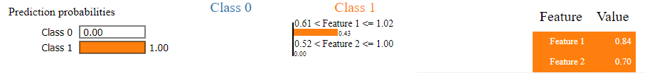

n = 1000000
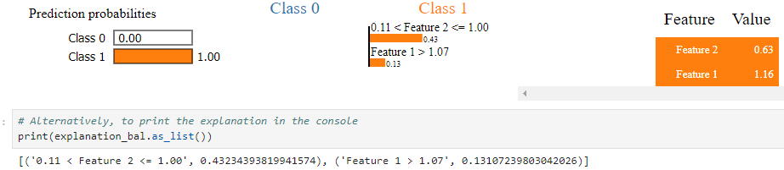
Figure 4: LIME Explanation of Logistic Regression Model using Balanced Dataset between n_samples=10000 and n_samples=1000000.
Interpretation:
Unlike the imbalanced dataset, for the balanced dataset for both small and huge dataset, LIME's explanation shows that the model can distinguish between classes 0 and class 1, considering all features. Lime's explanation for a balanced dataset shows that both features contribute to all classes.
No class was ignored. This balanced data helps models to make predictions that are more trusted for both classes, unlike models trained on unbalanced dataset, which has bias of the majority class.
4.5 Comparison of Precision-Recall Curve using Imbalanced Data versus Balanced Data
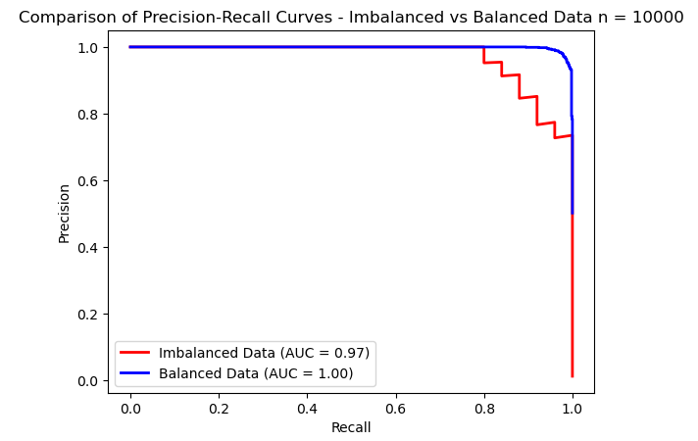
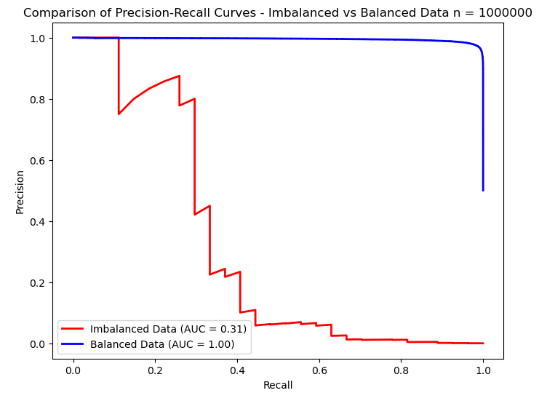
Figure 5: Comparison of Precision-Recall Curve using Imbalanced Data versus Balanced Data n_samples=10000 and n_samples=1000000.
Interpretation:
When the dataset size increases to n=1000000, the model's true inability to predict the minority class becomes obvious, with a significant drop in AUC from 0.97 to 0.31.
This phenomenon shows the importance of evaluating the model performance across different dataset sizes, to really understand its bias and limitations, especially with imbalanced data.
The key variable is that smaller sample sizes can mask/fake the effects of class imbalance, making fake perception of model fairness. It is critical to evaluate the model performance with larger sample sizes to reveal and shows the actual bias caused by the imbalance.
The area under the precision-recall curve (AP) for Balanced Data is higher than Imbalanced Data, means the model performs very well when the dataset is balanced. The balanced data allows the model to learn more effectively about both classes, reducing bias and has better overall performance.
The imbalanced dataset makes it difficult for the model to accurately identify the minority class, leading to poor performance in terms of precision when trying to recall many positives.
With balanced data, the model shows high precision across various recall levels, indicating a more fair and unbiased learning process for both classes.
4.6 Answers to Research Questions
4.6.1 Research Question 1:
How does the documentation of dataset homogeneity composition (balance vs. imbalanced) impact the AI model transparency and fairness in decision-making systems?
The results of this research show that documenting dataset composition increased the AI model transparency and fairness.
When dataset homogeneity composition (whether balanced or imbalanced) is documented and understood, it gave clean insights to the stakeholders about potential biases in the system to be considered.
Without proper documentation, these biases can go unnoticed, and stakeholders may believe that the model is performing very good.
Regarding AI’s fairness, the documentation of dataset characteristics including dataset homogeneity composition, the information about dataset imbalances helps AI developers and practitioners explain the limitations of the models, especially in critical applications such as healthcare or criminal justice.
This step will increase stakeholder trust, as it served a clear understanding of the dataset's role in model performance.
4.6.2 Research Question 2:
What is the relationship between data sparsity/ dataset’s size and the accuracy of bias evaluation in AI models, when the training data is imbalanced?
The relationship between data/ dataset size and evaluation can be proven in the performance of the model in various sample sizes. In small datasets, especially those that have unbalanced classes, this model often gives misleading results. For example, in a smaller dataset, minority classes may have high recall, wrongly showing that the model can handle class imbalances effectively, even though lies caused by statistical noise, rather than original learning from data.
When the size of the dataset increases, the true truth of the model of the model of the majority class becomes clear. A larger data collection explores the weaknesses of the model in learning from minority classes, with evidence that the minority class drops significantly. This shows that smaller dataset only gives illusion of fairness, when the model is not strong enough to perform well in the minority class.
That way, a larger data set provides a more accurate and reliable evaluation of models. They helped reveal how much the model was really biased to the majority class, especially in an unbalanced data collection, and enable AI practitioners to apply more effective corrective steps.
4.6.3 Research Question 3:
How do small sample sizes mislead bias evaluation, and what are the implications for models trained on imbalanced datasets?
The size of a small sample can be very misleading when we evaluate bias, because they often provide high performance metrics, especially for minority classes. In this study, the model trained in the unbalanced small data set initially shows a high accuracy for the minority class. However, this performance does not reflect the actual ability of the model. Conversely, it is only the result of statistical anomalies caused by a small sample size.
When the size of the dataset becomes large, the true bias of the model appears, with the AUC-PR Metric value for the minority class dropping to a very planned level. This shows that the size of a small sample can cover the actual level of bias. As a result, the model that is trained and evaluated on a small dataset may look fairer than when used on large scale samples.
Implications for models trained on unbalanced dataset are very significant. AI practitioners can make decisions based on misleading performance metrics, believe that their models are fair and impartial, only to find that these models fail to generalize after being applied to larger or more diverse datasets. This is especially problematic in high -risk domains such as health care or criminal justice, where a model that can cause unfair or very dangerous results for minority groups. Therefore, it is very important to evaluate the model on a large enough dataset to avoid this trap and ensure that the actual bias is revealed in the model development process.
5 Discussion
5.1 Result Interpretation
5.1.1 Summarize the key findings

In this chapter, I will try to summarize the findings from the analysis. This research reveals a significant impact of dataset composition on model fairness and transparency. This shows that:
- Dataset Imbalance:
An imbalanced data set results in bias in the model that discriminatively and unfairly predicts directly for the majority class. Minority groups are not represented, resulting in low accuracy.
- Impact of Sample Size:
Small sample size gave misleading impression of fairness, because it can fakely increase the model's performance on minority classes, when in fact it does not. As the size of the dataset increases, model bias becomes more pronounced, with performance metrics for minority classes decreasing sharply.
- Bias Evaluation:
The findings showed that the bias evaluation is failed when using unbalanced and small data sets. This study underlined the importance of documenting and analysing the data sparsity/ data scales and data composition/ homogeneity of data sets to avoid biases hidden by smaller sample sizes.

5.1.2 Analysis of Findings in the Context of Responsible AI

This research found the important and needs for more data documentation standard in Responsible AI practices. Usually, AI fairness has focused on model transparency and explainability, but this research shows that documenting dataset composition is also very important. By not addressing dataset homogeneity/ imbalance and how small sample sizes is, the biases can go undetected, and then leading to discriminative result in critical decision-making processes.
Ensuring that AI systems are trained on balanced datasets and using sufficiently large sample sizes is critical to reduce bias and increase fairness in Responsible AI field.

5.1.3 Unexpected Results and Speculation
The unexpected result was that small sample sizes using imbalanced data can falsely show very high accuracy on the model’s performance. In smaller datasets, the recall for the minority class was higher than expected, suggesting the model had learned some patterns for the minority class. When scaled up the sample size of dataset, it became clear that the model was not learning the patterns. The high accuracy was fake.

5.2 Discussion of Limitation
Several limitations of this research:
- This study only evaluates a few types of data characteristics, which are only data homogeneity and data sparsity.
- Another limitation of this study was the use of only a logistic regression model. Despite logistic regression is commonly used, other machine learning models may have different behavior under similar conditions of data homogeneity and data sparsity.
- The study was also limited to only the use of synthetic datasets. Although the imbalanced data set of synthetic data could reflect typical real-world scenarios, the complexity and noise of real-world data could affect the model behavior differently.
- The study also only focused on binary classification tasks. Evaluating multi-class classification problems would show how the dataset imbalance affects bias in more complex situations.

6 Conclusion
6.1 Summary of the Key Findings

The main findings:
- Impact of Dataset Imbalance:
Models trained on imbalanced datasets are prone to bias, favouring the majority class at the expense of underrepresented classes. This bias becomes more obvious when the size of the dataset increase.

- Misleading Effects of Small Sample Sizes:
The research also highlights how small sample sizes can provide a false sense of fairness, with models appearing to perform well on minority classes. As the sample size increases, the model’s bias becomes clearer, with performance metrics such as recall drop for the minority class.

- The Importance of Documentation:
This study recommends the documentation of dataset characteristics into Responsible AI (XAI) practices.
By documenting whether dataset’s characteristic, will gain more trust from the stakeholders about the AI systems.

Broader Impact on XAI
These insights have immediate and long-term effects on Responsible AI. In the short term, they highlight the need for stricter evaluations of model fairness, especially in high-stakes applications like healthcare, criminal justice, and hiring, where bias can have severe consequences. In the long term, integrating dataset composition analysis into Responsible AI frameworks can enhance trust in AI systems, fostering more ethical and accountable AI practices across industries.

The study underlines the importance of moving beyond model explainability alone. Transparency at both the model and dataset levels is essential for building fair AI systems, and this approach has the potential to reshape how AI fairness is evaluated and regulated in the future.
Pinpoint any gaps or unanswered questions that emerged from your study, and propose specific avenues for further investigation, detailing how these could continue to expand the knowledge base on the subject.

6.2 Recommendation for Future Research
Because this research work has revealed how dataset composition imbalance affects the performance of AI models and fairness, there are many areas that future research should focus on to improve AI transparency and fairness.
- Bias Mitigation Techniques:
One of the major recommendations is to explore and develop bias mitigation techniques in more detail, for example, Synthetic Minority Over-sampling Technique (SMOTE), that creates new instances for the minority class to balance the dataset, together with other advanced techniques of over-sampling or of under-sampling, to improve the performance in both classes.

- Exploring Other Models
This study was performed using logistic regression; while future research should include similar analysis of more complex models such as Deep Neural Networks (DNN), Convolutional Neural Networks (CNN), and Transformer models. These models may work differently when trained on imbalanced data sets, especially in high dimensional data space such as image classification or natural language processing. The following comes with the identification of the biases; it will be possible to establish how effectively these techniques can be applied to other machine learning tasks.

- Explore the Impact of other Dataset Characteristics
To investigate how the differences in the dataset’s characteristics such as data sparsity, feature noise, multivariate normality, correlation between features etc. could influence bias and fairness of the Model’s predictions.

By addressing these areas, future research can continue to build on the findings of this study, contributing to the development of more robust, transparent, and fair AI systems.

ACKNOWLEDGMENTS
I would like to express my gratitude to all tutors and advisors in the University of Hull for the guidance through the development of this research. I also wish to thank my colleagues at the University of Hull for their support, which really improved the quality of this work. Special thanks go to my families and friends for their understanding during this research. Thank you for inspiring me to contribute to the field of Responsible AI.

REFERENCES
[1] Burkov,A. 2019. The Hundred-Page Machine Learning Book. Retrieved on October 12, 2024, from
[2] Dadkhahnikoo, Neama. (2019-11-11). Incident Number 92. In McGregor, S. (ed.) Artificial Intelligence Incident Database. Responsible AI Collaborative. Retrieved on October 12, 2024, from https://incidentdatabase.ai/cite/92.
[3] Johnson, J.M. and Khoshgoftaar, T.M. 2019. Survey on deep learning with class imbalance. Journal of Big Data. 6, 27 (2019). https://doi.org/10.1186/s40537-019-0192-5
[4] Jurafsky, D., & Martin, J. H. (2024, August 20). Logistic Regression. In Speech and Language Processing (3rd ed.). Retrieved from https://web.stanford.edu/~jurafsky/slp3/5.pdf.
[5] Kou, G., Yang, P., Peng, Y., Xiao, F., Chen, Y., and Alsaadi, F.E. 2019. Evaluation of feature selection methods for text classification with small datasets using multiple criteria decision-making methods. Applied Soft Computing 86, 105836. DOI: https://doi.org/10.1016/j.asoc.2019.105836.
[6] Lee, Y., and Sun, H. 2023. A survey on imbalanced learning: latest research, applications, and future directions. Artificial Intelligence Review 56, 4, 721–739.
[7] Lin, L. 2018. Bias caused by sampling error in meta-analysis with small sample sizes. DOI: https://doi.org/10.1371/journal.pone.0204056.
[8] Murphey, Y., and Anand, S. 2021. The class imbalance problem in deep learning. Machine Learning 44, 3, 123–134. DOI:
[9] Miao, Y., Cao, H., and Tang, M. 2022. A method for analyzing the performance impact of imbalanced binary data on machine learning models. Axioms 11, 11, 607. DOI: https://doi.org/10.3390/axioms11110607.
[10]National Institute of Standards and Technology (NIST). 2021. Four Principles of Explainable Artificial Intelligence. NIST Internal Report 8312, 1–23. Available at: https://nvlpubs.nist.gov/nistpubs/ir/2021/NIST.IR.8312.pdf.
[11] Oreski, D., Oreski, S., and Klicek, B. 2017. Effects of dataset characteristics on the performance of feature selection techniques. Applied Soft Computing 52, 109-119. DOI: https://doi.org/10.1016/j.asoc.2016.12.023.
[12]Prashant. 2019. Explain Your Model Predictions with LIME. Retrieved from https://www.kaggle.com/code/prashant111/explain-your-model-predictions-with-lime/notebook.
[13]The Conference Board. 2023. Explainability in AI: The Key to Trustworthy AI Decisions. Retrieved from https://www.conference-board.org/publications/explainability-in-ai.

