Packet Tracer - Troubleshoot HSRP

Topology

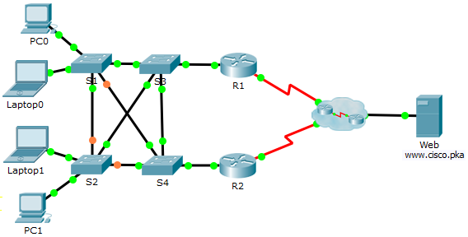

1. Addressing Table

|  |  |  |  |  |
| --- | --- | --- | --- | --- |
| Device | Interface | IP Address | Subnet Mask | Default Gateway |
| R1 | G0/1 | 192.168.1.1 | 255.255.255.0 | N/A |
| S0/0/0 | 209.165.200.226 | 255.255.255.252 | N/A |
| R2 | G0/1 | 192.168.1.2 | 255.255.255.0 | N/A |
| S0/0/1 | 209.165.200.230 | 255.255.255.252 | N/A |
| PC0 | NIC | 192.168.1.10 | 255.255.255.0 | 192.168.1.254 |
| Laptop0 | NIC | 192.168.1.11 | 255.255.255.0 | 192.168.1.254 |
| Laptop1 | NIC | 192.168.1.12 | 255.255.255.0 | 192.168.1.254 |
| PC1 | NIC | 192.168.1.13 | 255.255.255.0 | 192.168.1.254 |
| Web | NIC | 209.165.202.156 | 255.255.255.224 | 209.165.202.158 |

1. Objective

In this activity, you will troubleshoot and resolve the HSRP issues in the network. You will also verify that all the HSRP configurations meet the network requirement.

1. Background / Scenario

Currently the users can access www.cisco.pka. The network has been updated to use HSRP to ensure the network availability to the users. You must verify that the users can still access the website if one of the routers is down. R1 should always be the active router if it is functioning.

Network Requirement:

* HSRP virtual router is 192.168.1.254.
* HSRP standby group is 1.
* DNS server is 209.165.202.157.
* R1 should always be the active router when it is functioning properly.
* R2 uses the default HSRP priority.
* All users should be able to access www.cisco.pka as long as one of the routers is functioning.

1. Troubleshooting Process
   * 1. PCs and Laptops
        1. Verify the PCs and laptops are configured correctly using the provided network requirement.
        2. Based on the Network Requirement shown above, verify that the PCs and laptops can navigate to www.cisco.pka successfully.
     2. Troubleshoot R1.
        1. Disable the interface G0/1 on R2.
        2. Use **show** commands to determine issues. Record and correct any issues found on R1.

____________________________________________________________________________________

____________________________________________________________________________________

____________________________________________________________________________________

____________________________________________________________________________________

R1 is configured with the incorrect standby group and is not configured to preempt. The priority needs to be higher than 100, which is the priority on R2. If the PC0 and Laptop1 are still using R2 (192.168.1.2) as the default gateway, they will lose connectivity to the Web when the interface G0/1 on R2 is disabled. Without the correct default gateway (virtual router IP address) configured on PC0 and Laptop1, these end devices cannot switch the default gateway to R1’s G0/1 interface (192.168.1.1).

R1# **show standby brief**

P indicates configured to preempt.

|

Interface Grp Pri P State Active Standby Virtual IP

Gig0/1 11 50 Active local unknown 192.168.1.254

R1(config)# **interface g0/1**

R1(config-if)# **no standby 11**

R1(config-if)# **standby 1 ip 192.168.1.254**

R1(config-if)# **standby 1 priority 101**

R1(config-if)# **standby 1 preempt**

* + - 1. Re-enable the interface G0/1 on R2.
    1. Troubleshoot R2.
       1. Disable the interface G0/1 on R1.
       2. Use **show** commands to determine any issues. Record and correct any issues found on R2.

____________________________________________________________________________________

____________________________________________________________________________________

____________________________________________________________________________________

____________________________________________________________________________________

The PCs and laptop use 192.168.1.254 (HSRP’s virtual router IP) as gateway. Because R1’s G0/1 has been disabled and R2 is not yet a member of the HSRP standby group 1, laptops and PCs will lose connectivity to the server.

R2# **show standby brief**

P indicates configured to preempt.

|

Interface Grp Pri P State Active Standby Virtual IP

Gig0/1 111 100 Active local unknown 192.168.1.254

R2(config)# **interface g0/1**

R2(config-if)# **no standby 111**

R2(config-if)# **standby 1 ip 192.168.1.254**

* + - 1. After verifying that the PCs and laptops can navigate to www.cisco.pka successfully, re-enable the interface G0/1 on R1.
    1. Verify connectivity.
       1. Verify all PCs and laptops can navigate to www.cisco.pka.
       2. Verify all the HSRP requirements have been met.

1. Running Scripts
2. PC0 and Laptop1

The default gateway should be configured at 192.168.1.254.

1. R1 Configuration

interface g0/1

no standby 11

standby 1 ip 192.168.1.254

standby 1 priority 101

standby 1 preempt

1. R2 Configuration

interface g0/1

no standby 111

standby 1 ip 192.168.1.254