Vm1 and vm2 are single subnet in north europe

[SQL Server Failover Cluster on Azure Virtual Machines using Azure Shared Disks part-1 (youtube.com)](https://www.youtube.com/watch?v=mW7w6cuKFFU)

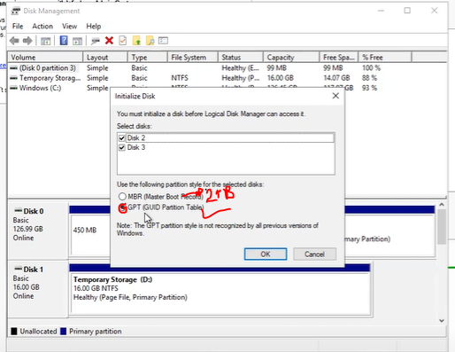

**Don’t allocate shared disk on the virtual machine initially!**

Cluster creation

* Add cluster feature…
* With 2019 by default we will get a distributed cluster, than a normal cluster.

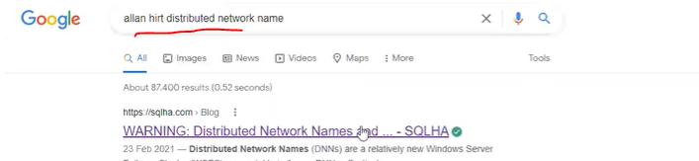

Additional reference

[How to Configure Failover Cluster in SQL Server 2019 – Step by Step – MS SQL Tutorial (kindsonthegenius.com)](https://kindsonthegenius.com/mssql/how-to-configure-failover-cluster-in-sql-server-2019-step-by-step/) kindson