Put the directory where the module is stored (poweshell script = henokdbmodule.psm1. It should be save so)
Execute the below 2:
C:\Users\ka***da\OneDrive\Documents\WindowsPowerShell\Modules\henokdbmodule\henokdbmodule.psm1 – this is needed to redirect it to the directory
Import-Module henokdbmodule –to import the moduel (adjust the name)

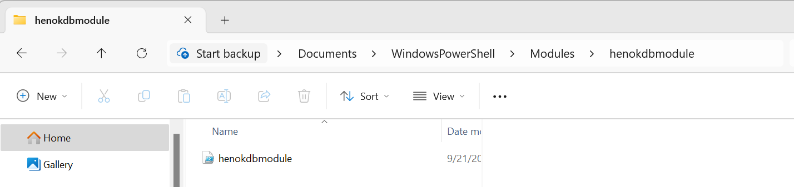
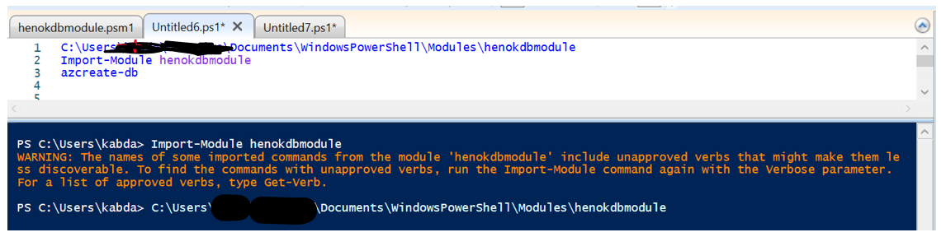
Once the module is imported, you can run create, delete or restore database options as needed.
azcreate-db
azdelete-db
azrestore-db

If you update the module, it is better to remove it first and reload (import) it again.
C:\Users\kabda\OneDrive\Documents\WindowsPowerShell\Modules\henokdbmodule\henokdbmodule.psm1 --redirect
Remove-Module henokdbmodule # Remove the module if it's already imported
Import-Module henokdbmodule # Re-import the module

