**Problem 1: We can’t use DNN** – go with LB

[Configure DNN for failover cluster instance - SQL Server on Azure VMs | Microsoft Learn](https://learn.microsoft.com/en-us/azure/azure-sql/virtual-machines/windows/failover-cluster-instance-distributed-network-name-dnn-configure?view=azuresql)

Also here [HADR configuration best practices - SQL Server on Azure VMs | Microsoft Learn](https://learn.microsoft.com/en-us/azure/azure-sql/virtual-machines/windows/hadr-cluster-best-practices?view=azuresql&tabs=windows2012#connectivity)

For single subnet VNN

[Configure an Azure load balancer for an FCI VNN - SQL Server on Azure VMs | Microsoft Learn](https://learn.microsoft.com/en-us/azure/azure-sql/virtual-machines/windows/failover-cluster-instance-vnn-azure-load-balancer-configure?view=azuresql&source=recommendations&tabs=ilb)

Problem 2: MSDTC is a problem for Window server 2016, FIN3??

Vm1 and vm2 are single subnet in north europe

[SQL Server Failover Cluster on Azure Virtual Machines using Azure Shared Disks part-1 (youtube.com)](https://www.youtube.com/watch?v=mW7w6cuKFFU)

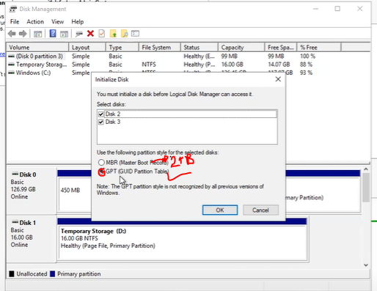

**Don’t allocate shared disk on the virtual machine initially!**

Cluster creation

* Add cluster feature…
* With 2019 by default we will get a distributed cluster, than a normal cluster.



Additional reference

[How to Configure Failover Cluster in SQL Server 2019 – Step by Step – MS SQL Tutorial (kindsonthegenius.com)](https://kindsonthegenius.com/mssql/how-to-configure-failover-cluster-in-sql-server-2019-step-by-step/) kindson