**A transparent method of calculating PM2.5 concentrations from Plantower sensors: comparison of bias, precision, and limit of detection with the Plantower CF1 data series**

Lance Wallace

7/28/2020

lwallace73@gmail.com

**Abstract**

A transparent and reproducible method of calculating PM2.5 concentrations from Plantower PMS 5003 sensors is presented. At present, these concentrations are provided with no explanation from the sensor manufacturer of how they are calculated. The alternative method presented here is a standard method employed in many optical particle monitors with multiple particle size measurement capabilities. It is transparent and reproducible by any user. It depends on the particle numbers in three size categories as recorded by the sensor. The basic approach is to select an intermediate particle diameter within each size category, calculate the number of particles and the associated particle volume (assuming sphericity) and resulting particle mass (assuming an arbitrary density). The resulting estimates of particle mass can then be compared to research-grade instruments to determine the calibration factor required to estimate PM2.5 accurately. The resulting best estimate CF is 3, with an uncertainty range from about 2.5 to 3.5. The results of this comparison show that the alternative method has better precision, smaller coefficient of variation, and a lower limit of detection (LOD) than either the CF1 or ATM data series provided by Plantower. The size distribution resulting from the alternative method also avoids the massive distortion caused by the Plantower choice to censor low concentrations.

**Introduction**

The Plantower data output includes two data series: CF1 and ATM. The CF1 series is described as for laboratory use and the ATM for “atmospheric” conditions. Many studies use the PM2.5 values reported in either the CF1 or ATM data series. However, we find serious deficiencies in both of these data series. For example, both series report multiple values of zero for typical indoor and outdoor measurements; yet in our studies of scores of sites with hundreds of thousands of observations there are never cases when the particle numbers in the 0.3-0.5 um or 0.5-1 um size categories are zero. The values of zero are apparently applied by the unknown Plantower algorithm to concentrations below an arbitrary cutoff number.

**Methods and Materials**

*Outline of method*

The approach adopted here is identical to that recommended by manufacturers of optical particle monitors capable of collecting simultaneous data on multiple particle size categories (e.g. the TSI Model 3330 (<https://tsi.com/products/particle-sizers/particle-size-spectrometers/optical-particle-sizer-3330/>)).

1. Calculate the number *N* of particles in each of the size categories 0.3-0.5 um, 0.5-1 um, and 1-2.5 um. Note: since the Plantower output provides the total number of particles >0.3 um, the total number >0.5 um, etc., one must subtract the total number >0.5 um from the total number > 0.3 um to arrive at the number of particles in the 0.3-0.5 um size category. Similar subtractions will result in three size categories under 2.5 um: 0.3-0.5 um, 0.5-1 um, and 1-2.5 um.
2. Select an average diameter *D* for each of the three size categories. For example, the average particle diameter D in the 0.3-0.5 um size category category must be between 0.3 and 0.5 um, so we can approximate it by the midpoint (0.4 um) or by the geometric mean of the size boundaries (0.387 um). Several manufacturers use the geometric mean so we use it throughout this work.
3. Calculate the total particle volume *V* in each size category. This is given by multiplying the number of particles *N* times the volume per particle:

*V = N πD*3/6.

1. Multiply by a density ρ to arrive at an estimate of the mass concentration M in each size category. We choose ρ to be the density of water, a choice that is also made by the Model 3330 manufacturers:

*M = ρV*

1. Add the mass concentrations in the three size categories to estimate PM2.5.
2. Multiply by a calibration factor (CF) based on comparisons with nearby or collocated reference monitors.

To compare results of the alternative method to the PM2.5 mass concentrations reported by Plantower, we consider measurements by two co-located PurpleAir monitors in a home in Santa Rosa, CA.

The PurpleAir monitors each contained two PA-II sensors, model PMS 5003, plus a sensor measuring temperature, relative humidity (RH) and atmospheric pressure (Bosch Model BME 280) (<https://www.bosch-sensortec.com/products/environmental-sensors/humidity-sensors-bme280/>). The monitors were placed on the front of a dresser 33” (83 cm) high 0.5 m from the wall in a 30 m3 room in a single-story 385 m3 private residence housing two people. The house employs forced air with a central fan on at all times. There is a return air filter with electret fibers. Blower door tests have been performed on the home twice, and air exchange measurements have been made multiple times, with results indicating a tight home with average outdoor air exchange rates of 0.15 (SD 0.05) h-1.

The data were collected between Jan 10, 2019 and March 26, 2020, a total of about 350,000 measurements over 433 days. The PurpleAir instruments took samples every 80 seconds for the first 6 months and every two minutes thereafter. On most days (N = 379) the room door was open to the rest of the house. On those days, normal household activities such as cooking were carried out. Neither resident was a smoker. On 55 days, the room was shut off from the rest of the house, the floor register was sealed, the central fan was turned off, and experiments were run using various sources of fine and ultrafine particles such as candles, laboratory hot plates, toaster ovens, and other typical particle sources. A full description of the experiments is contained in a paper being prepared for publication (Wallace et al, in preparation). The experiments typically elevated the PM2.5 concentrations to levels above 1 mg/m3. These high concentrations were permitted to decay over the next few hours before the room was opened up again.

**Data Analysis**

*Bias and precision.* Bias across the two independent sensors was calculated with respect to the average of the two values. The bias was then corrected and the bias-corrected precision was calculated using the equation

Precision = abs(A-T)/(A+T)

where A is a measurement from one sensor and T is the average of the two sensors.

*Coefficient of Variation (CV).* This is a measure of the amount of variation within a dataset. It is calculated as the Relative Standard Deviation (RSD), the SD divided by the mean. The smaller the CV, the more dependable will be the estimate of the mean.

*Calculation of the Limit of Detection (LOD).* To calculate an LOD for a continuous monitor such as the PurpleAir instrument, we use a method developed in Wallace et al (2010). To be 95% certain that a reported observation is >0, we require that the mean value of multiple collocated instruments be > 3 times the standard deviation. However, if the observations are in a series ordered by the mean of the instrument measurements, it can and typically does happen that an observation will meet this criterion whereas at a higher concentration it does not. Then the LOD is *not* this lower concentration. Therefore, we search for the lowest concentration above which higher concentrations *always* have at least 95% of the calculated mean/SD ratios > 3. For a large dataset, this can be done by considering “batches” of, say, 100 observations at a time in the dataset ordered by mean concentrations, and counting the number of cases in which the mean/SD ratio is <3. As higher concentrations are examined, eventually a batch is found with fewer than 5 such cases. If testing more batches at yet higher concentrations never shows 5 or more such cases, we assume that the earlier batch contains the limit of detection.

A large dataset was used to calculate the LOD for PM2.5. The dataset ran from Jan 30, 2020 to April 27, 2020 with 63091 observations. In all calculations, the bias of the two individual sensors compared to the mean was determined and the bias-corrected values were then analyzed to determine the mean and standard deviation of each observation. The mean/SD values were then sorted and examined in batches of 100 to identify the batch containing the LOD as described above.

**Results**

*Precision and bias* Over the 433 days measured at the Santa Rosa site, mean precision was excellent, ranging from 4-6% (Table 1). Corresponding values for the CF1 series were 7-14%. Bias relative to the mean of the two sensors ranged from 0.93-1.06. Corresponding values for the CF1 series were 0.96 to 1.03.

**Table 1. Precision and bias for the STANDARD series compared to the CF1 series for PM2.5 measured during 433 days in Santa Rosa. Sensors A and B in monitors 1 and 2 are labeled as 1A, 1B, 2A, and 2B.**

|  |  |  |  |  |
| --- | --- | --- | --- | --- |
| Data series | 1A | 1B | 2A | 2B |
| *Precision* |  |  |  |  |
| This method | 0.05 | 0.06 | 0.04 | 0.06 |
| CF1 | 0.07 | 0.09 | 0.12 | 0.14 |
| *Bias* |  |  |  |  |
| This method | 1.01 | 1.00 | 1.06 | 0.93 |
| CF1 | 1.02 | 0.96 | 1.03 | 0.99 |

*Coefficient of variance (CV).* Since the aerosol mixtures from the experiments may vary considerably from the normal indoor aerosol, we compare the PM2.5 results for the experimental and non-experimental days separately (Table 2).

**Table 2. Comparison of CF1 to alternative method: PM2.5 mean, SD, and CV for days with and without major sources of indoor particles.**

|  |  |  |  |  |
| --- | --- | --- | --- | --- |
|  | Santa Rosa (1/10/19 to 3/26/20) | | | |
|  | Experimental days | | No experiments | |
|  | CF1 | This method | PM2.5 CF1 | This method |
| N | 54 | 54 | 378 | 378 |
| mean | 29.2 | 5.61 | 3.97 | 0.91 |
| SD | 19.6 | 3.68 | 7.96 | 1.35 |
| RSD (CV) | 0.67 | 0.66 | 2,00 | 1.48 |
| CV improvement | 2% | | 26% | |
| Ratio of means (CF1/this method) | 5.2 | | 4.4 | |

The CVs of the CF1 and this method were not much different on the experimental days (higher concentrations), but for the lower concentrations, the CV was substantially lower (better) for this method, by 26%.

*Size Distribution of PM concentrations*

The CF 1 and CF ATM series distort the distribution of the PM1 and PM2.5 mass concentrations due to cutting off low concentrations and replacing them with zero. In our example dataset, for one monitor there were 353,551 observations, but 73,266 (20.7%) reported PM2.5 values of zero for the CF1 data series (Figure 1). This distorts the distribution to the point that a normal or log-normal fit could not be supplied by the software program (Statistica). Statisticians warn against replacing LOD values by 0 or some fixed multiple of the LOD, since besides distorting the distribution it produces bias.

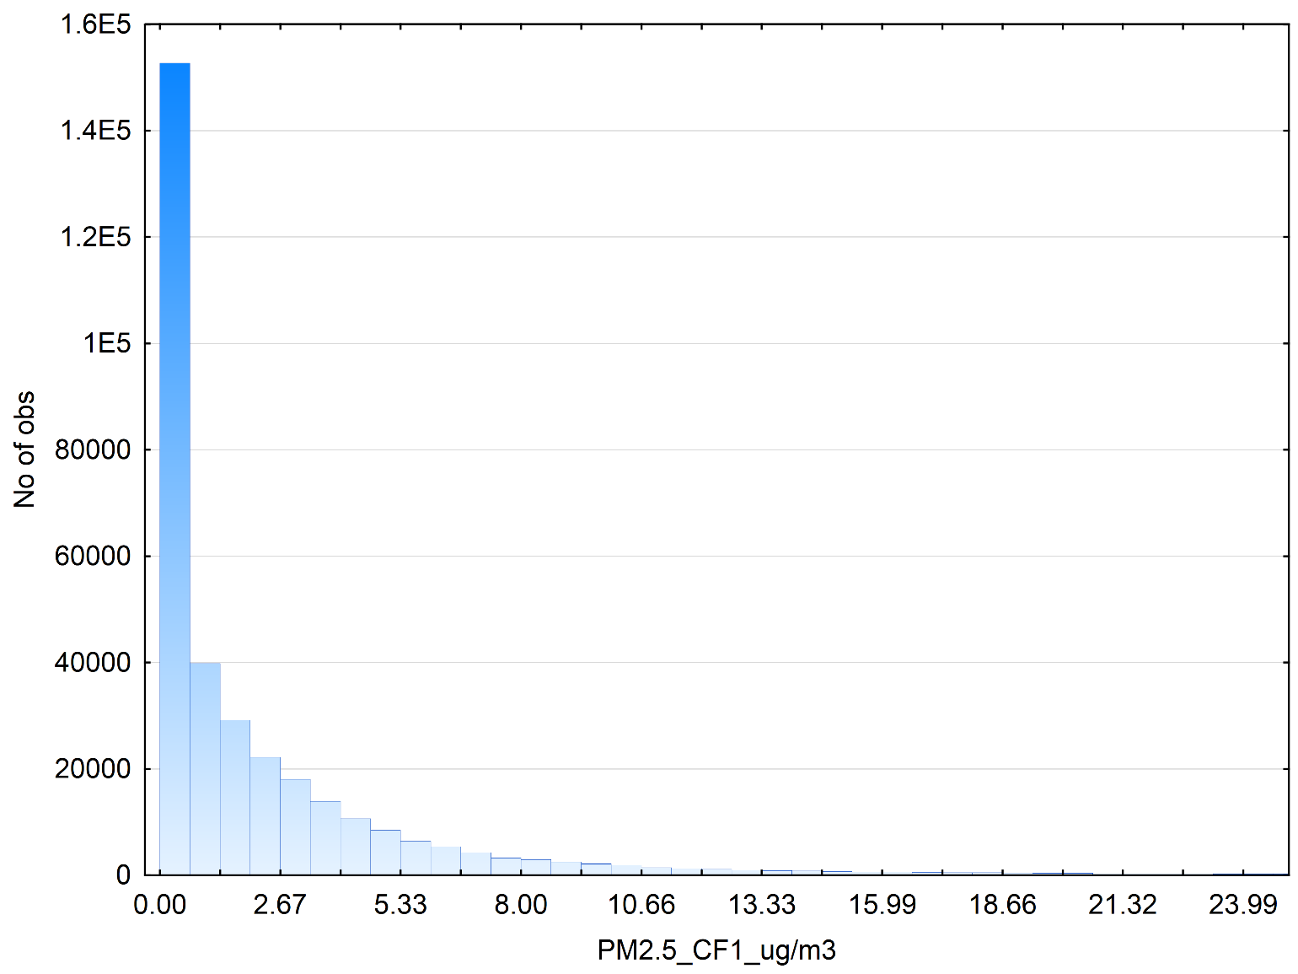

**Figure 1 . Histogram of 353,511 reported PM2.5 concentrations in the CF1 data series. The 73,266 reported values of zero distort the distribution**

For the alternative series, the PM2.5 size distribution is seen to approximate a log-normal distribution (Figure 2). No values of zero were reported.

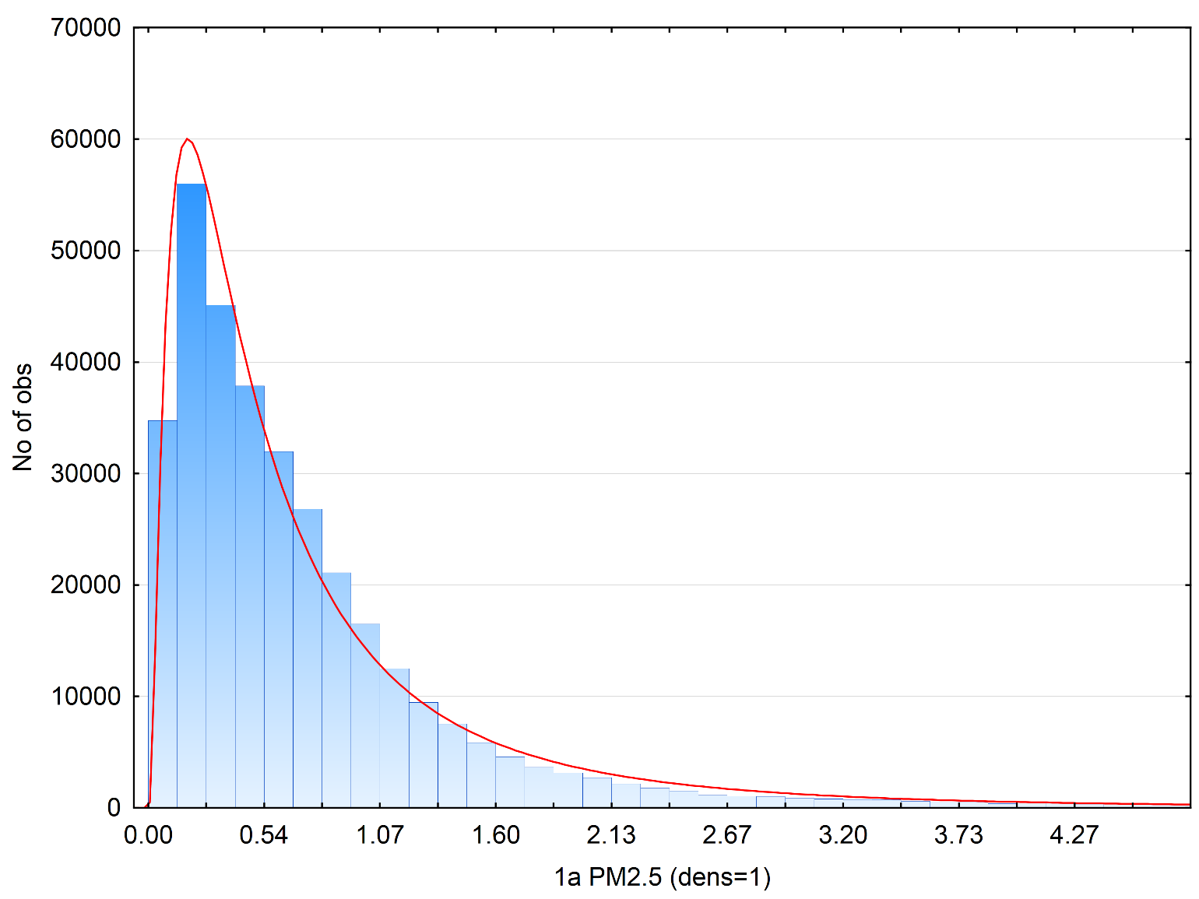

**Fig. 2 Histogram of PM2.5 concentrations reported by the STANDARD series. The shape is approximated by a log-normal fit**

*Calculation of the Limit of Detection*

A Santa Rosa database running from Jan 30, 2020 to April 27, 2020 with 63091 observations was used to calculate PM2.5 LODs for this method and the CF1 series (Table 3). For the CF1 series, the LOD was 1.77 ug/m3, a value that is comparable to those reported in other studies (e.g. the PM2.5 LODs found for two PMS 5003 sensors (2.62-3.65 μg/m3) in two seasons by Sayahi, Butterfield, and Kelly; Table S-3 in Sayahi Supplementary Material, 2018). Despite the lower LODs found in this study, only 13% of the PM2.5 concentrations exceeded the LOD for the CF1 series. By comparison, the improved LODs for our method resulted in 48% of PM2.5 concentrations exceeding the LOD.

**Table 3. Comparison of this method to the CF1 series LODs for PM2.5, with fraction of observations exceeding the LOD**

|  |  |  |
| --- | --- | --- |
|  | CF1 | This method |
| PM2.5 LOD | 1.77 | 1.15 |
| fraction >LOD | 0.13 | 0.48 |

This result is concerning, because outdoor values can be quite low in many parts of the US, and thus the PM2.5 estimates in the CF1 data series will be below the LOD (i.e., indistinguishable from zero) for a possibly large fraction of all measurements. This problem can be largely overcome by calculating the PM2.5 values in the way demonstrated here.

*Calibration of Plantower sensors*. Multiple comparisons of the two Purpleair monitors were made with two co-located research grade instruments: the SidePak (TSI) and Piezobalance (Kanomax). Both instruments were calibrated against gravimetric measurements when exposed to elevated concentrations of marijuana aerosol produced by vaping a commercial marijuana liquid. The SidePak was found to have a calibration factor of 0.44 for this aerosol. A series of 19 experiments calculated the source strengths (in mg/puff) determined by two SidePaks and two PurpleAir monitors. The calibration factor for the PurpleAir monitor was 2.95 (SD 0.32) (Table 4).

**Table 4. Calibration factor of PurpleAir monitor**

|  |  |  |
| --- | --- | --- |
| Date | SidePak (CF 0.44) source strength | Purpleair (CF 2.95) source strength (mg/puff) |
| 4/25/19 | 8.87 | 9.21 |
| 4/26/19 | 8.87 | 8.90 |
| 4/27/19 | 7.33 | 8.65 |
| 4/28/19 | 9.46 | 9.08 |
| 4/29/19 | 9.45 | 9.30 |
| 4/30/19 | 9.42 | 8.62 |
| 5/1/19 | 10.46 | 9.76 |
| 5/2/19 | 10.49 | 10.67 |
| 5/6/19 | 8.18 | 7.94 |
| 5/13/19 | 6.91 | 7.03 |
| 5/14/19 | 7.13 | 7.79 |
| 5/15/19 | 6.73 | 7.26 |
| 5/17/19 | 10.16 | 9.76 |
| 5/19/19 | 9.33 | 9.08 |
| 5/21/19 | 8.93 | 8.24 |
| 5/23/2019 | 9.24 | 8.77 |
| 5/25/2019 | 10.12 | 9.61 |
| 5/28/19 | 8.36 | 8.24 |
| 7/21/19 | 7.26 | 7.56 |
|  |  |  |
| count | 19 | 19 |
| mean | 8.77 | 8.71 |
| SD | 1.22 | 0.94 |
| CV (RSD) | 0.14 | 0.11 |
| SE | 0.28 | 0.22 |
| median | 8.93 | 8.77 |
| max | 10.49 | 10.67 |
| min | 6.73 | 7.03 |

**Discussion**

Many of the problems in using the CF1 or ATM data series provided by Plantower stem from the arbitrary decision to substitute zero for measurements falling below some value. For example, this obviously leads to distortions of the mass distributions if a substantial number of measurements fall below this limit. But it also leads to worse precision and higher coefficients of variation, since the clustering of otherwise positive values at zero serve to widen the standard deviation. Statisticians generally oppose the practice of substituting a single value, such as 0, the LOD/2, or the LOD itself because it leads to exactly these problems. A review of many of these studies is found in Helsel (2010). His first conclusion reads: “**In general, do not use substitution**. Journals should consider it a flawed method compared to the others that are available and reject papers that use it…” (emphasis added).

*Why is there such a large difference between this method and the CF1 estimates of PM2.5?* The short answer is that the Plantower sensor severely underestimates the particle numbers in the two smallest size categories by a factor on the order of 8-10. This has been shown in our work comparing the Plantower estimates in these two categories to estimates produced by a collocated reference monitor, the TSI Optical Sizer Model 3330 (Wallace et al., in preparation). The underestimate of PM2.5 was more like a factor of 4. This is in fair agreement with our finding of a CF of about 3 required for our method. The proper PM2.5 calibration factor for *outdoor* Plantower sensors would be determined from the PM2.5 estimates from nearby Federal Reference Method (FRM) daily measurements or Federal Equivalent Method (FEM) hourly measures. These estimates are presently being prepared by an ongoing study of 2200 PurpleAir monitors operated in California in 2019 (in preparation). Initial results suggest a CF of 3, with an uncertainty on the order of 0.5.

**Conclusion**

The alternative method presented here for estimating PM2.5 has superior performance compared to the CF1 data series. It has a lower limit of detection and thus a substantially higher percentage of measurements above the LOD. It has better precision. It does not have the arbitrary assignment of some measured values to zero, which distorts estimates of number and mass distributions. The method is widely used by environmental scientists working with instruments capable of multiple size channels. It is transparent and readily available to analysts. The Plantower manufacturer supplies the necessary estimates of particle numbers in the three size categories between 0.3 and 2.5 um. While it is true that these values are severe underestimates, nonetheless they can be corrected using the proper calibration factors. Therefore, we recommend that users of PurpleAir monitors consider calculating PM1 and PM2.5 using this method, as modified by inclusion of the appropriate calibration factors resulting from comparison of the aerosol mixture being studied with reference monitors.

**References**

AQ-SPEC (2016).<http://www.aqmd.gov/docs/default-source/aq-spec/field-evaluations/purpleair---field-evaluation.pdf>.

Becnel, T., Tingey, K., Whitaker, J., Sayahi, T., Le, K., Goffin, P., Butterfield, A., Kelly, K., & Gaillardon, P.E. (2019). A distributed low-cost pollution monitoring platform. *IEEE Internet of Things Journal* 6 (6):10738-48.

#### Bi, J., A. Wildani, A., H.H. Chang, H. H., & Liu, Y. (2020). Incorporating low-cost sensor measurements into high-resolution PM2.5 modeling at a large spatial scale. *Environmental Science & Technology* **Article ASAP.**

Bulot, F.M.J., Johnston, S. J., Basford, P. J., Easton, N. H. C., Apetroaie-Cristea, M., Foster, G. L., Morris, A.K.R., Cox, S.J. & Loxham, M. (2019). Long-term field comparison of multiple low-cost particulate matter sensors in an outdoor urban environment.*Scientific Rep*orts*9:7497* https://doi.org/10.1038/s41598-019-43716-3.

Chen, L. J., Ho, Y-H., Lee, H-C., Wu, H-C., Liu, H-M., Hsieh, H-H., Huang Y-T., & Lung, S-C. C. (2017). An open framework for participatory PM2.5 monitoring in smart cities. *IEEE Access* **5**, 14441–54, [https://doi.org/10.1109/accessed Jan 17](https://doi.org/10.1109/accessed%20Jan%2017), 2020.

Francis, A.S., Chee, F. P., Chang, J.H.W., Sentian, J., Dayou, J., & Payus, C. M. (2019). Parametric model for estimation of mass concentration based on particle count distribution for ambient air monitoring. *Journal of Phyics.: Conference Series* 1358012042 doi:10.1088/1742-6596/1358/1/012042.

He, M., Kuerbanjiang, N., & Dhaniyala, S. 2020. Performance characteristics of the low-cost Plantower PMS optical sensor. *Aerosol Science and Technology* 54 (2):232-241. doi: 10.1080/02786826.2019.1696015.

Helsel, D. (2010). Much Ado About Next to Nothing: Incorporating Nondetects in Science. *Annals of Occupational Hygiene* 54 (3):257–262.

Kaduwela, A. P., Kaduwela, A.P., Jrade, E., Brusseau, M., Morris, S., Morris, J., & Risk, V. (2019). Development of a low-cost air sensor package and indoor air quality monitoring in a California middle school: Detection of a distant wildfire. *Journal of the Air & Waste Management Association* 69 (9):1015-1022.

doi:10.1080/10962247.2019.1629362

Kelly, K.E., Whitaker, J., Petty, A., Widmer, C., Dybwad, A., Sleeth, D., Martin, R., & Butterfield, A. (2017). Ambient and laboratory evaluation of a low-cost particulate matter sensor. *Environmental Pollution* 221:491-500.

Klepeis, N.E., Bellettiere, J., Hughes, S.C., Nguyen, B., Berardi, V., Liles, S. et al. (2017). Fine particles in homes of predominantly low-income families with children and smokers: Key physical and behavioral determinants to inform indoor-air-quality interventions. *PLoS ONE* 12(5): e0177718. <https://doi.org/10.1371/journal.pone.0177718>

Levy Zamora, M., Xiong, F., Gentner, D., Kerkez, B., Kohrman-Glaser, J., &. Koehler, K. (2018). Field and laboratory evaluations of the low-cost plantower particulate matter sensor. *Environmental Science and Technology*. 53 (2), 838–49.

Magi, B.I., Cupini, C., Francis, J., Green, M., & Hauser, C. (2019). Evaluation of PM2.5 measured in an urban setting using a low-cost optical particle counter and a Federal Equivalent Method Beta Attenuation Monitor. *Aerosol Science and Technology* 54:147-159. doi:10.1080/02786826.2019.1619915.

Malings, C., anzer, R. Hauryliuk A., Saha, P. K.,Robinson, A. L.,Presto, A. A., & Subramanian, R. (2019). Fine particle mass monitoring with low-cost sensors: Corrections and long-term performance evaluation. *Aerosol Science and Technology,*54:160-174*.*doi:10.1080/02786826.2019.1623863.

Masic, A., D. Bibic, D., & Pikula, B. (2019). On the applicability of low-cost sensors for measurements of aerosol concentrations, *Proceedings of the 30th DAAAM International Symposium*, pp.0452-0456, B. Katalinic (Ed.), Published by DAAAM International, ISBN 978-3-902734-22-8, ISSN 1726-9679, Vienna, Austria.

doi:10.2507/30th.daaam.proceedings.060.

Plantower (2016)[*https://www.aqmd.gov/docs/default-source/aq-spec/resources-page/plantower-pms5003-manual_v2-3.pdf*](https://www.aqmd.gov/docs/default-source/aq-spec/resources-page/plantower-pms5003-manual_v2-3.pdf). Accessed Jan 17, 2020.

Sayahi, T., Butterfield, A., & Kelly, K.E. (2019). Long-term field evaluation of the Plantower PMS low-cost particulate matter sensors. *Environmental Pollution* 245:932-940.

Singer, B. C. & Delp, W.W. (2018). Response of consumer and research grade indoor air quality monitors to residential sources of fine particles. *Indoor Air* 28:624–639. <https://doi.org/10.1111/ina.12463>

Tryner, J., Quinn, C., Windom, B. C., & Volckens, J. (2019). Design and evaluation of a portable PM2.5 monitor

featuring a low-cost sensor in line with an active filter sampler. *Environmental Science Processes and Impacts* 21:1403-15*.*

US EPA (2017) <https://www.epa.gov/air-sensor-toolbox/how-use-air-sensors-air-sensor-guidebook>

Walker (2018). <http://conference2018.resnet.us/data/energymeetings/presentations/RESNET2018_LBL_LowCostMonitors_walker.pdf>.

Wallace, L. A., Wheeler, A., Kearney, J., Van Ryswyk, K., You, H., Kulka, R., Rasmussen, P., Brook, J., & Xu, X. (2010). Validation of continuous particle monitors for personal, indoor, and outdoor exposures. *Journal of Exposure Science and Environmental Epidemiology.* 21:49-64*.*

Wang, K., Chen, F. E.,,Au, W., Zhao, Z., & Xia, Z-L. (2019). Evaluating the feasibility of a personal particle exposure monitor in outdoor and indoor microenvironments in Shanghai, China. *International Journal of Environmental Health Research.* 29:209-20. doi:10.1080/09603123.2018.1533531.

Wang, Z., Delp, W. W., & Singer, B.C. (2020). Performance of low-cost indoor air quality monitors for PM2.5 and PM10 from residential sources. *Building and Environment.* <https://doi.org/10.1016/j.buildenv.2020.106654>.

Williams, R., Vasu, K., Snyder, E., Kaufman, A., Dye, T., Rutter, A., Russell, A., & Hafner, H. (2014). *Air Sensor Guidebook*. U.S. Environmental Protection Agency, Washington, DC, EPA/600/R-14/159 (NTIS PB2015-100610).

Zheng, T., Bergin, M. H., Johnson, K. K., Tripathi, S. N., Shirodkar, S., Landis, M. S., Sutaria, R., & Carlson, D. E. (2018). Field evaluation of low-cost particulate matter sensors in high-and low-concentration environments. *Atmospheric Measurement Techniques*. 11 (8), 4823–4846. doi.org/10.5194/amt-11-4823-2018.

Zusman, M., Schumacher, C.S., Gassett, A. J., Spalt, E.W., Austin, E., Larson, T.V., Arvlin, G. C., Seto, E., Kaufman, J.D., & Sheppard, L. (2020). Calibration of low-cost particulate matter sensors: Model development for a multi-city epidemiological study. *Environment International* 134:105329.