Gladly’s Survey

Andrew

## Getting started

The first thing to do in our analysis is load the R packages that we’ll use to do the work:

The next step is to load the data set itself. This time, we’ll assume the data is stored in a csv (comma-delimited) format. We’ll generally tend to use this from now on, because it’s a format that nearly any language can read. It’s usually a good idea to store data in general formats because that helps with sharing, so let’s get into the habit of that.

loc <- here("gladlysurvey2.csv")  
gdata <- read_csv(file = loc)

## Rows: 35 Columns: 9  
## ── Column specification ────────────────────────────────────────────────────────  
## Delimiter: ","  
## chr (4): name, species, food, gender  
## dbl (5): year, carrot, cake, mud, age  
##   
## ℹ Use `spec()` to retrieve the full column specification for this data.  
## ℹ Specify the column types or set `show_col_types = FALSE` to quiet this message.

## Creating a histogram

Let’s visualise our data. We’ll look at much more awesome ways to visualise data later, but for now, let’s just make a simple histogram of the years each person was born.

hist(x=gdata$age)

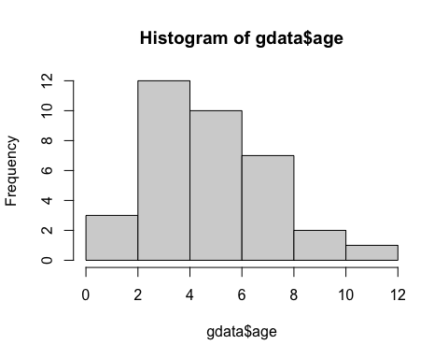

Now make it nicer.

hist(x=gdata$age,main="Ages of people in Gladly's Survey",xlab="Years Old",ylab="Number of people",col="darkviolet",breaks=11,xlim=c(0,12))

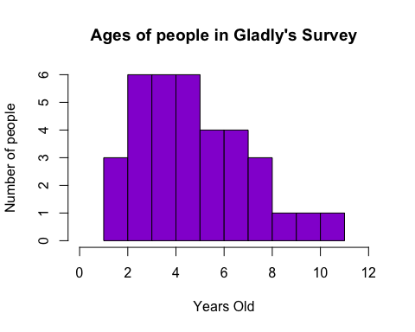 Now we want to view the dataset.

summary(gdata)

## name species year food   
## Length:35 Length:35 Min. :2010 Length:35   
## Class :character Class :character 1st Qu.:2014 Class :character   
## Mode :character Mode :character Median :2016 Mode :character   
## Mean :2016   
## 3rd Qu.:2018   
## Max. :2020   
##   
## carrot cake mud age   
## Min. : 5.000 Min. : 6.000 Min. :1.000 Min. : 1.000   
## 1st Qu.: 7.000 1st Qu.: 8.000 1st Qu.:1.000 1st Qu.: 3.500   
## Median : 8.000 Median : 9.000 Median :1.000 Median : 5.000   
## Mean : 7.912 Mean : 8.529 Mean :1.471 Mean : 5.229   
## 3rd Qu.: 9.000 3rd Qu.: 9.750 3rd Qu.:2.000 3rd Qu.: 7.000   
## Max. :10.000 Max. :10.000 Max. :3.000 Max. :11.000   
## NA's :1 NA's :1 NA's :1   
## gender   
## Length:35   
## Class :character   
## Mode :character   
##   
##   
##   
##