**KWAME NKRUMAH UNIVERSITY OF SCIENCE AND TECHNOLOGY**

**COLLEGE OF ENGINEERING**

**DEPARTMENT OF ELECTRICAL/ ELECTRONICS ENGINEERING**



**HARNESSING ELECTRICAL ENERGY FROM AIR-CONDITIONER MECHANICAL VIBRATION USING PIEZOELECTRIC SENSORS**

**BY:**

HENRY ANSAH

EMMANUEL ASAMOAH

LOUIS AKOLEY

**SUPERVISOR:**

MR. ADOM-BAMFI GIDEON

ABSTRACT

ACKNOWLEDGEMENT

Table of Contents

ABSTRACT 2

ACKNOWLEDGEMENT 3

INTRODUCTION 4

INTRODUCTION 4

AIMS AND OBJECTIVES 5

AIMS 5

OBJECTIVES 5

LITERATURE 7

1. **INTRODUCTION**

**1.1 BACKGROUND**

Piezoelectricity is a concept where we derive electrical energy from mechanical stress to a special sensor know as a piezoelectric sensor. Piezoelectricity was derived from *Piezein* which means squeezing and pressing. There are two types of piezoelectric effects – The Direct effect and the Converse effect. In the case of the Direct effect, electrical energy is generated from the application of the mechanical stress or strain to an object with piezoelectric properties. Conversely, mechanical energy is generated from the application of electrical energy in the case of the Converse effect. In harvesting useful electrical energy from the vibration of an air-conditioner unit, we employ the direct effect. For different piezoelectric materials, there is a factor, *k* called the piezoelectric coupling factor, which is a measure of the general strength of the electromechanical effect.

Mechanical stress or strain applied to a piezoelectric material causes charge separation across the device, producing an electric field and resulting in a voltage drop proportional the mechanical stress or strain applied. Piezoelectric materials leverage an oscillating system which is usually a cantilever beam with a mass at the unattached end of the lever. This setup provides a higher strain for a given input force. The output electrical energy from the piezoelectric material is an irregular AC voltage since the voltage varies with strain and time. Since the output voltage is almost unusable, we aim to build a system as part of the piezoelectric sensor that will convert this output voltage in something usable and direct.

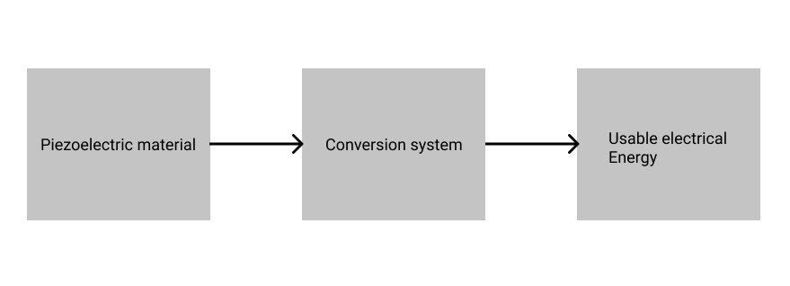

In the diagram above, the conversion system which does the actual conversion of the irregular AC voltage from the piezoelectric sensor to direct usable voltage is represented as a Blackbox. In reality, it consists of several electrical and electronic systems, most notable among them is a rectifier for converting the AC voltage into DC voltage. We plan to achieve some level of amplification through components assembled in the conversion system.

**1.2 AIM AND OBJECTIVES**

**1.2.1 AIM**

The aim of this project is to leverage the mechanical vibrations that emanate from the outside unit of an air-conditioner to produce usable electrical energy through the use of a piezoelectric sensor. The generated electrical energy should be usable and stable enough to be able to charge small devices such as mobile phones and calculators.

**1.2.2 OBJECTIVES**

* Review existing ways of generating electrical energy from piezoelectric materials
* Review existing piezoelectric materials, their strengths and drawbacks, how we can efficiently generate usable electricity with minimal compromise.
* Design a low-cost electronic system to convert barely usable electrical energy from a piezoelectric sensor into a stable and amplified form.
* Rigorously test energy harvesting system to be compliant with certain standards.

**CHAPTER 2 BACKGROUND**

**2.1 LITERATURE REVIEW**

In this chapter we review previous publications on piezoelectric sensors impact on mechanical devices.

**2.1.1 Title: Energy Harvesting from Air Conditioning Condensers with The Use of Piezoelectric Devices.**

*Author: Dr. Faruk Yildiz, Dr. Ulan Dakeev, Dr. Kenan Baltaci, Mr. Keith L.Coogler*

*2015*

This paper gives details on how energy was harvested from sources of waste on a university campus. Foremost several on-campus air conditioning units were used to determine potential sources of waste found in the air conditioning unit. Later, energy harvesting methods were obtained.

The paper then goes on to devise methods of energy harvesting called vibration and airflow-driven energy harvesting using piezoelectric devices. The paper then set an objective of generating power from the exhaust flow (analogous to jet engine afterburners, but on a much smaller scale).

According to the paper, the idea behind the piezoelectric device is to make the device vibrate to generate power. The paper then made students in the faculty of engineering, study air conditioning units to determine potential sources of waste energy.

The paper also detailed measurements to determine operational time based on seasons, vibration levels, and exhaust fan flow from a condenser. It goes on to take measurement which are compared to calculated potential power to be harvested from the condenser.

**Advantages**

* Harvesting of energy does not undergo a complex process
* This conversion principle is adapted to micro-engineering, since there exist several different processes for piezoelectric film deposition

**Disadvantages**

* There is constant low power output from a piezoelectric device due to vibrations from exhaust fans.
* The power generated by the piezoelectric material cannot be directly used by other electric devices and therefore some electric interface is necessary for the energy harvesting system to ensure the voltage is compatible with electric load or energy storage element

**2.1.2 Title: A Development of Piezoelectric Model as An Energy Harvester from Mechanical Vibrations**

*Author: Hanim M. Yatim, Fauzi M. Ismail, Shahrul E. Kosnan, Zulhaimi Mohammad, Fatihhi S. Januddi, Adnan Bakri.*

*2018*

[3] This paper aims to harness ambient from the environment, to help reduce the electricity energy consumption.

Foremost the paper presents the modelling for conversion of mechanical vibration into electricity using piezoelectric converter. The model development was based on the piezoelectric model of PI P-876 and the non-adaptive rectifier circuit was employed in order for direct voltage conversion that are much useful for electronic devices nowadays.

The paper then went on to make use of wasted vibration energy. Several sources of vibration energy such as ducting and piping system are reviewing and later fed into the piezoelectric model converter in MATLAB SIMULINK.

The paper then went on to identify and analyse the output from the system. The results from the simulation conducted includes direct voltage generated from various sources. Thus, a maximum direct voltage of 0.14V and 1.96V Watt of energy could be harnessed from ducting system

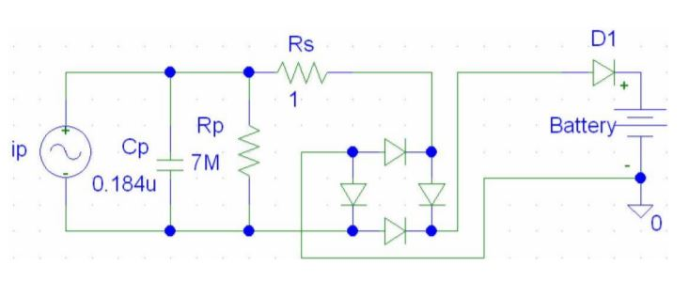

Figure 2.1: Non-adaptive harnessing circuit (Mingjie and Wei-Hsin, 2005)

**Advantages**

* The power output is sufficient for mini home appliances and low-powered wireless sensor networks in silent mode which can be used in variety of applications.
* Harvesting vibration energy provides a completely self-powered system

**Disadvantages**

* Energy harvested cannot act as a source of power for large appliances and equipment

**2.1.3 A geometric parameter study of piezoelectric coverage on a rectangular cantilever energy harvester**

*R. Patel, S. McWilliam and A. A. Popov*

*2011*

Patel et al. [4] proposed a versatile model for optimizing the performance of a rectangular cantilever beam piezoelectric energy harvester used to convert ambient vibrations into electrical energy. The model proposed by the authors accounts for geometric changes to the natural frequencies, mode shapes, and damping in the structure.

They managed achieve this through the combination of finite element modelling and a distributed parameter electromechanical model, including load resistor and charging capacitor models. Their model has the potential for use in investigating the influence of numerous geometric changes on harvester performance, and incorporates a model for accounting for changes in damping as the geometry changes. The model is used to investigate the effects of substrate and piezoelectric layer length, and piezoelectric layer thickness on the performance of a microscale device.

Findings from a parameter study indicate the existence of an optimum sample length due to increased mechanical damping for long beams and improved power output using thicker piezoelectric layers. To achieve unbiased comparisons between different harvester designs, parameter studies are performed by changing multiple parameters simultaneously with the natural frequency held fixed. Performance enhancements were observed using shorter piezoelectric layers as compared to the conventional design, in which the piezoelectric layer and substrate are of equal length.

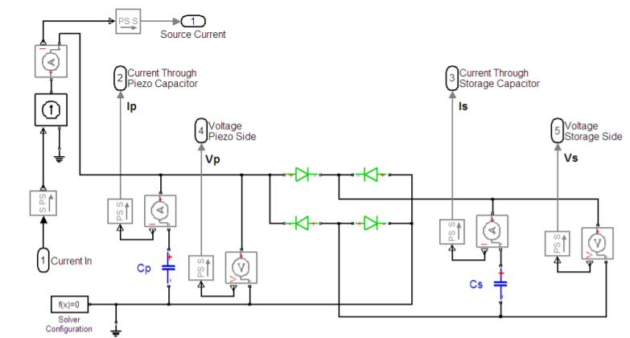

Figure 2.2: Model created in Simulink to represent an electrical system consisting of a storage capacitor in parallel with a resistor (assumed to have a magnitude of zero during this parameter study).

**Advantages**

* 1mW harvest power at 33Hz and 2.4cm(square)
* Cost effective and scalable technique at 150 degrees Celsius

**Disadvantages**

* Efficiency decrease at higher power output

**2.1.4 Piezoelectric Energy Harvester with a Multimode Dynamic Magnifier**

*W. L. Zhou, G. R. Penamalli and L. Zuo.*

2012

[5] In this paper, the authors proposed and investigated a new piezoelectric energy harvester with a multimode dynamic magnifier capable of significantly increasing the bandwidth and the energy harvested from ambient vibration. The design comprised a multimode intermediate beam with a tip mass, called a dynamic magnifier and an energy harvesting beam with a tip mass.

The theoretical analysis is conducted for the coupled beams by considering the interaction of one beam with the other. From the mode shapes of the first six resonant frequencies of the coupled structure drawn from the theoretical and finite element modelling (FEM) analyses, it is shown that the voltage generated by the energy harvesting beam is dramatically magnified in a broad bandwidth and the vibration of the primary beam is mitigated. Zhou et al. experimentally demonstrated that 25.5 times more energy can be harvested in a frequency range of 3 – 300 Hz from the energy harvesting beam by adding a multi-mode dynamic magnifier. The energy harvesting is increased by 100 – 1000 times near these resonances of the harvesting beam

**Advantages**

* The model proposed by the authors can generate electricity from vibrations of a wide frequency range (3 – 300Hz).

**Disadvantages**

* The model required an additional tip mass in order to magnify the output.

**2.1.5 A Composite Piezoelectric Cantilever Beam Generator**

*S. Roundy, P. H. Wright and J. M. Rabaey.*

2004

[6] This paper highlights the development of a composite piezoelectric cantilever beam generator. The cantilever used was of constant width which simplifies the analytical model and beam fabrication but results in an unequal distribution of strain along its length. A prototype generator was fabricated by attaching a PZT-5A shim to each side of a steel center beam.

With this proposed model, a cubic mass made from an alloy of tin and bismuth was attached to the end and the generator tuned to resonate at 120 HZ. The prototype produced a maximum power output of nearly 80 µW into a 250 kΩ load resistance with 2.5 ms-2 input acceleration and the results showed a reasonable level of agreement with the analytical models. These models were then used to optimize the generator design within an overall size constraint of 1 cm3. Two designs were adopted, each using PZT-5H attached to a 0.1 mm thick central brass shim. Design 2 using a PZT thickness of 0.28 mm, possessing a beam length of 11 mm and a tungsten proof mass of 17 × 7.7 × 3.6 mm, produced 375 µW with an input acceleration of 2.5 ms-2 at 120 Hz. This generator was demonstrated powering a radio transceiver with a capacitor used for energy  
storage and achieved a duty cycle of 1.6 %. Roundy et al. concluded that the generator output at resonance is proportional to the mass attached to the cantilever and this should be maximized provided size and strain constraints are not exceeded.

**Advantages**

* Using a constant width Cantilever for this model made analytical modelling of this harvest simple.

**Disadvantages**

* The constant width Cantilever used resulted in unequal distribution of strain along the width.

**2.1.6 Piezoelectric Harvester using Laser Micro Machined Resonant Copper**

*W. J. Li, T. C. H. Ho, G. M. H. Chan, P. H. W. Leong and H. Y. Wong*   
2000

Li et al [7] developed a vibration harvesting power generator with a volume of 1cm3 using a laser micro-machined resonant Copper spring based on Faraday’s law of induction according to which a spring can convert mechanical energy into useful electrical power. Using well studied designs, the mass can be vibrated horizontally while the vibration input is applied vertically. The Substantially horizontal vibration provides the output voltage of the generator.

The authors developed a generator capable of producing a voltage of 2 volts DC with 64 Hz to 120 Hz input frequency at 250 100 um vibration amplitude.

**Advantages**

* Requires low voltage operation of the Piezoelectric actuators
* Scaling of devices for miniaturization because the energy density of Piezoelectric material remains high with reducing film thickness

**Disadvantages**

* The cost can be higher when compared with the overall cost of a wireless sensor
* It is not always easy to have a small converter.

**2.1.7 ENERGY HARVERSTER USING A DOUBLE-MASS CONTACTLESS FREQUENCY-UP CONVERTER WITH BUCKLED CLAMPED-CLAMPED BEAMS**

*F. Cottone, P. Basset, R. Guillemet, D. Galayko, F. Marty and T. Bourouina*

2013

Cottone et al. [8] developed a novel vibration energy harvester design consisting of a double-mass contactless frequency-up converter with buckled clamped-clamped beams aimed at increasing energy harvesting efficiency from low-frequency vibrations. This concept aims at increasing the energy harvesting efficiency for low frequency vibrations. The mechanical to electrical energy conversion was performed through a silicon MEMS micro electrostatic  
generator based on interdigitated combs. A device prototype was fabricated and  
experimentally investigated under harmonic frequency sweeping at 0.2 g rms (g = 9.81 m/s2) and band-limited colored noise 0.15 g rms with a pre-charge voltage of 2.5 V. In the buckled beam bistable configuration, the researchers found that the electrostatic generator showed a gain factor of 100 % that mean the harvested power increases of more than 100 times at low frequencies in the interval vibrations between 20 and 50 Hz for the bistable mode versus the normal operation mode, despite of the fact that the converter itself was designed to resonate at 162 Hz. Cottone et al. claim that this concept can be applied to different transduction techniques.

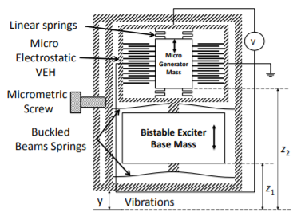

Figure 2.3: Scheme of the bistable multiple-mass VEH. The size of the micro electrostatic VEH is enhanced to facilitate the view but the illustrated configuration be applied at different scales

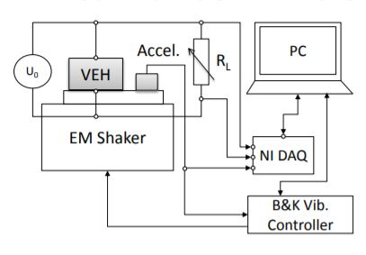

Figure 2.4: Scheme of the experimental equipment different scales

**Advantages**

* This design model is capable of increasing the energy harvesting efficiency for very low vibrations.

**Disadvantages**

* The device could be fabricated and investigated empirically under special conditions

**2.1.8 RESONANCE FREQUENCY TURNABLE ENERGY HARVESTING DEVICE USING A MAGNETIC FORCE**

*V. R. Challa, M. G. Prasad, Shi. Y. and F. T. Fisher*   
2008

Challa et al. [9] proposed the design and testing of a resonance frequency tunable energy harvesting device using a magnetic force. The technique was about to place a pair of magnets at the end of the collector and another on a case surrounding the recovery. Positions of the magnets are chosen so that an attraction force and repulsion force is applied on the collector thus inducing a magnetic stiffness. To control the frequency of resonance of the collector, the distances between pairs of magnets can be adjusted and so decrease or increase the magnetic stiffness. This technique enabled resonance tuning to ± 20% of the untuned resonant frequency. In particular, this magnetic-based approach enabled either an increase or decrease  
in the tuned resonant frequency. A piezoelectric cantilever beam with a natural frequency of 26 Hz was used as the energy harvesting cantilever, which was successfully tuned over a frequency range of 22–32 Hz to enable a continuous power output 240 – 280 µW over the entire frequency range tested.

**Advantages**

* It can operate effectively at low frequencies

**Disadvantages**

* As the source of vibration is aging it exhibits multiple frequencies and change in temperature, hence causing the energy harvester to fail in such environment

**2.1.9 VIBRATION CONTROL AND ENERGY HARVESTING USING PIEZOELECTRIC MATERIALS AND A NONLINEAR APPROACH BASED ON SYNCHRONIZED SWITCH DAMPING (SSD).**

*J. H. Qiu, H. L. Ji and H. Shen*

2009

Qiu et al. [10] introduced research activities of vibration control and energy harvesting using piezoelectric materials and a nonlinear approach based on Synchronized Switch Damping (SSD). The SSD technique, also called pulse-switched method, consists in a nonlinear processing of the voltage on a piezoelectric actuator. It is implemented with a simple electronic switch synchronously driven with the structural motion. This switch, which is used to cancel or inverse the voltage on the piezoelectric material, allows to briefly connecting a simple electrical network (short circuit, inductor, voltage sources depending on the SSD version) to the piezoelectric material. Due to this process, a voltage magnification is obtained and a phase shift appears between the strain in piezoelectric patch and the resulting voltage. The force generated by the resulting voltage is always opposite to the velocity of the structure, thus creating net mechanical energy dissipation. The dissipated energy corresponds to the part of the mechanical energy which is converted into electric energy. Maximizing this  
energy is equivalent to minimizing the mechanical energy in the structure under given excitation. This process increases the amount of converted electrical energy during a mechanical loading cycle of the piezoelectric material.

**Advantages**

* It exhibits excellent mechanical electrical coupling characteristics, thus increase the amount of electrically converted energy during a mechanical loading cycle.
* Excellent frequency response characteristics

**Disadvantages**

* Part of the energy produced is used by the Piezoelectric material.
* The material is expensive to build or produce.

**2.1.10 MICRO ELECTROMAGNETIC VIBRATION ENERGY HARVESTER WITH SANDWICHED STRUCTURE AND AIR CHANNEL**

*H. B. Fang, J. Q. Liu, Z. Y. Xu, L. Dong, L. Wang and D. Chen*

2006

Wang et al. [11] designed, simulated, fabricated and characterized a micro electromagnetic vibration energy harvester with sandwiched structure and air channel. The harvester consists of the lower coil, an upper coil, an NdFeB permanent magnet and a plane of nickel with the spring integrated frame of Silicon. The natural frequency of the magnet-spring system tested is 228.2 Hz. Comparison of the natural results tested and simulation shows that the micro electroplated Ni film Young’s modulus is about 163 GPa rather than 210 GPa of bulk Ni material. These experimental results show that the air channel in the silicone frame of the prototype and the sandwiched structure are able to increase the induced voltage to 42 % of the single coil. The prototype has a resonant frequency of 280.1 Hz at an acceleration of 8 m/s2 which results from the nonlinear magnet-spring system. The prototype at resonant frequency of 280.1 Hz and 8 m/s2 input vibration acceleration generated 162.5 mV charging.

**Advantages**

* The air channel in the silicone frame of the prototype and the sandwiched structure are able to increase the induced voltage by 42% of the single coil.

**Disadvantages**

* Results from natural testing and simulation testing were different.

**CHAPTER 3 DESIGN IMPLEMENTATIONS**

**3.0 Introduction**

In this chapter, we explore the design and architecture of the proposed solution, the specifications and costs of components and how these components come together form a Piezoelectric energy harvester.

**3.1 Block diagram of proposed solution**

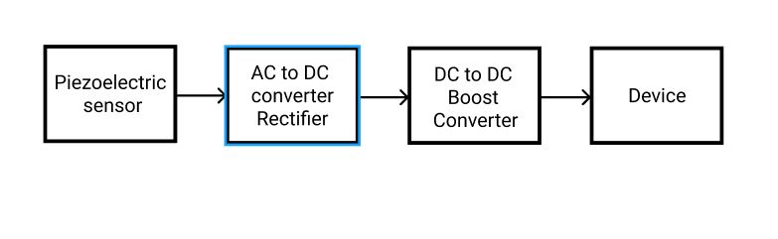

Figure 3.1 End to end block diagram for proposed solution

**3.3 Review of Sensors and modules**

Components:

* Piezoelectric sensor - Polyvinylidene Fluoride
* AC to DC converter (Rectifier)
* DC to DC boost converter
* Device

**3.3.1 Piezoelectric sensor**

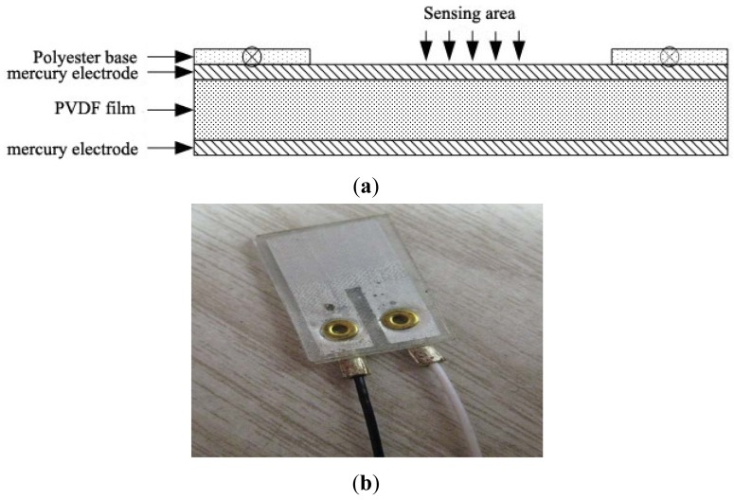

Figure 3.2 piezoelectric sensor made from a Polyvinylidene difluoride film

The main features considered when choosing a Piezoelectric sensor where mechanical flexibility, generation of suitable voltage with sufficient power output and low fabrication cost. Ultimately, the sensor that would fulfill these requirements is the Polyvinylidene difluoride (PVDF). The following table shows some reported Piezoelectric energy harvesters with different sizes and frequency. As can be seen, how the peak power changes with different sizes, shapes and applied frequency in different materials.

|  |  |  |  |  |
| --- | --- | --- | --- | --- |
| **Material type** | **Peak Power** | **Volume** | **Frequency (Hz)** | **Excitation** |
| PVDF | 2 | 28 modules of  16.5 x 9.5 x 0.15cm3 film | 2 | 0.1 or 0.2 G |
| PVDF | 0.0005 | 30 x 12 x 0.005 mm3 | 2 | 3-point bending at 3 N |
| PVDF | 610 | 72 x 16 x 0.41 mm3 | 2 | Wind speed of 4 m/s |
| PVDF | 2.75 | 10.94 x 22 x 0.354 mm3 | 104 | 1 G |
| P2T Ceramic | 47 | 25 x 10 x 0.8 mm3 biomorph | 1 | Shook by hand. Ball hits piezo beams |
| P2T Ceramic | 2000 | 1 x 1 x 2 cm3 | 1 | 900 N |
| P2T Ceramic | 40 | 45 x 20 0.3 mm3 | 20 | 1 N |
| P2T Fiber | 750 |  | 180 |  |

Though Polymers have the disadvantage of low power output as compared to Ceramics, its higher dielectric breakdown, maximum frictional field strength and faster processing makes it great choice over ones made from ceramics.

[14] For our project, we will be using the LDT0-028K. [13] The LDT0-028K is a flexible component comprising a 28 µm thick piezoelectric PVDF polymer film with screen-printed Ag-ink electrodes, laminated to a 0.125 mm polyester substrate, and fitted with two crimped contacts. As the piezo film is displaced from the mechanical neutral axis, bending creates very high strain within the piezopolymer and therefore high voltages are generated. When the assembly is deflected by direct contact, the device acts as a flexible "switch", and the generated output is sufficient to trigger MOSFET or CMOS stages directly. If the assembly is supported by its contacts and left to vibrate "in free space" (with the inertia of the clamped/free beam creating bending stress), the device will behave as an accelerometer or vibration sensor. Adding mass, or altering the free length of the element by clamping, can change the resonant frequency and sensitivity of the sensor to suit specific applications. Multi-axis response can be achieved by positioning the mass off center. The LDTM-028K is a vibration sensor where the sensing element comprises a cantilever beam loaded by an additional mass to offer high sensitivity at low frequencies.

FEATURES

* Solder Tab connection
* Both No Mass and With Mass Version
* Withstands High Impact
* Operating Temperature: 0 degree Celsius to 85 degrees Celsius
* Storage Temperature: -40 degree Celsius to 85 degrees Celsius

**EXPERIMENT TO DETERMINE HOW THE DEGREE OF BEND AFFECTS THE OUTPUT VOLTAGE**

LDT0 as Flexible Switch - using a charge amplifier to obtain "open-circuit" voltage sensitivity, the output was measured for controlled tip deflections applied to the sensor (supported by its crimped contacts as described above). 2 mm deflection was sufficient to generate about 7 V. Voltages above 70V could be generated by bending the tip of the sensor through 90°.

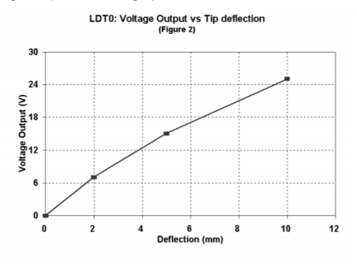

|  |  |  |
| --- | --- | --- |
| Tip Deflection | Charge Output | o/c Voltage Output |
| 2mm | 3.4 nC | 7 V |
| 5mm | 7.2 nC | 15 V |
| 10mm | 10 – 12 nC | 20 – 25 V |
| Max (90°) | * 30 nC | * 70 V |

**3.3.1 AC to DC Converter (Rectifier)**

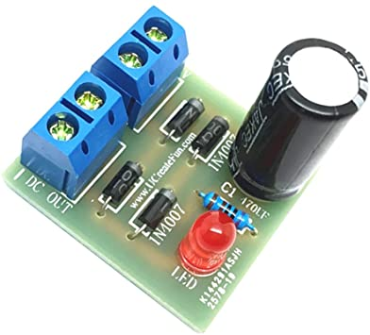

Figure 3.3 1N4007 Full wave bridge rectifier

The output from our PVDF Piezoelectric sensor will likely be in AC form which is not usable by devices that are going to be utilizing the energy from the harvester. It is therefore required that we convert the immediate output from the Piezoelectric sensor to Direct Current using an AC to DC Converter (Rectifier). In the project, we are going to be using the 1N4007 Full wave bridge rectifier which utilizes four 1N4007 diodes. The rectifier also employs a 470-microfarad capacitor to smoothen the DC output from the diode configuration.

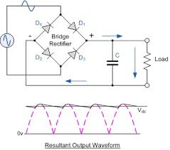

Figure 3.4 1N4007 Full wave bridge rectifier circuit diagram and corresponding output

Product Specification

* Input Communication: 3 – 18V
* Maximum output current: 1A
* Item Weight: 14g
* PCB size: PCB size: Approx. 3x2.8x0.4cm / 1.18x1.10x0.16inch

**DC to DC Boost Converter**

[12] This DC -DC switching boost converter is capable of driving a 4A load with excellent line and load regulation. The main switching component XL6009 IC is available in fixed output voltages of 3.3V, 5V,12V, and an adjustable output version. It is an efficient switching regulator and the output efficiency is significantly higher in comparison with the popular regulators. At higher input voltages, the regulator operates at a switching frequency of 400kHz thus allowing the overall board size to be smaller and space-saving

The XL6009 module is a DC to DC BUCK-BOOST converter module that operates at a switching frequency 0f 400kHz. In such high frequency, it provides smaller sized filter components compared with low frequency switching regulators. It is the upgraded version of the LM2577 based module.

Pin Description of XL6009 Power module Board

|  |  |
| --- | --- |
| PIN NAME | DESCRIPTION |
| IN+ | Positive input (unregulated or regulated) |
| IN- | Negative input (Ground) |
| OUT+ | Positive Output (Regulated) |
| OUT- | Negative Output (Ground) |

The pinout can be easily seen in the Board Legend, the pin names are also marked.

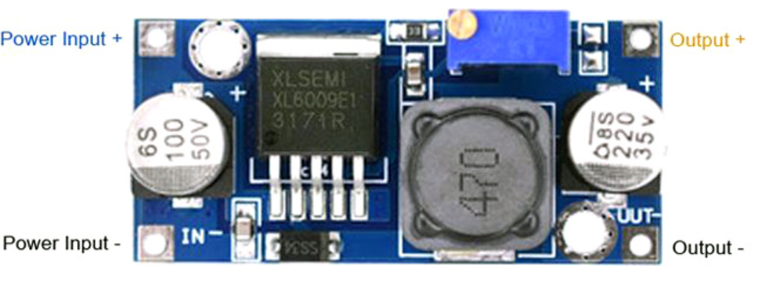

Features and Specification of XL6009 DC-DC Power module

* Input voltage: 3 -32v
* Output voltage: 5 – 35V (adjustable)
* Output current: Maximum output current 4A
* Efficiency of this regulator up to <94%
* Load Regulation: 0.5%
* Voltage Regulation: 0.5%
* Adjustable potentiometer onboard for output voltage adjustment
* Non-isolated constant voltage module
* Non-synchronous rectification
* Short circuit proportion: current limiting since the recovery
* Dimension: 45*20*14 mm (L*W*H)

XL6009 Power Module Board – Overview

The main driver is XL6009-Adj

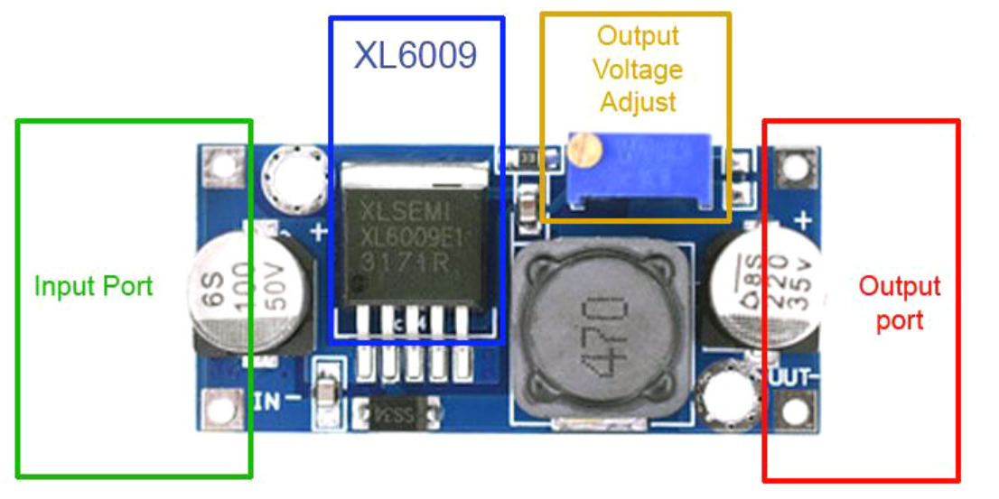

The XL6009-Adj based DC-DC step-up module offers 4A of rated current from 3 – 32V of input voltage. The power module has a potentiometer to adjust the output voltage according to the user needs. Although the module uses a PCB based heat sink, it is recommended to use an additional heat sink if the output power rating exceeds 15W. The module also offers a very high conversion efficiency of less than 94% with 0.5% load regulation that can be an excellent choice for audio electronics-related products. Higher conversion efficiency enables battery-operated applications as well.

Users can adjust the potentiometer to get the output voltage from 5V to 35V. However, the higher input voltage offers higher load current capabilities.

**Interfacing Diagram**

The interfacing of the XL6009 module is quite easy. Connect the regulated or unregulated input across the IN+ and the IN- pin and use the potentiometer to adjust the output voltage. Connect the load directly at OUT+ and OUT- pins.

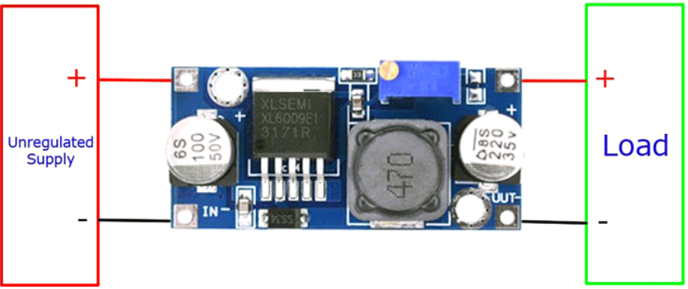

**Other Applications of XL6009 Power Module Board**

* DIY based power supply
* To serve the power requirements of Audio-based circuits
* High current applications with small space

Reasons for choosing the XL6009 over the LM2577 based module

* Built-in 4A efficient Mofset switch tube, make efficiency up to 94 percent (LM2577 current only has 3A)
* High switching frequency, 400 kHz, can use the small capacity of the filter capacitor, can achieve very good effect, ripple smaller and smaller
* Operating Temperature: -40 degrees to +85 degrees

**CHAPTER 4 THEORY**

In this chapter, we dive deep into the theoretical aspects of our project. We discuss the mathematical models of the sensors and converters and describe the relations between these mathematical models.

**PIEZOELECTRIC SENSOR**

Piezoelectric sensors work on the principle of piezoelectricity - appearance of an electrical potential across some faces of a crystal when it is under pressure, and of distortion when an electrical field is applied. This effect occurs naturally in quartz crystals, but can be induced in other materials, such as specially formulated ceramics consisting mainly of Lead, Zirconium, and Titanium (PZT). Because they are ceramics (piezoceramics), they can be formed to most any shape or size. In order to “activate” the piezo properties of the mix of metals, the material is first heated to its Curie temperature. There, a voltage field of a sufficient strength is applied in the desired direction, forcing the ions to realign along this “polling” axis. When the ceramic cools, the ions “remember” this polling and act accordingly.

Before subjecting a piezoelectric material to an external stress, the centers of the negative and positive charges of each molecule coincide—resulting into an electrically neutral molecule as indicated in Fig. A.3(a). However, in presence of an external mechanical stress the internal reticular can be deformed, thus causing the separation of the positive and negative centers of the molecule and generating little dipoles. As a result, the opposite facing poles inside the material cancel each other and fixed charges appear on the surface. That is to say, the material is polarized and the effect called direct piezoelectric effect. This polarization generates an electric field that can be used to transform the mechanical energy, used in the material’s deformation, into electrical energy.

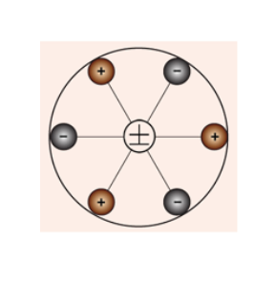

Figure 1: Piezoelectric material molecules in its unstress state

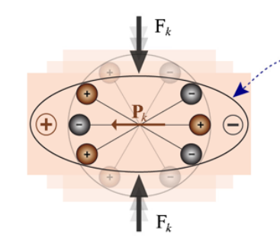

Figure 2: Piezoelectric material molecules in their stressed state. As can be noticed. the positive and negative centers of the molecule have been separated

**MATHEMATIC FORMULATION OF PIEZOELECTRICITY**

This section presents basic mathematical formulation describing the electromechanical properties of piezoelectric materials. The presentation is based on the linear theory of piezoelectricity, according to which, piezoelectric materials have a linear profile at low electric fields and at low mechanical stress levels.1 For the range of mechanical stresses and electrical fields used in this book, the piezoelectric materials exhibit the linear behavior.

As explained in previous sections, when a poled piezoelectric material is mechanically strained it becomes electrically polarized, producing fixed electric charge on the surface of the material. If electrodes are attached to the surfaces of the material, the generated electric charge can be collected and used. Following the linear theory of piezoelectricity [10], the density of generated fixed charge in a piezoelectric material is proportional to the external stress. In a first mathematical formulation, this relationship can be simply written as:

*Ppe = d × T*

where Ppe is the piezoelectric polarization vector, whose magnitude is equal to the fixed charge density produced as a result of piezoelectric effect, d is the piezoelectric strain coefficient and T is the stress to which piezoelectric material is subjected. For simplicity, the polarization, stress, and the strain generated by the piezoelectric effect have been specified with the ‘pe’ subscript, while those externally applied do not have any subscript. In a similar manner, the indirect/reverse piezoelectric effect can be formulated as:

*Spe = d × E*

where Spe is the mechanical strain produced by reverse piezoelectric effect and E is the magnitude of the applied electric field. Considering the elastic properties of the material, the direct and reverse piezoelectric effects can alternatively be formulated as:

*Ppe = d × T = d × c × S = e × S*

*Tpe = c × Spe = c × d × E = e × E*

where c is the elastic constant relating the generated stress and the applied strain (T = c ×S), s is the compliance coefficient which relates the deformation produced by the application of a stress (S = s × T ), and e is the piezoelectric stress constant.

**BOOST CONVERTER**

[15] A boost converter simply performs one function – steps up an input dc voltage at one level to a higher level

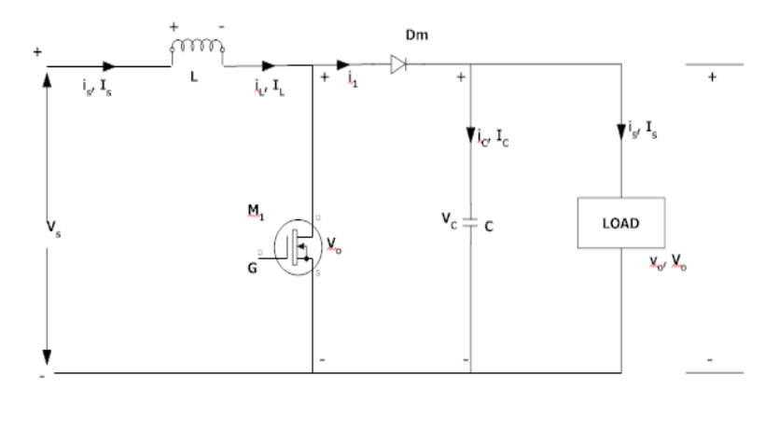

Figure 3: circuit diagram of a boost converter with a mosfet, a diode, capacitor and inductor

The function of boost converter can be divided into two modes, Mode 1 and Mode 2. Mode 1 begins when transistor M1 is switched on at time t=0. The input current rises and flows through inductor L and transistor M1. Mode 2 begins when transistor M1 is switched off at time t=t1. The input current now flows through L, C, load, and diode Dm. The inductor current falls until the next cycle. The energy stored in inductor L flows through the load.

Circuit diagrams for the two modes are shown below:

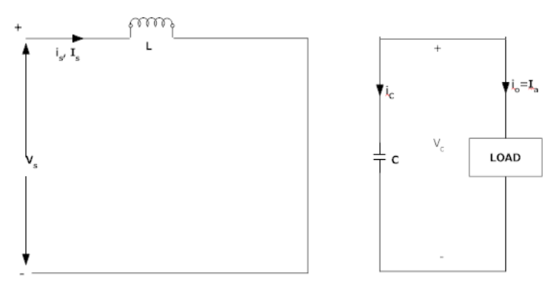

Figure 4: Mode 1

As can be seen in the diagram above, the mosfet which is acting as a switch is turned on at a certain time by a Pulse Width Modulator. At this time, the current from the source passes through the inductor which stores this current as well as the mosfet. We indicate the closed mosfet switch in the diagram above as a short circuit.

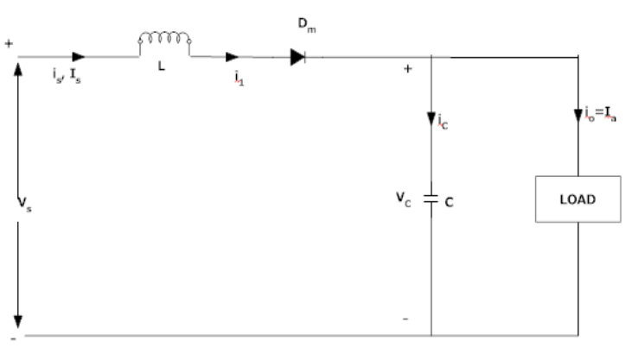

Figure 5: Mode 2

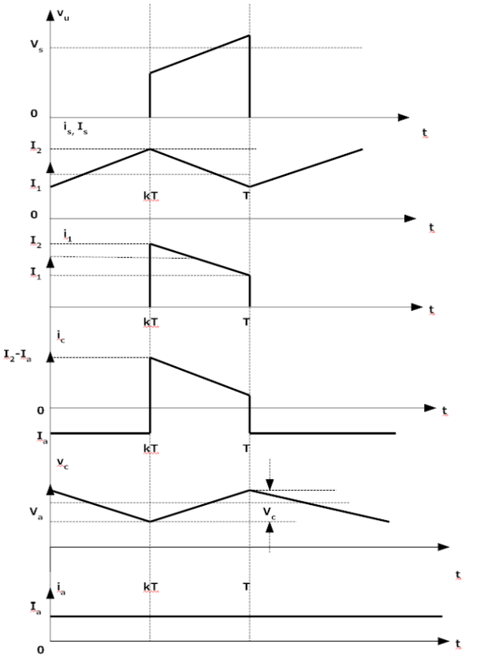

The voltage-current relation for the inductor L is:

0 or

For a constant rectangular pulse:

When the transistor M1 is switched:

And when the transistor is switched off the current is

Here VD is the voltage drop across the diode Dm, and VTrans is the voltage drop across the transistor M1.

By equating through delta i, we can solve for Vout:

Neglecting the voltage drops across the diode and the transistor:

It is clear that the output voltage is related directly to the duty cycle. The main challenge when designing a converter is the sort of inductor to be used. From above equations, it can be seen that the inductance is inversely proportional to the ripple current. So, to reduce the ripple, a larger inductor should be used.

**RECTIFIER CIRCUIT**

A rectifier is an electrical device that convert alternating current which periodically reverses direction to direct Current which flows in only one direction. The reverse operation is performed by the inverter. The process is known as rectification since it straightens the direction of current.

**HOW DOES THE RECTIFIER ACHIEVE THIS RECTIFICATION?**

**The Diode**

The diode is one of the semiconductor revolution's first offspring. The device is basically two tabs of semiconductors glued to each other. However, the semiconductor differs in their properties: one is electron-impoverished, or exhibits an excess of positive charges or holes, while the other is suffused with electrons and therefore exhibits an excess of negative charges. Together, they constitute what is called a PN Junction

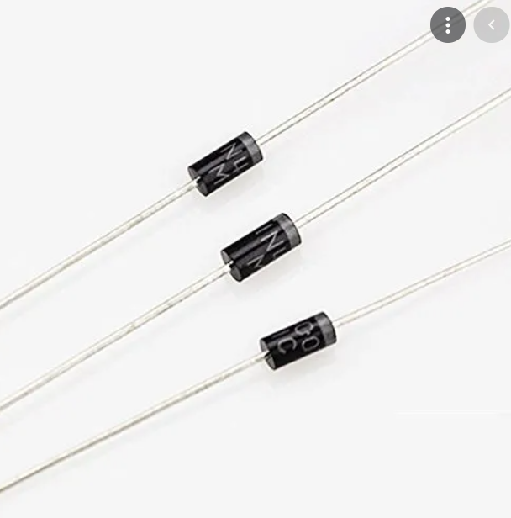

The fundamental purpose of a diode, unlike a resistor, is to allow current to flow in a single direction. Current through a diode will only flow when its positive semiconductor is connected to the positive terminal of the energy source and its negative semiconductor is connected to the negative terminal of the energy source.

Rectifier leverages the properties of a diode to fulfill its purpose.

**RECTIFICATION**

First of all, the AC voltage is stepped down using a transformer in most electronic appliances. A rectifier can generate a DC supply either by rectifying only one cycle (either positive or negative) of the AC supply or by rectifying both of them. (Full wave rectifier)

**HALF WAVE RECTIFICATION**

The magnitude of the AC supply is reduced with a regulator or a transformer and fed into a particular configuration of diodes. The configuration will rectify only positive cycles of the waveform

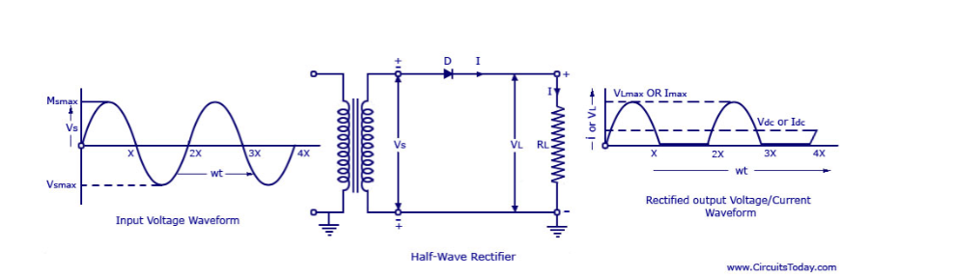

During a positive cycle, a positive charge is obtained on the upper nodes while a negative charge is obtained on the lower node. Now because a diode will allow the current to pass only when the anode (the triangle) is connected to the positive terminal and the cathode is connected to the negative terminal, both the diodes in the configuration will conduct during the positive cycle. The load is therefore supplied with a unidirectional current: the positive cycle is replicated on its output waveform.

However, when the AC Supply alternates, the polarity on the nodes swap now the upper nodes is negatively charged while the lower node is positively charged. The diodes are cross-connected and the current ceases to flow. When no current reaches the load, the output waveform for the negative cycle is a line tracing the x-axis, depicting the passage of time, but not any current

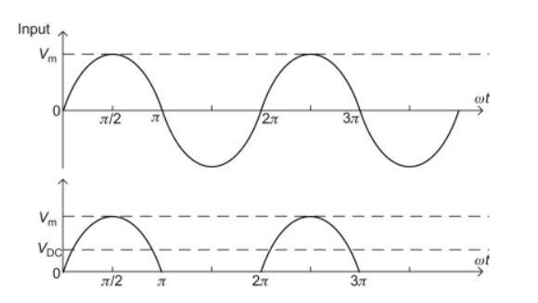

**FULL WAVE RECTIFIER**

On rectifier rectifies on the positive halve while another rectifies only the negative halves. This is done simply by combining two half-wave rectifiers.

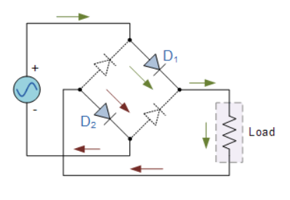

Figure 6: positive half cycle

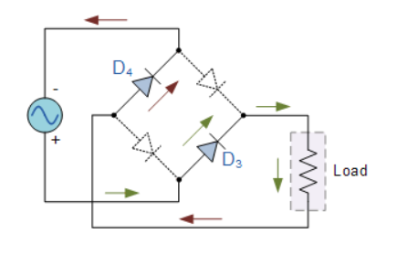

Figure 7: Negative half cycle

The first half-save rectifier conducts during the positive cycle, while the second half wave rectifier conducts during the negative cycle. As the current passes through the load during both cycles, no voids are found in the output waveform.

**CHAPTER 5: METHODOLOGY**

The main target of our work is to build a fully-fledged, end-to-end harvester system that converts energy from a vibrational source into useful electrical energy. Our approach to building the entire project was to start with simulating each major block of the circuitry in Proteus. By simulating each block such as the rectifier block, we are able to draw some analysis on how each of these blocks behave independently. When then combines all the blocks, simulate the entire stack and draw analysis. Hardware prototyping is then performed afterwards on a breadboard to validate the result of the simulation. We then transferred the best prototype onto a PCB as our final design.

**4.1 SIMULATION**

Individual simulations began with the simulation of the rectifier block. We replaced the source of energy (Piezo sensor) with an AC signal generator and performed simulation for two configurations of the rectifier circuit - First circuit with no smoothing capacitor and the second circuit with a capacitor.

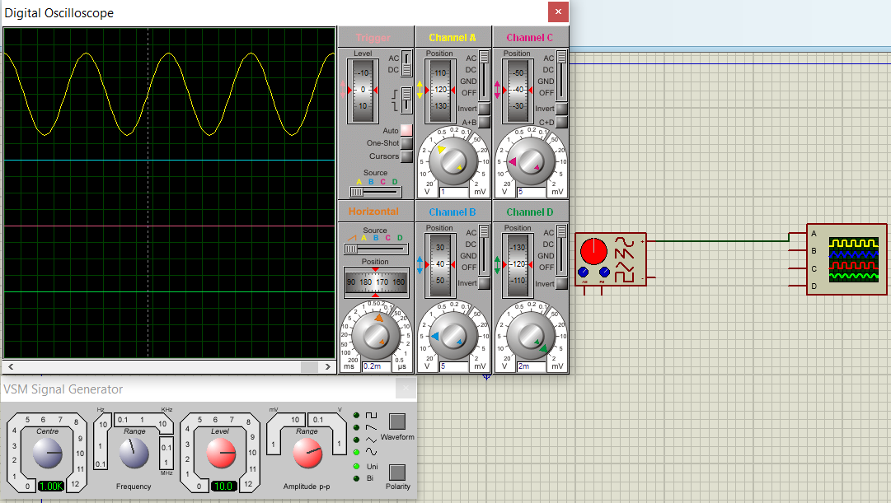

Figure 8: Oscilloscope reading (yellow line) of signal generator

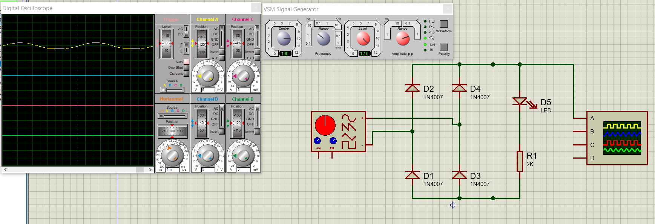

Figure 9: Oscilloscope reading (yellow line) from rectifier without smoothing capacitor

As can be observed, there are some traces of AC in the output voltage of the rectifier. This is eliminated with a smoothing capacitor.

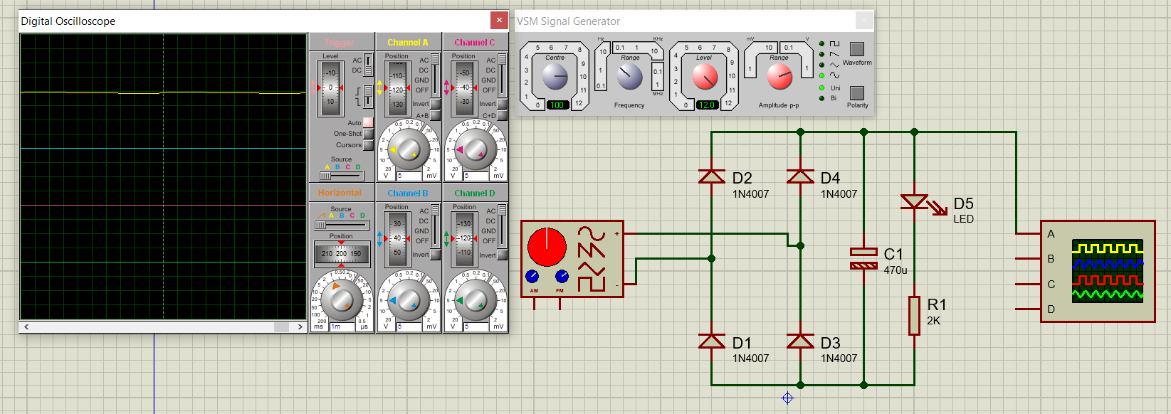

Figure 10: Oscilloscope reading (yellow line) from rectifier with smoothing capacitor

From almost all our simulations, we observed that the output from the rectifier is always slightly lesser than the input. This is due to losses introduced by diodes in the rectifier circuit.

The next simulation was to analyze how a dc-to-dc boost converter behaves when given a dc input source. Instead of first connecting the output from the rectifier as input to the booster, when first simulated with a battery source to validate the booster circuit without introducing any complexity.

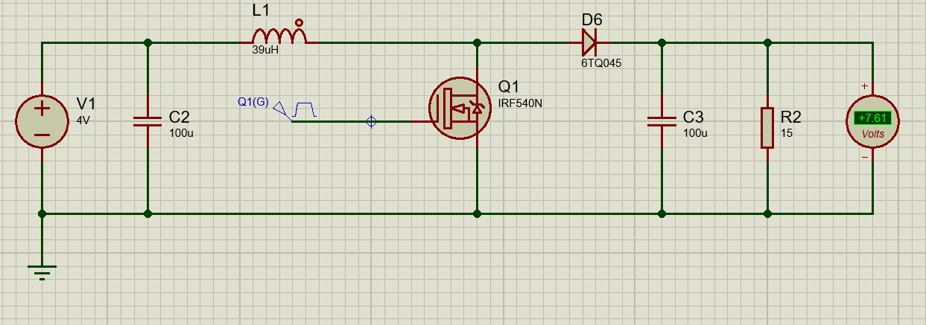

For the booster circuit above, we used the following settings for the Pulse Width Modulation.

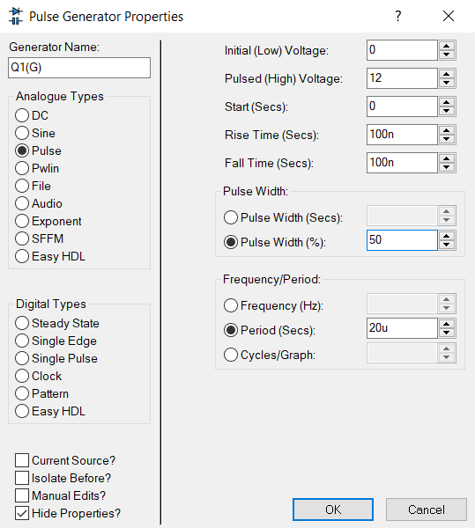

The voltage output can be calculated by this formula:

Vout = Vin * T / (T-T1) where:

Where T is the PWM period And, T1 is an OFF time of PWM.

For this example, we will convert 4 volts input, into approximately 8 volts output. That means we need a 50% duty cycle. If we put T = 20 microseconds, and T1 = to 10 microseconds in this formula, the output voltage will be about 16 volts. In other words, if we provide a 50% duty cycle to MOSFET, the output voltage will be about 16 volts. We use MOSFET as a switching device.

After verifying that the booster circuit for the simulation was working correctly, we combined the rectifier circuit with the booster. For this configuration, we provided a 75% duty cycle which resulted 4 times boost in output voltage of rectifier.

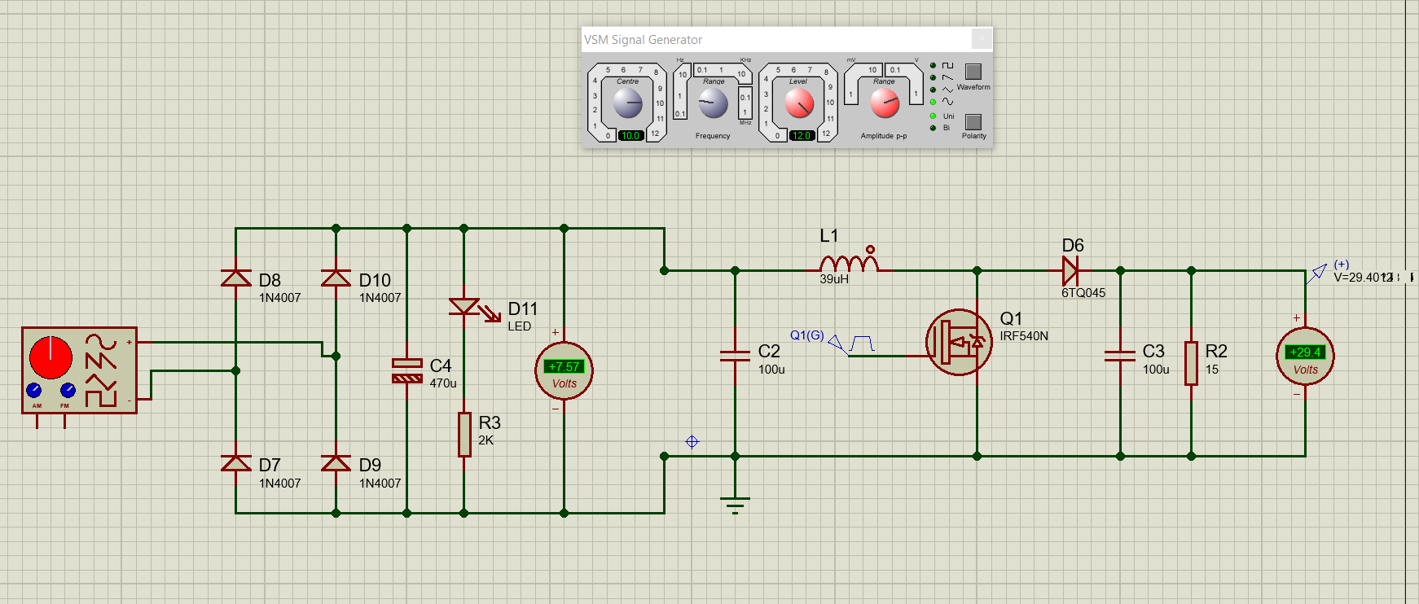

For the final simulation diagram, we replaced the ac signal generator with a piezo sensor.

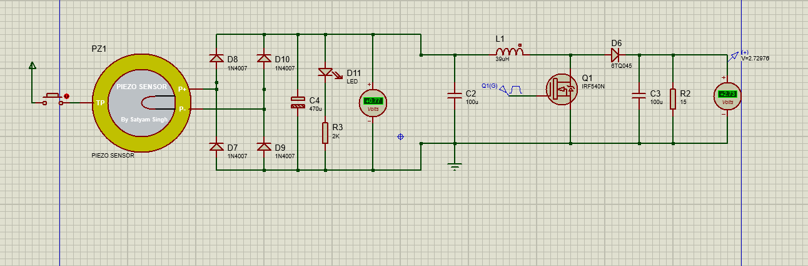

As can be observed, the output from the piezo sensor is quite small but we were able to boost that voltage to a decent level to validate the entire circuit.

**4.2 PROTOTYPING**

Unlike the simulation stage we performed individual simulator for each block, we took a straight forward approach to performed prototype testing on two or more blocks stacked together.

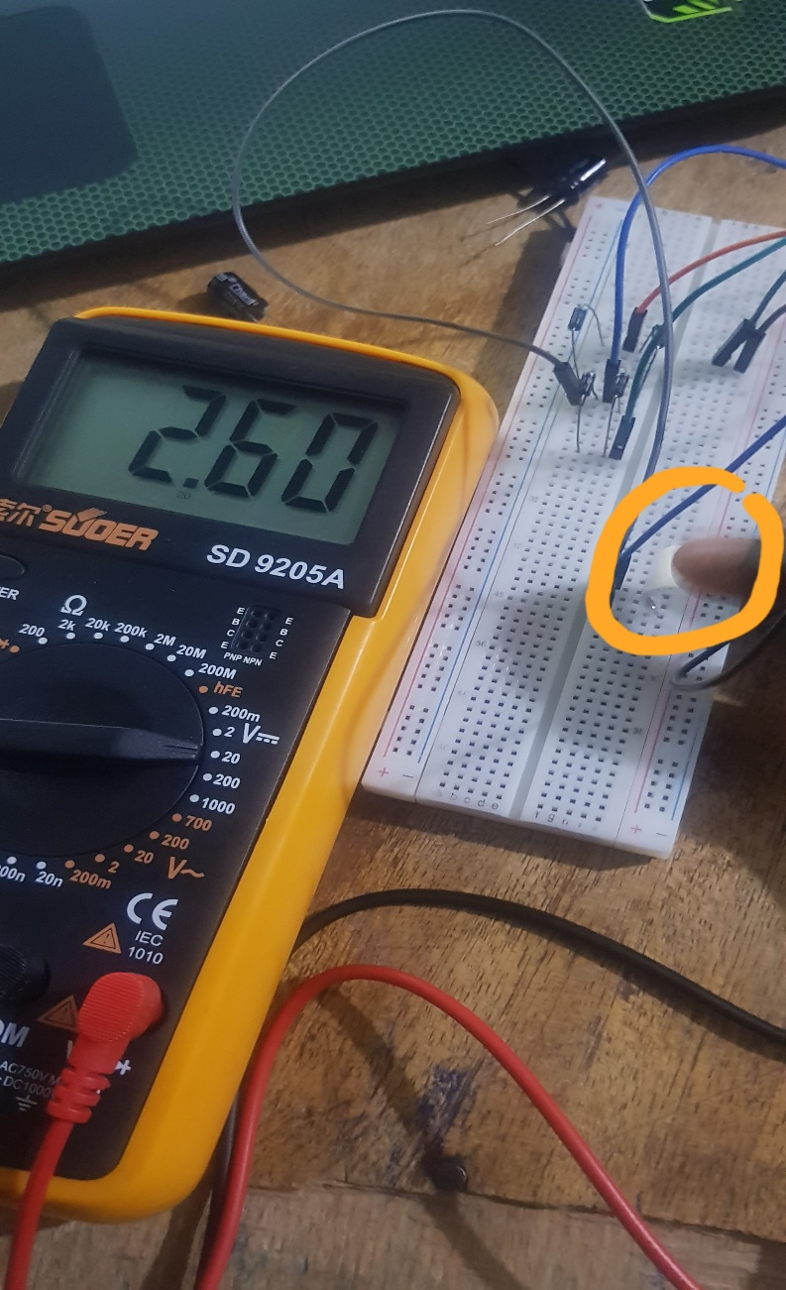

From our initial prototyping without the boost converter, we measured an average voltage of 2.90 V

**4.3 FINAL DESIGN**

After rigorous testing and prototyping, the final design was printed on a PCB board and components soldered on it.

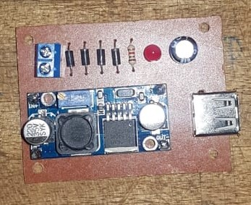

**REFERENCES**

[1] *Energy harvesting from Air Conditioning Condensers with the use of Piezo-electric Devices – Dr. Faruk Yildz-Sam Houston State University, Dr. Ulan Dakeev, University of Michigan, Flint, Dr. Kenan Baltaci, University of Wisconsin, Stout, Mr. Keith L Coogler, Sam Houston State University*

[3] *N. S. Lewis and G. Crabtree, "Basic research needs for solar energy utilization,"*  
*Report of the Basic Energy Sciences Workshop on Solar Energy Utilization. US*  
*Department of Energy, Office of Basic Energy Science, Washington, DC, April 18-*  
*21, 2005*

[4] *R. Patel, S. McWilliam and A. A. Popov, "A geometric parameter study of*  
*piezoelectric coverage on a rectangular cantilever energy harvester," Smart Materials*  
*and Structures, vol. 20, 2011.*

[5] *W. L. Zhou, G. R. Penamalli and L. Zuo, "An efficient vibration energy harvester*  
*with a multi-mode dynamic magnifier," Smart Materials and Structures, vol. 21,*  
*2012.*

[6] *S. Roundy, P. H. Wright and J. M. Rabaey, "Energy scavenging for wireless sensor*  
*networks with special focus on vibrations, " Boston, MA ; Kluwer, 2004*

[7] *W. J. Li, T. C. H. Ho, G. M. H. Chan, P. H. W. Leong and H. Y. Wong, "Infrared*  
*signal transmission by a laser-micromachined, vibration-induced power generator," In*  
*Circuits and Systems, IEEE Proceedings Midwest, vol. 01, pp. 236-239, 2000*

[8] *F. Cottone, P. Basset, R. Guillemet, D. Galayko, F. Marty and T. Bourouina,*  
*"Bistable multiple-mass electrostatic generator for low-frequency vibration energy*  
*harvesting," IEEE, MEMS, pp. 861-864, 2013.*

[9] *V. R. Challa, M. G. Prasad, Shi. Y. and F. T. Fisher, "A vibration energy harvesting*  
*device with bidirectional resonance frequency tunability," Smart Materials and*  
*Structures, vol. 17, pp. 1-12, 2008.*

[10] *J. H. Qiu, H. L. Ji and H. Shen, "Energy harvesting and vibration control using*  
*piezoelectric elements and a nonlinear approach," IEEE International Symposium on*  
*the Application of Ferroelectrics, vol. 18, pp. 1-8, 2009.*

[11] *H. B. Fang, J. Q. Liu, Z. Y. Xu, L. Dong, L. Wang and D. Chen, "Fabrication and*  
*performance of MEMS-based piezoelectric power generation for vibration energy*  
*harvesting," Microelectron. J., vol. 37, pp. 1280-1284, 2006*

[12] *XL6009 DC-DC Buck Boost Converter Module Pinout, Datasheet, Features & Specifications (components101.com*

[13] *http://cdn.sparkfun.com/datasheets/Sensors/ForceFlex/LDT_Series*.pdf

[14] [*https://www.cdiweb.com/datasheets/te/eng_ds_ldt_with_crimps_a.pdf*](https://www.cdiweb.com/datasheets/te/eng_ds_ldt_with_crimps_a.pdf)

[15] [53189349.pdf (core.ac.uk)](https://core.ac.uk/download/pdf/53189349.pdf)

[16] [Half Wave Rectifier Circuit with Diagram - Learn Operation & Working (circuitstoday.com)](https://www.circuitstoday.com/half-wave-rectifiers)

[17] [Half Wave Rectifier - an overview | ScienceDirect Topics](https://www.sciencedirect.com/topics/engineering/half-wave-rectifier)

[18] [Full Wave Rectifier and Bridge Rectifier Theory (electronics-tutorials.ws)](https://www.electronics-tutorials.ws/diode/diode_6.html)