MERG CAN-USB Drivers
Document version 1.0

This document and support files can be found in the MERG CBUS Yahoo group files area at: http://groups.yahoo.com/group/mergcbus/files/USB%20Drivers/

FTDI CDM Drivers

Download and install the Virtual COM Port (VCP) drivers from the FTDI driver page http://www.ftdichip.com/Drivers/VCP.htm. The latest versions of these drivers are also referred to as the Combined Driver Model (CDM) drivers. The terms are interchangeable for the purposes of this document. Installation guides for the drivers can be found here http://www.ftdichip.com/Documents/InstallGuides.htm

By default the FTDI ‘R’ modules used on the CAN-USB contain USB Vendor ID (VID) and Product ID (PID) relating to the manufacturer, FTDI. They also contain a unique serial number. The operating system on your computer uses these parameters to determine the correct driver software to be loaded.

The VCP drivers allow the CAN-USB to be used as if it were a legacy serial or COM port (a “virtual” COM port). Each time a CAN-USB with a unique serial number is connected to your computer, a new COM port will be assigned. The operating system stores the relationship between the serial number and the assigned COM port, so that the same COM port will be used each time the same module is connected.

If you will only be using a single CAN-USB then the VCP drivers are sufficient in most cases.

If you will be using multiple CAN-USBs, wish to use multiple CAN-USBs interchangeably, or have difficulty using the assigned COM port with your control software, please read the remaining sections of this document.

You should also download and refer to FTDI Application Note 123 from http://www.ftdichip.com/Documents/AppNotes.htm

Reassigning the COM Port Allocation
To see the COM port that has been assigned, use the Windows Device Manager. Right click on “My Computer” and select properties from the context menu.

Select the Hardware tab:

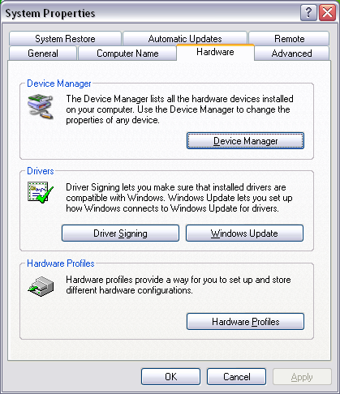

Select the Device Manager and open the Ports (COM & LPT) list by clicking the “+” symbol. Here the assigned port is COM5:

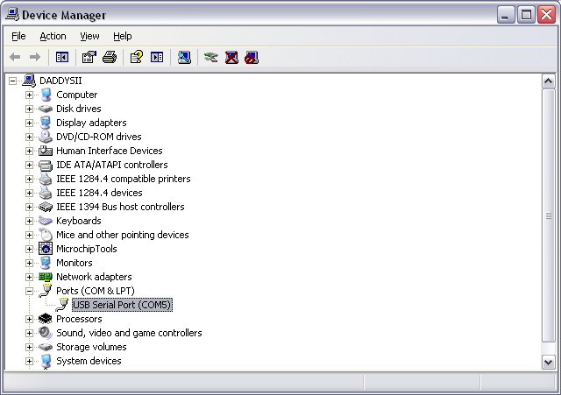

Reassigning the COM Port Allocation
If you intend using multiple CAN-USB or have a number of other USB serial adapters then an issue can arise whereby a COM port is assigned that is out of range of some software applications. E.g. the MSComm control in Visual Basic cannot use anything higher than COM16.

The simplest solution is to change the COM port assignment using the driver advanced settings. This is documented in section 3.1 of App note 123.

This solution is useful if you have a single CAN-USB. The re-assignment only needs to be done once and will be remembered by the driver.

Customising the CAN-USB
The remaining options require the use of the MPROG utility from the FTDI website http://www.ftdichip.com/Resources/Utilities/MProg3.5.zip

It is strongly recommended that you disconnect any other USB devices that use an FTDI chipset when using MPROG. It is all too easy to inadvertently reprogram the wrong device. If in doubt, disconnect any non-essential USB devices.

Ignore the fact that this utility has been superceded, it is fine for MERG requirements.

Ignore the requirement for D2XX drivers. The latest VCP and D2XX drivers are the same.

There is an apparent mismatch between the utility version number (3.5) and the documentation version number (3.0). This too can be ignored, and the MPROG documentation can be used as-is.

Using a Fixed Serial Number
See section 3.2 of App Note 123.

This solution is useful if you need to fix the relationship between a particular CAN-USB and a particular COM port. Two possible scenarios are:
(1) You only wish to connect a single CAN-USB at any time but wish to use multiple CAN-USB interchangeably with a fixed COM port assignment, e.g. allowing for a spare module to be used during an exhibition without having to re-configure the control software to use a different COM port.
(2) You wish to use multiple CAN-USB but to be able to disconnect them and reconnect them and guarantee that a particular CAN-USB will be assigned a particular COM port.

Only one instance of any serial number may be connected at any one time.

Run MPROG and load the fixed_serial.ept template, available from the Yahoo CBUS group files. The fixed serial number may be edited if desired.

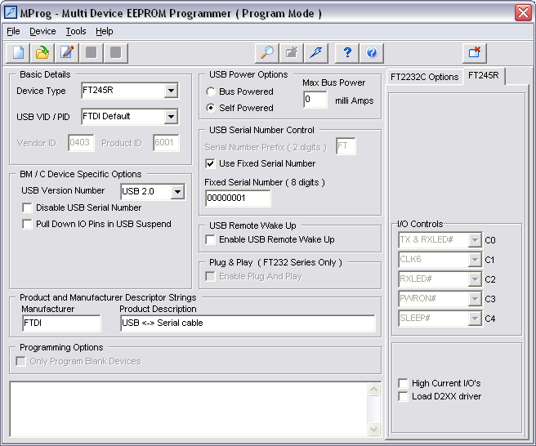

Follow the MPROG documentation for the process of re-programming the device.

Disabling the Serial Number
See section 3.3 of App Note 123.

With the serial number disabled, multiple devices may be connected and each device will be assigned a COM port determined by which USB port it is connected to. Thus if you disconnect the CAN-USB and plug into a different USB port, a new COM port will be assigned and you will need to re-configure your control software appropriately.

Run MPROG and load the disabled_serial.ept template, available from the Yahoo CBUS group files.

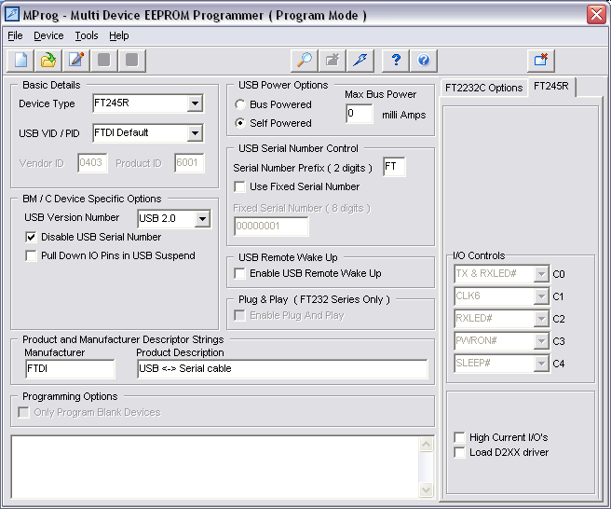

Follow the MPROG documentation for the process of re-programming the device.

Custom CAN-USB Drivers with the MERG Product ID (PID)
If you are using or experimenting with other modules based around the FTDI chipset then it can become confusing if they are all listed in the Device Manager as simply USB Serial Ports. To change the way devices are displayed, a customised driver may be used.

MERG has been assigned a range of USB PIDs within the FTDI VID range. These VIDs may only be used with FTDI chips.

For the CAN-USB, the PID is 8F98.

Download the custom drivers form the Yahoo files area Windows_2000_XP_Vista_7.zip and unzip into a convenient directory.

Run MPROG and load the mergCanUsb.ept template, available from the Yahoo CBUS group files.

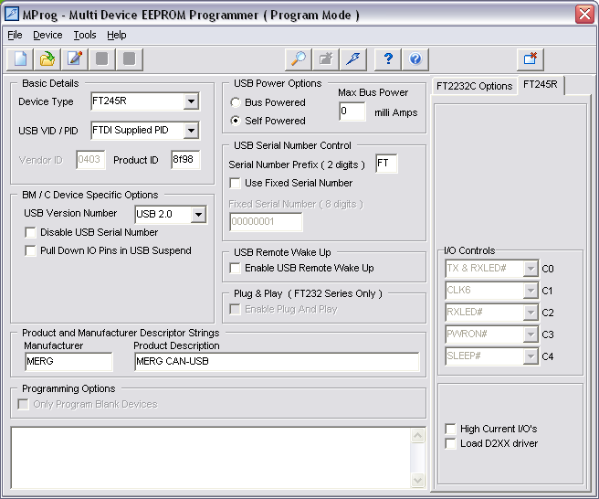

Select the appropriate serial number option depending upon your usage (see above) and then follow the MPROG documentation for the process of re-programming the device.

Cycle the device by clicking the rightmost button on the toolbar.

The Windows new hardware wizard should run. Follow the same procedure as for installing the VCP drivers, but browse to the newly unzipped custom drivers instead of the VCP drivers when prompted for the driver files.

Click “Continue Anyway” when the Windows Logo testing dialog appears:

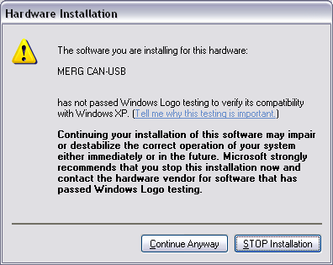

Now the CAN-USB will be identified in the Windows Device Manager. A new COM port will be assigned since the CAN-USB is now recognised differently.

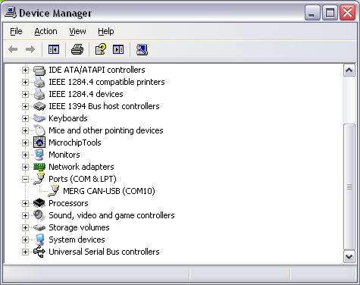

Showing Unused Devices in Device Manager
For advanced users, to be used with care.

By setting the Windows environment variable DevMgr_Show_NonPresent_Devices to a value of 1, and selecting View->show hidden devices in Device Manager, you can see which COM port assignments exist on your system.

By right clicking on the device you can uninstall unused or broken drivers.

