**CHARACTERIZING TRANSMISSION DYNAMICS OF RECENT VIRAL HEMORRHAGIC FEVER OUTBREAKS IN UGANDA USING SEQUENCE DATA (2000-PRESENT)**



**ADUDA HENRICK KOLA**

**SG30/PU/36144/18**

**MSc.Bioniformatics**

**A RESEARCH PROPOSAL SUBMITTED TO PWANI UNIVERSITY IN PARTIAL FULFILLMENT OF THE REQUIREMENTS FOR THE MASTER OF SCIENCE DEGREE IN BIOINFORMATICS**

29th January 2020

# DECLARATION

This research proposal is my original work and has not been presented to any other university for examination purposes

**NAME:** Henrick Aduda Kola **REG NO:** SG30/PU/36144/18

**SIGN:** …...........................................

**DATE:** …...........................................

We confirm that the work reported in this proposal was carried out by the candidate under our supervision.

**NAME:** …......................................................................................

**INSTITUTION:** ...................................................................................................

**SIGN:** ….................................................. **DATE:** ….................................................

**NAME:** ….......................................................................................

**INSTITUTION:** ...................................................................................................

**SIGN:** ….................................................. **DATE:** ….................................................

**SUPERVISOR DETAILS**

**NAME:** …........................................................................................

**INSTITUTION:** ...................................................................................................

**SIGN:** ….................................................. **DATE:** ….................................................

**NAME:** ….............................................................................................

**INSTITUTION:** ...................................................................................................

**SIGN:** ….................................................. **DATE:** ….................................................

# ACKNOWLEDGEMENT

I would like to express my appreciation to all who contributed to this proposal. First and foremost, special thanks to my supervisors; Dr. Jonathan Kayondo, Prof.Matthew Cotten, Dr. Julius Lutwaama and Dr. Etienne de Villiers for all the advice and guidance during the writing of this proposal. I would also like to acknowledge my host institution Uganda Virus Research Institute for providing me with the necessary resources and facilities to undertake my project. More specifically I would like to thank Alfred Ssekagiri and Hudson Onen for their advice and encouragement. I would also like to thank Pwani University for the resources and facilities provided during the course of my studies. Finally, I acknowledge the Eastern African Network for Bioinformatics Training (EANBIT) that provides funding for this project. Special thanks to Dr.Daniel Masiga, the principal investigator of the EANBIT program for the pivotal role he has played in making the program a success.

**TABLE OF CONTENTS**

**DECLARATION** **2**

**ACKNOWLEDGEMENT** **3**

**ABSTRACT** **6**

**1. INTRODUCTION** **7**

1.0 Background 7

1. 1 General objectives 9

1.1.0 Specific objectives 9

1.2 Statement of the problem 9

1.3 Study hypothesis/Predictions 10

1.3.0 Within outbreak sample genetic diversity 10

1.3.1 Phylodynamics topology/profiles 11

1.3.2 Between sample genetic distance 11

1.4 Significance of the study 11

1.5 Scope of the study 12

**2. LITERATURE REVIEW** **13**

2.0 Introduction 13

2.1 Marburg Virus Disease (MVD) 13

2.2 Crimean-Congo Hemorrhagic Fever Virus (CCHFV) 14

2.3 Rift Valley Fever Virus (RVFV) 16

2.4 Yellow Fever Virus (YFV) 16

2.5 Ebola Virus Disease (EVD) 18

**3. METHODOLOGY** **20**

3.0 Area of the Study 20

3.1 Research Design 21

3.2 Sampling Procedures 21

3.3 Research Instruments 21

3.4 Data Collection Procedures 21

3.5 Data Analysis 22

**4.REFERENCES** **24**

**5.BUDGET** **28**

**6.WORK PLAN** **29**

**LIST OF FIGURES**

Figure 1.…………………………………………………………………………………………. 8

Figure 2…………………………………………………………………………………………… 11

Figure 3…………………………………………………………………………………………… 21

Figure 4…………………………………………………………………………………………… 22

**LIST OF TABLES**

Table1……………………………………………………………………………………………… 10

# ABSTRACT

Uganda has experienced repeated outbreaks of viral hemorrhagic fevers (VHFs) over the last 20 years with Ebola, Marburg, Crimean Congo hemorrhagic fever (CCHF), Yellow fever, and Rift Valley fever (RVF) among those reported. Ebola occurred in Gulu in 2000; Bundibugyo in 2007; Luweero in 2011; Luweero in 2012; and Kibaale in 2012. Marburg was reported in Ibanda in 2007; and two outbreaks in Ibanda and Kabale in 2012; Kampala in 2014; and Kween in 2017. CCHF occurred in Wakiso twice in 2013; Nakaseke/Luweero in 2015; Kiboga in 2017; and Luweero in 2017. In 2010 an enhanced VHF surveillance and diagnostics system was introduced at the national reference laboratory facility at the Uganda Virus Research Institute (UVRI) resulting in improved detection and control of VHF outbreaks. With enhanced surveillance, subsequent outbreaks have tended to be detected much earlier, more frequently and intervention responses rapidly mounted resulting in a significant decrease in the overall intensity (P=0.001), duration (P<0.0001) and case fatalities of recent VHF outbreaks compared to the pre-2010 period. However, recent data has revealed that for Ebola, survivors may shed virus long after recovery. Ecological studies carried out in various caves has demonstrated the geographical movement of *R.aegyptiacus bats*, which is one of the natural hosts for VHFs. This opens up the possibility that some recently observed cases might partly be due to continued human to human transmission from survivors as opposed to new outbreaks after zoonosis. This study aims at understanding the transmission dynamics of recent VHF outbreaks as well as evaluating whether recent VHF outbreaks in Uganda are a result of preceding outbreaks or zoonosis from natural hosts. Phylogenetics with full virus genomes, as well as partial sequences can link infections and reveal patterns in virus transmission. The results of this project could provide information on transmission dynamics of recent Marburg outbreaks as well as inform strategies for future responses and containment. This study will obtain data from UVRI collaborations as well as sequence data deposited on online repositories. These data will be examined to determine phylogenetic linkage between temporally distinct outbreaks, as well as examine the transmission dynamics of recent VHF outbreaks.

# 1. INTRODUCTION

## 1.0 Background

Viral hemorrhagic fever (VHF) is a clinical syndrome caused by viruses from four different virus families; Filoviridae, Arenaviridae, Bunyaviridae and Flaviviridae (Drosten, Göttig, & Schilling, 2002).Viruses falling under these four viral families are all single stranded RNA viruses with a lipid envelope which makes them susceptible to detergents and environments with low pH; however, they are stable in blood and cold storage (Racsa, Kraft, Olinger, & Hensley, 2016)⁠. VHFs are often characterized by fever, malaise, increase in vascular permeability leading to a reduction in plasma volume and the development of coagulation defects that can result in bleeding (Bray, 2005) ⁠. Uganda has experienced numerous outbreaks of viral hemorrhagic fevers (VHFs) over the last 20 years, with Ebola Virus Disease (EVD), Marburg Virus Disease (MVD), Crimean Congo Hemorrhagic Fever Virus (CCHFV), Yellow fever Virus (YFV), and Rift Valley Fever Virus (RVFV) reported(A. K. Mbonye & Sekamatte, 2018) (A. Mbonye et al., 2012).

In 2000, the first Ebola Virus Disease (EVD) outbreak was reported in Gulu district, northern Uganda, a total of 425 confirmed cases and probable cases were reported, of which 224 cases (53%) were fatal(Okware et al., 2002)⁠. A second EVD outbreak was documented in Bundibugyo, western Uganda in 2007, 149 cases were reported, of which 37(25%) were fatal (Towner et al., 2008) ⁠; in 2011 another EVD outbreak was reported in Luweero, central Uganda, one single fatal case was recorded and one juvenile convalescent case identified during this outbreak (MacNeil et al., 2012)⁠. In 2012, two outbreaks were reported, one in Luweero, central Uganda and another in Kibaale, western Uganda; in Luweero there were six confirmed cases, of which three were fatal whereas in Kibaale there were eleven confirmed cases, of which four were fatal(Albariño et al., 2013a)⁠.

Marburg Virus Disease (MVD) was first reported in Ibanda in 2007, the outbreak involved four miners at Kitaka mine in south-western Uganda, four confirmed cases were reported, of which one (25%) was fatal(Adjemian et al., 2011)⁠. In 2012, two more outbreaks were documented in the south-western districts of Ibanda and Kabale, 26 confirmed and probable cases were reported, of which 15 (58%) were fatal (Albariño et al., 2013a) ⁠.In 2014, one fatality was reported in Kampala, central Uganda(Luke Nyakarahuka et al., 2017)⁠. The latest MVD outbreak was reported in 2017 in Kween district, Eastern Uganda, four MVD cases were reported, of which three (75%) were fatal (Luke Nyakarahuka, Shoemaker, et al., 2018) ⁠.

Yellow Fever Virus (YFV) was reported between 2010 and 2011 in Abim, Agago, and Kitgum districts in northern Uganda, 181 cases met the yellow fever suspected cases definition, 45 deaths were recorded (case fatality rate 24.9%) (McMullan et al., 2012) ⁠. In 2016, another outbreak was reported in Masaka south-western Uganda, there were 42 confirmed and probable cases, of which 14 were fatal (33%) (Kwagonza et al., 2018) ⁠.

In 2013, Crimean Congo Hemorrhagic Fever Virus (CHFV) was reported in the districts of Agago (3 cases) and Kiboga (2 cases), and in Kampala City (1 case)(Balinandi et al., 2018)⁠; one fatality was reported in Nakaseke/Luweero in 2015 (Balinandi et al., 2018) ⁠; seven cases were documented in 2017 in Kyankwanzi and Nakaseke, two patients died (28.6%)(Kizito et al., 2018).Rift Valley Fever Virus (RVFV) was documented in Kabale district, southwestern Uganda in 2016, four laboratory-confirmed acute cases and two probable deaths were identified (50%).

Since 2010, the frequency of detected VHF cases has increased in Uganda, this has been greatly attributed to enhanced surveillance programs and laboratory detection strategies established in Uganda (Luke Nyakarahuka, Shoemaker, et al., 2018). ⁠Despite the increase in the number of detected VHF cases, the transmission dynamics of most of the reported VHF outbreaks in Uganda are not clearly understood. Recent data has shown that for Ebola, convalescents may shed virus long after recovery (Chughtai, Barnes, & Macintyre, 2016) ⁠. During the 2012 MVD outbreak in Kabale, southwestern Uganda, 6 convalescent cases were identified via serological analysis, the positive IgM/IgG results implied that the outbreak had begun in early June in Ibanda district as opposed to Kabale area where the initial index case was identified (Knust et al., 2015)⁠.In another outbreak, one convalescent case was identified during the May 2011 EVD outbreak in Luweero district, Central Uganda, serological analysis indicated that the patient was IgG positive at a titer of 1600 but IgM negative, which implied past infection with EVD(MacNeil et al., 2012)⁠.Six convalescent cases were also identified during the 2012 EVD outbreak in Kibaale, consecutive follow up of these cases showed that none of the cases developed or reported symptoms related to EVD(Luke Nyakarahuka, Shoemaker, et al., 2018)⁠. Lastly, during the 2017 MVD outbreak in Kween district, Eastern Uganda, one convalescent case who was a close contact of the first probable case was identified via serological testing; he tested positive for both IgG and IgM for Marburg Virus Disease (MVD).

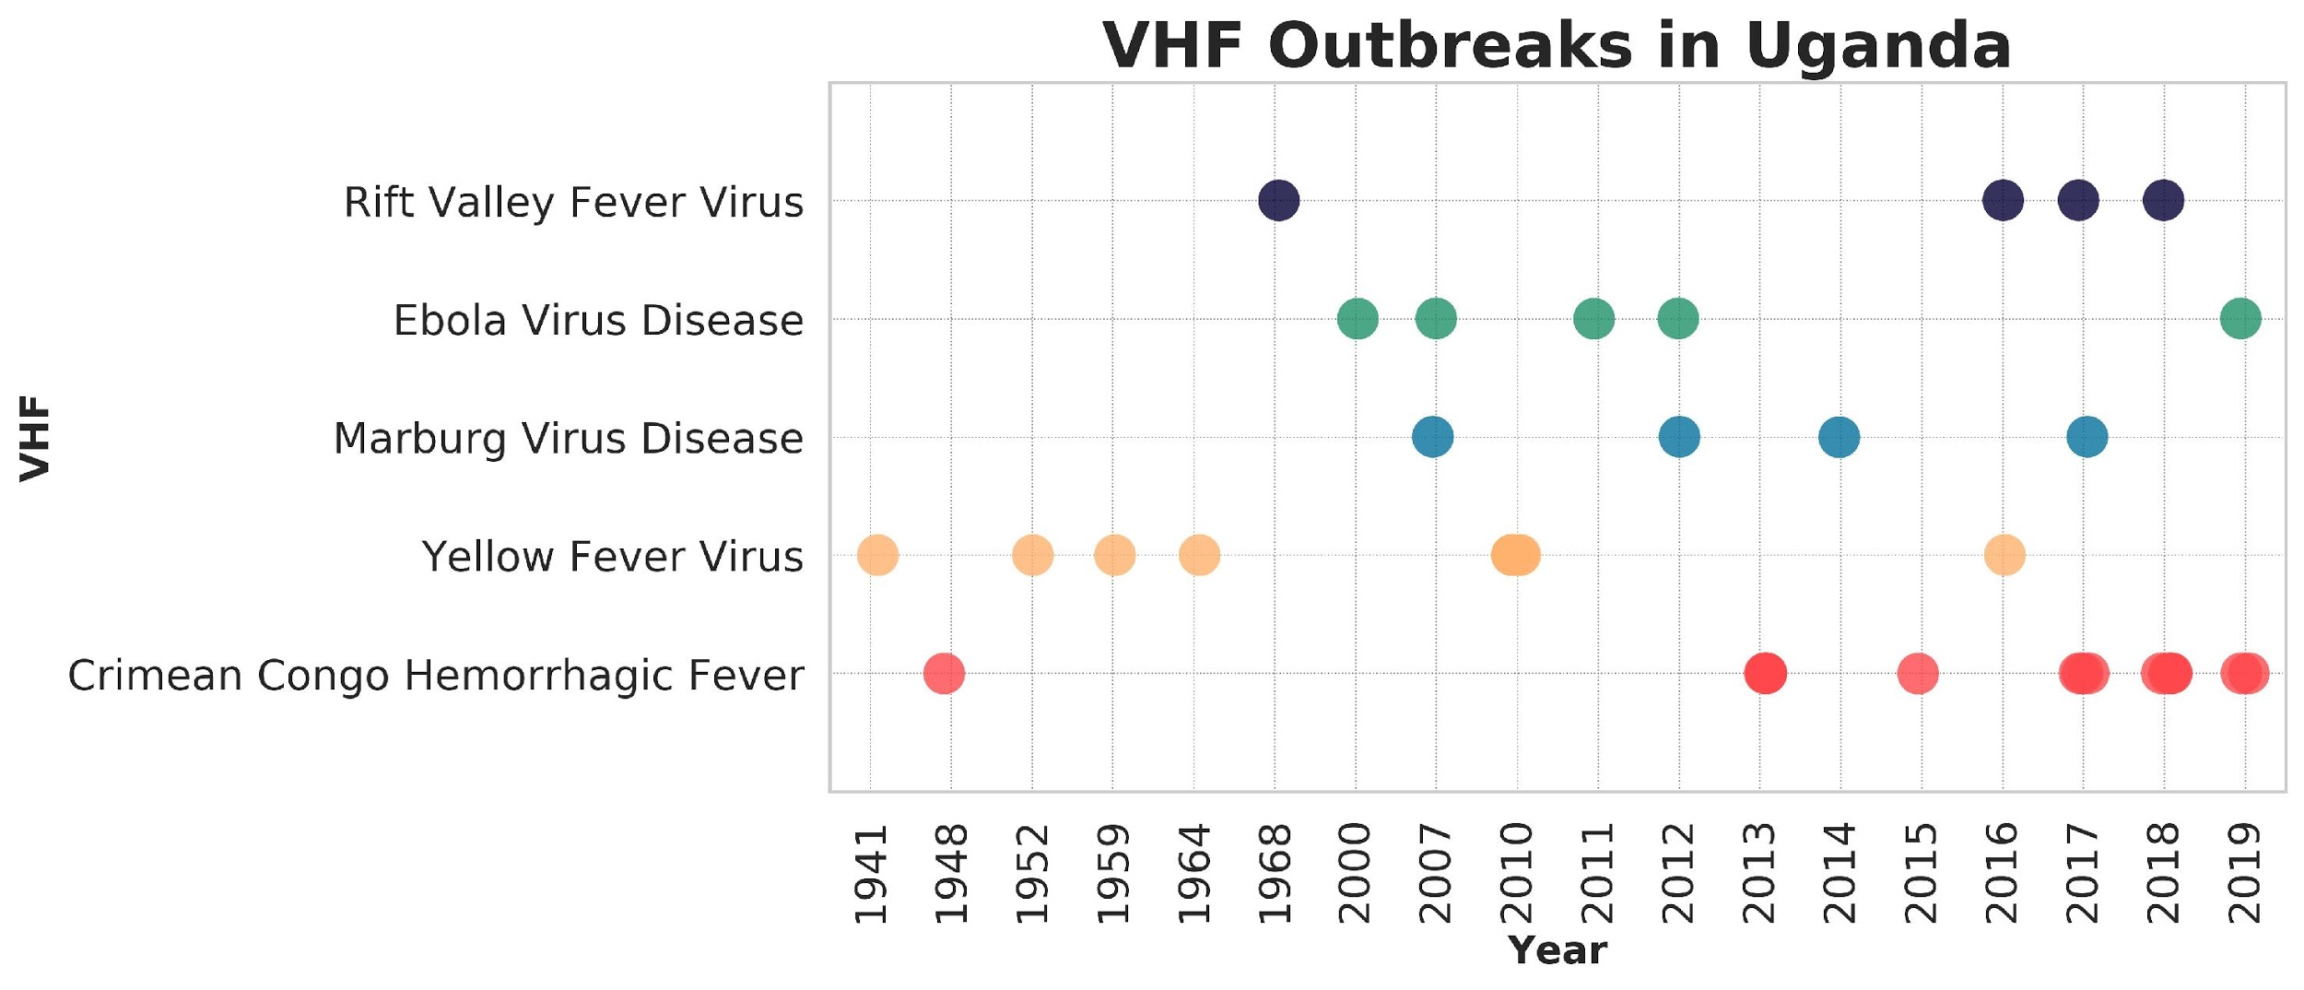

**Figure 1** *shows all the reported VHF outbreaks in Uganda. Each VHF is marked with a different color spot. This timeline was drawn based on available literature data for VHFs as well as expert data from Dr.Julius Lutwaama (UVRI)*

In 2007, four cases of MVD was reported in kitaka mine, Ibanda district, southwestern Uganda; case investigators attributed the outbreak to a zoonotic spillover event linked to infected *Rossetus aegyptiacus* bats harboring the kitaka mines (Adjemian et al., 2011). An ecological study conducted later on, estimated that over 5000 bats could be infected with MVD at any point in time in kitaka, five MVD isolates were extracted from the bats, implying that R.aegyptiacus bats can naturally harbor MVD (Towner et al., 2009)⁠.Geographic movement of bats between kitaka and Python cave has been established, a numbered collar was found at Python Cave in August 2008, the collar had initially been placed on an adult female *R. aegyptiacus* bat at Kitaka mine during a mark and recapture study conducted three months earlier. Python Cave situated in Queen Elizabeth National Park, western Uganda, is 50 kilometers away from Kitaka mine, separated by stretches of dense forest and zones of agricultural activity. These occurrences open up the possibility that recently observed VHF cases especially for MVD, might be due to continued human to human transmission from previous outbreaks as opposed to fresh outbreaks emanating from natural reservoir locations. The findings of this study could provide information on transmission dynamics of recent VHF outbreaks in Uganda as well as inform strategies for future responses and containment. This study may also inform international policies on how to handle future viral hemorrhagic fever outbreaks and the safety measures to put in place to protect the public.

## 1. 1 General objectives

* To investigate whether recent VHF outbreaks observed in Uganda are as a result of human-to-human transmission from survivors as opposed to spillover events from natural reservoirs.

### 1.1.0 Specific objectives

* To assess the transmission dynamics of recent VHF outbreaks in Uganda.
* To catalog the available viral sequence data of recent VHF cases/outbreaks in Uganda.
* Determine phylogenetic linkage between VHF outbreaks in Uganda.

## 1.2 Statement of the problem

Over the past two decades, Uganda has reported numerous VHF outbreaks, the largest and deadliest VHF outbreak occurred in northern Uganda in 2000, with 425 cases and a case fatality rate of 53% (224 cases)(Okware et al., 2002)⁠.The transmission dynamics of most of these outbreaks are not clearly understood. Recent data has shown that for EVD, survivors may shed virus long after recovery (Chughtai et al., 2016) ⁠. Some evidence also exists that MVD may persist in seminal fluid for up to 2 months after clinical recovery (Chughtai et al., 2016) ⁠. Ecological studies carried out in various caves has demonstrated geographical movement of *R.aegyptiacus bats*, which is one of the natural hosts for VHFs (Towner et al., 2009).This raises the problem that some recently observed VHF cases might be due to continued human to human transmission from survivors as opposed to fresh outbreaks from natural hosts. Could it be that some of the recent VHF outbreaks are a continuation of previous outbreaks or are the recent outbreaks sourced from zoonotic sources? This is the central predicament that this study aims to answer. This study will employ data mining techniques, phylodynamic analysis, genetic diversity and genetic distances to have some clarity on whether recent VHF outbreaks are a result of preceding outbreaks or fresh outbreaks from natural reservoirs. This study will not only provide insight on the transmission dynamics of VHF outbreaks but will also inform future strategies on surveillance, containment and preventive measures to be taken by survivors to protect close contacts.

## 1.3 Study hypothesis/Predictions

**Table 1** *shows our study hypothesis and predictions for each scenario we shall look at.*

|  |  |  |
| --- | --- | --- |
| **Parameter** | **Human to human transmission** | **Zoonotic** |
| **Within outbreak sample genetic diversity** | Higher/and stable over time | Lower/unstable over time (owing to a founders’ effect) |
| **Between sample genetic distance** | clustering of temporal samples based on genetic distance is expected to group together samples from a site during an outbreak with others taken across previous outbreaks reflecting ancestral continuity throughout the inter-outbreak period. | clustering of temporal samples based on genetic distance is expected to separate samples from a site from others taken across previous outbreaks reflecting founder effects and new arrivals during a new outbreak period |
| **Phylodynamic topology/profiles** | clustering of sequences from previous outbreak locations | clustering of sequences in natural host reservoirs site |

### 

### 1.3.0 Within outbreak sample genetic diversity

Genetic diversity is the quantitative measure of variability of a population, which reflects the equilibrium between mutation and the loss of genetic variation. In this study we will use genetic diversity as a parameter in elucidating VHF transmission dynamics in Uganda. Whenever there is a new introduction into the human population, the genetic diversity of the virus is usually low .This is because only a few viral pathogens are transmitted into the human population via contact with bodily fluids, blood or tissues of infected natural hosts. We therefore expect the genetic diversity to be low at the beginning of an outbreak, then rise as the outbreak continues, this is because the viral pathogens will replicate more as they strive to establish themselves within the human population, hence genetic diversity will steadily increase from low to high (unstable over time).

The other scenario is when there is an introduction from a previous outbreak (continued human to human transmission). In this circumstance, we expect the genetic diversity to remain fairly constant (stable over time) as it were in the preceding outbreak or increase (higher). The viral pathogens causing an infection in the preceding outbreak will be similar virus pathogens causing an infection in the consecutive outbreak. Their mutation and replication rate and other components of genetic diversity is therefore expected to be fairly constant (stable over time). The concept of genetic diversity has been illustrated further on figure 2.

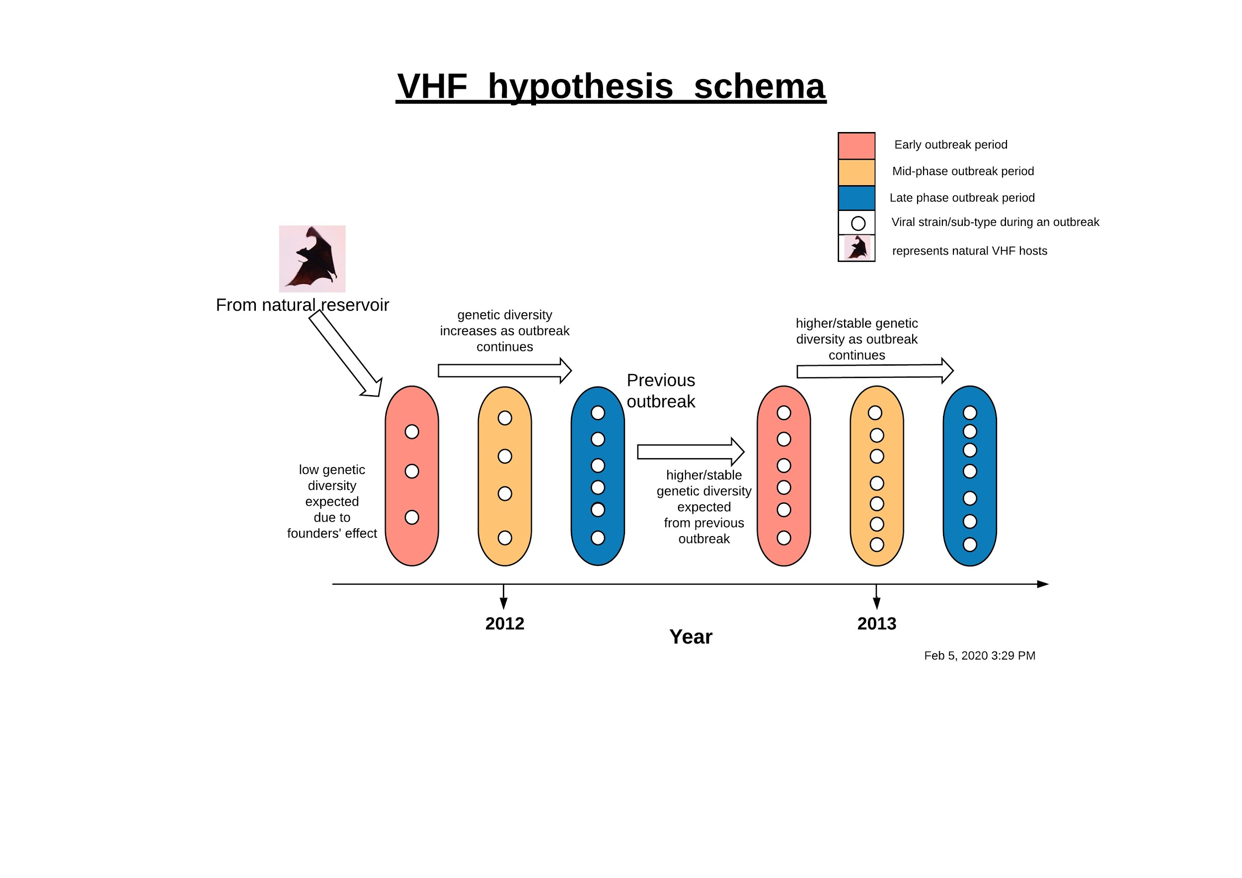

**Figure 2** *shows our prediction for outbreak sample genetic diversity. We expect genetic diversity to be stable over time if there is continued human to human transmission from a previous outbreak as shown by the distribution of circles (viral strain sequences) on the left-hand side. Whereas if the outbreak is presumably from zoonosis, we expect the genetic diversity to be low at first, then increase as the outbreak continues (unstable). This is represented by the increase in distribution of circles on the right-hand side.*

### 1.3.1 Phylodynamic topology/profiles

Phylodynamics is the study of how epidemiological, immunological, and pathogen evolutionary processes act within and among populations. If there were continued human to human transmission from a previous outbreak, we expect clustering of sequences from previously known outbreak location sites. Whereas if there were zoonotic spillovers from the hosts, we expect to see sequences clustering in the known natural host locations.

### 1.3.2 Between sample genetic distance

Genetic distance is the degree of genomic difference between species or populations that is measured by some numerical method, the average number of codon or nucleotide differences per gene usually gives the genetic distance. The predictions of genetic distance will be looked at as described above on (Table 1)

## 1.4 Significance of the study

The threats posed by emerging and re-emerging infectious diseases are well known to the public eye, the media, as well as national governments and the international governing bodies. As such, this study will focus on expanding the existing knowledge of emerging and re-emerging infectious diseases by employing phylodynamic data analysis methods so as to elucidate the transmission dynamics behind recent VHF outbreaks experienced in Uganda. Furthermore, this study will inform future strategies carried out by VHF response coordination teams during outbreak investigations in the field. Significantly, the findings of this study will enable outbreak investigators to assess the risk that convalescent cases pose to immediate contacts and the public; consequently, policy makers in the government will be able to make informed decisions on future strategies for surveillance, containment and prevention of VHF.

## 1.5 Scope of the study

The scope area of this study is the Republic of Uganda, a landlocked country in East Africa bordered to the east by Kenya, to the north by South Sudan, to the west by the Democratic Republic of the Congo, to the south-west by Rwanda, and to the south by Tanzania. The study will focus on VHF cases that have occurred in Uganda from 2000 to present day. The study sample will consider whole genome and partial genome data of VHF cases in Uganda, deposited on the National Center of Biotechnology Database (NCBI). We will exclude all synthetic sequences, vector sequences and patented sequences on the NCBI database. The possible constraints that may be faced during the implementation of this study includes lack of sequence data for some reported VHF cases, limited published data and limited data on convalescent cases who have recovered from VHF infections.

# 2. LITERATURE REVIEW

## 2.0 Introduction

This section will cover the literature review for this study. Literature will be reviewed from journals articles, review papers, policy papers and any other written material that will be relevant for this study. The literature material will be obtained by performing searches on search engines such as Google Scholar, Hinari and PubMed. The literature review section will be thematically reviewed under the following subtitles; Marburg Virus Disease, Yellow Fever Virus, Rift Valley Fever Virus, Crimean Congo Hemorrhagic Fever Virus and Ebola Virus Disease. The review will focus on available literature for VHF outbreaks reported in Uganda.

## 2.1 Marburg Virus Disease (MVD)

Marburg virus (family *Filoviridae*), is the causal agent of Marburg Virus Disease (MVD), a severe febrile illness associated with human to human transmission and high case fatality rates. MVD is usually transmitted to humans after a spillover event from a natural reservoir host such as fruit bats (*Rousettus aegyptiacus*) and infected primates (Amman et al., 2012) ⁠ (Luby & Sanders, 1969) ⁠. The incubation period for MVD is usually between 2- 21 days, after which a sudden onset of fever, headache and myalgia set in; hemorrhagic symptoms develop within 6-8 days after onset (Adjemian et al., 2011)⁠.The first MVD case was reported in Germany and Yugoslavia (present-day Serbia) in 1967, 31 cases were reported with 9 fatalities recorded, the outbreak was linked to infected monkeys imported from Uganda (Luby & Sanders, 1969)⁠.Since its earliest detection , the irregular nature of MVD outbreaks and the diverse history of human exposures have made it challenging to conclusively trace MVD to its natural source, however increasing evidence has revealed recurrent links to *R.aegyptiacus* bats (Amman et al., 2012)⁠.

Four previous MVD outbreaks have been reported in Uganda. The first MVD case in Uganda was reported in 2007 among miners working at Kitaka mine, located in Ibanda district, southwestern Uganda; case investigators attributed the outbreak to a zoonotic spillover event linked to *Rousettus aegyptiacus* bats inhabiting the kitaka mines (Adjemian et al., 2011) ⁠. A second study showed that the MVD-2007 outbreak involved two independent introductions from the natural reservoir (Towner et al., 2009) ⁠. A mark-recapture study conducted in August 2007 and May 2008 estimated that over 5000 bats were predicted to be infected at any one time, five Marburg virus isolates were extracted from the bats collected over an eight month period, this study implied that *R. aegyptiacus* bats can naturally harbor Marburg virus and also went on to conclude that multiple lineages of MVD can circulate in the same bat colony for an extended period of time (Towner et al., 2009)⁠.

In October 2012, a second MVD outbreak was documented in Kabale, Ibanda and Kamwenge, southwest Uganda; 26 cases were reported with 15 fatalities recorded, two separate chains of transmission were observed, molecular analyses of isolate from each chain showed high sequence similarity (>99%) indicating that the two chains are linked and likely originated from the same unidentified spillover event (Knust et al., 2015) ⁠. Sequence analysis from an earlier study, inferred that viral genomes from the 2012 outbreak were highly similar to MARV sequence isolated from *R.aegyptiacus* bats captured in 2008 and 2009 at Python Cave, which is housed in Ibanda district(Albariño et al., 2013b)⁠.

This fact raised the possibility that bats from Python Cave could have been the reservoir that ignited the 2012 outbreak, however Knust et al reports that none of the case patients reported activities that would place them in close contact with bats or other potential wildlife sources. Knust et al also raises the possibility that kitaka mine could be a possible reservoir for the MVD 2012 outbreak; the close proximity and there-opening of Kitaka mine in 2009 is a rather remarkable coincidence, however no solid links could be made to kitaka mine being a possible source for the 2012 outbreak (Knust et al., 2015)⁠.

In September 2014, a fatal case of MVD was reported in Kampala, making it the third MVD outbreak in Uganda; case investigators were unable to identify the zoonotic spillover source, however phylogenetic analyses indicated high similarity between the case patient’s viral sequence and viral sequence obtained from a juvenile male *R.aegyptiacus* bat captured in August 2009 at Python Cave(Luke Nyakarahuka et al., 2017)⁠.

The fourth MVD outbreak was confirmed in October 2017 in Kween district, eastern Uganda; four cases were reported, three fatalities were confirmed, *R.aegyptiacus* bats found in a cave in Kween district were linked to the outbreak, phylogenetic analyses indicated that the full genomic sequence of the 2017 outbreak falls into a cluster that consisting of MVD sequences isolated from bats and humans in the MVD 2007-9 and 2014 outbreak (Luke Nyakarahuka, Shoemaker, et al., 2018)⁠.

Two additional MVD outbreaks were also reported in 2008 and 2009. The first one was reported in southwest Uganda in June 2008, the case involved a Dutch tourist who became infected after a visit to Python cave in Queen Elizabeth National Park and later on died(Timen, 2009)⁠. Python cave is a prominent tourist attraction site on the southwestern side of Uganda, 50 kilometers from kitaka mine, it is prominent for the large African python snakes that feed on the large *R.aegyptiacus* colony in the cave. The Dutch MVD case in 2008 drew a lot of public attention, consequently, a second non-fatal MVD case was identified retrospectively, the case involved an American tourist who visited the python cave in late December 2007, the patient developed MVD symptoms soon after returning home in Colorado, USA (“Imported case of Marburg hemorrhagic fever - Colorado, 2008.,” 2009) ⁠. An ecological study conducted later on revealed that the virus sequence obtained from the Dutch patient and the American patient closely matched viral sequences isolated from two *R.aegyptiacus* bats collected at Python Cave between August 2008 and November 2009 (Amman et al., 2012)⁠.

## 2.2 Crimean-Congo Hemorrhagic Fever Virus (CCHFV)

CCHFV is the most widespread tick borne viral hemorrhagic fever in the world, occurring in Africa, Asia and Europe(Lukashev et al., 2016).⁠CCHF virus (causative agent for CCHFV) is maintained via vertical and horizontal transmission in several genera of ixodid (hard) ticks, these ticks spread the virus to a variety of wild and domestic mammals without any signs of illness(D.A. et al., 2013)⁠. CCHFV virus belongs to the genus Nairovirus, family Bunyaviridae. It has a negative-sense RNA genome with three segments; the small (S) segment which is about 1.7 kb long and encodes a nucleoprotein, the medium (M) segment which is about 5.3 kb long and encodes a single ORF, and the large (L) segment which is about 12.1 kb long and encodes a single protein that contains a polymerase domain. Infection occurs in humans through tick bites or contact with the blood or body fluids of infected persons or animals. Treatment of the infection is usually supportive, and the case-fatality rate ranges from 3%–40% (Kizito et al., 2018) ⁠. Following a tick bite, the incubation period for CCHFV is usually between 1- 5 days, after which a sudden onset of fever, lassitude and a variety of nonspecific signs and symptoms set in (D.A. et al., 2013) ⁠. The first recognized CCHFV case was reported in the Crimean region of the former Soviet Union in 1944, over subsequent decades, it was reported mostly in Soviet republic states, Bulgaria and South Africa (D.A. et al., 2013) ⁠.

The first CCHFV cases in Uganda were reported between 1958 and 1968 in and near Entebbe, central Uganda, 13 cases were reported; 6 of the 13 were laboratory personnel, one who was an animal attendant died (7.7%)(Hoogstraal et al., 1979)⁠. In 1978, two laboratory personnel handling inoculating mice became infected, CCHF virus was successfully isolated from both; it is unclear from the cited literature whether the cases were fatal or non-fatal (Hoogstraal et al., 1979)⁠. Since 1978, no subsequent cases of CCHFV were reported in Uganda until 2013, when enhanced surveillance capacity was put in place, three cases were reported in the district of Agago, two cases in Kiboga, and one case in Kampala City(Balinandi et al., 2018)⁠(Kizito et al., 2018)⁠.It is worth noting that there is insufficient literature evidence for the 2013 CCHFV outbreak, the cases reported previously are based on Balinandi et al who mentions them briefly while discussing the 2015 CCHFV outbreak in Nakaseke. However, expert data from Dr. Julius Lutwaama at Uganda Virus Research Institute indicates that one more outbreak was reported in Wakiso, central Uganda in 2013 (unpublished data).

In 2015, a single fatal case was reported in Nakaseke/Luweero, no secondary transmission was reported, ecological investigations identified one RT-PCR positive tick collected from two farms within 25 km of the index village, phylogenetic analyses of the human isolate revealed a high degree of relatedness with previously identified CCHFV isolates in the region – UG3010-1956 (DRC), Semuanya-1958 (Uganda), and Beruwe-2008 (DRC) – that form the African type 2 grouping (Balinandi et al., 2018)⁠. However, Balinandi et al could not prove whether the RT-PCR positive tick collected during the outbreak investigation was the tick that caused CCHFV in the index patient, this is due to low RNA copy number in the sample that made it difficult to sequence the tick sample. The index patient also reported to have contracted the infection while removing a tick from a colleague, follow up investigations to get in touch with the colleague were futile. The index patient also mentioned to the case investigators that the colleague never got ill, however the question to be raised is could he have survived the case but shed the virus later on?

In 2017, physicians in two districts in Uganda reported two cases of CCHFV in Kyankwanzi and Nakaseke in central Uganda, both of whom survived; upon further investigation five more suspected cases were identified, two of whom died (Kizito et al., 2018). Kizito reports that specimens were unavailable for confirmatory CCHFV testing for the five suspected case patients, the study further reports that tick exposure was documented in four of the seven suspected and confirmed case-patients and in three of 28 (11%) controls (Mantel-Haenszel odds ratio = 11.0; Fisher exact 95% confidence interval [CI] = 1.1–112.0). This report by Kizito lacks sequence data information which would provide in depth information on the lineage and possible transmission dynamics of the CCHF Virus that caused the 2017.

## 2.3 Rift Valley Fever Virus (RVFV)

Rift Valley fever (RVFV) is an arthropod-borne viral disease caused by Rift Valley fever virus (RVFV; Phlebovirus: Bunyaviridae)(Sekamatte et al., 2019)⁠.It severely affects ungulate livestock, leading to widespread abortions and death in juveniles (Davies, Linthicum, & James, 1985)⁠.RVFV also affects humans in regions of sub-Saharan Africa and parts of the Arabian Peninsula, human infection ranges from an asymptomatic or a mild flu-like illness to a more severe disease that includes hepatitis, retinitis, or encephalitis (Luke Nyakarahuka, de St. Maurice, et al., 2018)⁠. RVFV is usually transmitted via mosquitoes to livestock, humans can then be infected through contact with blood, body fluids, or tissues of RVFV infected animals. Human can also be infected by bites of infected mosquitoes (Aedes, Culex, Anopheles, Eretmapodites, Mansonia, and Coquillettidia genera) (Luke Nyakarahuka, de St. Maurice, et al., 2018) ⁠and seldom from other biting insects that have the virus on their mouth parts. RVFV was first isolated in mosquitoes collected in Semliki forest, Western Uganda, in 1944 (Shoemaker et al., 2019) ⁠. In 1955, RVFV was isolated from mosquitoes and febrile patients who were living in the area of Entebbe (Henderson, Mc Crae, Kirya, Ssenkubuge, & Sempala, 1972) ⁠. Retrospectively, the 1955 outbreak is the first documented case of RVFV in Uganda. Between 1960 and 1968 sixteen cases of RVFV were documented living in and near Entebbe, Uganda (Henderson et al., 1972) ⁠. However, the study by Henderson et al does not clearly report on the total case fatalities for each outbreak. It is therefore difficult to estimate the total disease burden for RVFV for that period in time.

In March 2016, the first RVFV outbreak in Uganda after 48 years of no human infections, was documented in Kabale district, southwestern Uganda; four laboratory-confirmed acute cases, two probable deaths and two seropositive convalescent cases were identified (Shoemaker et al., 2019)⁠.Phylogenetic analysis by Shoemaker et al infers that the 2016 RVFV sequences were closely related to the viral lineages of the 2006 – 2007 outbreak belonging to the Kenya-2 clade, which according to shoemaker implied an ongoing viral activity and maintenance of the viral lineages occurring during the inter-outbreak periods in East Africa. In another follow up study, evidence of RVFV seropositivity was recorded in 13% of humans and animals sampled in Kabale district, south western Uganda, implying that RVFV had been circulating in human and animals living in and around Kabale district before the 2016 outbreak (Luke Nyakarahuka, de St. Maurice, et al., 2018).The findings by Nyakarahuka et al also indicated an association between RVFV seropositivity in humans and occupation, butchers specifically were most likely to be seropositive (35%).

## 2.4 Yellow Fever Virus (YFV)

Yellow Fever is an acute viral hemorrhagic infection caused by the Yellow Fever Virus (YFV), an enveloped single-stranded RNA virus belonging to the genus Flavivirus(Kwagonza et al., 2018)⁠. It is transmitted to humans by mosquitoes of species Aedes africanus in forest areas and Aedes aegypti in urban areas (Wamala et al., 2012) ⁠.The acute phase usually occurs 3-6 days after infection (Wamala et al., 2012)⁠. Human infection can range from mild non-specific illness to a more severe disease that includes; severe fever, chills, headache, jaundice, hemorrhage, and failure of multiple organ failure and death (case fatality range: 20 -50%) (Goldani, 2017) ⁠.The first YFV outbreak was documented in 1941 in Bwamba county, western Uganda; two yellow fever cases were identified, YF virus was isolated from one of the patients, no fatalities were recorded during this outbreak (Mahaffy, Smithburn, & Jacobs, 1942) ⁠. During the 1941 outbreak study, sera of 168 individuals were collected, 48 (28.6%) of the 168 individuals were seropositive, however it was not possible to isolate YFV from these individuals which makes it difficult to estimate the scope and extent of the outbreak.

In 1952, a second outbreak of Yellow Fever was reported in Kabarole district, Western Uganda; one fatal case was recorded, 23 immune persons were identified living in the vicinity, no secondary cases were recorded, attempts to isolate YF virus from the cadaver failed(Ross, Haddow, Raper, & Trowell, 1953)⁠.In 1959, a single isolated case of Yellow Fever was documented in Entebbe, central Uganda in 1959 (Wamala et al., 2012) ⁠(Ellis1, 2009)⁠. Both documentations by Wamala and Ellis et al do not mention whether the single case in 1959 was fatal or non-fatal. In 1964, a fourth outbreak of Yellow Fever was documented in Luweero, Central Uganda; one fatal case was recorded (Tulloch & Patel, 1965) ⁠(Wamala et al., 2012)⁠. In 1971, another outbreak was documented in Entebbe, Central Uganda(Wamala et al., 2012)⁠, the scope and extent of this outbreak is not clear based on the literature evidence available at the moment.

In November 2010, an outbreak of Yellow Fever was reported in 15 districts in Northern Uganda, a total of 181 suspected cases were reported, 13 were laboratory confirmed as YF positive, 45 were fatal cases (case fatality rate (CFR) 24.9%), sequence analysis of one of the confirmed cases revealed 92% homology to the YFV strain-Couma (Ethiopia), which belongs to the East African genotype(Wamala et al., 2012). Previous study by McMullan et al employed NGS (Next generation sequencing) technique to detect YFV in the 36 collected clinical samples, one sample was identified positively, phylogenetic analyses of this sequence indicated that the Uganda 2010 YFV isolate belonged to the East/Central Africa genotype and was most closely related to YFV sequences isolated in the Central Africa Republic in 1977 and 1985(McMullan et al., 2012)⁠. From these studies, it is quite clear that there is little yellow fever genomic information, only one of 13 laboratory confirmed cases was sequenced, a predicament that makes it difficult to elucidate the viral lineages circulating during an outbreak.

In June 2016, the Ministry of Health of Uganda reported 68 suspected yellow fever cases, three probable and seven confirmed cases of YFV in Masaka, Rukungiri, and Kalangala districts, southwestern Uganda; BLAST analyses of the Uganda 2016 strain revealed 95% homology with strains from South Sudan in the envelope region, phylogenetic analyses confirmed the BLAST analysis, placing the Uganda 2016 YFV strain in a clade consisting of East African genotype strains (Hughes et al., 2018). The limitations of this study are that only one serum sample was sequenced due to its high concentration of RNA, sequencing more samples would have been more informative as it would have given a clearer picture of the viral lineages in circulation during the outbreak. Another study also reported the 2016 YFV outbreak in Uganda; 35 probable cases, seven confirmed cases and 14 fatalities (33%) were identified in the southwestern districts of Rukungiri, Masaka and Kalangala, sylvatic monkeys and *Aedes* mosquitoes were identified in the nearby forest areas, however YFV was not laboratory identified in both (Kwagonza et al., 2018).According to Kwangoza et al the study faced some limitations; sequencing of the virus samples was not conducted, therefore making it difficult to ascertain whether the outbreak in different districts was the same spreading outbreak or separate outbreaks of different sylvatic origins, recall bias in regards to disease history and risk factors was another hindering factor affecting credibility of the results. There are also some discrepancies between the number of probable cases reported by Hughes et al (three confirmed cases) and Kwangoza et al (35 cases). The Uganda 2016 strain and the Uganda 2010 strain show high sequence similarities with YFV strains from two different countries (Ethiopia and South Sudan), implying the presence of two different viral lineages in the country; Uganda 2010 belonging to the East African/Central African genotype and Uganda 2016 belonging to the East African genotype (Hughes et al., 2018)⁠.⁠⁠

## 2.5 Ebola Virus Disease (EVD)

Ebola Virus Disease (EVD), which belongs to the family of filoviruses, is comprised of four species; Zaire, Sudan, Bundibugyo, Reston and Tai forest ebolaviruses, all of which, with the exception of Reston and Tai forest ebolaviruses, have been associated with large outbreaks in Africa with numerous deaths reported (case fatality range: 53–90%)(Towner et al., 2008)⁠. EVD causes a severe illness often characterized by fever, malaise, myalgia, headache and pharyngitis followed by diarrhea, vomiting, limited renal and hepatic involvement and hemorrhagic diathesis (Lamunu et al., 2004)⁠. The natural reservoir hosts for the ebolaviruses is still unknown, however recent PCR and antibody data suggest that three species of arboreal fruit bats may be hosts of Zaire ebolavirus. Data is yet to be published to suggest possible reservoirs for Sudan, Tai forest, Reston (Towner et al., 2008) and Bundibugyo. EVD is usually transmitted through direct contact with infected persons or their bodily fluids (MacNeil et al., 2010). Treatment of the infection is usually supportive.

The first and the largest case of EVD in Uganda was reported in 2000 in Gulu district, total of 425 cases with 224 deaths (53%) were reported countrywide, most cases (393; 93%) were from Gulu district, 27 (6%) from Masindi, and five (1%) from Mbarara district, the natural reservoir for the outbreak was not identified(Okware et al., 2002).

A study by Borchert et al also reports on the outbreak response in Masindi district during the 2000 outbreak; the index case contracted the infection from Lacor hospital in Gulu , after which the index case traveled back home to Masindi district where the infection spread to extended family(18 cases), from index family members transmitted to healthcare workers (HCWs, 6 cases), and from HCWs to their household contacts (1 case). The large-scale transmission during the Masindi outbreak was halted by quarantine efforts enforced by the community as well as early identification and isolation of cases implemented by District Response Task Force. Another study also reported on the Gulu-2000 outbreak, the study documents outbreak detection in Gulu was delayed by six weeks attributed to a weak surveillance system, the nonspecific symptoms of EVD made it difficult to differentiate from other endemic conditions in Uganda (Lamunu et al., 2004).Furthermore, it was noted that most of the cases were exposed through the traditional practices of washing the corpses before burial whereas false positives and false negative diagnoses and inadequate quality of protective materials for healthcare workers were emerging issues during the Gulu 2000-outbreak in Uganda (Lamunu et al., 2004)⁠.In 2005, the entire genomic RNA of the Gulu (Uganda 2000) strain of Ebola virus was sequenced, comparative analysis with other EVD strains revealed that the genome organization and transcriptional signals of EVD-Gulu are highly similar to those of other EVD virus strains, however the amino acid sequences of their gene products differ significantly (Sanchez & Rollin, 2005) ⁠. From the 195 laboratory confirmed cases (Okware et al., 2002)⁠, only one genomic RNA was sequenced, revealing that a lot of sequence data was and is still missing to date.

The second EVD outbreak was reported in November 2007 in Bundibugyo district, Western Uganda;

149 cases were reported, of which, 37(25%) were fatalities, sequence analysis revealed a novel ebolavirus species (Bundibugyo ebolavirus) which is distantly related to the Coˆte d’Ivoire Ebola virus species found in western Africa (Towner et al., 2008) ⁠. The *Bundibugyo ebolavirus* was found to differ significantly from the other ebolavirus species, by approximately 32-45% genome divergence as observed by Towner et al. Another study also documented the 2007 Bundibugyo outbreak; fifty-six confirmed cases of EVD were identified, 43 cases confirmed from acute-phase samples, of which 17(40%) were fatal cases (MacNeil et al., 2010) ⁠. There is a difference in case fatality rates between the two studies; the proportion of fatalities in MacNeil’s study accounts only for acute-phase diagnosed samples (case patients who had a convalescent phase sample are by definition surviving case patients and therefore represent a biased sample), therefore only acute phase diagnosed samples were considered when calculating the case fatality rate.

A third outbreak of EVD was reported in May 2011 in Nakisamata village, Luweero district, Central Uganda; one single fatal case was identified, one juvenile relative who was IgG positive was also identified, phylogenetic analysis revealed that the Nakisamata isolate was closely related (99.3%identical) to the EVD Gulu strain obtained from northern Uganda in 2000, investigators were unable to conclusively identify an environmental source of the infection(MacNeil et al., 2012)⁠.

This study leaves some gaps that are still unanswered, for instance 64 bats were collected during the study near the index case’s school. There was no follow up study reporting the results of this investigation. Furthermore, sequence data for the juvenile relative who was IgG positive is also not available. This information would give a clear picture of the possible zoonotic sources of the 2011 outbreak.

In 2012, two EVD outbreaks were reported; one in Kibaale district, Western Uganda where eleven cases were identified, four (36%) of whom died, a second outbreak was identified in Luweero district, Central Uganda, five cases and three deaths (60%) were reported (Albariño et al., 2013a) ⁠. The study by Albarino et al identified EVD-Sudan (EVD-S) strain as the causative agent in the two outbreaks in 2012, phylogenetic analysis of the EVD-S isolates revealed a high degree of sequence similarity with EVD-S Gulu isolate in 2000 as well as EVD-S Nakisimata isolate in 2011. However the study by Albarino et al did not conclusively identify the zoonotic sources for the EVD outbreak, nevertheless sequence analysis from this study indicated that the two outbreaks had two independent chains of transmission possibly from separate zoonotic sources (Albariño et al., 2013a)⁠.

Apart from the outbreak studies mentioned above, other studies have demonstrated that EVD may persist in various body fluids during convalescence. In a study conducted during the Gulu 2000 epidemic, acute and convalescent samples were collected from a cohort of 26 EVD patients, breast milk sample collected on day 15 and semen samples collected on day 40 tested positive for EVD using RT-PCR (Bausch et al., 2007) ⁠. Follow up samples of breast milk and seminal fluid were not collected for culture or RT-PCR. Literature data is missing for the other outbreaks reported in Uganda, a gap in knowledge that requires further investigation.

# 3. METHODOLOGY

## 3.0 Area of the Study

Uganda is located in East Africa, about 800 kilometers inland from the Indian Ocean. It lies between 10 29’ South and 40 12’ North latitude, 290 34 East and 350 0’ East longitude. The country is landlocked, bordered by Kenya in the East; South Sudan in the North; Democratic Republic of Congo in the West; Tanzania in the South; and Rwanda in the South West. It has a total area of 241,551 square kilometers, of which the land area covers 200,523 square kilometers. The country is mostly plateau with some rolling hills and low mountains. Grassland and tropical forest dominate the central region, with volcanic foothills in the east. Uganda averages about 1100 meters (3609 ft) above sea level. The estimated population of Uganda was 34.6 million persons (2014 census). According to the 2014 census, nearly two thirds of the working population engage in subsistence agriculture, with professional accounting for less than one percent while technicians and associate professional workers accounting for less than 2 percent of the working population. The geography and the mountainous terrain of some parts of Uganda are host to many bat-inhabited caves that are frequently visited by cattle keepers to collect “salt” rocks to feed their animals, miners collecting salt and tourists visiting the caves. From literature and ecological investigations, some caves in Uganda have been associated with VHF outbreaks such as Python Cave on the west and a cave in Kayamoyo village, Eastern Uganda where infected R.aegyptiacus bats have been identified. Kitaka mine on the southwestern side was also implicated as a natural host reservoir location in 2007. These caves and mines are relevant to this study as they inhabit *R.aegyptiacus* bats that have been associated with MVD infections in Uganda. (Please find the cave and mine locations linked with VHFs marked in red and yellow place markers on figure 3)

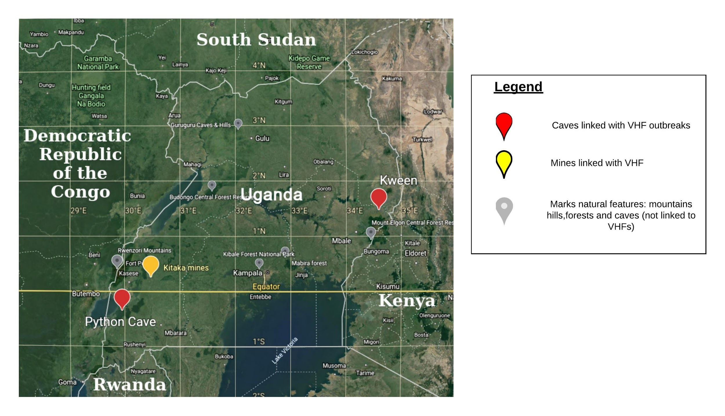**Figure 3** *shows a map of Uganda. The red and yellow place markers represent caves and mines linked to VHF outbreaks in Uganda*

## 3.1 Research Design

This study will adopt a descriptive survey design which will be qualitative in nature. This design will collate sequence data from the National Center for Biotechnology Institute database as well as data from UVRI collaborations. The design will be used because the study will gather currently available viral sequence data in the study location without manipulating any variables involved in acquiring the data.

## 3.2 Sampling Procedures

This study will employ non-probability sampling techniques. Non-probability sampling is a sampling method in which the researcher selects samples based on the subjective judgment of the researcher rather than random selection. More specifically we will utilize purposive sampling which is a non-probability sampling sub-type. Purposive sampling involves selection of samples from a population based on knowledge about the population and the purpose of the study. This study will pick out sequence samples for reported VHF outbreaks in Uganda obtained from NCBI database and UVRI collaborations as earlier described.

## 3.3 Research Instruments

A survey method for all available viral sequence data will be used for this research. This method will employ a python script which will parse through downloaded VHF GenBank files and output the FASTA files for each sequence and a csv file containing metadata on the sequences downloaded. The comma separated values file (csv) contains fields such as accession number, viral strain, record date, length, journal, country, collection date, journal, title and author whereas the FASTA files contains the nucleotide sequences for the downloaded VHF sequences.

## 3.4 Data Collection Procedures

**Figure 4** *schema showing the data collection process for our proposed study.*

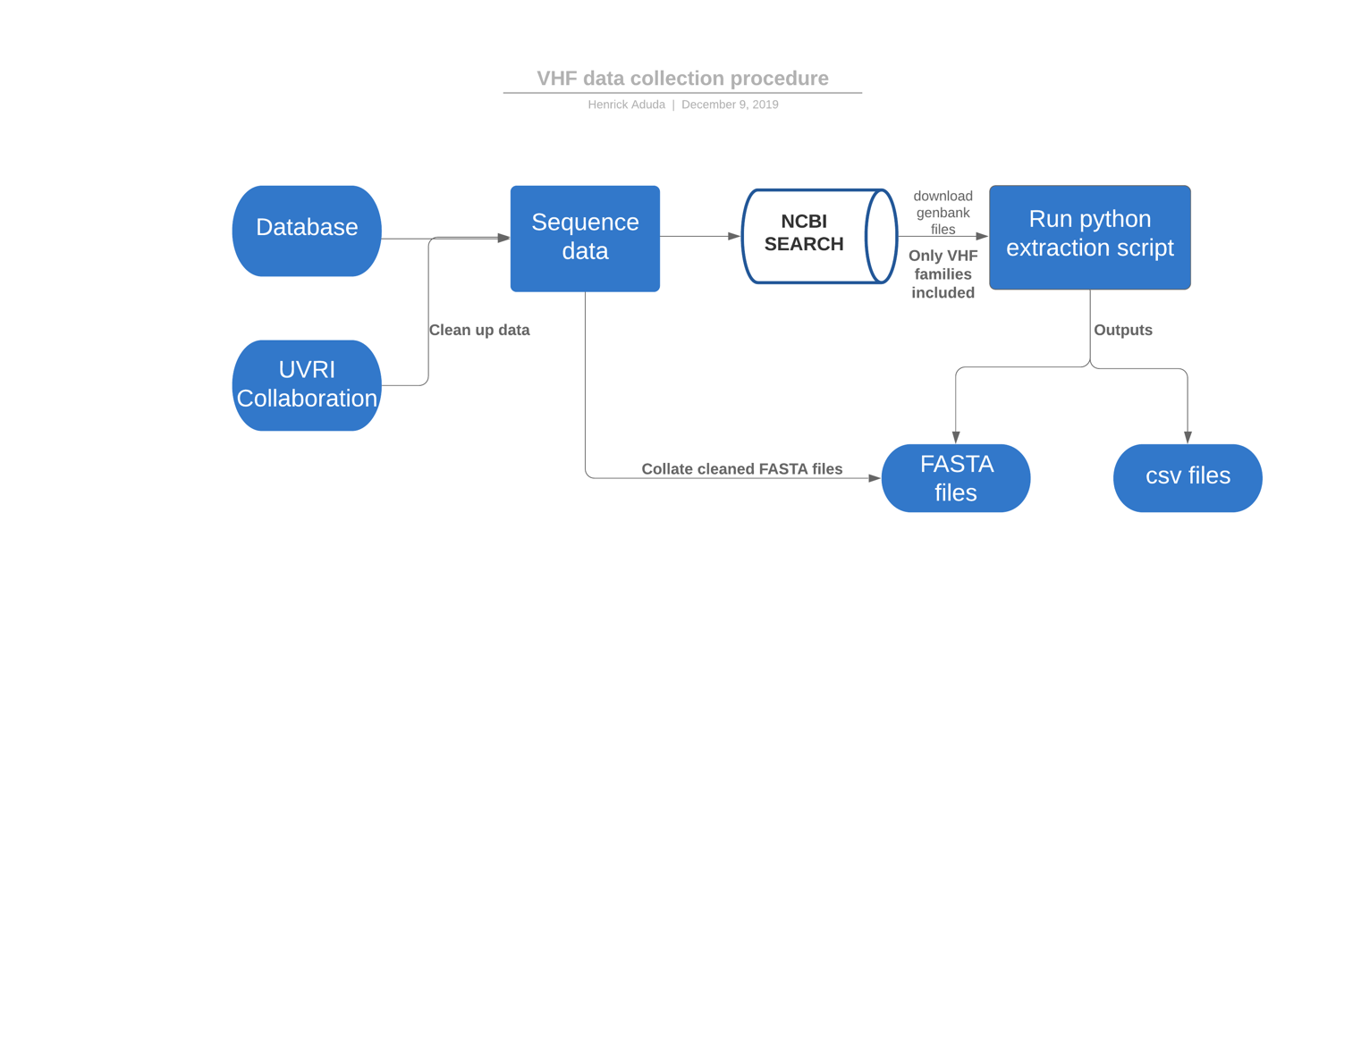

The process of data collection will take approximately one month. Sequence data for the proposed study will be collected using two routes. The first route will obtain sequence data from NCBI database by employing a search strategy. This strategy will involve using the NCBI advanced search tool whereby taxonomic ID for each VHF family is keyed in. All the families and genus that do not cause VHF are then excluded by keying in the word “NOT” - a Boolean term, followed by the taxonomic ID for each of the viral families and genus that do not cause VHF. The search term “AND Uganda” will also be included in the advanced search strategy to ensure that we obtain sequences only from Uganda. These sequences of activities will then be repeated for each of the four VHF families of interest: *Arenaviridae*, *Bunyaviridae*, *Flaviviridae* and *Filoviridae*. After search completion, the GenBank files for all the searched sequence records will be downloaded. A python script was written and will be used to extract FASTA files and metadata for all the searched sequences. The python script will utilize various python libraries and tools to parse the downloaded GenBank files to extract relevant features. It will then output a csv file which will contain information on the sequence data, as well as FASTA files containing the nucleotide sequences with the VHF’s of interest.

The second route will obtain sequence data from UVRI collaborations. The data will then be merged with the data extracted from NCBI. These merged data will be utilized for phylogenetic and phylodynamic analysis further downstream.

## 3.5 Data Analysis

The sequences will be aligned using Multiple Sequence Comparison by Log Expectation (MUSCLE). Phylogenetic trees will be constructed using PhyML version 3.1, Mr. Bayes and IQ tree (http://www.atgc-montpellier.fr/phyml/)(https://nbisweden.github.io/MrBayes/download.html)(http://www.iqtree.org/). The resulting phylogenetic trees from this three software will then be compared, we will then pick out the most informative tree. Evolutionary history will be inferred using the maximum likelihood method. We expect to observe sequences from a similar outbreak clustering together within one clade (only if there were no introductions from previous outbreaks). If there is an introduction from previous outbreak(s) our prediction is that sequences extracted from the previous outbreaks will cluster together with other outbreaks.

Transmission dynamics will be elucidated using three parameters; genetic diversity, genetic distances of the sequences and phylodynamic topology. Using genetic diversity measures, comparisons will be made within each outbreak and between outbreaks. We expect the genetic diversity to remain high/stable over time if the observed outbreak was a continuation of a previous outbreak. Whereas if the outbreak is from a presumed natural reservoir, we expect the genetic diversity to be lower/unstable over time owing to the founders' effect (see figure 2).

When considering genetic distances, if sequences from a site during an outbreak cluster with sequences across previous outbreaks this suggests continuity throughout the inter-outbreak period. Whereas if the outbreak is from a presumed natural reservoir harboring much great diversity, we expect to see a separation between the sequences obtained from a site during an outbreak and the sequences obtained from previous outbreaks, this will imply that there were new introductions from a non-human source during the new outbreak period.

Using the next strain web-based platform, we will visualize the geographic transmission patterns using the full and partial sequences used during the phylogenetic analysis. If there were continued human to human transmission, we expect clustering of sequences from previous outbreak location sites. Whereas if there were zoonotic spillovers from the hosts, we expect to see sequences clustering in known natural host locations. During the 2013-2016 West African Ebola outbreak, phylodynamic analysis revealed transmission chain movements during the outbreak in West Africa (Dudas et al., 2017) ⁠.⁠

# 4.REFERENCES

Adjemian, J., Farnon, E. C., Tschioko, F., Wamala, J. F., Byaruhanga, E., Bwire, G. S., … Rollin, P. E. (2011). Outbreak of Marburg hemorrhagic fever among miners in kamwenge and ibanda Districts, Uganda, 2007. *Journal of Infectious Diseases*, *204*(SUPPL. 3), 2–5. <https://doi.org/10.1093/infdis/jir312>

Albariño, C. G., Shoemaker, T., Khristova, M. L., Wamala, J. F., Muyembe, J. J., Balinandi, S., … Ströher, U. (2013a). Genomic analysis of filoviruses associated with four viral hemorrhagic fever outbreaks in Uganda and the Democratic Republic of the Congo in 2012. *Virology*, *442*(2), 97–100. https://doi.org/10.1016/j.virol.2013.04.014

Albariño, C. G., Shoemaker, T., Khristova, M. L., Wamala, J. F., Muyembe, J. J., Balinandi, S., … Ströher, U. (2013b). Genomic analysis of filoviruses associated with four viral hemorrhagic fever outbreaks in Uganda and the Democratic Republic of the Congo in 2012. *Virology*, *442*(2), 97–100. https://doi.org/10.1016/j.virol.2013.04.014

Amman, B. R., Carroll, S. A., Reed, Z. D., Sealy, T. K., Balinandi, S., Swanepoel, R., … Towner, J. S. (2012). Seasonal Pulses of Marburg Virus Circulation in Juvenile Rousettus aegyptiacus Bats Coincide with Periods of Increased Risk of Human Infection. *PLoS Pathogens*, *8*(10). https://doi.org/10.1371/journal.ppat.1002877

Arias, A., Watson, S. J., Asogun, D., Tobin, E. A., Lu, J., Phan, M. V. T., … Cotten, M. (2016). Rapid outbreak sequencing of Ebola virus in Sierra Leone identifies transmission chains linked to sporadic cases. *Virus Evolution*, *2*(1), vew016. https://doi.org/10.1093/ve/vew016

Balinandi, S., Patel, K., Ojwang, J., Kyondo, J., Mulei, S., Tumusiime, A., … Shoemaker, T. R. (2018). Investigation of an isolated case of human Crimean-Congo hemorrhagic fever in Central Uganda, 2015. *International Journal of Infectious Diseases : IJID : Official Publication of the International Society for Infectious Diseases*, *68*, 88–93. <https://doi.org/10.1016/j.ijid.2018.01.013>

Bausch, D. G., Towner, J. S., Dowell, S. F., Kaducu, F., Lukwiya, M., Sanchez, A., … Rollin, P. E. (2007). Assessment of the Risk of Ebola Virus Transmission from Bodily Fluids and Fomites. *The Journal of Infectious Diseases*, *196*(s2), S142–S147. https://doi.org/10.1086/520545

Bray, M. (2005). Pathogenesis of viral hemorrhagic fever. *Current Opinion in Immunology*, *17*(4 SPEC. ISS.), 399–403. https://doi.org/10.1016/j.coi.2005.05.001

Chughtai, A. A., Barnes, M., & Macintyre, C. R. (2016). Persistence of Ebola virus in various body fluids during convalescence: Evidence and implications for disease transmission and control. *Epidemiology and Infection*, *144*(8), 1652–1660. https://doi.org/10.1017/S0950268816000054

D.A., B., N.L., F., D.M., W., A.J., M., C.A., W., & M., B. (2013). Crimean-Congo hemorrhagic fever: History, epidemiology, pathogenesis, clinical syndrome and genetic diversity. *Antiviral Research*, *100*(1), 159–189. Retrieved from http://0-ovidsp.ovid.com.wam.city.ac.uk/ovidweb.cgi?T=JS&PAGE=reference&D=emed11&NEWS=N&AN=2013741328

Davies, F. G., Linthicum, K. J., & James, A. D. (1985). Rainfall and epizootic Rift Valley fever. *Bulletin of the World Health Organization*, *63*(5), 941–943.

Diallo, B., Sissoko, D., Loman, N. J., Bah, H. A., Bah, H., Worrell, M. C., … Duraffour, S. (2016). Resurgence of Ebola Virus Disease in Guinea Linked to a Survivor with Virus Persistence in Seminal Fluid for More Than 500 Days. *Clinical Infectious Diseases*, *63*(10), 1353–1356. https://doi.org/10.1093/cid/ciw601

Drosten, C., Göttig, S., & Schilling, S. (2002). quantification of RNA of Ebola and Marburg viruses, Lassa virus, Crimean-Congo hemorrhagic fever virus, Rift Valley fever virus, dengue virus, and yellow fever virus. *Journal of Clinical …*, *40*(7), 2323–2330. https://doi.org/10.1128/JCM.40.7.2323

Dudas, G., Carvalho, L. M., Bedford, T., Tatem, A. J., Baele, G., Faria, N. R., … Rambaut, A. (2017). Virus genomes reveal factors that spread and sustained the Ebola epidemic. *Nature*, *544*(7650), 309–315. https://doi.org/10.1038/nature22040

Ellis1, B. R. A. D. T. B. (2009). The enigma of yellow fever in East Africa. *Reviews in Medical Virology*, *19*(1), 57–64. https://doi.org/10.1002/rmv

Goldani, L. Z. (2017). Yellow fever outbreak in Brazil, 2017. *Brazilian Journal of Infectious Diseases*, *21*(2), 123–124. https://doi.org/10.1016/j.bjid.2017.02.004

Henderson, B. E., Mc Crae, A. W. R., Kirya, B. G., Ssenkubuge, Y., & Sempala, S. D. K. (1972). Arbovirus epizootics involving man, mosquitoes and vertebrates at lunyo, uganda 1968. *Annals of Tropical Medicine and Parasitology*, *66*(3), 343–355. <https://doi.org/10.1080/00034983.1972.11686834>

Hoogstraal, H., Merl, J., Asia, F. I. N., Casals, D., Henderson, B. E., Karl, M., … Work, T. H. (1979). *THE EPIDEMIOLOGY OF TICK-BORNE CRIMEAN-CONGO HEMORRHAGIC*.

Hughes, H. R., Kayiwa, J., Mossel, E. C., Lutwama, J., Staples, J. E., & Lambert, A. J. (2018). Phylogeny of yellow fever virus, Uganda, 2016. *Emerging Infectious Diseases*, *24*(8), 1598–1599. https://doi.org/10.3201/eid2408.180588

Imported case of Marburg hemorrhagic fever - Colorado, 2008. (2009). *MMWR. Morbidity and Mortality Weekly Report*, *58*(49), 1377–1381.

Kizito, S., Okello, P. E., Kwesiga, B., Nyakarahuka, L., Balinandi, S., Mulei, S., … Zhu, B. P. (2018). Crimean-congo hemorrhagic fever outbreak — Central Uganda, august–september 2017. *Morbidity and Mortality Weekly Report*, *67*(22), 646–647. https://doi.org/10.15585/mmwr.mm6722a6

Knust, B., Schafer, I. J., Wamala, J., Nyakarahuka, L., Okot, C., Shoemaker, T., … Rollin, P. E. (2015). Multidistrict Outbreak of Marburg Virus Disease - Uganda, 2012. *Journal of Infectious Diseases*, *212*(Suppl 2), S119–S128. https://doi.org/10.1093/infdis/jiv351

Kwagonza, L., Masiira, B., Kyobe-Bosa, H., Kadobera, D., Atuheire, E. B., Lubwama, B., … Zhu, B.-P. (2018). Outbreak of yellow fever in central and southwestern Uganda, February–may 2016. *BMC Infectious Diseases*, *18*(1), 548. https://doi.org/10.1186/s12879-018-3440-y

Lamunu, M., Lutwama, J. J., Kamugisha, J., Opio, A., Nambooze, J., Ndayimirije, N., & Okware, S. (2004). Containing a haemorrhagic fever epidemic: The Ebola experience in Uganda (October 2000-January 2001). *International Journal of Infectious Diseases*, *8*(1), 27–37. https://doi.org/10.1016/j.ijid.2003.04.001

Luby, J. P., & Sanders, C. V. (1969). Green monkey disease (“Marburg virus” disease): a new zoonosis. *Annals of Internal Medicine*, *71*(3), 657–660. https://doi.org/10.7326/0003-4819-71-3-657

Lukashev, A. N., Klimentov, A. S., Smirnova, S. E., Dzagurova, T. K., Drexler, J. F., & Gmyl, A. P. (2016). Phylogeography of crimean congo hemorrhagic fever virus. *PLoS ONE*, *11*(11), 1–14. https://doi.org/10.1371/journal.pone.0166744

MacNeil, A., Farnon, E. C., Wamala, J., Okware, S., Cannon, D. L., Reed, Z., … Rollin, P. E. (2010). Proportion of deaths and clinical features in Bundibugyo Ebola virus infection, Uganda. *Emerging Infectious Diseases*, *16*(12), 1969–1972. https://doi.org/10.3201/eid1612.100627

MacNeil, A., Shoemaker, T., Balinandi, S., Campbell, S., Wamala, J. F., McMullan, L. K., … Nichol, S. T. (2012). Reemerging Sudan Ebola virus disease in Uganda, 2011. *Emerging Infectious Diseases*, *18*(9), 1480–1483. https://doi.org/10.3201/eid1809.111536

Mahaffy, A. F., Smithburn, K. C., & Jacobs, H. R. (1942). Yellow fever in Western Uganda. *Transactions of the Royal Society of Tropical Medicine and Hygiene*, *36*(1), 9–20. <https://doi.org/10.1016/S0035-9203(42)90051-8>

Mbonye, A. K., & Sekamatte, M. (2018). Disease outbreaks and reporting in Uganda. *The Lancet*, *392*(10162), 2347–2348. https://doi.org/10.1016/S0140-6736(18)32414-0

Mbonye, A., Wamala, J., Kaboyo, W., Tugumizemo, V., Aceng, J., & Makumbi, I. (2012). Repeated outbreaks of viral hemorrhagic fevers in Uganda. *African Health Sciences*, *12*(4), 579–583. https://doi.org/10.4314/ahs.v12i4.31

McMullan, L. K., Frace, M., Sammons, S. A., Shoemaker, T., Balinandi, S., Wamala, J. F., … Nichol, S. T. (2012). Using next generation sequencing to identify yellow fever virus in Uganda. *Virology*, *422*(1), 1–5. https://doi.org/10.1016/j.virol.2011.08.024

Nyakarahuka, L., Balinandi, S., Mulei, S., Kyondo, J., Tumusiime, A., Klena, J., … Shoemaker, T. (2019). Ten outbreaks of rift valley fever in Uganda 2016-2018: epidemiological and laboratory findings. *International Journal of Infectious Diseases*, *79*(2019), 4. https://doi.org/10.1016/j.ijid.2018.11.029

Nyakarahuka, Luke, de St. Maurice, A., Purpura, L., Ervin, E., Balinandi, S., Tumusiime, A., … Shoemaker, T. R. (2018). Prevalence and risk factors of Rift Valley fever in humans and animals from Kabale district in Southwestern Uganda, 2016. *PLoS Neglected Tropical Diseases*, *12*(5), 1–16. https://doi.org/10.1371/journal.pntd.0006412

Nyakarahuka, Luke, Ojwang, J., Tumusiime, A., Balinandi, S., Whitmer, S., Kyazze, S., … Shoemaker, T. R. (2017). Isolated case of marburg virus disease, Kampala, Uganda, 2014. *Emerging Infectious Diseases*, *23*(6), 1001–1004. https://doi.org/10.3201/eid2306.170047

Nyakarahuka, Luke, Shoemaker, T. R., Balinandi, S., Chemos, G., Kwesiga, B., Mulei, S., … Lutwama, J. J. (2018). Marburg virus disease outbreak in Kween District Uganda, 2017: Epidemiological and laboratory findings. *PLoS Neglected Tropical Diseases*, *13*(3), 1–19. https://doi.org/10.1371/journal.pntd.0007257

Okware, S. I., Omaswa, F. G., Zaramba, S., Opio, A., Lutwama, J. J., Kamugisha, J., … Lamunu, M. (2002). An outbreak of Ebola in Uganda. *Tropical Medicine and International Health*, *7*(12), 1068–1075. https://doi.org/10.1046/j.1365-3156.2002.00944.x

Racsa, L. D., Kraft, C. S., Olinger, G. G., & Hensley, L. E. (2016). Viral Hemorrhagic Fever Diagnostics. *Clinical Infectious Diseases*, *62*(2), 214–219. https://doi.org/10.1093/cid/civ792

Ross, E. W., Haddow, A. J., Raper, A. B., & Trowell, H. C. (1953). A Fatal Case of Yellow Fever in a European in Uganda. *East African Medical Journal*, *30*(1), 1–11. Retrieved from https://www.cabdirect.org/cabdirect/abstract/19532901224

Sanchez, A., & Rollin, P. E. (2005). Complete genome sequence of an Ebola virus (Sudan species) responsible for a 2000 outbreak of human disease in Uganda. *Virus Research*, *113*(1), 16–25. https://doi.org/10.1016/j.virusres.2005.03.028

Sekamatte, M., Riad, M. H., Tekleghiorghis, T., Linthicum, K. J., Britch, S. C., Richt, J. A., … Scoglio, C. M. (2019). Individual-based network model for Rift Valley fever in Kabale District, Uganda. *PLoS ONE*, *14*(3), 1–19. <https://doi.org/10.1371/journal.pone.0202721>

Shoemaker, T. R., Nyakarahuka, L., Balinandi, S., Ojwang, J., Tumusiime, A., Mulei, S., … Lutwama, J. (2019). First laboratory-confirmed outbreak of human and animal rift valley fever virus in Uganda in 48 years. *American Journal of Tropical Medicine and Hygiene*, *100*(3), 659–671. https://doi.org/10.4269/ajtmh.18-0732

Timen, A. (2009). Response to Imported Case of Marburg Hemorrhagic Fever, the Netherlands. *Emerging Infectious Diseases*, *15*(8), 1171–1175. https://doi.org/10.3201/eid1508.090051

Towner, J. S., Amman, B. R., Sealy, T. K., Reeder Carroll, S. A., Comer, J. A., Kemp, A., … Rollin, P. E. (2009). Isolation of genetically diverse Marburg viruses from Egyptian fruit bats. *PLoS Pathogens*, *5*(7). https://doi.org/10.1371/journal.ppat.1000536

Towner, J. S., Sealy, T. K., Khristova, M. L., Albariño, C. G., Conlan, S., Reeder, S. A., … Nichol, S. T. (2008). Newly discovered Ebola virus associated with hemorrhagic fever outbreak in Uganda. *PLoS Pathogens*, *4*(11), 3–8. https://doi.org/10.1371/journal.ppat.1000212

Tulloch, J. A., & Patel, K. M. (1965). Yellow fever in central uganda, 1964 part ii. report of a fatal case. *Transactions of the Royal Society of Tropical Medicine and Hygiene*, *59*(4), 441–443. https://doi.org/10.1016/0035-9203(65)90063-5

Wamala, J. F., Malimbo, M., Okot, C. L., Atai-Omoruto, A. D., Tenywa, E., Miller, J. R., … Mbonye, A. K. (2012). Epidemiological and laboratory characterization of a yellow fever outbreak in northern Uganda, October 2010-January 2011. *International Journal of Infectious Diseases*, *16*(7), e536–e542. <https://doi.org/10.1016/j.ijid.2012.03.004>

# 5.BUDGET

|  |  |
| --- | --- |
| **DESCRIPTION** | **COST (USD)** |
| Monthly living expenses | 400 |
| Travel expenses | 400 |
| Conferences | 400 |
| Printing | 30 |
| Computer | 850 |
| Bioinformatics Training | 350 |
| Publishing manuscript | 1300 |
| IRB costs | 100 |
| UNCST costs | 300 |
| **TOTAL** | **$4130** |

# 6.WORK PLAN

|  |  |  |
| --- | --- | --- |
| **MONTH** | **SECTION** | **TASKS** |
| **Sept-Nov** | **Literature familiarization &**  **Proposal development** | * Reading relevant articles, journals and papers * Building up a project concept * Presentation to supervisors on the project concept * Proposal presentation in Pwani. |
| **Dec** | **Data collection** | * Writing a python script for data extraction * Searching and downloading sequence data from online databases * Collating online & UVRI collaborations sequence data |
| **Jan-Mar** | **Data analysis** | * Alignment & Phylogenetics analysis * Phylodynamic analysis * Visualization using next strain software |
| **Apr-May** | **Thesis writing** | * Build up the thesis framework. * Write thesis; divide into sections and assign time for each * Prepare proposal defense slides |
| **June** | **Thesis Defense** | * Thesis defense presentation at Pwani University |
| **Jul- Aug** | **Thesis editing & submission** | * Make corrections on the thesis * Submission of the thesis to University * Manuscript writing for publication |